**2** SYNOPSIS OF CLINICAL OPHTHALMOLOGY



**Visual acuity**

Visual acuity is directly related to the minimum angle of separation between two objects that allows them to be seen distinctly. Visual acuity should always be determined first, regardless of whether the patient complains of visual disturbance or not. Each eye is tested separately, with and without spectacles. A pinhole disc is a simple method of focusing light and temporarily removes the eect of refractive error.

**SNELLEN VISUAL ACUITY**

A Snellen chart is used, with the subject reading the chart from a standard distance (Fig. 1.1A). Normal visual acuity equates to 6/6 (20/20 in non-metric notation). If the patient is unable to see the chart using either spectacles or a pinhole disc the vision can be determined by counting fingers (CF), seeing hand movements (HM), or by assessing the ability to see light (PL).

**LOGMAR VISUAL ACUITY**

LogMAR is an acronym for the base-10 logarithm of the minimum angle of resolution. A Bailey– Lovie chart is used, which has an equal number of letters on each line and the lines are balanced for consistency of readability (Fig. 1.1B). LogMAR 0.00 is equivalent to 6/6 and logMAR 1.00 is equivalent to 6/60. Because logMAR acuity addresses many of the deficiencies of the Snellen chart it is commonly used when research is undertaken.

**Contrast sensitivity**

Contrast sensitivity is a measure of the ability of the visual system to distinguish an object against its background. e Pelli–Robson contrast sensitivity letter chart is viewed at 1 m and consists of rows of letters of equal size, but with decreasing contrast of 0.15 log units for groups of three letters (Fig. 1.2A).

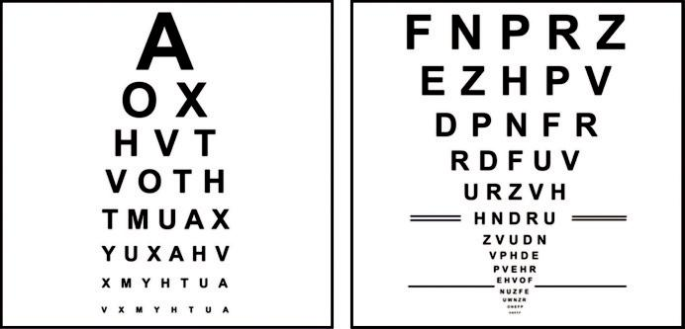

A B

Fig. 1.1 Visual acuity chart: (A) Snellen, (B) Bailey–Lovie logMAR chart. (From Salmon JF, Kanski’s Clinical

Ophthalmology: A Systematic Approach, 9th edition. Oxford, UK: Elsevier; 2020.)

#*" ##%"#"+!#(&&%"'+$'""#* "%#! " +#!+ &)%#"$'!%

#%$%&#" (&#" +##'%(&&*'#('$%!&&#"#$+%', &)%" %'&%&%)

|  |  |
| --- | --- |
| Chapter 1—EXAMINATION OF THE EYE | **3** |
|  |  |

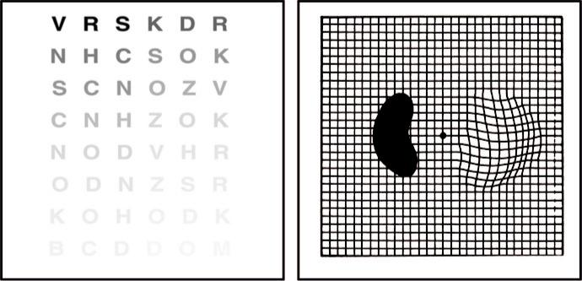

A B

Fig. 1.2 (A) Pelli–Robson contrast sensitivity letter chart, (B) Amsler grid showing wavy lines indicating metamorphopsia and a dense scotoma. (From Salmon JF, Kanski’s Clinical Ophthalmology: A Systematic Approach, 9th edition. Oxford, UK: Elsevier; 2020.)

**Amsler grid**

e Amsler grid evaluates the central 20° of the visual field centred on fixation ( Fig. 1.2B). It is an easy method of monitoring central visual field and is commonly abnormal in patients with macular disease.

**Colour vision**

**ISHIHARA**

is test is simple to undertake, is widely available, and is frequently used to screen for red-green colour anomalies. Inherited colour vision deficiency aects 8% of men and 0.5% of women. e test can also be used to assess optic nerve disease (Fig. 1.3A).

**FARNSWORTH–MUNSELL 100-HUE TEST**

is test is sensitive but takes longer than the Ishihara to perform. It is used for congenital and acquired colour defects (Fig. 1.3B).

**Visual field**

Visual field results should always be used in conjunction with the clinical findings. e test is particularly important in glaucoma and neurological disease.

***e visual field:*** can be represented as a three-dimensional structure akin to a hill of increas-ing sensitivity. e outer aspect extends approximately 50° superiorly, 60° nasally, 70° inferi - orly and 90° temporally.

***Static perimetry:*** is a method of assessing fields in which the stimulus remains fixed, with intensity increasing until it is seen by the subject or decreasing until it is no longer detected. Standard automated perimetry (SAP) uses this method (Fig. 1.4).

#*" ##%"#"+!#(&&%"'+$'""#* "%#! " +#!+ &)%#"$'!%

#%$%&#" (&#" +##'%(&&*'#('$%!&&#"#$+%', &)%" %'&%&%)

**4** SYNOPSIS OF CLINICAL OPHTHALMOLOGY

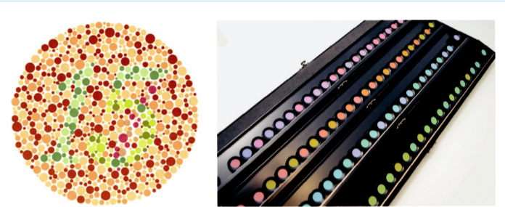

A B

Fig. 1.3 Colour vision tests: (A) Ishihara, (B) Farnsworth–Munsell 100-hue test. (From Salmon JF, Kanski’s

Clinical Ophthalmology: A Systematic Approach, 9th edition. Oxford, UK: Elsevier; 2020.)

***Kinetic perimetry:*** is undertaken by moving a stimulus of constant intensity from a non-seeing area to a seeing area at a constant speed until it is perceived.

**ANALYSIS OF VISUAL FIELDS**

***Reliability indices (****Fig. 1.4A****):*** with SITA strategies false positive or false negative responses over 15% should be considered significant. If the test is found to be unreliable, further evalu-ation of the printout is pointless.

***A numerical display (****Fig. 1.4B****):*** gives the threshold in dB at each point tested in the field. A grey scale ***(****Fig. 1.4C****)*** represents the numerical display in graphical form; decreasing sensi-tivity is represented in darker tones.

***Total deviation (****Fig. 1.4D****):*** shows the dierence between a test-derived threshold at a given point and the normal sensitivity at that point for the general population.

***Pattern deviation (****Fig. 1.4E****):*** is the total deviation adjusted for a generalized decrease in sensitivity in the whole field (for example, the presence of cataract).

***Summary values (****Fig. 1.4F****):*** represent distilled statistical information: (a) visual field index (VFI) is a measure of overall visual field function expressed as a percentage, (b) mean devia-tion (MD) provides an indication of the overall sensitivity of the field, (c) pattern standard deviation (PSD) is a measure of focal loss (an increased PSD is an indicator of glaucoma),

1. the glaucoma hemifield test (GHT) compares corresponding areas in the superior and inferior hemifields.

**Microperimetry**

Microperimetry is a subjective visual field test that measures retinal sensitivity and fixation behaviour in patients with macular disease and glaucoma involving the central 9° of visual field (Fig. 1.5).

**EXTERNAL EXAMINATION**

External examination of the eye, periorbital tissues and orbit should be undertaken before mag-nification is used. Fluorescein dye allows pathology on the surface of the cornea to be visualized (see Fig. 22.8B) and is used when Goldmann applanation tonometry is undertaken.

#*" ##%"#"+!#(&&%"'+$'""#* "%#! " +#!+ &)%#"$'!%

#%$%&#" (&#" +##'%(&&*'#('$%!&&#"#$+%', &)%" %'&%&%)

|  |  |
| --- | --- |
| Chapter 1—EXAMINATION OF THE EYE | **5** |
|  |  |

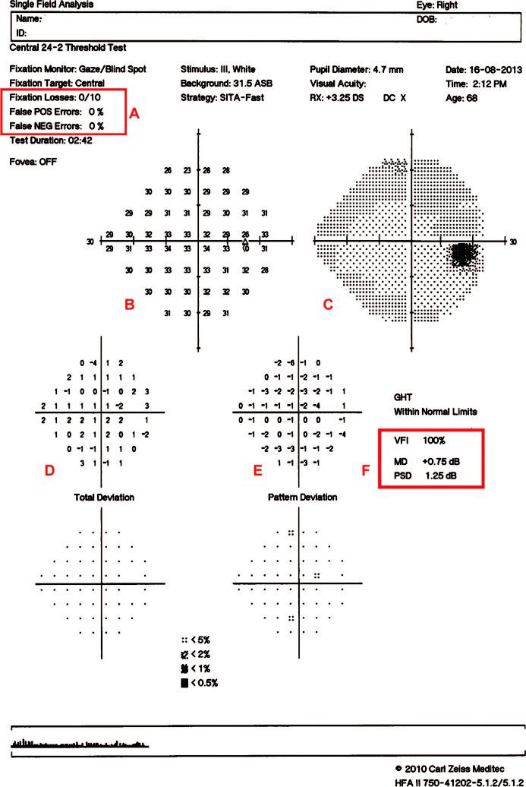

Fig. 1.4 Humphrey SITA-Fast printout (A–F; see text). (From Salmon JF, Kanski’s Clinical Ophthalmology: A

Systematic Approach, 9th edition. Oxford, UK: Elsevier; 2020.)

#*" ##%"#"+!#(&&%"'+$'""#* "%#! " +#!+ &)%#"$'!%

#%$%&#" (&#" +##'%(&&*'#('$%!&&#"#$+%', &)%" %'&%&%)

**6** SYNOPSIS OF CLINICAL OPHTHALMOLOGY

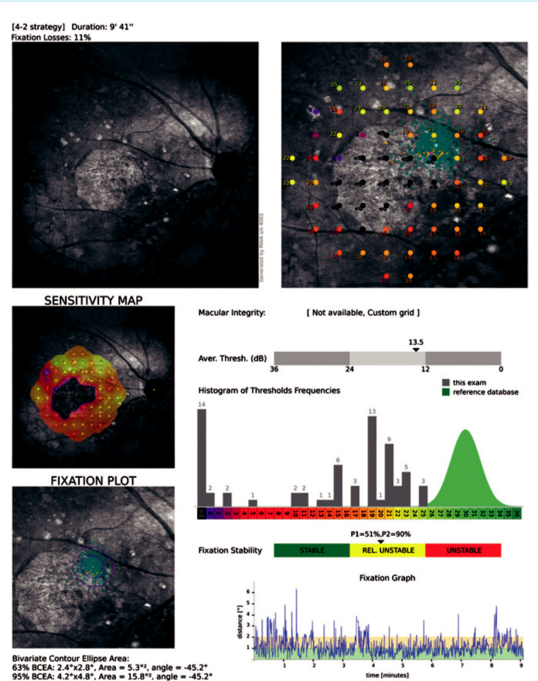

Fig. 1.5 Microperimetry in a patient with geographic atrophy of the macula. (From Salmon JF, Kanski’s Clinical Ophthalmology: A Systematic Approach, 9th edition. Oxford, UK: Elsevier; 2020.)

**Slit lamp biomicroscopy of the anterior segment**

e purpose of slit lamp examination is to determine the position, depth and size of any abnormality of the cornea and anterior segment. It provides good lighting and a stereoscopic view: (a) direct illu-mination with a diuse light is used to detect gross abnormalities, (b) scleral scatter involves decen - tring the slit beam laterally so that the light is incident on the limbus with the microscope focused centrally; light is transmitted within the cornea by total internal reflectivity which allows subtle

#*" ##%"#"+!#(&&%"'+$'""#* "%#! " +#!+ &)%#"$'!%

#%$%&#" (&#" +##'%(&&*'#('$%!&&#"#$+%', &)%" %'&%&%)

|  |  |
| --- | --- |
| Chapter 1—EXAMINATION OF THE EYE | **7** |
|  |  |

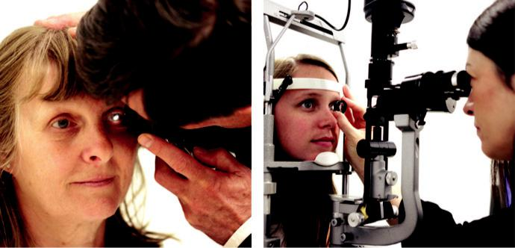

A B

Fig. 1.6 (A) Direct ophthalmoscopy, (B) indirect slit lamp biomicroscopy. (From Salmon JF, Kanski’s Clinical Ophthalmology: A Systematic Approach, 9th edition. Oxford, UK: Elsevier; 2020.)

stromal haze to be detected, (c) retroillumination uses reflected light from the iris to illuminate the cornea, permitting the detection of fine epithelial and endothelial changes, (d) specular reflection shows abnormalities of the endothelium such as reduced cell density and guttata.

**DIRECT OPHTHALMOSCOPY**

***Ophthalmoscope (****Fig. 1.6A****)***. Direct examination of the structures of the fundus using an ophthalmoscope can reveal disease of the eye itself or may reveal an abnormality indica-tive of disease elsewhere in the body (for example: diabetes, systemic hypertension, raised intracranial pressure). e image obtained is magnified ( ×15), but the disadvantages are that there is no stereopsis and that the field of view is small.

**INDIRECT OPHTHALMOSCOPY**

is can be undertaken using a slit lamp or a head-mounted ophthalmoscope. A condensing lens is held at the focal point of the eye and provides an inverted and laterally reversed image.

***Slit lamp biomicroscopy (****Fig. 1.6B****):*** (a) non-contact lenses: 60D (high magnification); when estimating optic disc size use a correction factor of ×1.0; for the 90D (wide-field) lens use a correction factor of 1.3 and for the 78D lens use ×1.1, (b) contact lenses: the Goldman three mirror lens has a central lens and three mirrors set at dierent angles. A viscous coupling solu - tion is required.

***Head-mounted binocular indirect ophthalmoscopy (****Fig. 1.7A and B****):*** allows retinal visualiza-tion through a greater degree of media opacification than slit lamp ophthalmoscopy. A 20D lens magnifies ×3 and a 28D lens (shorter working distance; used in a smaller pupil) magni-fies ×2.27.

**Tonometry**

Tonometry is the method of measuring the intraocular pressure (IOP) using calibrated instru-ments. e normal range for individuals over 40 years of age is 11–21 mm Hg, but 4–7% of normal individuals have an IOP of more than 21 mm Hg (see Chapter 11).

#*" ##%"#"+!#(&&%"'+$'""#* "%#! " +#!+ &)%#"$'!%

#%$%&#" (&#" +##'%(&&*'#('$%!&&#"#$+%', &)%" %'&%&%)

**8** SYNOPSIS OF CLINICAL OPHTHALMOLOGY

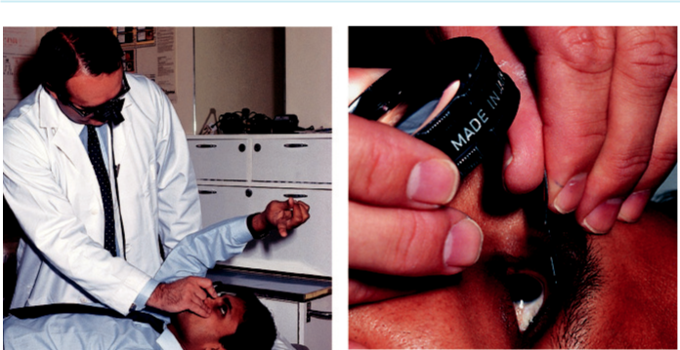

A B

Fig 1.7 (A) Head-mounted binocular indirect ophthalmoscopy, (B) showing technique of indentation. (From Salmon JF, Kanski’s Clinical Ophthalmology: A Systematic Approach, 9th edition. Oxford, UK: Elsevier; 2020.)

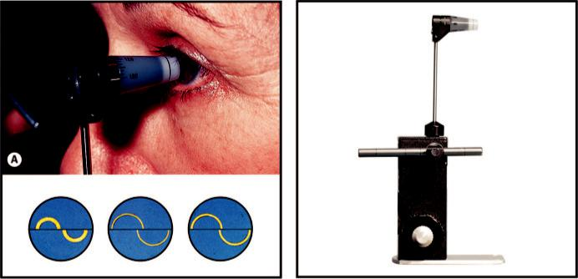

B C

Fig. 1.8 Goldmann applanation tonometry: (A) contact between the tonometer prism and the cornea, (B) cor-rect end-point using mires of appropriate thickness, (C) tonometer calibration bar in position. (From Salmon JF, Kanski’s Clinical Ophthalmology: A Systematic Approach, 9th edition. Oxford, UK: Elsevier; 2020.)

***Goldmann tonometry***: is is an accurate variable-force tonometer consisting of a double prism which applanates the central cornea (Fig. 1.8A). Fluorescein stain is used to create semi-circular mires (Fig. 1.8B). Accuracy is lost with constant use and the tonometer should be checked on a regular basis for calibration error (Fig. 1.8C). Calculations are based on a central corneal thickness of 520 microns (if the cornea is thinner, an underestimation of IOP is likely to result and if thicker, an overestimation). Corneal oedema may result in an artificial reduction in the IOP value. Other sources of error include inappropriate fluores-cein pattern and pressure on the globe.

***Perkins applanation tonometry***: as above, but hand-held with portable light source.

#*" ##%"#"+!#(&&%"'+$'""#* "%#! " +#!+ &)%#"$'!%

#%$%&#" (&#" +##'%(&&*'#('$%!&&#"#$+%', &)%" %'&%&%)

|  |  |
| --- | --- |
| Chapter 1—EXAMINATION OF THE EYE | **9** |
|  |  |

***Other methods:*** (a) pneumotonometry (‘air-pu’) is based on the principle of applanation using a jet of air rather than a prism, (b) electronic applanation tonometry (tonopen); the probe tip contains a transducer that measures applied force, (c) dynamic contour tonometry; a solid-state sensor and a corneal contour-matching surface is used. It has the advantage of measuring the IOP independent of corneal mechanical factors.

***Ocular response analyser and corneal hysteresis***

is instrument uses air-pu technology to record two applanation measurements: one while the cornea is moving inward and one when the cornea returns to its normal position. e aver - age of these two measurements provides a Goldmann-related IOP measurement. e dierence between the IOP measurements is called corneal hysteresis. e value obtained is accurate in individuals who have undergone laser refractive surgery. Patients with a low hysteresis value are at greater risk of glaucoma progression and it may serve as a biomarker to aid glaucoma case detection.

**Central corneal thickness**

is can be measured using pachymetry or by imaging with an Orbscan. e average value is

540 microns (range: 510–570 microns). It is an important measurement when determining the risk of conversion to glaucoma in individuals with raised intraocular pressure.

**Gonioscopy**

Gonioscopy is a method of evaluating the anterior chamber angle. A contact lens is used, e.g. Goldmann one-mirror lens (Fig. 1.9A), Zeiss four-mirror lens (Fig. 1.9B). e examination should take place in a darkened room. Abnormalities that can be detected using gonioscopy include: (a) angle closure, (b) neovascularization, (c) hyper-pigmentation, (d) angle recession (see Chapter 11).

***Indirect gonioscopy*** provides an inverted view of the portion of the angle opposite the mirror. Non-indentation requires a coupling fluid. Indentation gonioscopy does not require a cou-pling fluid and allows a view of the angle when there is apposition between the peripheral iris and cornea. It allows the degree of synechiae to be determined.

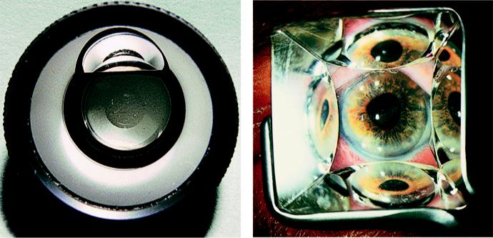

A B

Fig 1.9 (A) Goldmann one-mirror goniolens, (B) Zeiss lens in position. (From Salmon JF, Kanski’s Clinical Ophthalmology: A Systematic Approach, 9th edition. Oxford, UK: Elsevier; 2020.)

#*" ##%"#"+!#(&&%"'+$'""#* "%#! " +#!+ &)%#"$'!%

#%$%&#" (&#" +##'%(&&*'#('$%!&&#"#$+%', &)%" %'&%&%)

**10** SYNOPSIS OF CLINICAL OPHTHALMOLOGY

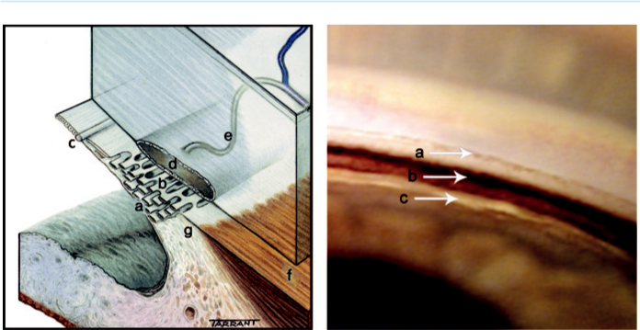

A B

Fig. 1.10 (A) Anatomy of outflow channels: (a) uveal meshwork, (b) corneoscleral meshwork, (c) Schwalbe line, (d) Schlemm canal, (e) collector channels, (f) longitudinal muscle of the ciliary body, (g) scleral spur. (B) Normal structures on gonioscopy: (a) Schwalbe line, (b) pigmented meshwork, (c) ciliary body band. (From Salmon JF, Kanski’s Clinical Ophthalmology: A Systematic Approach, 9th edition. Oxford, UK: Elsevier; 2020.)

***Direct gonioscopy***: light rays from the angle are viewed directly. e examination is under - taken with the patient in a supine position, usually under general anaesthesia in the evalu-ation and surgical treatment of congenital glaucoma or under local anaesthesia when undertaking MIGS.

***Identification of angle structures:*** (a) Schwalbe line is the most anterior structure and demarcates the peripheral termination of Descemet membrane and the anterior limit of the trabeculum, (b) the corneal wedge is useful in identifying an inconspicuous Schwalbe line (see Fig. 11.5), (c) the trabeculum extends from the Schwalbe line to the scleral spur; the non-functioning part has a whitish colour, while the functioning part is pigmented in adults, (d) the Schlemm canal is a slightly darker line deep to the posterior trabeculum,

1. the ciliary body stands out just behind the scleral spur as a pink, dull brown or slate-grey band (Fig. 1.10A and B).

**Optical coherence tomography (OCT)**

OCT is a non-invasive, non-contact imaging system that provides high resolution images of the ante-rior and posterior segments (Fig. 1.11). e diagnosis and monitoring of macular pathology has been revolutionized by this technology (see Chapters 13–15). OCT is commonly used in the imaging of the retinal nerve fibre layer in individuals with ocular hypertension and glaucoma (see Chapter 11).

**OCT angiography**

is is a new, non-invasive diagnostic technique that allows the blood flow in the retina and choroid to be visualized without the need for an injection of contrast medium. e disadvantage of the technique is that the classic abnormalities of traditional angiography (leakage, staining, pooling) are not shown.

***Indications:*** (a) diagnosis and monitoring of choroidal neovascular membranes (Fig. 1.12A),

1. diabetic retinopathy (Fig. 1.12B), (c) visualization of abnormal choroidal vessels and polyps, (d) chronic central serous retinopathy, (e) some intraocular tumours.

#*" ##%"#"+!#(&&%"'+$'""#* "%#! " +#!+ &)%#"$'!%

#%$%&#" (&#" +##'%(&&*'#('$%!&&#"#$+%', &)%" %'&%&%)

|  |  |
| --- | --- |
| Chapter 1—EXAMINATION OF THE EYE | **11** |
|  |  |

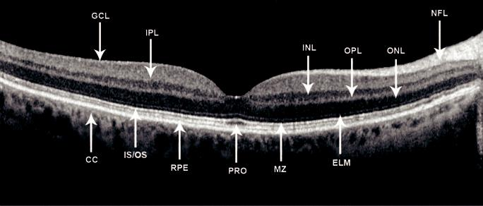

Fig. 1.11 High resolution image provided by spectral-domain OCT: cc = choriocapillaris, ELM = external limiting membrane, GLC = ganglion cell layer, INL = inner nuclear layer, IPL = inner plexiform layer, IS/OS = photoreceptor inner-segment/outer segment junction, MZ = myoid zone, NFL = nerve fibre layer, ONL = outer nuclear layer, OPL = outer plexiform layer, PRO = photoreceptor outer segments, RPE = retinal pig-ment epithelium. (From Salmon JF, Kanski’s Clinical Ophthalmology: A Systematic Approach, 9th edition. Oxford, UK: Elsevier; 2020.)

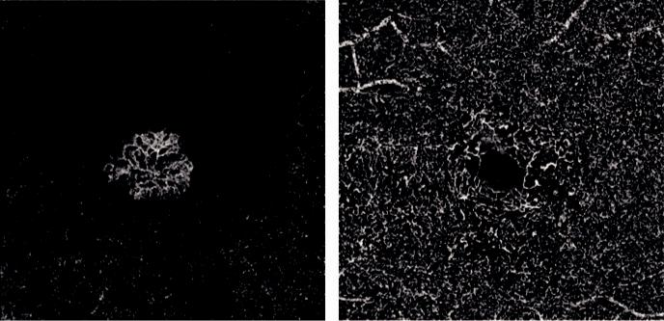

A B

Fig. 1.12 OCT angiography: (A) choroidal neovascular membrane, (B) loss of perifoveal network in diabetic maculopathy. (Courtesy of A Ambresin.)

**Fundus angiography**

**FLUORESCEIN ANGIOGRAPHY (FA)**

is involves photographic surveillance of the passage of fluorescein through the retinal and choroidal circulations following intravenous injection.

***Fluorescein binding:*** 70–85% of fluorescein molecules are bound to serum proteins and the rest is unbound (free).

***e outer blood–retinal barrier:*** while the major choroidal vessels are impermeable to fluo-rescein, free molecules can pass through the choriocapillaris into the extravascular space. e fluorescein passes across Bruch membrane, but cannot cross the tight junctions of the retinal pigment epithelium (RPE).

#*" ##%"#"+!#(&&%"'+$'""#* "%#! " +#!+ &)%#"$'!%

#%$%&#" (&#" +##'%(&&*'#('$%!&&#"#$+%', &)%" %'&%&%)

**12** SYNOPSIS OF CLINICAL OPHTHALMOLOGY



***e inner blood–retinal barrier:*** tight junctions between the retinal capillary endothelial cells confine fluorescein to the lumen of the capillaries. Disruption of this barrier permits leakage into the extravascular space.

***Adverse eects:*** (a) discolouration of skin and urine, (b) nausea and vomiting, (c) itching and

sneezing, (d) rarely: syncope, laryngeal oedema, bronchospasm and anaphylactic shock.

***Phases of the angiogram:*** (a) choroidal, (b) arterial, (c) arteriovenous, (d) venous, (e) late (elimination) (Fig. 1.13A-D).

***Hyperfluorescence:*** (a) transmission (window) defect caused by atrophy or absence of the RPE, e.g. atrophic AMD, (b) pooling of dye because of break-down of the outer blood– retinal barrier, e.g. central serous retinopathy, pigment epithelial detachment, (c) leakage of dye from abnormal vessels, e.g. choroidal neovascular membrane (CNV), breakdown of the inner blood–retinal barrier, e.g. cystoid macular oedema or retinal neovascularization, e.g. proliferative diabetic retinopathy, (d) staining of tissue, e.g. drusen.

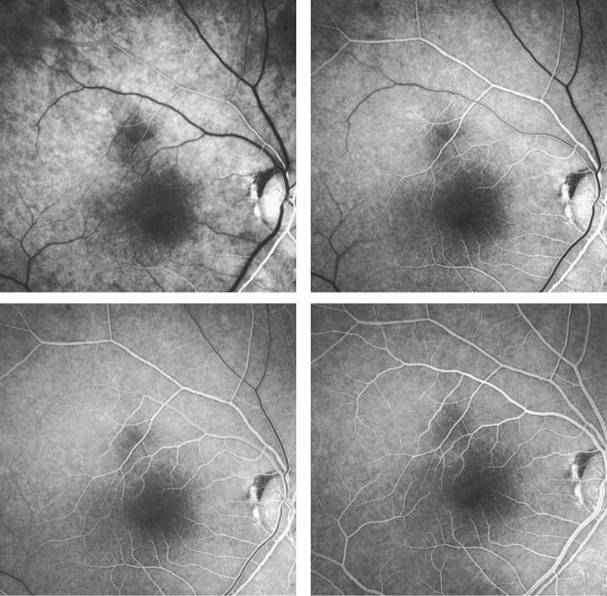

A B

C D

Fig. 1.13 Fluorescein angiography: (A) arterial phase showing filling of the choroid and retinal arteries,

1. arteriovenous phase showing complete arterial filling and early laminar venous flow, (C) early venous phase showing marked laminar venous flow, (D) mid-venous phase showing almost complete venous filling. (From Salmon JF, Kanski’s Clinical Ophthalmology: A Systematic Approach, 9th edition. Oxford, UK: Elsevier; 2020.)

#*" ##%"#"+!#(&&%"'+$'""#* "%#! " +#!+ &)%#"$'!%

#%$%&#" (&#" +##'%(&&*'#('$%!&&#"#$+%', &)%" %'&%&%)

|  |  |
| --- | --- |
| Chapter 1—EXAMINATION OF THE EYE | **13** |
|  |  |

***Hypofluorescence:*** (a) blockage of retinal fluorescence, e.g. retinal haemorrhage,

1. blockage of background choroidal fluorescence, e.g. subretinal or sub-RPE blood, increased RPE density, choroidal lesions, (c) filling defects, e.g. vascular occlusion, loss of capillary bed.

**INDOCYANINE GREEN ANGIOGRAPHY (ICG)**

is is of value when studying the choroidal circulation and is a useful adjunct to FA.

Particular indications include: (a) occult CNV, (b) CNV associated with pigment epithe-lial detachment, (c) recurrent CNV adjacent to a laser scar, (d) identification of feeder vessels,

1. polypoidal choroidal vasculopathy, (f ) chronic central serous retinopathy, (g) breaks in Bruch membrane.

***ICG binding:*** about 98% of ICG molecules bind to serum proteins on entering the circulation. is phenomenon reduces the passage of ICG through the fenestrations of the choriocapillaris.

***Adverse eects:*** (a) should not be used in patients who are allergic to iodine or who are pregnant, (b) staining of stools, (c) nausea and vomiting, (d) sneezing, (e) pruritis, (f ) rarely: skin eruptions, pyrexia, backache, skin necrosis at the injection site.

***Phases of the angiogram:*** (a) early phase, (b) early mid-phase, (c) late mid-phase, (d) late phase (Fig. 1.14A and B).

***Hyperfluorescence:*** (a) RPE window defect, (b) leakage from the retinal or choroidal circu-lations or optic nerve head, (c) abnormal blood vessels and polyps.

***Hypofluorescence:*** (a) blockage by blood, pigment or exudate, (b) obstruction of the circula-tion, (c) loss of vascular tissue, (d) pigment epithelial detachment.

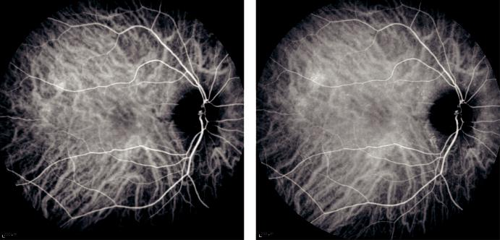

A B

Fig. 1.14 Indocyanine green angiography: (A) early mid-phase (1–3 minutes) showing prominence of choroi-dal and retinal vessels, (B) late mid-phase (3–15 minutes) showing fading of choroidal vessels and diffuse tis-sue staining. (From Salmon JF, Kanski’s Clinical Ophthalmology: A Systematic Approach, 9th edition. Oxford, UK: Elsevier; 2020.)

#*" ##%"#"+!#(&&%"'+$'""#* "%#! " +#!+ &)%#"$'!%

#%$%&#" (&#" +##'%(&&*'#('$%!&&#"#$+%', &)%" %'&%&%)



C H A P T E R 2

Eyelids



C H A P T E R O U T L I N E

Benign Nodules and Cysts 16

Chalazion (meibomian cyst) 16

Miscellaneous 17

Benign Tumours 18

Squamous cell papilloma 18

Basal cell papilloma (seborrhoeic keratosis) 19

Actinic (solar, senile) keratosis 19

Congenital melanocytic naevus 19

Acquired melanocytic naevus 19

Capillary haemangioma (strawberry naevus) 19

Port-wine stain (naevus flammeus) 20

Xanthelasma 21

Neurofibroma 22

Malignant Tumours 22

Rare predisposing conditions 22 Basal cell carcinoma (BCC) 22 Squamous cell carcinoma (SCC) 23 Keratoacanthoma 25 Sebaceous gland carcinoma 25 Malignant melanoma 26 Principles of surgical treatment 26

Disorders of Eyelashes 27

Trichiasis 27

Congenital distichiasis 28

Acquired distichiasis (metaplastic lashes) 28

Eyelash ptosis 28

Trichomegaly 28

Madarosis 29

Poliosis 30

Allergic Disorders 30

Acute allergic oedema 30

Contact dermatitis 30

Atopic dermatitis (eczema) 30

Viral Infections 32 Molluscum contagiosum 32 Herpes zoster ophthalmicus 32 Herpes simplex 33

Chronic Blepharitis 34 Chronic marginal blepharitis 34 Phthiriasis palpebrarum 36

Ptosis 36

Simple congenital ptosis 37

Involutional ptosis 39

Ectropion 40

Involutional ectropion 40

Cicatricial ectropion 40

Paralytic ectropion 40

Entropion 40

Involutional entropion 40

Cicatricial entropion 42

Miscellaneous Acquired Disorders 43 Blepharochalasis 43 Floppy eyelid syndrome 43

Cosmetic Eyelid and Periocular Surgery 44 Nonsurgical cosmetic techniques 44 Surgical cosmetic techniques 44

Congenital Malformations 44

Epicanthus 44

Telecanthus 44

Epiblepharon 45

Blepharophimosis, ptosis and epicanthus inversus syndrome 46

Coloboma 46

Cryptophthalmos 46

Ankyloblepharon filiforme adnatum 46

**15**

#*" ##%"#"+!#(&&%"'+$'""#* "%#! " +#!+ &)%#"$'!%

#%$%&#" (&#" +##'%(&&*'#('$%!&&#"#$+%', &)%" %'&%&%)

**16** SYNOPSIS OF CLINICAL OPHTHALMOLOGY



**Benign Nodules and Cysts**

**CHALAZION (MEIBOMIAN CYST)**

**Definition:**

very common chronic sterile inflammation of a meibomian gland that may resolve spontaneously.

**Diagnosis**

***Signs:*** (a) gradually enlarging tarsal nodule (Fig. 2.1A), (b) conjunctival granuloma-tous extension is common, (c) secondary infection (internal hordeolum) may occur (Fig. 2.1B).

***Associations:*** (a) meibomian gland dysfunction, (b) rosacea, (c) seborrhoeic dermatitis, (d) use of bortezomib, used in the treatment of myeloma.

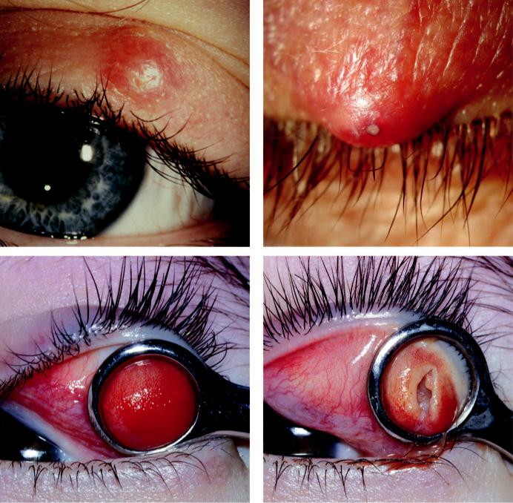

A B

C D

Fig. 2.1 Meibomian cyst: (A) tarsal nodule, (B) superimposed bacterial infection, (C) conjunctival view of cyst

with clamp in position, (D) after curettage. (From Salmon JF, Kanski’s Clinical Ophthalmology: A Systematic

Approach, 9th edition. Oxford, UK: Elsevier; 2020.)

#*" ##%"#"+!#(&&%"'+$'""#* "%#! " +#!+ &)%#"$'!%

#%$%&#" (&#" +##'%(&&*'#('$%!&&#"#$+%', &)%" %'&%&%)

|  |  |
| --- | --- |
| Chapter 2—EYELIDS | **17** |
|  |  |

**Treatment:**

1. incision and curettage (Fig. 2.1C and D), (b) local steroid injection (0.2–1 ml of 5 mg/ml tri-amcinolone diacetate), (c) prophylactic systemic tetracycline in severe recurrent disease.

**MISCELLANEOUS**

***Cyst of Zeis:*** nontranslucent cyst on the anterior lid margin arising from an obstructed sebaceous gland associated with a lash follicle (Fig. 2.2A).

***Cyst of Moll:*** translucent, fluid-filled retention cyst on the anterior lid margin (Fig. 2.2B) arising from an apocrine gland.

***Epidermal inclusion cyst:*** slow-growing, firm, round lesion containing keratin; located away from the lid margin. Caused by implantation of epidermis into dermis following trauma or surgery.

***Sebaceous (pilar) cyst:*** may occasionally occur at the medial canthus (Fig. 2.2C).

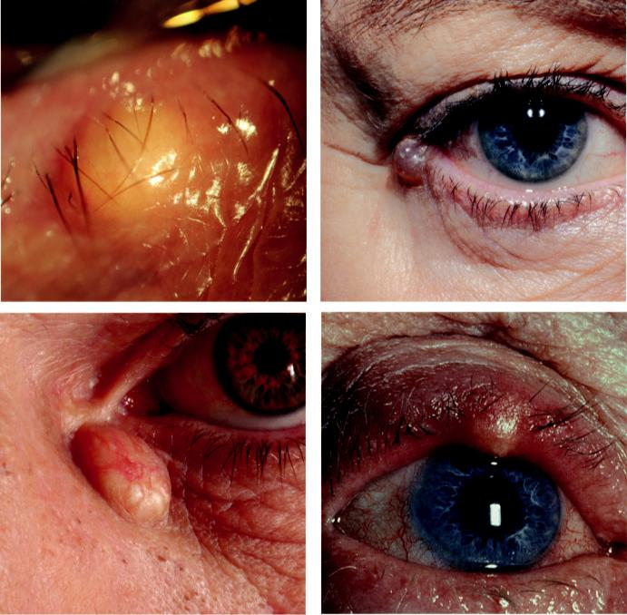

A B

C D

Fig. 2.2 (A) Cyst of Zeis, (B) cyst of Moll, (C) sebaceous cyst, (D) external hordeolum. (From Salmon JF, Kanski’s Clinical Ophthalmology: A Systematic Approach, 9th edition. Oxford, UK: Elsevier; 2020.)

#*" ##%"#"+!#(&&%"'+$'""#* "%#! " +#!+ &)%#"$'!%

#%$%&#" (&#" +##'%(&&*'#('$%!&&#"#$+%', &)%" %'&%&%)

**18** SYNOPSIS OF CLINICAL OPHTHALMOLOGY



***External hordeolum (stye):*** tender, pointing swelling in the lid margin, usually with a lash at its apex (Fig. 2.2D). Caused by an acute staphylococcal infection of a lash follicle.

**Benign Tumours**

**SQUAMOUS CELL PAPILLOMA**

**Pathogenesis:**

human papilloma virus.

**Diagnosis:**

narrow-based pedunculated (skin tag; Fig. 2.3A) or broad-based sessile lesion (Fig. 2.3B).

**Treatment:**

simple excision.

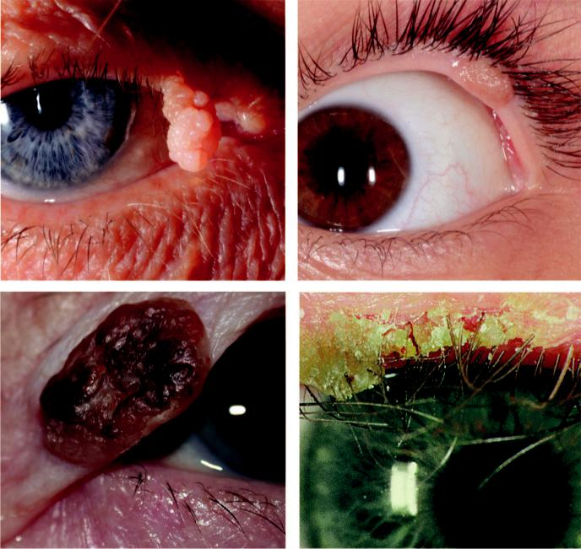

A B

C D

Fig. 2.3 (A) Pedunculated squamous papilloma, (B) sessile squamous papilloma, (C) basal cell papilloma, (D)

actinic keratosis. (Figure 2.3C courtesy of A. Pearson.)

#*" ##%"#"+!#(&&%"'+$'""#* "%#! " +#!+ &)%#"$'!%

#%$%&#" (&#" +##'%(&&*'#('$%!&&#"#$+%', &)%" %'&%&%)

|  |  |
| --- | --- |
| Chapter 2—EYELIDS | **19** |
|  |  |

**BASAL CELL PAPILLOMA (SEBORRHOEIC KERATOSIS)**

**Diagnosis:**

discrete brown pedunculated or sessile lesion, often with a ‘stuck on’ appearance (Fig. 2.3C), in an elderly individual.

**Treatment:**

curettage or excision.

**ACTINIC (SOLAR, SENILE) KERATOSIS**

**Predisposition:**

elderly fair-skinned individuals with a history of chronic sun exposure; carries low malignant potential (squamous cell carcinoma).

**Diagnosis:**

hyperkeratotic plaque with a scaly surface and well-defined borders (Fig. 2.3D).

**Treatment:**

cryotherapy, or excision biopsy if there is suspicion of malignancy.

**CONGENITAL MELANOCYTIC NAEVUS**

**Diagnosis:**

small and of uniform colour. A rare variant is a ‘kissing’ or split naevus, that involves the upper and lower eyelid and may contain hair (Fig. 2.4A)

**Treatment:**

large lesions may need surgical excision, as there is a 15% risk of late malignant transformation.

**ACQUIRED MELANOCYTIC NAEVUS**

**Diagnosis:**

***Intradermal naevus:*** nonpigmented papilloma that may show protruding lashes (Fig. 2.4B), in an elderly individual. e cells are confined to the dermis and have no malignant potential.

***Junctional naevus:*** flat brown lesion (Fig. 2.4C) in a young individual. e cells are located at the junction of the dermis and epidermis and they carry very low malignant potential. ***Compound naevus:*** raised papule with variable pigmentation (Fig. 2.4D), in a middle-aged individual. e cells extend from the epidermis into the dermis and have low malignant potential.

**Treatment:**

excision for cosmesis or suspicion of malignancy.

**CAPILLARY HAEMANGIOMA (STRAWBERRY NAEVUS)**

**Definition:**

common tumour of childhood with a female-to-male ratio of 3:1. Visceral haemangiomas may be present in patients with multiple cutaneous lesions. Most present soon after birth with a rapid growth phase during infancy, followed by gradual involution.

#*" ##%"#"+!#(&&%"'+$'""#* "%#! " +#!+ &)%#"$'!%

#%$%&#" (&#" +##'%(&&*'#('$%!&&#"#$+%', &)%" %'&%&%)

**20** SYNOPSIS OF CLINICAL OPHTHALMOLOGY

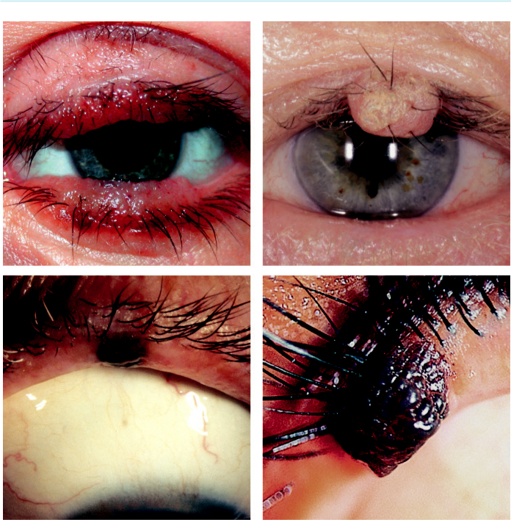

A B

C D

Fig. 2.4 Melanocytic naevus: (A) congenital, (B) intradermal, (C) junctional, (D) compound. (From Salmon JF,

Kanski’s Clinical Ophthalmology: A Systematic Approach, 9th edition. Oxford, UK: Elsevier; 2020.)

**Diagnosis:**

raised, bright red lesion (Fig. 2.5A) that blanches on pressure and may swell on crying; orbital extension may be present (see Chapter 4).

**Treatment**

***Indications:*** (a) cosmesis, (b) severe ptosis, (c) corneal distortion that may give rise to amblyopia.

***Treatment:*** topical timolol or systemic propranolol (2 mg/kg/day in two divided doses).

**PORT-WINE STAIN (NAEVUS FLAMMEUS)**

**Definition:**

congenital lesion that is usually unilateral and occasionally bilateral. In some cases, it forms a component of Sturge–Weber syndrome.

#*" ##%"#"+!#(&&%"'+$'""#* "%#! " +#!+ &)%#"$'!%

#%$%&#" (&#" +##'%(&&*'#('$%!&&#"#$+%', &)%" %'&%&%)

|  |  |
| --- | --- |
| Chapter 2—EYELIDS | **21** |
|  |  |

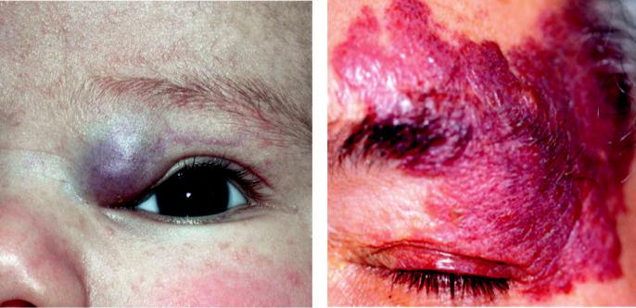

A B

Fig. 2.5 (A) Capillary haemangioma, (B) port-wine stain. (From Salmon JF, Kanski’s Clinical Ophthalmology: A

Systematic Approach, 9th edition. Oxford, UK: Elsevier; 2020.)

**Diagnosis:**

1. sharply demarcated, soft pink patch that does not blanch with pressure (Fig. 2.5B), (b) darkens with age, but does not enlarge, (c) overlying skin may become hypertrophied, coarse and nodular.

**Treatment:**

erbium laser may decrease skin discoloration if undertaken early; photodynamic therapy. Topical imiquimod and rapamycin alone or with adjunctive laser may be considered.

**Diagnosis of Sturge–Weber syndrome (encephalotrigeminal angiomatosis)**

***Skin:*** unilateral naevus flammeus in the distribution of one or more branches of the trigemi-nal nerve.

***Brain:*** ipsilateral parietal or occipital leptomeningeal haemangioma.

***Ipsilateral ocular features:*** (a) glaucoma, (b) episcleral haemangioma, (c) diuse choroidal haemangioma (see Chapter 20), (d) heterochromia iridis is uncommon.

***Classification:*** (a) trisystem involves the face, leptomeninges, and eyes, (b) bisystem disease involves the face and eyes or the face and leptomeninges.

**XANTHELASMA**

**Definition:**

common, typically bilateral lesion occurring in middle-aged and elderly individuals. It is associ-ated with increased risk of coronary heart disease. In younger patients xanthelasma may indicate hypercholesterolaemia.

**Diagnosis:**

white-yellow subcutaneous plaques usually located medially (Fig. 2.6A).

**Treatment:**

1. excision, (b) laser ablation, (c) cryotherapy, (d) systemic cholesterol abnormalities should be addressed to reduce risk of recurrence.

#*" ##%"#"+!#(&&%"'+$'""#* "%#! " +#!+ &)%#"$'!%

#%$%&#" (&#" +##'%(&&*'#('$%!&&#"#$+%', &)%" %'&%&%)

**22** SYNOPSIS OF CLINICAL OPHTHALMOLOGY

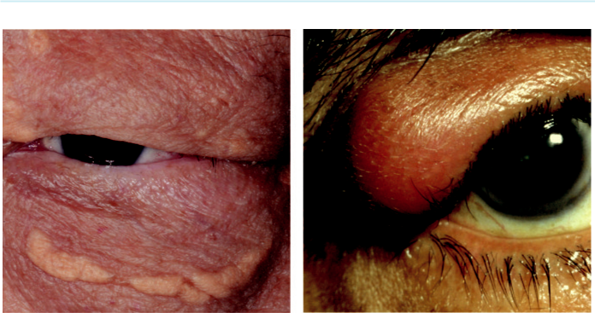

A B

Fig. 2.6 (A) Xanthelasma, (B) neurofibroma. (From Salmon JF, Kanski’s Clinical Ophthalmology: A Systematic

Approach, 9th edition. Oxford, UK: Elsevier; 2020.)

**NEUROFIBROMA**

***Plexiform:*** aects children with neurofibromatosis type 1 (NF1).

***Solitary:*** occurs in adults, 25% of whom have NF1.

**Diagnosis:**

upper lid involvement by a plexiform lesion gives rise to a characteristic S-shaped deformity (Fig. 2.6B).

**Treatment:**

solitary lesions can be excised, but removal of diuse plexiform lesions may be dicult.

**Malignant Tumours**

**RARE PREDISPOSING CONDITIONS**

***Xeroderma pigmentosa:*** AR inheritance. Skin damage on exposure to sunlight. Predisposes to BCC, squamous carcinoma, melanoma. 90% have ocular or periocular involvement (Fig. 2.7A)

***Gorlin–Goltz syndrome:*** AD inheritance. Extensive congenital deformities of eye, face, CNS, developing BCC in the second decade of life.

***Immunosuppression***

***Other:*** albinism, Muir–Torre syndrome, Bazex syndrome, dysplastic naevus syndrome.

**BASAL CELL CARCINOMA (BCC)**

**Definition:**

common, slow-growing, and locally invasive but non-metastasizing tumour. 90% occur on the head and neck and 10% of these involve the eyelids; most commonly the lower.

**Diagnosis**

***Nodular:*** shiny, pearly nodule with overlying fine irregular blood vessels (Fig. 2.7B).

#*" ##%"#"+!#(&&%"'+$'""#* "%#! " +#!+ &)%#"$'!%

#%$%&#" (&#" +##'%(&&*'#('$%!&&#"#$+%', &)%" %'&%&%)

|  |  |
| --- | --- |
| Chapter 2—EYELIDS | **23** |
|  |  |

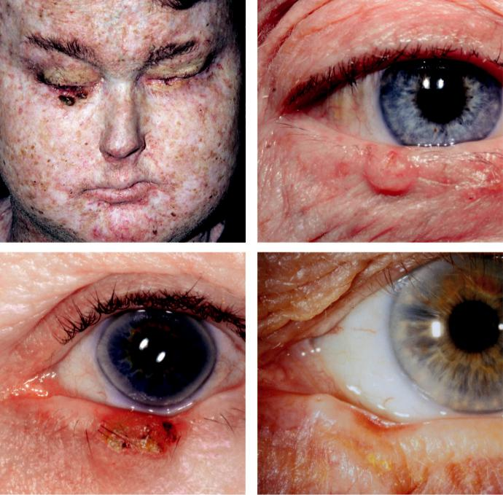

A B

C D

Fig. 2.7 Basal cell carcinoma: (A) xeroderma pigmentosa, (B) nodular, (c) nodulo-ulcerative, (D) scleros-

ing. (From Salmon JF, Kanski’s Clinical Ophthalmology: A Systematic Approach, 9th edition. Oxford, UK:

Elsevier; 2020.)

***Nodulo-ulcerative (rodent ulcer*):** nodule with central ulceration and rolled telangiectatic edges (Fig. 2.7C).

***Sclerosing (morphoeic):*** indurated plaque whose margins may be impossible to delineate clinically; often associated with loss of overlying lashes. is can mimic a localized area of chronic blepharitis (Fig. 2.7D).

**Treatment**

(see below).

**SQUAMOUS CELL CARCINOMA (SCC)**

**Introduction:**

SCC is much less common than BCC but is more aggressive, with metastasis to lymph nodes in about 20%. Perineural spread into the orbit may occur.

#*" ##%"#"+!#(&&%"'+$'""#* "%#! " +#!+ &)%#"$'!%

#%$%&#" (&#" +##'%(&&*'#('$%!&&#"#$+%', &)%" %'&%&%)

**24** SYNOPSIS OF CLINICAL OPHTHALMOLOGY



***Origin:*** (a) *de novo*, (b) in pre-existing actinic keratosis or (c) from carcinoma *in situ* (Bowen disease). (Fig. 2.8A)

***Risk factors:*** (a) increasing age, (b) fair skin, (c) chronic sun exposure, (d) immunosuppres-sion (e.g. HIV, post-transplantation).

**Diagnosis**

***Signs:*** (a) nodular (Fig. 2.8B), (b) nodulo-ulcerative (Fig. 2.8C), (c) associated with a cuta-

neous horn (Fig. 2.8D). It has a predilection for the lower eyelid and the lid margin.

***Diﬀerentiation from BCC:*** hyperkeratosis is frequent; telangiectasis is less common and

growth is usually more rapid.

**Treatment**

(see below).

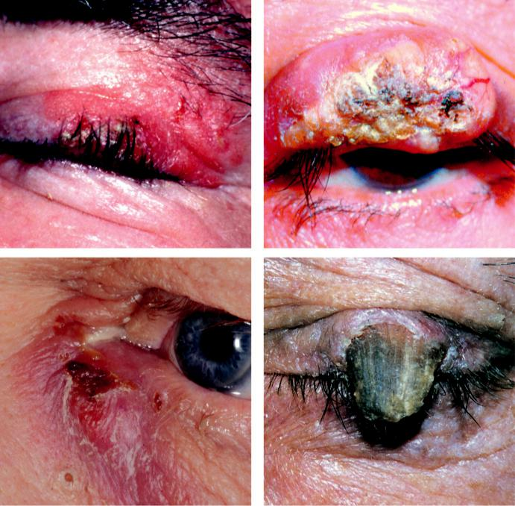

A B

C D

Fig. 2.8 Squamous cell carcinoma: (A) carcinoma in situ, (B) nodular, (C) nodulo-ulcerative, (D) associated with a cutaneous horn. (Figure 2.8B from Singh AD, Damato BE, Pe’er J, Murphree AL, Perry JD. Clinical Ophthalmic Oncology, Saunders 2007.)

#*" ##%"#"+!#(&&%"'+$'""#* "%#! " +#!+ &)%#"$'!%

#%$%&#" (&#" +##'%(&&*'#('$%!&&#"#$+%', &)%" %'&%&%)

|  |  |
| --- | --- |
| Chapter 2—EYELIDS | **25** |
|  |  |

**KERATOACANTHOMA**

**Definition:**

often regarded as a well-dierentiated form of SCC. Risk factors include chronic sun exposure and immunosuppression.

**Diagnosis**

***Presentation:*** fast-growing, pink, dome-shaped hyperkeratotic lesion (Fig. 2.9A).

***Course:*** (a) development of a keratin-filled crater (Fig. 2.9B), (b) no change in size for 2 or 3 months, then (c) slow involution.

**Treatment:**

excision biopsy, radiotherapy or cryotherapy if less than 0.5 cm.

**SEBACEOUS GLAND CARCINOMA**

**Definition:**

rare, slow-growing but aggressive tumour that usually arises from the meibomian glands. It most commonly aects elderly females and has a mortality of 5–10%. In contrast to BCC and SCC, it occurs more commonly on the upper eyelid.

**Diagnosis**

***Nodular:*** beware mistaken diagnosis of chalazion. Biopsy should be performed on any atypical chalazion or suspicious persistent eyelid thickening, particularly in an older individual.

***Spreading:*** diuse thickening of the lid margin ( Fig. 2.10A), which can be mistaken for chronic blepharitis.

***Pagetoid spread:*** extension of the tumour within the epithelium including the conjunctiva, which may be mistaken for chronic inflammation.

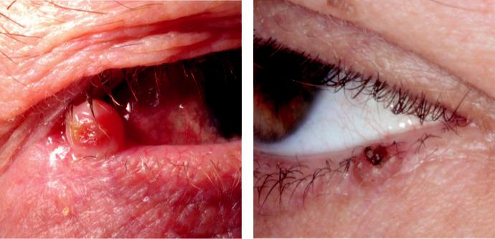

A B

Fig. 2.9 Keratoacanthoma: (A) dome-shaped, hyperkeratotic lesion, (B) keratin-filled crater. (From Salmon JF,

Kanski’s Clinical Ophthalmology: A Systematic Approach, 9th edition. Oxford, UK: Elsevier; 2020.)

#*" ##%"#"+!#(&&%"'+$'""#* "%#! " +#!+ &)%#"$'!%

#%$%&#" (&#" +##'%(&&*'#('$%!&&#"#$+%', &)%" %'&%&%)

**26** SYNOPSIS OF CLINICAL OPHTHALMOLOGY

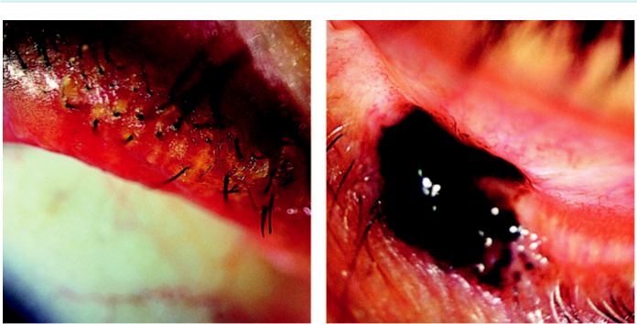

A B

Fig. 2.10 (A) Sebaceous gland carcinoma, (B) malignant melanoma. (From Salmon JF, Kanski’s Clinical Ophthalmology: A Systematic Approach, 9th edition. Oxford, UK: Elsevier; 2020.)

**MALIGNANT MELANOMA**

**Diagnosis**

***Nodular:*** blue-black nodule (Fig. 2.10B)

***Superficial spreading:*** plaque with irregular outline and variable pigmentation.

**Treatment**

(see below).

**PRINCIPLES OF SURGICAL TREATMENT**

**Biopsy**

***Incisional:*** only part of the lesion is removed to allow histological diagnosis.

***Excisional:*** entire lesion is removed.

**Excision**

***Shave excision:*** for shallow epithelial tumours, such as papilloma and seborrhoeic keratosis.

***Full-thickness skin excision:*** most small BCCs can be excised with a 2 to 4 mm clearance margin.

***Radical surgical excision:*** for large BCCs and aggressive malignant tumours.

***Mohs micrographic surgery:*** allows maximal tumour detection and is particularly useful for lesions in which extension may not be clinically detectable such as sclerosing BCC and in dicult anatomical sites such as the medial canthus.

**Reconstruction**

***Skin defects:*** closed directly or with a local flap or skin graft.

***Small defects:*** (less than one-third of lid) can be closed directly, with a lateral cantholysis if necessary (Fig. 2.11A and B)

***Moderate defects:*** (up to half of lid) require a flap (e.g. Tenzel semicircular; Fig. 2.12A and B)

***Large defects:*** (over half of lid) may require: (a) posterior lamellar reconstruction using hard palate graft, buccal mucous membrane graft or a Hughes flap, (b) anterior lamellar recon-struction may involve skin advancement, a local skin flap or a free skin graft.

***Laissez-faire:*** approximation of wound edges with residual defect left to heal spontaneously.

#*" ##%"#"+!#(&&%"'+$'""#* "%#! " +#!+ &)%#"$'!%

#%$%&#" (&#" +##'%(&&*'#('$%!&&#"#$+%', &)%" %'&%&%)

|  |  |
| --- | --- |
| Chapter 2—EYELIDS | **27** |
|  |  |

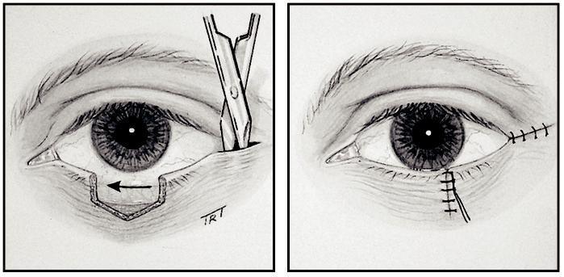

A B

Fig. 2.11 (A and B) Reconstruction, showing incisions, direct closure and lateral cantholysis. (From Salmon JF, Kanski’s Clinical Ophthalmology: A Systematic Approach, 9th edition. Oxford, UK: Elsevier; 2020.)

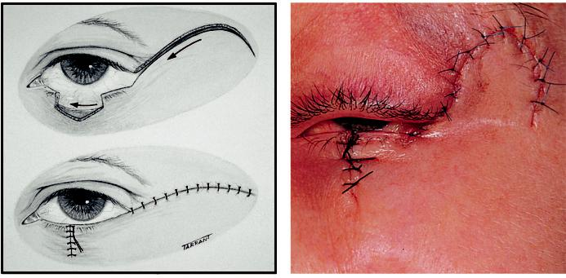

A B

Fig. 2.12 (A and B) Tenzel semicircular flap. (From Salmon JF, Kanski’s Clinical Ophthalmology: A Systematic

Approach, 9th edition. Oxford, UK: Elsevier; 2020.)

**Disorders of Eyelashes**

**TRICHIASIS**

**Definition:**

common acquired condition, which may occur in isolation or secondary to scarring of the lid margin.

**Diagnosis**

***Presentation:*** foreign body sensation worse on blinking; sometimes asymptomatic, parti-cularly in long-standing cases.

#*" ##%"#"+!#(&&%"'+$'""#* "%#! " +#!+ &)%#"$'!%

#%$%&#" (&#" +##'%(&&*'#('$%!&&#"#$+%', &)%" %'&%&%)

**28** SYNOPSIS OF CLINICAL OPHTHALMOLOGY



***Signs:*** lashes are posteriorly misdirected but arise from normal sites. Corresponding punctate corneal epithelial erosions are common.

***Complications:*** corneal ulceration and pannus, in severe cases.

**Treatment**

***Epilation:*** with forceps for temporary control.

***Ablation:*** (a) argon laser for sparse lashes, (b) electrolysis (may cause scarring) or (c) cryo-therapy for profuse lashes.

***Surgery:*** full-thickness wedge resection or anterior lamellar rotation in resistant cases.

**CONGENITAL DISTICHIASIS**

**Definition:**

very rare disorder which may be autosomal dominant (AD), and is frequently associated with lymphoedema of the legs (lymphoedema–distichiasis syndrome).

**Diagnosis:**

partial or complete second row of lashes emerge at or behind the meibomian gland orifices; usu-ally well tolerated during infancy.

**Treatment:**

cryotherapy for lower lid distichiasis, or lamellar lid splitting with cryotherapy to the posterior lamella for upper lid involvement.

**ACQUIRED DISTICHIASIS (METAPLASTIC LASHES)**

**Pathogenesis:**

metaplasia and dedierentiation of the meibomian glands to become hair follicles; typically asso - ciated with cicatrizing conjunctivitis (e.g. chemical injury, Stevens–Johnson syndrome, ocular cicatricial pemphigoid; see Chapter 6).

**Diagnosis:**

nonpigmented, often stunted, lashes originating from meibomian gland orifices (Fig. 2.13A).

**Treatment:**

mild cases as for trichiasis; severe cases require lamellar lid splitting and cryotherapy to the pos-terior lamella.

**EYELASH PTOSIS**

***Definition:*** downward sagging of upper lashes.

***Causes:*** (a) involutional changes, (b) long-standing facial palsy, (c) floppy eyelid syndrome (see below).

**TRICHOMEGALY**

***Definition:*** excessive eyelash growth (Fig. 2.13B).

***Acquired causes:*** (a) drug-induced (topical prostaglandin analogues, phenytoin, ciclosporin),

(b) malnutrition, (c) AIDS, (d) porphyria, (e) hypothyroidism, (f ) familial.

#*" ##%"#"+!#(&&%"'+$'""#* "%#! " +#!+ &)%#"$'!%

#%$%&#" (&#" +##'%(&&*'#('$%!&&#"#$+%', &)%" %'&%&%)

|  |  |
| --- | --- |
| Chapter 2—EYELIDS | **29** |
|  |  |

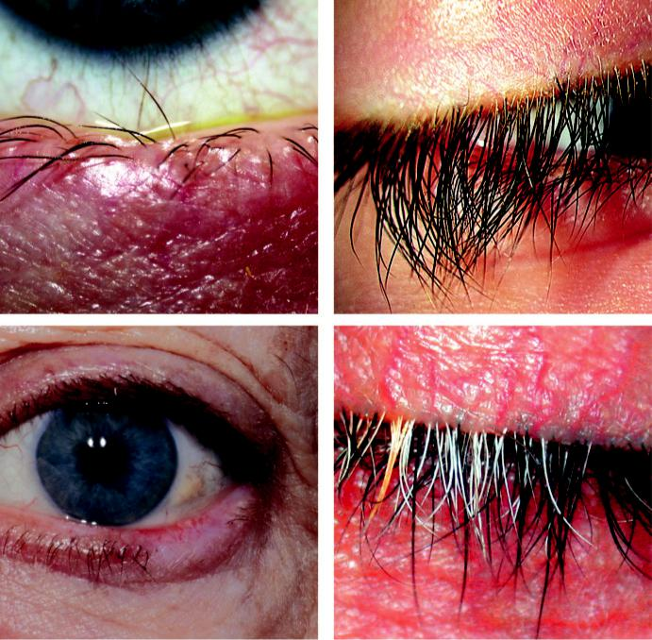

A B

C D

Fig. 2.13 (A) Acquired distichiasis, (B) trichomegaly, (C) madarosis, (D) poliosis. (From Salmon JF, Kanski’s Clinical Ophthalmology: A Systematic Approach, 9th edition. Oxford, UK: Elsevier; 2020.)

***Associated congenital syndromes:*** (a) Oliver–McFarlane (pigmentary retinopathy, dwarfism, mental handicap), (b) Cornelia de Lange (mental and physical developmental abnormali-ties), (c) Goldstein–Hutt (cataract, hereditary spherocytosis), (d) Hermansky–Pudlak (albi-nism, bleeding diathesis).

**MADAROSIS**

***Definition:*** absence or decreased number of lashes (Fig. 2.13C).

***Local causes:*** (a) infiltrating lid tumours, (b) burns, (c) iatrogenic following radiotherapy or cryotherapy to the lids.

***Associated skin disorders:*** (a) generalized alopecia, (b) psoriasis, (c) atopic dermatitis.

***Associated systemic diseases:*** (a) myxoedema, (b) systemic lupus erythematosus, (c) acquired syphilis, (d) lepromatous leprosy.

***Following lash removal:*** (a) iatrogenic for trichiasis, (b) trichotillomania (psychiatric disor-der of hair removal).

#*" ##%"#"+!#(&&%"'+$'""#* "%#! " +#!+ &)%#"$'!%

#%$%&#" (&#" +##'%(&&*'#('$%!&&#"#$+%', &)%" %'&%&%)

**30** SYNOPSIS OF CLINICAL OPHTHALMOLOGY



**POLIOSIS**

***Definition:*** premature localized whitening of hair, which may involve the lashes and eyebrows (Fig. 2.13D).

***Ocular causes:*** (a) chronic anterior blepharitis, (b) sympathetic ophthalmitis, (c) idiopathic uveitis.

***Systemic associations:*** (a) Vogt–Koyanagi–Harada syndrome, (b) Waardenburg syndrome, (c) vitiligo, (d) Marfan syndrome, (e) tuberous sclerosis.

**Allergic Disorders**

**ACUTE ALLERGIC OEDEMA**

**Pathogenesis:**

pollens that typically aect children during the spring/summer months.

**Diagnosis:**

sudden onset of profuse bilateral periorbital oedema (Fig. 2.14A), often accompanied by promi-nent jelly-like conjunctival swelling (chemosis).

**Treatment:**

usually unnecessary as spontaneous resolution occurs within a few hours, once exposure to the allergen is discontinued.

**Diﬀerential diagnosis**

***Dermatomyositis:*** rare chronic inflammatory disorder of muscles. In children, about half develop eyelid swelling and a heliotrope rash (Fig. 2.14B)

**CONTACT DERMATITIS**

**Pathogenesis:**

inflammatory response following exposure to a causative substance, usually a medication or contained preservative, a cosmetic preparation, or a metal. is is a type IV delayed hypersensi - tivity response with initial sensitizing exposure and reaction to subsequent exposure.

**Diagnosis**

***Presentation:*** itching and tearing.

***Signs:*** (a) eyelids show oedema, scaling, angular fissuring and tightness (Fig. 2.14C),

(b) chemosis and papillary conjunctivitis, (c) mild punctate corneal epithelial erosions.

**Treatment**

Avoidance of exposure to antigen, if identified.

Change to preservative-free drops, if sensitivity to preservative is suspected.

Topical steroids are rarely required.

Oral antihistamines for severe cases.

**ATOPIC DERMATITIS (ECZEMA)**

**Definition:**

common idiopathic condition, typically associated with asthma and hay fever; eyelid involvement is infrequent.

#*" ##%"#"+!#(&&%"'+$'""#* "%#! " +#!+ &)%#"$'!%

#%$%&#" (&#" +##'%(&&*'#('$%!&&#"#$+%', &)%" %'&%&%)

|  |  |
| --- | --- |
| Chapter 2—EYELIDS | **31** |
|  |  |

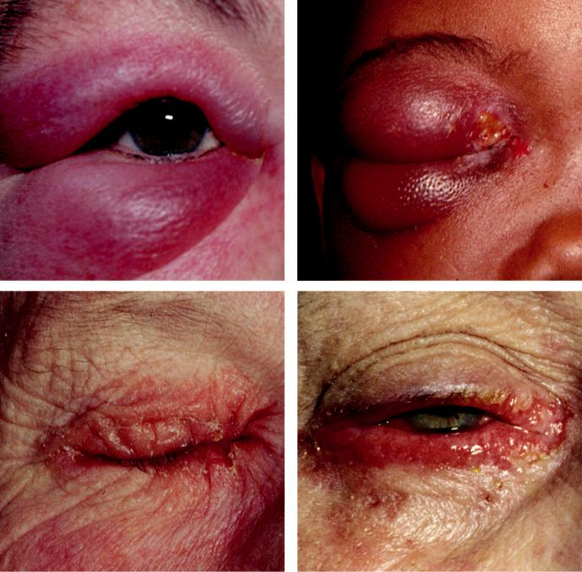

A B

C D

Fig. 2.14 (A) Acute allergic oedema, (B) dermatomyositis, (C) contact dermatitis, (D) atopic dermatitis. (Figure. 2.14D courtesy of S. Tuft.)

**Diagnosis**

***Presentation:*** itching and irritability of eyelid skin.

***Signs:*** (a) eyelids show erythema, thickening, crusting, and fissuring (Fig. 2.14D), (b) staph-ylococcal blepharitis, (c) madarosis, (d) keratinization of the lid margin, (e) tightening of facial skin and lower lid ectropion.

**Ocular associations**

***Common:*** vernal disease in children and chronic atopic keratoconjunctivitis in adults.

***Uncommon:*** (a) keratoconus, (b) presenile cataract, (c) retinal detachment.

**Treatment:**

emollients and mild topical steroids (e.g. hydrocortisone 1% skin cream). Beware of excessive use of periocular steroids as this can cause glaucoma.

#*" ##%"#"+!#(&&%"'+$'""#* "%#! " +#!+ &)%#"$'!%

#%$%&#" (&#" +##'%(&&*'#('$%!&&#"#$+%', &)%" %'&%&%)

**32** SYNOPSIS OF CLINICAL OPHTHALMOLOGY



**Viral Infections**

**MOLLUSCUM CONTAGIOSUM**

**Pathogenesis:**

skin infection typically aecting healthy children (peak 2–4 years) or immunocompromised indi - viduals; transmission is by contact and subsequent autoinoculation.

**Diagnosis**

Single or multiple pale, waxy, umbilicated nodules (Fig. 2.15A), (b) cheesy material can be expressed from the lesions, (c) ipsilateral chronic follicular conjunctivitis may be present.

e lid margins should be examined carefully in any patient with chronic conjunctivitis because a causative molluscum lesion may be overlooked (Fig. 2.15B).

**Treatment**

Spontaneous resolution is the rule in the immunocompetent, although autoinoculation may cause recurrences.

Lid margin lesions with secondary conjunctivitis may be treated with: (a) shave excision, (b) cauterization, (c) cryotherapy, (d) curettage, or (e) laser.

**HERPES ZOSTER OPHTHALMICUS**

**Pathogenesis:**

shingles aecting the first division of the trigeminal nerve. It is caused by varicella zoster virus (VZV) and typically aects the elderly; tends to be more severe in immunocompromised individuals.

**Diagnosis**

***Presentation:*** 3- to 5-day prodromal phase of tiredness, fever, malaise and headache precedes the appearance of the rash. ere may be pain in the aected dermatome.

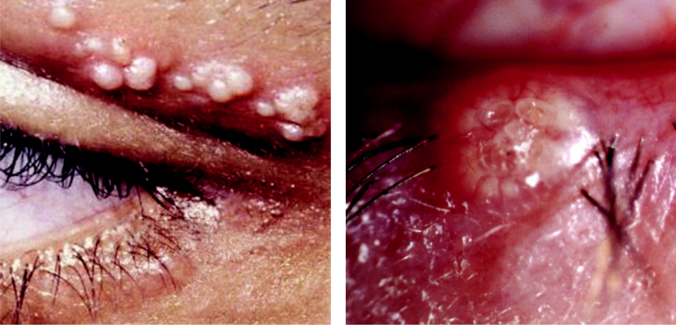

A B

Fig 2.15 Molluscum contagiosum: (A) multiple nodules, (B) single nodule involving the lid margin, causing follicular conjunctivitis.

#*" ##%"#"+!#(&&%"'+$'""#* "%#! " +#!+ &)%#"$'!%

#%$%&#" (&#" +##'%(&&*'#('$%!&&#"#$+%', &)%" %'&%&%)

|  |  |
| --- | --- |
| Chapter 2—EYELIDS | **33** |
|  |  |

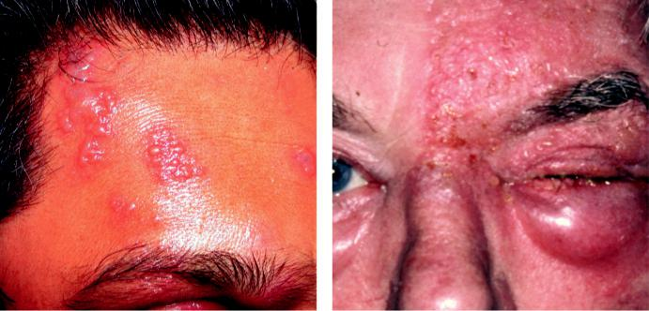

A B

Fig. 2.16 Herpes zoster ophthalmicus: (A) vesicles, (B) periorbital oedema. (From Salmon JF, Kanski’s Clinical

Ophthalmology: A Systematic Approach, 9th edition. Oxford, UK: Elsevier; 2020.)

***Signs:*** (a) erythematous maculopapular rash on the forehead respecting the midline,

1. appearance of groups of vesicles (Fig. 2.16A) within 24 hours, (c) confluent vesicles, which may become pustular before crusting and drying after 2–3 weeks, (d) periorbital oedema that may spread to the other side (Fig. 2.16B), (e) depigmented scars may follow healing.

***Ocular complications*** (see Chapter 7).

**Treatment**

***Systemic antivirals:*** (a) oral aciclovir 800 mg five times daily for 7–10 days, ideally com-menced within 72 hours of onset of symptoms in order to reduce the risk and severity of late complications, (b) alternatives (often better tolerated and may be more eective) include famciclovir, valaciclovir and brivudine, (c) intravenous aciclovir may be required for severe complications (e.g. encephalitis).

***Topical:*** (a) skin should be kept clean to avoid secondary bacterial infection, (b) an antibiotic (e.g. erythromycin) or steroid–antibiotic combination (e.g. Fucidin-H 1% and fusidic acid 2%). ***Patients can transmit chickenpox:*** avoid contact with the non-immune, pregnant and immu-nodeficient individuals until crusting is complete.

***Vaccination:*** against VZV reduces the incidence of shingles.

**HERPES SIMPLEX**

**Pathogenesis:**

primary infection, or rarely reactivation, of herpes simplex virus previously dormant in the trigeminal ganglion.

**Diagnosis**

***Prodromal phase:*** facial and lid tingling (24 hours).

***Signs:*** (a) eyelid and periorbital vesicles (Fig. 2.17A) which break down over 48 hours,

1. boggy lid swelling, (c) gradual resolution over a week, (d) in atopic children skin involve-ment can be extensive and severe: eczema herpeticum (Fig. 2.17B).

***Other ocular features:*** papillary conjunctivitis and dendritic corneal ulceration.

#*" ##%"#"+!#(&&%"'+$'""#* "%#! " +#!+ &)%#"$'!%

#%$%&#" (&#" +##'%(&&*'#('$%!&&#"#$+%', &)%" %'&%&%)

**34** SYNOPSIS OF CLINICAL OPHTHALMOLOGY

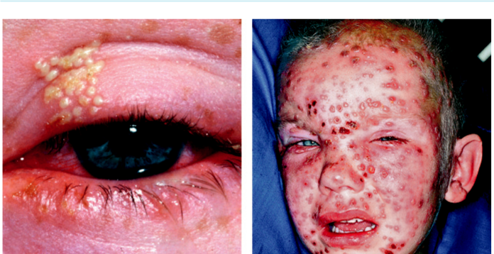

A B

Fig. 2.17 Herpes simplex: (A) eyelid vesicles, (B) eczema herpeticum. (From Salmon JF, Kanski’s Clinical

Ophthalmology: A Systematic Approach, 9th edition. Oxford, UK: Elsevier; 2020.)

**Treatment**

***Topical antiviral:*** (aciclovir cream) 5 times daily for 5 days.

***Oral antiviral:*** aciclovir 400–800 mg 5 times daily for 3–5 days; famciclovir and valaciclovir are alternatives.

***Oral antibiotic:*** co-amoxiclav or erythromycin for secondary staphylococcal infection in patients with eczema herpeticum.

**Chronic Blepharitis**

**CHRONIC MARGINAL BLEPHARITIS**

**Pathogenesis**

***Anterior blepharitis:*** may be staphylococcal (partly immune-mediated) and/or seborrhoeic (often associated with seborrhoeic dermatitis).

***Posterior blepharitis:*** associated with meibomian gland dysfunction with alterations in mei-bomian gland secretions (often associated with acne rosacea).

***Angular blepharitis:*** usually caused by *Moraxella lacunata* or *S. aureus* leading to red, scaly, macerated and fissured skin at the lateral canthus. Skin chafing secondary to tear overflow can look similar.

**Diagnosis**

***Presentation:*** (a) burning, grittiness, mild photophobia, (b) rusting and redness of the lid margins, usually worse in the mornings.

***Staphylococcal blepharitis:*** (a) scales and crusting around the base of lashes (collarettes; Fig. 2.18A), (b) mild papillary conjunctivitis and chronic conjunctival hyperaemia, (c) long-standing cases may develop scarring and notching (tylosis) of the lid margin, as well as madarosis, trichiasis, and poliosis, (d) secondary changes including styes, marginal keratitis, and occasionally phlyctenulosis.

***Seborrhoeic blepharitis:*** (a) hyperaemic and greasy anterior lid margins (Fig. 2.18B), (b) adherence of lashes to each other.

***Posterior blepharitis:*** (a) meibomian gland orifices show pouting, recession or plugging (Fig. 2.18C), (b) hyperaemia and telangiectasis of the posterior lid margin, (c) oily and

#*" ##%"#"+!#(&&%"'+$'""#* "%#! " +#!+ &)%#"$'!%

#%$%&#" (&#" +##'%(&&*'#('$%!&&#"#$+%', &)%" %'&%&%)

|  |  |
| --- | --- |
| Chapter 2—EYELIDS | **35** |
|  |  |

foamy tear film (Fig. 2.18D), (d) secondary changes including papillary conjunctivitis and inferior corneal punctate epithelial erosions.

***Associations:*** tear film instability and dry eye syndrome.

**Treatment**

***Lid hygiene:*** (a) warm compresses to soften crusts, (b) lid cleaning to remove crusts mechan-ically, (c) massaging the lid to express accumulated meibomian secretions may be useful in posterior blepharitis.

***Tear substitutes:*** for associated tear dysfunction.

***Topical antibiotics:*** fusidic acid, bacitracin or chloramphenicol ointment can be applied to the lid margin to treat acute folliculitis but are of limited value in long-standing cases. ***Oral antibiotics:*** (a) azithromycin (500 mg daily for 3 days) to control acute exacerbations in staphylococcal blepharitis, (b) oral tetracyclines are often highly eective (but should not be used in children younger than the age of 12 years or in pregnant or breastfeeding women):

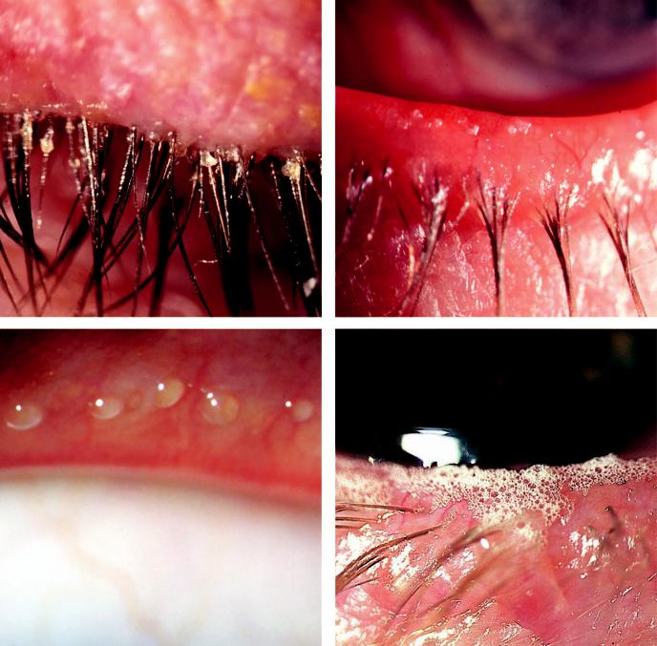

A B

C D

Fig. 2.18 Chronic marginal blepharitis: (A) staphylococcal, (B) seborrhoeic, (C) posterior showing capping of meibomian gland orifices by oil globules, (D) foamy tear film. (From Salmon JF, Kanski’s Clinical Ophthalmology: A Systematic Approach, 9th edition. Oxford, UK: Elsevier; 2020.)

#*" ##%"#"+!#(&&%"'+$'""#* "%#! " +#!+ &)%#"$'!%

#%$%&#" (&#" +##'%(&&*'#('$%!&&#"#$+%', &)%" %'&%&%)

**36** SYNOPSIS OF CLINICAL OPHTHALMOLOGY



oxytetracycline 250 mg twice daily for 6–12 weeks or doxycycline 100 mg twice daily for 1 week and then daily for 6–12 weeks, (c) erythromycin 250 mg once or twice daily is an alternative to tetracycline.

***Weak topical steroid:*** fluorometholone 0.1% three or four times daily for 1 week in patients with severe papillary conjunctivitis or marginal keratitis.

**PHTHIRIASIS PALPEBRARUM**

**Pathogenesis:**

the crab louse *Phthirus pubis* is principally adapted to living in pubic hair, but can also infest the chest, axillae, or eyelids. Eyelash infestation, phthiriasis palpebrarum, typically aects children living in conditions of poor hygiene.

**Diagnosis**

***Presentation:*** chronic irritation and itching of the lids.

***Signs:*** (a) lice anchored to the lashes (Fig. 2.19A), (b) ova and empty shells appear as brown-ish, opalescent pearls adherent to the base of the cilia.

**Treatment:**

1. mechanical removal of the lice with forceps (Fig. 2.19B), (b) topical yellow mercuric oxide 1% or petroleum jelly applied to the lashes and lids twice a day for 10 days.

**Ptosis**

**Definition:**

congenital or acquired abnormally low position of the upper eyelid.

**Classification**

***Neurogenic:*** innervational defect (e.g. 3rd nerve paresis (Fig. 2.20A), Horner syndrome; see Chapter 19).

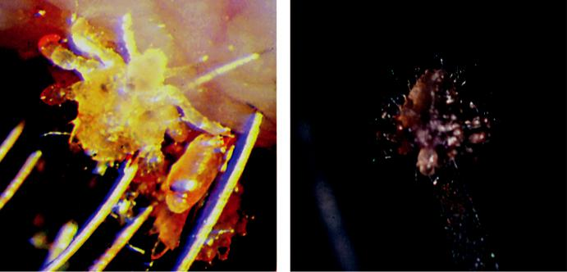

A B

Fig. 2.19 Phthiriasis: (A) lice anchored to lashes, (B) mechanical removal. (From Salmon JF, Kanski’s Clinical

Ophthalmology: A Systematic Approach, 9th edition. Oxford, UK: Elsevier; 2020.)

#*" ##%"#"+!#(&&%"'+$'""#* "%#! " +#!+ &)%#"$'!%

#%$%&#" (&#" +##'%(&&*'#('$%!&&#"#$+%', &)%" %'&%&%)

|  |  |
| --- | --- |
| Chapter 2—EYELIDS | **37** |
|  |  |

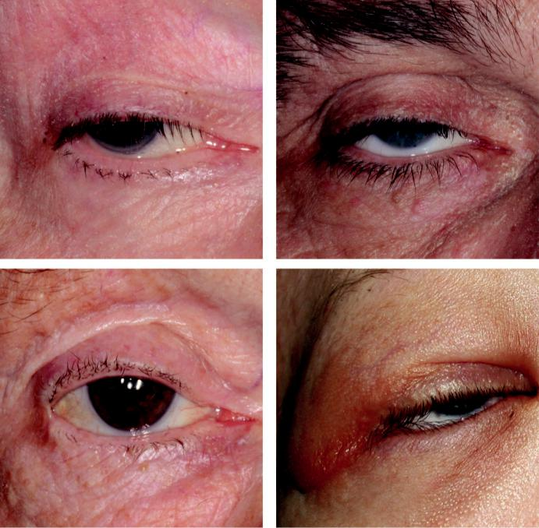

A B

C D

Fig. 2.20 Ptosis: (A) neurogenic (divergent eye), (B) myogenic, (C) aponeurotic, (D) mechanical. (From Salmon

JF, Kanski’s Clinical Ophthalmology: A Systematic Approach, 9th edition. Oxford, UK: Elsevier; 2020.)

***Myogenic:*** (a) myopathic (e.g. myotonic dystrophy), (b) neuromyopathic (e.g. myasthenia gravis) (Fig. 2.20B).

***Aponeurotic:*** defect in the levator aponeurosis, commonly involutional. (Fig. 2.20C)

***Mechanical:*** (a) gravitational eect (e.g. tumour) ( Fig. 2.20D), or (b) contracted scar tissue.

**Measurements**

Margin-corneal light reflex distance (Fig. 2.21A): normal 4–4.5 mm.

Palpebral fissure height (Fig. 2.21B): normal in males is 7–10 mm and in females 8–12 mm.

Levator function (Fig. 2.21C) normal 15 mm.

Upper lid crease: normal in males is 8 mm and in females 10 mm.

**SIMPLE CONGENITAL PTOSIS**

**Pathogenesis:**

developmental failure of neuronal migration. Ptosis may be associated with amblyopia due to occlusion of the visual axis or from coexisting refractive errors.

#*" ##%"#"+!#(&&%"'+$'""#* "%#! " +#!+ &)%#"$'!%

#%$%&#" (&#" +##'%(&&*'#('$%!&&#"#$+%', &)%" %'&%&%)

**38** SYNOPSIS OF CLINICAL OPHTHALMOLOGY

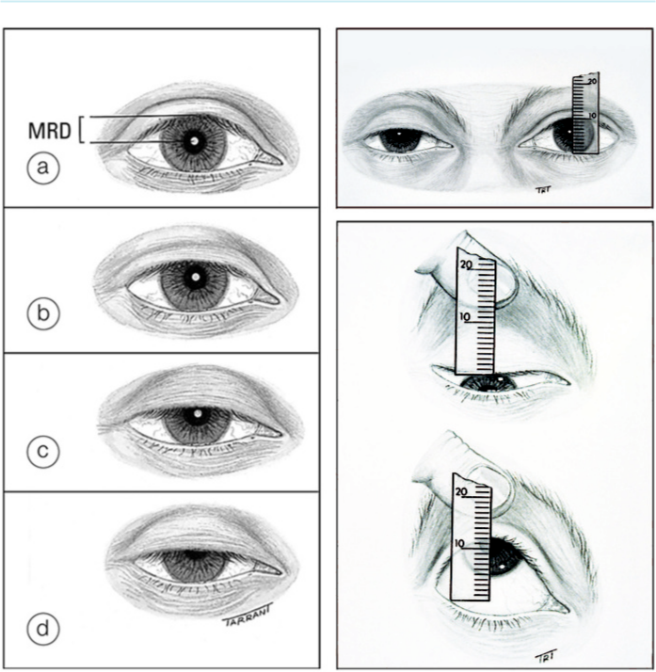

A B

C

Fig. 2.21 Ptosis measurement: (A) margin-corneal light reflex distance, (B) palpebral fissure height, (C) leva-tor function (place a thumb firmly against the orbital rim to reduce the effect of the frontalis muscle). (From Salmon JF, Kanski’s Clinical Ophthalmology: A Systematic Approach, 9th edition. Oxford, UK: Elsevier; 2020.)

**Diagnosis**

Unilateral or bilateral ptosis of variable severity with absent or diminished upper lid crease (Fig. 2.22A).

Poor levator function (Fig. 2.22B).

In downgaze the ptotic lid is higher than the normal because of poor relaxation of the leva-

tor muscle (contrast with acquired ptosis).

Compensatory chin elevation in bilateral cases.

5% show Marcus Gunn jaw-winking phenomenon: retraction of the ptotic lid with stimula-tion of the ipsilateral pterygoid (e.g. chewing or opening the mouth; Fig. 2.22C and D).

**Treatment:**

levator resection during preschool years.

#*" ##%"#"+!#(&&%"'+$'""#* "%#! " +#!+ &)%#"$'!%

#%$%&#" (&#" +##'%(&&*'#('$%!&&#"#$+%', &)%" %'&%&%)

|  |  |
| --- | --- |
| Chapter 2—EYELIDS | **39** |
|  |  |

**INVOLUTIONAL PTOSIS**

**Pathogenesis:**

age-related dysfunction of the levator aponeurosis.

**Diagnosis:**

1. typically bilateral and often asymmetrical ptosis, (b) high or absent upper lid crease with deep sulcus, (c) good levator function.

**Treatment:**

levator advancement or resection.

**Diﬀerential diagnosis:**

see Table 2.1.



TABLE 2.1 Causes of pseudoptosis



* Lack of support of the lids by the globe (e.g. phthisis bulbi, enophthalmos)
* Contralateral lid retraction
* Ipsilateral hypotropia
* Brow ptosis
* Dermatochalasis

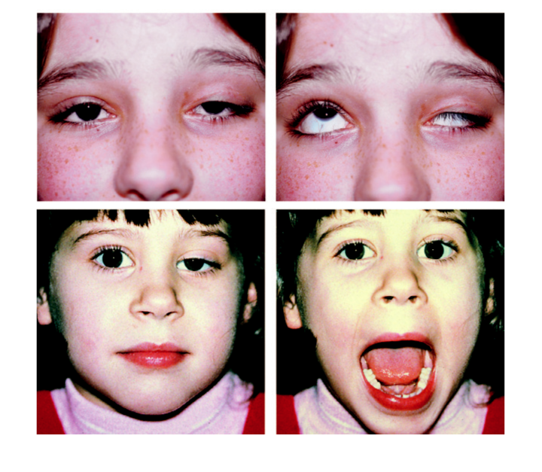

A B

C D

Fig. 2.22 Congenital ptosis: (A) severe showing absent lid crease, (B) poor levator function, (C and D) Marcus

Gunn jaw-winking phenomenon. (From Salmon JF, Kanski’s Clinical Ophthalmology: A Systematic Approach,

9th edition. Oxford, UK: Elsevier; 2020.)

#*" ##%"#"+!#(&&%"'+$'""#* "%#! " +#!+ &)%#"$'!%

#%$%&#" (&#" +##'%(&&*'#('$%!&&#"#$+%', &)%" %'&%&%)

**40** SYNOPSIS OF CLINICAL OPHTHALMOLOGY



**Ectropion**

**INVOLUTIONAL ECTROPION**

**Diagnosis:**

1. epiphora, (b) lower lid ectropion, (c) exposed tarsal conjunctiva may become thickened and keratinized (Fig. 2.23A) in long-standing cases.

**Treatment**

***Generalized ectropion:*** horizontal lid shortening (lateral canthal sling or full-thickness wedge excision).

***Medial ectropion:*** medial tarsoconjunctival diamond excision.

**CICATRICIAL ECTROPION**

**Pathogenesis:**

contracture that pulls the lid away from the globe (Fig. 2.23B). Causes include: (a) trauma, (b) chronic dermatitis, (c) ichthyosis.

**Diagnosis:**

1. ectropion may be relieved by pushing the skin up over the orbital margin and (b) opening the mouth may accentuate the ectropion.

**Treatment:**

scar tissue excision with lengthening procedure (e.g. Z-plasty) in mild cases and transposition flap or free skin graft in severe cases.

**PARALYTIC ECTROPION**

**Pathogenesis:**

facial nerve palsy (e.g. Bell palsy, surgery for acoustic/parotid tumour; Fig. 2.23C).

**Diagnosis**

***Epiphora:*** caused by a combination of punctual malposition, lacrimal pump failure and increased tear production due to corneal exposure.

***Associated features:*** (a) retraction of upper and lower lids, (b) brow ptosis, (c) exposure keratopathy.

**Treatment**

***Temporizing measures:*** (a) lubrication, (b) overnight lid taping, (c) botulinum toxin-induced ptosis, (d) tarsorrhaphy (Fig. 2.23D).

***Definitive measures:*** (a) medial canthoplasty, (b) lateral canthal sling, (c) upper eyelid gold or platinum weight implantation for lagophthalmos.

**Entropion**

**INVOLUTIONAL ENTROPION**

**Pathogenesis:**

the following age-related changes: (a) tissue laxity with stretching of the canthal tendons and tarsal plate, (b) dysfunction of the lower lid retractors, (c) overriding of the pretarsal orbicularis

#*" ##%"#"+!#(&&%"'+$'""#* "%#! " +#!+ &)%#"$'!%

#%$%&#" (&#" +##'%(&&*'#('$%!&&#"#$+%', &)%" %'&%&%)

|  |  |
| --- | --- |
| Chapter 2—EYELIDS | **41** |
|  |  |

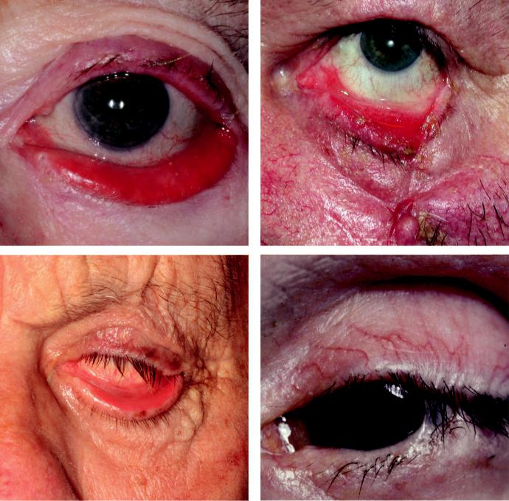

A B

C D

Fig. 2.23 Ectropion: (A) involutional ectropion, (B) cicatricial, (C) paralytic, (D) tarsorrhaphy. (Figure 2.23A courtesy of Chris Barry, Lions Eye Institute, Perth, Australia; Figure 2.23C courtesy of J. Norris.)

muscle by the preseptal component (Fig. 2.24A), (d) orbital septum laxity with prolapse of orbital fat into the lower lid. See Fig. 2.2 for other age-related changes.

**Diagnosis:**

1. grittiness from pseudotrichiasis and (b) intermittent or constant turning in of the lower lid (Fig. 2.24B).

**Treatment**

***Temporary:*** (a) lubrication, (b) lid taping, (c) bandage contact lens, (d) botulinum toxin orbicularis chemodenervation.

***Transverse everting sutures*** (Fig. 2.24C) usually last several months.

***For horizontal laxity:*** lateral canthal sling or full-thickness wedge excision.

***For overriding and disinsertion:*** (a) Wies procedure (full-thickness horizontal lid splitting with insertion of everting sutures (Fig. 2.24D) or (b) Jones procedure to tighten the lower lid retractors.

#*" ##%"#"+!#(&&%"'+$'""#* "%#! " +#!+ &)%#"$'!%

#%$%&#" (&#" +##'%(&&*'#('$%!&&#"#$+%', &)%" %'&%&%)

**42** SYNOPSIS OF CLINICAL OPHTHALMOLOGY



TABLE 2.2 Involutional changes



* Loose, wrinkled eyelid and periocular skin
* Orbital fat prolapse due to orbital septal weakness
* Generalized eyelid laxity with involutional ptosis, entropion and ectropion
* Enophthalmos due to orbital fat atrophy
* Brow ptosis

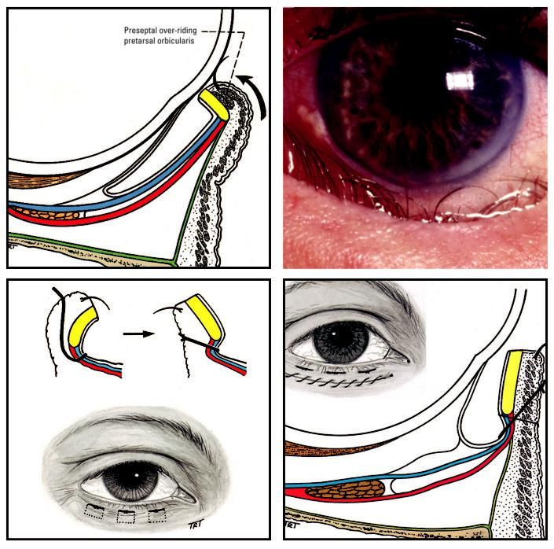

A B

C D

Fig. 2.24 Entropion: (A) overriding of pretarsal orbicularis muscle by the preseptal component, (B) involutional,

1. transverse everting sutures, (D) Wies procedure. (Figure 2.24A,C,D from Tyers AG and Collin JRO, Colour Atlas of Ophthalmic Plastic Surgery. Butterworth-Heinemann, 2001.)

**CICATRICIAL ENTROPION**

**Pathogenesis:**

scarring of the palpebral conjunctiva pulls the lid margin toward the globe. Causes include cicatrizing conjunctivitis (see Chapter 6) and trauma.

#*" ##%"#"+!#(&&%"'+$'""#* "%#! " +#!+ &)%#"$'!%

#%$%&#" (&#" +##'%(&&*'#('$%!&&#"#$+%', &)%" %'&%&%)

|  |  |
| --- | --- |
| Chapter 2—EYELIDS | **43** |
|  |  |

**Diagnosis:**

in contrast to involutional entropion, both upper or lower lids may be aected. Symptoms and findings may relate to the cause as well as to the entropion itself.

**Treatment:**

1. corneal protection (e.g. bandage contact lens), (b) transverse tarsotomy with anterior lid margin rotation for mild cases, (c) tissue replacement with grafting for severe cases.

**Miscellaneous Acquired Disorders**

**BLEPHAROCHALASIS**

**Diagnosis**

***Presentation:*** around puberty with episodic painless oedema of the upper lids lasting a few days, becoming less frequent over time.

***Signs:*** redundant wrinkled atrophic lid skin, with aponeurotic ptosis in severe cases (Fig. 2.25A).

***Diﬀerential diagnosis:*** drug-induced urticaria and angioedema.

**Treatment:**

blepharoplasty and correction of ptosis.

**FLOPPY EYELID SYNDROME**

**Diagnosis**

***Presentation:*** typically, in an obese middle-aged man with chronic ocular irritation, usually worse on awaking.

***Signs:*** lax, rubbery, easily everted upper lids (Fig. 2.25B).

***Associated features:*** (a) conjunctival hyperaemia and palpebral papillae, especially superior, caused by contact with the pillow during sleep, (b) punctate epithelial keratopathy, (c) fila-mentary keratitis, (d) superior corneal vascularization in long-standing cases.

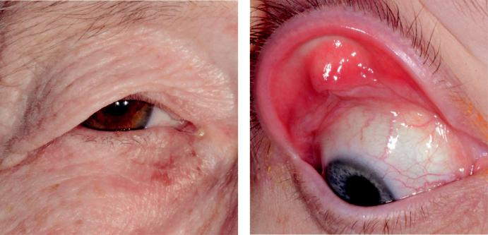

A B

Fig. 2.25 (A) Blepharochalasis, (B) floppy eyelid syndrome. (From Salmon JF, Kanski’s Clinical Ophthalmology:

A Systematic Approach, 9th edition. Oxford, UK: Elsevier; 2020.)

#*" ##%"#"+!#(&&%"'+$'""#* "%#! " +#!+ &)%#"$'!%

#%$%&#" (&#" +##'%(&&*'#('$%!&&#"#$+%', &)%" %'&%&%)

**44** SYNOPSIS OF CLINICAL OPHTHALMOLOGY



**Treatment:**

lubrication, nocturnal eye shields or lid taping in mild cases; horizontal upper lid shortening in severe cases.

**Cosmetic Eyelid and Periocular Surgery**

**NONSURGICAL COSMETIC TECHNIQUES**

***Periocular botulinum toxin injection:*** for (a) lateral canthal ‘crow’s feet’, (b) glabellar frown lines, (c) brow lift by depressor inhibition; complications include temporary lagophthalmos, ptosis, ectropion, and diplopia.

***Hyaluronic acid tissue fillers:*** to replace lost volume; usually lasts 6–12 months.

***Fat transfer:*** longer lasting, with 50–60% tissue survival.

***Skin resurfacing*:** removal of superficial skin layers by chemical peeling or laser to reduce wrinkling and remove blemishes.

**SURGICAL COSMETIC TECHNIQUES**

***Upper eyelid blepharoplasty:*** excess skin removal can be combined with reduction of supe-rior orbital fat.

***Lower eyelid blepharoplasty:*** can be combined with reduction of the inferior orbital fat pads. Complications include lower eyelid retraction, and contour abnormalities including ectropion.

***Brow ptosis correction:*** (a) direct, in which an incision is made above the eyebrows and an ellipse of skin removed, (b) endoscopic via small incisions within the hairline.

**Congenital Malformations**

**EPICANTHUS**

**Definition:**

common bilateral condition in which vertical skin folds extend from the upper or lower lids toward the medial canthi; there are four main types (see below).

**Diagnosis**

***Palpebralis:*** folds are equally prominent between the upper and lower lids; most common type in whites.

***Tarsalis:*** folds are most prominent superiorly; common in Asians.

***Inversus:*** folds begin inferiorly and extend upwards to the medial canthal area; occurs in blepharophimosis syndrome (see below) (Fig. 2.26A).

***Superciliaris:*** folds arise above the brow and extend downwards toward the lateral aspect of the nose.

**Treatment:**

Y–V plasty for small folds; Mustardé Z-plasty if large.

**TELECANTHUS**

**Definition:**

abnormally long medial canthal tendons; may occur in isolation or in association with blepharo-phimosis syndrome (see below) and other systemic syndromes.

#*" ##%"#"+!#(&&%"'+$'""#* "%#! " +#!+ &)%#"$'!%

#%$%&#" (&#" +##'%(&&*'#('$%!&&#"#$+%', &)%" %'&%&%)

|  |  |
| --- | --- |
| Chapter 2—EYELIDS | **45** |
|  |  |

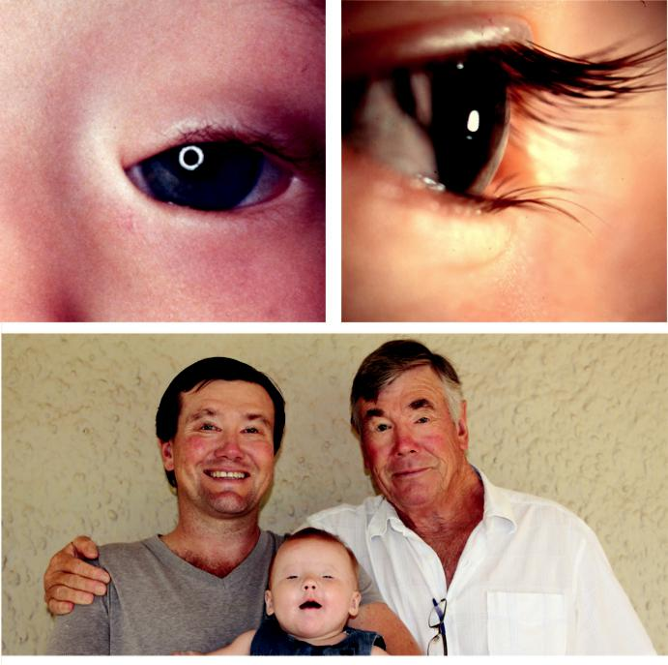

A B

C

Fig. 2.26 Congenital malformations: (A) epicanthus inversus, (B) epiblepharon, (C) blepharophimosis syn-

drome. (From Salmon JF, Kanski’s Clinical Ophthalmology: A Systematic Approach, 9th edition. Oxford, UK:

Elsevier; 2020.)

**Diagnosis:**

increased distance between the medial canthi; should not be confused with hypertelorism (wide separation of the orbits).

**Treatment:**

shortening and refixation of the medial canthal tendons.

**EPIBLEPHARON**

**Definition:**

excess lower lid tissue rotating the lower lid inwards; very common in Asians and usually resolves spontaneously. Epiblepharon should not be confused with congenital entropion, which is much less common.

#*" ##%"#"+!#(&&%"'+$'""#* "%#! " +#!+ &)%#"$'!%

#%$%&#" (&#" +##'%(&&*'#('$%!&&#"#$+%', &)%" %'&%&%)

**46** SYNOPSIS OF CLINICAL OPHTHALMOLOGY



**Diagnosis:**

1. horizontal fold of skin stretched across the anterior lid margin, and (b) vertical direction of lashes, especially medially (Fig. 2.26B).

**Treatment:**

excision of a strip of skin and muscle in persistent cases.

**BLEPHAROPHIMOSIS, PTOSIS AND EPICANTHUS INVERSUS SYNDROME**

**Genetics:**

AD (*FOXL*2 gene); associated with premature ovarian failure in some females.

**Diagnosis:**

1. symmetrical ptosis with poor levator function, (b) telecanthus and epicanthus inversus,
2. poorly developed nasal bridge with hypoplasia of the superior orbital rims, (d) amblyopia is common (Fig. 2.26C).

**Treatment:**

initial correction of epicanthus and telecanthus; subsequent bilateral frontalis suspension.

**COLOBOMA**

**Associations:**

1. upper lid coloboma is occasionally associated with Goldenhar syndrome; (b) lower lid colo-boma is frequently associated with systemic conditions, most notably Treacher Collins syndrome.

**Diagnosis**

***Upper lid coloboma:*** defect at the junction of middle and inner third of lid (Fig. 2.27A).

***Lower lid coloboma:*** defect at the junction of middle and outer third.

**Treatment:**

primary closure of small defects; skin flaps/grafts if large.

**CRYPTOPHTHALMOS**

**Pathogenesis:**

failure of neural crest migration; may be associated with Fraser syndrome.

**Diagnosis**

***Complete:*** lids are replaced by a layer of skin fused with a microphthalmic eye (Fig. 2.27B).

***Incomplete:*** (a) microphthalmos, (b) rudimentary lids, (c) small conjunctival sac.

**ANKYLOBLEPHARON FILIFORME ADNATUM**

e upper and lower lids are joined with thin tags ( Fig. 2.27C). Most cases are sporadic.

Treatment involves transection with scissors, usually without anaesthesia.

#*" ##%"#"+!#(&&%"'+$'""#* "%#! " +#!+ &)%#"$'!%

#%$%&#" (&#" +##'%(&&*'#('$%!&&#"#$+%', &)%" %'&%&%)

|  |  |
| --- | --- |
| Chapter 2—EYELIDS | **47** |
|  |  |

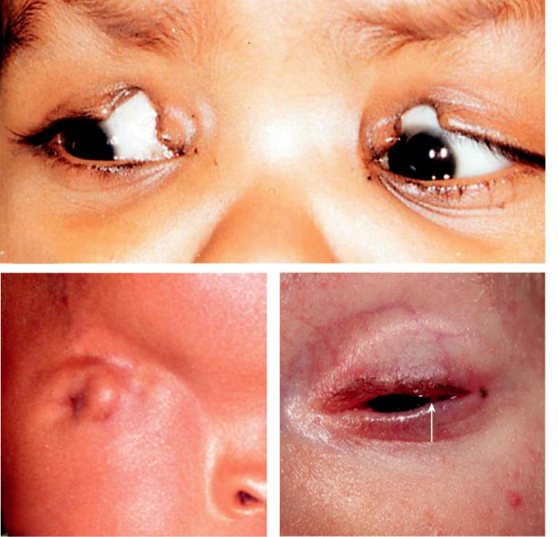

A

B C

Fig. 2.27 (A) Upper lid coloboma, (B) cryptophthalmos, (C) ankyloblepharon filiforme adnatum (arrow shows adhesion). (Figure 2.27A courtesy of R. Malhotra; Figure 2.27B courtesy of D. Meyer; Figure 2.27C courtesy of M. Parulekar.)

#*" ##%"#"+!#(&&%"'+$'""#* "%#! " +#!+ &)%#"$'!%

#%$%&#" (&#" +##'%(&&*'#('$%!&&#"#$+%', &)%" %'&%&%)



CHAPTER 3

Lacrimal Drainage System



C H A P T E R O U T L I N E

|  |  |  |
| --- | --- | --- |
| Anatomy 49 | Congenital obstruction 52 |  |
| Causes of a watering eye 49 | Nasolacrimal duct obstruction 52 |  |
| Acquired obstruction 49 | Congenital dacryocoele (amniontocoele) 54 |  |
|  |  |
| Primary punctal stenosis 49 | Principles of adult lacrimal |  |
| Secondary punctal stenosis 50 | surgery 54 |  |
| Canalicular obstruction 51 | Infections 55 |  |
| Nasolacrimal duct obstruction 51 | Chronic canaliculitis 55 |  |
| Dacryolithiasis 52 | Dacryocystitis 56 |  |
|  |  |  |

**Anatomy**

e lacrimal drainage system consists of: (a) puncta, (b) canaliculi, (c) lacrimal sac, (d) nasolacri - mal duct (Fig. 3.1).

**CAUSES OF A WATERING EYE**

***Hypersecretion*** secondary to anterior segment disease such as dry eye or inflammation. ***Defective drainage*** secondary to: (a) malposition of lacrimal puncta, (b) obstruction along the drainage system, (c) lacrimal pump failure secondary to lower lid laxity or orbicularis muscle weakness.

**Acquired obstruction**

**PRIMARY PUNCTAL STENOSIS**

**Causes:**

1. idiopathic, (b) chronic marginal blepharitis, (c) herpetic (simplex, zoster) lid infection,
2. conjunctival cicatrization.

**Diagnosis:**

narrow inferior punctum in the absence of punctal malposition.

**Treatment:**

dilatation alone (Fig. 3.2A) rarely confers long-term improvement; surgical punctoplasty is usually necessary (Fig. 3.2B).

**49**

#*" ##%"#"+!#(&&%"'+$'""#* "%#! " +#!+ &)%#"$'!%

#%$%&#" (&#" +##'%(&&*'#('$%!&&#"#$+%', &)%" %'&%&%)

|  |  |  |
| --- | --- | --- |
| **50** | SYNOPSIS OF CLINICAL OPHTHALMOLOGY |  |
|  |  |  |
|  | Canaliculus (8 mm) |  |
|  | Lacrimal |  |
|  | sac (10 mm) |  |
|  | Nasolacrimal |  |
| Ampulla (2 mm) | duct (12 mm) |  |
| Common canaliculus | Valve of Hasner |  |
|  |  |

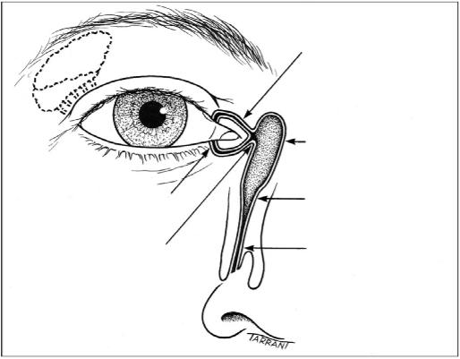

Fig. 3.1 Anatomy of the lacrimal drainage system. (From Salmon JF, Kanski’s Clinical Ophthalmology: A

Systematic Approach, 9th edition. Oxford, UK: Elsevier; 2020.)

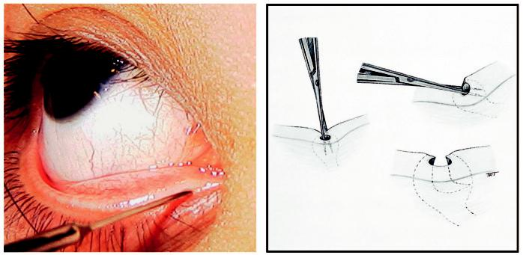

A B

Fig. 3.2 Punctal stenosis: (A) dilatation of the inferior punctum, (B) two-snip punctoplasty. (Figure. 3.2A cour-tesy of Dr Ken K. Nischal.)

**SECONDARY PUNCTAL STENOSIS**

**Diagnosis:**

narrow inferior punctum associated with punctal eversion (Fig. 3.3A).

**Treatment**

***Retropunctal cautery:*** for pure punctal eversion.

***Medial conjunctivoplasty:*** for medial ectropion without lid laxity (Fig. 3.3B)

***Wider lid positional abnormalities:*** see Chapter 2.

#*" ##%"#"+!#(&&%"'+$'""#* "%#! " +#!+ &)%#"$'!%

#%$%&#" (&#" +##'%(&&*'#('$%!&&#"#$+%', &)%" %'&%&%)

|  |  |
| --- | --- |
| Chapter 3—LACRIMAL DRAINAGE SYSTEM | **51** |
|  |  |

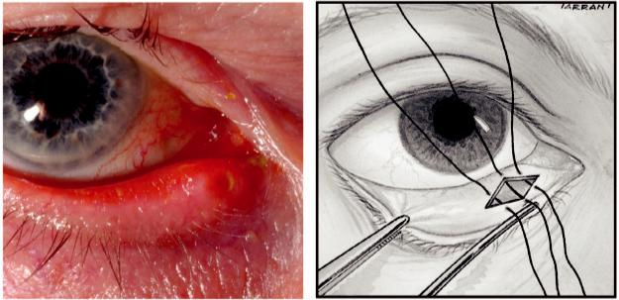

A B

Fig. 3.3 Secondary punctal stenosis: (A) small, everted inferior punctum, (B) medial conjunctivoplasty. (From

Salmon JF, Kanski’s Clinical Ophthalmology: A Systematic Approach, 9th edition. Oxford, UK: Elsevier; 2020.)

**CANALICULAR OBSTRUCTION**

**Causes:**

1. congenital and (b) acquired (e.g. trauma, herpes simplex infection, drugs, irradiation, chronic dacryocystitis).

**Diagnosis:**

site of obstruction will usually be evident on lacrimal irrigation as a ‘soft stop’ (Fig. 3.4A).

**Treatment**

***Intubation:*** silicone stents for partial obstruction.

***Canaliculo-dacryocystorhinostomy* (CDCR):** for total individual canalicular obstruc-tion when there is 6–8 mm of patent normal canaliculus between the punctum and the obstruction.

***Lester Jones tube insertion:*** when it is not possible to connect the functional canaliculus to the sac (see below).

**NASOLACRIMAL DUCT OBSTRUCTION**

**Causes:**

1. idiopathic age-related stenosis (most common), (b) trauma, (c) granulomatosis with polyangi-itis, (d) nasopharyngeal tumours.

**Diagnosis**

***Lacrimal irrigation:*** ‘hard stop’, without passage of irrigated fluid (complete obstruction) (Fig. 3.4B), or sparse passage of fluid (partial obstruction).

***Other investigations:*** conventional dacryocystography, digital subtraction dacryocystogra-phy and nuclear lacrimal scintigraphy

**Treatment**

Dacryocystorhinostomy (DCR): (see below).

Other procedures: stent insertion or balloon dilatation, usually in partial obstruction.

#*" ##%"#"+!#(&&%"'+$'""#* "%#! " +#!+ &)%#"$'!%

#%$%&#" (&#" +##'%(&&*'#('$%!&&#"#$+%', &)%" %'&%&%)

**52** SYNOPSIS OF CLINICAL OPHTHALMOLOGY

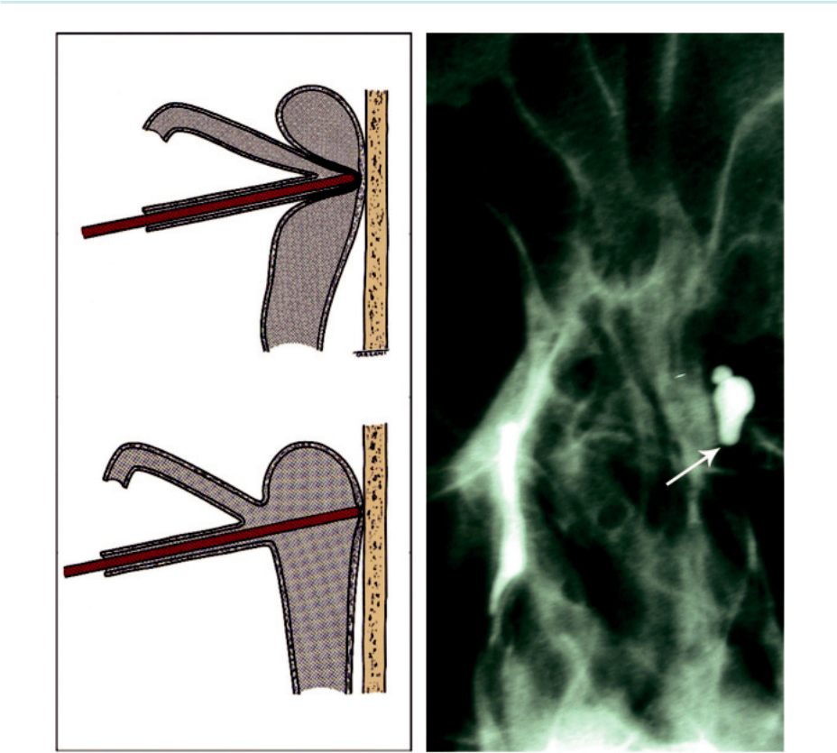

1

2

A B

Fig. 3.4 Obstruction of the nasolacrimal system: (A) results of probing (1) soft stop, (2) hard stop, (B) dacryo-cystography, showing obstruction at the junction of the left sac and nasolacrimal duct.

**DACRYOLITHIASIS**

**Pathogenesis:**

inflammatory obstruction with tear stagnation and lacrimal epithelial metaplasia.

**Diagnosis:**

1. intermittent epiphora and recurrent dacryocystitis usually in late adulthood, (b) distended and firm lacrimal sac that may form a mucocoele.

**Treatment:**

DCR.

**Congenital obstruction**

**NASOLACRIMAL DUCT OBSTRUCTION**

**Pathogenesis:**

delayed canalization of the lower end of the nasolacrimal duct, aecting at least 20% of neonates.

#*" ##%"#"+!#(&&%"'+$'""#* "%#! " +#!+ &)%#"$'!%

#%$%&#" (&#" +##'%(&&*'#('$%!&&#"#$+%', &)%" %'&%&%)

|  |  |
| --- | --- |
| Chapter 3—LACRIMAL DRAINAGE SYSTEM | **53** |
|  |  |

**Diagnosis**

***Presentation***: constant or intermittent epiphora (Fig. 3.5A), stickiness and sometimes frank bacterial conjunctivitis.

***Signs***: reflux of purulent material from the puncta on pressure over the lacrimal sac.

***Jones dye test***: a drop of fluorescein 2% is inserted into the conjunctival sac. A positive test occurs when fluorescein is seen in the nostril, indicating that watering is secondary to hypersecretion of tears. A negative test occurs when no dye is recovered indicating a partial naso-lacrimal obstruction (Fig. 3.5B).

***Diﬀerential diagnosis***: congenital glaucoma should be considered in an infant with a water-ing eye.

**Treatment**

***Conservative***: spontaneous resolution occurs in approximately 95% of cases within 12 months.

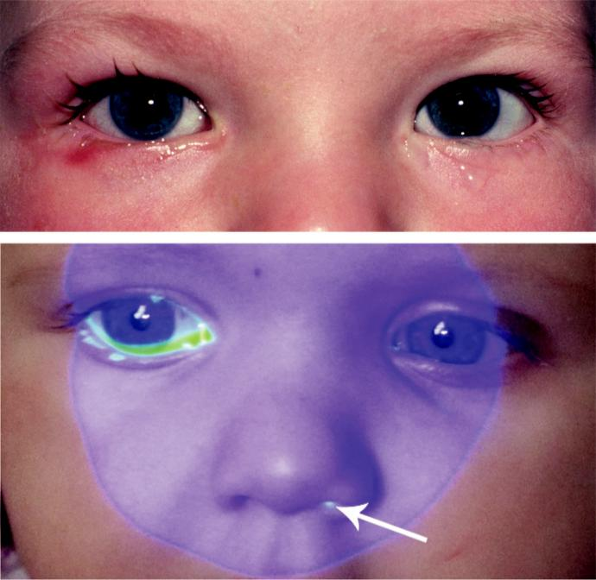

A

B

Fig. 3.5 Congenital nasolacrimal obstruction: (A) epiphora, (B) drainage test showing fluorescein in the left nostril only, confirming a patent duct on that side only. (Figure. 3.5B courtesy of D. Hildebrand.)

#*" ##%"#"+!#(&&%"'+$'""#* "%#! " +#!+ &)%#"$'!%

#%$%&#" (&#" +##'%(&&*'#('$%!&&#"#$+%', &)%" %'&%&%)

**54** SYNOPSIS OF CLINICAL OPHTHALMOLOGY

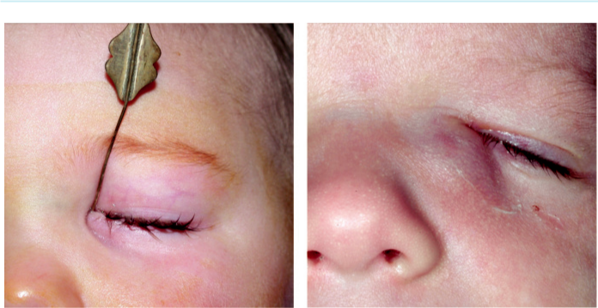

A B

Fig. 3.6 (A) Probing in a child, (B) congenital dacryocoele. (Figure. 3.6A courtesy of Dr Ken K. Nischal; Fig. 3.6B courtesy of A. Pearson.)

***Massage of the lacrimal sac***: may rupture the membranous obstruction.

***Probing***: considered after 12–18 months (90% cure) (Fig. 3.6A).

**CONGENITAL DACRYOCOELE (AMNIONTOCOELE)**

**Pathogenesis:**

collection of amniotic fluid or mucus in the lacrimal sac caused by an imperforate Hasner valve.

**Diagnosis**

***Presentation***: perinatal epiphora and a bluish cystic swelling at or below the medial canthus (Fig. 3.6B).

***Diﬀerential diagnosis***: encephalocele, characterized by a pulsatile swelling above the medial canthal tendon.

***Treatment***: probing in persistent cases.

**Principles of adult lacrimal surgery**

***Conventional (open) DCR***: for obstruction beyond the medial opening of the common can-aliculus. ere is a small risk of postoperative haemorrhage and the success rate is approxi - mately 90%. (a) e skin is incised 10 mm medial to the inner canthus, avoiding the angular vein, (b) the anterior lacrimal crest is exposed and the periosteum is divided and reflected forwards, (c) the lacrimal sac is reflected laterally from the lacrimal fossa (Fig. 3.7A),

1. the anterior lacrimal crest and the bone from the lacrimal fossa are removed (Fig. 3.7B),
2. the sac is incised in an ‘H-shaped’ fashion to create two flaps, (f ) a vertical incision is made in the nasal mucosa to create anterior and posterior flaps, (g) the posterior flaps are sutured (Fig. 3.7C), followed by the anterior flaps (Fig. 3.7D).

***Endoscopic approach (***± ***laser)***: has a slightly lower success rate than open DCR.

***Intubation (silicone stents)***: option for partial obstruction (Fig. 3.8A).

***CDCR***: for total individual canalicular obstruction.

***Lester Jones tube insertion***: to bypass extensive canalicular obstruction (Fig. 3.8B).

#*" ##%"#"+!#(&&%"'+$'""#* "%#! " +#!+ &)%#"$'!%

#%$%&#" (&#" +##'%(&&*'#('$%!&&#"#$+%', &)%" %'&%&%)

|  |  |
| --- | --- |
| Chapter 3—LACRIMAL DRAINAGE SYSTEM | **55** |
|  |  |

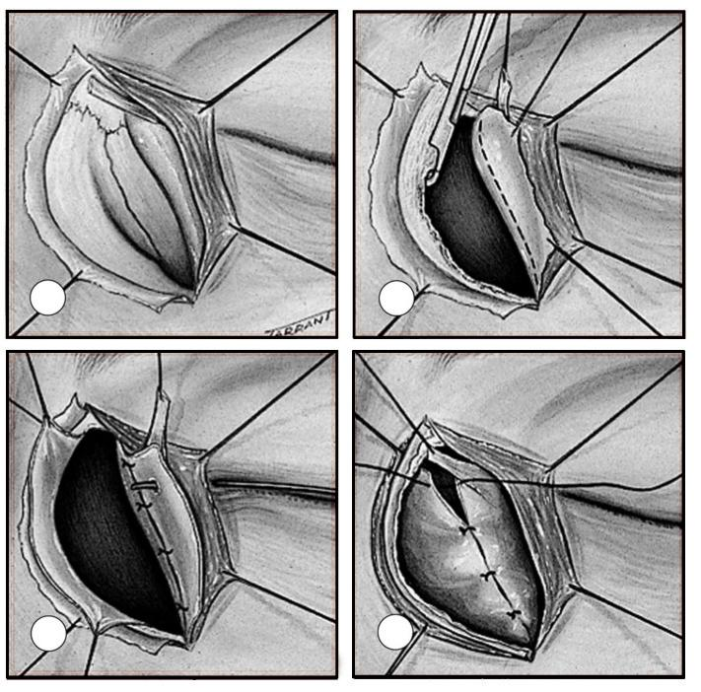

A B

C D

Fig. 3.7 Dacryocystorhinostomy: (A–D) the skin is incised over the lacrimal sac and an anastomosis is then created between the sac and the nasal mucosa (see text). (From Salmon JF, Kanski’s Clinical Ophthalmology: A Systematic Approach, 9th edition. Oxford, UK: Elsevier; 2020.)

**Infections**

**CHRONIC CANALICULITIS**

**Pathogenesis:**

infection with *Actinomyces israelii* without any identifiable predisposition.

**Diagnosis**

***Presentation***: unilateral epiphora with refractory chronic mucopurulent conjunctivitis.

***Signs***: (a) ‘pouting’ punctum with pericanalicular oedema, (b) mucopurulent discharge (Fig. 3.9A), (c) concretions (Fig. 3.9B) may appear on pressure over the canaliculus. ***Diﬀerential diagnosis***: (a) herpes simplex infection (acute canaliculitis), (b) mucocoele,

(c) dacryolithiasis, (d) lacrimal diverticulum, (e) giant fornix syndrome.

#*" ##%"#"+!#(&&%"'+$'""#* "%#! " +#!+ &)%#"$'!%

#%$%&#" (&#" +##'%(&&*'#('$%!&&#"#$+%', &)%" %'&%&%)

**56** SYNOPSIS OF CLINICAL OPHTHALMOLOGY

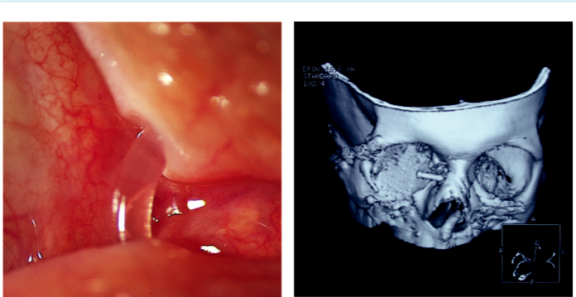

A B

Fig. 3.8 (A) Silicone lacrimal stent, (B) CT scan 3D reconstruction of a Lester Jones tube. (From Salmon JF, Kanski’s Clinical Ophthalmology: A Systematic Approach, 9th edition. Oxford, UK: Elsevier; 2020.)

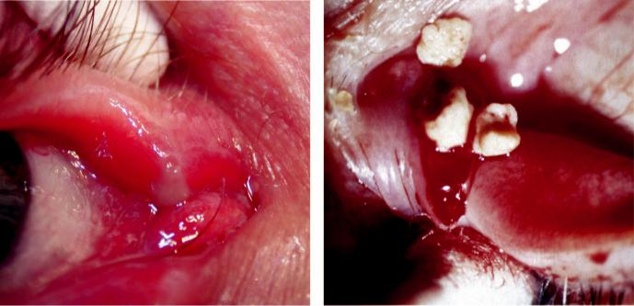

A B

Fig. 3.9 Chronic canaliculitis: (A) mucopurulent discharge on pressure over an inflamed upper canaliculus, (B) concretions. (Figure. 3.9B courtesy of S. Tuft.)

**Treatment**

***Topical antibiotics***: (e.g. levofloxacin) may be tried.

***Transconjunctival canaliculotomy with curettage***: necessary in most cases.

**DACRYOCYSTITIS**

**Pathogenesis:**

secondary to nasolacrimal duct obstruction; may be acute or chronic.

#*" ##%"#"+!#(&&%"'+$'""#* "%#! " +#!+ &)%#"$'!%

#%$%&#" (&#" +##'%(&&*'#('$%!&&#"#$+%', &)%" %'&%&%)

|  |  |
| --- | --- |
| Chapter 3—LACRIMAL DRAINAGE SYSTEM | **57** |
|  |  |

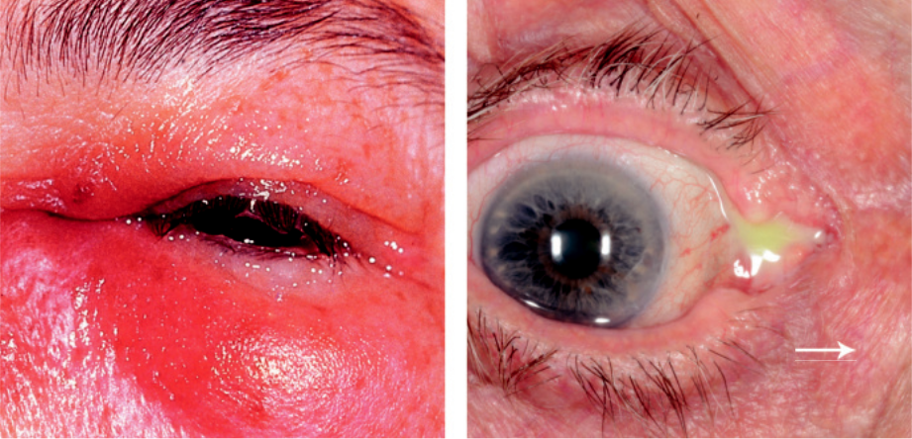

A B

Fig. 3.10 Dacrocystitis: (A) inflamed mucocoele, (B) reflux of mucopurulent material by applying pressure

to the sac (arrow). (From Salmon JF, Kanski’s Clinical Ophthalmology: A Systematic Approach, 9th edition.

Oxford, UK: Elsevier; 2020.)

**Diagnosis**

***Acute***: (a) subacute onset of medial canthal pain and epiphora, (b) tender tense red swelling (Fig. 3.10A) that may progress to abscess formation and cellulitis.

***Chronic***: (a) epiphora and chronic/recurrent unilateral conjunctivitis, (b) reflux of mucopu-rulent material on pressure over medial canthus (Fig. 3.10B), with or without a mucocele.

**Treatment**

***Acute***: (a) oral antibiotics (e.g. co-amoxiclav or erythromycin), (b) incision and drainage may be considered for a pointing abscess (small risk of subsequent fistula), (c) DCR may be considered once the infection has settled.

***Chronic***: DCR.

#*" ##%"#"+!#(&&%"'+$'""#* "%#! " +#!+ &)%#"$'!%

#%$%&#" (&#" +##'%(&&*'#('$%!&&#"#$+%', &)%" %'&%&%)



CHAPTER 4

Orbit



C H A P T E R O U T L I N E

Thyroid eye disease 59

Infections 61

Preseptal cellulitis 61

Bacterial orbital cellulitis 62

Non-infective inflammatory disease 63

Idiopathic orbital inflammatory disease (IOID) 63

Acute dacryoadenitis 63

Tolosa–Hunt syndrome 64

Vascular abnormalities 64

Varices 64

Carotid-cavernous fistula 65

Cystic lesions 67

Dacryops 67

Dermoid cyst 68

Encephalocoele 68

Tumours 69

Capillary haemangioma 69

Cavernous haemangioma 70

Pleomorphic lacrimal gland adenoma (benign mixed cell tumour) 70

Lacrimal gland carcinoma 72

Optic nerve glioma 72

Optic nerve sheath meningioma 73 Plexiform neurofibroma 73 Lymphoma 74

Rhabdomyosarcoma (embryonal sarcoma) 74

Adult metastatic tumours 75

Childhood metastatic tumours 76

Orbital invasion from adjacent structures 76

Anophthalmic socket 77

Surgical procedures for removal of an eye or the contents of the orbit 77

Rehabilitation of the anophthalmic socket 77

Craniosynostoses 78

Crouzon syndrome 78

Apert syndrome 79

**Thyroid eye disease**

**Pathogenesis:**

organ-specific autoimmune reaction in which a humoral agent (IgG antibody) produces inflam-mation and swelling of orbital tissue, especially extraocular muscles. It consists of an active inflam-matory stage (<3 years) followed by a quiescent/fibrotic stage. Only about 10% develop serious long-term ocular problems.

**Diagnosis**

***Lid retraction***: (a) superior lid margin is either level with or above the superior limbus, with ‘scleral show’ (Fig. 4.1A), (b) von Graefe sign (‘lid lag’) describes retarded descent of the upper lid on downgaze, (c) inferior lid retraction.

***Ocular surface involvement***: (a) grittiness, photophobia, lacrimation, and retrobulbar dis-comfort, (b) conjunctival hyperaemia, (c) chemosis and lid swelling (Fig. 4.1B), (d) superior limbic keratoconjunctivitis.

**59**

#*" ##%"#"+!#(&&%"'+$'""#* "%#! " +#!+ &)%#"$'!%

#%$%&#" (&#" +##'%(&&*'#('$%!&&#"#$+%', &)%" %'&%&%)

**60** SYNOPSIS OF CLINICAL OPHTHALMOLOGY



***Axial proptosis***: if severe, along with lid retraction (Fig. 4.1C) may compromise lid closure resulting in exposure keratopathy.

***Restrictive myopathy***: motility defects in order of frequency are: (a) elevation, abduction, depression and adduction, (b) intraocular pressure increase in upgaze.

***Optic neuropathy***: compression of the optic nerve by enlarged muscles (Fig. 4.1D); optic disc often appears normal.

**Treatment**

***Lifestyle***: patients should stop smoking.

***Ocular surface involvement***: (a) lubricants, (b) topical anti-inflammatory agents (e.g. steroids, nonsteroidal anti-inflammatory drugs), (c) specific treatment of superior limbic keratoconjunctivitis (SLK).

***Proptosis***: (a) systemic steroids (e.g. oral prednisolone, initially 60–80 mg with tapering on response) in acute sight-threatening cases, (b) radiotherapy (takes weeks–months for

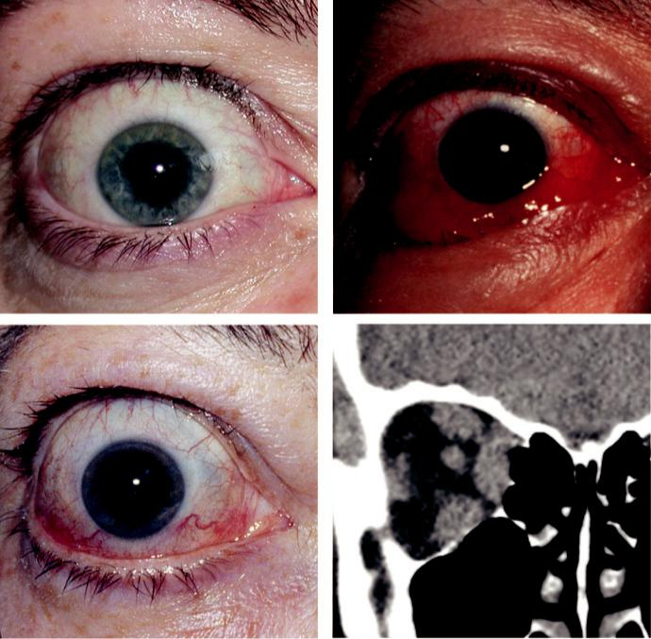

A B

C D

Fig. 4.1 Thyroid eye disease: (A) lid retraction, (B) chemosis and lid swelling, (C) axial proptosis, (D) coronal

CT scan showing symmetrical muscle enlargement. (From Salmon JF, Kanski’s Clinical Ophthalmology: A

Systematic Approach, 9th edition. Oxford, UK: Elsevier; 2020.)

#*" ##%"#"+!#(&&%"'+$'""#* "%#! " +#!+ &)%#"$'!%

#%$%&#" (&#" +##'%(&&*'#('$%!&&#"#$+%', &)%" %'&%&%)

|  |  |
| --- | --- |
| Chapter 4—ORBIT | **61** |
|  |  |
| eect) in addition to steroids, or when these are contraindicated, (c) orbital decompres | - |

sion is sometimes used acutely, but more commonly is reserved for the quiescent phase,

1. teprotumumab is a new monoclonal antibody which inhibits insulin-like growth factor 1 receptor and is eective in reducing clinical activity and proptosis.

***Restrictive myopathy***: (a) initially prisms, (b) surgery (inferior and/or medial rectus reces-sions with adjustable sutures) for diplopia in the primary or reading positions of gaze once stable for at least 6 months, (c) botulinum toxin injection.

***Lid retraction***: (a) lid taping during sleep, (b) surgery (disinsertion of Müller muscle, leva-tor recession, recession of the lower lid retractors) for stable retraction, but only after first addressing proptosis and strabismus, (c) botulinum toxin chemodenervation for temporary eect.

***Optic neuropathy***: (a) systemic steroids (oral prednisolone or intravenous methylpredniso-

lone), (b) surgical decompression if steroids are ineective or inappropriate; vision, particu - larly colour vision, should be monitored regularly.

**Infections**

**PRESEPTAL CELLULITIS**

**Pathogenesis:**

infection of subcutaneous tissue anterior to the orbital septum. Causes include (a) skin trauma (*S. aureus*, *S. pyogenes*), (b) spread f rom local or remote infection (e.g. stye, dacryocys-titis, sinusitis).

**Diagnosis**

***Presentation***: unilateral tender, red and swollen lid (Fig. 4.2A).

***Signs***: proptosis and chemosis are absent. Optic nerve function and ocular motility are unimpaired.

***CT***: opacification anterior to the orbital septum (Fig. 4.2B).

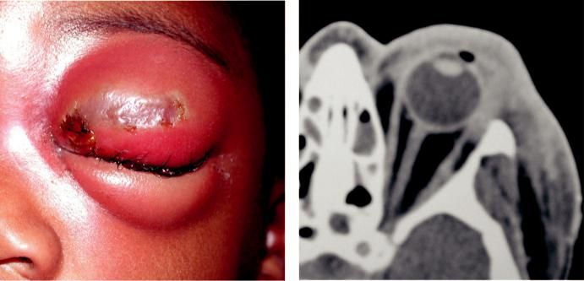

A B

Fig. 4.2 Preseptal cellulitis: (A) secondary to infected skin abrasion, (B) axial CT showing opacification anterior

to the orbital septum. (From Salmon JF, Kanski’s Clinical Ophthalmology: A Systematic Approach, 9th edition.

Oxford, UK: Elsevier; 2020.)

#*" ##%"#"+!#(&&%"'+$'""#* "%#! " +#!+ &)%#"$'!%

#%$%&#" (&#" +##'%(&&*'#('$%!&&#"#$+%', &)%" %'&%&%)

**62** SYNOPSIS OF CLINICAL OPHTHALMOLOGY



**Treatment:**

oral antibiotics (e.g. co-amoxiclav) are usually adequate. Severe infection/abscess may require intravenous administration.

**BACTERIAL ORBITAL CELLULITIS**

**Pathogenesis:**

life-threatening infection of the tissues behind the orbital septum, more common in children. Causes:

1. secondary to sinusitis (most common), (b) spread from local or remote infection, (c) post-trauma,
2. post-surgery; common isolates are *S. pneumoniae*, *S. aureus*, *S. pyogenes*, and *H. influenzae*.

**Diagnosis**

***Presentation***: rapid onset of pain, visual impairment, malaise, and periocular swelling.

***Signs***: (a) unilateral, tender, warm and red periorbital oedema, (b) proptosis, (c) painful ophthalmoplegia (Fig. 4.3A), (d) optic nerve dysfunction.

***Ocular complications***: (a) exposure keratopathy, (b) optic atrophy, (c) retinal vascular occlu-sion, (d) endophthalmitis.

***Other serious complications***: (a) subperiosteal abscess, (b) meningitis, (c) cavernous sinus thrombosis (bilateral rapidly progressive proptosis with abrupt general deterioration). ***Investigations***: (a) CT of orbit (Fig. 4.3B), sinuses and brain, (b) white cell count, (c) blood culture, (d) nasal swab for culture, (e) lumbar puncture if meningeal signs develop.

**Treatment**

Hospital admission with otorhinolaryngological co-management.

Urgent intravenous antibiotic therapy (e.g. cephalosporin or vancomycin, with metro-nidazole to cover anaerobes).

Frequent ophthalmic review including optic nerve function.

Surgical drainage of (a) infected sinuses and orbital collections if lack of response to antibi-

otics or (b) subperiosteal/intracranial abscess.

Orbital biopsy may be considered if atypical.

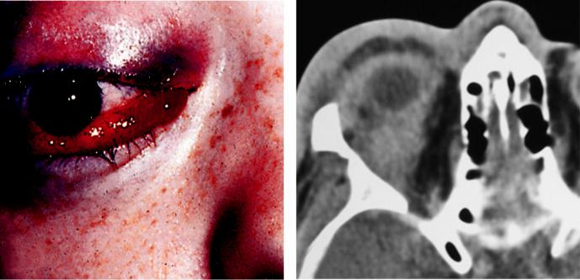

A B

Fig. 4.3 Orbital cellulitis: (A) proptosis with ophthalmoplegia, (B) axial CT showing preseptal and orbital opaci-

fication. (From Salmon JF, Kanski’s Clinical Ophthalmology: A Systematic Approach, 9th edition. Oxford, UK:

Elsevier; 2020.)

#*" ##%"#"+!#(&&%"'+$'""#* "%#! " +#!+ &)%#"$'!%

#%$%&#" (&#" +##'%(&&*'#('$%!&&#"#$+%', &)%" %'&%&%)

|  |  |
| --- | --- |
| Chapter 4—ORBIT | **63** |
|  |  |

**Non-infective inflammatory disease**

**IDIOPATHIC ORBITAL INFLAMMATORY DISEASE (IOID)**

**Pathogenesis:**

non-neoplastic and non-infective cellular infiltration that may involve any of the soft tissues of the orbit; previously referred to as ‘orbital pseudotumour.’

**Diagnosis**

***Presentation***: acute or subacute onset of periorbital redness, swelling and pain (Fig. 4.4A).

***Signs***: (a) proptosis, (b) conjunctival hyperaemia and chemosis, (c) ophthalmoplegia,

1. optic nerve dysfunction if the posterior orbit is involved. ***CT***: ill-defined opacification (Fig. 4.4B).

***Course***: varies f rom spontaneous remission without sequelae to severe prolonged inflam-mation with fibrosis (‘f rozen orbit’).

***Diﬀerential diagnosis***: (a) bacterial orbital cellulitis, (b) acute thyroid eye disease, (c) sys-temic inflammatory disorder (e.g. granulomatosis with polyangiitis).

**Treatment:**

observation for very mild disease; options in moderate–severe cases include NSAIDs, systemic steroids, radiotherapy and antimetabolites.

**ACUTE DACRYOADENITIS**

**Pathogenesis:**

usually idiopathic but occasionally infective (mumps, infective mononucleosis, rarely bacterial).

**Diagnosis**

***Presentation***: acute discomfort with swelling of the lateral eyelid.

***Signs***: (a) S-shaped ptosis and slight downward and inward dystopia (Fig. 4.5A), (b) local tenderness, with conjunctival injection overlying the lacrimal gland.

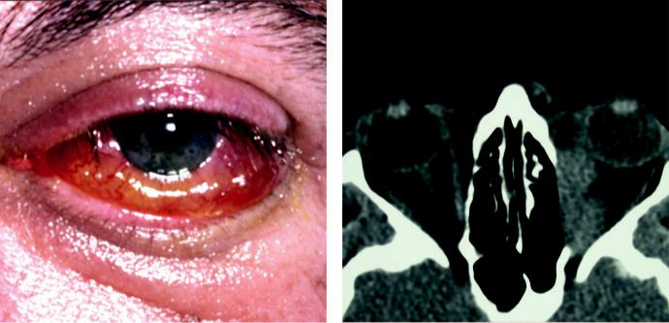

A B

Fig. 4.4 Idiopathic orbital inflammatory disease: (A) proptosis with ptosis, (B) axial CT showing ill-defined

orbital opacification. (From Salmon JF, Kanski’s Clinical Ophthalmology: A Systematic Approach, 9th edition.

Oxford, UK: Elsevier; 2020.)

#*" ##%"#"+!#(&&%"'+$'""#* "%#! " +#!+ &)%#"$'!%

#%$%&#" (&#" +##'%(&&*'#('$%!&&#"#$+%', &)%" %'&%&%)

**64** SYNOPSIS OF CLINICAL OPHTHALMOLOGY

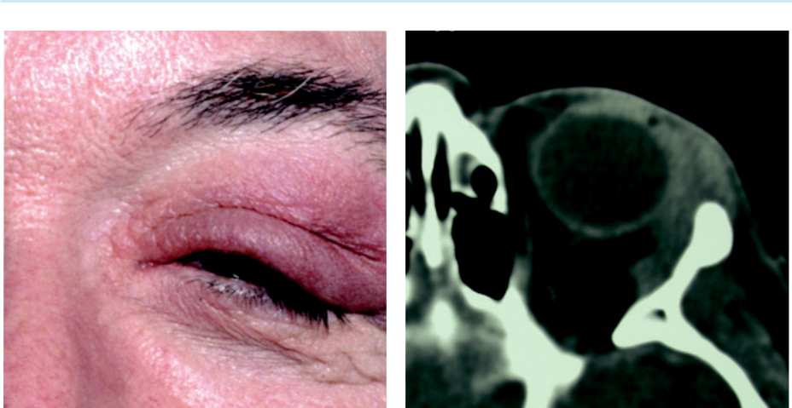

A B

Fig. 4.5 Acute dacryoadenitis: (A) swelling on the lateral aspect of the eyelid and S-shaped ptosis, (B) CT showing enlargement of the lacrimal gland and adjacent tissues.

***Imaging***: enlargement of the lacrimal gland (Fig. 4.5B).

***Diﬀerential diagnosis***: ruptured dermoid cyst and malignant lacrimal gland tumour.

**Treatment:**

spontaneous resolution is the rule; otherwise as for IOID.

**TOLOSA–HUNT SYNDROME**

**Definition:**

idiopathic condition characterized by granulomatous inflammation of the cavernous sinus, supe-rior orbital fissure and/or orbital apex.

**Diagnosis**

***Presentation***: diplopia associated with unilateral periorbital or hemi-cranial pain.

***Signs***: (a) proptosis is mild or absent, (b) ophthalmoplegia, often with pupillary involve-ment, (c) sensory loss (first and second trigeminal divisions).

***Course***: remissions and recurrences are common.

**Treatment:**

systemic steroids.

**Vascular abnormalities**

**VARICES**

**Definition:**

weakened orbital venous segments, usually unilateral and involving the upper nasal orbit.

**Diagnosis**

***Presentation***: from early childhood to late middle age.

***Signs***: (a) intermittent non-pulsatile proptosis not associated with a bruit, precipitated by coughing, straining, or assuming a dependent position, (b) often demonstrable with

#*" ##%"#"+!#(&&%"'+$'""#* "%#! " +#!+ &)%#"$'!%

#%$%&#" (&#" +##'%(&&*'#('$%!&&#"#$+%', &)%" %'&%&%)

|  |  |
| --- | --- |
| Chapter 4—ORBIT | **65** |
|  |  |

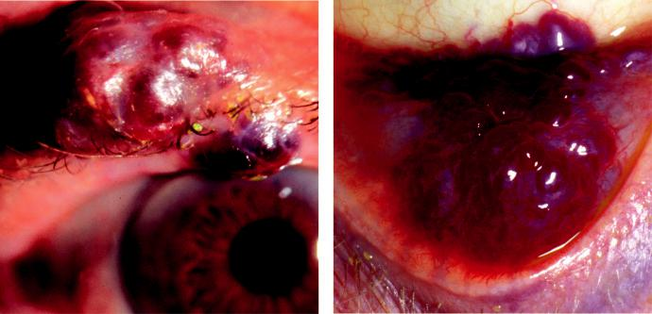

A B

Fig. 4.6 Varices: (A) eyelid, (B) conjunctiva. (From Salmon JF, Kanski’s Clinical Ophthalmology: A Systematic

Approach, 9th edition. Oxford, UK: Elsevier; 2020.)

the Valsalva manoeuvre or jugular vein compression, (c) coexisting varices of the eyelids (Fig. 4.6A) and conjunctiva (Fig. 4.6B) may be present.

***Imaging***: may show phleboliths.

***Complications***: acute haemorrhage and thrombosis; orbital fat atrophy.

**Treatment:**

indications include recurrent thrombosis, pain, severe proptosis and optic nerve compression.

Surgical excision is dicult as the lesions are friable.

**CAROTID-CAVERNOUS FISTULA**

**Introduction**

***Definition***: acquired communication between the carotid artery and the cavernous sinus resulting in increased episcleral venous pressure and decreased arterial blood flow. ere are two types:

***Direct fistula***: high-flow shunt with intracavernous carotid arterial blood passing directly into the sinus. Trauma is responsible for 75%; spontaneous rupture of an aneurysm or atherosclerotic artery accounting for the remainder.

***Indirect fistula***: low-flow shunt in which arterial blood flows indirectly into the cavern-ous sinus through the meningeal branches of the external or internal carotid arteries; frequently spontaneous or following straining.

**Diagnosis of direct fistula**

***Presentation***: days or weeks after head injury with the classic triad of: (a) pulsatile proptosis,

(b) chemosis, (c) ‘whooshing’ noise in the head.

***Signs***: (a) conjunctival injection (Fig. 4.7A) and haemorrhagic chemosis (Fig. 4.7B),

1. ophthalmoplegia and ptosis (3rd nerve involvement), (c) pulsatile proptosis associated with a thrill and a bruit; may be abolished by ipsilateral carotid compression, (d) increased intraocular pressure, (e) anterior segment ischaemia (corneal epithelial oedema, aqueous cells and flare), (f ) optic disc swelling, (g) retinal venous dilatation.

#*" ##%"#"+!#(&&%"'+$'""#* "%#! " +#!+ &)%#"$'!%

#%$%&#" (&#" +##'%(&&*'#('$%!&&#"#$+%', &)%" %'&%&%)

**66** SYNOPSIS OF CLINICAL OPHTHALMOLOGY

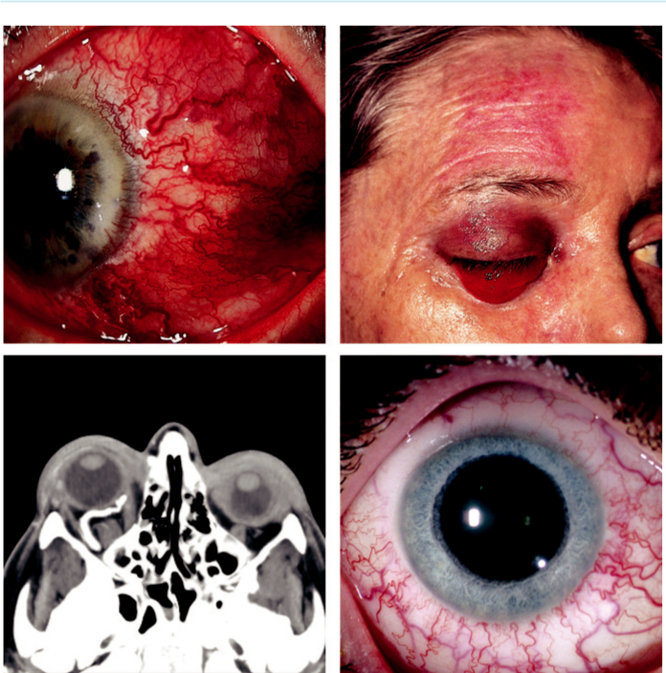

A B

C D

Fig. 4.7 Carotid-cavernous fistula: (A) marked epibulbar vascular dilatation in a direct fistula, (B) haemorrhagic chemosis, (C) axial CT showing enlargement of superior ophthalmic vein, (D) mild epibulbar vascular dilatation in an indirect fistula. (Figure 4.7A courtesy of S. Chen; Figure 4.7D courtesy of Chris Barry, Lions Eye Institute, Perth, Australia.)

***CT and magnetic resonance (MR) imaging***: may show an enlarged superior ophthalmic vein and extraocular muscles. Definitive diagnosis involves CT or MR angiography (Fig. 4.7C).

**Diagnosis of indirect fistula**

***Typical signs***: may be subtle and include: (a) elevated intraocular pressure, (b) epibulbar vas-cular engorgement (classically corkscrew-like vessels; Fig. 4.7D) with or without chemosis, (c) exaggerated ocular pulsation.

***Uncommon signs***: (a) mild proptosis, occasionally associated with a soft bruit, (b) subtle retinal venous dilatation.

**Treatment**

Most fistulae are not hazardous to life, with intervention usually indicated only when sight is threatened. Spontaneous closure may occur, particularly in low-flow shunts. Endovascular embolization or balloon occlusion are options. Direct surgical repair is sometimes required.

#*" ##%"#"+!#(&&%"'+$'""#* "%#! " +#!+ &)%#"$'!%

#%$%&#" (&#" +##'%(&&*'#('$%!&&#"#$+%', &)%" %'&%&%)

|  |  |
| --- | --- |
| Chapter 4—ORBIT | **67** |
|  |  |

**Cystic lesions**

**DACRYOPS**

**Pathogenesis:**

ductal cyst of the lacrimal gland.

**Diagnosis:**

frequently bilateral; round cystic lesion originating from the palpebral portion of the lacrimal gland, protruding into the superior fornix (Fig. 4.8A).

**Treatment:**

excision or marsupialization.

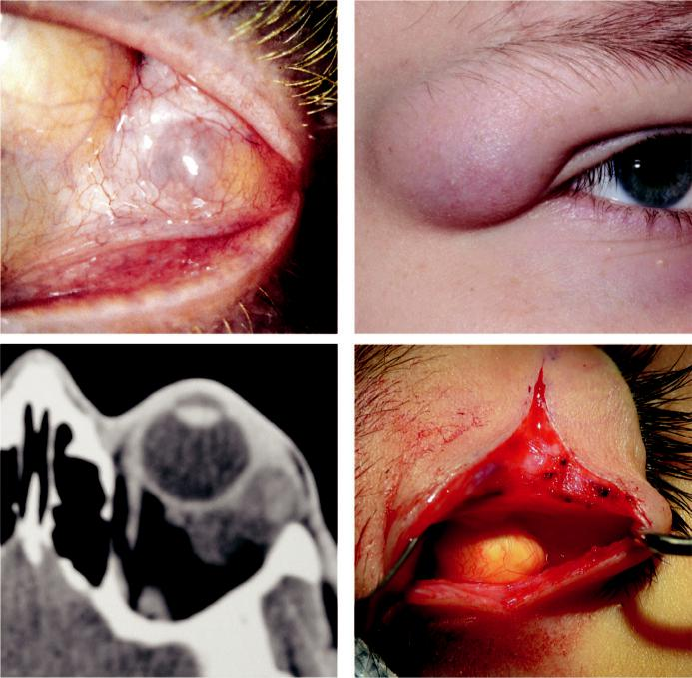

A B

C D

Fig. 4.8 Cystic lesions: (A) dacryops, (B) superficial dermoid, (C) axial CT showing well-circumscribed cyst, (D) surgical appearance of dermoid. (Figure 4.8D courtesy of J. Norris.)

#*" ##%"#"+!#(&&%"'+$'""#* "%#! " +#!+ &)%#"$'!%

#%$%&#" (&#" +##'%(&&*'#('$%!&&#"#$+%', &)%" %'&%&%)

**68** SYNOPSIS OF CLINICAL OPHTHALMOLOGY



**DERMOID CYST**

**Pathogenesis:**

choristoma derived from displacement of ectoderm to a subcutaneous location; lined by skin-like epithelium, has a fibrous wall and contains dermal appendages; may be superficial or deep (i.e., anterior or posterior to the orbital septum).

**Diagnosis**

***Superficial dermoid***: (a) presents in infancy with a firm, round, smooth, nontender 1–2 cm nodule, (b) usually tethered to the adjacent periosteum, (c) most commonly located in the superotemporal orbit (Fig. 4.8B), (d) easily palpable posterior margins.

***Deep dermoid***: (a) presents in adolescence/adulthood with proptosis, dystopia or a mass lesion with indistinct posterior margins, (b) may extend into the inferotemporal fossa or intracranially, (c) may enlarge and rupture spontaneously, inducing a substantial inflamma-tory reaction, (d) imaging shows a well-circumscribed cystic lesion (Fig. 4.8C).

**Treatment**

***Superficial dermoid***: excision, taking care not to rupture the lesion.

***Deep dermoid***: excision is advisable to avoid spontaneous rupture (Fig. 4.8D).

**ENCEPHALOCOELE**

**Pathogenesis:**

herniation of intracranial contents through a congenital defect of the base of the skull. ese can be anterior involving the superomedial part of the orbit, displacing the globe forwards and later-ally (Fig. 4.9A), or posterior displacing the globe forwards and downwards (frequently associated with NF1) (Fig. 4.9B). A meningocoele contains only dura and a meningoencephalocoele also contains brain tissue; associations include other bony facial abnormalities, several developmental ocular anomalies and NF1.

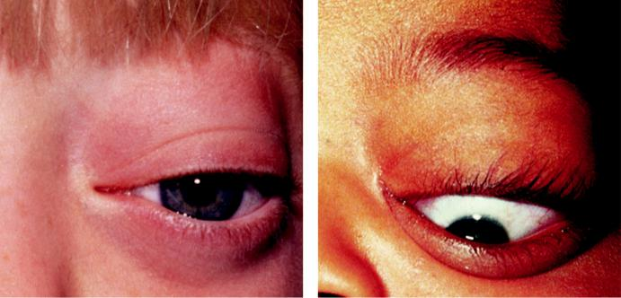

A B

Fig. 4.9 Encephalocoele: (A) anterior, causing proptosis and down and out dystopia, (B) posterior encephalo-

coele causing proptosis and inferior dystopia. (From Salmon JF, Kanski’s Clinical Ophthalmology: A Systematic

Approach, 9th edition. Oxford, UK: Elsevier; 2020.)

#*" ##%"#"+!#(&&%"'+$'""#* "%#! " +#!+ &)%#"$'!%

#%$%&#" (&#" +##'%(&&*'#('$%!&&#"#$+%', &)%" %'&%&%)

|  |  |
| --- | --- |
| Chapter 4—ORBIT | **69** |
|  |  |

**Diagnosis**

***Presentation***: during infancy.

***Signs***: (a) proptosis and dystopia, increasing on crying, (b) pulsation may occur due to com-munication with the subarachnoid space but there is neither a thrill nor a bruit.

***CT***: bony defect.

**Treatment:**

surgical repair.

**Tumours**

**CAPILLARY HAEMANGIOMA**

**Definition:**

vascular tumour composed of anastomosing small vascular channels without true encapsulation. It is the most common orbital tumour in childhood and aects girls more commonly than boys by a 3:1 ratio.

**Diagnosis**

***Presentation***: first few weeks of life (30% at birth).

***Signs***: (a) cutaneous lesions often coexist (see Chapter 2), (b) preseptal lesions appear blue/ purple through the skin (Fig. 4.10A), (c) deep orbital tumours give rise to proptosis without skin discoloration, (d) involvement of the forniceal conjunctiva may be an important diag-nostic clue.

***Imaging***: required when the diagnosis is not apparent on inspection.

***Course***: rapid growth for 3–6 months after diagnosis, followed by a slower phase of natural resolution; 30% of lesions resolve by the age of 3 years and 70% by the age of 7 years.

***Systemic associations***: (a) high-output heart failure (large lesions), (b) Kasabach–Merritt syndrome (thrombocytopenia, coagulation abnormalities, multiple haemangiomas), (c) Maucci syndrome (multiple haemangiomas, enchondromatosis).

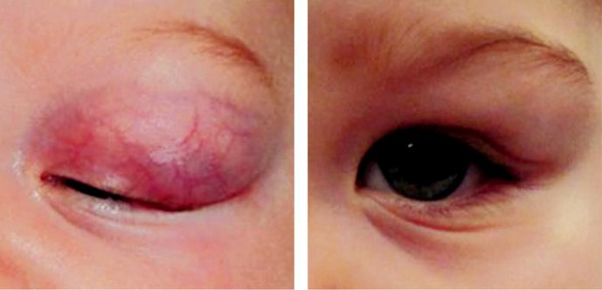

A B

Fig. 4.10 Capillary haemangioma: (A) at presentation, (B) 6 months after treatment with topical timolol. (Courtesy of D. Hildebrand.)

#*" ##%"#"+!#(&&%"'+$'""#* "%#! " +#!+ &)%#"$'!%

#%$%&#" (&#" +##'%(&&*'#('$%!&&#"#$+%', &)%" %'&%&%)

**70** SYNOPSIS OF CLINICAL OPHTHALMOLOGY



**Treatment**

***Indications***: (a) amblyopia (induced astigmatism, anisometropia, occlusion), (b) optic nerve compression, (c) exposure keratopathy, (d) severe cosmetic blemish, (e) necrosis or infection. ***Beta-blockers***: systemic propranolol (2 mg/kg/day in two divided doses) or topical timolol (Fig. 4.10B).

***Systemic steroids***: administered daily over several weeks.

**CAVERNOUS HAEMANGIOMA**

**Definition:**

vascular lesion that behaves like a low-flow arteriovenous malformation, typically located just behind the globe within the muscle cone; female preponderance of 70%.

**Diagnosis**

***Presentation***: (a) 4th and 5th decades with slowly progressive unilateral axial proptosis,

(b) gaze-evoked blurring of vision is typical.

***Imaging***: well-circumscribed oval lesion with slow contrast enhancement (Fig. 4.11A).

**Treatment:**

symptomatic lesions require surgical excision (Fig. 4.11B).

**PLEOMORPHIC LACRIMAL GLAND ADENOMA (BENIGN MIXED CELL TUMOUR)**

**Definition:**

most common epithelial tumour of the lacrimal gland, derived from the ducts and secretory elements.

**Diagnosis**

***Presentation***: in young to middle-aged adults with painless, slowly progressive proptosis or swelling in the superolateral orbit, usually of more than a year’s duration.

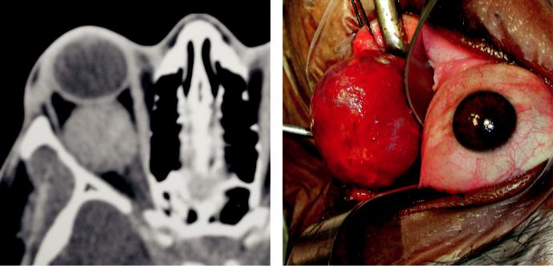

A B

Fig. 4.11 Cavernous haemangioma: (A) axial CT showing a well-circumscribed retrobulbar lesion and prop-tosis, (B) removal of an encapsulated tumour. (Courtesy of A. Pearson.)

#*" ##%"#"+!#(&&%"'+$'""#* "%#! " +#!+ &)%#"$'!%

#%$%&#" (&#" +##'%(&&*'#('$%!&&#"#$+%', &)%" %'&%&%)

|  |  |
| --- | --- |
| Chapter 4—ORBIT | **71** |
|  |  |

***Orbital lobe tumour***: (a) smooth, firm, nontender mass in the lacrimal gland fossa with inferonasal dystopia (Fig. 4.12A), (b) eversion of the upper lid reveals the tumour (Fig. 4.12B), (c) posterior extension may cause proptosis, ophthalmoplegia, and cho-roidal folds.

***CT***: round or oval mass, with indentation but not destruction of the lacrimal gland fossa.

***Palpebral lobe tumour***: less common; tends to grow anteriorly causing upper lid swelling without dystopia; may be visible to inspection.

**Treatment**

***Surgical excision***: (a) palpebral lobe tumours via an anterior (trans-septal) orbitotomy,

1. orbital lobe lesions via a lateral orbitotomy. Prior biopsy should be avoided, in order to prevent tumour seeding into adjacent orbital tissue.

***Prognosis***: excellent. Incomplete excision or preliminary incisional biopsy with seeding is associated with recurrence and occasional malignant change.

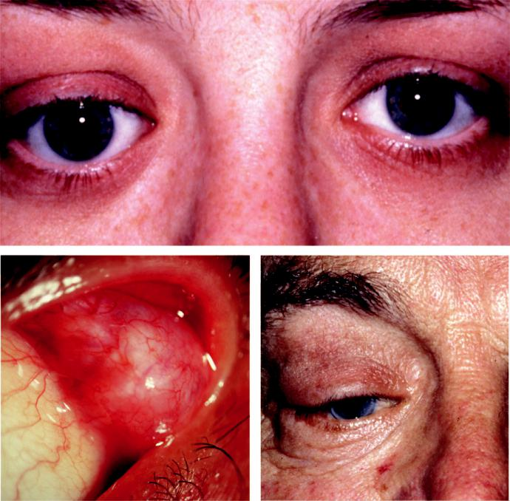

A

B C

Fig. 4.12 Lacrimal gland tumours: (A) inferonasal dystopia, (B) eversion of the upper eyelid showing pleo-morphic adenoma, (C) lacrimal gland carcinoma showing dystopia and ptosis. (Figure 4.12A courtesy of A. Pearson.

#*" ##%"#"+!#(&&%"'+$'""#* "%#! " +#!+ &)%#"$'!%

#%$%&#" (&#" +##'%(&&*'#('$%!&&#"#$+%', &)%" %'&%&%)

**72** SYNOPSIS OF CLINICAL OPHTHALMOLOGY



**LACRIMAL GLAND CARCINOMA**

**Histological types:**

1. adenocystic carcinoma, (b) pleomorphic adenocarcinoma, (c) mucoepidermoid carcinoma,
2. squamous cell carcinoma.

**Diagnosis**

***Presentation***: in early middle age with: (a) rapidly growing lacrimal gland mass of several months’ duration (Fig. 4.12C), (b) long-standing swollen upper lid that suddenly starts to increase in size, (c) following incomplete excision of a benign pleomorphic lacrimal gland adenoma.

***Signs***: posterior extension, with involvement of the superior orbital fissure, may give rise

to: (a) periorbital oedema, (b) epibulbar hyperaemia, (c) proptosis, (d) ophthalmoplegia,

1. optic disc swelling and choroidal folds, (f ) hypoaesthesia in the region supplied by the lacrimal nerve is common.

***CT***: globular lesion with irregular edges, often with invasion of bone and calcification.

***Investigations***: (a) biopsy to establish the histology, (b) neurological imaging because ade-nocystic carcinoma exhibits perineural spread and may extend into the cavernous sinus.

**Treatment:**

1. excision of the tumour and adjacent tissues, (b) extensive tumours may require orbital exen-teration and are associated with a poor prognosis for life, (c) radiotherapy may prolong life and reduce pain.

**OPTIC NERVE GLIOMA**

**Definition:**

slow-growing pilocytic astrocytoma typically aecting children; approximately 30% have associ - ated NF1 (see Chapter 19). Malignant gliomas are rare, almost always occur in adults and have a very poor prognosis.

**Diagnosis**

***Presentation***: slowly progressive visual loss followed by proptosis (Fig. 4.13A).

***Signs***: (a) optic nerve head swelling followed by atrophy, (b) opticociliary collaterals and central retinal vein occlusion (uncommon), (c) intracranial spread to the chiasm and hypo-thalamus may occur.

***Imaging***: (a) in patients with NF1, the tumour shows fusiform enlargement of the optic nerve with a clear-cut margin (Fig. 4.13B) produced by the intact dural sheath,

1. inpatients without NF1 the lesion is more irregular; MR may show intracranial extension.

**Treatment**

May not be required in patients with no evidence of growth and good vision.

Surgical excision with preservation of the globe in those with large or growing tumours confined to the orbit, particularly if vision is poor. Radiotherapy/chemotherapy when intracranial extension precludes excision.

Prognosis for life in childhood tumours is variable.

#*" ##%"#"+!#(&&%"'+$'""#* "%#! " +#!+ &)%#"$'!%

#%$%&#" (&#" +##'%(&&*'#('$%!&&#"#$+%', &)%" %'&%&%)

|  |  |
| --- | --- |
| Chapter 4—ORBIT | **73** |
|  |  |

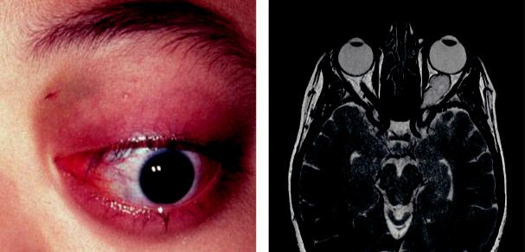

A B

Fig. 4.13 Optic nerve glioma: (A) proptosis with inferior dystopia, (B) axial MRI showing fusiform optic nerve enlargement. (Figure 4.13A courtesy of Dr Ken K. Nischal.)

**OPTIC NERVE SHEATH MENINGIOMA**

**Definition:**

benign tumour arising from the arachnoid villi surrounding the intraorbital or, less commonly, the intracanalicular portion of the optic nerve. It typically aects women and has a good prognosis forlife.

**Diagnosis**

***Presentation***: in middle-age with gradual unilateral visual impairment, and occasionally transient obscurations.

***Subsequent course***: (a) optic nerve dysfunction and chronic disc swelling followed by atro-phy, with opticociliary collaterals in 30% (Fig. 4.14A), (b) ophthalmoplegia, (c) proptosis caused by intraconal growth.

***CT***: thickening and calcification of the optic nerve.

***MR***: more clearly delineates smaller tumours and those around the optic canal (Fig.4.14B ).

**Treatment**

***May not be required***: in patients with slow-growing tumours.

***Surgical excision***: in young patients with aggressive tumours, particularly if the eye is blind.

***Fractionated stereotactic radiotherapy***: in selected cases.

**PLEXIFORM NEUROFIBROMA**

**Definition:**

most common peripheral neural tumour of the orbit, occurring almost exclusively in NF1.

**Diagnosis**

***Presentation***: early childhood with periorbital swelling.

***Signs***: (a) diuse involvement of the orbit often causes disfiguring hypertrophy of periocular tissues, (b) lid involvement causes mechanical ptosis with a characteristic S-shaped defor-mity, (c) palpation of involved tissues is said to resemble a ‘bag of worms.’

***Imaging***: demonstrates extent of orbital involvement.

**Treatment:**

often unsatisfactory; complete surgical removal is extremely dicult due to the intricate relation - ship between the tumour and important orbital structures.

#*" ##%"#"+!#(&&%"'+$'""#* "%#! " +#!+ &)%#"$'!%

#%$%&#" (&#" +##'%(&&*'#('$%!&&#"#$+%', &)%" %'&%&%)

**74** SYNOPSIS OF CLINICAL OPHTHALMOLOGY

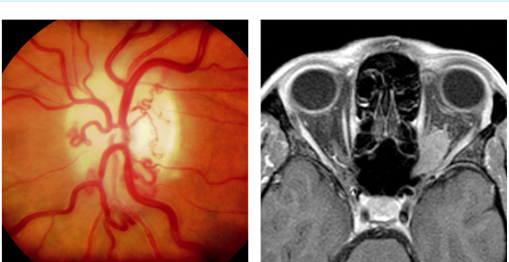

A B

Fig. 4.14 Optic nerve sheath meningioma: (A) optic atrophy and optociliary shunt vessels, (B) axial MRI show-

ing lesion associated with left optic nerve. (From Salmon JF, Kanski’s Clinical Ophthalmology: A Systematic

Approach, 9th edition. Oxford, UK: Elsevier; 2020.)

**LYMPHOMA**

**Pathogenesis:**

lymphomas represent one end of the spectrum of lymphoproliferative disorders, with benign reac-tive lymphoid hyperplasia at the other. Most orbital lymphomas are composed of ‘small’ B cells.

**Diagnosis**

***Presentation***: in old age with an insidious onset that may occasionally be bilateral (Fig.4.15A ).

***Signs***: (a) proptosis with periocular swelling (Fig. 4.15B), (b) conjunctival involvement may be present.

***Systemic assessment***: (a) chest X-ray, (b) serum immunoprotein electrophoresis, (c) thora-co-abdominal CT, (d) bone marrow aspiration.

***Course***: variable and often unpredictable.

**Treatment:**

radiotherapy for localized lesions; chemotherapy for disseminated disease.

**RHABDOMYOSARCOMA (EMBRYONAL SARCOMA)**

**Histology:**

1. most common primary orbital malignancy of childhood, (b) derived from undierentiated mesenchyme and histologically varies from undierentiated to dierentiated; the latter often showing features of striated muscle (rhabdomyosarcoma).

**Diagnosis**

***Presentation***: average age is 7 years with rapidly progressive, unilateral proptosis that may mimic inflammation (Fig. 4.16A).

***Signs***: (a) most common sites are upper nasal and retrobulbar, (b) overlying skin is swollen and red but not warm.

***Imaging***: poorly defined mass (Fig. 4.16B), often with bony destruction.

#*" ##%"#"+!#(&&%"'+$'""#* "%#! " +#!+ &)%#"$'!%

#%$%&#" (&#" +##'%(&&*'#('$%!&&#"#$+%', &)%" %'&%&%)

|  |  |
| --- | --- |
| Chapter 4—ORBIT | **75** |
|  |  |

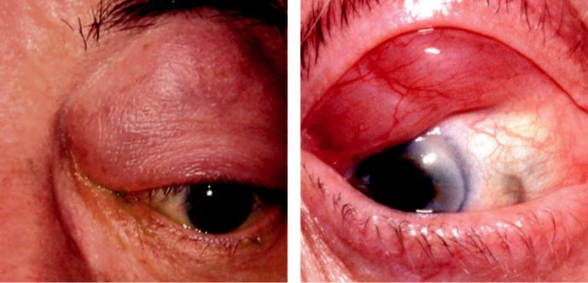

A B

Fig. 4.15 Lymphoma: (A) lesion in superior orbit causing inferior dystopia and proptosis, (B) anterior lesion. (Figure 4.15A courtesy of A. Pearson.)

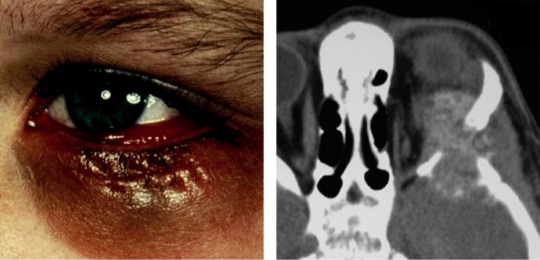

A B

Fig. 4.16 Rhabdomyosarcoma: (A) anteriorly located tumour, (B) axial CT showing bony destruction and intracranial spread. (Figure 4.16B courtesy of S. Chen.)

**Treatment:**

radiotherapy and chemotherapy; surgical excision is reserved for recurrent or radio-resistant tumours.

**ADULT METASTATIC TUMOURS**

**Primary sites:**

orbital metastases are an inf requent cause of proptosis and are much less common than metastases to the choroid. In order of f requency the most common primary sites are: breast, bronchus, prostate and cutaneous melanoma. e prognosis is poor; most patients dying within 1 year.

#*" ##%"#"+!#(&&%"'+$'""#* "%#! " +#!+ &)%#"$'!% #%$%&#" (&#" +##'%(&&*'#('$%!&&#"#$+%', &)%" %'&%&%)

**76** SYNOPSIS OF CLINICAL OPHTHALMOLOGY



**Diagnosis**

***Presentation***: (a) sudden onset of proptosis with dystopia, (b) orbital apex lesions may cause only mild proptosis with predominance of cranial nerve involvement.

***Signs***: (a) infiltration and inflammation of orbital tissues, (b) ‘firm’ orbit with resistance to globe retropulsion or (c) enophthalmos with scirrhous tumours.

***Imaging***: non-encapsulated mass.

**Treatment:**

radiotherapy and occasionally surgery.

**CHILDHOOD METASTATIC TUMOURS**

***Neuroblastoma***: arises from primitive sympathetic neural cells, most commonly in the abdo-men. Orbital metastases, sometimes bilateral, typically present with abrupt onset of propto-sis with lid ecchymosis and a superior orbital mass (Fig. 4.17A).

***Myeloid sarcoma***: localized tumour composed of malignant cells of myeloid origin; may be associated with myeloid leukaemia. Orbital involvement usually presents at approximately age 7 years with rapid-onset proptosis, sometimes bilateral.

***Langerhans cell histiocytosis***: proliferation of histiocytes. Presentation ranges from local-ized disease with bone destruction (eosinophilic granuloma) to fulminant systemic dis-ease. Orbital involvement consists of unilateral or bilateral osteolytic lesions, typically in the superotemporal quadrant.

**ORBITAL INVASION FROM ADJACENT STRUCTURES**

***Sinus tumours***: (a) maxillary carcinoma may cause facial pain and swelling, epistaxis and nasal discharge, epiphora, diplopia and upward dystopia (Fig. 4.17B), (b) ethmoidal carci-noma may present with lateral dystopia, (c) nasopharyngeal carcinoma may spread to the orbit through the inferior orbital fissure—proptosis is a late finding.

***Bony invasion***: by intracranial meningiomas (sphenoidal ridge, tuberculum sellae, olfactory groove).

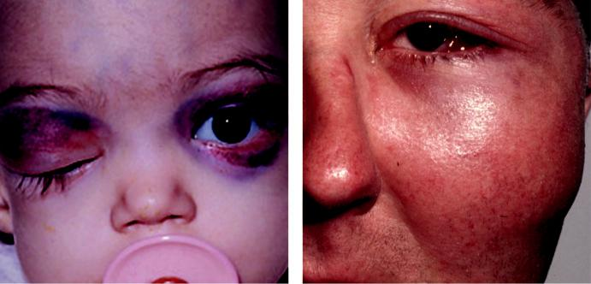

A B

Fig. 4.17 Secondary tumours: (A) neuroblastoma, (B) advanced maxillary carcinoma. (Figure 4.17A from Zitelli B, Davis H. Atlas of Pediatric Physical Diagnosis. Mosby; 2002.)

#*" ##%"#"+!#(&&%"'+$'""#* "%#! " +#!+ &)%#"$'!%

#%$%&#" (&#" +##'%(&&*'#('$%!&&#"#$+%', &)%" %'&%&%)

|  |  |
| --- | --- |
| Chapter 4—ORBIT | **77** |
|  |  |

***Fibrous dysplasia***: benign developmental disorder leading to slowly developing irregular expansion of bone with a mass eect on adjacent structures; may cause facial asymme - try, proptosis, dystopia and visual loss. Most orbital disease is ‘monostotic’; polyostotic is associated with endocrine disorders and cutaneous pigmentation (McCune–Albright syndrome).

***Orbital invasion***: from (a) eyelid malignancies (e.g. squamous cell carcinoma), (b) con-junctival tumours (e.g. melanoma), (c) intraocular tumours (e.g. choroidal melanoma, retinoblastoma).

**Anophthalmic socket**

**SURGICAL PROCEDURES FOR REMOVAL OF AN EYE OR THE CONTENTS OF THE ORBIT**

***Enucleation***: removal of the globe is indicated for the following: (a) primary intraocular malignancies where other treatment modalities are not appropriate, (b) after severe trauma where the eye is either unsalvageable or the risk of sympathetic ophthalmitis may outweigh any prospect of visual recovery (see Chapter 12), (c) when the eye is blind and painful or unsightly, although evisceration is generally preferred.

***Evisceration***: removal of the cornea and the contents of the globe, leaving the sclera and extraocular muscles intact. It provides better postoperative motility than enucleation but is not suitable for suspected malignancy.

***Exenteration***: removal of the globe and the soft tissues of the orbit (Fig. 4.18A) is indicated for the following: (a) orbital malignancies where other forms of treatment are unlikely to be eective, (b) rarely, for nonmalignant disease such as orbital mucormycosis. Anteriorly sited tumours may allow sparing of posterior orbital tissue, and posterior tumours may allow sparing of eyelid skin to line the socket.

**REHABILITATION OF THE ANOPHTHALMIC SOCKET**

A cosmetic shell is a prosthesis used to cover a phthisical or unsightly eye. It can restore volume and often provides a good cosmetic appearance and motility.

Orbital implants are used to counteract orbital volume deficit following enucleation or evisceration. A ball implant is usually placed at the time of eye removal; secondary placement can also be performed. Materials used may be solid (e.g. silicone) or porous (hydroxyapatite).

Prostheses following exenteration can be stuck onto the surrounding skin, mounted on glasses (Fig. 4.18B), or secured with osseo-integrated magnets mounted on the orbital rim bones.

Post-enucleation socket syndrome (PESS) is caused by failure to correct the volume deficit adequately. It is characterized by a deep upper lid sulcus, ptosis, enophthalmos and back-wards rotation of the top of the prosthesis (Fig. 4.18C).

After enucleation or evisceration, a conformer is placed to support the conjunctival fornices until the socket is fitted with an artificial eye (Fig. 4.18D). Initial impression moulds are taken at 6–8 weeks for a prosthesis shaped to fit the individual socket and matched to the fellow eye.

#*" ##%"#"+!#(&&%"'+$'""#* "%#! " +#!+ &)%#"$'!%

#%$%&#" (&#" +##'%(&&*'#('$%!&&#"#$+%', &)%" %'&%&%)

**78** SYNOPSIS OF CLINICAL OPHTHALMOLOGY

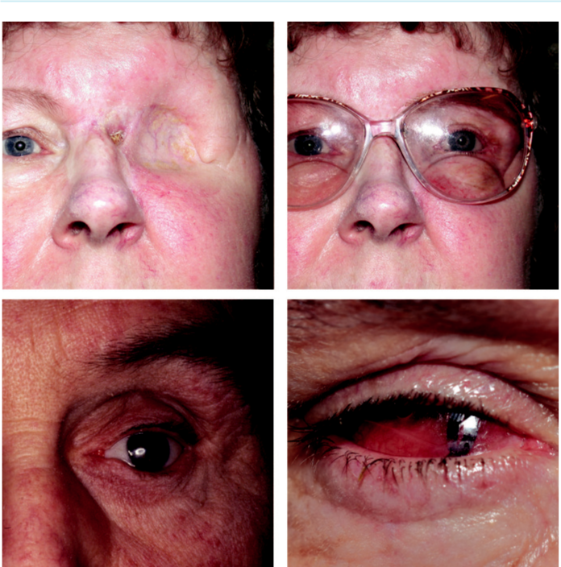

A B

C D

Fig. 4.18 Anophthalmic socket: (A) healed exenteration, (B) prosthesis attached to glasses, (C) post-enucleation socket syndrome, (D) conformer in position. (From Salmon JF, Kanski’s Clinical Ophthalmology: A Systematic Approach, 9th edition. Oxford, UK: Elsevier; 2020.)

**Craniosynostoses**

**CROUZON SYNDROME**

**Pathogenesis:**

premature fusion of the coronal and sagittal sutures; majority are AD, with a fresh mutation in 25%.

**Diagnosis**

***General signs***: (a) short anteroposterior head distance but wide cranium, (b) ‘frog-like’ facial appearance, (c) mandibular prognathism.

***Ocular signs***: (a) proptosis due to shallow orbits (can lead to exposure keratopathy) (Fig. 4.19A), (b) hypertelorism, (c) ‘ V ’ exotropia, (d) ref ractive errors and amblyopia, (e) optic atrophy in 10–20%.

***Uncommon ocular associations***: (a) blue sclera, (b) cataract, (c) ectopia lentis, (d) congenital glaucoma, (e) coloboma, (f ) megalocornea, (g) optic nerve hypoplasia.

#*" ##%"#"+!#(&&%"'+$'""#* "%#! " +#!+ &)%#"$'!%

#%$%&#" (&#" +##'%(&&*'#('$%!&&#"#$+%', &)%" %'&%&%)

|  |  |
| --- | --- |
| Chapter 4—ORBIT | **79** |
|  |  |

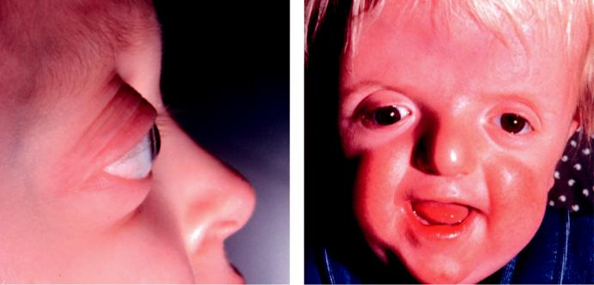

A B

Fig. 4.19 Craniosynostosis: (A) Crouzon syndrome, (B) Apert syndrome. (From Salmon JF, Kanski’s Clinical

Ophthalmology: A Systematic Approach, 9th edition. Oxford, UK: Elsevier; 2020.)

**APERT SYNDROME**

**Pathogenesis:**

most severe of the craniosynostoses which may involve all the cranial sutures. e majority are sporadic but can be AD.

**Diagnosis**

***General signs***: (a) oxycephaly, (b) midfacial hypoplasia with a beak-like nose, (c) low-set ears, (d) horizontal groove above the supraorbital ridge (Fig. 4.19B), (e) high-arched palate, cleft palate, and bifid uvula, (f ) syndactyly of the hands and feet, (g) anomalies of the heart, lungs and kidneys.

***Ocular signs***: (a) shallow orbits (proptosis and hypertelorism are generally less pronounced than in Crouzon syndrome), (b) exotropia and extorted slanting of the palpebral apertures. ***Uncommon ocular associations***: (a) keratoconus, (b) ectopia lentis, (c) congenital glaucoma.

#*" ##%"#"+!#(&&%"'+$'""#* "%#! " +#!+ &)%#"$'!%

#%$%&#" (&#" +##'%(&&*'#('$%!&&#"#$+%', &)%" %'&%&%)



CHAPTER 5

Dry Eye



C H A P T E R O U T L I N E

|  |  |
| --- | --- |
| Definitions 81 | Sjögren syndrome 82 |
| Physiology 81 | Diagnosis of dry eye syndrome 83 |
| Mechanism of disease 81 | Treatment 85 |
| Classification of keratoconjunctivitis |  |
| sicca 81 |  |
|  |  |

**Definitions**

***Keratoconjunctivitis sicca (KCS)***: eye with some degree of dryness.

***Xerophthalmia***: dry eye associated with vitamin A deficiency.

***Xerosis***: extreme dryness with keratinization occurring secondary to severe conjunctival cicatrization.

***Sjögren syndrome***: autoimmune inflammatory disease of which KCS is a typical feature (see below).

**Physiology**

e tear film has three layers ( Fig. 5.1):

***Lipid layer***: secreted by the meibomian glands. Functions: (a) to prevent evaporation and maintain tear film thickness, (b) to act as a surfactant allowing spread of the tear film. ***Aqueous layer***: secreted by the lacrimal glands. Functions: (a) to provide oxygen to the cor-neal epithelium, (b) antibacterial activity, (c) to wash away debris, (d) to optically enhance the corneal surface.

***Mucous layer***: secreted principally by the goblet cells. Functions: (a) lubrication, (b) permits wetting by converting the corneal surface from a hydrophobic to a hydrophilic state. ***Regulation of tear film components***: (a) hormonal, especially androgens, oestrogens and pro-gesterones, (b) neural.

**Mechanism of disease**

e four core inter-related mechanisms responsible for the manifestations of dry eye are: (a) tear instability, (b) tear hyperosmolarity, (c) inflammation, (d) ocular surface damage.

**Classification of keratoconjunctivitis sicca**

***Aqueous layer deficiency***: (a) Sjögren syndrome, (b) non-Sjögren age-related hyposecre-tion, (c) absence or damage to lacrimal tissue, (d) conjunctival scarring with obstruction

**81**

#*" ##%"#"+!#(&&%"'+$'""#* "%#! " +#!+ &)%#"$'!%

#%$%&#" (&#" +##'%(&&*'#('$%!&&#"#$+%', &)%" %'&%&%)

**82** SYNOPSIS OF CLINICAL OPHTHALMOLOGY

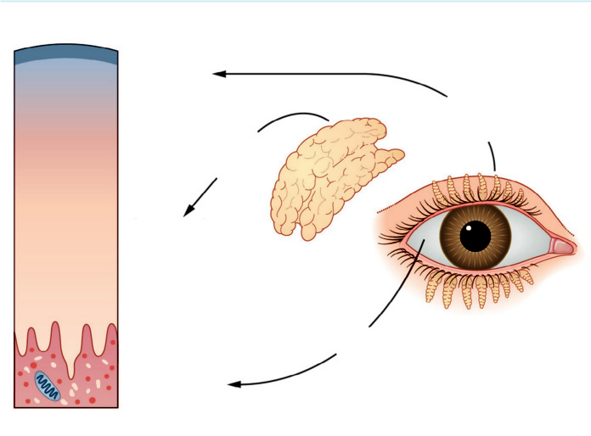

Lipid layer

0.1 um

Meibomian

glands

Lacrimal

gland

Aqueous layer

7.0 um

Goblet cells

Mucous layer

0.2 um

Fig. 5.1 The three layers of the tear film. (From Salmon JF, Kanski’s Clinical Ophthalmology: A Systematic

Approach, 9th edition. Oxford, UK: Elsevier; 2020.)

of lacrimal gland ductules, (e) neurological lesions with sensory or motor reflex loss, (f ) vitamin A deficiency.

***Evaporative***: (a) meibomian gland disease, (b) exposure keratopathy, (c) defective blinking, (d) contact lens-associated, (e) environmental factors.

**Sjögren syndrome**

**Pathogenesis:**

autoimmune inflammation and destruction of lacrimal and salivary glands occurring in isolation (primary), or in association with other diseases such as rheumatoid arthritis and systemic lupus erythematosus (secondary); aects females more commonly than males.

**Diagnosis**

***Presentation***: adult life with grittiness of the eyes and dryness of the mouth (xerostomia).

***Signs***: (a) enlarged salivary and occasionally lacrimal glands, (b) xerostomia with a fissured tongue, (c) dry nasal passages, (d) diminished vaginal secretions, (e) Raynaud phenomenon, (f ) arthralgia, myalgia and fatigue.

***Complications***: (a) dental caries, (b) reflux oesophagitis and gastritis, (c) malabsorption due to pancreatic failure, (d) pulmonary disease.

***Investigations***: (a) serum autoantibodies, (b) Schirmer test, (c) biopsy of minor salivary glands.

**Treatment:**

symptomatic (see below), salivary stimulants and immunosuppression.

#*" ##%"#"+!#(&&%"'+$'""#* "%#! " +#!+ &)%#"$'!%

#%$%&#" (&#" +##'%(&&*'#('$%!&&#"#$+%', &)%" %'&%&%)

|  |  |
| --- | --- |
| Chapter 5—DRY EYE | **83** |
|  |  |

**Diagnosis of dry eye syndrome**

**Symptoms**

Dryness, grittiness and burning, characteristically worse during the day.

Stringy discharge, transient blurring of vision, redness and crusting of the lids are common.

**Signs**

Marginal tear meniscus is thinned or absent (normal height 1 mm).

Corneal punctate epithelial erosions (Fig. 5.2A)

Corneal filaments (mucous/epithelial debris strands; Fig. 5.2B).

Mucous debris in the tear film (Fig. 5.2C).

Conjunctival injection and mild keratinization.

Mucous plaques attached to the corneal surface staining with rose Bengal.

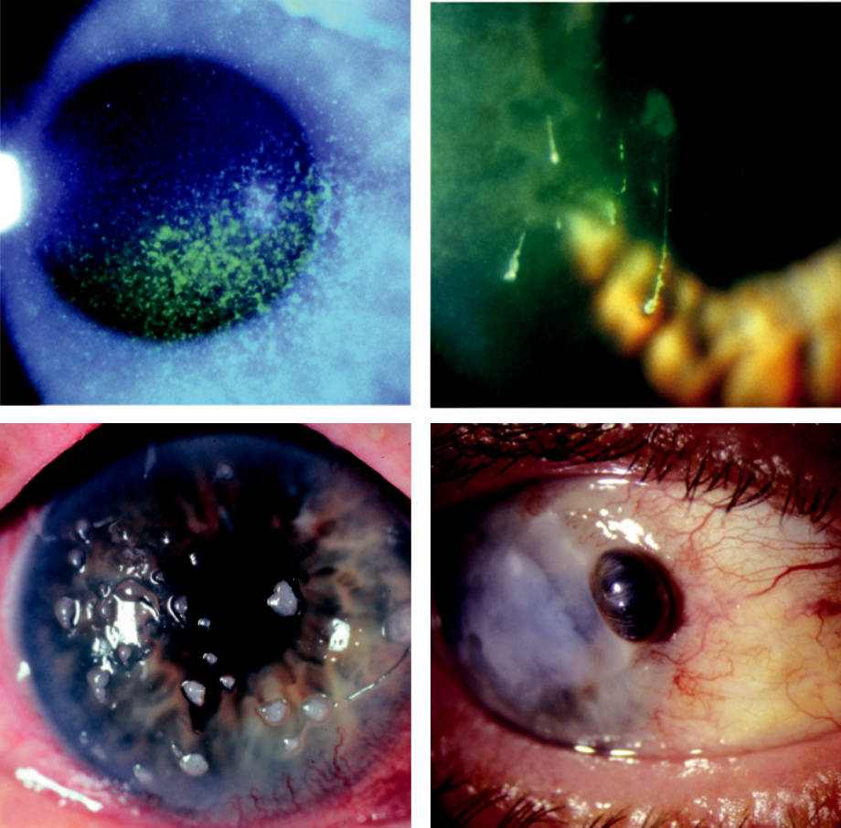

A B

C D

Fig. 5.2 Signs of dry eye syndrome: (A) superficial punctate keratitis staining with fluorescein, (B) corneal filaments, (C) mucous debris, (D) corneal melting. (Figure 5.2 B,D courtesy of S. Tuft; Figure 5.2 C courtesy of R. Bates.)

#*" ##%"#"+!#(&&%"'+$'""#* "%#! " +#!+ &)%#"$'!%

#%$%&#" (&#" +##'%(&&*'#('$%!&&#"#$+%', &)%" %'&%&%)

**84** SYNOPSIS OF CLINICAL OPHTHALMOLOGY



Complications in severe cases: (a) peripheral superficial corneal neovascularization, (b) epi-thelial breakdown, (c) corneal melting (Fig. 5.2D), (d) corneal perforation, (e) secondary bacterial keratitis.

**Special investigations**

***Tear film breakup time (BUT)***: abnormal in aqueous tear deficiency and meibomian gland disorders. (a) Fluorescein is instilled into the lower fornix and the tear film is examined at the slit lamp using the cobalt blue filter, (b) after an interval, black spots or lines appear in the stained film, indicating the formation of dry areas (Fig. 5.3A). (c) BUT is the interval between the last blink and the appearance of the first randomly distributed dry spot; BUT of less than 10 sec is abnormal.

***Schirmer test***: amount of wetting of a special (No. 41 Whatman) filter paper 5 mm wide and 35 mm long is measured (Fig. 5.3B); (a) when performed without anaesthetic

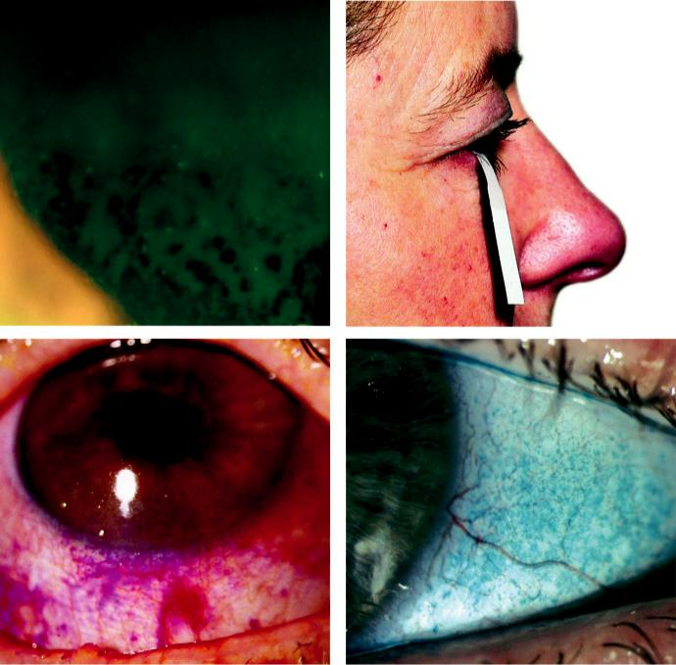

A B

C D

Fig. 5.3 Diagnostic tests in dry eye: (A) tear break-up time; numerous dry spots are present in a fluorescein-stained tear film, (B) Schirmer test, (C) corneal and conjunctival staining with rose Bengal and (D) with lissa-mine green. (From Salmon JF, Kanski’s Clinical Ophthalmology: A Systematic Approach, 9th edition. Oxford, UK: Elsevier; 2020.)

#*" ##%"#"+!#(&&%"'+$'""#* "%#! " +#!+ &)%#"$'!%

#%$%&#" (&#" +##'%(&&*'#('$%!&&#"#$+%', &)%" %'&%&%)

|  |  |
| --- | --- |
| Chapter 5—DRY EYE | **85** |
|  |  |

(Schirmer 1), it measures maximum basic and reflex secretion, (b) when performed with an anaesthetic (Schirmer 2), it is said to measure basic secretion. Less than 10 mm of wet-ting after 5 min without anaesthesia and less than 6 mm with anaesthesia are considered abnormal.

***Ocular surface staining***: (a) fluorescein stains corneal and conjunctival epithelium where there is sucient damage to allow the dye to enter the tissues; (b) rose Bengal has an anity for dead or devitalized epithelial cells that have a lost or altered mucous layer and also stains corneal filaments and plaques (Fig. 5.3C); (c) lissamine green stains in the same way (Fig. 5.3D), but is more comfortable than rose Bengal.

***Staining pattern***: (a) interpalpebral staining of the cornea and conjunctiva is common in aqueous tear deficiency, (b) inferior corneal and conjunctival stain is often seen in blephari-tis or exposure.

***Tear film osmolarity measurement***: the threshold value that distinguishes between a healthy eye and an eye with dry eye syndrome is between 308 mOsm/l and 316 mOsm/l, depending on the degree of tear film instability. A value of 316 mOsm/l discriminates between mild and moderate symptoms. e value correlates with a response to treatment in the long term.

***Other tests***: (a) tear lactoferrin (decreased in Sjögren syndrome and other lacrimal gland diseases), (b) fluorescein clearance test/tear function index, (c) phenol red thread test, (d) tear film meniscometry, (e) impression cytology to determine goblet cell population.

**Treatment**

Dry eye is generally not curable and management is therefore structured around the control of symptoms and prevention of surface damage.

***Patient education***: establishment of realistic expectations, emphasis on compliance, instruc-tion on importance of blinking while reading/using a visual display unit and review of work environment.

***Conservation of existing tears***: (a) reduction of room temperature to minimize evaporation,

1. room humidifiers may be tried but are frequently disappointing, (c) moist chamber goggles or side shields to glasses can be helpful but may be cosmetically unacceptable. ***Tear substitutes***: (a) cellulose derivatives (e.g. hypromellose) for mild cases, (b) carbomers(e.g. Viscotears, GelTears) are longer lasting, (c) polyvinyl alcohol (e.g. Hypotears, Liquifilm) in mucin deficiency, (d) sodium hyaluronate (e.g. Hylo) may promote epi-thelial healing. Preservative-f ree drops should be used when f requent instillation is needed.

***Mucolytics***: acetylcysteine 5% drops (Ilube) for corneal filaments.

***Ointments***: at bedtime.

***Anti-inflammatory agents***: low-dose topical steroids for acute exacerbations.

***Topical ciclosporin (0.05%, 0.1%)***: reduces T cell–mediated inflammation of lacrimal tissue and increases the number of goblet cells.

***Autologous serum/blood***: used in severe cases. Finger prick autologous blood is a low cost, readily accessible and practical treatment, that is safe and eective.

***Systemic tetracycline***: for associated chronic blepharitis and reduction of lacrimal inflamma-tory mediators.

***Punctal occlusion***: in moderate to severe KCS if there is inadequate response to frequent topical treatment; (a) temporary (1–2 weeks) occlusion can be achieved by inserting dis-solvable collagen plugs to exclude epiphora, (b) prolonged (silicone plugs) or permanent (cautery) occlusion can then be carried out but all four puncta should not be permanently occluded at the same time.

#*" ##%"#"+!#(&&%"'+$'""#* "%#! " +#!+ &)%#"$'!%

#%$%&#" (&#" +##'%(&&*'#('$%!&&#"#$+%', &)%" %'&%&%)

**86** SYNOPSIS OF CLINICAL OPHTHALMOLOGY



***Contact lenses***: long-term contact lens wear may increase tear film evaporation, reduce tear flow and increase the risk of infection, but these eects can be outweighed by the reservoir eect of fluid trapped behind the lens. Specially designed silicone hydrogel single-use daily disposable lenses retain moisture for 12–16 hours and may be used in this situation. ***Other options***: (a) tarsorrhaphy, (b) oral cholinergic agonists (e.g. pilocarpine), (c) zidovu-dine in primary Sjögren syndrome, (d) botulinum toxin to the medial canthus to reduce tear drainage.

#*" ##%"#"+!#(&&%"'+$'""#* "%#! " +#!+ &)%#"$'!%

#%$%&#" (&#" +##'%(&&*'#('$%!&&#"#$+%', &)%" %'&%&%)



CHAPTER 6

Conjunctiva



C H A P T E R O U T L I N E

Bacterial conjunctivitis 87 Acute bacterial conjunctivitis 87 Adult chlamydial conjunctivitis 88 Trachoma 89

Neonatal conjunctivitis (ophthalmia neonatorum) 91

Viral conjunctivitis 91

Adenoviral conjunctivitis 91

Molluscum contagiosum conjunctivitis 93

Allergic conjunctivitis 94 Acute allergic conjunctivitis 94

Seasonal and perennial allergic conjunctivitis 94

Vernal keratoconjunctivitis (VKC) 95

Atopic keratoconjunctivitis (AKC) 95

Giant papillary conjunctivitis 97

Conjunctivitis in blistering mucocutaneous disease 98

Mucous membrane (cicatricial) pemphigoid 98

Stevens–Johnson syndrome/toxic epidermal necrolysis 100

Graft vs host disease 100 Miscellaneous conjunctivitis 102

Superior limbic keratoconjunctivitis 102 Ligneous conjunctivitis 103

Parinaud oculoglandular syndrome 104 Factitious conjunctivitis 104

Degenerations 105

Pingueculum 105

Pterygium 105

Concretions 106

Conjunctivochalasis 106

Retention (epithelial inclusion) cyst 107

**Bacterial conjunctivitis**

**ACUTE BACTERIAL CONJUNCTIVITIS**

**Pathogenesis:**

direct eye contact with infected secretions. Most common isolates are *S. pneumoniae*, *S. aureus*, *H. influenzae*, and *Moraxella catarrhalis*; uncommon, but serious are gonococci and meningococci.

**Diagnosis**

***Presentation***: acute onset of redness, grittiness, burning and sticky discharge, aecting first one then both eyes.

***Conjunctival injection***: maximal toward the fornices (Fig. 6.1A).

***Discharge***: (a) typically mucopurulent (Fig. 6.1B), (b) hyperacute purulent (see Fig. 6.4A) in gonococcal or meningococcal infection.

***Eyelids***: oedema and erythema in severe infection.

***Cornea***: (a) mild punctate epithelial erosions, (b) ulceration may occur in gonococcal and meningococcal infection.

**87**

#*" ##%"#"+!#(&&%"'+$'""#* "%#! " +#!+ &)%#"$'!%

#%$%&#" (&#" +##'%(&&*'#('$%!&&#"#$+%', &)%" %'&%&%)

**88** SYNOPSIS OF CLINICAL OPHTHALMOLOGY

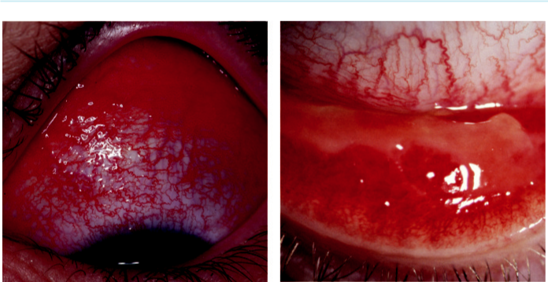

A B

Fig. 6.1 Bacterial conjunctivitis: (A) conjunctival injection, (B) mucopurulent discharge. (Figure 6.1A courtesy of P. Saine.)

***Investigations***: not performed routinely but may be indicated in severe or atypical cases (e.g. urgent Gram staining to exclude gonococcal or meningococcal infection), and polymerase chain reaction (PCR) for *Chlamydia*.

**Treatment**

***Topical antibiotics***: options include (a) chloramphenicol, (b) aminoglycosides (gentamicin, neomycin), (c) quinolones (ciprofloxacin, ofloxacin, levofloxacin, lomefloxacin, gatifloxacin, moxifloxacin), (d) polymyxin B, fusidic acid, or bacitracin. Gonococcal and meningococcal conjunctivitis require a quinolone, gentamicin, chloramphenicol, or bacitracin 1–2 hourly as well as systemic therapy.

***Systemic antibiotics***: (a) gonococcal infection is treated with a third-generation cephalospo-rin, (b) *H. influenzae*, particularly in children, requires oral amoxicillin with clavulanic acid,

1. meningococcal infection is treated with intramuscular benzylpenicillin. ***Topical steroids***: may reduce scarring in severe conjunctivitis.

**ADULT CHLAMYDIAL CONJUNCTIVITIS**

**Pathogenesis:**

oculogenital infection usually caused by serovars (serological variants) D–K of *Chlamydia tracho-matis*. Transmission is usually by autoinoculation from genital secretions. In males, chlamydialinfection is the most common cause of nongonococcal urethritis, and is frequently asymptomatic. In females, chlamydial urethritis typically causes dysuria and discharge.

**Diagnosis**

***Presentation***: subacute onset of unilateral or bilateral redness, watering and discharge.

***Discharge***: watery or mucopurulent.

***Conjunctiva***: (a) large follicles (characterized by vessels that run around or across the follicles) are typical (Fig. 6.2A), (b) chronic cases have less prominent follicles and may develop mild conjunctival scarring and superior corneal pannus (Fig. 6.2B).

#*" ##%"#"+!#(&&%"'+$'""#* "%#! " +#!+ &)%#"$'!%

#%$%&#" (&#" +##'%(&&*'#('$%!&&#"#$+%', &)%" %'&%&%)

|  |  |
| --- | --- |
| Chapter 6—CONJUNCTIVA | **89** |
|  |  |

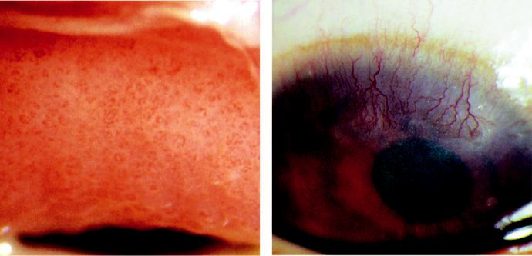

A B

Fig. 6.2 Chlamydial conjunctivitis: (A) superior tarsal follicles, (B) superior corneal pannus. (From Salmon JF,

Kanski’s Clinical Ophthalmology: A Systematic Approach, 9th edition. Oxford, UK: Elsevier; 2020.)

***Cornea***: superficial punctate keratitis is common and peripheral subepithelial corneal infil-trates may appear 2–3 weeks after onset.

***Tender preauricular lymphadenopathy***: very common.

***Investigations***: (a) conjunctival scraping with Giemsa staining for basophilic intracyto-plasmic bodies, (b) PCR, (c) immunoassay, (d) cell culture and serology in selected cases.

**Treatment**

***Systemic antibiotics***: options include (a) azithromycin 1 g repeated after 1 week (second or third course required in 30%), (b) doxycycline 100 mg twice daily for 10 days (avoid in pregnancy/breast-feeding and children), (c) erythromycin, amoxicillin, and ciprofloxacin as alternatives.

***Topical antibiotics***: supplementary erythromycin or tetracycline for rapid relief of ocular symptoms.

**TRACHOMA**

**Pathogenesis:**

recurrent infection occurring in individuals living in poor overcrowded communities eliciting a chronic immune response, particularly in vulnerable young children. Trachoma is associated prin-cipally with infection by *C. trachomatis* (serovars A, B, Ba, and C); the fly is an important vector.

**Diagnosis**

***Active stage***: (a) mixed follicular/papillary conjunctivitis (Fig. 6.3A), (b) mucopurulent dis-charge, (c) superior epithelial keratitis and pannus formation.

***Cicatricial disease***: (a) conjunctival scars, most prominent on the upper tarsus (linear/stellate or broad and confluent [Arlt lines]; Fig. 6.3B), (b) superior limbal follicles which may leave a row of depressions (Herbert pits; Fig. 6.3C), (c) trichiasis, distichiasis and cicatricial entro-pion, (d) dry eye (goblet cells and lacrimal gland ductule destruction), (e) eventual cicatricial entropion leading to severe corneal vascularization and opacification (Fig. 6.3D).

#*" ##%"#"+!#(&&%"'+$'""#* "%#! " +#!+ &)%#"$'!%

#%$%&#" (&#" +##'%(&&*'#('$%!&&#"#$+%', &)%" %'&%&%)

**90** SYNOPSIS OF CLINICAL OPHTHALMOLOGY

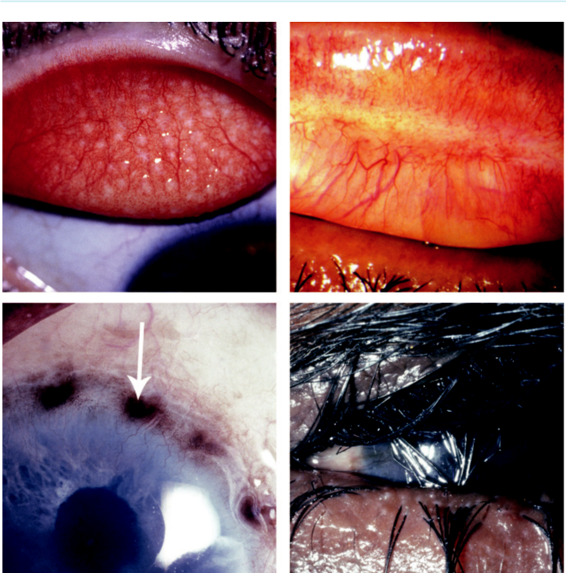

A B

C D

Fig. 6.3 Trachoma: (A) typical white subtarsal follicles, (B) subtarsal Arlt line, (C) Herbert pit (arrow), (D) cicatri-cial entropion. (Figure 6.3A, B, C and D courtesy of Chris Barry, Lions Eye Institute, Perth, Australia.)

**World Health Organization grading of trachoma**

**TF** = trachomatous inflammation (follicular): five or more follicles (>0.5 mm) on the superior tarsus.

**TI** = trachomatous inflammation (intense): diuse involvement of the tarsal conjunctiva, obscuring 50% or more of the normal deep tarsal vessels; papillae are evident.

**TS** = trachomatous conjunctival scarring: easily visible fibrous white tarsal bands.

1. = trachomatous trichiasis: at least one lash touching the globe.

**CO** = corneal opacity sucient to blur details of at least part of the pupillary margin.

**Treatment**

***SAFE strateg y***: (a) *s*urgery for trichiasis, (b) *a*ntibiotics for active disease, (c) *f*acial hygiene and (d) *e*nvironmental improvement.

***Antibiotics***: a single antibiotic course does not always eliminate the infection and com-munities may need to receive annual treatment to suppress infection. Treatment includes: (a) systemic azithromycin (single dose of 20 mg/kg up to 1 g) or (b) erythromycin 500 mg

#*" ##%"#"+!#(&&%"'+$'""#* "%#! " +#!+ &)%#"$'!%

#%$%&#" (&#" +##'%(&&*'#('$%!&&#"#$+%', &)%" %'&%&%)

|  |  |
| --- | --- |
| Chapter 6—CONJUNCTIVA | **91** |
|  |  |

twice daily for 14 days; (c) tetracycline ointment is less eective than oral treatment and should be given for 6 weeks.

***Hygiene***: personal and environmental.

***Surger y***: for entropion and trichiasis; bilamellar tarsal rotation is commonly performed.

**NEONATAL CONJUNCTIVITIS (OPHTHALMIA NEONATORUM)**

**Pathogenesis:**

conjunctival inflammation developing within the first month of life, usually as the result of infec-tion transmitted from mother to baby during delivery. Staphylococci are usually responsible for mild conjunctivitis, but severe systemic involvement can result from infection with *C. trachomatis*, *N. gonorrhoeae*, and herpes simplex virus (HSV); chemical conjunctival irritation from infectionprophylaxis may also occur.

**Diagnosis**

***Presentation***: (a) chemical irritation – first few days, (b) gonococcal – first week, (c) staphy-lococci and other bacteria – end of the first week, (d) herpes simplex – 1–2 weeks, (e) chla-mydia – 1–3 weeks.

***Discharge***: depends on cause.

***Eyelids***: (a) severe oedema may denote gonococcal infection (Fig. 6.4A), (b) vesicles in HSV infection.

***Investigations in moderate to severe cases***: (a) conjunctival scrapings for Gram and Giemsa staining, (b) conjunctival swabs for bacterial culture (chocolate agar if *N. gonorrhoeae* sus-pected), (c) Papanicolaou smear, (d) separate scrapings for PCR if indicated, (e) viral culture for HSV of conjunctival scrapings or skin vesicle fluid.

**Treatment**

***Prophylaxis***: single instillation of povidone–iodine 2.5%, erythromycin 0.5%, tetracycline 1% ointment, or silver nitrate 1% is utilized in areas where gonococcal infection is common. A single intramuscular dose of benzylpenicillin is given when maternal infection is present. ***Chemical conjunctivitis***: no treatment apart from artificial tears.

***Mild conjunctivitis (sticky eye)***: may require a broad-spectrum topical antibiotic (e.g. fusidic acid, chloramphenicol).

***Chlamydial conjunctivitis***: oral (± topical) erythromycin for 2 weeks.

***Gonococcal conjunctivitis***: hospital admission and systemic third-generation cephalosporin; co-treatment for chlamydia is prudent.

***Herpes simplex infection***: should always be regarded as a systemic condition and treated with high-dose intravenous and topical aciclovir. Early diagnosis and treatment of encephalitis may be life-saving or prevent serious disability.

***Co-management***: paediatrician, microbiologist and genitourinary specialist.

**Viral conjunctivitis**

**ADENOVIRAL CONJUNCTIVITIS**

**Pathogenesis:**

highly contagious disease that may be sporadic or epidemic. Transmission is by contact with respi-ratory or ocular secretions, including fomites such as contaminated towels.

**Diagnosis**

***Nonspecific acute follicular conjunctivitis***: most common form, usually mild; sore throat may be present.

#*" ##%"#"+!#(&&%"'+$'""#* "%#! " +#!+ &)%#"$'!%

#%$%&#" (&#" +##'%(&&*'#('$%!&&#"#$+%', &)%" %'&%&%)

**92** SYNOPSIS OF CLINICAL OPHTHALMOLOGY

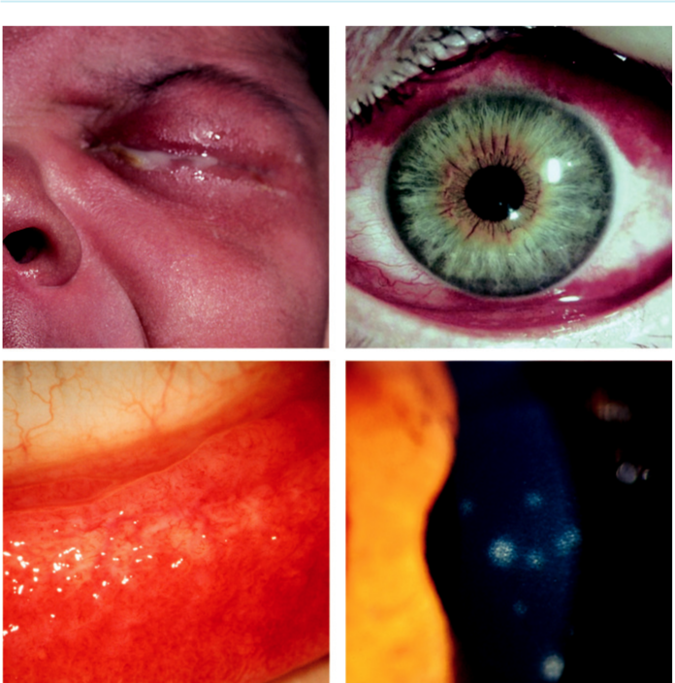

A B

C D

Fig. 6.4 (A) Neonatal conjunctivitis, (B) epidemic keratoconjunctivitis: adenovirus conjunctivitis showing subconjunctival haemorrhages, (C) follicular conjunctivitis, (D) keratitis showing subepithelial infiltrates. (From Salmon JF, Kanski’s Clinical Ophthalmology: A Systematic Approach, 9th edition. Oxford, UK: Elsevier; 2020.)

***Pharyngoconjunctival fever (PCF)***: spread by droplets from patients with associated upper respiratory tract infection; keratitis (usually mild) occurs in approximately 30%.

***Epidemic keratoconjunctivitis (EKC)***: most severe type, associated with keratitis in approxi-

mately 80% of cases. Signs: (a) eyelid oedema, (b) tender pre-auricular lymphadenopathy,

1. petechial conjunctival haemorrhages (Fig. 6.4B), (d) chemosis, (e) pseudomembranes. ***Chronic/relapsing conjunctivitis***: nonspecific follicular/papillary lesions; can rarely persistfor years (Fig. 6.4C).

***Keratitis***: (a) non-staining epithelial microcysts (early), (b) punctate epithelial keratitis (resolves within 2 weeks), (c) focal white subepithelial infiltrates (Fig. 6.4D) that may persist or recur over months or years.

***Diﬀerential diagnosis***: (a) acute haemorrhagic conjunctivitis (tropical areas, enterovirus or coxsackievirus), (b) herpes simplex infection (usually unilateral, may have skin vesicles),

#*" ##%"#"+!#(&&%"'+$'""#* "%#! " +#!+ &)%#"$'!%

#%$%&#" (&#" +##'%(&&*'#('$%!&&#"#$+%', &)%" %'&%&%)

|  |  |
| --- | --- |
| Chapter 6—CONJUNCTIVA | **93** |
|  |  |

1. systemic viral infections (varicella, measles, mumps), (d) molluscum contagiosum (see below).

***Investigations***: usually unnecessary but may include the following: (a) Giemsa stain shows mononuclear cells in adenoviral and multinucleated giant cells in herpetic disease, (b) PCR is sensitive and specific for viral DNA, (c) viral culture is expensive and slow but highly specific, (d) ‘point-of-care’ immunochromatography test is rapid and accurate.

**Treatment**

***Reduction of transmission risk***: meticulous hygiene and avoidance of towel sharing.

***Topical steroids***: for symptomatic keratitis but do not speed resolution and the lesions com-monly recur after early discontinuation; may extend the infectious period.

***Other measures***: (a) artificial tears for symptomatic relief, (b) discontinuation of contact lens wear, (c) removal of symptomatic pseudomembranes, (d) topical antibiotics for secondary bacterial infection, (e) povidone–iodine is eective against free adenovirus, (f ) ganciclovir shows some activity against adenovirus.

**MOLLUSCUM CONTAGIOSUM CONJUNCTIVITIS**

**Pathogenesis:**

skin infection caused by a DNA poxvirus that typically aects children. Transmission is by contact with subsequent autoinoculation. Virus shedding from a lesion on the lid margin may be associ-ated with conjunctivitis.

**Diagnosis**

***Presentation***: chronic unilateral ocular irritation and mild mucoid discharge.

***Signs***: (a) follicular conjunctivitis (Fig. 6.5A), (b) waxy umbilicated nodule on the lid margin (Fig. 6.5B).

**Treatment:**

expression, facilitated by a small nick at the lesion apex.

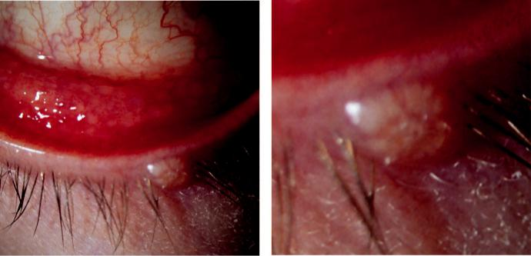

A B

Fig. 6.5 Molluscum contagiosum: (A) follicular conjunctivitis, (B) eyelid lesion (magnified). (From Salmon JF,

Kanski’s Clinical Ophthalmology: A Systematic Approach, 9th edition. Oxford, UK: Elsevier; 2020.)

#*" ##%"#"+!#(&&%"'+$'""#* "%#! " +#!+ &)%#"$'!%

#%$%&#" (&#" +##'%(&&*'#('$%!&&#"#$+%', &)%" %'&%&%)

**94** SYNOPSIS OF CLINICAL OPHTHALMOLOGY



**Allergic conjunctivitis**

**ACUTE ALLERGIC CONJUNCTIVITIS**

**Pathogenesis:**

acute conjunctival reaction to an environmental allergen, usually pollen, typically occurring in younger children after playing outside in spring or summer.

**Diagnosis:**

acute itching and watering associated with severe chemosis (Fig. 6.6A) settling within a few hours.

**Treatment:**

not usually required; cool compresses can improve comfort and a drop of adrenaline 0.1% may reduce extreme chemosis.

**SEASONAL AND PERENNIAL ALLERGIC CONJUNCTIVITIS**

**Classification**

***Seasonal allergic conjunctivitis (‘hay fever eyes’)***: worse during the spring and summer; is the more common and involves allergy to pollen.

***Perennial allergic conjunctivitis***: causes symptoms throughout the year. Allergens include house dust mites and animal fur.

**Diagnosis**

***Presentation***: episodes of redness, watering and itching, with sneezing and nasal discharge.

***Signs***: (a) conjunctival hyperaemia, (b) mild papillary reaction with elevated lesions contain-ing a vascular core (Fig. 6.6B), (c) chemosis, (d) lid oedema.

**Treatment**

***Artificial tears***: for mild symptoms.

***Mast cell stabilizers***: (e.g. sodium cromoglicate, nedocromil sodium, lodoxamide).

***Antihistamines***: (e.g. emedastine, epinastine, levocabastine, bepotastine).

***Combined antihistamine/vasoconstrictor***: (e.g. Otrivine-Antistin).

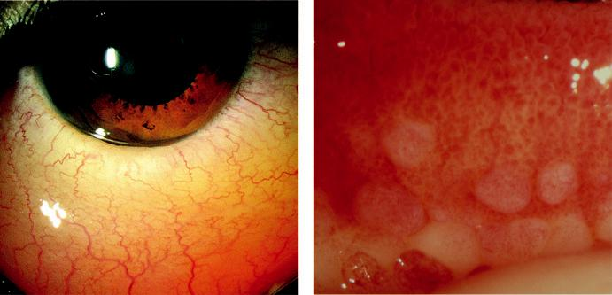

A B

Fig. 6.6 Acute allergy: (A) chemosis, (B) palpebral papillae with focal inflammatory infiltrates. (From Salmon JF,

Kanski’s Clinical Ophthalmology: A Systematic Approach, 9th edition. Oxford, UK: Elsevier; 2020.)

#*" ##%"#"+!#(&&%"'+$'""#* "%#! " +#!+ &)%#"$'!%

#%$%&#" (&#" +##'%(&&*'#('$%!&&#"#$+%', &)%" %'&%&%)

|  |  |
| --- | --- |
| Chapter 6—CONJUNCTIVA | **95** |
|  |  |

***Dual-action antihistamine and mast cell stabilizers***: (e.g. azelastine, ketotifen, olopatadine).

***Topical steroids***: rarely necessary.

***Oral antihistamines***: for severe symptoms.

**VERNAL KERATOCONJUNCTIVITIS (VKC)**

**Pathogenesis:**

recurrent bilateral disease involving IgE and cell-mediated immune mechanisms. It primarily aects boys (mean age 7 years), 95% remitting by the late teens. It is particularly common in warm dry climates such as the Mediterranean and the Middle East.

**Classification**

***Palpebral***: primarily involves the upper tarsal conjunctiva often with significant corneal disease.

***Limbal***: typically aects black and Asian patients.

***Mixed***: features of both.

**Diagnosis**

***Presentation***: intense itching, lacrimation, photophobia, grittiness, burning and mucoid discharge.

***Palpebral***: conjunctival hyperaemia, diuse superior tarsal papillary hypertrophy, sometimes giant (Fig. 6.7A).

***Limbal***: gelatinous papillae and transient apically located white cellular collections (Horner– Trantas dots; Fig. 6.7B).

***Keratopathy***: (a) superior punctate epithelial erosions associated with sheets of mucus,

1. epithelial macroerosions, (c) plaques and ‘shield’ ulcers (Fig. 6.7C), (d) subepithelial scarring, (e) pseudogerontoxon (Fig. 6.7D), (f ) mild superior superficial vessel ingrowth,
2. increased risk of keratoconus and herpes simplex keratitis.

**Treatment:**

see below.

**ATOPIC KERATOCONJUNCTIVITIS (AKC)**

**Pathogenesis:**

chronic condition with a peak onset at age 30–50 years occurring in atopic patients (eczema, asthma). It tends to be perennial and unremitting with significant visual morbidity; distinction between AKC and VKC is clinical.

**Diagnosis**

***Presentation***: similar to VKC, but usually more severe and unremitting; watery discharge.

***Lids***: (a) erythema, (b) thickening, crusting and fissuring (Fig. 6.8A), (c) madarosis,

1. staphylococcal blepharitis, (e) keratinization of the lid margin, (f ) tight facial skin with lower lid ectropion.

***Conjunctiva***: (a) papillae but smaller than VKC, (b) diuse infiltration and cicatrization may give a whitish, featureless appearance (Fig. 6.8B), (c) symblepharon formation and forniceal shortening (Fig. 6.8C), (d) keratinization of the caruncle.

***Limbitis***: similar to limbal VKC.

***Keratopathy***: (a) punctate epithelial erosions (inferior third), (b) persistent epithelial defects, sometimes with focal thinning, (c) plaques, (d) peripheral vascularization (Fig. 6.8D),

1. stromal scarring.

#*" ##%"#"+!#(&&%"'+$'""#* "%#! " +#!+ &)%#"$'!%

#%$%&#" (&#" +##'%(&&*'#('$%!&&#"#$+%', &)%" %'&%&%)

**96** SYNOPSIS OF CLINICAL OPHTHALMOLOGY

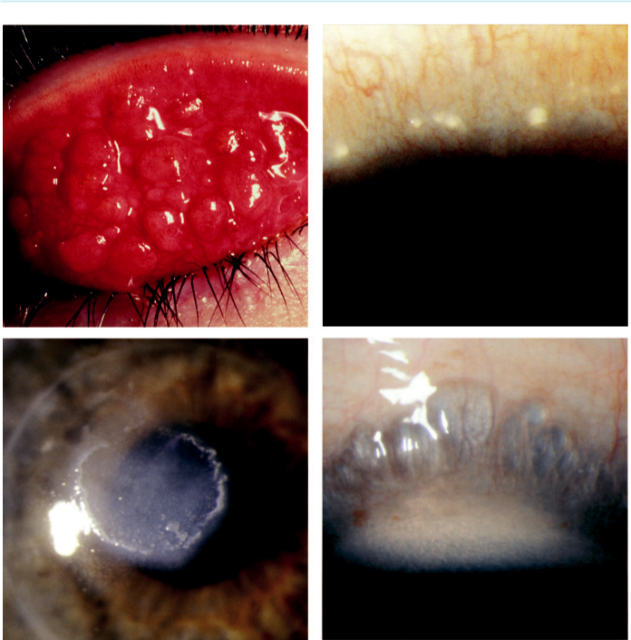

A B

C D

Fig. 6.7 Vernal keratoconjunctivitis: (A) giant tarsal papillae, (B) Horner–Trantas dots, (C) corneal ‘shield’ ulcer, (D) pseudogerontoxon. (Figure 6.7D courtesy S. Tuft.)

***Ocular associations***: (a) infective keratitis, including aggressive herpes simplex, (b) kerato-conus (15%), (c) presenile cataract (common), (d) retinal detachment (rare).

**Treatment of VKC and AKC**

***General***: allergen avoidance, cool compresses, lid hygiene (blepharitis), and moisturizing cream (e.g. E45) for dry fissured skin.

***Topical***: (a) mast cell stabilizers may be needed long term, (b) antihistamines for acute exac-erbations, (c) dual-action preparations (e.g. antihistamine/mast cell stabilizers), (d) topi-cal steroids for severe exacerbations, particularly with keratopathy (e.g. fluorometholone 0.1%, rimexolone 1%, prednisolone 0.5%, loteprednol etabonate 0.2% or 0.5%), (e) immune modulators (e.g. ciclosporin 0.05%, tacrolimus 0.03%), (f ) acetylcysteine for mucolysis.

***Supratarsal steroid injection***: for severe palpebral VKC or noncompliance.

***Systemic***: (a) antihistamines help itching, promote sleep and reduce nocturnal eye rubbing,

1. antibiotics (doxycycline 50–100 mg daily for 6 weeks or azithromycin 500 mg once daily for 3 days) to reduce blepharitis-aggravated inflammation, (c) immunosuppressive agents

#*" ##%"#"+!#(&&%"'+$'""#* "%#! " +#!+ &)%#"$'!%

#%$%&#" (&#" +##'%(&&*'#('$%!&&#"#$+%', &)%" %'&%&%)

|  |  |
| --- | --- |
| Chapter 6—CONJUNCTIVA | **97** |
|  |  |

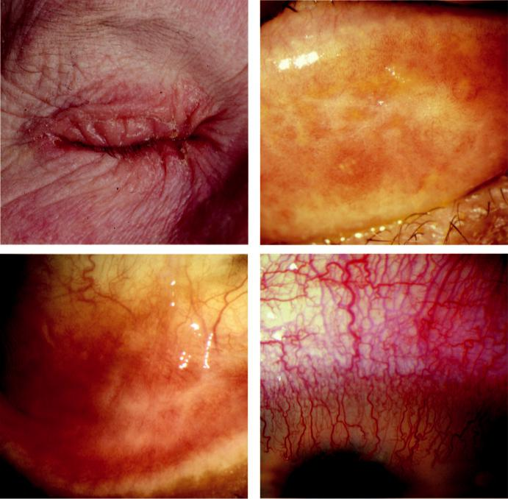

A B

C D

Fig. 6.8 Atopic keratoconjunctivitis: (A) severe eyelid involvement, (B) infiltration and scarring of tarsal con-junctiva, (C) forniceal shortening, (D) intense corneal vascularization. (Figure 6.8B–D courtesy of S. Tuft.)

(e.g. steroids, ciclosporin, tacrolimus, azathioprine) may be eective at low doses in AKC unresponsive to other measures.

***Surger y***: (a) superficial keratectomy for plaques/shield ulcers, (b) surface maintenance/ restoration procedures for severe persistent epithelial defects, ulceration or perforation (e.g. gluing, amniotic membrane grafting, lamellar keratoplasty, botulinum toxin to induce ptosis, lateral tarsorrhaphy).

**GIANT PAPILLARY CONJUNCTIVITIS**

**Pathogenesis:**

mechanically induced inflammation of the tarsal conjunctiva, e.g. contact lenses (Fig. 6.9A), ocular prosthesis (Fig. 6.9B), exposed sutures.

**Diagnosis**

***Presentation***: foreign body sensation, redness, itching, increased mucus production, blurring and loss of contact lens tolerance.

#*" ##%"#"+!#(&&%"'+$'""#* "%#! " +#!+ &)%#"$'!%

#%$%&#" (&#" +##'%(&&*'#('$%!&&#"#$+%', &)%" %'&%&%)

**98** SYNOPSIS OF CLINICAL OPHTHALMOLOGY

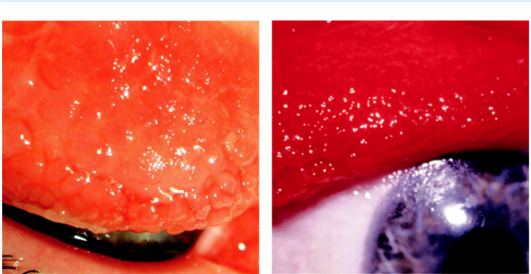

A B

Fig 6.9 Giant papillary conjunctivitis (everted upper lid): (A) secondary to contact lens, (B) secondary to

prosthesis. (From Salmon JF, Kanski’s Clinical Ophthalmology: A Systematic Approach, 9th edition. Oxford,

UK: Elsevier; 2020.)

***Signs***: (a) mucous discharge, (b) superior tarsal hyperaemia, (c) superior tarsal papillae, initially fine-medium then larger.

**Treatment**

***Removal of stimulus***: (e.g. contact lens replacement/change of solution type and assessment of ocular prosthesis fit).

***Topical***: Preservative-free drops with soft contact lenses, or instilled when the lenses are not in the eye: (a) mast cell stabilizers, (b) antihistamines, (c) NSAIDs, (d) combined antihista-mines/mast cell stabilizers, (e) steroids for the acute phase of severe cases.

**Conjunctivitis in blistering mucocutaneous disease**

**MUCOUS MEMBRANE (CICATRICIAL) PEMPHIGOID**

**Pathogenesis:**

group of chronic autoimmune mucocutaneous blistering diseases characterized by a type II hyper-sensitivity response with antibody and complement deposition at epithelial basement membranes. A wide range of epithelial tissues can be involved. Particular clinical forms have a predilection for specific tissues (e.g. bullous pemphigoid for the skin and ocular cicatricial pemphigoid for the conjunctiva).

**Diagnosis**

***Presentation***: in old age with insidious onset of nonspecific bilateral conjunctivitis.

***Conjunctiva***: (a) papillary conjunctivitis, (b) diuse hyperaemia and oedema; necro - sis in severe cases, (c) subconjunctival fibrosis with shortening of the inferior fornices (Fig. 6.10A), (d) flattening of the plica and keratinization of the caruncle, (e) symblepharon formation (Fig. 6.10B), (f ) dry eye.

***Keratopathy***: (a) epithelial defects, (b) peripheral vascularization, (c) keratinization,

(d) ‘conjunctivalization’ of the cornea.

***End-stage disease***: total symblepharon and corneal opacification (Fig. 6.10C).

#*" ##%"#"+!#(&&%"'+$'""#* "%#! " +#!+ &)%#"$'!%

#%$%&#" (&#" +##'%(&&*'#('$%!&&#"#$+%', &)%" %'&%&%)

|  |  |
| --- | --- |
| Chapter 6—CONJUNCTIVA | **99** |
|  |  |

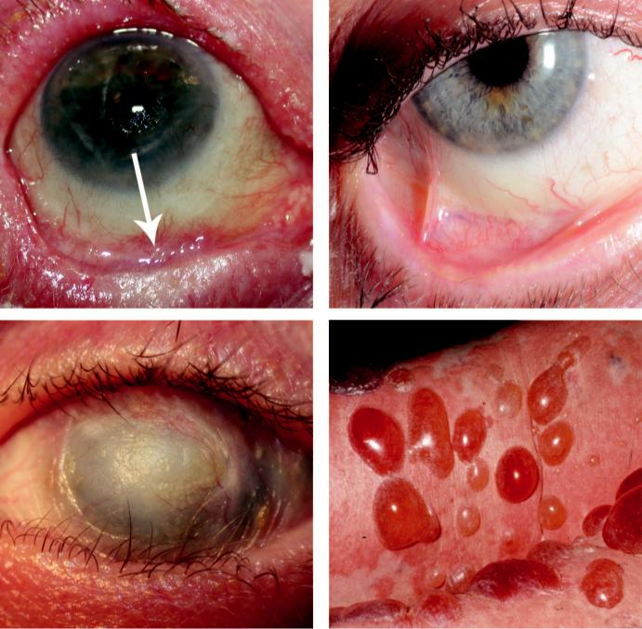

A B

C D

Fig. 6.10 Ocular cicatricial pemphigoid: (A) early disease with hyperaemia and conjunctival fibrosis (arrow), (B) symblepharon formation, (C) keratinization with ankyloblepharon, (D) skin blistering. (From Salmon JF, Kanski’s Clinical Ophthalmology: A Systematic Approach, 9th edition. Oxford, UK: Elsevier; 2020.)

***Eyelids***: (a) aberrant lashes, (b) chronic blepharitis, (c) keratinization of the lid margin, (d) ankyloblepharon (adhesions between the upper and lower lids).

***Systemic***: (a) subepidermal mucosal (e.g. oral) blisters, (b) oesophageal stricture, (c) laryn-geal and tracheal stenosis, (d) skin blisters (Fig. 6.10D) and erosions.

**Treatment**

***Systemic***: dapsone, antimetabolites (azathioprine, methotrexate, and mycophenolate), pred-nisolone, intravenous immunoglobulin and rituximab.

***Local***: (a) lid hygiene for blepharitis, (b) punctal occlusion for dry eyes, (c) laser or surgery for aberrant lashes, (d) lateral tarsorrhaphy or botulinum toxin-induced ptosis to promote corneal healing, (e) subconjunctival mitomycin C and/or steroid (if systemic immuno-suppression is not possible).

***Topical***: (a) lubricants, (b) steroids, (c) retinoic acid.

#*" ##%"#"+!#(&&%"'+$'""#* "%#! " +#!+ &)%#"$'!%

#%$%&#" (&#" +##'%(&&*'#('$%!&&#"#$+%', &)%" %'&%&%)

**100** SYNOPSIS OF CLINICAL OPHTHALMOLOGY



***Reconstructive surgery***: (a) entropion repair, (b) mucous membrane autografting or amniotic membrane transplantation, (c) limbal stem cell transfer, (d) keratoplasty, (e) keratoprosthesis in end-stage disease.

**STEVENS–JOHNSON SYNDROME/TOXIC EPIDERMAL NECROLYSIS**

**Pathogenesis:**

Stevens–Johnson syndrome (SJS) is now believed to be a condition distinct from erythema multi-forme. Toxic epidermal necrolysis (TEN), also known as Lyell syndrome, is a severe variant of SJS. It is thought that a cell-mediated hypersensitivity immune reaction is responsible, with precipitat-ing agents including a very wide range of drugs such as antibiotics (especially sulfonamides and trimethoprim), NSAIDs, anticonvulsants; microorganisms such as *Mycoplasma pneumoniae* and herpes simplex virus. In more than 50% of cases, the cause is uncertain.

**Diagnosis**

***Presentation***: flu-like symptoms for up to 14 days.

***Acute signs***: (a) haemorrhagic crusting of the lid margins (Fig. 6.11A), (b) papillary con-junctivitis, (c) conjunctival membranes, pseudomembranes, haemorrhages, blisters, patchy infarction (Fig. 6.11B), (d) punctate corneal epithelial erosions progressing to larger epithe-lial defects.

***Late signs***: (a) keratinization of the conjunctiva, (b) forniceal shortening and symblepha-ron formation, (c) cicatricial entropion and ectropion, (d) trichiasis, (e) ankyloblepharon, (f ) keratopathy, including scarring and keratinization (Fig. 6.11C), (g) watery eyes due to fibrosis of the lacrimal puncta; dry eyes may also occur.

***Systemic features***: (a) blistering and haemorrhagic crusting of the lips and sometimes the tongue, oropharynx and elsewhere, (b) small purpuric, vesicular, or necrotic skin lesions involving the extremities (Fig. 6.11D), face, and trunk – usually heal within weeks, leaving a scar.

**Treatment**

***Systemic***: (a) removal of the precipitant if possible, (b) general supportive measures (e.g. hydration), (c) immunosuppressive agents, including steroids in selected cases, (d) antibiot-ics, when indicated, (e) intravenous immunoglobulin may be eective, (f ) anticoagulation with heparin.

***Acute ocular***: (a) lubricants, (b) topical steroids, (c) lysis of developing symblepharon with a sterile glass rod or damp cotton bud, (d) peeling of pseudomembranes or true membrane. ***Later ocular***: (a) lubrication and punctal occlusion, (b) topical transretinoic acid to reverse keratinization, (c) treatment of aberrant lashes, (d) contact lenses (gas permeable scleral) for protection, (e) mucous membrane grafting (e.g. buccal mucosa autograft) for forniceal reconstruction.

***Corneal rehabilitation***: (a) superficial keratectomy for keratinization, (b) lamellar kerato-plasty for superficial scarring (provided limbal stem cell population is adequate), (c) amni-otic membrane grafting, (d) limbal stem cell transplantation (cadaveric or living relative), (e) keratoprosthesis in end-stage disease.

**GRAFT VS HOST DISEASE**

**Pathogenesis:**

occurs in 40–60% of patients after allogenic haematological stem cell transplantation. Immune response leads to infiltration of the lacrimal gland, conjunctiva and ocular surface.

#*" ##%"#"+!#(&&%"'+$'""#* "%#! " +#!+ &)%#"$'!%

#%$%&#" (&#" +##'%(&&*'#('$%!&&#"#$+%', &)%" %'&%&%)

|  |  |
| --- | --- |
| Chapter 6—CONJUNCTIVA | **101** |
|  |  |

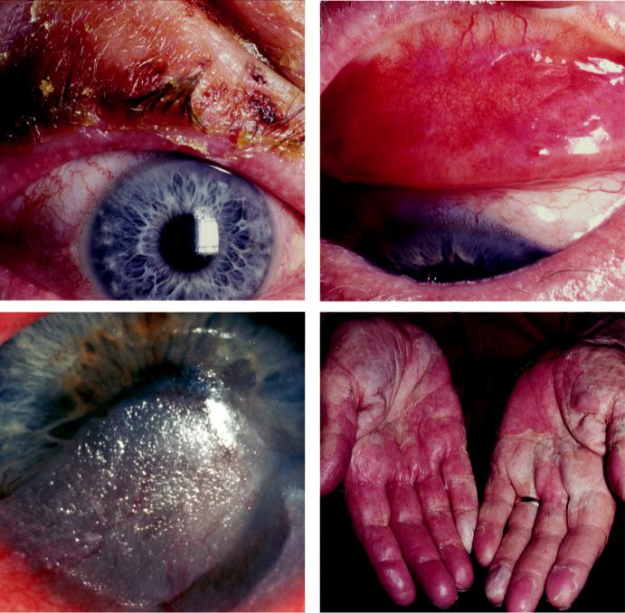

A B

C D

Fig. 6.11 Stevens–Johnson syndrome: (A) lid crusting and conjunctivitis, (B) conjunctival scarring, (C) corneal keratinization, (D) excoriated skin on hands. (Figure 6.11C courtesy of S. Tuft.)

**Diagnosis**

***Presentation***: dry eye symptoms and visual blurring.

***Lids***: (a) anterior and posterior blepharitis, (b) late cicatricial entropion (rare).

***Conjunctiva***: (a) hyperaemia, (b) pseudomembrane and membrane formation, (c) palpebral fibrovascular changes.

***Cornea***: (a) superficial punctate keratitis, (b) filamentary keratitis, (c) corneal erosion, (d) ulceration.

**Treatment**

***Topical***: (a) lubricating drops, (b) steroids, (c) topical cyclosporin 0.5% is the mainstay of treatment.

***Systemic steroids***

***Bandage and scleral lenses***

***PROSE***: (prosthetic replacement of the ocular surface ecosystem); constant lubrication provided by a reservoir of sterile saline incorporated in a highly gas-permeable plastic prosthesis.

#*" ##%"#"+!#(&&%"'+$'""#* "%#! " +#!+ &)%#"$'!%

#%$%&#" (&#" +##'%(&&*'#('$%!&&#"#$+%', &)%" %'&%&%)

**102** SYNOPSIS OF CLINICAL OPHTHALMOLOGY



**Miscellaneous conjunctivitis**

**SUPERIOR LIMBIC KERATOCONJUNCTIVITIS**

**Pathogenesis:**

chronic disease of the superior limbus and superior conjunctiva; typically aects both eyes of middle-aged women, approximately 50% of whom have abnormal thyroid function. It is believed to be the result of a self-perpetuating cycle of blink-related trauma between the upper lid and bulbar conjunctiva, exacerbated by tear insuciency.

**Diagnosis**

***Presentation***: foreign body sensation, burning, mild photophobia, and mucoid discharge, often intermittent and typically more marked than the signs.

***Conjunctiva***: (a) hyperaemia of the limbus (Fig. 6.12A), (b) velvety papillary hypertrophy of the superior tarsus (Fig. 6.12B) and (c) light downward pressure on the upper lid results in a fold of redundant conjunctiva crossing the upper limbus.

***Cornea***: (a) superior punctate epithelial erosions, (b) superior filamentary keratitis (Fig. 6.12C), (c) keratoconjunctivitis sicca in approximately 50%.

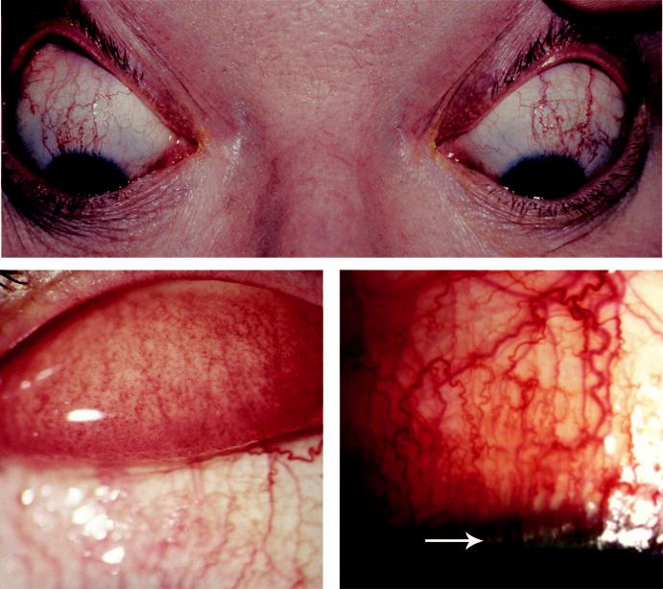

A

B C

Fig. 6.12 Superior limbic keratoconjunctivitis: (A) macroscopic appearance, (B) diffuse velvety papillary hyper-

trophy, (C) hyperaemic band with limbal papillae (arrow). (From Salmon JF, Kanski’s Clinical Ophthalmology: A

Systematic Approach, 9th edition. Oxford, UK: Elsevier; 2020.)

#*" ##%"#"+!#(&&%"'+$'""#* "%#! " +#!+ &)%#"$'!%

#%$%&#" (&#" +##'%(&&*'#('$%!&&#"#$+%', &)%" %'&%&%)

|  |  |
| --- | --- |
| Chapter 6—CONJUNCTIVA | **103** |
|  |  |

**Treatment**

***Topical***: (a) lubricants, (b) mucolytics (e.g. acetylcysteine 5% or 10%) to break down filaments, (c) mast cell stabilizers and steroids to address the inflammatory component, (d) ciclosporin 0.05% twice daily, (e) retinoic acid to retard keratinization.

***Soft contact lenses***: may help by intervening between the lid and the superior conjunctiva.

***Supratarsal steroid injection***: (0.1 ml of triamcinolone acetonide 40 mg/ml).

***Other measures***: (a) temporary punctal occlusion, (b) resection of the superior limbal con-junctiva, (c) conjunctival ablation with silver nitrate 0.5% or thermocautery, (d) treatment of associated thyroid dysfunction.

**LIGNEOUS CONJUNCTIVITIS**

**Pathogenesis:**

systemic disease in which deficiency in plasmin-mediated fibrinolysis may be a key factor. Death can occasionally occur from pulmonary involvement.

**Diagnosis**

***Presentation***: nonspecific conjunctivitis in childhood, although may be at any age.

***Signs***: (a) red-white conjunctival masses of wood-like consistency (Fig. 6.13A), (b) thick yellow-white mucoid discharge (Fig. 6.13B), (c) corneal scarring and vascularization, with melting in advanced disease.

**Treatment**

Discontinue any antifibrinolytic drugs.

Surgical removal with diathermy of the base of the lesion.

Following removal, hourly heparin and steroids are continued until the wound has re-epithelialized.

Recurrence may be retarded by long-term topical ciclosporin and steroids.

Intravenous and/or topical plasminogen may be helpful.

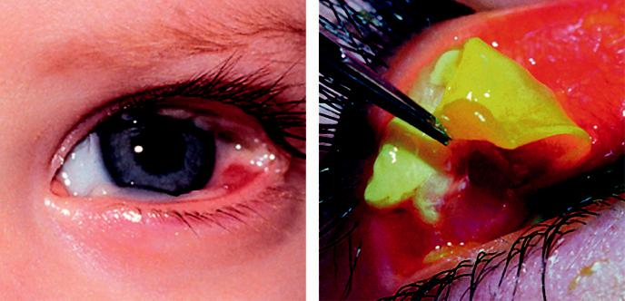

**A** **B**

Fig. 6.13 Ligneous conjunctivitis: (A) multiple ligneous lesions, (B) removal of thick mucoid lesion. (Figure 6.13B courtesy of J. Dart.)

#*" ##%"#"+!#(&&%"'+$'""#* "%#! " +#!+ &)%#"$'!%

#%$%&#" (&#" +##'%(&&*'#('$%!&&#"#$+%', &)%" %'&%&%)

**104** SYNOPSIS OF CLINICAL OPHTHALMOLOGY



**PARINAUD OCULOGLANDULAR SYNDROME**

**Pathogenesis:**

cat-scratch disease (*Bartonella henselae*) is by far the most common cause; others include various infective agents, and insect hairs (ophthalmia nodosum).

**Diagnosis:**

1. chronic low-grade fever, (b) unilateral granulomatous conjunctivitis (Fig. 6.14A), (c) ipsilateral preauricular lymphadenopathy.

**Treatment:**

(see Chapter 12 for cat-scratch disease).

**FACTITIOUS CONJUNCTIVITIS**

**Pathogenesis:**

self-injury, usually intentional although can also occur inadvertently (e.g. mucus fishing syndrome and removal of contact lenses). Instillation of readily accessible irritant substances, such as soap, can also be responsible.

**Diagnosis**

e patient may have sought multiple opinions over an extended period for a range of conditions.

Aected site is usually inferior conjunctiva, with hyperaemia and staining ( Fig. 6.14B).

Linear corneal abrasions, persistent epithelial defects and occasionally corneal perforation.

Secondary infection may occur, particularly fungal with *Candida* spp.

**Management:**

1. exclusion of other diagnoses, (b) confrontation (often leads to failure to return for review),
2. psychiatric opinion may be appropriate.

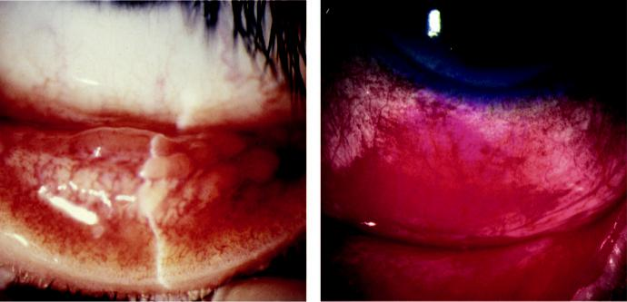

A B

Fig. 6.14 (A) Granulomatous conjunctivitis in Parinaud syndrome, (B) factitious conjunctivitis stained with rose Bengal. (Figure 6.14B courtesy of S. Tuft.)

#*" ##%"#"+!#(&&%"'+$'""#* "%#! " +#!+ &)%#"$'!%

#%$%&#" (&#" +##'%(&&*'#('$%!&&#"#$+%', &)%" %'&%&%)

|  |  |
| --- | --- |
| Chapter 6—CONJUNCTIVA | **105** |
|  |  |

**Degenerations**

**PINGUECULUM**

**Pathogenesis:**

degeneration of the collagen fibres of the conjunctival stroma resulting from actinic damage, simi-lar to the aetiology of pterygium (see below).

**Diagnosis**

Usually asymptomatic yellow-white mound on the bulbar conjunctiva adjacent to the limbus (Fig. 6.15A), more frequently nasal than temporal. Calcification is occasionally visible.

Acute inflammation (pingueculitis) may occasionally occur.

**Treatment:**

usually unnecessary; short course of a weak topical steroid for pingueculitis; excision occasionally required.

**PTERYGIUM**

**Pathogenesis:**

actinic damage in people living in sunny climates. Pseudopterygium broadly resembles pterygium, but is caused by a band of conjunctiva adhering to cornea at its apex as a response to an acute inflammatory episode.

**Diagnosis**

***Presentation***: (a) often asymptomatic, but sometimes irritation, (b) inflammation, (c) occa-sionally visual interference (obstruction of the visual axis or induced astigmatism).

***Signs***: triangular fibrovascular ingrowth, usually located medially, consisting of (a) a ‘cap’ (avascular zone at the advancing edge), (b) head, (c) body (Fig. 6.15B).

**Treatment**

Lubricants and topical steroids for inflammatory episodes.

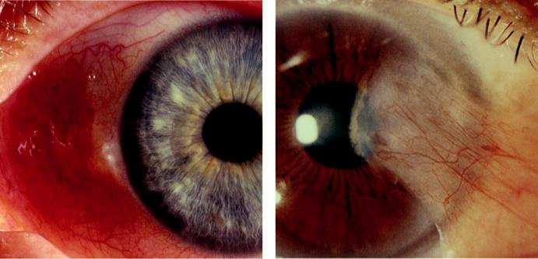

A B

Fig. 6.15 Degeneration: (A) inflamed pinguecula, (B) pterygium. (From Salmon JF, Kanski’s Clinical

Ophthalmology: A Systematic Approach, 9th edition. Oxford, UK: Elsevier; 2020.)

#*" ##%"#"+!#(&&%"'+$'""#* "%#! " +#!+ &)%#"$'!%

#%$%&#" (&#" +##'%(&&*'#('$%!&&#"#$+%', &)%" %'&%&%)

**106** SYNOPSIS OF CLINICAL OPHTHALMOLOGY



Sunglasses with an ultraviolet light filter may decrease the growth stimulus.

Simple excision using adjunctive treatment with mitomycin C or beta irradiation to prevent recurrence (risk of late scleral necrosis).

Conjunctival autografting is commonly performed (donor patch from superior paralimbal area). Amniotic membrane patch grafting or peripheral lamellar keratoplasty is occasionally indicated.

**CONCRETIONS**

**Pathogenesis:**

deposits of epithelial debris, usually age-related although can also form in patients with chronic conjunctivitis.

**Diagnosis:**

multiple tiny yellowish-white subepithelial cysts in the inferior tarsal and forniceal conjunctiva (Fig. 6.16A). Can become calcified and may erode the overlying epithelium to cause irritation.

**Treatment:**

if symptomatic can be removed at the slit lamp with a needle.

**CONJUNCTIVOCHALASIS**

**Pathogenesis:**

normal ageing change exacerbated by chronic blepharitis or dry eye.

**Diagnosis:**

fold of redundant conjunctiva protruding over the lower eyelid margin. May cause watering by mechanically obstructing the inferior punctum.

**Treatment:**

1. treatment of blepharitis, (b) lubricants, (c) short course of topical steroids, (d) conjunctival resection in severe cases.

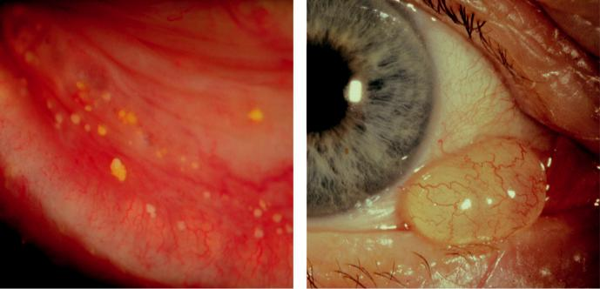

A B

Fig. 6.16 (A) Concretions, (B) retention cyst. (From Salmon JF, Kanski’s Clinical Ophthalmology: A Systematic

Approach, 9th edition. Oxford, UK: Elsevier; 2020.)

#*" ##%"#"+!#(&&%"'+$'""#* "%#! " +#!+ &)%#"$'!%

#%$%&#" (&#" +##'%(&&*'#('$%!&&#"#$+%', &)%" %'&%&%)

|  |  |
| --- | --- |
| Chapter 6—CONJUNCTIVA | **107** |
|  |  |

**RETENTION (EPITHELIAL INCLUSION) CYST**

**Pathogenesis:**

fluid-filled cyst lined by a double epithelial layer that may be primary or secondary (e.g.

post-surgical).

**Diagnosis**

***Signs***: clear-walled lesion containing clear (Fig. 6.16B) or occasionally turbid fluid.

***Diﬀerential diagnosis***: lymphangiectasia, characterized by strings of cystic or sausage-shaped clear-walled channels that may fill with blood (haemorrhagic lymphangiectasia).

**Treatment:**

needle puncture, with bleeding encouraged to promote adhesion; excision if puncture fails.

#*" ##%"#"+!#(&&%"'+$'""#* "%#! " +#!+ &)%#"$'!%

#%$%&#" (&#" +##'%(&&*'#('$%!&&#"#$+%', &)%" %'&%&%)



CHAPTER 7

Cornea



C H A P T E R O U T L I N E

Bacterial keratitis 110

Fungal keratitis 111

Herpes simplex keratitis 112

Pathogenesis 112

Epithelial keratitis 113

Disciform keratitis 113

Necrotizing stromal keratitis 114

Neurotrophic ulceration 114

Other considerations 115

Herpes zoster ophthalmicus 115

Interstitial keratitis 117

Pathogenesis 117

Syphilitic 117

Cogan syndrome 117

Protozoan keratitis 119

Acanthamoeba 119

Onchocerciasis 120

Bacterial hypersensitivity-mediated corneal disease 120

Marginal keratitis 120

Phlyctenulosis 121

Rosacea 121

Severe peripheral corneal ulceration 122 Mooren ulcer 123

Peripheral ulcerative keratitis associated with systemic autoimmune disease 123

Terrien marginal degeneration 124

Neurotrophic keratopathy 125

Exposure keratopathy 126

Miscellaneous keratopathies 127

Infectious crystalline keratopathy 127

Thygeson superficial punctate keratitis 127

Filamentary keratopathy 128

Recurrent corneal epithelial erosion 129

Xerophthalmia 129

Corneal ectasias 130

Keratoconus 130

Pellucid marginal degeneration 131

Keratoglobus 132

Corneal dystrophies 132

Epithelial dystrophies 132

Bowman layer/anterior stromal dystrophies 133

Stromal dystrophies 134

Endothelial dystrophies 135

Corneal degenerations 137

Age-related degenerations 137

Lipid keratopathy 137

Band keratopathy 138

Spheroidal degeneration (Labrador keratopathy) 139

Salzmann nodular degeneration 140

Metabolic keratopathies 140

Cystinosis 140 Mucopolysaccharidoses 141 Wilson disease 141 Fabry disease 142

Contact lenses 142

Therapeutic uses 142

Complications 143

Congenital anomalies of the cornea and globe 143

Microcornea 143

Megalocornea 144

Microphthalmos 144

Sclerocornea 144

Anophthalmos 144

**109**

#*" ##%"#"+!#(&&%"'+$'""#* "%#! " +#!+ &)%#"$'!%

#%$%&#" (&#" +##'%(&&*'#('$%!&&#"#$+%', &)%" %'&%&%)

**110** SYNOPSIS OF CLINICAL OPHTHALMOLOGY



**Bacterial keratitis**

**Pathogenesis**

***Pathogens***: most common are (a) *Pseudomonas aeruginosa*, (b) *S. aureus*, (c) streptococci.

***Risk factors***: (a) contact lens wear, (b) trauma, (c) ocular surface disease.

**Diagnosis**

***Presentation***: subacute onset of pain, photophobia, blurred vision and discharge.

***Signs***: (a) epithelial defect with larger infiltrate (Fig. 7.1A), (b) early ulcer (Fig. 7.1B),

1. stromal oedema, (d) anterior uveitis, often with hypopyon (Fig. 7.1C), (e) severe ulcer-ation may lead to descemetocoele formation and perforation (Fig. 7.1D).

***Dierential diagnosis*** : (a) alternative microorganisms (fungi, acanthamoeba, stromal herpes simplex keratitis, mycobacteria), (b) severe marginal keratitis, (c) sterile infiltrates associated with contact lens wear.

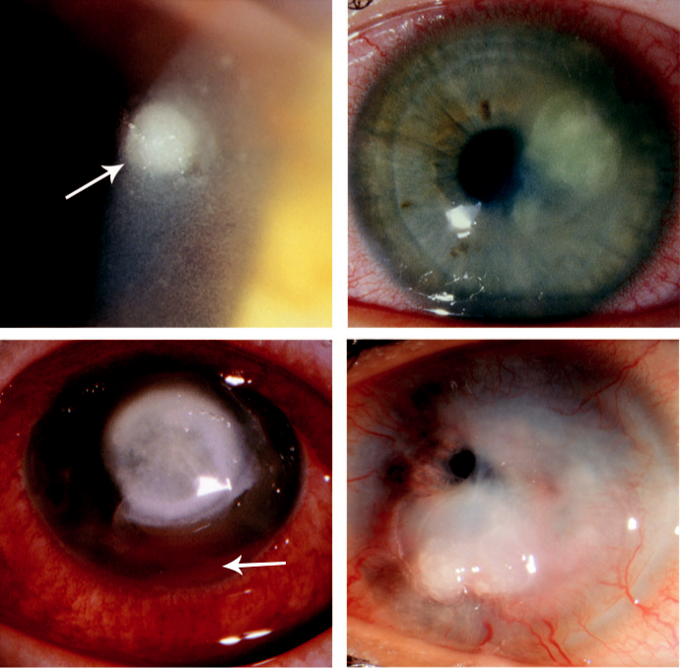

A B

C D

Fig. 7.1 Bacterial keratitis: (A) epithelial defect with infiltrate (arrow), (B) early ulcer, (C) large ulcer with hypo-pyon, (D) descemetocoele formation and perforation. (Figure 7.1B courtesy of T. Carmichael; Figure 7.1D courtesy of S. Tuft.)

#*" ##%"#"+!#(&&%"'+$'""#* "%#! " +#!+ &)%#"$'!%

#%$%&#" (&#" +##'%(&&*'#('$%!&&#"#$+%', &)%" %'&%&%)

|  |  |
| --- | --- |
| Chapter 7—CORNEA | **111** |
|  |  |

***Investigations***: (a) corneal scraping for microscopy, (b) culture (blood, chocolate, and Sabouraud agar) with antibiotic sensitivity determination, (c) conjunctival swabs, (d) culture of contact lenses and lens cases.

**Treatment**

***Indications for hospital admission***: (a) patients unlikely to comply or unable to self-administer treatment, (b) aggressive disease/only eye.

***Topical antibiotics***: after corneal scraping, instillation at hourly intervals for 24–48 hours and then taper according to clinical progress. Options include (a) monotherapy with a fluoroquinolone (e.g. ciprofloxacin, ofloxacin, moxifloxacin, gatifloxacin), (b) duotherapy (e.g. cefuroxime 5%, gentamicin 1.5%) may be preferred as first-line empirical treatment in aggressive disease or if streptococci suspected, (c) if no improvement is evident after 24–48 hours, the regimen should be reviewed and (d) if there is still no improvement after a further 48 hours, suspension of treatment should be considered for 24 hours and then re-scraping performed, with investigation for nonbacterial infection (additional stains and culture media). Corneal biopsy for histology and culture may be necessary in dicult cases.

***Topical steroids***: may be commenced once clinical improvement is seen, but early discon-tinuation may lead to recurrence of sterile inflammation.

***Indications for systemic antibiotics***: (a) potential for systemic involvement (*N. meningitidis*, *H. influenzae*, *N. gonorrhoeae*), (b) severe corneal thinning with threatened perforation (ciproflox-acin for antibacterial activity and a tetracycline for anticollagenase eect), (c) scleral involvement.

***Surgery***: excisional keratoplasty (penetrating or deep lamellar) may be considered in resis-tant cases or for incipient or actual perforation.

**Fungal keratitis**

**Predisposing factors:**

1. chronic ocular surface disease, (b) trauma, often involving plant matter or gardening/agricul-tural tools (filamentous keratitis), (c) long-term use of topical steroids, often with prior corneal transplantation, (d) contact lens wear, (e) systemic immunosuppression, (f ) diabetes.

**Diagnosis**

***Presentation***: gradual onset of pain, grittiness, photophobia, blurred vision and watery or muco-purulent discharge. e diagnosis is often delayed unless there is a high index of suspicion. ***Candida keratitis***: (a) yellow-white densely suppurative infiltrate (Fig. 7.2A), (b) a collar-stud morphology may be seen.

***Filamentous keratitis***: (a) grey or yellow-white stromal infiltrate with indistinct fluy margins, satellite lesions (Fig. 7.2B), (b) feathery extensions and/or (c) ring-shaped infiltrate. ***Other features***: (a) anterior uveitis, (b) endothelial plaque, (c) scleritis, (d) sterile or infective endophthalmitis; an epithelial defect is not always present.

***Dierential diagnosis*** : bacterial, herpetic and acanthamoebal keratitis; co-infection can occur.

***Investigations***: (a) scraping for Gram and Giemsa staining (both approximately 50% sen-sitive), (b) silver stains (more commonly performed on histological sections), (c) culture on Sabouraud agar (most fungi will also grow on blood agar and enrichment media),

1. ) corneal biopsy, (e) polymerase chain reaction (PCR) is rapid and highly sensitive, (f ) culture of contact lenses and lens cases, (g) confocal microscopy may permit *in vivo* identification.

#*" ##%"#"+!#(&&%"'+$'""#* "%#! " +#!+ &)%#"$'!%

#%$%&#" (&#" +##'%(&&*'#('$%!&&#"#$+%', &)%" %'&%&%)

**112** SYNOPSIS OF CLINICAL OPHTHALMOLOGY

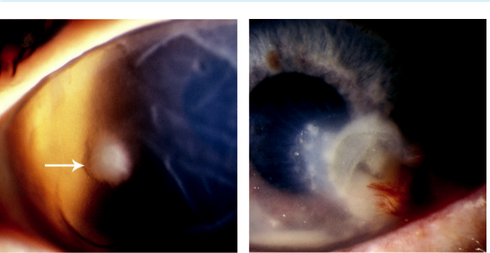

A B

Fig. 7.2 Fungal keratitis: (A) suppurative infiltrate secondary to candida (arrow), (B) filamentous keratitis with satellite lesions. (Figure 7.2A courtesy of S. Tuft.)

**Treatment**

***Topical***: initially hourly for 48 hours and then reduced, depending on response to treat-ment. Most antifungals are only fungistatic, so treatment should be continued for at least 12 weeks. Improvement may be slower than in bacterial infection; removal of epithelium over the lesion may enhance drug penetration.

***Candida infection***: amphotericin B 0.15% or econazole 1%. Alternatives include natamycin 5%, fluconazole 2%, and clotrimazole 1%.

***Filamentous infection***: natamycin 5% or econazole 1%. Alternatives include amphotericin B 0.15% and miconazole 1%.

***Systemic antifungals*** (voriconazole, itraconazole, fluconazole) should be considered in (a) severe cases, (b) lesions near the limbus, (c) suspected endophthalmitis.

***Other measures***: (a) systemic tetracycline for significant thinning, (b) superficial keratec-tomy can be eective for de-bulking, (c) therapeutic keratoplasty (penetrating or deep ante - rior lamellar) when medical therapy is ineective or following perforation.

**Herpes simplex keratitis**

**PATHOGENESIS**

Herpes simplex keratitis is the most common infectious cause of corneal blindness in developed countries. Herpes simplex virus (HSV) has two subtypes:

***HSV-1***: causes disease principally above the waist.

***HSV-2***: causes venereally acquired infection (genital herpes).

***Primary infection***: usually occurs sub-clinically in childhood. Sub-clinical reactivation can occur, during which patients are contagious.

***Clinical reactivation***: can occur in response to a variety of stressors (e.g. fever, hormonal change, ultraviolet radiation, topical prostaglandin analogues). e virus replicates and is transported in the sensory axons to the periphery, the pattern of disease depending on the site of reactivation.

***Epithelial (dendritic or geographic) keratitis***: caused by active viral replication.

#*" ##%"#"+!#(&&%"'+$'""#* "%#! " +#!+ &)%#"$'!%

#%$%&#" (&#" +##'%(&&*'#('$%!&&#"#$+%', &)%" %'&%&%)

|  |  |
| --- | --- |
| Chapter 7—CORNEA | **113** |
|  |  |

***Disciform keratitis***: caused by hypersensitivity reaction to viral antigen.

***Necrotizing stromal keratitis***: caused by active viral replication within the stroma, although immune-mediated inflammation plays a significant role.

**Epithelial keratitis**

**Diagnosis**

***Presentation***: mild discomfort, redness, photophobia, watering and blurred vision.

***Signs***: (a) swollen opaque epithelial cells arranged in a coarse punctate or stellate pattern,

1. formation of a branching ‘dendritic’ ulcer with characteristic terminal buds (Fig. 7.3A),
2. reduced corneal sensation. e use of topical steroids may promote enlargement of the ulcer to a geographic configuration (Fig. 7.3B).

**Treatment**

***Topical antivirals***: (aciclovir ointment, ganciclovir gel, trifluridine solution) have approxi-mately equivalent eect, with vidarabine an alternative; most cases resolve within 2 weeks on treatment.

***Debridement***: 2 mm beyond the ulcer edge with a sterile cellulose sponge may be used as an adjunct. is protects adjacent epithelium from infection and reduces the antigenic stimulus to inflammation.

***Oral antivirals*** (aciclovir, famciclovir, valaciclovir) are an eective alternative to topical therapy, when the latter is poorly tolerated, or in resistant cases. Combination of two topical agents with oral valaciclovir or famciclovir may be eective.

**Disciform keratitis**

**Diagnosis**

***Presentation***: blurred vision, mild discomfort and redness.

***Signs***: (a) central zone of stromal oedema with overlying epithelial oedema, underlying keratic precipitates and folds in Descemet membrane (Fig. 7.4A), (b) surrounding (Wessely) immune ring of stromal haze (Fig. 7.4B), (c) reduced corneal sensation.

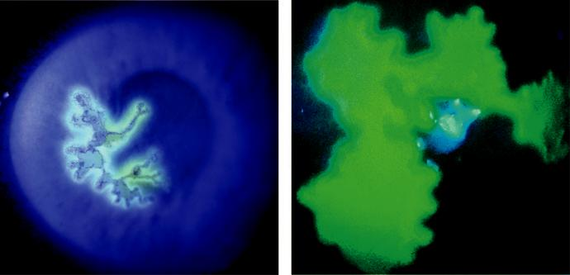

A B

Fig. 7.3 Herpes keratitis: (A) dendritic ulcer, (B) geographic ulcer. (From Salmon JF, Kanski’s Clinical

Ophthalmology: A Systematic Approach, 9th edition. Oxford, UK: Elsevier; 2020.)

#*" ##%"#"+!#(&&%"'+$'""#* "%#! " +#!+ &)%#"$'!%

#%$%&#" (&#" +##'%(&&*'#('$%!&&#"#$+%', &)%" %'&%&%)

**114** SYNOPSIS OF CLINICAL OPHTHALMOLOGY

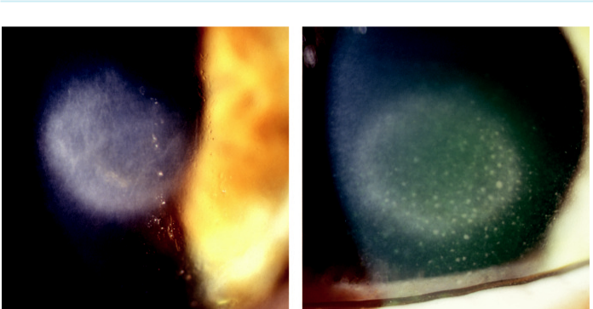

A B

Fig. 7.4 Disciform keratitis: (A) stromal oedema with underlying keratic precipitates, (B) Wessely immune ring. (From Salmon JF, Kanski’s Clinical Ophthalmology: A Systematic Approach, 9th edition. Oxford, UK: Elsevier; 2020.)

***Course***: consecutive episodes may be associated with gradually worsening scarring and superficial or deep vascularization; mid-stromal scarring can appear as interstitial keratitis.

**Treatment**

***Initial***: topical steroids (prednisolone 1%, dexamethasone 0.1%) with antiviral cover, both four times daily.

***Subsequent***: as improvement occurs, both are tapered. Some patients require a weaker ste-roid (fluorometholone 0.1%, loteprednol 0.2%) on alternate days for many months. Topical ciclosporin 0.05% may be useful as a steroid-sparing agent.

**Necrotizing stromal keratitis**

**Diagnosis:**

1. most commonly seen in patients with multiple recurrences, especially HSV-2, (b) stromal necrosis and melting, (c) may be associated with an epithelial defect (Fig. 7.5A), (d) progression to scarring, vascularization and lipid deposition (Fig. 7.5B).

**Treatment:**

similar to aggressive disciform keratitis (see above), but oral antivirals are required; restoration of epithelial integrity is vital.

**Neurotrophic ulceration**

**Pathogenesis:**

failure of epithelial integrity resulting principally from corneal anaesthesia.

**Diagnosis:**

1. nonhealing epithelial defect, (b) underlying stroma is grey and opaque and may become progressively thin.

#*" ##%"#"+!#(&&%"'+$'""#* "%#! " +#!+ &)%#"$'!%

#%$%&#" (&#" +##'%(&&*'#('$%!&&#"#$+%', &)%" %'&%&%)

|  |  |
| --- | --- |
| Chapter 7—CORNEA | **115** |
|  |  |

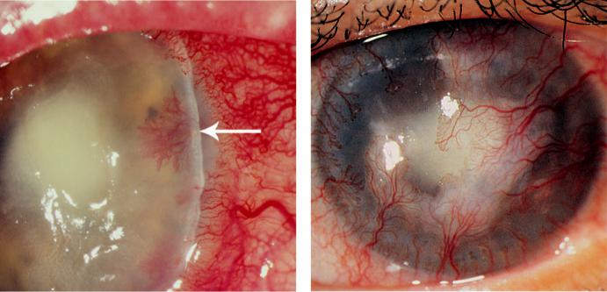

A B

Fig. 7.5 Necrotizing stromal keratitis: (A) stromal necrosis and melting (arrow), (B) scarring and vasculariza-tion. (Figure 7.5A courtesy of T. Carmichael.)

**Treatment:**

as for any persistent epithelial defect; topical steroid to control any inflammatory component should be kept to a minimum.

**OTHER CONSIDERATIONS**

***Prophylaxis***: long-term daily oral aciclovir reduces the rate of recurrence of epithelial and stromal keratitis by approximately 50%. It should be considered in patients with frequent recurrences, particularly if bilateral or involving an only eye.

***Major complications***: (a) secondary microbial infection, (b) glaucoma secondary to inflam-mation or prolonged topical steroids, (c) cataract secondary to inflammation or prolonged topical steroids, (d) patchy iris atrophy following keratouveitis.

***Keratoplasty***: carries a high risk of recurrence of active infection and rejection; prophylactic oral antivirals may improve the prognosis.

**Herpes zoster ophthalmicus**

**Pathogenesis:**

VZV causes both chickenpox (varicella) and shingles (herpes zoster). After an episode of chicken-pox, the virus travels to sensory ganglia and remains dormant, with reactivation thought to occur after specific immunity has faded. Herpes zoster ophthalmicus (HZO) is shingles involving a der-matome of the ophthalmic division of the trigeminal nerve. HZO occurs most frequently in the elderly. Immunocompromised patients tend to have more severe disease. Hutchinson’s sign refers to the rash of HZO aecting the skin on the tip and side of the nose ( Fig. 7.6A), and correlates strongly with involvement of the eye.

**Diagnosis and treatment**

of cutaneous lesions (see Chapter 2).

#*" ##%"#"+!#(&&%"'+$'""#* "%#! " +#!+ &)%#"$'!%

#%$%&#" (&#" +##'%(&&*'#('$%!&&#"#$+%', &)%" %'&%&%)

**116** SYNOPSIS OF CLINICAL OPHTHALMOLOGY

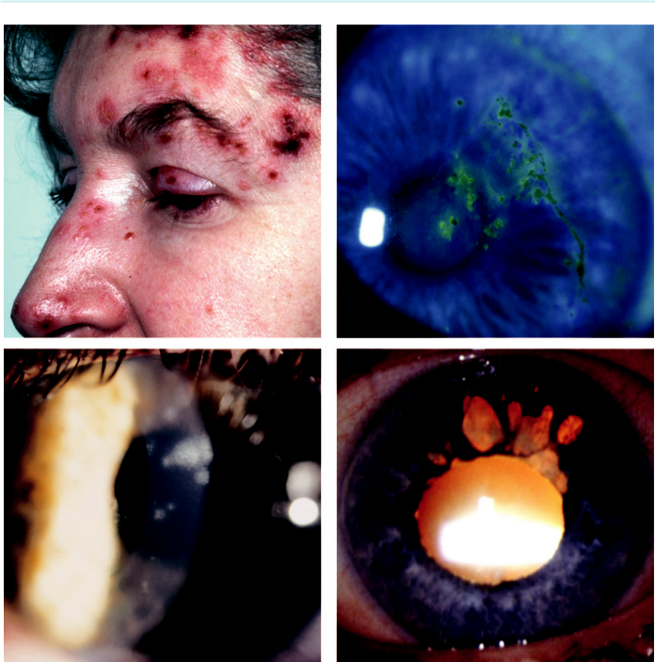

A B

C D

Fig. 7.6 Herpes zoster ophthalmicus: (A) Hutchinson’s sign, (B) acute epithelial keratitis, (C) stromal keratitis,

1. sectoral iris atrophy. (From Salmon JF, Kanski’s Clinical Ophthalmology: A Systematic Approach, 9th edition. Oxford, UK: Elsevier; 2020.)

**Ocular manifestations**

***Acute epithelial keratitis***: small fine dendritiform lesions (Fig. 7.6B) which resolve sponta-neously within a few days.

***Conjunctivitis***: follicular and/or papillary is common; treatment is not required.

***Episcleritis***: NSAIDs may be used if necessary (see Fig. 9.6C).

***Scleritis and sclerokeratitis***: treatment is with oral flurbiprofen.

***Nummular keratitis*** may develop at the site of epithelial lesions; treatment is with topical steroids if symptomatic, with slow tapering.

***Stromal keratitis***: responds to topical steroids, but can become chronic and requires slow tapering (Fig. 7.6C).

***Disciform keratitis***: less common than with herpes simplex infection; treatment is with topical steroids.

***Anterior uveitis***: aects at least one-third of patients and can be associated with sectoral iris atrophy (Fig. 7.6D).

#*" ##%"#"+!#(&&%"'+$'""#* "%#! " +#!+ &)%#"$'!%

#%$%&#" (&#" +##'%(&&*'#('$%!&&#"#$+%', &)%" %'&%&%)

|  |  |
| --- | --- |
| Chapter 7—CORNEA | **117** |
|  |  |

***Intraocular pressure (IOP) elevation***: inflammatory or steroid-induced.

***Neuro-ophthalmological complications***: may require intravenous antivirals and systemic steroids.

***Neurotrophic keratitis***: common but usually mild and settles over months.

***Mucous plaque keratitis***: uncommon; treatment involves topical steroids and acetylcysteine.

***Eyelids***: cicatricial ptosis, entropion, and trichiasis.

***Reactivation***: keratitis, episcleritis, scleritis or iritis may occur years after an acute episode.

***Post-herpetic neuralgia***: pain that persists for more than 1 month after the rash has healed develops in up to 75% of patients older than 70 years of age. Treatment in staged fashion:

1. simple analgesics, (b) stronger analgesics (codeine), (c) tricyclic antidepressants (amitrip-tyline 25 mg nightly), (d) carbamazepine , (e) gabapentin.

**Interstitial keratitis**

**PATHOGENESIS**

Interstitial keratitis (IK) is inflammation of the corneal stroma without primary involvement of the epithelium or endothelium; usually an immune-mediated process. Congenital syphilis is the classic cause, but is now rare in developed countries. IK is less common in acquired than in con-genital disease. Other causes include herpetic and other viral infections, tuberculosis, sarcoidosis and Cogan syndrome (see below).

**SYPHILITIC**

**Diagnosis**

***Systemic features of congenital syphilis***: (a) early features include rhinitis, failure to thrive, rash, mucosal ulcers, fissures around the lips (rhagades), pneumonia, and neurological and cardiovascular problems; (b) late features include deafness, ‘saddle’ nose, ‘sabre’ tibiae, ‘bull-dog’ jaw, Hutchinson’s teeth and Clutton joints (painless eusions).

***Ocular features of congenital syphilis***: (a) anterior uveitis, (b) IK, (c) subluxated lens, (d) ‘salt-and-pepper’ pigmentary retinopathy, (e) Argyll Robertson pupils.

***Progression of IK in congenital syphilis***: presents between the ages of 5 and 25 years with

1. deep stromal vascularization associated with clouding (‘salmon patch’; Fig. 7.7A), (b) the cornea clears over months and the vessels become nonperfused (‘ghost’ vessels; Fig. 7.7B),
2. the healed stage is characterized by feathery deep stromal scarring.

***Ocular features of acquired syphilis***: (a) anterior uveitis, (b) IK, (c) madarosis, (d) optic neu-ritis, (e) ocular motor nerve palsies, (f ) Argyll Robertson pupils.

**Treatment**

***Acquired syphilis***: penicillin or alternatives if allergic to penicillin.

***Congenital syphilis***: all patients with positive treponemal serology should be referred to a genitourinary medicine specialist for evaluation.

***Treatment of active syphilitic IK***: systemic antibiotics, topical steroids and cycloplegics.

**COGAN SYNDROME**

**Pathogenesis:**

rare autoimmune systemic vasculitis, typically aecting young adults; characterized by corneal inflammation and vestibuloauditory dysfunction.

#*" ##%"#"+!#(&&%"'+$'""#* "%#! " +#!+ &)%#"$'!%

#%$%&#" (&#" +##'%(&&*'#('$%!&&#"#$+%', &)%" %'&%&%)

**118** SYNOPSIS OF CLINICAL OPHTHALMOLOGY

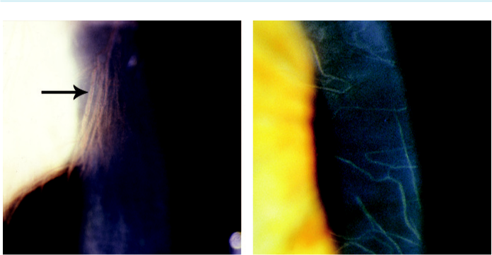

A B

Fig. 7.7 Interstitial keratitis in congenital syphilis: (A) salmon patch showing deep stromal vascularization

(arrow), (B) ghost vessels. (From Salmon JF, Kanski’s Clinical Ophthalmology: A Systematic Approach, 9th

edition. Oxford, UK: Elsevier; 2020.)

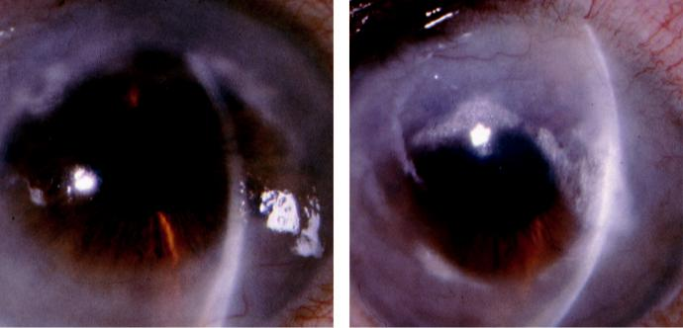

A B

Fig. 7.8 Old interstitial keratitis in Cogan syndrome: (A) peripheral, (B) central extension.

**Diagnosis**

***Presentation***: hearing loss and vertigo that may be separated by months.

***Signs***: faint bilateral peripheral anterior stromal corneal opacities progressing to deeper opacification and neovascularization (Fig. 7.8A and B).

***Associated features***: uveitis, scleritis and retinal vasculitis.

**Treatment**

***Topical steroids***: for keratitis.

***Systemic steroids***: for scleritis, retinal vasculitis and vestibuloauditory symptoms.

***Immunosuppressive therapy***: may be required.

#*" ##%"#"+!#(&&%"'+$'""#* "%#! " +#!+ &)%#"$'!%

#%$%&#" (&#" +##'%(&&*'#('$%!&&#"#$+%', &)%" %'&%&%)

|  |  |
| --- | --- |
| Chapter 7—CORNEA | **119** |
|  |  |

**Protozoan keratitis**

**ACANTHAMOEBA**

**Pathogenesis:**

*Acanthamoeba* spp. are commonly found in soil, water, and the upper respiratory tract. e cystic form is highly resilient. In developed countries, keratitis is most frequently associated with contact lens wear, especially if tap water is used for rinsing.

**Diagnosis**

***Presentation***: blurred vision and pain, which may be severe and disproportionate to the clinical signs.

***Keratitis***: (a) irregular and greyish epithelium (Fig. 7.9A), (b) pseudodendrites, (c) peri-neural infiltrates are pathognomonic (radial keratoneuritis) (Fig. 7.9B), (d) diuse or focal anterior stromal infiltrates may coalesce to a ring abscess (Fig. 7.9C) which may progress to melting (Fig. 7.9D) and to (e) slowly progressive stromal opacification and vascularization.

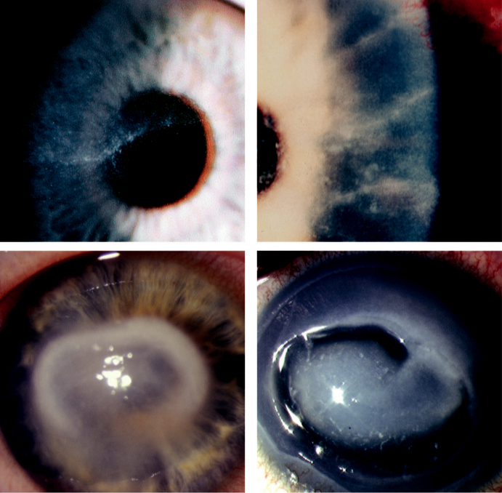

A B

C D

Fig. 7.9 Acanthamoeba keratitis: (A) focal anterior stromal infiltrates, (B) radial perineuritis (arrow), (C) ring abscess, (D) progressive infiltration with melting. (Figure 7.9D courtesy of S. Tuft.)

#*" ##%"#"+!#(&&%"'+$'""#* "%#! " +#!+ &)%#"$'!%

#%$%&#" (&#" +##'%(&&*'#('$%!&&#"#$+%', &)%" %'&%&%)

**120** SYNOPSIS OF CLINICAL OPHTHALMOLOGY



***Limbitis***: progressing to scleritis.

***Dierential diagnosis*** : herpes simplex keratitis.

***Investigations***: (a) staining of corneal scrapings using periodic acid–Schi or calcofluor white stains (Gram and Giemsa may also demonstrate cysts), (b) culture on non-nutrient agar seeded with dead *Escherichia coli*; 30% culture negative, (c) immunohistochemistry, (d) PCR, (e) *in vivo* confocal microscopy, (f ) corneal biopsy.

**Treatment**

***Debridement*** of infected epithelium.

***Topical amoebicides***: (e.g. polyhexamethylene biguanide, chlorhexidine digluconate), hourly at first and gradually reduced. Relapses are common and treatment may be required for many months.

***Topical steroids***: avoided if possible.

***Pain control***: oral NSAIDs (e.g. flurbiprofen).

***Keratoplasty***: for residual scarring.

**ONCHOCERCIASIS**

**Pathogenesis:**

onchocerciasis (‘river blindness’) is caused by infestation with the parasitic helminth *Onchocerca volvulus*. It is the second most common infectious cause of blindness in the world and is endemicin areas of Africa.

**Diagnosis**

***Systemic features***: (see Chapter 12).

***Signs***: (a) anterior uveitis and pear-shaped pupillary dilatation, (b) sclerosing keratitis which starts at 3 and 9 o’clock and progresses to involve the entire cornea, (c) chorioretinitis, (d) live microfilariae may be seen in the anterior chamber.

**Treatment:**

systemic ivermectin and topical steroids.

**Bacterial hypersensitivity-mediated corneal disease**

**MARGINAL KERATITIS**

**Pathogenesis:**

hypersensitivity reaction to staphylococcal exotoxins and cell wall proteins.

**Diagnosis**

***Presentation***: mild discomfort, redness, and lacrimation.

***Signs***: (a) marginal subepithelial infiltrates separated from the limbus by a clear zone (Fig. 7.10A), (b) epithelial defects, characteristically smaller than the underlying infiltrate,

1. superficial scarring, slight thinning and mild pannus (Fig. 7.10B), associated chronic anterior blepharitis is common.

**Treatment**

Spontaneous resolution generally occurs in 3–4 weeks, unless secondary infection occurs.

Treat associated chronic blepharitis if necessary.

Weak topical steroid three times daily for 1 week, sometimes in combination with an antibiotic.

Oral tetracycline (erythromycin in children) may rarely be required.

#*" ##%"#"+!#(&&%"'+$'""#* "%#! " +#!+ &)%#"$'!%

#%$%&#" (&#" +##'%(&&*'#('$%!&&#"#$+%', &)%" %'&%&%)

|  |  |
| --- | --- |
| Chapter 7—CORNEA | **121** |
|  |  |

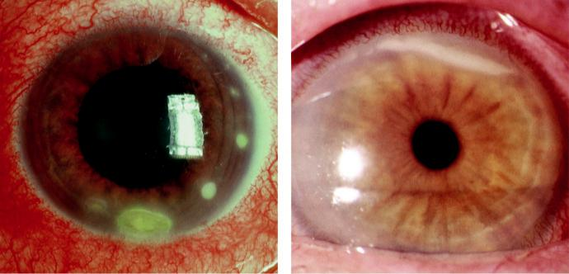

A B

Fig. 7.10 Marginal keratitis: (A) and (B) marginal infiltrates. (From Salmon JF, Kanski’s Clinical Ophthalmology:

A Systematic Approach, 9th edition. Oxford, UK: Elsevier; 2020.)

**PHLYCTENULOSIS**

**Pathogenesis:**

delayed hypersensitivity reaction to staphylococcal antigen. In developing countries most are asso-ciated with a hypersensitivity to the tuberculosis bacillus.

**Diagnosis**

***Presentation***: in a child or young adult with photophobia, lacrimation, and blepharospasm.

***Signs***: (a) small white nodule on the conjunctiva (Fig. 7.11A) or limbus, associated with intense local hyperaemia, (b) a limbal phlycten which may extend onto the cornea (Fig. 7.11B) and leave a scar, (c) spontaneous resolution within 2–3 weeks, (d) rarely, thinning and perforation.

**Treatment:**

topical steroids accelerate healing; oral tetracycline for recurrent disease. In developing countries screen family members for tuberculosis.

**Rosacea**

**Pathogenesis:**

uncertain, with interaction of dierent factors likely.

**Diagnosis**

***Presentation***: in adult life with (a) facial flushing principally involving the forehead, nose, cheeks, and chin (Fig. 7.12A), (b) papulopustular rash and focal skin thickening (e.g. rhino-phyma), (c) nonspecific ocular irritation, burning, and lacrimation.

***Eyelids***: (a) telangiectasia, (b) chronic posterior blepharitis, (c) recurrent chalazion.

***Conjunctiva***: hyperaemia and occasionally phlyctenulosis.

***Cornea***: (a) inferior punctate epithelial erosions, (b) peripheral vascularization (Fig. 7.12B),

(c) marginal keratitis, (d) corneal thinning, (e) melting/perforation and scarring.

#*" ##%"#"+!#(&&%"'+$'""#* "%#! " +#!+ &)%#"$'!%

#%$%&#" (&#" +##'%(&&*'#('$%!&&#"#$+%', &)%" %'&%&%)

**122** SYNOPSIS OF CLINICAL OPHTHALMOLOGY

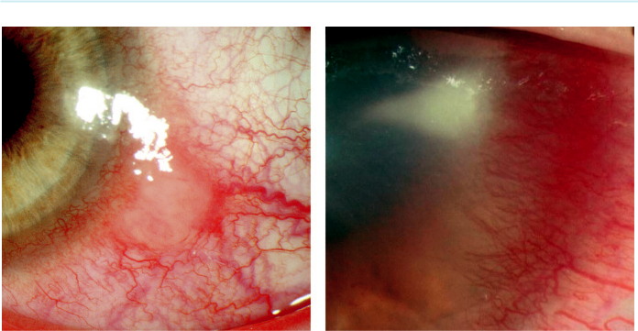

A B

Fig. 7.11 Phlyctenulosis: (A) limbal, (B) corneal. (Figure 7.11B courtesy of S. Tuft.)

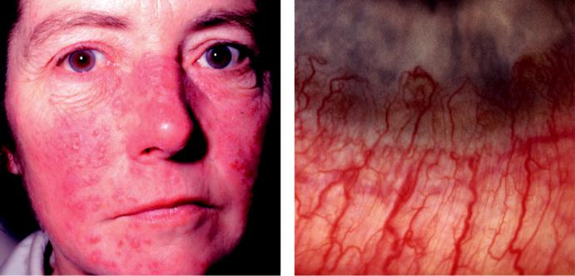

A B

Fig. 7.12 Rosacea: (A) facial appearance with papulopustular signs, (B) peripheral corneal vascularization. (From

Salmon JF, Kanski’s Clinical Ophthalmology: A Systematic Approach, 9th edition. Oxford, UK: Elsevier; 2020.)

**Treatment**

***General***: (a) avoidance of trigger factors (e.g. alcohol, spicy food), (b) topical metronidazole gel, azelaic acid cream, (c) oral isotretinoin (not in pregnancy), (d) oral tetracycline (not in children or in pregnant or breast-feeding women); alternatives include clarithromycin and metronidazole. ***Ocular***: (a) lubricants for mild symptoms, (b) hot compresses and lid hygiene, (c) topical antibiotics such as fusidic acid ointment to the lid margins at bedtime for 4 weeks, (d) weak topical steroids for exacerbations.

**Severe peripheral corneal ulceration**

Peripheral ulcerative keratitis is caused by an infection until proven otherwise. In the absence of an infection, consider the following:

#*" ##%"#"+!#(&&%"'+$'""#* "%#! " +#!+ &)%#"$'!%

#%$%&#" (&#" +##'%(&&*'#('$%!&&#"#$+%', &)%" %'&%&%)

|  |  |
| --- | --- |
| Chapter 7—CORNEA | **123** |
|  |  |

**MOOREN ULCER**

**Pathogenesis:**

probably an autoimmune disease, characterized by progressive peripheral stromal ulceration. One form aects predominantly older patients, whereas the second tends to occur in younger individu - als, is more aggressive, more likely to be bilateral and less responsive to treatment.

**Diagnosis**

***Cornea***: (a) peripheral ulceration involving the superficial stroma, with variable epithelial loss,

1. circumferential (Fig. 7.13A) and then central thinning with an undermined infiltrated leading edge, (c) vascularization involving the bed of the ulcer up to its leading edge but not beyond (Fig. 7.13B), (d) healing characterized by thinning, vascularization and scarring.

***Complications***: (a) severe astigmatism, (b) perforation following minor trauma (spontaneous perforation is rare), (c) secondary bacterial infection, (d) cataract, (e) glaucoma.

***Dierential diagnosis*** : ulceration associated with systemic autoimmune disease (see below).

**Treatment**

***Topical***: lubricants, steroids, ciclosporin, and acetylcysteine 10%.

***Conjunctival resection***: if no response to topical therapy.

***Systemic***: immunosuppressives for bilateral or advanced disease (e.g. ciclosporin, predniso-lone, methotrexate, azathioprine).

***Lamellar keratectomy***: dissection of the residual central island in advanced disease may remove the stimulus for further inflammation.

**PERIPHERAL ULCERATIVE KERATITIS ASSOCIATED WITH SYSTEMIC AUTOIMMUNE DISEASE**

**Systemic associations:**

rheumatoid arthritis is the most common, followed by granulomatosis with polyangiitis; occasion-ally, relapsing polychondritis, systemic lupus erythematosus and Crohn disease.

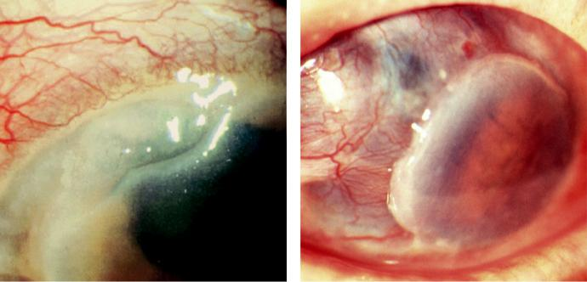

A B

Fig. 7.13 Mooren ulcer: (A) local peripheral ulceration, (B) advanced disease. (From Salmon JF, Kanski’s

Clinical Ophthalmology: A Systematic Approach, 9th edition. Oxford, UK: Elsevier; 2020.)

#*" ##%"#"+!#(&&%"'+$'""#* "%#! " +#!+ &)%#"$'!%

#%$%&#" (&#" +##'%(&&*'#('$%!&&#"#$+%', &)%" %'&%&%)

**124** SYNOPSIS OF CLINICAL OPHTHALMOLOGY



**Diagnosis**

Crescentic ulceration and stromal infiltration at the limbus (Fig. 7.14A).

Limbitis, episcleritis, or scleritis is usually present.

Circumferential and occasionally central spread. In contrast to Mooren ulcer, the process

may also extend into the sclera.

End-stage disease may result in a ‘contact lens’ cornea (Fig. 7.14B).

**Treatment**

***Systemic***: (a) high dose steroids to control acute disease, (b) cytotoxic therapy for long-term management, (c) tetracycline to retard thinning.

***Topical***: lubricants; steroids are generally avoided because they may worsen thinning.

***Other***: conjunctival excision if medical treatment is ineective.

**TERRIEN MARGINAL DEGENERATION**

**Definition:**

uncommon idiopathic thinning of the peripheral cornea. It is bilateral in 75% of patients, the majority of whom are older males.

**Diagnosis**

***Presentation***: asymptomatic.

***Signs***: (a) fine yellow-white punctate peripheral stromal opacities, frequently associated with mild superficial vascularization which start superiorly, spread circumferentially and are separated from the limbus by a clear zone, (b) peripheral guttering (Fig. 7.15A) and rarely perforation, either spontaneously or following blunt trauma, (c) gradual visual dete-rioration mainly due to astigmatism, (d) formation of pseudopterygia in long-standing cases (Fig. 7.15B).

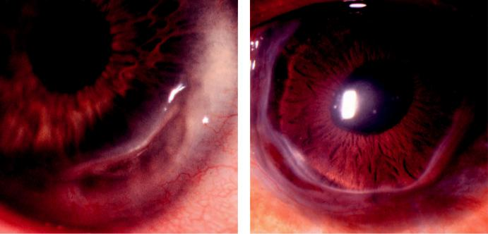

A B

Fig. 7.14 Peripheral ulcerative keratitis: (A) early crescentic ulceration in rheumatoid arthritis, (B) end-stage

disease (‘contact lens cornea’). (From Salmon JF, Kanski’s Clinical Ophthalmology: A Systematic Approach,

9th edition. Oxford, UK: Elsevier; 2020.)

#*" ##%"#"+!#(&&%"'+$'""#* "%#! " +#!+ &)%#"$'!%

#%$%&#" (&#" +##'%(&&*'#('$%!&&#"#$+%', &)%" %'&%&%)

|  |  |
| --- | --- |
| Chapter 7—CORNEA | **125** |
|  |  |

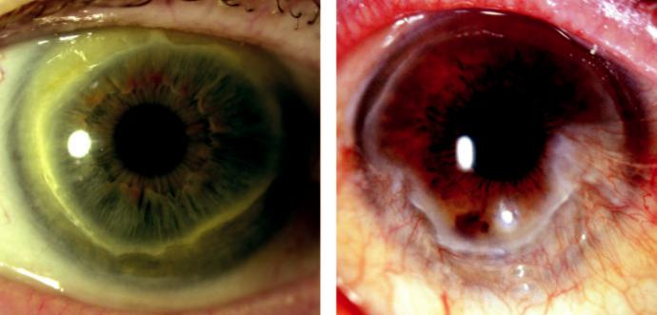

A B

Fig. 7.15 Terrien marginal degeneration: (A) circumferential thinning with peripheral guttering, (B) pseudo-pterygium.

**Treatment**

***General***: safety spectacle lenses if thinning is significant; contact lenses for astigmatism.

***Topical***: lubricants or weak steroids (with caution) for inflammatory episodes.

***Surgery***: crescent-shaped excision of the gutter with suturing of the margins, or peripheral lamellar transplantation; keratoplasty for actual or threatened perforation.

**Neurotrophic keratopathy**

**Pathogenesis:**

loss of trigeminal innervation to the cornea resulting in partial or complete anaesthesia. Causes include: (a) ocular disease (e.g. herpes zoster keratitis), (b) focal neurological disease (e.g. acoustic neuroma), (c) generalized conditions (e.g. diabetes, leprosy).

**Diagnosis**

Corneal sensation is tested with a wisp of cotton or an anaesthesiometer.

Interpalpebral punctate keratopathy; mild epithelial opacification, oedema, and small epithelial defects.

Persistent epithelial defect in which the epithelium at the edge of the lesion appears rolled and thickened (Fig. 7.16A).

Stromal oedema, infiltration, melting and occasionally perforation (Fig. 7.16B).

**Treatment**

***Protection of the ocular surface***: (a) taping of the lids, particularly at night, (b) botulinum toxin-induced ptosis, (c) tarsorrhaphy (temporary or permanent), (d) contact lens (with careful monitoring).

***Topical lubricants (non-preserved)***.

***Amniotic membrane patching***.

***Corneal neurotization***: from the contralateral supratrochlear nerve using a sural nerve graft.

***Cenegermin***: a topical human nerve growth factor for moderate/severe cases.

#*" ##%"#"+!#(&&%"'+$'""#* "%#! " +#!+ &)%#"$'!%

#%$%&#" (&#" +##'%(&&*'#('$%!&&#"#$+%', &)%" %'&%&%)

**126** SYNOPSIS OF CLINICAL OPHTHALMOLOGY

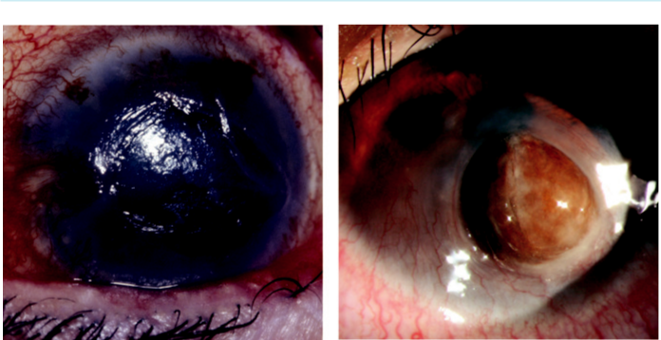

A B

Fig. 7.16 Neurotrophic keratopathy: (A) large epithelial defect, (B) melting with iris prolapse. (Figure 7.16A courtesy of S. Tuft.)

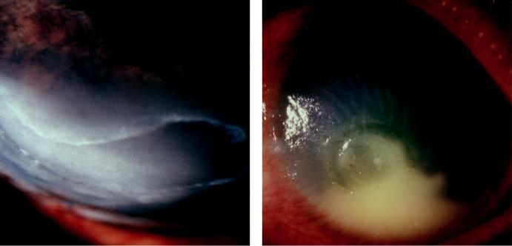

A B

Fig. 7.17 Exposure keratopathy: (A) inferior epithelial defect, (B) secondary bacterial infection. (Figure 7.17B courtesy of T. Carmichael.)

**Exposure keratopathy**

**Pathogenesis:**

inadequate lid closure (lagophthalmos), resulting in inadequate corneal wetting. Causes include facial nerve palsy, reduced muscle tone as in coma or parkinsonism, mechanical (e.g. eyelid scar-ring), and severe proptosis.

**Diagnosis**

***Presentation***: symptoms are those of dry eye.

***Signs***: (a) mild inferior third punctate epithelial changes, often progressing to breakdown (Fig. 7.17A), (b) stromal melting (sometimes with perforation), (c) secondary infection (Fig. 7.17B), (d) inferior fibrovascular change.

#*" ##%"#"+!#(&&%"'+$'""#* "%#! " +#!+ &)%#"$'!%

#%$%&#" (&#" +##'%(&&*'#('$%!&&#"#$+%', &)%" %'&%&%)

|  |  |
| --- | --- |
| Chapter 7—CORNEA | **127** |
|  |  |

**Treatment**

***Reversible exposure***: (a) daytime artificial tears, (b) ointment or lid taping at night, (c) ban-dage contact lens, (d) temporary tarsorrhaphy.

***Permanent exposure***: (a) permanent lateral tarsorrhaphy, (b) upper lid gold/platinum weight insertion, (c) permanent central tarsorrhaphy and/or conjunctival flap in extreme cases.

**Miscellaneous keratopathies**

**INFECTIOUS CRYSTALLINE KERATOPATHY**

**Pathogenesis:**

indolent condition usually seen after long-term topical steroid therapy when an epithelial defect has previously been present, especially following penetrating keratoplasty. *Streptococcus viridans* is most commonly isolated.

**Diagnosis:**

1. slowly progressive grey-white branching stromal opacities (Fig. 7.18A), (b) minimal inflamma-tion, (c) intact overlying epithelium.

**Treatment:**

topical antibiotics for several weeks; stopping steroid without adequate antibiotic cover can pre-cipitate a rapid increase in inflammation.

**THYGESON SUPERFICIAL PUNCTATE KERATITIS**

**Definition:**

uncommon, usually bilateral, idiopathic condition characterized by exacerbations and remissions; recurrences can continue for decades.

**Diagnosis**

***Presentation***: typically, in young adult life with recurrent attacks of irritation, photophobia, blurred vision and watering.

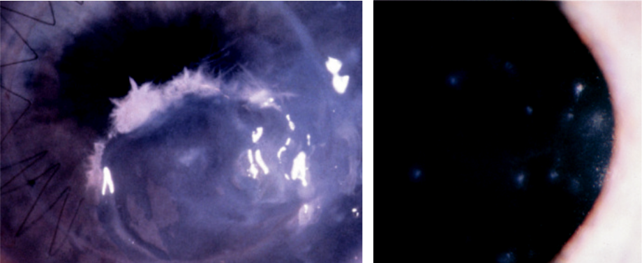

A B

Fig. 7.18 (A) Infectious crystalline keratopathy, (B) Thygeson superficial punctate keratitis.

#*" ##%"#"+!#(&&%"'+$'""#* "%#! " +#!+ &)%#"$'!%

#%$%&#" (&#" +##'%(&&*'#('$%!&&#"#$+%', &)%" %'&%&%)

**128** SYNOPSIS OF CLINICAL OPHTHALMOLOGY



***Signs***: (a) central, coarse, distinct, granular, greyish, slightly elevated epithelial lesions (Fig. 7.18B) which stain with fluorescein, (b) mild subepithelial haze if topical antivirals have been used; the conjunctiva is uninvolved, and the eye is not hyperaemic.

***Dierential diagnosis*** : adenoviral keratitis.

**Treatment**

***Topical***: (a) lubricants in mild cases, (b) steroids (e.g. fluorometholone 0.1% or loteprednol 0.2%) twice daily, (c) ciclosporin 0.05% is a good alternative to steroids, particularly long term, (d) bandage contact lenses.

***Phototherapeutic keratectomy***: confers short-term relief but recurrence is likely.

**FILAMENTARY KERATOPATHY**

**Pathogenesis:**

focal deposition of mucus and cellular debris at loose areas of epithelium. Causes include: (a) dry eye, (b) excessive contact lens wear, (c) recurrent erosions, (d) superior limbic keratoconjunctivitis, (e) neurotrophic keratopathy, (f ) prolonged eye closure.

**Diagnosis**

***Presentation***: discomfort with foreign body sensation and redness.

***Signs***: (a) strands of degenerated epithelial cells and mucous (Fig. 7.19A), which move with blinking and are attached at one end to the cornea, (b) filaments stain better with rose Bengal than with fluorescein (Fig. 7.19B), (c) chronic filaments may form plaques.

**Treatment**

An underlying cause such as dry eye should be treated.

Mechanical removal of filaments provides short-term relief.

Mucolytic drops (e.g. acetylcysteine 5% or 10%).

NSAIDs (e.g. diclofenac).

Hypertonic (5%) saline may encourage adhesion of loose epithelium.

Bandage contact lenses of high oxygen permeability.

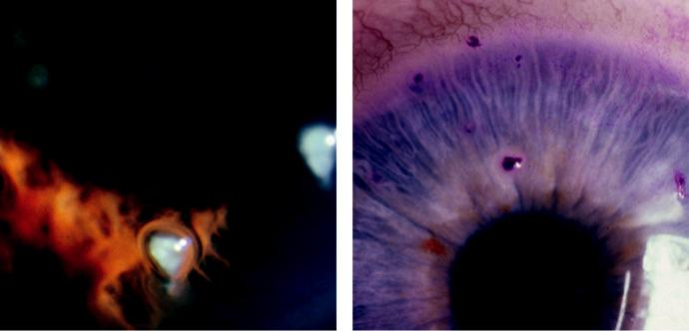

A B

Fig. 7.19 Filamentary keratopathy: (A) mucous strands, (B) filaments staining with rose Bengal. (Figure 7.19A courtesy of S. Tuft; Figure 7.19B courtesy of R. Bates.)

#*" ##%"#"+!#(&&%"'+$'""#* "%#! " +#!+ &)%#"$'!%

#%$%&#" (&#" +##'%(&&*'#('$%!&&#"#$+%', &)%" %'&%&%)

|  |  |
| --- | --- |
| Chapter 7—CORNEA | **129** |
|  |  |

**Recurrent corneal epithelial erosion**

**Pathogenesis:**

tendency for minor trauma to precipitate significant corneal epithelial disturbance, due to an abnormally weak attachment between the epithelium and the underlying basement membrane. Eyelid–corneal interaction during sleep is a typical precipitant. May be associated with some corneal dystrophies (see below).

**Diagnosis**

***Presentation***: severe pain, photophobia, redness, blepharospasm and watering, often waking the patient during the night or present on waking in the morning. ere is often a prior history of corneal abrasion.

***Signs***: a frank epithelial defect may not be present because healing can be very rapid (hours), but the extent of loose epithelium may be highlighted by areas of pooling of fluorescein and rapid tear film breakup.

**Treatment**

***Acute lesions***: (a) antibiotic ointment and a cycloplegic, (b) topical diclofenac 0.1% reduces pain (topical anaesthetic dramatically relieves pain but should not be dispensed for patient use), (c) bandage contact lens, (d) debridement of heaped/scrolled areas of epithelium with a cellulose sponge, (e) hypertonic sodium chloride drops and ointment may improve epithe-lial adhesion, (f ) following resolution, prophylactic topical lubricant such as carbomer gel four times daily for several months.

***Prophylaxis for recurrent episodes***: (a) long-term gel or ointment instilled at bedtime,

1. debridement of the epithelium of involved areas (may be followed by smoothing of Bowman layer with a diamond burr or excimer laser), (c) long-term extended-wear ban-dage contact lens, (d) anterior stromal puncture for localized areas not involving the visual axis.

**Xerophthalmia**

**Pathogenesis:**

severe deficiency of vitamin A.

**Diagnosis**

***Presentation***: night blindness (nyctalopia), ocular discomfort and impairment of vision.

***Conjunctiva***: (a) xerosis (dryness of the interpalpebral conjunctiva with loss of goblet cells and squamous metaplasia/keratinization), (b) Bitot spots (triangular patches of foamy kera-tinized epithelium) (Fig. 7.20A).

***Cornea***: (a) lack of lustre, (b) interpalpebral punctate corneal epithelial erosions which can progress to epithelial defects, (c) keratinization, (d) corneal melting by liquefactive necrosis (keratomalacia) (Fig. 7.20B).

***Retinopathy***: yellowish peripheral dots in advanced cases.

**Treatment**

***Systemic***: oral vitamin A (intramuscular for keratomalacia, which is an indicator of very severe deficiency, with risk of death), multivitamin supplements and dietary sources of vita-min A.

***Topical***: intense lubrication and retinoic acid to promote healing, but is insucient without systemic supplements.

#*" ##%"#"+!#(&&%"'+$'""#* "%#! " +#!+ &)%#"$'!%

#%$%&#" (&#" +##'%(&&*'#('$%!&&#"#$+%', &)%" %'&%&%)

**130** SYNOPSIS OF CLINICAL OPHTHALMOLOGY

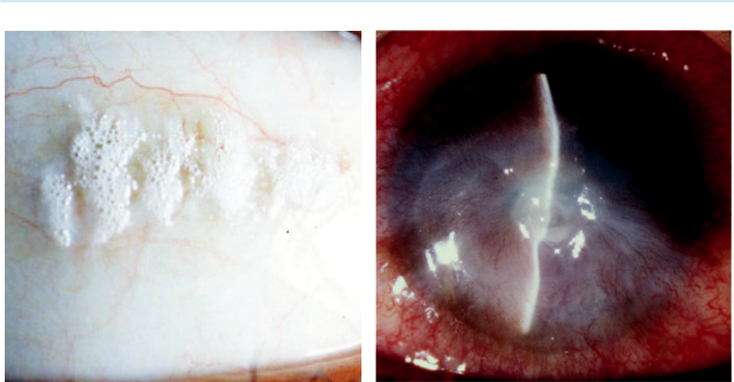

A B

Fig. 7.20 Xerophthalmia: (A) Bitot spots, (B) keratomalacia.

**Corneal ectasias**

**KERATOCONUS**

**Introduction**

***Definition***: progressive disorder in which the cornea assumes a conical protruding shape (Fig. 7.21A). Both eyes are aected in almost all cases, although asymmetrically.

***Systemic associations***: (a) Down, Turner, Ehlers–Danlos and Marfan syndromes, (b) atopy,

(c) osteogenesis imperfecta.

***Ocular associations***: (a) vernal keratoconjunctivitis, (b) aniridia, (c) retinitis pigmentosa,

(d) persistent eye rubbing.

**Diagnosis**

***Presentation***: during adolescence with unilateral progressive myopia and irregular astigmatism.

***Signs***: (a) central or paracentral stromal thinning, accompanied by apical protrusion,

1. red reflex shows a fairly well-delineated ‘oil droplet’ (Fig. 7.21B), (c) retinoscopy shows an irregular ‘scissoring’ reflex, (d) fine vertical deep stromal stress lines (Vogt striae), (e) epi-thelial iron deposits may surround the base of the cone (Fleischer ring), (f ) bulging of the lower lid in downgaze (Munson sign) (Fig. 7.21C).

***Acute hydrops***: occurs when a rupture in Descemet membrane allows an influx of aqueous, causing acute discomfort and blurring (Fig. 7.21D). Stromal scarring may develop. ***Investigations***: (a) keratometry shows steep readings, (b) topography detects early keratoco-nus and can be used to monitor progression.

**Treatment**

***Optical***: spectacles or soft contact lenses in early cases, progressing to rigid lenses as the disease advances.

***Surgery***: (a) keratoplasty in advanced disease (penetrating or deep anterior lamellar kerato-plasty (DALK), (b) intracorneal ring segment (Intacs) implantation is usually of moderate benefit.

#*" ##%"#"+!#(&&%"'+$'""#* "%#! " +#!+ &)%#"$'!%

#%$%&#" (&#" +##'%(&&*'#('$%!&&#"#$+%', &)%" %'&%&%)

|  |  |
| --- | --- |
| Chapter 7—CORNEA | **131** |
|  |  |

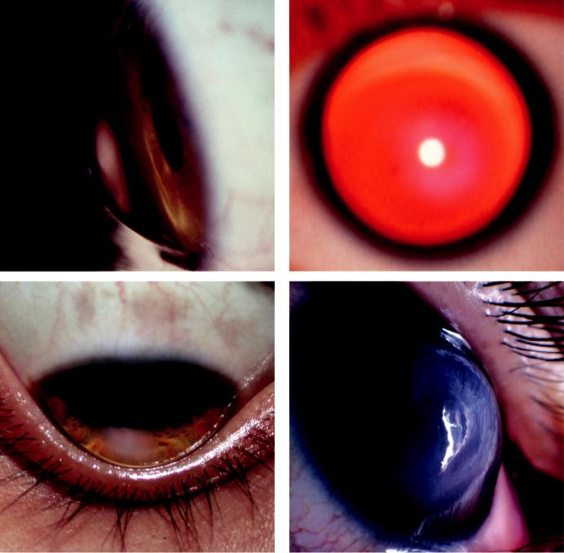

A B

C D

Fig. 7.21 Keratoconus: (A) typical cone, (B) ‘oil droplet’ red reflex, (C) Munson sign, (D) acute hydrops. (Figure 7.21A courtesy of W. Lisch; Figure 7.21B courtesy of T. Carmichael; Figure 7.21D courtesy of Chris Barry, Lions Eye Institute, Perth, Australia.)

***Corneal collagen cross-linking***: using riboflavin drops to photosensitize the eye followed by exposure to ultraviolet-A light; can be combined with Intacs insertion.

***Of acute hydrops***: (a) cycloplegia, (b) hypertonic (5%) saline ointment, (c) patching or a bandage contact lens.

**PELLUCID MARGINAL DEGENERATION**

**Definition:**

rare, usually bilateral, progressive peripheral corneal thinning, typically involving the inferior region.

**Diagnosis**

***Presentation***: 4th or 5th decade with blurring of vision.

***Signs***: crescentic band of slowly progressive inferior thinning (Fig. 7.22A); acute hydrops is rare.

***Topography***: ‘butterfly’ pattern with diuse steepening inferiorly ( Fig. 7.22B).

#*" ##%"#"+!#(&&%"'+$'""#* "%#! " +#!+ &)%#"$'!%

#%$%&#" (&#" +##'%(&&*'#('$%!&&#"#$+%', &)%" %'&%&%)

**132** SYNOPSIS OF CLINICAL OPHTHALMOLOGY

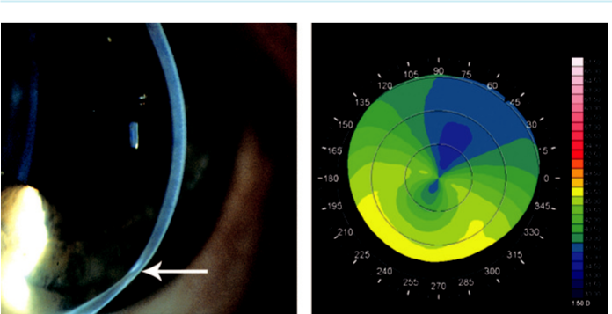

A B

Fig. 7.22 Pellucid marginal degeneration: (A) crescentic band of inferior corneal thinning (arrow), (B) topog-raphy showing severe astigmatism and steepening of inferior cornea. (From Salmon JF, Kanski’s Clinical Ophthalmology: A Systematic Approach, 9th edition. Oxford, UK: Elsevier; 2020.)

**Treatment:**

1. spectacles usually fail early, necessitating contact lenses; (b) surgery is more dicult than in keratoconus. Options include large eccentric penetrating keratoplasty and collagen cross-linking.

**KERATOGLOBUS**

**Definition:**

extremely rare congenital condition in which the entire cornea is abnormally thin; possibly geneti-cally related to keratoconus.

**Diagnosis**

***Signs***: generalized thinning, with globular rather than conical ectasia. e cornea is more prone to rupture from relatively mild trauma, but acute hydrops is rare.

***Dierential diagnosis*** : congenital glaucoma (enlarged diameter) and megalocornea (absence of thinning).

**Treatment:**

care to protect the eyes and scleral contact lenses.

**Corneal dystrophies**

**EPITHELIAL DYSTROPHIES**

**Introduction:**

Cogan epithelial basement membrane dystrophy is the most common corneal dystrophy seen in clinical practice. It is usually sporadic and rarely AD. Other epithelial dystrophies (Meesmann and the clinically similar Lisch) are very rare.

**Diagnosis**

***Presentation***: in the 3rd decade with recurrent corneal erosions, often bilateral; many cases are asymptomatic.

#*" ##%"#"+!#(&&%"'+$'""#* "%#! " +#!+ &)%#"$'!%

#%$%&#" (&#" +##'%(&&*'#('$%!&&#"#$+%', &)%" %'&%&%)

|  |  |
| --- | --- |
| Chapter 7—CORNEA | **133** |
|  |  |

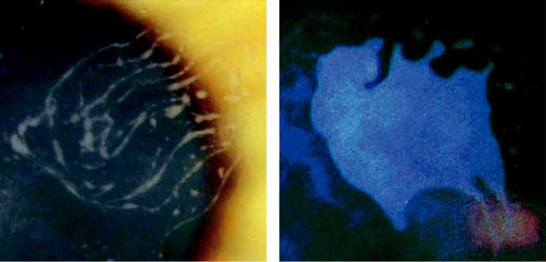

A B

Fig. 7.23 Cogan epithelial basement membrane dystrophy: (A) fingerprint-like appearance, (B) map-like pat-

tern. (From Salmon JF, Kanski’s Clinical Ophthalmology: A Systematic Approach, 9th edition. Oxford, UK:

Elsevier; 2020.)

***Signs*** are often subtle or even absent. ey may include: (a) dot-like opacities, (b) epithelial microcysts, (c) whorled fingerprint-like lines (Fig. 7.23A), (d) subepithelial map-like pat-terns surrounded by a faint haze (Fig. 7.23B).

**Treatment:**

that of recurrent corneal erosions (see above).

**BOWMAN LAYER/ANTERIOR STROMAL DYSTROPHIES**

**Genetics and histology**

***Reis–Bücklers***: AD (gene *TGFB1*); Bowman layer and epithelial basement membrane are replaced by fibrous tissue.

***iel–Behnke*** : AD (two main genes implicated, including *TGFB1*); ‘curly fibres’ in Bowman layer on electron microscopy.

***Schnyder central crystalline***: AD disorder of corneal lipid metabolism associated with raised serum cholesterol in 50%.

**Diagnosis**

***Reis–Bücklers***: onset in the 1st or 2nd decade with severe recurrent corneal erosions. Fine grey-white polygonal subepithelial opacities, most dense centrally (Fig. 7.24A). ***iel–Behnke*** : onset at end of the 1st decade with recurrent erosions. Central honeycomb pattern subepithelial opacities.

***Schnyder central crystalline***: onset in the 2nd decade with visual impairment and glare. Central subepithelial crystalline changes progressing by the 3rd decade to diuse haze and dense corneal arcus (Fig. 7.24B).

**Treatment**

***Reis–Bücklers***: recurrent erosions (see above) are the main concern. Excimer laser keratec-tomy achieves satisfactory control, as well as visual benefit, in many patients. ***iel–Behnke*** : surgery is required less often than in Reis–Bücklers.

***Schnyder***: usually excimer laser keratectomy.

#*" ##%"#"+!#(&&%"'+$'""#* "%#! " +#!+ &)%#"$'!%

#%$%&#" (&#" +##'%(&&*'#('$%!&&#"#$+%', &)%" %'&%&%)

**134** SYNOPSIS OF CLINICAL OPHTHALMOLOGY

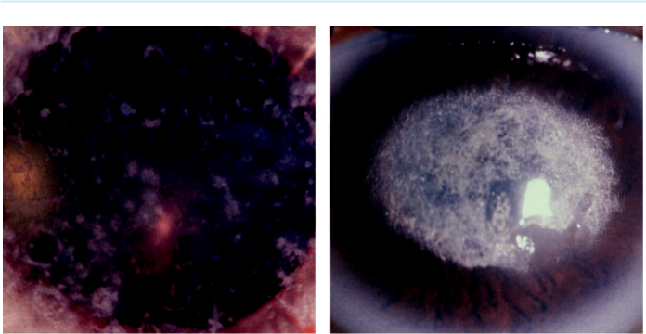

A B

Fig. 7.24 (A) Reis-Bücklers dystrophy, (B) Schnyder central crystalline dystrophy. (Figure 7.24A from Salmon JF, Kanski’s Clinical Ophthalmology: A Systematic Approach, 9th edition. Oxford, UK: Elsevier; 2020; Figure7.24B courtesy of T. Carmichael.)

**STROMAL DYSTROPHIES**

**Genetics and histology**

***Lattice type I***: AD (gene *TGFB1*). Stromal amyloid staining with Congo red on histology, with characteristic green birefringence when viewed with a polarizing filter.

***Lattice type II, gelsolin type (Meretoja syndrome)***: AD; systemic and corneal amyloid.

***Lattice type IIIA***: AD (gene *TGBF1*); corneal amyloid.

***Granular type I (classic)***: AD (gene *TGFB1*); hyaline deposits staining with Masson trichrome.

***Granular type II (Avellino)***: AD (gene *TGFB1*); hyaline and amyloid deposition.

***Macular***: rare autosomal recessive (AR) inborn error of keratan sulphate metabolism.

**Diagnosis**

***Lattice type I***: onset at the end of the 1st decade with recurrent erosions, preceding stromal changes; anterior stromal refractile dots coalescing into a fine lattice, sparing the periphery; vision progressively impaired by haze.

***Lattice type II***: onset in the 2nd decade; erosions are rare; short, sparse, fine lattice lines more radially orientated and peripheral than type I. Systemic features include progressive neuropathy, a characteristic ‘mask-like’ facial expression and renal and cardiac problems.

***Lattice type IIIA***: onset in old age; rope-like bands of amyloid (Fig. 7.25A).

***Granular type I***: onset 1st decade; vision is usually unaected until later. Small white depos - its resembling sugar granules, separated by clear, but later hazy, stroma (Fig. 7.25B). ***Granular type II (Avellino)***: onset in 2nd decade. Superficial opacities resembling rings, stars, or snowflakes, most dense centrally (Fig. 7.25C).

***Macular***: onset in late 1st decade with visual deterioration. Anterior stromal haze, initially central, with greyish-white, dense, poorly delineated lesions (Fig. 7.25D) with eventual involvement of full-thickness stroma up to the limbus.

**Treatment**

***Lattice type I***: penetrating or deep lamellar keratoplasty is frequently required; recurrence in the graft may occur.

***Lattice type II***: keratoplasty may rarely be required in later life to improve vision.

#*" ##%"#"+!#(&&%"'+$'""#* "%#! " +#!+ &)%#"$'!%

#%$%&#" (&#" +##'%(&&*'#('$%!&&#"#$+%', &)%" %'&%&%)

|  |  |
| --- | --- |
| Chapter 7—CORNEA | **135** |
|  |  |

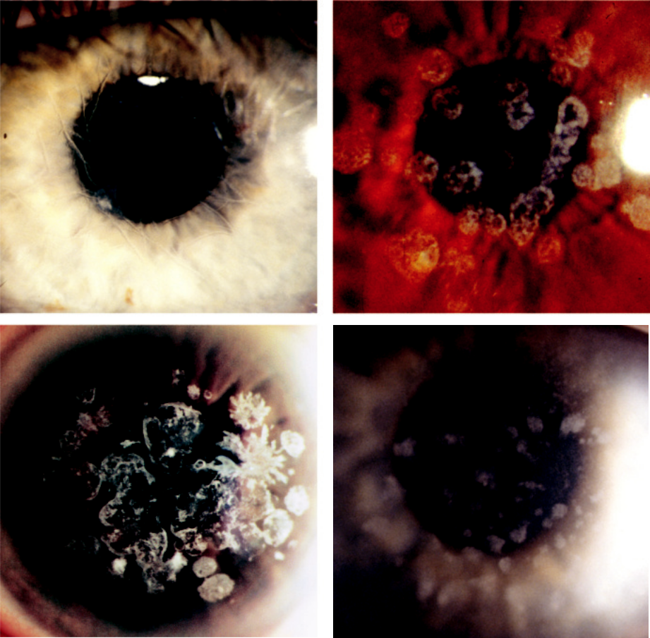

A B

C D

Fig. 7.25 Stromal dystrophy: (A) lattice, (B) granular type I, (C) granular type II (Avellino), (D) macular. (Figure 7.25C courtesy of W. Lisch.)

***Granular type I***: keratoplasty usually required by the 5th decade, with later superficial kera-tectomy for anterior recurrences.

***Granular type II (Avellino)***: treatment is usually not required.

***Macular***: penetrating keratoplasty; recurrence in the graft may occur.

**ENDOTHELIAL DYSTROPHIES**

**Genetics and histology**

***Fuchs endothelial***: majority sporadic, occasionally AD. Bilateral accelerated endothelial cell loss.

***Posterior polymorphous (PPCD)***: genetically heterogeneous with three distinct types; endo-thelial cells display characteristics similar to epithelium.

C***ongenital hereditary (CHED)***: AD and AR forms; focal or generalized absence of endothelium.

#*" ##%"#"+!#(&&%"'+$'""#* "%#! " +#!+ &)%#"$'!%

#%$%&#" (&#" +##'%(&&*'#('$%!&&#"#$+%', &)%" %'&%&%)

**136** SYNOPSIS OF CLINICAL OPHTHALMOLOGY



**Diagnosis**

***Fuchs***: (a) onset in old age initially with cornea guttata (Fig. 7.26A), which are excrescences on Descemet membrane secreted by abnormal endothelial cells, (b) slow progression to a ‘beaten metal’ appearance, (c) endothelial decompensation leading to stromal then epithelial oedema with blurred vision, worse in the morning, (d) formation of epithelial bullae (bul-lous keratopathy) with discomfort on rupture (Fig. 7.26B), (e) cataract surgery accelerates endothelial cell loss. Persistent corneal oedema may occur postoperatively if the preopera-tive central corneal thickness is more than 630–640 microns.

***PPCD***: typically identified incidentally; subtle bilateral vesicular endothelial lesions of vari-able appearance (Fig. 7.26C).

***CHED***: perinatal onset; bilateral, symmetrical, diuse corneal oedema ranging from a blue-grey, ground-glass appearance (Fig. 7.26D) to total opacification; visual impairment is variable. Dierential diagnosis includes other causes of neonatal corneal opacification: (a) congenital glaucoma, (b) birth trauma, (c) sclerocornea.

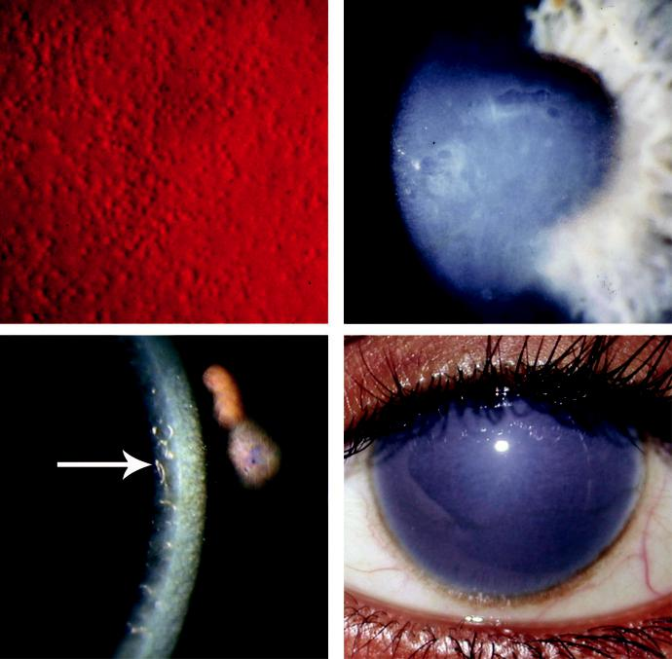

A B

C D

Fig. 7.26 Corneal dystrophy: (A) cornea guttata in Fuchs endothelial dystrophy, (B) bullous keratopathy,

1. posterior polymorphous dystrophy (arrow), (D) congenital hereditary endothelial dystrophy. (Figure 7.26C courtesy of W. Lisch.)

#*" ##%"#"+!#(&&%"'+$'""#* "%#! " +#!+ &)%#"$'!%

#%$%&#" (&#" +##'%(&&*'#('$%!&&#"#$+%', &)%" %'&%&%)

|  |  |
| --- | --- |
| Chapter 7—CORNEA | **137** |
|  |  |

**Treatment**

***Fuchs***: (a) topical sodium chloride 5% drops or ointment, (b) reduction of intraocular pres-sure, (c) hair dryer to speed dehydration in the morning, (d) bandage contact lens for com-fort, (e) keratoplasty (penetrating or Descemet stripping endothelial keratoplasty [DSEK]). ***PPCD***: not required.

***CHED***: early keratoplasty is technically dicult but has reasonable success; delay is likely to worsen amblyopia.

**Corneal degenerations**

**AGE-RELATED DEGENERATIONS**

**Diagnosis**

***Arcus senilis***: perilimbal stromal lipid deposition, initially superior and inferior, progressing circumferentially to form a band approximately 1 mm wide separated from the limbus by a clear zone (Fig. 7.27A). Extremely common in the elderly, but in younger individuals may be associated with dyslipidaemia.

***Vogt limbal girdle***: common and innocuous arc-like whitish bands of chalk-like flecks at 9 and/or 3 o’clock, more common nasally; (a) type I has a ‘Swiss cheese’ hole pattern and a clear peripheral band (Fig. 7.27B), (b) type II does not show holes and sometimes there is no clear zone.

***Cornea farinata***: uncommon and innocuous minute flour-like deposits in the deep stroma, most prominent centrally.

***Crocodile shagreen***: uncommon and innocuous greyish-white polygonal stromal (usu-ally anterior) opacities, separated by relatively clear spaces (Fig. 7.27C) resembling central cloudy dystrophy of François.

***West Indian punctate keratopathy***: uncommon condition of unknown cause. Seen in elderly asymptomatic individuals of West Indian origin, with male preponderance. A few round white lesions of less than 0.5 mm at the level of Bowman membrane within the interpalpe-bral fissure (Fig. 7.27D).

**Treatment:**

not required, although arcus senilis in a young person should prompt investigation for a lipid abnormality.

**LIPID KERATOPATHY**

**Pathogenesis:**

the primary form is rare and occurs spontaneously (Fig. 7.28A). Secondary lipid keratopathy is associated with corneal vascularization due to injury or disease (e.g. herpes simplex and zoster) (Fig. 7.28B).

**Diagnosis:**

white-yellow stromal deposits with or without vascularization, with a pattern dependent on any identifiable causative pathology

**Treatment**

***Control*** of any underlying inflammatory disease is critical.

***Photocoagulation of arterial feeder vessels***: may induce resorption; needle cautery is an alternative.

***Penetrating keratoplasty***: may be required in advanced disease, although the prognosis is often guarded.

#*" ##%"#"+!#(&&%"'+$'""#* "%#! " +#!+ &)%#"$'!%

#%$%&#" (&#" +##'%(&&*'#('$%!&&#"#$+%', &)%" %'&%&%)

**138** SYNOPSIS OF CLINICAL OPHTHALMOLOGY

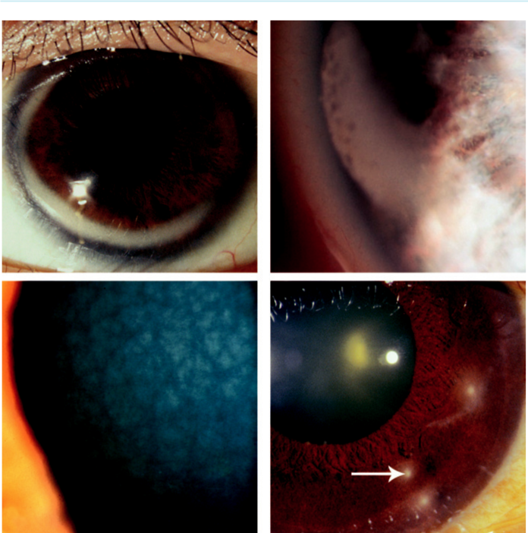

A B

C D

Fig. 7.27 Corneal degeneration: (A) arcus senilis, (B) Vogt limbal girdle, (C) crocodile shagreen, (D) West Indian

punctate keratopathy (arrow). (From Salmon JF, Kanski’s Clinical Ophthalmology: A Systematic Approach, 9th

edition. Oxford, UK: Elsevier; 2020.)

**BAND KERATOPATHY**

**Introduction**

***Definition***: band-like deposition of calcium salts in Bowman layer, epithelial basement membrane and anterior stroma.

***Ocular causes***: (a) chronic anterior uveitis (especially JIA), (b) glaucoma, (c) phthisis bulbi, (d) silicone oil in the anterior chamber.

S***ystemic causes***: (a) age-related (common) and metastatic calcification secondary to hyper-calcaemia (very rare).

**Diagnosis:**

1. starts as peripheral interpalpebral calcification with a clear marginal zone (Fig. 7.29A),
2. gradual central spread as a plaque containing small holes (Fig. 7.29B), (c) elevation of calcium may result in epithelial breakdown and discomfort.

#*" ##%"#"+!#(&&%"'+$'""#* "%#! " +#!+ &)%#"$'!%

#%$%&#" (&#" +##'%(&&*'#('$%!&&#"#$+%', &)%" %'&%&%)

|  |  |
| --- | --- |
| Chapter 7—CORNEA | **139** |
|  |  |

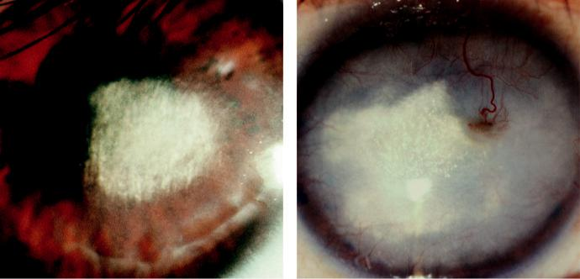

A B

Fig. 7.28 Lipid keratopathy: (A) primary, (B) secondary to corneal vascularization. (Figure 7.28B courtesy of T. Carmichael.)

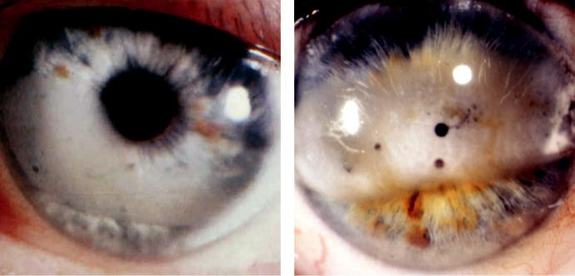

A B

Fig. 7.29 Band keratopathy: (A) peripheral, (B) plaque containing small holes. (From Salmon JF, Kanski’s

Clinical Ophthalmology: A Systematic Approach, 9th edition. Oxford, UK: Elsevier; 2020.)

**Treatment:**

for discomfort or for visual compromise in a seeing eye.

Underlying ocular or systemic disease should be addressed.

Chelation: with ethylenediaminetetraacetic acid (EDTA) 1.5–3.0%.

Large chips of calcium: can be removed with forceps and a blade.

Other options (a) removal with a diamond burr, (b) excimer laser keratectomy, (c) lamellar keratoplasty.

**SPHEROIDAL DEGENERATION (LABRADOR KERATOPATHY)**

**Pathogenesis:**

bilateral condition typically occurring in men working outdoors; ultraviolet exposure is probably a key aetiological factor.

#*" ##%"#"+!#(&&%"'+$'""#* "%#! " +#!+ &)%#"$'!%

#%$%&#" (&#" +##'%(&&*'#('$%!&&#"#$+%', &)%" %'&%&%)

**140** SYNOPSIS OF CLINICAL OPHTHALMOLOGY

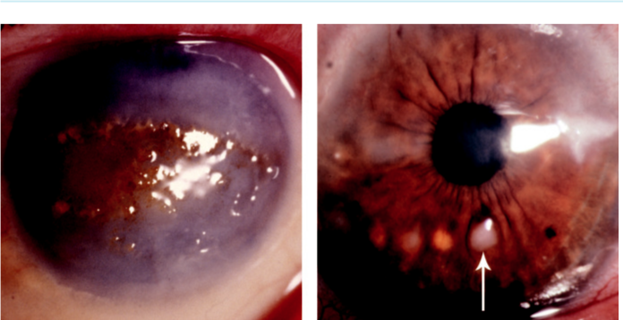

A B

Fig. 7.30 (A) Spheroidal degeneration, (B) Salzmann nodular degeneration. (From Salmon JF, Kanski’s Clinical Ophthalmology: A Systematic Approach, 9th edition. Oxford, UK: Elsevier; 2020.)

**Diagnosis:**

1. amber-coloured granules in the interpalpebral superficial stroma, (b) advanced lesions are nodular and the surrounding stroma is often hazy (Fig. 7.30A).

**Treatment:**

sunglasses to reduce ultraviolet exposure and superficial keratectomy or lamellar keratoplasty to improve vision.

**SALZMANN NODULAR DEGENERATION**

**Pathogenesis:**

chronic corneal irritation or inflammation.

**Diagnosis:**

blue-grey or whitish elevated nodular superficial stromal opacities in scarred cornea or at the edge of transparent cornea (Fig. 7.30B).

**Treatment:**

principally of the underlying cause; may require surgery as for spheroidal degeneration.

**Metabolic keratopathies**

**CYSTINOSIS**

**Pathogenesis:**

AR disorder characterized by widespread tissue deposition of cystine crystals; ‘ocular’ cystinosis is non-nephropathic.

**Diagnosis**

***Presentation***: by age of 1 year with photophobia, recurrent erosions and blepharospasm; visual impairment occurs by the end of the 1st decade.

***Systemic features***: severe growth retardation and early renal failure; death may occur in childhood.

#*" ##%"#"+!#(&&%"'+$'""#* "%#! " +#!+ &)%#"$'!%

#%$%&#" (&#" +##'%(&&*'#('$%!&&#"#$+%', &)%" %'&%&%)

|  |  |
| --- | --- |
| Chapter 7—CORNEA | **141** |
|  |  |

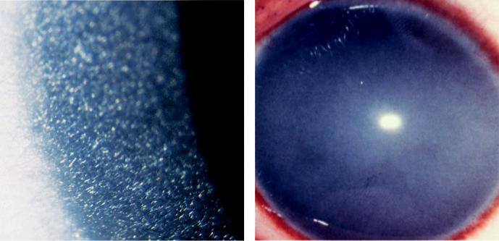

A B

Fig. 7.31 (A) Cystinosis, (B) mucopolysaccharidoses showing diffuse corneal haze. (From Salmon JF, Kanski’s Clinical Ophthalmology: A Systematic Approach, 9th edition. Oxford, UK: Elsevier; 2020.)

***Keratopathy***: diuse cystine crystal deposition in the conjunctiva and cornea ( Fig. 7.31A).

***Other ocular features***: iris, lens and retina may be aected later.

**Treatment:**

systemic cysteamine may forestall renal disease; topical cysteamine to reduce corneal crystals.

**MUCOPOLYSACCHARIDOSES**

**Pathogenesis:**

group of inherited metabolic deficiencies with accumulation of anomalous metabolite in various tissues; inheritance is mainly AR; features vary with the type.

**Diagnosis**

***Systemic features***: (a) facial coarseness, (b) skeletal anomalies, (c) mental handicap, (d) heart disease.

***Keratopathy***: punctate corneal opacification and diuse stromal haze ( Fig. 7.31B) occur in all mucopolysaccharidoses except Hunter and Sanfilippo, but are most severe in Hurler and Scheie syndromes.

***Other ocular features***: (a) pigmentary retinopathy, (b) optic atrophy, (c) occasionally con-genital glaucoma.

**Treatment:**

principally supportive care, although some advances have been made in specific therapies. Bone marrow transplantation is helpful in some cases.

**WILSON DISEASE**

**Pathogenesis:**

deficiency of caeruloplasmin leading to widespread tissue deposition of copper.

#*" ##%"#"+!#(&&%"'+$'""#* "%#! " +#!+ &)%#"$'!%

#%$%&#" (&#" +##'%(&&*'#('$%!&&#"#$+%', &)%" %'&%&%)

**142** SYNOPSIS OF CLINICAL OPHTHALMOLOGY

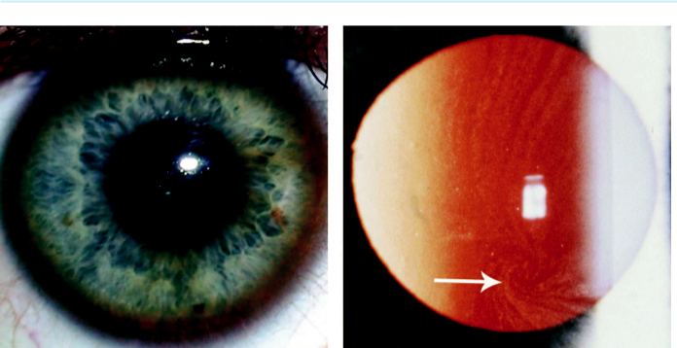

A B

Fig. 7.32 (A) Wilson disease (Kayser–Fleisher ring), (B) Fabry disease; red reflex showing vortex keratopathy (arrow). (Figure 7.32A courtesy of S. Chen.)

**Diagnosis**

***Presentation***: liver disease, basal ganglia dysfunction or psychiatric disturbance.

***Keratopathy***: zone of copper granules in peripheral Descemet membrane (Kayser–Fleischer ring (Fig. 7.32A); best detected on gonioscopy when subtle.

***Another ocular feature***: anterior capsular ‘sunflower’ cataract is less common.

**Treatment:**

1. reduction of copper absorption (e.g. zinc), (b) increased secretion (e.g. penicillamine), (c) liver transplantation may be required.

**FABRY DISEASE**

**Pathogenesis:**

X-linked lysosomal storage disorder caused by deficiency of alpha-galactosidase.

**Diagnosis**

***Systemic features***: (a) periodic burning pain in the extremities, (b) purple cutaneous telangiectasia (angiokeratoma corporis diusum), (c) hypertrophic cardiomyopathy, (d) renal disease.

***Keratopathy***: vortex keratopathy (Fig. 7.32B).

***Other ocular features***: conjunctival and retinal vascular tortuosity.

**Treatment:**

enzyme replacement therapy and supportive measures.

**Contact lenses**

**THERAPEUTIC USES**

***Optical***: irregular astigmatism, and anisometropia when binocular vision cannot be achieved by spectacles.

***Promotion of epithelial healing***: persistent epithelial defects and recurrent corneal erosions.

#*" ##%"#"+!#(&&%"'+$'""#* "%#! " +#!+ &)%#"$'!%

#%$%&#" (&#" +##'%(&&*'#('$%!&&#"#$+%', &)%" %'&%&%)

|  |  |
| --- | --- |
| Chapter 7—CORNEA | **143** |
|  |  |

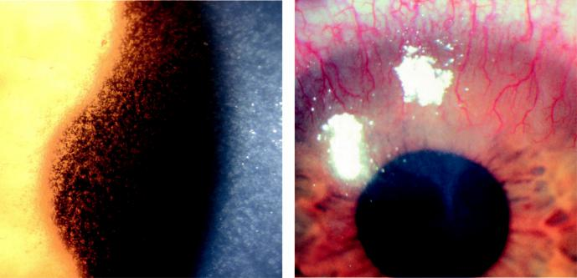

A B

Fig. 7.33 Contact lens: (A) acute ischaemia showing microcysts, (B) acute toxic keratitis. (Figure 7.33A cour-tesy of S. Tuft; Figure 7.33B courtesy of J. Dart.)

***Pain relief***: (a) bullous keratopathy, (b) filamentary keratitis, (c) ygeson superficial punc - tate keratitis, (d) protection from aberrant lashes.

***Preservation of corneal integrity***: temporary capping of a descemetocoele, splinting of a small corneal wound or supporting a glued larger wound.

***Other***: maintenance of the fornices in cicatrizing conjunctivitis, and drug delivery.

**COMPLICATIONS**

***Acute mechanical and hypoxic keratitis***: (a) superficial punctate keratitis, (b) tight lens syn-drome (indentation and staining of the conjunctival epithelium in a ring around the cornea), (c) acute hypoxia (epithelial microcysts, endothelial blebs; Fig. 7.33A).

***Chronic hypoxia***: vascularization and rarely lipid deposition; superficial peripheral neovas-cularization of <1.5 mm is common.

***Immune response keratitis***: mildly red eye with small, often marginal, infiltrates but no or minimal epithelial defects; probably due to a hypersensitivity response to bacterial antigen and/or lens care chemicals.

***Acute toxic keratitis***: mild chemical trauma caused by insertion of a lens without first remov-ing or neutralizing a cleaning agent such as hydrogen peroxide (Fig. 7.33B).

***Chronic toxicity***: long-term exposure to disinfecting preservatives.

***Suppurative keratitis***: bacterial and other microorganisms.

***Giant papillary conjunctivitis***: (see Chapter 6).

**Congenital anomalies of the cornea and globe**

**MICROCORNEA**

**Genetics:**

AD.

**Diagnosis**

***Signs***: unilateral or bilateral; (a) adult horizontal corneal diameter of 10 mm or less (Fig. 7.34A), (b) hypermetropia and shallow anterior chamber but other dimensions normal.

#*" ##%"#"+!#(&&%"'+$'""#* "%#! " +#!+ &)%#"$'!%

#%$%&#" (&#" +##'%(&&*'#('$%!&&#"#$+%', &)%" %'&%&%)

**144** SYNOPSIS OF CLINICAL OPHTHALMOLOGY

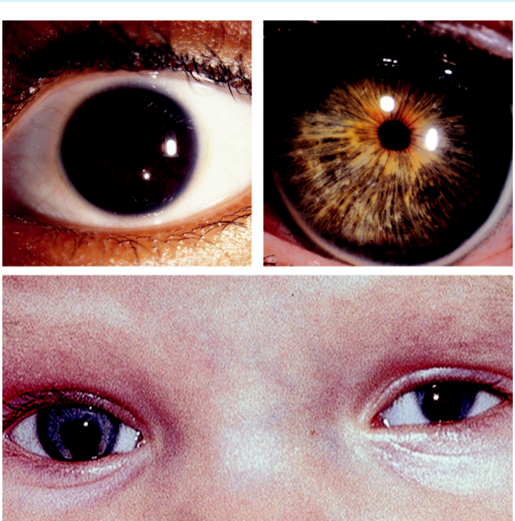

A B

C

Fig. 7.34 Congenital anomalies: (A) microcornea, (B) megalocornea, (C) complex microphthalmos showing

coloboma. (From Salmon JF, Kanski’s Clinical Ophthalmology: A Systematic Approach, 9th edition. Oxford,

UK: Elsevier; 2020.)

***Associations***: (a) glaucoma (closed and open angle), (b) congenital cataract, (c) other anterior segment malformations, (d) optic nerve hypoplasia.

**MEGALOCORNEA**

**Genetics:**

X-linked.

**Diagnosis**

***Signs***: bilateral; (a) corneal diameter 13 mm or more (Fig. 7.34B) and (b) high myopia and astigmatism but usually normal visual acuity.

***Ocular associations***: pigment dispersion syndrome (common), and lens subluxation.

***Systemic associations***: (a) Alport, Marfan, Ehlers–Danlos and Down syndromes, (b) osteo-genesis imperfecta.

#*" ##%"#"+!#(&&%"'+$'""#* "%#! " +#!+ &)%#"$'!%

#%$%&#" (&#" +##'%(&&*'#('$%!&&#"#$+%', &)%" %'&%&%)

|  |  |
| --- | --- |
| Chapter 7—CORNEA | **145** |
|  |  |

**MICROPHTHALMOS**

**Definition:**

total axial length at least two standard deviations less than normal for age. It is the result of stunted growth of the anterior or posterior segment or both; may be unilateral or bilateral.

**Diagnosis**

***Simple microphthalmos***: no other major ocular malformations besides short axial length.

***Nanophthalmos***: entire eye is small with an axial length of less than 20 mm, (a) microcornea,

1. high lens: eye volume ratio, (c) thickened abnormal sclera, (d) increased risk of uveal eusion and angle closure glaucoma.

***Complex microphthalmos***: with anterior and/or posterior segment dysgenesis (e.g. colo-boma) (Fig. 7.34C).

***Microphthalmos with cyst***: orbital cyst communicating with the eye.

***Posterior microphthalmos***: normal corneal diameter.

**SCLEROCORNEA**

**Genetics:**

sporadic, but may be AD or AR.

**Diagnosis**

***Signs***: bilateral, with peripheral corneal opacification with no visible border between the sclera and cornea; reduced corneal diameter, flat cornea (Fig. 7.35A).

***Associations***: cornea plana

**ANOPHTHALMOS**

***Simple***: complete failure of budding of the optic vesicle or early arrest in its development. Associated ocular abnormalities such as the absence of extraocular muscles, a short conjunc-tival sac and microblepharon (Fig. 7.35B).

***With cyst***: globe replaced by a cyst.

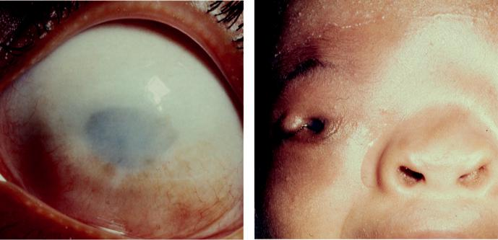

A B

Fig. 7.35 (A) Sclerocornea, (B) anophthalmos. (From Salmon JF, Kanski’s Clinical Ophthalmology: A

Systematic Approach, 9th edition. Oxford, UK: Elsevier; 2020.)

#*" ##%"#"+!#(&&%"'+$'""#* "%#! " +#!+ &)%#"$'!%

#%$%&#" (&#" +##'%(&&*'#('$%!&&#"#$+%', &)%" %'&%&%)



CHAPTER 8

Corneal and Refractive Surgery



C H A P T E R O U T L I N E



Keratoplasty 147

Introduction 147

Penetrating keratoplasty 147

Corneal graft rejection 147

Superficial lamellar keratoplasty 149

Deep anterior lamellar keratoplasty 149

Descemet stripping endothelial keratoplasty 149

Limbal stem cell grafting 149 Keratoprosthesis 149

Refractive procedures 150 Introduction 150

Laser refractive procedures 151

**Keratoplasty**

**INTRODUCTION**

***Classification***: (a) partial (anterior or posterior lamellar), (b) full-thickness (penetrating).

***Indications***: (a) optical, (b) tectonic, (c) therapeutic, (d) cosmetic.

***Donor tissue***: should be removed within 12–24 hr of death and stored under special condi-tions. Contraindications to donation include certain infections (e.g. HIV) and some forms of ocular disease.

**PENETRATING KERATOPLASTY**

***Technique***: (a) determination of graft size, (b) trephination of donor tissue (Fig. 8.1A),

1. excision of host tissue (Fig. 8.1B), (d) fixation of donor button (Fig. 8.1C); postoperative topical steroids and cycloplegics.

***Early postoperative complications***: (a) persistent epithelial defect, (b) wound dehiscence,

1. uveitis, (d) elevation of intraocular pressure, (e) endophthalmitis, (f ) fixed dilated pupil (Urrets–Zavalia syndrome).

***Late complications***: (a) astigmatism, (b) recurrence of disease in graft (Fig. 8.2A), (c) wound separation, (d) retrocorneal membrane formation, (e) glaucoma, (f ) cystoid macular oedema.

**CORNEAL GRAFT REJECTION**

Can be endothelial, stromal, epithelial (rare), or combined.

***Presentation***: may be asymptomatic (particularly in early stages). Later with blurred vision, redness, photophobia and pain.

***Signs***: (a) ciliary injection, (b) anterior uveitis, (c) linear endothelial precipitates (Khodadoust line) (Fig. 8.2B), (d) elevated epithelial line (Fig. 8.2C), (e) focal subepithelial (Krachmer) infiltrates (Fig. 8.2D), (f ) stromal oedema (increase in central corneal thickness).

**147**

#*" ##%"#"+!#(&&%"'+$'""#* "%#! " +#!+ &)%#"$'!%

#%$%&#" (&#" +##'%(&&*'#('$%!&&#"#$+%', &)%" %'&%&%)

**148** SYNOPSIS OF CLINICAL OPHTHALMOLOGY

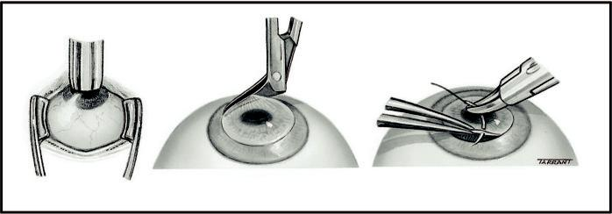

A B C

Fig. 8.1 Penetrating keratoplasty: (A) trephination, (B) excision of host tissue, (C) fixation of donor but-

ton. (From Salmon JF, Kanski’s Clinical Ophthalmology: A Systematic Approach, 9th edition. Oxford, UK:

Elsevier; 2020.)

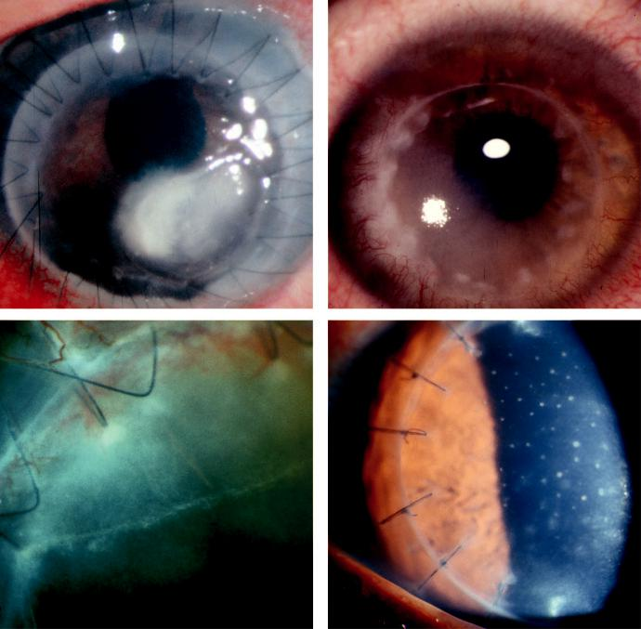

A B

C D

Fig. 8.2 Complications: (A) recurrence of microbial keratitis, (B) allograft rejection showing Khodadoust line, (C) epithelial rejection line, (D) Krachmer spots. (Figure 8.2C,D courtesy of S. Tuft.)

#*" ##%"#"+!#(&&%"'+$'""#* "%#! " +#!+ &)%#"$'!%

#%$%&#" (&#" +##'%(&&*'#('$%!&&#"#$+%', &)%" %'&%&%)

|  |  |
| --- | --- |
| Chapter 8—CORNEAL AND REFRACTIVE SURGERY | **149** |
|  |  |

***Treatment***: (a) topical steroid (dexamethasone 0.1% or prednisolone 1%) hourly for 24 hours tapered over months, (b) topical cycloplegics, (c) systemic and/or subconjunc-tival steroids, (d) topical ciclosporin, (e) systemic immunosuppressives may be used in some cases.

***Diﬀerential diagnosis***: (a) graft failure (no inflammation), (b) infective keratitis, (c) sterile suture reaction, (d) epithelial ingrowth.

**SUPERFICIAL LAMELLAR KERATOPLASTY**

***Technique***: partial-thickness excision of the stroma.

***Indications***: (a) opacification of the superficial one-third of the stroma, (b) marginal corneal thinning or infiltration, (c) Terrien marginal degeneration, (d) limbal tumours.

**DEEP ANTERIOR LAMELLAR KERATOPLASTY**

***Technique***: opaque corneal tissue removed almost to the level of Descemet membrane.

***Indications***: (a) disease of the anterior 95% of corneal thickness with normal endothelium and intact Descemet membrane (e.g. no history of acute hydrops), (b) chronic inflammatory disease with a higher risk of rejection (e.g. atopic keratoconjunctivitis).

***Advantages***: (a) no endothelial rejection, (b) less astigmatism, (c) structurally stronger globe,

1. increased availability of graft material because endothelial quality is irrelevant. ***Disadvantages***: technically diﬃcult and time-consuming; interface haze may limit visualoutcome.

**DESCEMET STRIPPING ENDOTHELIAL KERATOPLASTY**

***Technique***: (a) endothelium and Descemet membrane are removed (descemetorhexis),

1. folded donor tissue is introduced through a small limbal incision, (c) anterior cham-ber air.

***Indications***: endothelial disease (e.g. pseudophakic bullous keratopathy).

***Advantages***: (a) little refractive change, (b) structurally stronger globe, (c) no sutures.

***Disadvantages***: (a) significant learning curve, (b) expensive equipment required for automated method, (c) posterior graft dislocation rate of 15%, (d) endothelial rejection can occur.

**Limbal stem cell grafting**

***Technique***: (a) transplantation of a limbal area of limited size from a healthy fellow eye,

1. transplantation of a donor annulus and *ex vivo* expansion by tissue culture of either host or donor stem cells.

***Indications***: (a) congenital, e.g. aniridia, (b) traumatic, e.g. chemical and thermal burns,

1. chronic inflammatory disease, e.g. Stevens–Johnson syndrome, ocular cicatricial pem-phigoid, (d) ocular surface malignancy, (e) contact lens-related pathology.

***Complications***: (a) infection, (b) rejection, (c) scarring of donor eye, (d) filamentary conjunc-tivitis, (e) conjunctivalization.

**Keratoprosthesis**

***Technique***: insertion of an artificial corneal implant such as an osteoodontokeratopros-thesis (Fig. 8.3A), in which the patient’s tooth root and alveolar bone support an optical cylinder.

#*" ##%"#"+!#(&&%"'+$'""#* "%#! " +#!+ &)%#"$'!% #%$%&#" (&#" +##'%(&&*'#('$%!&&#"#$+%', &)%" %'&%&%)

**150** SYNOPSIS OF CLINICAL OPHTHALMOLOGY

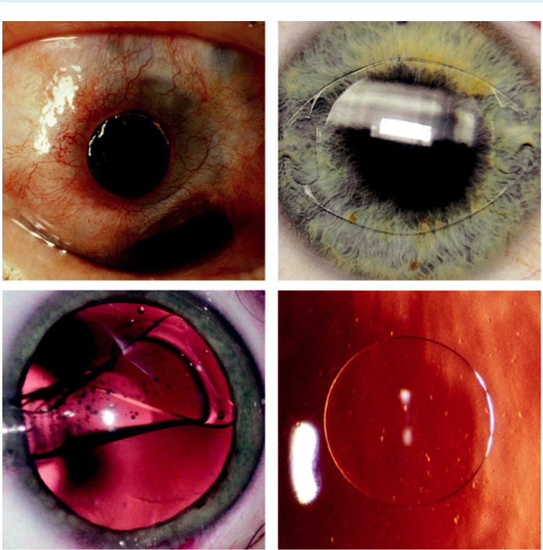

A B

C D

Fig. 8.3 (A) Keratoprosthesis, (B) anterior chamber iris claw implant, (C) insertion of posterior chamber pha-kic implant, (D) intracorneal refractive inlay. (Figure 8.3A courtesy of R. Bates; Figure 8.3C from Krachmer J, Mannis M, Holland E. Cornea, Mosby 2005; Figure 8.3D courtesy of Chris Barry, Lions Eye Institute, Perth, Australia.)

***Indications***: when conventional keratoplasty is not possible in severe but inactive corneal disease (e.g. Stevens–Johnson, chemical burns), but with intact optic nerve and retinal function.

***Complications***: (a) glaucoma, (b) retro-prosthetic membrane formation, (c) tilting, (d) extru-sion, (e) endophthalmitis.

**Refractive procedures**

**INTRODUCTION**

***Correction of myopia***: (a) photorefractive keratectomy (PRK), (b) laser epithelial keratomi-leusis (LASEK), (c) laser *in situ* keratomileusis (LASIK), (d) clear lens exchange, (e) iris clip implant (‘lobster claw’; Fig. 8.3B), (f ) phakic posterior chamber implant (Fig. 8.3C).

#*" ##%"#"+!#(&&%"'+$'""#* "%#! " +#!+ &)%#"$'!%

#%$%&#" (&#" +##'%(&&*'#('$%!&&#"#$+%', &)%" %'&%&%)

|  |  |
| --- | --- |
| Chapter 8—CORNEAL AND REFRACTIVE SURGERY | **151** |
|  |  |

***Correction of hypermetropia (hyperopia)***: (a) PRK and LASEK (low degrees), (b) LASIK (up to 4 D), (c) conductive keratoplasty (radiofrequency energy-induced peripheral stromal shrinkage), (d) laser thermal keratoplasty, (e) intracorneal inlays (Fig. 8.3D), (f ) clear lens extraction, (g) phakic lens implants.

***Correction of astigmatism***: (a) limbal relaxing incisions/arcuate keratotomy, (b) PRK and LASEK (up to 3 D), (c) LASIK (up to 5 D), (d) lens exchange using a ‘toric’ implant incor-porating an astigmatic correction, (e) conductive keratoplasty.

***Correction of presbyopia***: (a) lens extraction with a multifocal implant, (b) conductive kera-toplasty, (c) ‘monovision’ following lens or laser surgery (one eye set for emmetropia and the other for low myopia), (d) corneal multifocality (e.g. using laser), (e) scleral expansion surgery, (f ) intracorneal inlays.

**LASER REFRACTIVE PROCEDURES**

***PRK***: (a) corrects myopia by ablating the central anterior corneal surface with the excimer laser so that it flattens (Fig. 8.4A), (b) corrects hypermetropia by ablation of the periphery so that the center steepens. Complications include slowly healing epithelial defects, corneal haze (Fig. 8.4B), poor night vision and regression of refractive correction.

***LASEK***: adaptation of PRK in which the epithelium is first detached and peeled back, then repositioned after laser has been applied, giving less pain, less haze and more rapid visual recovery than PRK.

***LASIK***: corrects higher levels of refractive error; involves creation of a superficial stro-mal flap followed by laser treatment of the underlying bed. Complications include:

1. flap damage or amputation, (b) tear film instability, (c) flap distortion (Fig. 8.5A),
2. subepithelial haze, (e) bacterial keratitis (Fig. 8.5B), (f ) diﬀuse lamellar keratitis (‘sands of Sahara’; Fig. 8.5C), (g) epithelial ingrowth (Fig. 8.5D).

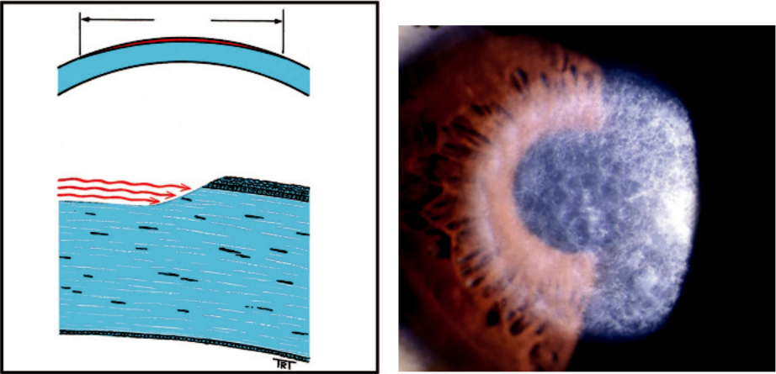

A B

Fig. 8.4 PRK: (A) ablation of central anterior corneal surface, (B) postoperative stromal haze.

#*" ##%"#"+!#(&&%"'+$'""#* "%#! " +#!+ &)%#"$'!%

#%$%&#" (&#" +##'%(&&*'#('$%!&&#"#$+%', &)%" %'&%&%)

**152** SYNOPSIS OF CLINICAL OPHTHALMOLOGY

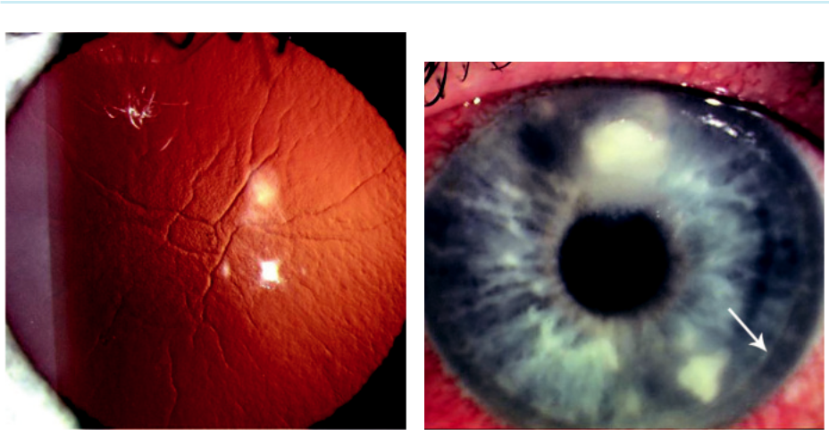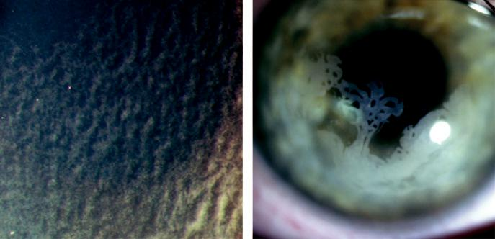

A B

C D

Fig. 8.5 LASIK: (A) flap distortion, (B) bacterial infection (arrow showing edge of flap), (C) diffuse lamellar keratitis, (D) epithelial ingrowth. (Figure 8.5C courtesy of S. Tuft; Figure 8.5D courtesy of M. Leyland.)

#*" ##%"#"+!#(&&%"'+$'""#* "%#! " +#!+ &)%#"$'!%

#%$%&#" (&#" +##'%(&&*'#('$%!&&#"#$+%', &)%" %'&%&%)



CHAPTER 9

Episclera and Sclera



C H A P T E R O U T L I N E

|  |  |  |
| --- | --- | --- |
| Episcleritis 153 | Scleromalacia perforans 156 |  |
| Simple episcleritis 153 | Posterior scleritis 157 |  |
| Nodular episcleritis 153 | Treatment of immune-mediated scleritis 157 |  |
| Immune-mediated scleritis 153 | Systemic associations of scleritis 158 |  |
|  |  |
| Anterior non-necrotizing scleritis 153 | Scleral discoloration 158 |  |
| Anterior necrotizing scleritis with |  |  |
| inflammation 155 |  |  |
|  |  |  |

**Episcleritis**

**SIMPLE EPISCLERITIS**

**Diagnosis**

***Presentation***: acute onset of redness and mild discomfort.

***Signs***: hyperaemia may be sectoral (typically interpalpebral; Fig. 9.1A) or diﬀuse.

***Course***: spontaneous improvement occurs within several days, but recurrences may occur.

**Treatment:**

not required if mild; otherwise lubricants or a weak steroid four times daily for 1–2 weeks.

**NODULAR EPISCLERITIS**

**Diagnosis**

***Presentation***: less acute onset than simple episcleritis with redness and discomfort worsen-ing over 2–3 days.

***Signs***: (a) one or more tender interpalpebral nodules (Fig. 9.1B) and (b) absence of deeper scleral thickening. After several attacks, the vessels surrounding the inflamed area may become permanently dilated.

***Course***: more prolonged than simple episcleritis.

**Treatment:**

similar to that of simple episcleritis.

**Immune-mediated scleritis**

**ANTERIOR NON-NECROTIZING SCLERITIS**

**Definition:**

scleritis is inflammation of the entire thickness of the sclera and results in oedema and cellular infiltration. It is much less common than episcleritis and ranges from a mild and self-limiting inflammation to a necrotizing sight-threatening condition.

**153**

#*" ##%"#"+!#(&&%"'+$'""#* "%#! " +#!+ &)%#"$'!%

#%$%&#" (&#" +##'%(&&*'#('$%!&&#"#$+%', &)%" %'&%&%)

**154** SYNOPSIS OF CLINICAL OPHTHALMOLOGY

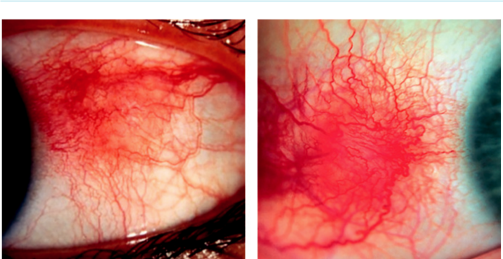

A B

Fig. 9.1 Episcleritis: (A) simple sectoral, (B) nodular. (From Salmon JF, Kanski’s Clinical Ophthalmology: A

Systematic Approach, 9th edition. Oxford, UK: Elsevier; 2020.)

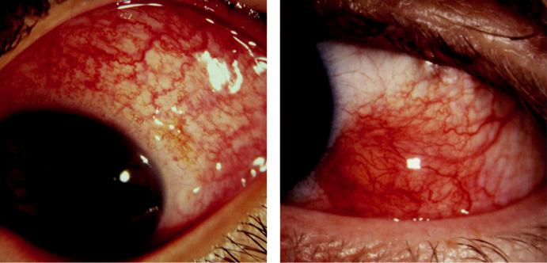

A B

Fig. 9.2 Anterior non-necrotizing scleritis: (A) diffuse, (B) nodular. (From Salmon JF, Kanski’s Clinical

Ophthalmology: A Systematic Approach, 9th edition. Oxford, UK: Elsevier; 2020.)

**Diagnosis**

***Presentation***: in 5th decade with redness, pain and aching.

***Diﬀuse disease***: redness; generalized (Fig. 9.2A) or localized to one quadrant.

***Nodular disease***: (a) single or multiple scleral nodules, of a deeper blue-red colour than episcleral nodules (Fig. 9.2B), (b) vascular congestion and dilatation with oedema and dis-placement of the entire beam of the slit lamp.

***Course***: as inflammation settles, the aﬀected area often takes on a slight grey/blue appear-ance due to increased translucency. Episodes recur over several years, with the frequency decreasing after approximately 18 months.

***Prognosis***: usually good, although more than 10% of patients with nodular scleritis develop necrotizing disease if early treatment is not instituted.

#*" ##%"#"+!#(&&%"'+$'""#* "%#! " +#!+ &)%#"$'!%

#%$%&#" (&#" +##'%(&&*'#('$%!&&#"#$+%', &)%" %'&%&%)

|  |  |
| --- | --- |
| Chapter 9—EPISCLERA AND SCLERA | **155** |
|  |  |

**ANTERIOR NECROTIZING SCLERITIS WITH INFLAMMATION**

**Definition:**

aggressive form of scleritis, bilateral in 60%, which may result in severe visual morbidity unless appropriately treated.

**Diagnosis**

***Presentation***: later than in non-necrotizing scleritis with the gradual onset of pain that becomes severe and radiating, often interfering with sleep and responding poorly to analgesia.

***Vaso-occlusive type***: often associated with rheumatoid arthritis; (a) starts as isolated patches of scleral oedema with overlying nonperfused episclera and conjunctiva, (b) may progress to scleral necrosis (Fig. 9.3A).

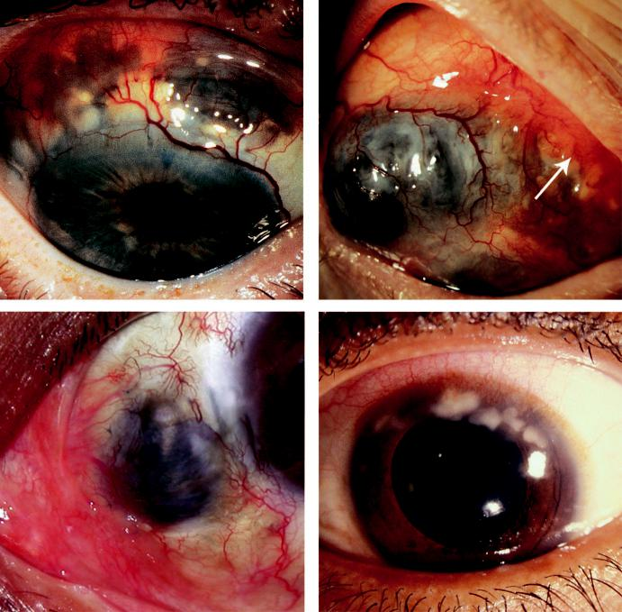

A B

C D

Fig. 9.3 Anterior necrotizing with inflammation: (A) severe vaso-occlusive, (B) granulomatous (arrow), (C) surgically induced after pterygium excision, (D) peripheral stromal keratitis.

#*" ##%"#"+!#(&&%"'+$'""#* "%#! " +#!+ &)%#"$'!%

#%$%&#" (&#" +##'%(&&*'#('$%!&&#"#$+%', &)%" %'&%&%)

**156** SYNOPSIS OF CLINICAL OPHTHALMOLOGY



***Granulomatous type***: associated with granulomatosis with polyangiitis and polyarteritis nodosa; (a) starts with paralimbal injection, (b) subsequently extends posteriorly, (c) within 24 hours the sclera, episclera, conjunctiva and adjacent cornea become irregularly raised and oedematous (Fig. 9.3B).

***Surgically induced***: develops within weeks of ocular surgery and tends to remain localized to one segment (Fig. 9.3C).

***Investigations***: (a) markers of connective tissue disease such as rheumatoid factor, anti-nuclear antibody, antineutrophil cytoplasmic autoantibodies and antiphospholipid antibod-ies, (b) anterior segment fluorescein angiography (FA) and indocyanine green angiography (ICGA) may detect vascular nonperfusion.

***Complications***: (a) acute and chronic keratitis (Fig. 9.3D), (b) uveitis, (c) glaucoma, (d) hypotony, (e) scleral perforation (rare).

**SCLEROMALACIA PERFORANS**

**Definition:**

specific type of necrotizing scleritis without inflammation that typically aﬀects elderly women with long-standing rheumatoid arthritis; perforation of the globe is extremely rare.

**Diagnosis**

***Presentation***: mild nonspecific irritation; pain is absent and vision unaﬀected.

***Signs***: (a) absence of vascular congestion, (b) necrotic scleral plaques near the limbus which coalesce and enlarge (Fig. 9.4A), (c) slow progression of scleral thinning and exposure of underlying uvea (Fig. 9.4B).

***Diﬀerential diagnosis***: scleral hyaline plaque (see below).

**Treatment:**

eﬀective in early disease but usually by presentation either no treatment is needed or it is unlikely to be eﬀective.

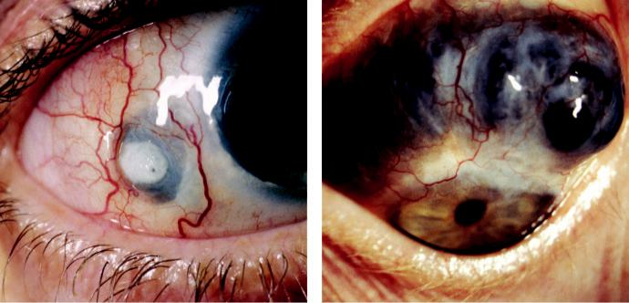

A B

Fig. 9.4 Scleromalacia perforans: (A) asymptomatic necrotic patch, (B) severe thinning and exposure of underlying uvea. (Figure 9.4A courtesy of R. Bates.)

#*" ##%"#"+!#(&&%"'+$'""#* "%#! " +#!+ &)%#"$'!%

#%$%&#" (&#" +##'%(&&*'#('$%!&&#"#$+%', &)%" %'&%&%)

|  |  |
| --- | --- |
| Chapter 9—EPISCLERA AND SCLERA | **157** |
|  |  |

**POSTERIOR SCLERITIS**

**Diagnosis**

***Important facts***: (a) patients with posterior scleritis can go blind extremely rapidly, so early diagnosis is crucial, (b) a third of those older than age 55 years have an associated systemic disease.

***Presentation***: pain or blurred vision; anterior scleritis may coexist.

***Fundus signs***: (a) choroidal folds (Fig. 9.5A), (b) uveal eﬀusion, (c) yellowish-brown subreti-nal mass which may be mistaken for a choroidal tumour, (d) disc oedema.

***Other features***: (a) myositis, (b) proptosis and periorbital oedema, (c) elevated IOP, (d) che-mosis and conjunctival injection.

***Imaging***: (a) ultrasonography (US) shows scleral thickening and fluid in the Tenon space gives the characteristic ‘T’ sign formed by the optic nerve and the fluid-containing gap (Fig. 9.5B), (b) MR and CT may show scleral thickening.

**TREATMENT OF IMMUNE-MEDIATED SCLERITIS**

***Topical steroids***: for symptomatic relief.

***Periocular steroid injections***: only in selected cases; should not be used in necrotizing scleritis.

***Systemic NSAIDs***: only in non-necrotizing disease.

***Systemic steroids***: (e.g. prednisolone 1.0–1.5 mg/kg/day) when NSAIDs are inappropri-ate or ineﬀective, especially in necrotizing disease; intravenous preparations are sometimes necessary.

***Immunosuppressives***: should be considered if control is: (a) incomplete with steroids alone,

1. as a steroid-sparing measure in long-term treatment, (c) to treat underlying systemic disease (see below). Options include: (a) cytostatic agents (cyclophosphamide, azathioprine, methotrexate), (b) drugs acting on immunophilins (ciclosporin, tacrolimus), (c) specific monoclonal antibodies (e.g. infliximab, rituximab).

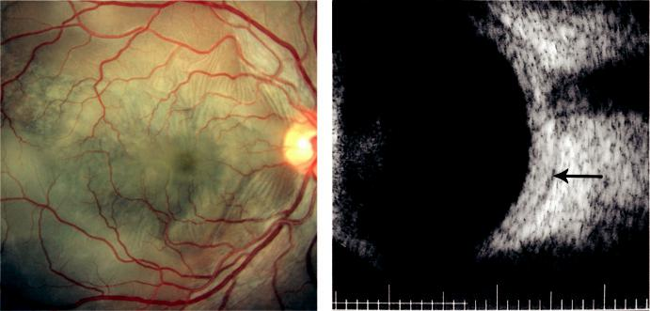

A B

Fig. 9.5 Posterior scleritis: (A) choroidal folds, (B) B-scan ultrasound showing scleral thickening with char-

acteristic ‘T’ sign (arrow). (From Salmon JF, Kanski’s Clinical Ophthalmology: A Systematic Approach, 9th

edition. Oxford, UK: Elsevier; 2020.)

#*" ##%"#"+!#(&&%"'+$'""#* "%#! " +#!+ &)%#"$'!%

#%$%&#" (&#" +##'%(&&*'#('$%!&&#"#$+%', &)%" %'&%&%)

**158** SYNOPSIS OF CLINICAL OPHTHALMOLOGY

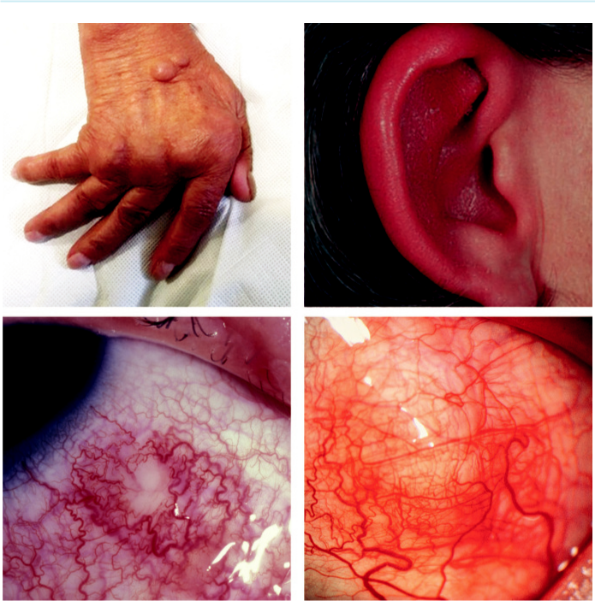

A B

C D

Fig. 9.6 Systemic associations: (A) rheumatoid arthritis, (B) relapsing polychondritis, (C) herpes zoster,

1. Lyme disease. (From Salmon JF, Kanski’s Clinical Ophthalmology: A Systematic Approach, 9th edition. Oxford, UK: Elsevier; 2020.)

**SYSTEMIC ASSOCIATIONS OF SCLERITIS**

Up to half of patients with scleritis have one of the following systemic diseases:

***Collagen vascular diseases***: (a) rheumatoid arthritis (Fig. 9.6A), (b) granulomatosis with polyangiitis, (c) polyarteritis nodosa, (d) relapsing polychondritis (Fig. 9.6B), (e) systemic lupus erythematosus.

***Infections***: (a) herpes zoster (most common) (Fig. 9.6C), (b) certain fungi, (c) syphilis, (d) leprosy, (e) Lyme disease (Fig. 9.6D), (f ) tuberculosis.

***Other associations***: (a) lymphoma, (b) dysproteinaemias, (c) thyroid eye disease, (d) hyper-uricaemia/gout, (e) inflammatory bowel disease.

**Scleral discoloration**

***Alkaptonuria***: bluish-grey or black generalized pigmentation of the sclera and the horizontal recti tendons, associated with discrete pigmented globules (Fig. 9.7A).

#*" ##%"#"+!#(&&%"'+$'""#* "%#! " +#!+ &)%#"$'!%

#%$%&#" (&#" +##'%(&&*'#('$%!&&#"#$+%', &)%" %'&%&%)

|  |  |
| --- | --- |
| Chapter 9—EPISCLERA AND SCLERA | **159** |
|  |  |

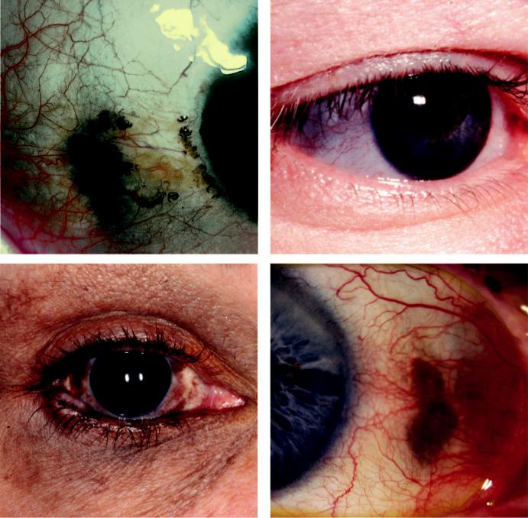

A B

C D

Fig. 9.7 Scleral discoloration: (A) alkaptonuria, (B) blue sclera in osteogenesis imperfecta, (C) congenital

melanocytosis, (D) scleral hyaline plaque. (From Salmon JF, Kanski’s Clinical Ophthalmology: A Systematic

Approach, 9th edition. Oxford, UK: Elsevier; 2020.)

***Haemochromatosis***: rusty brown perilimbal conjunctival and scleral discoloration.

***Blue sclera***: group of conditions featuring thinning or transparency of scleral collagen with visualization of the underlying uvea (Fig. 9.7B) as in osteogenesis imperfecta and Ehlers– Danlos syndrome type VI.

***Congenital ocular melanocytosis***: increased number, size and pigmentation of melanocytes in the sclera and uvea, which may also involve the periocular skin, orbit, meninges, and soft palate. Classified as: (a) ocular (involves only the eye), (b) dermal (only skin) and (c) ocu-lodermal (naevus of Ota) (Fig. 9.7C); slightly increased risk of uveal melanoma mandates observation.

***Post-inflammatory scleral changes***.

***Scleral hyaline plaque***: innocuous oval dark greyish area located close to the insertion of the horizontal rectus muscles (Fig. 9.7D) seen in elderly patients.

#*" ##%"#"+!#(&&%"'+$'""#* "%#! " +#!+ &)%#"$'!%

#%$%&#" (&#" +##'%(&&*'#('$%!&&#"#$+%', &)%" %'&%&%)



CHAPTER 10

Lens



C H A P T E R O U T L I N E

Introduction 161

Acquired cataract 161

Effect on vision 161

Age-related cataract 162

Cataract in systemic disease 163

Causes of secondary cataract 163

Causes of traumatic cataract 163

Management of age-related cataract 164

Preoperative considerations 164

Intraocular lenses 165

Anaesthesia 166

Phacoemulsification 166

Operative complications 166

Acute postoperative endophthalmitis 167

Delayed-onset postoperative

endophthalmitis 169

Posterior capsular opacification 169

Miscellaneous postoperative

complications 170

Congenital cataract 171

Ectopia lentis 173

Abnormalities of shape 174

**Introduction**

***Primary function***: to focus light on the retina.

***Cataract (lens opacification)***: is the commonest cause of reversible visual disability in the world. Phacoemulsification with intra-ocular lens implantation is the commonest surgical procedure undertaken in the developed world.

***Presbyopia***: is the gradual loss of the ability of the lens to focus on near objects. It is an inevitable ageing phenomenon and occurs as a consequence of a loss of accommodation secondary to reduced lens elasticity.

***Anatomy***: (a) zonules hold the lens in position, (b) the capsule is an acellular membrane that encloses the lens material, (c) cuboid epithelial cells are located beneath the anterior capsule and extend to the lens equator; cells in the germinative area divide continuously and dier - entiate to form lens fibers, (d) the lens substance is made up of a central nucleus surrounded by corticular material.

**Acquired cataract**

**EFFECT ON VISION**

***Depends on***: (a) extent of the cataract, (b) the position of the opacification, (c) the morpho-logical appearance.

***Reduced visual acuity***: which can initially be corrected with spectacles.

***Loss of contrast sensitivity***.

***Change in colour perception***: particularly an inability to accurately perceive blue colours.

**161**

#*" ##%"#"+!#(&&%"'+$'""#* "%#! " +#!+ &)%#"$'!%

#%$%&#" (&#" +##'%(&&*'#('$%!&&#"#$+%', &)%" %'&%&%)

**162** SYNOPSIS OF CLINICAL OPHTHALMOLOGY



***Glare***: secondary to light scattering, causing diculty with night driving.

***Monocular diplopia***: especially when looking at a point source of light.

**AGE-RELATED CATARACT**

***Subcapsular***: (a) anterior lies directly under the lens capsule, (b) posterior lies immediately in front of the posterior capsule and appears black on retroillumination. is type has a more profound eect on vision than a nuclear or cortical cataract and is often associated with glare and poor near vision (Fig. 10.1A).

***Nuclear***: the most common; often associated with myopia due to an increase in the refrac-

tive index of the nucleus; when advanced, the nucleus appears brown (Fig. 10.1B).

***Cortical***: starts as clefts and vacuoles between lens fibres due to hydration of the cortex and

evolves into wedge-shaped or radial spoke-like opacities (Fig. 10.1C).

***Christmas tree***: polychromatic opacities (Fig. 10.1D).

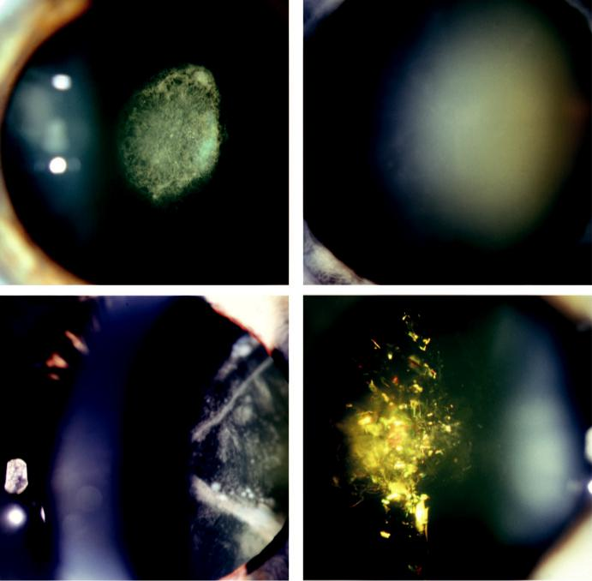

A B

C D

Fig. 10.1 Age-related cataract: (A) posterior subcapsular, (B) nuclear sclerotic, (C) corticular, (D) Christmas

tree. (From Salmon JF, Kanski’s Clinical Ophthalmology: A Systematic Approach, 9th edition. Oxford, UK:

Elsevier; 2020.)

#*" ##%"#"+!#(&&%"'+$'""#* "%#! " +#!+ &)%#"$'!%

#%$%&#" (&#" +##'%(&&*'#('$%!&&#"#$+%', &)%" %'&%&%)

|  |  |
| --- | --- |
| Chapter 10—LENS | **163** |
|  |  |

***Cataract maturity***: (a) immature (lens is partially opaque), (b) mature (lens is completely opaque), (c) hypermature (shrunken and wrinkled capsule) (Fig. 10.2A), (d) Morgagnian cataract (inferior sinking of nucleus in a liquefied cortex) (Fig. 10.2B).

**CATARACT IN SYSTEMIC DISEASE**

***Diabetes mellitus***: hyperglycaemia leads to the overaccumulation of metabolic products in the lens, initially leading to fluctuating refraction and later to cataract, particularly acceler-ated age-related nuclear.

***Myotonic dystrophy***: fine cortical iridescent opacities that evolve into a visually disabling stellate posterior subcapsular cataract (Fig. 10.3A).

***Atopic dermatitis***: dense anterior subcapsular plaque is characteristic (Fig. 10.3B).

***NF2***: cataract develops in approximately 60% of patients, often before the age of 30 years.

**CAUSES OF SECONDARY CATARACT**

A secondary (complicated) cataract develops as a result of other primary ocular disease such as the following:

***Chronic anterior uveitis***: cataract may be caused both by inflammation and by steroids; progresses more rapidly in the presence of posterior synechiae (Fig. 10.4A).

***Acute congestive angle closure***: small, grey-white, anterior opacities within the pupillary area (glaukomflecken; Fig. 10.4B).

***High (pathological) myopia***: posterior subcapsular opacities and early onset nuclear sclerosis.

***Hereditary fundus dystrophies***: retinitis pigmentosa, Leber congenital amaurosis, gyrate atrophy and Stickler syndrome (see Chapter 15).

**CAUSES OF TRAUMATIC CATARACT**

Penetrating trauma (Fig. 10.5A)

Blunt trauma: may cause a characteristic flower-shaped opacity (Fig. 10.5B).

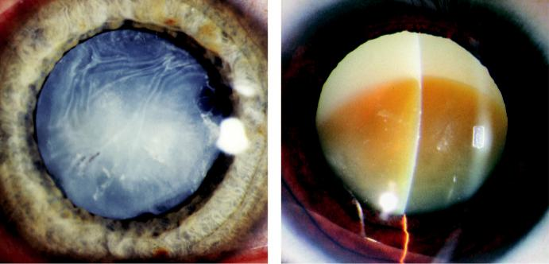

A B

Fig. 10.2 Mature cataract: (A) shrunken and wrinkled capsule, (B) Morgagnian showing inferior sinking of

nucleus in a liquefied cortex. (From Salmon JF, Kanski’s Clinical Ophthalmology: A Systematic Approach, 9th

edition. Oxford, UK: Elsevier; 2020.)

#*" ##%"#"+!#(&&%"'+$'""#* "%#! " +#!+ &)%#"$'!%

#%$%&#" (&#" +##'%(&&*'#('$%!&&#"#$+%', &)%" %'&%&%)

**164** SYNOPSIS OF CLINICAL OPHTHALMOLOGY

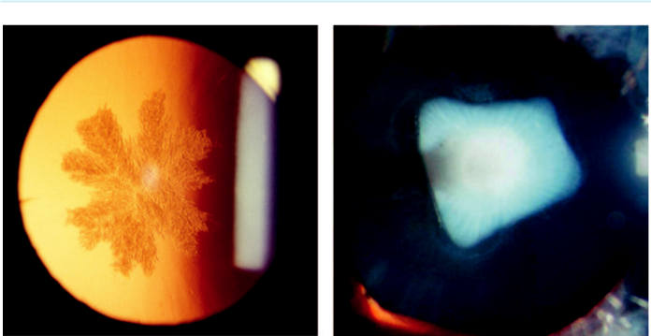

A B

Fig. 10.3 Cataract in systemic disease: (A) myotonic dystrophy, (B) atopic dermatitis. (From Salmon JF,

Kanski’s Clinical Ophthalmology: A Systematic Approach, 9th edition. Oxford, UK: Elsevier; 2020.)

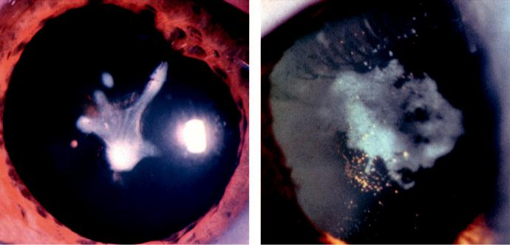

A B

Fig. 10.4 Secondary cataract: (A) chronic anterior uveitis, (B) glaukomflecken. (From Salmon JF, Kanski’s

Clinical Ophthalmology: A Systematic Approach, 9th edition. Oxford, UK: Elsevier; 2020.)

Electric shock.

Infrared radiation (e.g. occupational exposure).

Ionizing radiation (e.g. for ocular tumours).

**Management of age-related cataract**

**PREOPERATIVE CONSIDERATIONS**

***Indications for surgery***: (a) visual improvement, (b) medical indications (e.g. phacomorphic glaucoma; see Chapter 11), (c) to facilitate management of fundus disease (e.g. diabetic retinopathy).

***Systemic preoperative assessment***: general medical history; investigations are not usually performed for routine local anaesthesia.

#*" ##%"#"+!#(&&%"'+$'""#* "%#! " +#!+ &)%#"$'!%

#%$%&#" (&#" +##'%(&&*'#('$%!&&#"#$+%', &)%" %'&%&%)

|  |  |
| --- | --- |
| Chapter 10—LENS | **165** |
|  |  |

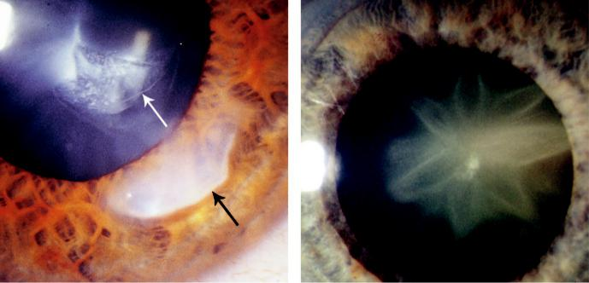

A B

Fig. 10.5 Traumatic cataract: (A) penetrating (arrows showing corneal and lens entry site), (B) blunt injury,

showing typical flower-shaped opacity. (From Salmon JF, Kanski’s Clinical Ophthalmology: A Systematic

Approach, 9th edition. Oxford, UK: Elsevier; 2020.)

***Ophthalmic preoperative assessment***: (a) past ophthalmic history, (b) visual acuity (VA), (c) cover testing, (d) pupillary responses, (e) slit lamp biomicroscopy, (f ) ocular adnexa (e.g. chronic dacryocystitis), (f ) red reflex quality, (g) fundus examination (ultrasound if poor view), (h) refractive status (including postoperative result from the other eye).

***Biometr y***: facilitates calculation of the lens power for a planned refractive outcome by measuring corneal power (keratometry) and axial length (e.g. optical interferometry, US). Refractive outcome planning may need to take into account the refractive status of the fellow eye as well as the patient’s preferences and the eect of previous ocular surgery.

**INTRAOCULAR LENSES**

e intraocular lens (IOL) is optimized for positioning within the intact capsular bag

(Fig. 10.6A). Complicated surgery may necessitate alternative placement within the ciliary sulcus or in the anterior chamber.

***Flexible IOLs***: made of silicone, acrylic, or Collamer; can be rolled or folded for introduc-tion into the eye through a small incision.

***Rigid IOLs***: still occasionally used.

***Sharp/square-edged optics***: associated with a lower rate of posterior capsular opacification (PCO) compared with round-edged optics.

***Ultraviolet filter***: routine in modern IOLs to reduce energy incident on the retina; blue light filters are also available.

***Aspheric IOL optics***: counteract spherical aberration.

***Heparin coating***: reduces the attraction and adhesion of inflammatory cells, which may have particular application in eyes with uveitis.

***Multifocal, accommodative and pseudo-accommodative IOLs***: aim to provide clear vision over a range of focal distances (Fig. 10.6B).

***Toric IOLs***: integral cylindrical refractive component to compensate for pre-existing cor-neal astigmatism.

***Adjustable IOLs***: alteration of refractive power following implantation.

#*" ##%"#"+!#(&&%"'+$'""#* "%#! " +#!+ &)%#"$'!%

#%$%&#" (&#" +##'%(&&*'#('$%!&&#"#$+%', &)%" %'&%&%)

**166** SYNOPSIS OF CLINICAL OPHTHALMOLOGY

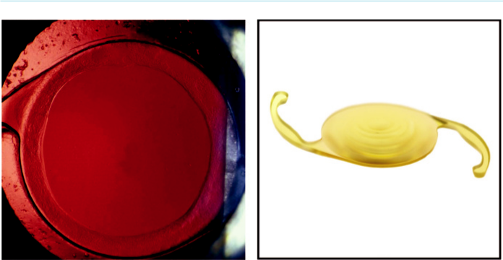

A B

Fig. 10.6 Intraocular lens: (A) IOL in situ in the capsular bag, (B) one-piece, flexible, multifocal IOL with blue-

light filter. (From Salmon JF, Kanski’s Clinical Ophthalmology: A Systematic Approach, 9th edition. Oxford, UK:

Elsevier; 2020.)

**ANAESTHESIA**

Most cataract surgery is performed under local anaesthesia (LA), sometimes with the aid of oral or intra-venous sedation. General anaesthesia is sometimes used (e.g. for children and very anxious patients).

***Topical anaesthesia***: (drops or gel) can be augmented with intracameral preservative-free lidocaine. Despite the absence of akinesia, most patients can cooperate adequately. ***Sub-Tenon periocular LA***: cannula is introduced through an incision in the conjunctiva and Tenon capsule 5 mm from the limbus inferonasally. Akinesia is variable.

***Peribulbar block***: needle is introduced through the skin or conjunctiva. Provides eective anaesthesia and akinesia.

**PHACOEMULSIFICATION**

***Definition***: most cataract surgery is performed using phacoemulsification (‘phaco’) in which the nucleus is broken down within the eye using ultrasound.

***Technique***: (a) corneal incision (Fig. 10.7A), (b) a continuous curvilinear capsulorhexis (cir-cular opening in the anterior lens capsule) is created to gain access to the lens (Fig. 10.7B),

1. hydrodissection, (d) sculpting of the nucleus (Fig. 10.7C), (e) emulsified nucleus is aspi-rated (Fig. 10.7D), as is the softer cortical material (irrigation/aspiration or ‘I/A’), (f) the IOL is introduced into the capsular bag (Fig. 10.8A and B). A novel approach involves the use of a femtosecond laser to perform the corneal incision, the capsulorhexis and to soften the lens. ***‘Viscoelastics’***: maintain intraocular cavities that would otherwise collapse and to provide adegree of protection for delicate intraocular structures, especially the corneal endothelium.

**OPERATIVE COMPLICATIONS**

***Rupture of the posterior lens capsule***: typically accompanied by the migration of vitreous gel into the anterior chamber, with an increased risk of various sequelae (e.g. chronic cystoid macular oedema, retinal detachment, uveitis, glaucoma and endophthalmitis).

***Dislocation of lens fragments into the vitreous cavity***: occurs after zonular dehiscence or posterior capsular rupture and may result in subsequent problems (e.g. glaucoma, chronic

#*" ##%"#"+!#(&&%"'+$'""#* "%#! " +#!+ &)%#"$'!%

#%$%&#" (&#" +##'%(&&*'#('$%!&&#"#$+%', &)%" %'&%&%)

|  |  |
| --- | --- |
| Chapter 10—LENS | **167** |
|  |  |

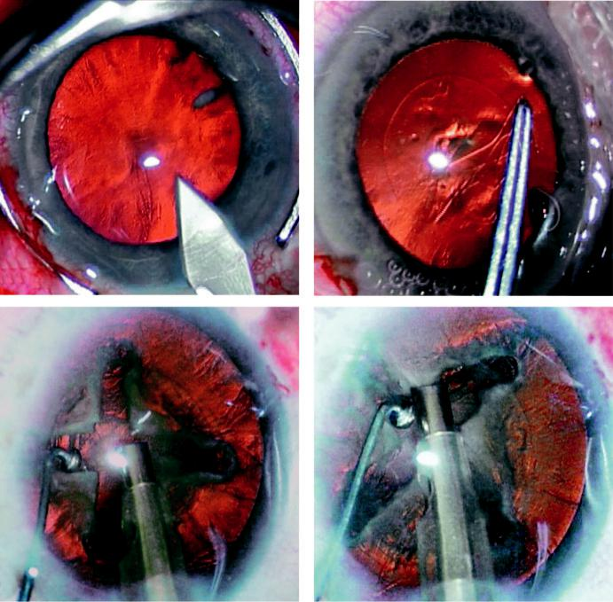

A B

C D

Fig. 10.7 Phacoemulsification: (A) corneal incision, (B) capsulorhexis, (C) sculpting, (D) removal of quad-

rants. (From Salmon JF, Kanski’s Clinical Ophthalmology: A Systematic Approach, 9th edition. Oxford, UK:

Elsevier; 2020.)

uveitis, retinal detachment and chronic cystoid macular oedema). Large fragments may require removal by pars plana vitrectomy.

***Dislocation of an IOL into the vitreous cavity***: rare; removal requires pars plana vitrectomy.

***Suprachoroidal haemorrhage***: bleeding into the suprachoroidal space from a posterior ciliary artery. If suciently severe may result in extrusion of intraocular contents (‘expulsive’ haem - orrhage). If suspected intraoperatively, the operation should be terminated and the incision sutured immediately.

**ACUTE POSTOPERATIVE ENDOPHTHALMITIS**

**Introduction**

Incidence: 0.3%.

Risk factors: (a) operative complications (see above), (b) prolonged procedure time, (c) clear cornea sutureless incision, (d) wound leak on the first day, (e) adnexal disease (e.g. chronic blepharitis, dacryocystitis), (f ) socket infection in only eye patient, (g) diabetes.

#*" ##%"#"+!#(&&%"'+$'""#* "%#! " +#!+ &)%#"$'!%

#%$%&#" (&#" +##'%(&&*'#('$%!&&#"#$+%', &)%" %'&%&%)

**168** SYNOPSIS OF CLINICAL OPHTHALMOLOGY

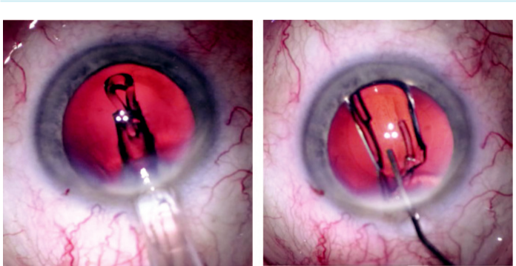

A B

Fig. 10.8 Implantation of IOL: (A) immediately after insertion, (B) unfolding in the capsular bag. (From Salmon

JF, Kanski’s Clinical Ophthalmology: A Systematic Approach, 9th edition. Oxford, UK: Elsevier; 2020.)

Pathogens: 90% of isolates are Gram positive (e.g. S. epidermidis, S. aureus), with the flora of the eyelids and conjunctiva the most frequent source.

Prophylaxis: (a) preoperative 5% povidone–iodine into the conjunctival fornices, (b) treat-ment of pre-existing adnexal infections and contralateral socket, (c) scrupulous preparation of the surgical site, (d) intracameral antibiotics at the end of surgery (cefuroxime 1 mg in 0.1 ml or moxifloxacin 0.5 mg in 0.1 ml, (e) postoperative subconjunctival injection of anti-biotics can achieve bactericidal levels in the AC for 1–2 hours.

**Diagnosis**

***Presentation***: within first few days of surgery with acute or subacute onset of pain, redness, eyelid swelling and visual deterioration.

***Signs***: (a) anterior chamber activity with fibrinous exudate and hypopyon (Fig. 10.9A),

1. corneal haze, (c) eyelid swelling, (d) chemosis, (e) conjunctival injection and discharge, (f ) relative aerent pupillary defect, (g) vitreous inflammation with loss of the red reflex. ***Diﬀerential diagnosis***: sterile uveitis, including secondary to retained lens material in theanterior chamber or vitreous.

***Investigations***: vitreous and aqueous samples should be obtained under aseptic conditions and sent for urgent microscopy and culture.

**Treatment**

***Intravitreal antibiotics***: injected immediately after vitreous sampling. Concentrations are: ceftazidime 2 mg in 0.1 ml and vancomycin 2 mg in 0.1 ml. Amikacin 0.4 mg in 0.1 ml is an alternative in patients with a penicillin allergy.

***Topical and subconjunctival antibiotics***: limited benefit, but are typically given to protect the fresh wounds from re-infection.

***Oral antibiotics***: (e.g. moxifloxacin, clarithromycin).

***Topical steroids***: (e.g. dexamethasone 0.1% 2-hourly).

***Oral steroids***: often commenced after 12–24 hr.

***Topical cycloplegics***: (e.g. atropine 1% twice daily).

***Pars plana vitrectomy***: is beneficial when VA is worse than ‘hand movements’. Can also be per-formed to address late complications such as persistent vitreous opacities or epimacular membrane.

#*" ##%"#"+!#(&&%"'+$'""#* "%#! " +#!+ &)%#"$'!%

#%$%&#" (&#" +##'%(&&*'#('$%!&&#"#$+%', &)%" %'&%&%)

|  |  |
| --- | --- |
| Chapter 10—LENS | **169** |
|  |  |

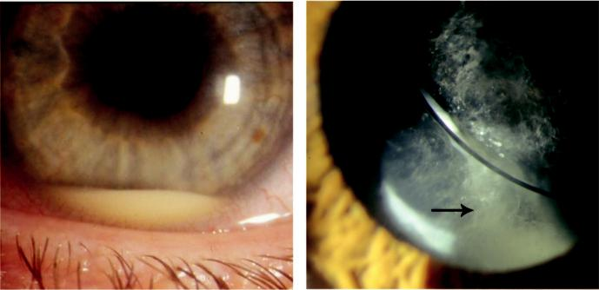

A B

Fig. 10.9 Postoperative endophthalmitis: (A) acute, showing hypopyon, (B) delayed onset, showing capsu-

lar plaque (arrow). (From Salmon JF, Kanski’s Clinical Ophthalmology: A Systematic Approach, 9th edition.

Oxford, UK: Elsevier; 2020.)

**DELAYED-ONSET POSTOPERATIVE ENDOPHTHALMITIS**

**Pathogenesis**

organisms of low virulence become trapped within the capsular bag (‘saccular endophthalmitis’). e pathogens can become sequestered within macrophages, protected from eradication but with continued expression of bacterial antigen; most frequent isolate is *Propionibacterium acnes* (new terminology: *Cutibacterium acnes*).

**Diagnosis**

***Presentation***: several months following surgery with painless progressive visual deteriora-tion and floaters.

***Signs***: (a) low-grade anterior uveitis, sometimes with mutton-fat keratic precipitates, ini-tially responding well to topical steroids but recurring when treatment is stopped, (b) a white, enlarging capsular plaque is characteristic (Fig. 10.9B).

**Treatment**

***Initial***: oral moxifloxacin or clarithromycin for 10–14 days.

***Subsequent***: persistent cases may require removal of the capsular bag, residual cortex and IOL.

**POSTERIOR CAPSULAR OPACIFICATION**

**Pathogenesis**

visually significant PCO, caused by the proliferation and migration of residual lens epithelial cells.

It is a common late consequence of uncomplicated cataract surgery.

**Diagnosis**

***Presentation***: weeks or months following surgery with diminished VA, monocular diplopia and glare.

***Signs***: vacuolated opacification is most frequent (Elschnig pearls) (Fig. 10.10A), (b) fibrosis (Fig. 10.10B), (c) contraction of the anterior capsular opening (capsulophimosis; Fig. 10.10C).

#*" ##%"#"+!#(&&%"'+$'""#* "%#! " +#!+ &)%#"$'!%

#%$%&#" (&#" +##'%(&&*'#('$%!&&#"#$+%', &)%" %'&%&%)

**170** SYNOPSIS OF CLINICAL OPHTHALMOLOGY

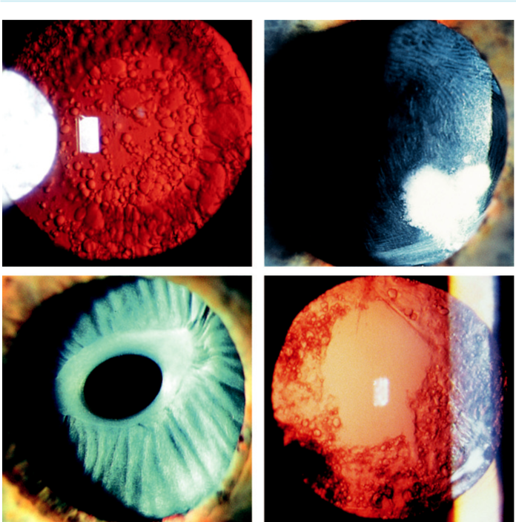

A B

C D

Fig. 10.10 Posterior capsular opacification: (A) Elschnig pearl formation on retroillumination, (B) fibrotic cap-sule, (C) anterior capsular contraction and fibrosis, (D) appearance following laser capsulotomy. (From Salmon JF, Kanski’s Clinical Ophthalmology: A Systematic Approach, 9th edition. Oxford, UK: Elsevier; 2020.)

**Treatment**

***Technique***: Nd:YAG laser is used to create an opening in the posterior capsule (Fig. 10.10D).

***Complications***: (a) ‘pitting’ of the IOL (typically asymptomatic), (b) inflammation, (c) rheg-matogenous retinal detachment, (d) elevation of IOP (usually mild), (e) cystoid macular oedema(CMO), (f ) posterior IOL dislocation (rare).

**MISCELLANEOUS POSTOPERATIVE COMPLICATIONS**

***Refractive ‘surprise’***: small under- or over-corrections are not uncommon. If there is a sig-nificant residual refractive error: (a) examine the eye to exclude a distended capsular bag or CMO, (b) check the biometry and strength of the implanted IOL, (c) repeat the measure-ments. Management depends on the cause: (a) no treatment if the patient is prepared to wear a contact lens or spectacles, (b) IOL exchange, (c) corneal refractive surgery, (d) ‘piggy-back’ sulcus IOL for high degrees of uncorrected refractive error.

#*" ##%"#"+!#(&&%"'+$'""#* "%#! " +#!+ &)%#"$'!%

#%$%&#" (&#" +##'%(&&*'#('$%!&&#"#$+%', &)%" %'&%&%)

|  |  |
| --- | --- |
| Chapter 10—LENS | **171** |
|  |  |

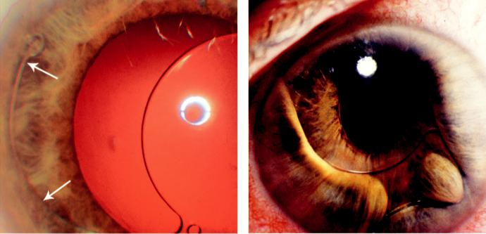

A B

Fig. 10.11 Postoperative complications: (A) IOL malposition, with haptic in anterior chamber (arrows), (B) anterior chamber IOL with pupillary block and vitreous incarceration into incision, predisposing to cystoid macular oedema. (From Salmon JF, Kanski’s Clinical Ophthalmology: A Systematic Approach, 9th edition. Oxford, UK: Elsevier; 2020.)

***Malposition of IOL***: glare, haloes and monocular diplopia may occur if the edge of the IOL becomes displaced into the pupil (Fig. 10.11A). If significant, the IOL may require reposi-tioning or replacement.

***Cystoid macular oedema***: risk factors are: (a) operative complications, especially vitreous loss, (b) topical prostaglandin treatment, (c) diabetes, (d) uveitis, (e) epiretinal membrane. Treatment involves: (a) correction of a likely cause (e.g. anterior vitrectomy for vitreous incarceration) (Fig. 10.11B), (b) topical NSAIDs and steroids, (c) periocular or intravitreal steroids, (d) topical or systemic carbonic anhydrase inhibitors, (e) intravitreal anti-VEGF agents (seldom helpful), (f ) pars plana vitrectomy in resistant cases.

***Rhegmatogenous retinal detachment***: risk factors include: (a) lattice degeneration, (b) high myopia, (c) posterior capsule rupture, (d) early postoperative laser capsulotomy.

**Congenital cataract**

**Introduction**

***Prevalence***: approximately 3 in 10,000 live births.

***Laterality***: two-thirds are bilateral, with an identifiable cause in approximately half of these – usually an AD mutation. Unilateral cataracts are typically sporadic with a cause identified in only 10%.

***Morpholog y***: may indicate likely aetiology and visual prognosis; (a) lamellar opacities (Fig. 10.12A) may be AD, sporadic, or occur in infants with metabolic disorders and intrauterine infections, (b) blue dot opacities (Fig. 10.12B) are common and innocuous,

1. sutural, in which the opacity follows the anterior or posterior Y suture (Fig. 10.12C),
2. central ‘oil droplet’ opacities are characteristic of galactosaemia, (e) posterior polar cataract (Fig. 10.12D) may occasionally be associated with persistent hyaloid remnants (Mittendorf dot or persistent posterior fetal vasculature (hyperplastic primary vitreous). ***Systemic metabolic associations***: (a) galactosaemia, (b) Lowe syndrome, (c) Fabry disease,
3. mannosidosis, (e) hypoparathyroidism and pseudo-hypoparathyroidism, (f ) hypo- and hyperglycaemia.

#*" ##%"#"+!#(&&%"'+$'""#* "%#! " +#!+ &)%#"$'!%

#%$%&#" (&#" +##'%(&&*'#('$%!&&#"#$+%', &)%" %'&%&%)

**172** SYNOPSIS OF CLINICAL OPHTHALMOLOGY

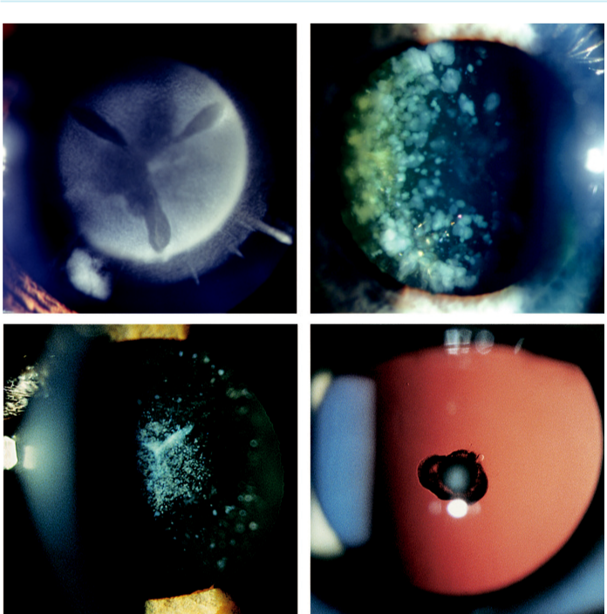

A B

C D

Fig. 10.12 Congenital cataract: (A) lamellar, (B) blue dot opacities, (C) sutural, (D) posterior polar. (From

Salmon JF, Kanski’s Clinical Ophthalmology: A Systematic Approach, 9th edition. Oxford, UK: Elsevier; 2020.)

***Associated intrauterine infections***: (a) congenital rubella, (b) toxoplasmosis, (c) cytomegalo-virus, (d) varicella.

***Associated chromosomal abnormalities***: (a) Down syndrome (trisomy 21), (b) Edwards syn-drome (trisomy 18), (c) cri du chat syndrome (partial deletion of 5p).

**Management**

***Ocular examination***: (a) estimation of the density and probable visual impact of the opacity,

1. morphology and the presence of other ocular pathology including indicators of severe visual impairment such as nystagmus.

***Systemic investigations***: (a) serology for intrauterine infection, (b) urinalysis (galactosaemia, Lowe syndrome), (c) glucose, (d) electrolyte, calcium, and phosphorus analysis; other tests under the care of a paediatric specialist.

***Treatment***: early surgery is required in dense unilateral or bilateral opacities. e cataract is removed by aspiration supplemented by posterior capsulorhexis and limited vitrectomy.

#*" ##%"#"+!#(&&%"'+$'""#* "%#! " +#!+ &)%#"$'!%

#%$%&#" (&#" +##'%(&&*'#('$%!&&#"#$+%', &)%" %'&%&%)

|  |  |
| --- | --- |
| Chapter 10—LENS | **173** |
|  |  |

***Postoperative*** ***complications***: (a) PCO, (b) secondary pupillary membrane formation,

1. proliferation of residual lens epithelial cells (Soemmering ring surrounding the visual axis), (d) glaucoma (20%), (e) retinal detachment.

***Visual rehabilitation***: (a) spectacles and contact lenses, (b) IOL implantation is safe and eective in selected cases, although refractive changes with growth must be addressed,

1. treatment of amblyopia is vital.

**Ectopia lentis**

**Definitions**

displacement of the lens from its normal position may be complete (luxation) or partial (sublux-ation) (Fig. 10.13A and B) in which the lens remains substantially in the pupillary area.

**Aetiology**

***Acquired***: (a) trauma, (b) large eye (e.g. high myopia, buphthalmos), (c) anterior uveal tumours, (d) hypermature cataract.

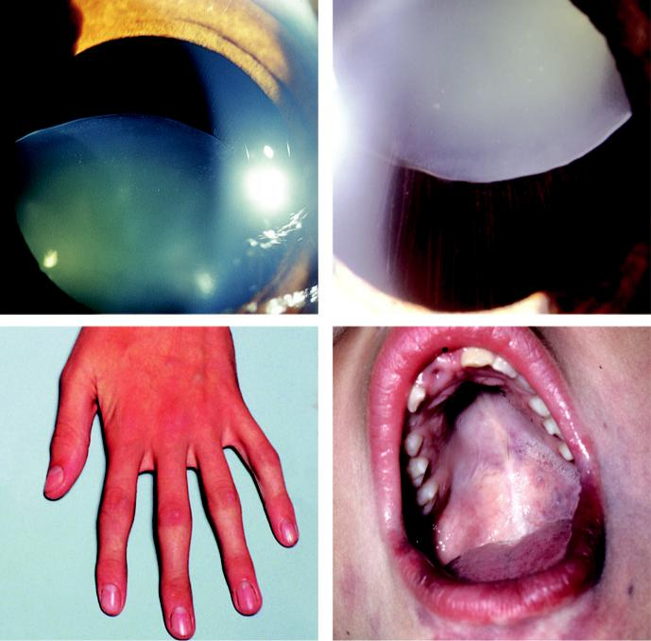

A B

C D

Fig. 10.13 Ectopia lentis: (A) partial inferior subluxation in homocystinuria, (B) superotemporal in Marfan syn-

drome, (C) arachnodactyly, (D) high-arched palate. (From Salmon JF, Kanski’s Clinical Ophthalmology: A

Systematic Approach, 9th edition. Oxford, UK: Elsevier; 2020.)

#*" ##%"#"+!#(&&%"'+$'""#* "%#! " +#!+ &)%#"$'!%

#%$%&#" (&#" +##'%(&&*'#('$%!&&#"#$+%', &)%" %'&%&%)

**174** SYNOPSIS OF CLINICAL OPHTHALMOLOGY



***Hereditary without systemic associations***: (a) familial (AD, bilateral superotemporal ectopia),

1. ectopia lentis et pupillae (AR, displacement of pupil and lens in opposite directions,
2. aniridia (inferior ectopia).

***Hereditary with systemic associations***: (a) Marfan syndrome (AD, tall, thin stature, arach-nodactyly; Fig. 10.13C), high-arched palate (Fig. 10.13D), cardiovascular lesions, bilateral superotemporal ectopia with zonule intact) (see Fig. 10.13B), (b) Weill–Marchesani syn-drome (AR or AD, short stature, brachydactyly, mental handicap, inferior ectopia in 50%), (c) homocystinuria (zonules disrupted) (see Fig. 10.13A), (d) sulphite oxidase deficiency.

**Management**

***Nonsurgical***: conventional spectacle correction may be adequate in mild subluxation; apha-kic spectacle or contact lens correction if appropriate.

***Indications for surgical removal***: (a) intractable ametropia, (b) optical distortion due to astig-matism and/or lens edge eect, (c) cataract, (d) lens-induced glaucoma (see Chapter 11), (d) lens-induced uveitis (rare), (e) endothelial touch.

**Abnormalities of shape**

***Anterior lenticonus***: bilateral axial projection of the anterior surface of the lens into the anterior chamber (Fig. 10.14A). Occurs in Alport syndrome (AD or X-L); characterized by progressive sensorineural deafness and renal disease. Other ocular features are fleck reti-nopathy and posterior polymorphous corneal dystrophy.

***Posterior lenticonus***: bulging and opacification of the posterior axial zone of the lens. Most cases are unilateral, sporadic and not associated with systemic abnormalities.

***Lentiglobus***: very rare, usually unilateral, generalized hemispherical deformity of the lens.

***Microspherophakia***: small spherical lens; may be isolated familial or associated with

1. Peters anomaly, (b) Marfan and Weill–Marchesani syndromes, (c) hyperlysinaemia,
2. congenital rubella.

***Microphakia***: lens with a smaller than normal diameter (Fig. 10.14B); may occur in Lowe syndrome.

***Coloboma***: notching at the inferior equator with corresponding absence of zonular fibres, may be associated with iris or fundus colobomas.

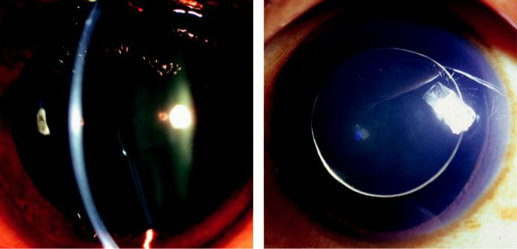

A B

Fig. 10.14 Abnormalities of lens shape: (A) anterior lenticonus, (B) microphakia. (From Salmon JF, Kanski’s

Clinical Ophthalmology: A Systematic Approach, 9th edition. Oxford, UK: Elsevier; 2020.)

#*" ##%"#"+!#(&&%"'+$'""#* "%#! " +#!+ &)%#"$'!%

#%$%&#" (&#" +##'%(&&*'#('$%!&&#"#$+%', &)%" %'&%&%)



CHAPTER 11

Glaucoma



C H A P T E R O U T L I N E

Ocular Hypertension 176

Primary Open-Angle Glaucoma (POAG) 176

Optic Disc Changes 178

Normal-Pressure Glaucoma (NTG) 180

Primary Angle-Closure Glaucoma (PACG) 181

Pseudoexfoliation Syndrome 185

Pseudoexfoliation glaucoma 185

Pigment Dispersion 186

Pigment dispersion syndrome 186 Pigmentary glaucoma 186

Neovascular Glaucoma 187 Introduction 187 Rubeosis iridis 188

Secondary open-angle glaucoma 188 Secondary angle-closure glaucoma 189

Inflammatory Glaucoma 189 Angle-closure glaucoma with pupillary block 189 Angle-closure glaucoma without pupillary block 189 Open-angle glaucoma 189

Treatment of inflammatory glaucoma 190

Posner–Schlossman syndrome (glaucomatocyclitic crisis) 190

Steroid-Induced Glaucoma 191

Lens-related glaucoma 191

Phacolytic glaucoma 191

Phacomorphic glaucoma 191

Lens dislocation into the anterior chamber 192

Traumatic Glaucoma 192

Hyphaema 192

Angle recession glaucoma 193

Iridocorneal Endothelial Syndrome 194

Glaucoma Associated With Intraocular Tumours 195

Glaucoma Associated With Iridoschisis 195

Primary Congenital Glaucoma 196

Iridocorneal Dysgenesis 197

Posterior embryotoxon 197 Axenfeld–Rieger syndrome 197 Aniridia 198

Glaucoma Medication 199 Prostaglandin analogues 199 Beta-blockers 200 Alpha-2 agonists 201

Topical carbonic anhydrase inhibitors 201 Miotics 201

Combined preparations 201

New topical medications 202

Systemic carbonic acid inhibitors 202

Osmotic agents 202

Laser Therapy 202

Argon laser trabeculoplasty 202

Selective laser trabeculoplasty 202

Nd:YAG laser iridotomy 203

Diode laser ablation (cyclodiode) 203 Laser iridoplasty 203

Trabeculectomy 203 Shallow anterior chamber 203 Failure of filtration 204 Late bleb leakage 205

Bleb-associated bacterial infection and endophthalmitis 206

Nonpenetrating surgery 206 Drainage Shunts 207

Shunts using episcleral explants 207 Mini shunts 207

Minimally Invasive Glaucoma Surgery (MIGS) 207

**175**

#*" ##%"#"+!#(&&%"'+$'""#* "%#! " +#!+ &)%#"$'!%

#%$%&#" (&#" +##'%(&&*'#('$%!&&#"#$+%', &)%" %'&%&%)

**176** SYNOPSIS OF CLINICAL OPHTHALMOLOGY



**Ocular Hypertension**

**Introduction**

***Intraocular pressure (IOP):*** this is determined by the balance between the rate of aqueous production and the rate of aqueous outflow. About 90% of the outflow is through the tra-becular meshwork into the Schlemm canal and then into the episcleral veins (Figs. 11.1A) and 10% passes through the face of the ciliary body and iris (the uveoscleral route.) A reduc-tion in outflow through the trabeculum causes a rise in IOP.

**Diagnosis**

***Normal IOP:*** mean IOP in the general population is 16 mm Hg; two standard deviations to either side of this gives a statistical ‘normal’ IOP range of 11–21 mm Hg (Fig. 11.1B). e upper range of normal is 23 mm Hg for individuals over 70 years.

***Definition:*** 4–7% of individuals over the age of 40 years have an IOP >21 mm Hg without detectable glaucomatous damage; so-called ‘ocular hypertension’ (OHT).

***Risk factors for conversion of OHT to glaucoma:*** (a) greater age, (b) higher IOP, (c) lower central corneal thickness, (d) larger C/D ratio, (e) higher ‘pattern standard deviation’ on perimetry.

**Management**

Most individuals with OHT do not require treatment: follow at yearly intervals.

Risk of conversion to POAG: after 5 years if untreated the risk is 9.5% and 4.4% if treated with an IOP-lowering eye-drop. Validated prediction models allow the risk for a given individual to be determined and expressed as a percentage.

Drug choice for those at high risk: as for primary open-angle glaucoma (see below). Other considerations: (a) individual patient profile (e.g. age/life expectancy, patient prefer-ence and risk factors), (b) consider treating every patient with an IOP of 30 mm Hg.

**Primary Open-Angle Glaucoma (POAG)**

**Introduction**

***Definition:*** POAG is a chronic, progressive optic neuropathy of adult onset. It is char-

acterized by: (a) retinal nerve fibre layer thinning, (b) glaucomatous optic neuropathy,

1. characteristic visual field loss as damage progresses, (d) an open anterior chamber angle, (e) absence of signs of secondary glaucoma, (f ) IOP is a key modifiable risk factor.

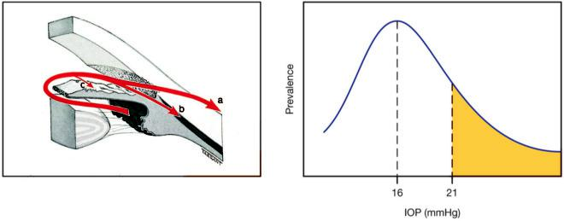

A B

Fig. 11.1 (A) Routes of aqueous outflow: (a) trabecular, (b) uveoscleral, (c) iris, (B) distribution of IOP in the

general population. (From Salmon JF, Kanski’s Clinical Ophthalmology: A Systematic Approach, 9th edition.

Oxford, UK: Elsevier; 2020.)

#*" ##%"#"+!#(&&%"'+$'""#* "%#! " +#!+ &)%#"$'!%

#%$%&#" (&#" +##'%(&&*'#('$%!&&#"#$+%', &)%" %'&%&%)

|  |  |
| --- | --- |
| Chapter 11—GLAUCOMA | **177** |
|  |  |

***Risk factors:*** (a) elevated IOP, (b) older age, (c) race (more common in black than white individuals), (d) family history of POAG (first-degree relatives), (e) myopia. ***Epidemiology:*** glaucoma is the second commonest cause of blindness worldwide. Half of individuals with glaucoma are unaware that they have the condition.

***Goal of treatment:*** to slow the rate of progression throughout the patient’s lifetime, in order to maintain visual function and a good quality of life.

**Diagnosis**

***History:*** usually asymptomatic until damage is advanced: (a) past ophthalmic history includ-ing refractive status, (b) family history, (c) past medical history, (d) current medication. ***General examination:*** (a) pupils, (b) slit lamp, (c) tonometry, (d) pachymetry for central corneal thickness (CCT), (e) gonioscopy, (f ) optic disc examination with dilated pupils. ***Perimetry*:** visual field defects include: (a) small paracentral depression (70% of early defects), (b) arcuate-shaped defect, (c) nasal step, (d) ring scotoma, (e) end-stage changes with a small residual island of central vision (Fig. 11.2A–D).

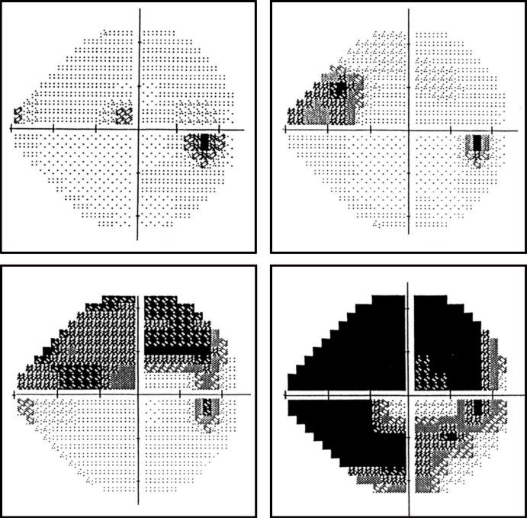

A B

C D

Fig. 11.2 Grey scale display showing progressive glaucomatous damage in different patients: (A) small para-central defect, (B) nasal ‘step’, (C) extended arcuate defect, (D) ring scotoma. (From Salmon JF, Kanski’s Clinical Ophthalmology: A Systematic Approach, 9th edition. Oxford, UK: Elsevier; 2020.)

#*" ##%"#"+!#(&&%"'+$'""#* "%#! " +#!+ &)%#"$'!%

#%$%&#" (&#" +##'%(&&*'#('$%!&&#"#$+%', &)%" %'&%&%)

**178** SYNOPSIS OF CLINICAL OPHTHALMOLOGY

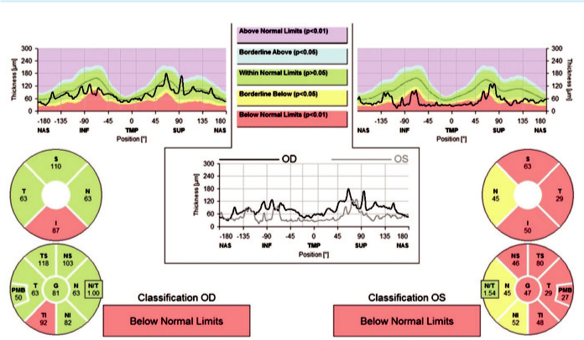

Fig. 11.3 OCT of the optic disc showing infero-temporal thinning of the right RNFL and extensive thinning of the left RNFL. (From Salmon JF, Kanski’s Clinical Ophthalmology: A Systematic Approach, 9th edition. Oxford, UK: Elsevier; 2020.)

***Imaging:*** (a) stereo disc photography, (b) confocal scanning laser tomography (e.g. Heidelberg retinal tomography), (c) scanning laser polarimetry (e.g. GDx) and especially (d) optical coherence tomography (OCT) (Fig. 11.3).

**Optic Disc Changes**

Retinal nerve fibre layer defects.

Focal notching of the neuroretinal rim: often inferior (Fig. 11.4A).

Diuse enlargement of the cup ( Fig. 11.4B).

C/D ratio asymmetry: comparison of overall disc diameter is critical.

‘Sharpened’ disc edge: as adjacent neuroretinal rim is lost (Fig. 11.4C).

Loss of nasal neuroretinal rim.

Lamina dot sign: exposed grey dot-like fenestrations in the lamina cribrosa.

Vascular changes: (a) disc ‘splinter’ haemorrhages (Fig. 11.4D), (b) baring of circumlinear blood vessels (space between a superficial vessel and the disc margin), (c) bayoneting (dou-ble angulation of a vessel as it bends backwards due to loss of underling NRR), (d) collateral disc vessels.

Progression of peripapillary atrophy: particularly the inner (beta) zone.

**Management:**

lowering IOP is the only proven method of slowing progression. A target IOP should be set with subsequent monitoring and target resetting if progression occurs.

***Initial medical therapy:*** with one drug in its lowest concentration, instilled as infrequently as possible consistent with the desired eect (see later in this chapter).

***Review:*** after 4–8 weeks, when response is assessed against target IOP. If satisfactory response, review in 3–6 months.

***Causes of failure:*** (a) poor adherence (25% of patients), (b) inadequate instillation technique, (c) inappropriate target pressure, (d) IOP fluctuations including wide diurnal variation.

#*" ##%"#"+!#(&&%"'+$'""#* "%#! " +#!+ &)%#"$'!%

#%$%&#" (&#" +##'%(&&*'#('$%!&&#"#$+%', &)%" %'&%&%)

|  |  |
| --- | --- |
| Chapter 11—GLAUCOMA | **179** |
|  |  |

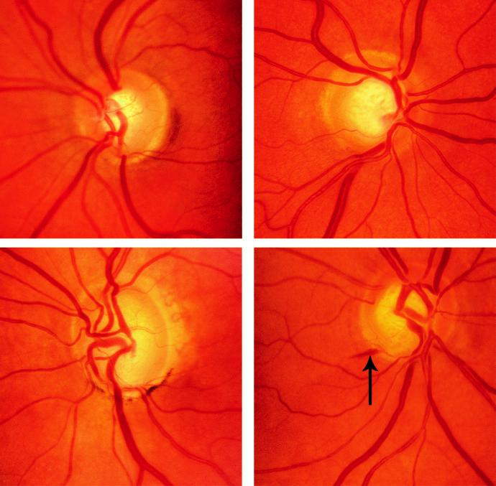

A B

C D

Fig. 11.4 Optic disc changes in glaucoma: (A) focal notch, (B) concentric cupping, (C) advanced cupping with sharp edges of neuroretinal rim, (D) flame-shaped haemorrhage (arrow). (From Salmon JF, Kanski’s Clinical Ophthalmology: A Systematic Approach, 9th edition. Oxford, UK: Elsevier; 2020.)

***Ongoing monitoring:*** IOP, optic disc assessment, perimetry (annually in most low–moderate risk cases).

***Laser trabeculoplasty:*** selective laser trabeculoplasty (SLT) or argon laser trabeculoplasty (ALT) can be used to replace or supplement medical treatment. Indications include:

1. patient preference, (b) intolerance of medical therapy, (c) avoidance of polypharmacy or surgery.

***Indications for surgery:*** (a) failed medical therapy, (b) intolerance of medical therapy,

1. avoidance of polypharmacy, (d) progressive deterioration despite seemingly adequate IOP control, (e) as primary therapy in some patients.

***Trabeculectomy:*** is the most common surgical procedure, although nonpenetrating surgery is also widely performed. If significant lens opacity is present, phacoemulsification alone may be associated with a fall in IOP; alternatively, it can be combined with a filtration procedure (e.g. phacotrabeculectomy). Mitomycin C is often used at the time of surgery to reduce the risk of postoperative bleb scarring.

#*" ##%"#"+!#(&&%"'+$'""#* "%#! " +#!+ &)%#"$'!%

#%$%&#" (&#" +##'%(&&*'#('$%!&&#"#$+%', &)%" %'&%&%)

**180** SYNOPSIS OF CLINICAL OPHTHALMOLOGY



***MIGS:*** minimally invasive glaucoma surgery is commonly combined with cataract surgery and is not suitable for all forms of glaucoma. Current procedures can be divided into:

1. surgery that bypasses or manipulates the canal of Schlemm and (b) implants that result in the formation of a bleb (see later).

**Normal-Pressure Glaucoma (NTG)**

**Introduction**

***Definition:*** is is a variant of primary open-angle glaucoma that features an IOP that

is within the normal range. It is characterized by: (a) glaucomatous optic neuropathy, (b)

characteristic visual field loss, (c) IOP consistently 21 mm Hg on diurnal testing, (d) open

angle, (e) absence of signs of secondary glaucoma.

***Distinction between NTG and POAG:*** this is an arbitrary division based on an epidemio-logically derived range of normal IOP that may not have significant clinical value.

***Risk factors:*** (a) age (older than in POAG), (b) race (particularly prevalent in Japan),

1. family history of glaucoma, (d) CCT (thinner than in POAG), (e) systemic hypoten-sion including nocturnal blood pressure dips, (f ) possibly abnormal vasoregulation (e.g. migraine, Raynaud phenomenon), (g) low CSF pressure.

***Diﬀerential diagnosis:*** (a) nocturnal IOP spikes, (b) previous secondary raised IOP (trauma, uveitis, steroids, resolved pigmentary glaucoma), (c) masking of elevated IOP by systemic treatment with a beta-blocker, (d) previous acute optic nerve insult (e.g. anterior ischaemic optic neuropathy), (e) hypovolaemic or septicaemic shock, (f ) progressive retinal nerve fibre defects not due to glaucoma (e.g. myopic degeneration, disc drusen), (g) congenital disc anomalies (e.g. disc pits, coloboma), (h) chiasmal or optic nerve compression.

**Diagnosis**

***Specific points in the history:*** (a) migraine and Raynaud phenomenon, (b) an episode of hypovolaemic shock, (c) headache and other neurological symptoms, (d) intermittent use of topical and systemic steroids, (e) systemic beta-blockers.

***Specific points in the examination:*** (a) IOP is usually in the high teens but may be lower,

1. glaucomatous cupping is similar to POAG, although focal neuroretinal notching is more common, (b) peripapillary atrophic changes and disc splinter haemorrhages are more fre-quent than in POAG.

***Field defects***: may be closer to fixation and more localized than in POAG.

***Other investigations:*** as for POAG, but in certain patients consider assessment of:

1. systemic vascular risk factors, (b) 24-hour ambulatory blood pressure monitoring to exclude nocturnal systemic hypotension, (c) blood tests for other causes of nonglaucoma-tous optic neuropathy, (d) cranial MRI.

***Indications for neuroimaging:*** (a) loss of VA out of proportion to cupping, (b) loss of colour vision on Ishihara testing, (c) visual field loss not consistent with retinal nerve fibre layer drop-out, (d) pallor of the neuroretinal rim, (f ) rapid progression despite normal IOP.

**Treatment**

***Indications:*** visual fields are stable in 50% over 5 years without treatment. In mild cases it may be appropriate to demonstrate progression before treating. IOP reduction is eective in reducing progression in many patients.

***Topical:*** may include betaxolol (possibly by increasing optic nerve blood flow). Beware of using topical beta-blockers at bedtime (drop in nocturnal BP).

***Surgery (or laser trabeculoplasty):*** if progression occurs despite reduced IOP.

#*" ##%"#"+!#(&&%"'+$'""#* "%#! " +#!+ &)%#"$'!%

#%$%&#" (&#" +##'%(&&*'#('$%!&&#"#$+%', &)%" %'&%&%)

|  |  |
| --- | --- |
| Chapter 11—GLAUCOMA | **181** |
|  |  |

***Systemic:*** (a) control of systemic vascular disease, (b) calcium channel blockers to counter vasospasm, (c) if significant nocturnal dips in BP are detected, consider reducing antihyper-tensive medication (especially bedtime dosing), (d) sleep with the head of the bed elevated (IOP increases with supine positioning).

**Primary Angle-Closure Glaucoma (PACG)**

**Introduction**

***Definition:*** ‘angle closure’ refers to occlusion of the trabecular meshwork by the peripheral iris–iridotrabecular contact (ITC), obstructing aqueous outflow. e condition is respon - sible for up to half of all cases of glaucoma globally and is typically associated with greater visual morbidity than POAG.

***‘Occludable angle’:*** where the pigmented trabecular meshwork is not visible in 3 out of 4 quadrants using a Goldmann lens, with the patient looking straight ahead in a dark room. ***Grading of angle width:*** the Shaer system is commonly used. e slit beam converges at the Schwalbe line (Fig. 11.5). (a) Grade 4 (35–45°) wide open with ciliary body visible,

1. Grade 3 (25–35°) open angle with scleral spur visible, (c) Grade 2 (20°) trabeculum is visible, (d) Grade 1 (10°) only Schwalbe line is visible, (e) Grade 0 (0°) is closed due to iridocorneal contact

***Mechanisms:*** (a) pupillary block – failure of aqueous flow through the pupil leading to ante-rior bowing of the iris (Fig. 11.6A) is relieved by peripheral iridotomy, (b) non-pupillary block secondary to plateau iris, which is due to anteriorly positioned ciliary processes in the presence of a normal or slightly shallow central anterior chamber depth (Fig. 11.6B). A thick peripheral iris may be important in the pathogenesis in Asians.

***Risk factors:*** (a) age (usually over 60 years), (b) gender (female > male), (c) race (high Asian prevalence), (d) family history, (e) hypermetropia, (f ) short axial length, (g) shallow anterior chamber dimensions, associated with a relatively forward lens position.

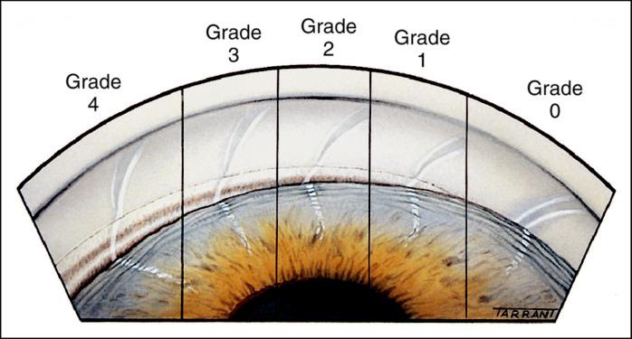

Fig. 11.5 Grading of angle width according to number of visible structures (see text). The slit beam converges at the Schwalbe line. (From Salmon JF, Kanski’s Clinical Ophthalmology: A Systematic Approach, 9th edition. Oxford, UK: Elsevier; 2020.)

#*" ##%"#"+!#(&&%"'+$'""#* "%#! " +#!+ &)%#"$'!%

#%$%&#" (&#" +##'%(&&*'#('$%!&&#"#$+%', &)%" %'&%&%)

**182** SYNOPSIS OF CLINICAL OPHTHALMOLOGY

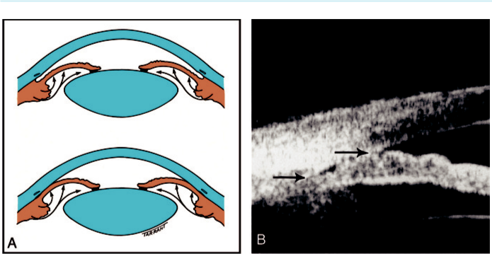

Fig. 11.6 Mechanism of angle closure: (A) pupillary block, (B) plateau iris configuration using UBM (showing

anteriorly rotated ciliary processes and slit-like angle). (From Salmon JF, Kanski’s Clinical Ophthalmology: A

Systematic Approach, 9th edition. Oxford, UK: Elsevier; 2020.)

**Diagnosis**

***Primary angle closure suspect (PACS):*** (a) shallow anterior chamber (Fig. 11.7A), (b) goni-oscopy shows an ‘occludable angle’: ITC in three or more quadrants but no peripheral ante-rior synechiae (PAS), (c) narrow angle on dark-room anterior segment OCT (Fig. 11.7B), (d) normal IOP, discs and fields.

***Primary angle closure (PAC):*** (a) gonioscopy shows three or more quadrants of ITC

(b) raised IOP and/or PAS (Fig. 11.7C), (c) normal discs and fields.

***Primary angle-closure glaucoma (PACG):*** (a) gonioscopy shows ITC in three or more quad-rants, (b) glaucomatous optic neuropathy.

**Clinical presentation**

***Acute congestive angle closure:*** acute onset of blurring and haloes, ocular pain and headache, sometimes malaise and gastrointestinal symptoms. (a) VA usually 6/60-HM, (b) IOP very high (50–80 mm Hg), (c) corneal oedema (Fig. 11.7D), (d) ciliary injection, (e) shallow anterior chamber, (f) unreactive mid-dilated vertically oval pupil, (g) fellow eye shows an occludable angle. ***Resolved acute primary angle closure:*** (a) early signs (low IOP, Descemet membrane folds, optic nerve head congestion) (Fig. 11.8A), (b) late signs (iris atrophy, glaukomflecken, optic disc pallor) (Fig. 11.8B).

***Subacute presentation:*** (a) intermittent ocular pain and headache, (b) intermittent IOP elevation, (c) occludable angle.

***Chronic presentation:*** (a) asymptomatic although episodic mild blurring may be present,

1. PAS may be broad (‘creeping’) or discrete (‘sawtooth’), (c) optic nerve head appearance depends on the severity of the damage.

**Treatment**

***PACS:*** prophylactic laser iridotomy (Fig. 11.9A). If significant ITC persists, options include:

observation (most cases), laser iridoplasty (Fig. 11.9B) and lens extraction.

***PAC and PACG:*** (a) as for PACS, although subsequent medical treatment (as for POAG) is often required, or (b) lens extraction with IOL implantation should be considered in patients with PAC and IOP >29 mm Hg and in those with PACG.

#*" ##%"#"+!#(&&%"'+$'""#* "%#! " +#!+ &)%#"$'!%

#%$%&#" (&#" +##'%(&&*'#('$%!&&#"#$+%', &)%" %'&%&%)

|  |  |
| --- | --- |
| Chapter 11—GLAUCOMA | **183** |
|  |  |

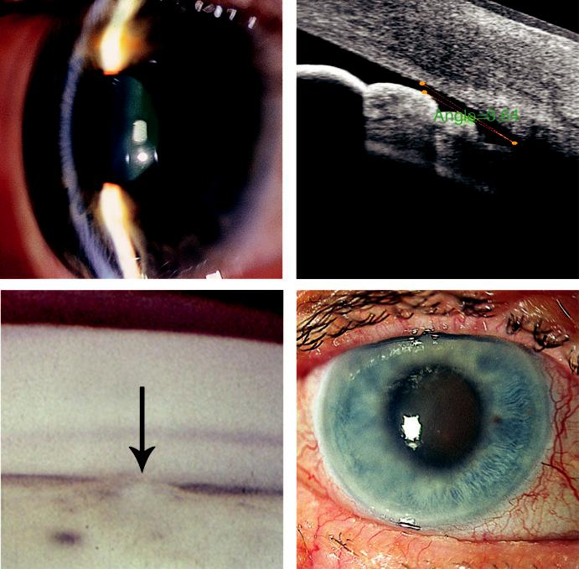

A B

C D

Fig. 11.7 Primary angle closure: (A) shallow anterior chamber, (B) very narrow angle on anterior segment OCT, (C) gonioscopic appearance on indentation showing PAS (arrow), (D) acute closure showing corneal oedema and a mid-dilated pupil. (From Salmon JF, Kanski’s Clinical Ophthalmology: A Systematic Approach, 9th edition. Oxford, UK: Elsevier; 2020.)

***Initial treatment of acute and subacute presentation:*** (a) intravenous acetazolamide 500 mg,

1. topical apraclonidine 1%, timolol 0.5%, prednisolone 1%, or dexamethasone 0.1% to the aected eye, (c) pilocarpine 2%–4% one drop to the aected eye, repeated after 30 min, with one drop of 1% as prophylaxis to the fellow eye; it is only eective once the IOP begins to fall, (d) place patient in a supine position.

***Subsequent treatment of acute and subacute presentation:*** (a) pilocarpine 2% four times daily to the aected eye and 1% to the fellow eye, (b) ongoing treatment according to IOP with timolol 0.5% twice daily, apraclonidine 1% three times daily and oral acetazolamide 250 mg four times daily. Once the cornea is clear, bilateral laser iridotomy is performed and medical treatment tapered.

***Options in unresponsive acute cases:*** (a) intravenous mannitol or oral glycerol, (b) cor-neal indentation, (c) laser iridotomy or iridoplasty (clear oedema with glycerol 50% first),

1. cyclodiode laser treatment, (e) paracentesis, (f ) surgery (peripheral iridectomy, lens extraction, trabeculectomy).

#*" ##%"#"+!#(&&%"'+$'""#* "%#! " +#!+ &)%#"$'!%

#%$%&#" (&#" +##'%(&&*'#('$%!&&#"#$+%', &)%" %'&%&%)

**184** SYNOPSIS OF CLINICAL OPHTHALMOLOGY

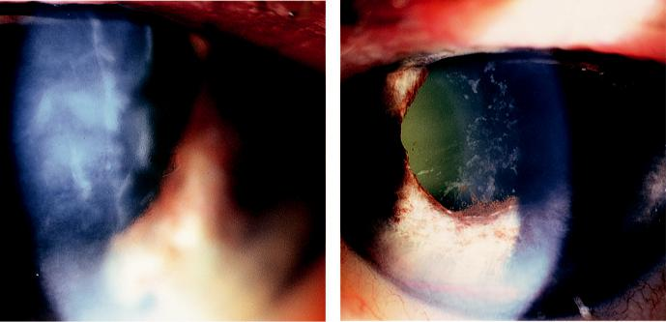

A B

Fig. 11.8 Resolved acute primary angle closure: (A) Descemet membrane folds, (B) iris atrophy with irregular

pupil. (From Salmon JF, Kanski’s Clinical Ophthalmology: A Systematic Approach, 9th edition. Oxford, UK:

Elsevier; 2020.)

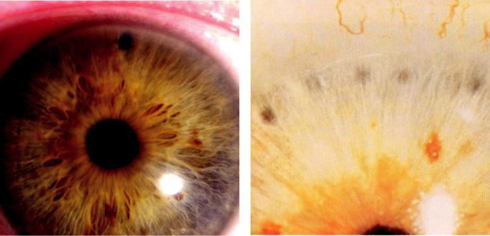

A B

Fig. 11.9 Treatment: (A) laser peripheral iridotomy, (B) laser iridoplasty. (From Salmon JF, Kanski’s Clinical

Ophthalmology: A Systematic Approach, 9th edition. Oxford, UK: Elsevier; 2020.)

**Diﬀerential diagnosis of acute IOP elevation:**

consider alternatives to angle closure, particularly if the fellow eye has an open angle.

***Lens-induced angle closure:*** due to an intumescent or subluxated lens.

***‘Malignant glaucoma’:*** especially if intraocular surgery has recently taken place causing aqueous misdirection.

***Other causes of secondary angle closure with or without pupillary block:*** (a) topiramate (epilepsy and migraine drug) causing ciliochoroidal eusion, (b) neovascular glaucoma sometimes presents acutely, (c) inflammation with an open angle, e.g. iridocyclitis/trabe-culitis, glaucomatocyclitic crisis (Posner–Schlossman syndrome), (d) scleritis without angle closure, (e) pigment dispersion syndrome, (f ) pseudoexfoliation syndrome, (g) orbital/ retro-orbital lesions (e.g. inflammation, retrobulbar haemorrhage).

#*" ##%"#"+!#(&&%"'+$'""#* "%#! " +#!+ &)%#"$'!%

#%$%&#" (&#" +##'%(&&*'#('$%!&&#"#$+%', &)%" %'&%&%)

|  |  |
| --- | --- |
| Chapter 11—GLAUCOMA | **185** |
|  |  |

**Pseudoexfoliation Syndrome**

**Pathogenesis:**

grey-white fibrillary material is produced by abnormal basement membranes of ageing intraocular epi-thelial cells and deposited in structures including the trabeculum; particularly common in Scandinavia. Single nucleotide polymorphisms in the *LOX1* gene on chromosome 15 predisposes to the condition.

**Diagnosis**

***Cornea:*** pseudoexfoliation (PXF) material and pigment may be seen on the endothelium.

***Iris:*** PXF on the pupillary margin and ‘moth-eaten’ sphincter atrophy.

***Anterior lens surface:*** central disc and peripheral band of PXF, with a clear zone between (Fig. 11. 10A), which may be seen only with pupillary dilatation.

***Gonioscopy:*** (a) trabecular hyperpigmentation and a band running on or anterior to the Schwalbe line (Sampaolesi line; Fig. 11.10B)*;* (b) dandru-like PXF particles may be seen,

1. there is an increased risk of angle closure, probably due to zonular laxity. ***Inner ear:*** high tone hearing loss.

**Treatment:**

observation at 12-monthly intervals to detect elevation of IOP.

**PSEUDOEXFOLIATION GLAUCOMA**

**Pathogenesis:**

trabecular obstruction and damage by PXF material and pigment. e cumulative risk of glau - coma in eyes with PXF is approximately 5% at 5 years and 15% at 10 years. A patient with unilat-eral pseudoexfoliation glaucoma and only PXF in the fellow eye has a 50% 5-year risk of glaucoma in the fellow eye, but only a low risk if there is no PXF.

**Diagnosis**

***Presentation:*** in 7th decade with chronic unilateral elevation of IOP. An acute elevation may occasionally occur.

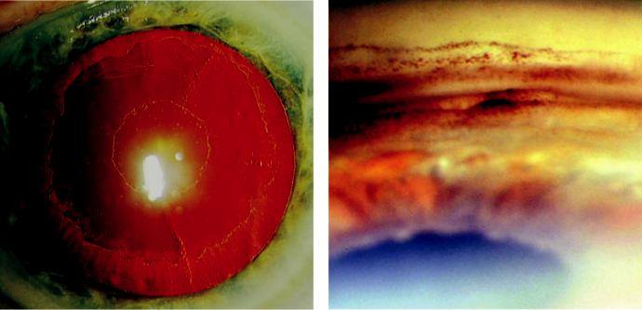

A B

Fig. 11.10 Pseudoexfoliation syndrome: (A) pseudoexfoliation material on lens, more obvious on pupillary dil-atation, (B) gonioscopy showing patchy hyperpigmentation and a Sampaolesi line. (From Salmon JF, Kanski’s Clinical Ophthalmology: A Systematic Approach, 9th edition. Oxford, UK: Elsevier; 2020.)

#*" ##%"#"+!#(&&%"'+$'""#* "%#! " +#!+ &)%#"$'!%

#%$%&#" (&#" +##'%(&&*'#('$%!&&#"#$+%', &)%" %'&%&%)

**186** SYNOPSIS OF CLINICAL OPHTHALMOLOGY



***Signs:*** PXF and glaucomatous optic neuropathy.

***Prognosis:*** worse than in POAG because the IOP is often significantly elevated and may also exhibit great fluctuation. Severe damage may therefore develop relatively rapidly.

**Treatment**

***Medical:*** same as for POAG but with a greater likelihood of requiring laser or surgery.

***Laser trabeculoplasty:*** eective in the short term, but IOP may increase significantly at around two years post treatment.

***Surgery:*** same success rate as in POAG.

***Trabecular aspiration:*** performed at the same time as cataract surgery or trabeculectomy confers a short-term benefit.

**Pigment Dispersion**

**PIGMENT DISPERSION SYNDROME**

**Pathogenesis:**

liberation of pigment granules from the iris pigment epithelium due to ‘reverse pupil block,’ with resultant posterior bowing of the iris and iridozonular touch (Fig. 11.11A). Pigment is deposited throughout the anterior segment. e condition primarily aects white individuals with myopia; males more than females.

**Diagnosis**

***Presentation:*** usually asymptomatic, although corneal oedema with blurring and haloes may occasionally occur in response to an IOP spike. In some patients, this may be pre-cipitated by exercise.

***Cornea:*** pigment deposition on the endothelium in a vertical spindle-shaped distribution (Krukenberg spindle; Fig. 11.11B).

***Anterior chamber:*** usually very deep.

***Iris:*** radial slit-like transillumination defects (Fig. 11.11C) and fine surface pigment granules.

***Gonioscopy:*** very wide angle with mid-peripheral iris concavity and homogeneous trabecu-lar hyperpigmentation in all four quadrants (Fig. 11.11D). Pigment may also be seen on or anterior to Schwalbe line.

**Treatment:**

observation at 6- to 12-monthly intervals to detect elevation of IOP.

**PIGMENTARY GLAUCOMA**

**Pathogenesis:**

approximately 15% of patients with pigment dispersion syndrome (PDS) develop OHT or chronic open-angle glaucoma after 15 years. Elevation of IOP appears to be caused by both pig-mentary obstruction of the intertrabecular spaces and secondary damage to the trabeculum; men are aected twice as frequently as women.

**Diagnosis**

***Presentation:*** in 3rd and 4th decades, usually with chronic glaucoma.

***Signs:*** those of PDS, together with glaucomatous optic neuropathy. IOP may be unstable and asymmetric disease is common.

***Diﬀerential diagnosis:*** (a) POAG with a heavily pigmented trabeculum, (b) pseudoexfo-liation, (c) pseudophakic pigmentary glaucoma, (d) sequelae of uveitis, (e) subacute angle-closure glaucoma.

#*" ##%"#"+!#(&&%"'+$'""#* "%#! " +#!+ &)%#"$'!%

#%$%&#" (&#" +##'%(&&*'#('$%!&&#"#$+%', &)%" %'&%&%)

|  |  |
| --- | --- |
| Chapter 11—GLAUCOMA | **187** |
|  |  |

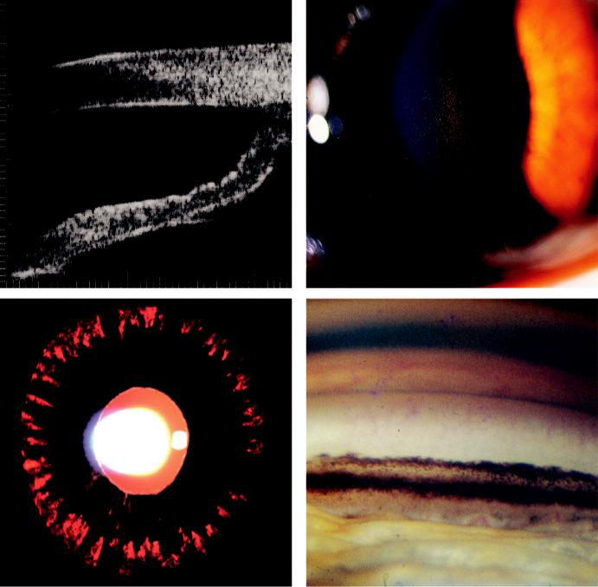

A B

C D

Fig. 11.11 Pigment dispersion syndrome: (A) UBM showing backward bowing of the iris, (B) Krukenberg spindle, (C) radial spoke-like iris transillumination defects, (D) heavily pigmented angle. (From Salmon JF, Kanski’s Clinical Ophthalmology: A Systematic Approach, 9th edition. Oxford, UK: Elsevier; 2020.)

**Treatment**

***Medical:*** similar to that of POAG, but monitor at 4-monthly intervals because the combi-nation of high IOP and myopia can cause a rapid deterioration in vision.

***Laser trabeculoplasty:*** often initially eective. Use the lowest laser settings and only treat 2 quadrants to prevent a spike in IOP.

***Trabeculectomy:*** more commonly performed than in POAG.

**Neovascular Glaucoma**

**INTRODUCTION**

***Pathogenesis:*** iris neovascularization (rubeosis iridis) occurs under the influence of vascular endothelial growth factor (VEGF) produced in response to severe retinal ischaemia. Angle involvement initially impairs aqueous outflow in the presence of an open angle and later synechiae develop, resulting in angle closure.

#*" ##%"#"+!#(&&%"'+$'""#* "%#! " +#!+ &)%#"$'!%

#%$%&#" (&#" +##'%(&&*'#('$%!&&#"#$+%', &)%" %'&%&%)

**188** SYNOPSIS OF CLINICAL OPHTHALMOLOGY



***Causes:*** (a) ischaemic central retinal vein occlusion (most common), (b) diabetes, (c) arte-rial disease (especially ocular ischaemic syndrome; rarely central retinal artery occlusion),

1. intraocular tumours, (e) long-standing retinal detachment, (f ) chronic intraocular inflammation.

***Classification:*** (a) rubeosis iridis, (b) secondary open-angle glaucoma, (c) secondary synechial angle-closure glaucoma.

**RUBEOSIS IRIDIS**

**Diagnosis**

Tiny dilated capillary tufts or red spots at the pupillary margin (Fig. 11.12A). New vessels grow radially over the surface of the iris toward the angle.

Angle neovascularization in the absence of pupillary involvement may occur after an isch-aemic central retinal vein occlusion. Gonioscopy without mydriasis should be performed in eyes at high risk.

**Treatment**

Early panretinal photocoagulation (PRP).

Intravitreal anti-VEGF agents (e.g. bevacizumab) to decrease neovascularization and improve IOP control.

e underlying cause needs to be determined and treated in order to: (a) reduce the risk of visual loss in the other eye, (b) reduce the risk of CNS/cardiovascular disease, (c) increase life expectancy.

**SECONDARY OPEN-ANGLE GLAUCOMA**

**Diagnosis:**

neovascular tissue proliferation on the iris and across the face of the angle (Fig. 11.12B).

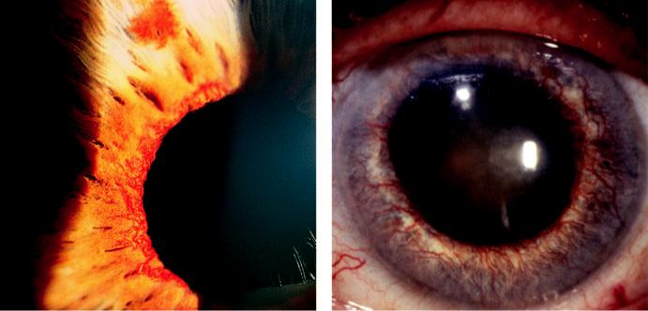

A B

Fig. 11.12 Neovascular glaucoma: (A) rubeosis irides at pupil margin, (B) advanced neovascular changes

associated with a fixed dilated pupil. (From Salmon JF, Kanski’s Clinical Ophthalmology: A Systematic

Approach, 9th edition. Oxford, UK: Elsevier; 2020.)

#*" ##%"#"+!#(&&%"'+$'""#* "%#! " +#!+ &)%#"$'!%

#%$%&#" (&#" +##'%(&&*'#('$%!&&#"#$+%', &)%" %'&%&%)

|  |  |
| --- | --- |
| Chapter 11—GLAUCOMA | **189** |
|  |  |

**Treatment**

***Medical:*** (a) topical atropine 1% and steroids, (b) as for POAG (avoiding miotics), (c) topi-cal apraclonidine and/or oral acetazolamide as temporizing measures, (d) intravitreal anti-VEGF agents may be eective if fibrovascular angle closure has not supervened.

***PRP:*** should be performed as soon as possible, but will not reverse an established fibro-vascular membrane in the angle. Indirect ophthalmoscopic application may be required. ***Cyclodiode:*** consider if medical IOP control is not possible, particularly if the eye is painful, has no useful visual potential or if corneal oedema precludes PRP.

**SECONDARY ANGLE-CLOSURE GLAUCOMA**

**Diagnosis**

As rubeosis progresses, contraction of fibrovascular tissue occludes the angle.

IOP can be very high, with globe congestion and pain.

Severe visual impairment is typical, due to the glaucoma or to the underlying cause.

Prognosis is poor unless the neovascular process can be arrested.

**Treatment**

***Medical:*** as above; steroids and atropine alone may be adequate if there is no potential for vision. Intravitreal anti-VEGF agents will not reverse established angle closure.

***Retinal ablation:*** (a) PRP if the fundus can be adequately visualized or (b) trans-scleral cryotherapy or diode laser for eyes with opaque media.

***Surgery:*** (a) cyclodiode, (b) endocyclodiode or (c) drainage surgery (enhanced trabeculec-tomy or shunt) to control IOP, particularly in an eye with visual potential.

***Other:*** retrobulbar alcohol injection or enucleation for intractable pain.

**Inflammatory Glaucoma**

**ANGLE-CLOSURE GLAUCOMA WITH PUPILLARY BLOCK**

**Pathogenesis:**

1. formation of 360° posterior synechiae (seclusio pupillae) obstructs aqueous flow from the posterior to the anterior chamber, (b) anterior bowing of the iris (iris bombé), occurs and (c) iris becomes apposed to the trabeculum and PAS develop.

**Diagnosis**

***Signs:*** (a) seclusio pupillae, (b) iris bombé (Fig. 11.13A), (c) shallow anterior chamber,

(d) signs of the underlying inflammatory condition.

***Gonioscopy:*** iridotrabecular contact; indentation may be used to assess the extent of PAS.

**ANGLE-CLOSURE GLAUCOMA WITHOUT PUPILLARY BLOCK**

**Pathogenesis:**

1. inflammatory cells and debris accumulate in the angle, (b) subsequent organization and con-traction of debris pulls the peripheral iris over the trabeculum and (c) PAS develop, particularly inferiorly (Fig. 11.13B), but the anterior chamber remains deep.

**OPEN-ANGLE GLAUCOMA**

**Pathogenesis**

***In acute uveitis:*** (a) trabecular obstruction by inflammatory cells and debris, (b) acute trabe-culitis, (c) steroid-induced IOP elevation.

#*" ##%"#"+!#(&&%"'+$'""#* "%#! " +#!+ &)%#"$'!%

#%$%&#" (&#" +##'%(&&*'#('$%!&&#"#$+%', &)%" %'&%&%)

**190** SYNOPSIS OF CLINICAL OPHTHALMOLOGY

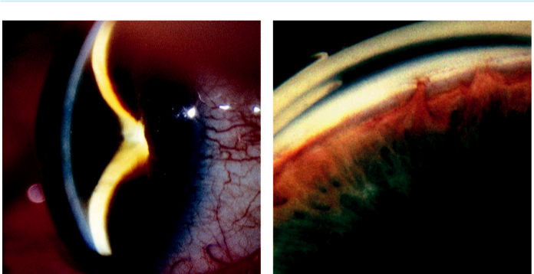

A B

Fig. 11.13 Inflammatory glaucoma: (A) iris bombé, (B) inferior saw-toothed peripheral anterior synechiae.

(From Salmon JF, Kanski’s Clinical Ophthalmology: A Systematic Approach, 9th edition. Oxford, UK:

Elsevier; 2020.)

***In chronic anterior uveitis:*** scarring secondary to chronic trabeculitis, although PAS are also often present.

**TREATMENT OF INFLAMMATORY GLAUCOMA**

Beware of a steroid response (see below).

Medical control of IOP is more likely to be achieved if the angle is completely open. e IOP-lowering eect of ocular hypotensive drugs may be unpredictable (e.g. increased sensitivity to topical carbonic anhydrase inhibitors [CAI]).

Miotics are contraindicated because they increase vascular permeability and may promote formation of posterior synechiae.

A beta-blocker may be the drug of first choice, followed by an alpha-adrenergic agonist or a topical CAI, with a systemic CAI if needed.

Laser iridotomy in eyes with pupillary block. Occlusion of the opening may occur with active uveitis and surgical iridectomy is sometimes necessary.

Drainage surgery (enhanced trabeculectomy or shunt) should be preceded by aggres-sive control of inflammation using systemic steroids and other immunomodulatory medication. Postoperative hypotony is a risk; steroids should be tapered carefully postoperatively.

Cyclodestructive procedures should be used with caution because overtreatment can lead to phthisis bulbi.

**POSNER–SCHLOSSMAN SYNDROME (GLAUCOMATOCYCLITIC CRISIS)**

**Pathogenesis:**

unilateral acute elevation of IOP associated with mild anterior uveitis and an open angle, pre-sumed to be the result of acute trabeculitis. e cause is uncertain, but cytomegalovirus infection has been implicated. Young adults are typically aected; 40% are positive for HLA-Bw54. Some will develop chronic open-angle glaucoma.

#*" ##%"#"+!#(&&%"'+$'""#* "%#! " +#!+ &)%#"$'!%

#%$%&#" (&#" +##'%(&&*'#('$%!&&#"#$+%', &)%" %'&%&%)

|  |  |
| --- | --- |
| Chapter 11—GLAUCOMA | **191** |
|  |  |

**Diagnosis**

***Presentation:*** subacute onset of mild discomfort, haloes and slight blurring.

***Signs:*** (a) epithelial oedema, (b) high IOP (40–80 mm Hg), (c) a few aqueous cells, (d) fine white central keratic precipitates.

**Treatment:**

topical steroids and aqueous suppressants.

**Steroid-Induced Glaucoma**

**Pathogenesis:**

elevation of IOP occurs as a consequence of reduced aqueous outflow, secondary to altered func-tion of the extracellular matrix or endothelial cells of the trabecular meshwork. e IOP response to steroids depends on: (a) steroid type, (b) potency, (c) dose, (d) duration of treatment, (e) route of administration.

**Risk factors:**

1. established glaucoma/ocular hypertension, (b) family history of glaucoma, (c) high myopia,
2. children.

**Diagnosis:**

raised IOP usually occurs 2–4 weeks after commencing steroids in predisposed individuals.

**Treatment:**

1. stop the steroid treatment. In the acute form the IOP returns to normal within days and in the chronic form within 1–4 weeks, (b) consider a less potent steroid (fluorometholone 0.1%, rimexo-lone 1%, or loteprednol etabonate), (c) trabeculectomy in those with persistent IOP elevation.

**Lens-related glaucoma**

**PHACOLYTIC GLAUCOMA**

**Pathogenesis:**

open-angle glaucoma occurring in association with a hypermature cataract. Trabecular obstruction is caused by lens proteins leaking through the intact capsule, and macrophages.

**Diagnosis**

***Presentation:*** pain in an eye with very poor vision due to a hypermature cataract.

***Signs:*** (a) epithelial oedema; (b) deep anterior chamber, sometimes with white particles (Fig. 11.14A) or pseudohypopyon.

**Treatment:**

medical control of IOP followed by cataract removal.

**PHACOMORPHIC GLAUCOMA**

**Pathogenesis:**

acute angle closure precipitated by an intumescent cataract.

**Diagnosis**

***Presentation:*** similar to acute congestive primary angle closure.

#*" ##%"#"+!#(&&%"'+$'""#* "%#! " +#!+ &)%#"$'!%

#%$%&#" (&#" +##'%(&&*'#('$%!&&#"#$+%', &)%" %'&%&%)

**192** SYNOPSIS OF CLINICAL OPHTHALMOLOGY

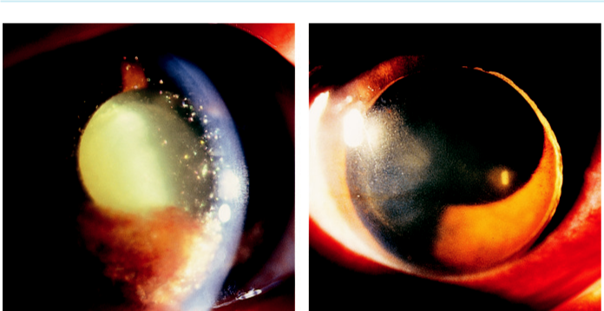

A B

Fig. 11.14 Lens-related glaucoma: (A) phacolytic glaucoma showing lens-protein containing macrophages

in the anterior chamber, (B) traumatic lens dislocation. (From Salmon JF, Kanski’s Clinical Ophthalmology: A

Systematic Approach, 9th edition. Oxford, UK: Elsevier; 2020.)

***Signs:*** shallow anterior chamber, mid-dilated pupil, and cataract; fellow eye usually shows an open angle.

**Treatment**

Similar to acute PAC, but miotics are omitted.

Laser iridotomy/iridoplasty is often not possible or is ineective.

Cataract extraction is the definitive treatment.

**LENS DISLOCATION INTO THE ANTERIOR CHAMBER**

**Pathogenesis:**

blunt ocular trauma is the typical precipitant, particularly in eyes with predisposing conditions such as PXF. e dislocated lens may cause acute pupillary block ( Fig. 11.14B)

**Diagnosis:**

presentation is with sudden onset of visual impairment and symptoms of raised IOP.

**Treatment:**

osmotic agents are generally included in the initial treatment. Relief of pupillary block by laser iridotomy may be sucient in some cases. Subsequent treatment:

***Intact zonule:*** patient should lie supine with the pupil dilated to try to reposition the lens in the posterior chamber.

***Soft lens without zonular attachments:*** lensectomy through an anterior approach.

***Hard lens without zonular attachments:*** pars plana vitrectomy and lensectomy.

**Traumatic Glaucoma**

**HYPHAEMA**

**Pathogenesis:**

in most cases a traumatic hyphaema is a relatively innocuous consequence of ocular trauma. However, prolonged marked elevation of IOP, principally due to trabecular obstruction, may

#*" ##%"#"+!#(&&%"'+$'""#* "%#! " +#!+ &)%#"$'!%

#%$%&#" (&#" +##'%(&&*'#('$%!&&#"#$+%', &)%" %'&%&%)

|  |  |
| --- | --- |
| Chapter 11—GLAUCOMA | **193** |
|  |  |

damage the optic nerve and cause corneal blood staining. Secondary haemorrhage is often more severe than the primary bleed and the risk of complications increases when there is a large hypha-ema. In patients with sickle cell haemoglobinopathy there is an increased risk of IOP elevation. e visual prognosis is usually determined by the associated retinal damage.

**Treatment**

Hospital admission and sometimes bed rest may be prudent for patients with a large hypha-ema (Fig. 11.15A).

A coagulation abnormality should be excluded and anticoagulant medication discontinued after liaison with an appropriate physician; NSAIDs should be avoided.

IOP is treated initially with a beta-blocker and/or a topical or systemic CAI; the latter should be avoided in individuals with sickle haemoglobinopathy.

Topical steroids reduce inflammation and the risk of secondary haemorrhage.

Mydriatics (e.g. atropine) may be considered to immobilize the pupil.

Systemic anti-fibrinolysis (tranexamic acid or aminocaproic acid) can be used to reduce the risk of a secondary haemorrhage.

Surgical evacuation of the blood if there is a risk of permanent corneal staining or intrac-table IOP, amblyopia, or for a total hyphaema of more than 5 days’ duration.

Avoidance of activity with a risk of even minor eye trauma for several weeks; rebleed should prompt immediate review.

**ANGLE RECESSION GLAUCOMA**

**Pathogenesis:**

rupture of the ciliary body between the iris root and the scleral spur due to blunt trauma. e risk of glaucoma is directly related to the extent of angle recession. Only 6–9% develop glaucoma after 10 years, probably due to associated trabecular damage.

**Diagnosis**

Signs of previous blunt trauma may be only mild (e.g. a small sphincter rupture).

Gonioscopy may initially show irregular widening of the ciliary body (Fig. 11.15B).

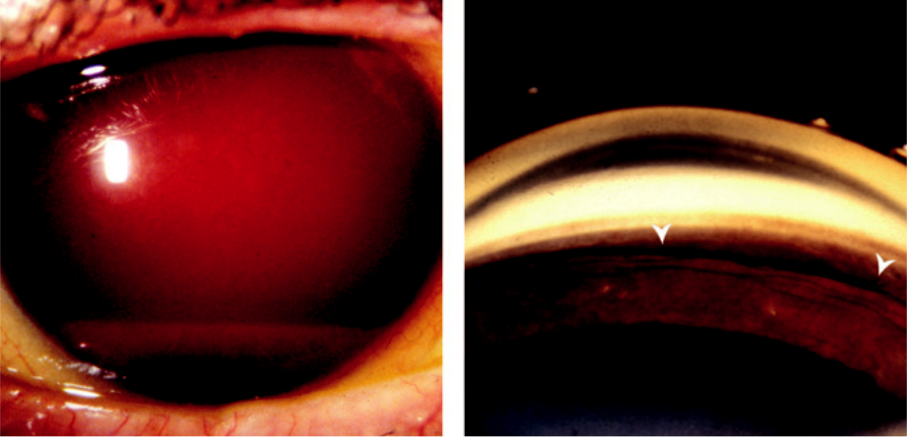

A B

Fig. 11.15 Trauma: (A) large hyphaema, (B) angle recession (between arrow heads). (From Salmon JF,

Kanski’s Clinical Ophthalmology: A Systematic Approach, 9th edition. Oxford, UK: Elsevier; 2020.)

#*" ##%"#"+!#(&&%"'+$'""#* "%#! " +#!+ &)%#"$'!%

#%$%&#" (&#" +##'%(&&*'#('$%!&&#"#$+%', &)%" %'&%&%)

**194** SYNOPSIS OF CLINICAL OPHTHALMOLOGY



**Treatment:**

lifelong periodic review to detect elevated IOP. Medical treatment as for other types of open-angle glaucoma, although surgery is often required.

**Iridocorneal Endothelial Syndrome**

**Pathogenesis:**

proliferation of an abnormal corneal endothelial cell layer across the angle and iris causing a spectrum of disease which can result in glaucoma and corneal decompensation. Iridocorneal endothelial syn-drome (ICE) typically aects one eye of a middle-aged woman. Herpes simplex is commonly found on aqueous PCR testing. ree clinical patterns are distinguished, although overlap is common.

**Diagnosis**

***Essential iris atrophy:*** (a) atrophy of varying severity, (b) corectopia (malposition of the pupil, (c) pseudopolycoria (supernumerary false pupils; Fig. 11.16A).

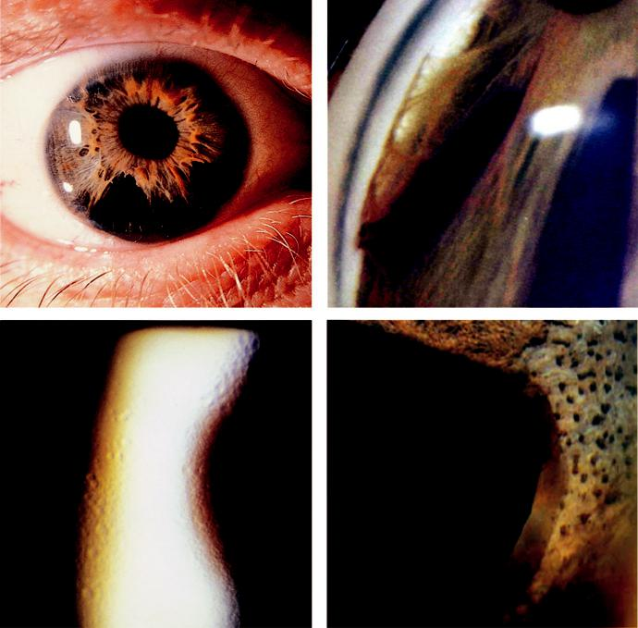

A B

C D

Fig. 11.16 Iridocorneal endothelial syndrome: (A) iris atrophy with pseudopolycoria, (B) gonioscopy show-ing broad PAS, (C) Chandler syndrome, showing ‘hammered silver’ corneal endothelial appearance, (D) iris nodules in Cogan–Reese syndrome.

#*" ##%"#"+!#(&&%"'+$'""#* "%#! " +#!+ &)%#"$'!%

#%$%&#" (&#" +##'%(&&*'#('$%!&&#"#$+%', &)%" %'&%&%)

|  |  |
| --- | --- |
| Chapter 11—GLAUCOMA | **195** |
|  |  |

***Glaucoma:*** with broad-based PAS, extending to Schwalbe line (Fig. 11.16B) in 50% of cases.

***Chandler syndrome:*** ‘hammered silver’ corneal endothelial abnormalities (Fig. 11.16C), often with corneal oedema; absence of iris atrophy in 60% and less severe glaucoma.

***Iris naevus (Cogan–Reese) syndrome:*** either a diuse naevus that covers the anterior iris or iris nodules (Fig. 11.16D); absence of iris atrophy in 50%.

**Treatment:**

medical treatment is often ineective; filtering shunts or cyclodiode are eventually required.

**Glaucoma Associated With Intraocular Tumours**

**Pathogenesis:**

approximately 5% of eyes with an intraocular tumour develop a secondary elevation of IOP by one of the following mechanisms:

***Trabecular obstruction:*** direct invasion by an iris or ciliary body melanoma or seeding from a remote tumour (Fig. 11.17A).

***Trabecular blockage by macrophages:*** that have ingested pigment and tumour cells.

***Secondary angle closure:*** due to (a) angle neovascularization (e.g. with choroidal melanoma, retinoblastoma) or (b) anterior displacement of iris–lens diaphragm with ciliary body mela-noma or a large posterior segment tumour.

**Glaucoma Associated With Iridoschisis**

**Pathogenesis:**

rare condition that typically aects the elderly and is often bilateral. In most cases, the iris atrophy results from IOP spikes secondary to intermittent angle closure.

**Diagnosis:**

1. shallow anterior chamber and narrow angle, (b) iris atrophy usually inferiorly, (c) normal pupil (Fig. 11.17B).

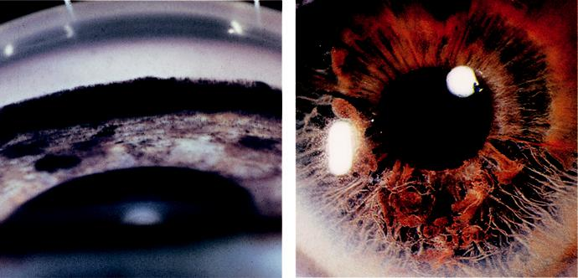

A B

Fig. 11.17 (A) Melanoma cells infiltrating the meshwork, (B) iridoschisis.

#*" ##%"#"+!#(&&%"'+$'""#* "%#! " +#!+ &)%#"$'!%

#%$%&#" (&#" +##'%(&&*'#('$%!&&#"#$+%', &)%" %'&%&%)

**196** SYNOPSIS OF CLINICAL OPHTHALMOLOGY

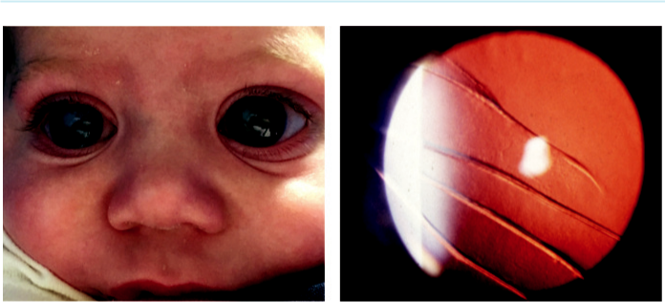

A B

Fig. 11.18 Primary congenital glaucoma: (A) bilateral buphthalmos, (B) Haab striae on retroillumination. (From

Salmon JF, Kanski’s Clinical Ophthalmology: A Systematic Approach, 9th edition. Oxford, UK: Elsevier; 2020.)

**Treatment:**

(a) laser iridotomy, (b) phacoemulsification with IOL implantation in PACG.

**Primary Congenital Glaucoma**

**Pathogenesis:**

impaired aqueous outflow in primary congenital glaucoma is caused by maldevelopment of the anterior chamber angle; by definition not associated with any other major ocular anomaly. Most cases are sporadic, but about 10% are inherited in an AR fashion. Two-thirds of patients are boys, with bilateral involvement in 75%. In 40% IOP is elevated *in utero* and by the third birthday in just over half (infantile glaucoma).

**Diagnosis**

***Presentation:*** corneal haze, lacrimation, photophobia, and blepharospasm.

***Buphthalmos:*** large eye (Fig. 11.18A) due to elevated IOP prior to the age of 3 years.

Corneal diameter >11 mm before 1 year of age or >13 mm at any age is suspicious.

***Haab striae:*** healed curvilinear breaks in Descemet membrane (Fig. 11.18B).

***Optic disc cupping:*** may regress in infants once the IOP is normalized; most normal infants exhibit no (or a very small) cup.

***Evaluation under general anaesthesia:*** (a) measurement of corneal diameter, (b) gonioscopy may reveal a normal-appearing or frankly abnormal angle.

***Diﬀerential diagnosis:*** (a) lacrimation due to delayed canalization of the nasolacrimal duct,

1. other causes of corneal clouding (e.g. trauma, rubella), (c) large cornea (e.g. megalo-cornea), (d) secondary infantile glaucoma (e.g. retinoblastoma, persistent posterior fetal vasculature, iridocorneal dysgenesis).

**Treatment**

***Goniotomy:*** horizontal incision at the midpoint of the superficial layers of the trabecular meshwork (Fig. 11.19A); eventual success in approximately 85%.

***Trabeculotomy:*** if corneal clouding prevents visualization of the angle or when repeated goniotomy has failed. A Harms probe is inserted into the Schlemm canal via a partial thick-ness scleral flap and rotated into the anterior chamber (Fig. 11.19B). A modification uses an illuminated canaloplasty device threaded into the Schlemm canal followed by a 6-0 vicryl suture which is then pulled into the anterior chamber.

#*" ##%"#"+!#(&&%"'+$'""#* "%#! " +#!+ &)%#"$'!%

#%$%&#" (&#" +##'%(&&*'#('$%!&&#"#$+%', &)%" %'&%&%)

|  |  |
| --- | --- |
| Chapter 11—GLAUCOMA | **197** |
|  |  |

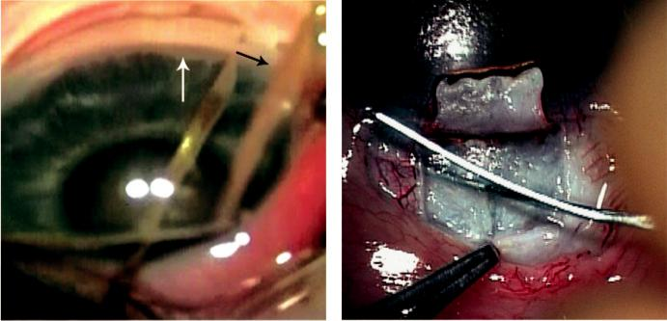

A B

Fig. 11.19 Surgical treatment of buphthalmos: (A) goniotomy, (B) trabeculotomy. (Figure 11.19A courtesy of M. Papadopoulos; Figure 11.19B courtesy of Dr Ken K. Nischal.)

***Trabeculectomy with adjunctive antimetabolite:*** can be considered if the above options are unsuccessful.

***Follow-up:*** progressive enlargement of the corneal diameter is a key marker of uncontrolled IOP; correction of refractive errors and prevention of amblyopia is important.

**Iridocorneal Dysgenesis**

**POSTERIOR EMBRYOTOXON**

**Definition:**

posterior embryotoxon is an isolated innocuous finding in 15% of the general population and consists of a prominent and anteriorly displaced Schwalbe line, seen as a thin grey-white arcuate ridge. Axenfeld–Rieger anomaly (see below) always includes posterior embryotoxon.

**AXENFELD–RIEGER SYNDROME**

**Definition:**

Axenfeld–Rieger syndrome is a spectrum of disorders featuring bilateral developmental ocular anomalies commonly including glaucoma. AD inheritance is frequent but there is no gender pre-dilection (*PITX2* and *FOXC1*. gene mutations). Individual entities are distinguished: (a) Axenfeld anomaly, (b) Rieger anomaly, (c) Rieger syndrome.

**Diagnosis**

***Axenfeld anomaly:*** posterior embryotoxon with attached strands of peripheral iris tissue (Fig. 11.20A).

***Rieger anomaly:*** (a) posterior embryotoxon, (b) iris stromal hypoplasia (Fig. 11.20B)

1. ectropion uveae, (d) corectopia and full-thickness iris defects (Fig. 11.20C–D), (e) gonio-scopic abnormalities ranging from Axenfeld anomaly to broad leaves of iris stroma adherent to the cornea, (f) glaucoma occurs in approximately 50%, usually in childhood or early adulthood. ***Rieger syndrome:*** Rieger anomaly associated with extraocular malformations such as
2. dental (hypodontia, microdontia), (b) facial (maxillary hypoplasia, hypertelorism), (c)redundant paraumbilical skin, (d) hypospadias.

#*" ##%"#"+!#(&&%"'+$'""#* "%#! " +#!+ &)%#"$'!%

#%$%&#" (&#" +##'%(&&*'#('$%!&&#"#$+%', &)%" %'&%&%)

**198** SYNOPSIS OF CLINICAL OPHTHALMOLOGY

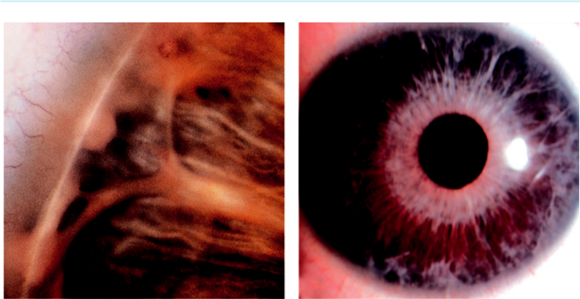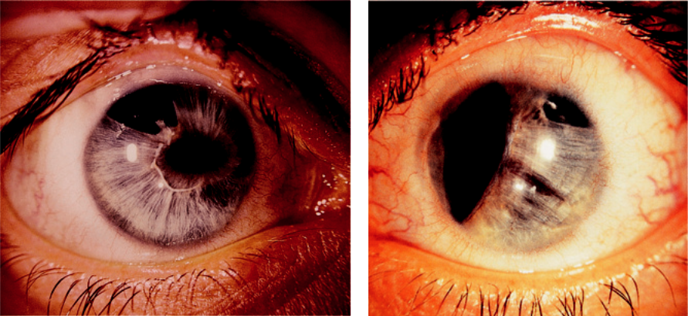

A B

C D

Fig. 11.20 Axenfeld–Rieger syndrome: (A) Axenfeld anomaly, (B) severe iris stromal hypoplasia, (C) corectopia with full-thickness iris hole (in the right eye), (D) severe corectopia (in the left eye of the same patient).

**Treatment:**

IOP should initially be managed medically; surgery may be required.

**ANIRIDIA**

**Genetics:**

aniridia is a rare bilateral condition occurring as a result of abnormal neuroectodermal develop-ment secondary to a mutation in the PAX6 gene on chromosome 11; PAX6 is adjacent to gene WT1, mutation of which predisposes to the life-threatening Wilms tumour (nephroblastoma). AD aniridia accounts for approximately two-thirds of cases and has no systemic implications. Approximately one-third of cases are sporadic, conferring a 30% chance of developing Wilms tumour (WARG: **W**ilms tumour, **a**niridia, mental **r**etardation, **g**enitourinary abnormalities).

**Diagnosis**

***Presentation:*** at birth with nystagmus and photophobia; parents may have noticed an absent iris or ‘dilated pupils’ (Fig. 11.21A).

#*" ##%"#"+!#(&&%"'+$'""#* "%#! " +#!+ &)%#"$'!%

#%$%&#" (&#" +##'%(&&*'#('$%!&&#"#$+%', &)%" %'&%&%)

|  |  |
| --- | --- |
| Chapter 11—GLAUCOMA | **199** |
|  |  |

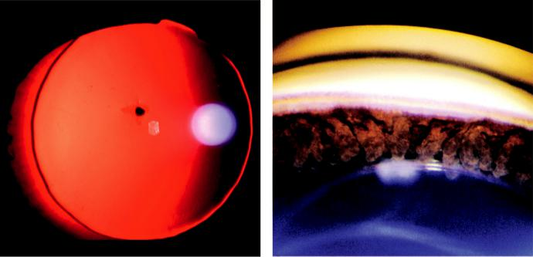

A B

Fig. 11.21 Aniridia: (A) total on retroillumination, (B) open angle showing remnants of iris root.

***Gonioscopy:*** hypoplastic iris, which may consist only of a rudimentary frill.

***Cornea:*** limbal stem cell deficiency may result in ‘conjunctivalization’ of the cornea; dry eye and epithelial defects are common; dense central scarring sometimes occurs.

***Lens:*** cataract and subluxation.

***Fundus:*** foveal and optic nerve hypoplasia, and choroidal coloboma.

***Glaucoma:*** present in 75%, which is caused by synechial angle closure (Fig. 11.21B), and usually presents in adolescence.

**Treatment:**

all patients with sporadic aniridia should undergo regular abdominal ultrasonography unless absence of a predisposing WT1 mutation is confirmed.

***Glaucoma:*** (a) can be resistant to medical treatment, (b) glaucoma drainage devices oer the best chance of long-term control, (c) cyclodiode may be necessary if other modalities fail. ***Opaque contact lenses:*** to create an artificial pupil, may improve both vision and cosmesis. ***Limbal stem cell transplantation***.

**Glaucoma Medication**

**PROSTAGLANDIN ANALOGUES**

***Mechanism of action:*** principally by promoting uveoscleral outflow; bimatoprost also enhances trabecular drainage.

***Preparations:*** (a) latanoprost 0.005% once daily at bedtime provides greater IOP-lowering than timolol, although a proportion may show no response, (b) travoprost 0.004% is similar in eect to latanoprost; conjunctival hyperaemia occurs in up to 50% of patients but tends to subside with time, (c) bimatoprost (0.01% or 0.03%) is similar to latanoprost but is more likely to cause conjunctival hyperaemia; 0.01% may have a similar IOP-lowering eect to 0.03% but with less hyperaemia, (d) tafluprost 0.0015% is available in preservative-free form.

***Ocular side eﬀects:*** (a) conjunctival hyperaemia, (b) eyelash lengthening, thickening and hyperpigmentation (Fig. 11.22A), (c) irreversible iris hyperpigmentation, particularly in

#*" ##%"#"+!#(&&%"'+$'""#* "%#! " +#!+ &)%#"$'!%

#%$%&#" (&#" +##'%(&&*'#('$%!&&#"#$+%', &)%" %'&%&%)

**200** SYNOPSIS OF CLINICAL OPHTHALMOLOGY

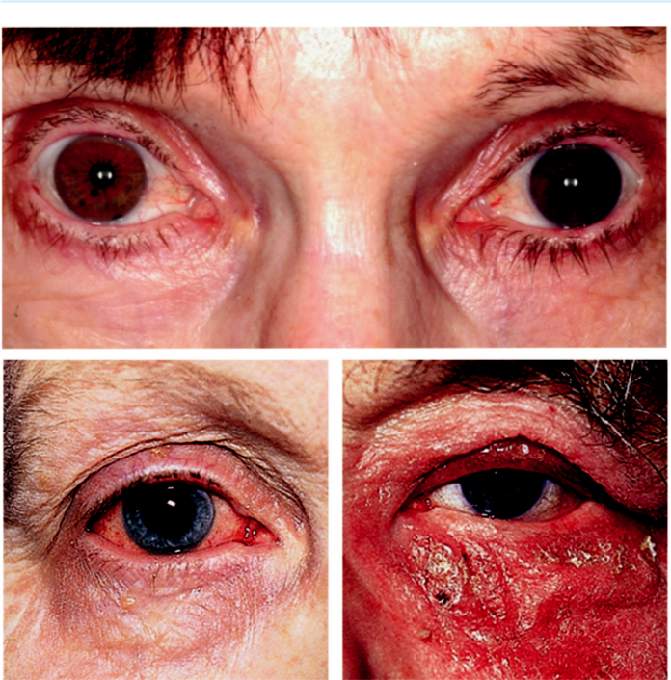

A

B C

Fig. 11.22 Side effects of topical treatment: (A) lengthening and hyperpigmentation of lashes, with iris hetero-chromia left eye (monocular prostaglandin), (B) allergic conjunctivitis (brimonidine), (C) contact dermatitis (topi-cal carbonic anhydrase inhibitor). (From Salmon JF, Kanski’s Clinical Ophthalmology: A Systematic Approach, 9th edition. Oxford, UK: Elsevier; 2020.)

green-brown/hazel irides (Fig. 11.22A), (d) hyperpigmentation of periocular skin (common but reversible), (e) periocular atrophy, (f ) occasionally, cystoid macular oedema, anterior uveitis and herpetic keratitis.

***Systemic side eﬀects:*** rarely mild upper respiratory tract symptoms in susceptible individuals, skin rash and headaches/migraine; should be avoided in pregnancy.

**BETA-BLOCKERS**

***Mechanism of action:*** decrease aqueous secretion and are therefore useful in all types of glau-coma, irrespective of the state of the angle. Bedtime instillation should be avoided because systemic absorption can result in a nocturnal blood pressure dip, leading to a reduction in optic nerve perfusion.

***Tachyphylaxis:*** occurs in approximately 10%; additional eect is limited if a topical beta blocker is used in a patient already taking a systemic beta-blocker.

#*" ##%"#"+!#(&&%"'+$'""#* "%#! " +#!+ &)%#"$'!%

#%$%&#" (&#" +##'%(&&*'#('$%!&&#"#$+%', &)%" %'&%&%)

|  |  |
| --- | --- |
| Chapter 11—GLAUCOMA | **201** |
|  |  |

***Ocular side eﬀects:*** allergy, corneal punctate epithelial erosions and reduced aqueous tear secretion.

***Systemic side eﬀects:*** (a) bradycardia and hypotension (pulse must be palpated before pre-scribing), (b) bronchospasm, (c) sleep disorders, (d) hallucinations, (e) depression, (f) fatigue,

1. headache, (h) alopecia. Reduction of systemic absorption may be achieved by lacrimal occlu-sion following instillation (digital pressure over the lacrimal sac area for approximately 3 min). Simply closing the eyelids for 3 min will reduce systemic absorption by approximately 50%.

***Contraindications:*** (a) asthma and obstructive airways disease, (b) bradycardia, (c) conges-tive cardiac failure, (d) second- or third-degree heart block, (e) brittle diabetes. ***Preparations:*** (a) timolol (0.25% and 0.5%) twice daily, (b) Timoptol-LA (0.25% and 0.5%) once daily, (c) timolol 0.1% gel once daily, (d) betaxolol 0.25% and 0.5% twice daily,

1. levobunolol 0.5% once or twice daily, (f ) carteolol 1% or 2% twice daily (may induce less bradycardia than timolol).

**ALPHA-2 AGONISTS**

***Mechanism of action:*** reduce IOP by both decreasing aqueous secretion and enhancing uveoscleral outflow.

***Preparations:*** (a) brimonidine 0.2% twice daily is slightly less eective than timolol although may have a neuroprotective eect; main side eects are allergic conjunctivitis, xerostomia, drows - iness and fatigue, (b) apraclonidine 1% is used mainly after laser surgery on the anterior segment to prevent an acute rise in IOP; 0.5% concentration may be used short-term, typically while a patient is awaiting glaucoma surgery. Tachyphylaxis and local side eects limit long-term use. ***Ocular side eﬀects:*** (a) allergic conjunctivitis is common but the onset is often delayed by up to 18 months (Fig. 11.22B), (b) granulomatous uveitis is rare.

**TOPICAL CARBONIC ANHYDRASE INHIBITORS**

***Mechanism of action:*** inhibition of aqueous secretion.

***Preparations:*** (a) dorzolamide 2% three times daily is used as monotherapy or adjunctive treatment, and it is similar in ecacy to betaxolol but inferior to timolol. Main side eects are allergic blepharoconjunctivitis (Fig. 11.22C) and a transient bitter taste. May occasion-ally precipitate corneal decompensation, (b) brinzolamide 1% twice or three times daily is similar to dorzolamide, but with a lower incidence of stinging and local allergy.

**MIOTICS**

***Mechanisms of action:*** (a) in POAG, contraction of the ciliary muscle and so increase tra-becular outflow, (b) in PACG, the peripheral iris is pulled away from the trabeculum and the angle is opened.

***Preparations:*** (a) pilocarpine (0.5–4%) is equal in ecacy to beta blockers but for mono - therapy must typically be used four times daily.

***Ocular side eﬀects:*** miosis, brow-ache, myopic shift, retinal detachment and exacerbation of cataract symptoms.

**COMBINED PREPARATIONS**

Numerous combined ‘fixed’ preparations (e.g. a beta blocker and a prostaglandin analogue) oer ocular hypotensive eects close to the sum of the individual components, improve compliance, and are often more cost-eective.

#*" ##%"#"+!#(&&%"'+$'""#* "%#! " +#!+ &)%#"$'!%

#%$%&#" (&#" +##'%(&&*'#('$%!&&#"#$+%', &)%" %'&%&%)

**202** SYNOPSIS OF CLINICAL OPHTHALMOLOGY



**NEW TOPICAL MEDICATIONS**

***Latanoprostene bunod 0.024%:*** has a dual action, increasing outflow through the trabecular meshwork and the uveo-scleral route. Used once daily with similar side eects to prosta - glandin analogues.

***Rho-kinase (ROCK) inhibitors:*** increase outflow through the trabecular meshwork. Used once daily and can be used as a combination drop with latanoprost.

**SYSTEMIC CARBONIC ACID INHIBITORS**

***Mechanism of action:*** inhibition of aqueous secretion.

***Indications:*** principally as short-term treatment; systemic side eects limit long-term use to patients at high risk of visual loss.

***Preparations:*** (a) acetazolamide (tablets, sustained-release capsules and vials for injection),

1. dichlorphenamide tablets, (c) methazolamide tablets (useful alternative to acetazol-amide with longer duration of action).

***Systemic side eﬀects:*** (a) paraesthesia (tingling) of the extremities, (b) malaise, (c) low-ered mood, (d) gastrointestinal symptoms, (e) hypokalaemia, (f ) renal stone formation,

1. Stevens–Johnson syndrome, (h) blood dyscrasia.

**OSMOTIC AGENTS**

***Mechanism of action:*** creation of an osmotic gradient so that water is ‘drawn out’ from the vitreous into the blood.

***Indications:*** when a temporary drop in IOP is required that cannot be achieved by other means (e.g. in acute angle-closure glaucoma and prior to intraocular surgery when the IOP is very high).

***Preparations:*** (a) mannitol (intravenous), (b) glycerol (oral; may be given to well-controlled diabetics), (c) isosorbide (metabolically inert oral agent).

***Side eﬀects:*** cardiovascular overload (use with caution in cardiac or renal disease), urinary retention, headache, backache, nausea, and confusion.

**Laser Therapy**

**ARGON LASER TRABECULOPLASTY**

***Mechanism of action:*** application of discrete laser burns to the trabecular meshwork enhances aqueous outflow.

***Indications:*** adult open-angle glaucoma, usually as an adjunct to medical therapy.

***Complications:*** (a) elevation of IOP, (b) anterior uveitis (usually mild), (c) possibly an adverse eect on subsequent filtration surgery.

***Eﬃcacy:*** in POAG, the initial success rate is 75–85%, with an average reduction in IOP of approximately 30%. Up to 50% of eyes are still controlled after 5 years, with failure occur-ring most frequently in the first year. Second treatment usually ineective.

**SELECTIVE LASER TRABECULOPLASTY**

***Mechanism of action:*** SLT targets melanin pigment in the trabecular meshwork cells, leav-ing nonpigmented structures unscathed.

***Technique:*** the spot size is large (400 microns), which makes the aiming easy compared to ALT.

#*" ##%"#"+!#(&&%"'+$'""#* "%#! " +#!+ &)%#"$'!%

#%$%&#" (&#" +##'%(&&*'#('$%!&&#"#$+%', &)%" %'&%&%)

|  |  |
| --- | --- |
| Chapter 11—GLAUCOMA | **203** |
|  |  |

***Eﬃcacy:*** when used as primary treatment in OHT and early glaucoma, 75% are free of drops at 3 years. Repeat treatment sessions are more eective than with ALT.

***Predictors of success:*** initial IOP and amount of angle pigment.

**ND:YAG LASER IRIDOTOMY**

***Mechanism of action:*** relieves pupillary block by creating a small opening in the peripheral iris.

***Indications:*** PACS, PAC, PACG, and secondary angle-closure with pupillary block.

***Technique:*** (a) topical anaesthetic, (b) apraclonidine, (c) pilocarpine 2%, (d) Abraham con-tact lens, (e) 2–4 mJ power setting, (f ) intensive postop dexamethasone 0.1%. ***Complications:*** (a) IOP elevation, (b) anterior uveitis (usually mild and transient), (c) glare,

(d) dysphotopsia, (e) cataract

**DIODE LASER ABLATION (CYCLODIODE)**

***Mechanism of action:*** lowers IOP by destroying part of the secretory ciliary epithelium, thereby reducing aqueous secretion.

***Indications:*** uncontrolled end-stage secondary glaucoma with minimal visual potential, mainly to control pain; lower intensity regimens can be used in eyes with good vision. ***Complications:*** (a) anterior segment inflammation, (b) IOP elevation, (c) hypotony,

(d) suprachoroidal haemorrhage, (e) corneal decompensation.

**LASER IRIDOPLASTY**

***Mechanism of action:*** widens the anterior chamber angle by contracting the peripheral iris away from the angle recess, often in non-pupillary block angle closure.

***Complications:*** iritis, IOP spikes, altered accommodation (common but transient).

**Trabeculectomy**

**Definition:**

trabeculectomy remains the most commonly performed surgical drainage procedure. Lowering of IOP is caused by the creation of a guarded fistula allowing aqueous outflow from the anterior chamber to the sub-Tenon space (Fig. 11.23A and B). Surgery can include an Ex-PressTH mini shunt. Major complications are discussed below.

**SHALLOW ANTERIOR CHAMBER**

***Pupillary block:*** caused by a non-patent surgical iridectomy. ***Signs:*** (a) high IOP and flat bleb, (b) negative Seidel test, (c) iris bombé with a non-patent iridectomy. Treatment involves YAG laser to the iridectomy site.

***Overfiltration:*** caused by conjunctival bleb leakage (positive Seidel test; Fig. 11.24A), over

drainage at the scleral flap, or a combination. ***Signs:*** (a) low IOP, bleb may be flat (conjunc-tival leak) or well-formed (scleral over-drainage alone), (b) choroidal detachment may be present (Fig. 11.24B). Treatment depends on the cause and degree of shallowing.

***‘Malignant’ glaucoma:*** caused by anterior rotation of the ciliary processes and iris root, often with aqueous misdirection (ciliolenticular block) in which aqueous is forced backwards into the vitreous. Patients become aware of a decrease in distance vision, but an improvement in near vision because of forward movement of the lens. **Signs:** (a) myopic shift, (b) high

#*" ##%"#"+!#(&&%"'+$'""#* "%#! " +#!+ &)%#"$'!%

#%$%&#" (&#" +##'%(&&*'#('$%!&&#"#$+%', &)%" %'&%&%)

**204** SYNOPSIS OF CLINICAL OPHTHALMOLOGY

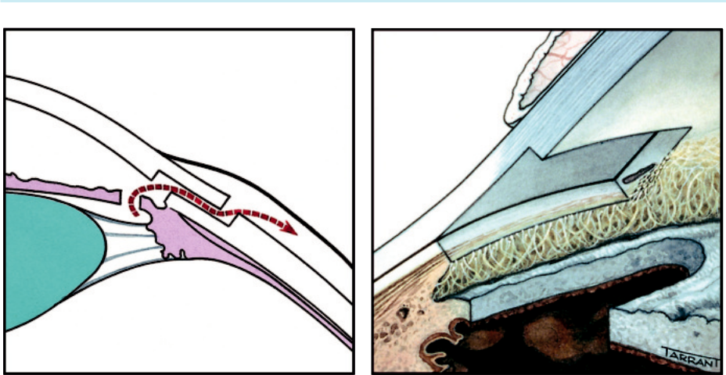

A B

Fig. 11.23 Trabeculectomy principles: (A) pathway of aqueous egress, (B) schematic representation of appear-ance from inside the eye following completion of surgery. (From Salmon JF, Kanski’s Clinical Ophthalmology: A Systematic Approach, 9th edition. Oxford, UK: Elsevier; 2020.)

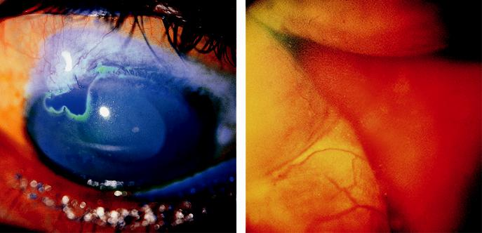

A B

Fig. 11.24 Overfiltration: (A) positive Seidel test, (B) choroidal detachment. (From Salmon JF, Kanski’s Clinical

Ophthalmology: A Systematic Approach, 9th edition. Oxford, UK: Elsevier; 2020.)

IOP but no bleb, (c) negative Seidel test. **Initial treatment:** (a) mydriatics and (b) if nec-essary, osmotic agents (e.g. mannitol) to shrink the vitreous. **Subsequent treatment** may involve: (a) YAG laser disruption of the anterior hyaloid face in a pseudophakic patient,

1. cyclodiode laser or (c) pars plana vitrectomy. When surgery is required, the key is to remove sucient anterior vitreous gel to allow free flow of aqueous to the anterior chamber.

**FAILURE OF FILTRATION**

***Appearance of a normal bleb:*** slightly elevated, avascular and shows superficial microcysts (Fig. 11.25A).

***A thin polycystic bleb:*** may develop, particularly after the use of mitomycin C (Fig. 11.25B).

#*" ##%"#"+!#(&&%"'+$'""#* "%#! " +#!+ &)%#"$'!%

#%$%&#" (&#" +##'%(&&*'#('$%!&&#"#$+%', &)%" %'&%&%)

|  |  |
| --- | --- |
| Chapter 11—GLAUCOMA | **205** |
|  |  |

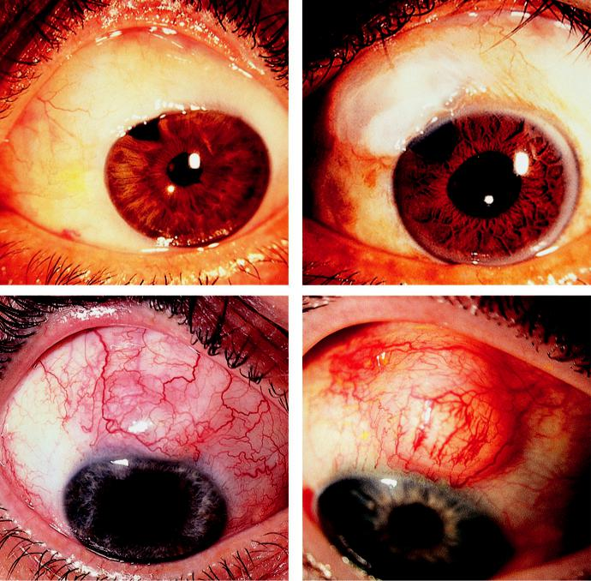

A B

C D

Fig. 11.25 Filtering blebs: (A) diffuse microcystic, (B) thin polycystic, (C) failing bleb with vascularization, (D)

encapsulated bleb. (From Salmon JF, Kanski’s Clinical Ophthalmology: A Systematic Approach, 9th edition.

Oxford, UK: Elsevier; 2020.)

***Poorly functioning bleb:*** may be (a) flat and avascular, (b) vascularized due to episcleral fibrosis (Fig. 11.25C) or (c) encapsulated (Tenon cyst) – dome-shaped, firm, fluid-filled (Fig. 11.25D).

***Causes of failure:*** (a) extrascleral (e.g. conjunctival and episcleral fibrosis), (b) scleral (e.g. overtight suturing of the scleral flap or scarring in the scleral bed), (c) intraocular causes (e.g. blockage of the sclerostomy by vitreous, blood, uveal, or scar tissue).

***Treatment:*** (a) ocular ‘massage’ to encourage fistula flow, (b) suture manipulation, (c) nee-dling of an encysted bleb, (d) subconjunctival anti-metabolite injection, (e) surgical revision.

**LATE BLEB LEAKAGE**

***Cause:*** disintegration of conjunctiva overlying the sclerostomy, particularly after prior mito-mycin C application.

***Complications:*** infection and hypotony maculopathy (see Chapter 14).

#*" ##%"#"+!#(&&%"'+$'""#* "%#! " +#!+ &)%#"$'!%

#%$%&#" (&#" +##'%(&&*'#('$%!&&#"#$+%', &)%" %'&%&%)

**206** SYNOPSIS OF CLINICAL OPHTHALMOLOGY



***Signs:*** (a) low IOP, (b) avascular cystic bleb, (c) sometimes only multiple punctate staining areas (‘sweating’) rather than a frank leak may be seen, (d) shallow anterior chamber and choroidal detachment in severe cases.

***Treatment:*** (a) sweating blebs may be treated by injection of autologous blood, conjunc-tival compression, or transconjunctival scleral flap sutures; (b) full-thickness holes usually require revisional surgery, such as conjunctival advancement or free conjunctival and/or scleral patch grafts.

**BLEB-ASSOCIATED BACTERIAL INFECTION AND ENDOPHTHALMITIS**

***Classification:*** (a) limited to the bleb (blebitis) and (b) endophthalmitis.

***Risk factors:*** (a) mitomycin C, (b) bleb leak, (c) inferior or thin-walled bleb, (d) chronic blepharitis, (e) children.

***Blebitis:*** (a) presents with mild discomfort and redness, (b) bleb contains whitish inflam-matory material (Fig. 11.26A), (c) anterior uveitis may be absent, (d) red reflex is normal. Treatment is with topical and oral antibiotics.

***Endophthalmitis:*** (a) presents with rapidly worsening vision, pain, and redness, (b) milky-white bleb containing pus, (c) severe anterior uveitis, often with hypopyon (Fig. 11.26B),

1. vitritis with impairment of the red reflex. Treatment involves topical and systemic therapy, although intravitreal antibiotics as for post-cataract surgery endophthalmitis (see Chapter 10) should be considered if there is no early response.

**Nonpenetrating surgery**

***Definition:*** in nonpenetrating surgery, the anterior chamber is not entered, reducing the incidence of postoperative hypotony.

***Indications:*** mainly POAG, although other types of open-angle glaucoma may also be ame-nable. Conventional filtration is often still the procedure of choice when the target IOP is in the low teens.

***Deep sclerectomy:*** a Descemet window is created that allows aqueous percolation from the anterior chamber to the subconjunctival space via an intrascleral chamber.

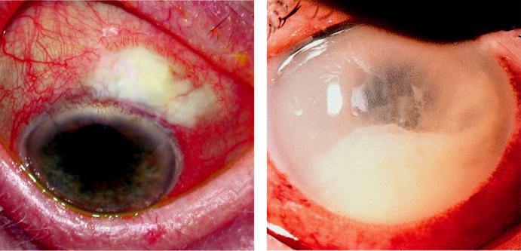

A B

Fig. 11.26 Bacterial infection: (A) blebitis, (B) endophthalmitis showing a large hypopyon. (From Salmon JF,

Kanski’s Clinical Ophthalmology: A Systematic Approach, 9th edition. Oxford, UK: Elsevier; 2020.)

#*" ##%"#"+!#(&&%"'+$'""#* "%#! " +#!+ &)%#"$'!%

#%$%&#" (&#" +##'%(&&*'#('$%!&&#"#$+%', &)%" %'&%&%)

|  |  |
| --- | --- |
| Chapter 11—GLAUCOMA | **207** |
|  |  |

***Viscocanalostomy:*** creation of the filtering window is followed by dilatation of Schlemm canal with high-density viscoelastic, with drainage principally utilizing the canal rather than the subconjunctival space. A variation involves cannulation of the entire circumference of Schlemm canal with a microcatheter (canaloplasty).

**Drainage Shunts**

**SHUNTS USING EPISCLERAL EXPLANTS**

***Mechanism of action:*** creation of a communication between the anterior chamber and sub-Tenon space through a tube attached to a posterior episcleral explant. Some contain pres-sure-sensitive valves for regulation of aqueous flow. Examples include Molteno, Baerveldt, PAUL, and Ahmed implants.

***Indications:*** traditionally cases in which trabeculectomy has a particularly poor prognosis (e.g. previous failed trabeculectomy, neovascular glaucoma, aniridia, ICE syndrome). e threshold for their use has decreased in recent years.

***Complications:*** (a) excessive drainage with hypotony, (b) tube erosion (Fig. 11.27A), (c) tube malposition (Fig. 11.27B) with endothelial or lenticular touch, (d) bleb encapsulation over the footplate, (e) ocular motility abnormalities.

**MINI SHUNTS**

***Ex-Press mini shunt:*** stainless-steel device without a valve that is inserted under a scleral flap during a modified trabeculectomy. Reduces postoperative complications, with similar long-term IOP reduction.

**Minimally Invasive Glaucoma Surgery (MIGS)**

***Surgery that avoids the formation of a bleb:*** (a) excision of the trabecular meshwork (Trabectome, Kahook Dual Blade), (b) bypassing the meshwork (iStent inject, Hydrus) (Fig. 11.28A), (c) dilation of the canal (ab-interno canaloplasty with iTrack).

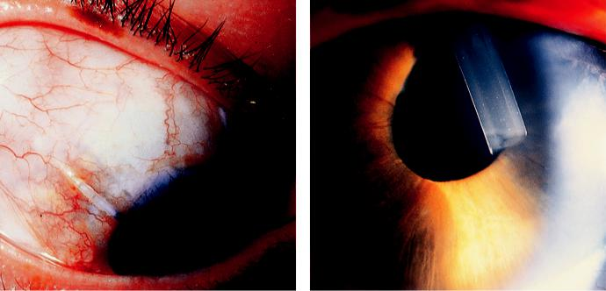

A B

Fig. 11.27 Drainage tubes: (A) erosion at the limbus, (B) malposition. (From Salmon JF, Kanski’s Clinical

Ophthalmology: A Systematic Approach, 9th edition. Oxford, UK: Elsevier; 2020.)

#*" ##%"#"+!#(&&%"'+$'""#* "%#! " +#!+ &)%#"$'!%

#%$%&#" (&#" +##'%(&&*'#('$%!&&#"#$+%', &)%" %'&%&%)

**208** SYNOPSIS OF CLINICAL OPHTHALMOLOGY



***Surgery that results in drainage under Tenon capsule and conjunctiva:*** mitomycin C is usu-ally injected under the conjunctiva adjacent to the implant. Bleb needling is often needed postoperatively. (a) Xen (Fig. 11.28B), (b) Preserflo Microshunt.

***Indications:*** (a) mild to moderate glaucoma, (b) often combined with phacoemulsification and IOL implantation, (c) intolerance to topical medication.

***Results:*** modest reduction of IOP on less medication. Results influenced by simultaneous lens extraction (15%–20% reduction of IOP from preoperative level).

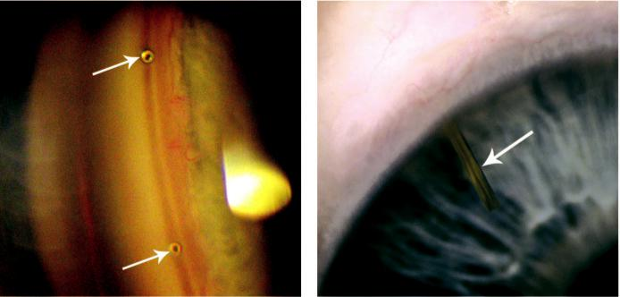

A B

Fig. 11.28 MIGS: (A) gonioscopic appearance of iStent (arrows), (B) Xen (arrow). (Figure 11.28A courtesy of G. Ratnarajan.)

#*" ##%"#"+!#(&&%"'+$'""#* "%#! " +#!+ &)%#"$'!%

#%$%&#" (&#" +##'%(&&*'#('$%!&&#"#$+%', &)%" %'&%&%)



CHAPTER 12

Uveitis



C H A P T E R O U T L I N E

Terminology 210

Clinical Features 210

Acute anterior uveitis 210

Chronic anterior uveitis 210

Posterior uveitis 211

Principles of Treatment 212 Mydriatics 212

Topical steroids 213 Periocular steroid injection 213 Intraocular steroids 213 Systemic steroids 213 Antimetabolites 214 Alkylating agents 214 Other drugs 214

Intermediate Uveitis 214

Uveitis In Spondyloarthropathies 215 Ankylosing spondylitis 215 Reiter syndrome 215

Psoriatic arthritis 215

Juvenile idiopathic arthritis 215

Uveitis in Bowel Disease 216 Ulcerative colitis 216 Crohn disease 217

Sarcoidosis 217

Behçet Syndrome 217

Toxoplasmosis 219

Pathogenesis 219

Toxoplasma retinitis 219

Toxocariasis 221

Onchocerciasis 222

Uveitis in Individuals With AIDS 224

AIDS 224

Ocular involvement in AIDS 224

HIV microangiopathy 225

Cytomegalovirus retinitis 225

Progressive retinal necrosis 226

Acute Retinal Necrosis 226

Fungal Uveitis 227

Presumed ocular histoplasmosis syndrome (POHS) 227

Cryptococcosis 228

Endogenous fungal endophthalmitis 228

Bacterial Uveitis 229

Tuberculosis 229

Syphilis 229

Lyme disease (borreliosis) 230

Endogenous (metastatic) bacterial endophthalmitis 231

Cat-scratch disease 232

Leprosy 233

White dot syndromes 233

Multiple evanescent white dot syndrome (MEWDS) 234

Acute idiopathic blind spot enlargement syndrome 234

Acute posterior multifocal placoid pigment epitheliopathy (APMPPE) 235

Multifocal choroiditis and panuveitis 235

Punctate inner choroidopathy 236

Birdshot retinochoroiditis 237

Serpiginous choroidopathy 237

Acute Zonal Occult Outer

Retinopathy (Azoor) 239

Primary Stromal Choroiditis 239

Vogt–Koyanagi–Harada syndrome (VKH) 239

Sympathetic ophthalmitis 241

Fuchs Uveitis Syndrome 241

**209**

#*" ##%"#"+!#(&&%"'+$'""#* "%#! " +#!+ &)%#"$'!%

#%$%&#" (&#" +##'%(&&*'#('$%!&&#"#$+%', &)%" %'&%&%)

**210** SYNOPSIS OF CLINICAL OPHTHALMOLOGY



**Terminology**

***Uveitis:*** inflammation of the uveal tract.

***Anterior uveitis:*** iritis and iridocyclitis (iris and ciliary body).

***Intermediate uveitis:*** inflammation of the pars plana, the peripheral retina and the vitreous.

***Posterior uveitis:*** inflammation posterior to the vitreous base.

***Retinitis:*** primary retinal focus of inflammation.

***Choroiditis:*** primary choroidal focus.

***Vasculitis:*** inflammation of veins, arteries or both.

***Panuveitis:*** involvement of the entire uveal tract.

***Endophthalmitis:*** involves all intraocular tissues except the sclera.

***Panophthalmitis:*** involves the entire globe.

**Clinical Features**

**ACUTE ANTERIOR UVEITIS**

Acute anterior uveitis (AAU) is the most common form of uveitis.

***Presentation:*** rapid onset of unilateral pain, photophobia and redness.

***Signs:*** (a) ciliary injection (Fig. 12.1A), (b) miosis, (c) endothelial dusting by inflammatory cells progresses to fine/medium keratic precipitates (KP) after a few days, (d) hypopyon in intense inflammation (Fig. 12.1B), (e) anterior vitreous cells in iridocyclitis, (f) aqueous flare, (g) fibrinous exudate in severe AAU (Fig. 12.2A).

***Duration:*** most episodes completely resolve within 5–6 weeks.

***Prognosis:*** good with adequate treatment.

**CHRONIC ANTERIOR UVEITIS**

Chronic anterior uveitis (CAU) is less common than the acute type and it is more frequently bilateral. Inflammation may be granulomatous or non-granulomatous.

***Presentation:*** often insidious and may be asymptomatic until complications such as cataract or band keratopathy develop.

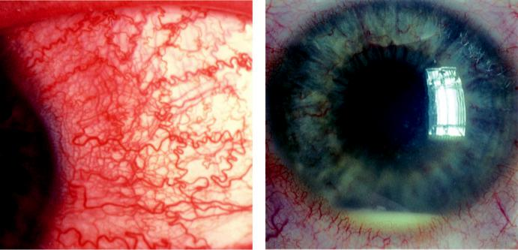

A B

Fig. 12.1 Acute anterior uveitis: (A) ciliary injection, (B) hypopyon. (From Salmon JF, Kanski’s Clinical

Ophthalmology: A Systematic Approach, 9th edition. Oxford, UK: Elsevier; 2020.)

#*" ##%"#"+!#(&&%"'+$'""#* "%#! " +#!+ &)%#"$'!%

#%$%&#" (&#" +##'%(&&*'#('$%!&&#"#$+%', &)%" %'&%&%)

|  |  |
| --- | --- |
| Chapter 12—UVEITIS | **211** |
|  |  |

***Signs:*** (a) eye may be mildly injected or white, depending on the cause, (b) aqueous cells vary in number according to activity, (c) aqueous flare may be more marked than cells, in eyes with prolonged activity, (d) large KP with a greasy ‘mutton-fat’ appearance (Fig. 12.2B) and iris nodules (Busacca in the iris stroma, Koeppe on the pupil margin) in granulomatous disease (Fig. 12.2C), (e) posterior synechiae (Fig. 12.2D).

***Duration:*** prolonged; may last for months or even years with remissions and exacerbations.

***Prognosis:*** influenced by complications such as cataract, glaucoma, hypotony and phthisis bulbi. Oral immunotherapy has improved the prognosis in recent years.

**POSTERIOR UVEITIS**

***Presentation****:* varies according to the location of the inflammatory focus and the presence of vitritis.

***Cause:*** the clinical features and special investigations will usually allow a definitive diagnosis to be made. To determine the cause of a persistent and severe posterior uveitis of unknown

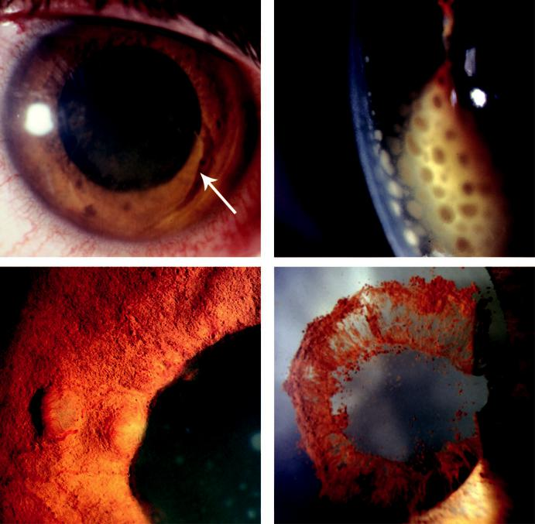

A B

C D

Fig. 12.2 Chronic anterior uveitis: (A) fibrinous exudate (arrow), (B) ‘mutton fat’ keratic precipitates, (C) Busacca nodule (iris stroma) and Koeppe nodule (pupil margin), (D) posterior synechiae after dilatation show-ing pigment on lens. (Figure 12.2C courtesy of C. Pavesio.)

#*" ##%"#"+!#(&&%"'+$'""#* "%#! " +#!+ &)%#"$'!%

#%$%&#" (&#" +##'%(&&*'#('$%!&&#"#$+%', &)%" %'&%&%)

**212** SYNOPSIS OF CLINICAL OPHTHALMOLOGY



aetiology for which all workup is negative, consider undertaking a vitreous and/or retino-choroidal biopsy.

***Retinitis:*** whitish retinal opacities with indistinct borders (Fig. 12.3A) and overlying vitritis.

***Choroiditis:*** deep, round, yellow nodules (Fig. 12.3B).

***Vasculitis:*** (periphlebitis, periarteritis) may be primary or secondary to retinitis; yellow-ish or grey-white patchy perivascular cung which may be associated with haemorrhages (Fig. 12.3C).

**Principles of Treatment**

**MYDRIATICS**

***Indications:*** (a) to relieve pain caused by iridociliary spasm, (b) prevent (or break recently formed) posterior synechiae.

***Topical short-acting:*** (a) cyclopentolate (0.5%, 1%) acts for approximately 24 hours, (b) tropicamide and phenylephrine are shorter-acting.

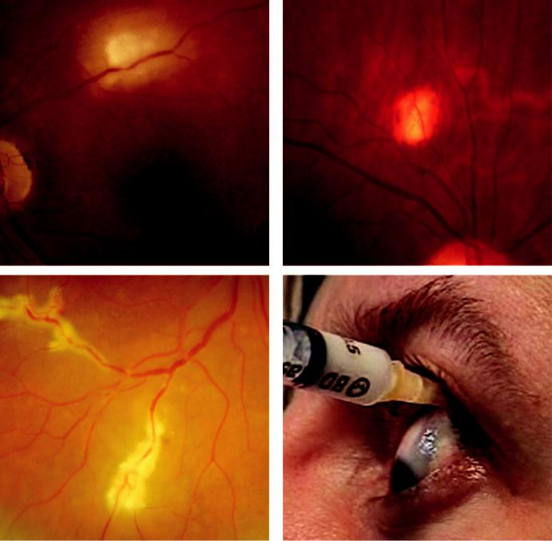

A B

C D

Fig. 12.3 Posterior uveitis: (A) retinitis, (B) choroiditis, (C) vasculitis, (D) posterior sub-Tenon steroid injection. (Figure 12.3D courtesy of C. Pavesio.)

#*" ##%"#"+!#(&&%"'+$'""#* "%#! " +#!+ &)%#"$'!%

#%$%&#" (&#" +##'%(&&*'#('$%!&&#"#$+%', &)%" %'&%&%)

|  |  |
| --- | --- |
| Chapter 12—UVEITIS | **213** |
|  |  |

***Topical long-acting:*** (a) homatropine 2% (approximately 2 days), (b) atropine 1% (up to 2 weeks).

***Subconjunctival:*** Mydricaine (adrenaline, atropine and procaine) if no response to drops.

**TOPICAL STEROIDS**

***Indications:*** anterior uveitis.

***Preparations:*** dexamethasone, prednisolone (range of concentrations available), betametha-sone, loteprednol, fluorometholone and rimexolone.

***Complications:*** glaucoma, cataract and corneal infection.

**PERIOCULAR STEROID INJECTION**

***Advantages over topical administration:*** (a) higher posterior segment concentrations may be achieved, (b) water-soluble drugs, incapable of penetrating topically, but can enter across the sclera, (c) prolonged eect can be achieved with ‘depot’ preparations.

***Indications:*** (a) primary treatment of intermediate and certain types of posterior uveitis,

1. to supplement systemic therapy or when it is contraindicated, (c) poor compliance with topical or systemic medication, (d) perioperatively in uveitic eyes.

***Complications:*** (a) globe penetration, (b) elevation of IOP (may be refractory with depot preparations), (c) ptosis, (d) subdermal fat atrophy, (e) ocular motility paresis, (f ) optic nerve injury, (g) retinal and choroidal vascular occlusion, (h) cutaneous hypopigmentation.

***Technique:*** via the superotemporal conjunctiva (posterior sub-Tenon; Fig. 12.3D), or to the orbital floor via skin or conjunctiva.

**INTRAOCULAR STEROIDS**

***Intravitreal injection:*** triamcinolone acetonide can be used for some forms of posterior uveitis unresponsive to other modalities and for refractory cystoid macular oedema (CMO). ***Complications:*** (a) elevation of IOP, (b) cataract, (c) endophthalmitis (sterile or infectious),

(d) haemorrhage, (e) retinal detachment.

***Slow-release implants:*** biodegradable insert or a slow-release reservoir (fluocinolone aceton-ide, dexamethasone) oer the benefits of intravitreal steroid injection but over an extended period of up to 3 years; complications are similar to those of intravitreal triamcinolone injection.

**SYSTEMIC STEROIDS**

***Indications:*** (a) intermediate uveitis unresponsive to periocular injection, (b) sight-threaten-ing posterior uveitis, particularly if bilateral.

***Contraindications:*** (a) poorly-controlled diabetes (relative contraindication), (b) peptic ulceration, (c) osteoporosis, (d) active systemic infection, (e) psychosis on previous exposure to steroids.

***Preparations:*** oral prednisolone and intravenous methylprednisolone.

***Common cause of failure:*** inadequate dosage; a large dose should be used initially and subse-quently tapered.

***Side eﬀects with short-term use:*** (a) dyspepsia, (b) mental changes, (c) electrolyte imbalance, (d) aseptic necrosis of the head of the femur, (e) destabilization of diabetic control.

***Side eﬀects with long-term use:*** (a) Cushing syndrome, (b) osteoporosis, (c) limitation of growth in children, (d) reactivation of infections such as TB, (e) cataract, (f) elevation of IOP.

#*" ##%"#"+!#(&&%"'+$'""#* "%#! " +#!+ &)%#"$'!%

#%$%&#" (&#" +##'%(&&*'#('$%!&&#"#$+%', &)%" %'&%&%)

**214** SYNOPSIS OF CLINICAL OPHTHALMOLOGY



**ANTIMETABOLITES**

***Indications:*** (a) sight-threatening uveitis, typically bilateral, noninfectious and reversible, after failure to respond to adequate steroid therapy, (b) steroid-sparing therapy in patients with intolerable side eects from systemic steroids, (c) chronic relapsing disease requiring a daily dose of prednisolone above approximately 10 mg.

***Preparations:*** azathioprine, methotrexate and mycophenolate mofetil.

***Side eﬀects:*** (a) gastrointestinal disturbance, (b) bone marrow suppression, (c) hepatotoxicity.

**ALKYLATING AGENTS**

***Indications:*** retinal vasculitis (not commonly used, as safer medication is available).

***Preparations:*** cyclophosphamide, chlorambucil

***Side eﬀects:*** (a) gastrointestinal disturbance, (b) infection, (c) bone marrow suppression,

(d) infertility, (e) allergic reactions, (f ) cancer.

**OTHER DRUGS**

***Ciclosporin:*** particularly useful in Behçet disease; side eects include nephrotoxicity and hepatotoxicity.

***Tacrolimus:*** alternative to ciclosporin; for severe refractory uveitis.

***Biopharmacologicals:*** interleukin receptor antagonists (daclizumab, anakinra) and tumour necrosis factor-alpha antagonists (infliximab, adalimumab, etanercept, golimumab, certoli-zumab). ese agents take time to suppress inflammation (2 weeks to 3 months). Topical and systemic steroids may be needed initially to control acute inflammation.

**Intermediate Uveitis**

**Definition:**

intermediate uveitis (IU) is a chronic/relapsing condition that may be idiopathic or associated with systemic disease. It is typically bilateral but asymmetrical. Systemic associations include: (a) multiple sclerosis (MS), (b) sarcoidosis, (c) Lyme disease, (d) tuberculosis. e course and prog - nosis are very variable.

**Diagnosis**

***Presentation:*** in childhood or early adult life with insidious onset of blurred vision and floaters.

***Signs:*** (a) mild anterior uveitis, (b) vitreous cells with anterior predominance (Fig. 12.4A),

1. inferior vitreous ‘snowballs’, (d) peripheral phlebitis, (e) inferior ‘snowbanking’ (Fig. 12.4B),
2. neovascularization on the snowbank or the optic nerve head.

***Complications:*** (a) CMO in 30% is the major cause of visual impairment, (b) epimacu-lar membranes and occasionally (c) retinal detachment (tractional, rhegmatogenous, or exudative).

**Treatment**

***Medical:*** (a) initially topical and/or periocular steroids, (b) systemic steroids and immuno-suppressive agents may be required, (c) interferon beta for IU in MS.

***Vitrectomy:*** following failure of systemic steroids to control CMO; other indications include retinal detachment, vitreous haemorrhage and epiretinal membranes.

***Photocoagulation:*** to peripheral retina for neovascularization at the vitreous base.

#*" ##%"#"+!#(&&%"'+$'""#* "%#! " +#!+ &)%#"$'!%

#%$%&#" (&#" +##'%(&&*'#('$%!&&#"#$+%', &)%" %'&%&%)

|  |  |
| --- | --- |
| Chapter 12—UVEITIS | **215** |
|  |  |

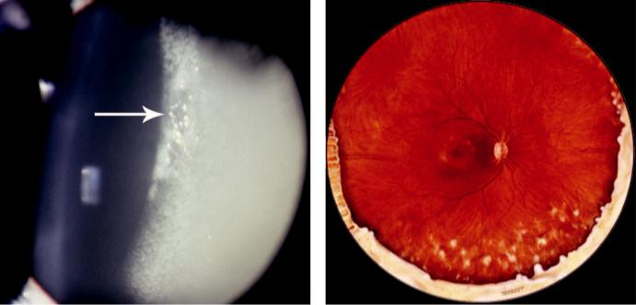

A B

Fig. 12.4 Intermediate uveitis: (A) severe vitreous activity showing haze and condensation visible in the slit

beam (arrow), (B) inferior snowbanking and snowballs. (From Salmon JF, Kanski’s Clinical Ophthalmology: A

Systematic Approach, 9th edition. Oxford, UK: Elsevier; 2020.)

**Uveitis In Spondyloarthropathies**

**ANKYLOSING SPONDYLITIS**

***Definition***: an inflammatory disease leading to ossification of joints with bony ankylosis of the axial skeleton. It typically aects adult males, of whom 90% are HLA-B27 positive. Radiology of the sacroiliac joints and spine reveals characteristic changes.

***Ocular features:*** AAU occurs in approximately 25% of patients with ankylosing spondylitis; conversely, 25% of males with AAU will have ankylosing spondylitis.

**REITER SYNDROME**

***Definition***: Reiter syndrome comprises the triad of: (a) nonspecific urethritis, (b) conjunc-tivitis, (c) arthritis. ose aected are commonly men in the 3rd and 4th decades, of whom 85% are positive for HLA-B27.

***Ocular features:*** (a) conjunctivitis is common and usually precedes the arthritis, with spon-taneous resolution occurring within 7–10 days, (b) AAU occurs in up to 12% of patients but is higher in carriers of HLA-B27.

**PSORIATIC ARTHRITIS**

***Definition:*** arthritis developing in patients with psoriasis.

***Ocular features:*** (a) AAU occurs in approximately 7%, (b) other uncommon manifestations include conjunctivitis, marginal corneal infiltrates and secondary Sjögren syndrome.

**JUVENILE IDIOPATHIC ARTHRITIS**

**Definition:**

idiopathic arthritis of at least 6 weeks’ duration occurring before the age of 16 years. Juvenile idiopathic arthritis ( JIA) is by far the most common disease associated with childhood anterior uveitis. Girls are aected more commonly than boys. Positivity for antinuclear antibodies (ANA) is associated with a higher risk of uveitis.

#*" ##%"#"+!#(&&%"'+$'""#* "%#! " +#!+ &)%#"$'!%

#%$%&#" (&#" +##'%(&&*'#('$%!&&#"#$+%', &)%" %'&%&%)

**216** SYNOPSIS OF CLINICAL OPHTHALMOLOGY

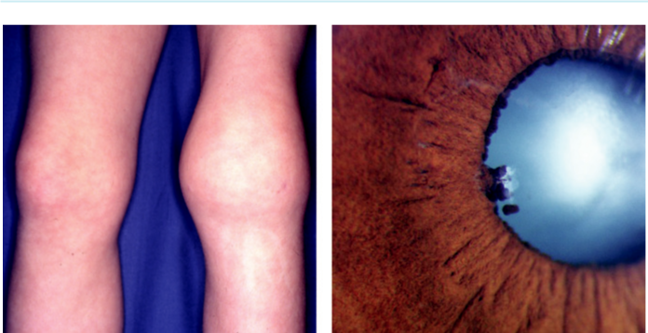

A B

Fig. 12.5 JIA: (A) arthritis of the knee, (B) posterior synechiae and cataract. (From Salmon JF, Kanski’s Clinical

Ophthalmology: A Systematic Approach, 9th edition. Oxford, UK: Elsevier; 2020.)

**Diagnosis**

***Pauci-articular onset (60% of cases):*** four or fewer joints, most commonly the knees (Fig. 12.5A), are involved during the first 6 months with a peak age of onset around 2 years; approximately 75% of children are ANA-positive and uveitis aects approxi - mately 20%.

***Poly-articular onset (20%):*** five or more joints are involved; may commence throughout childhood; 40% ANA-positive and uveitis aects 5%.

***Systemic onset (Still’s disease; 20%):*** presents with fever, maculopapular rash, generalized lymphadenopathy, hepatosplenomegaly, and serositis; arthritis may be absent or minimal; most are ANA-negative and uveitis does not occur.

***Features of anterior uveitis in JIA:*** (a) onset is usually asymptomatic with a white eye,

1. chronic non-granulomatous inflammation, (c) 70% bilateral, (d) other complications include band keratopathy, cataract (Fig. 12.5B), glaucoma and hypotony.

***Diﬀerential diagnosis:*** (a) idiopathic juvenile chronic iridocyclitis, (b) other types of juvenile arthritis and uveitis (e.g. juvenile spondyloarthropathies, sarcoidosis, Lyme disease, IU), and

1. masquerade syndromes (e.g. anterior segment involvement by retinoblastoma).

**Treatment**

***Screening:*** regular slit lamp examinations at intervals ranging from (a) 9-monthly in low-risk ANA-negative polyarticular-onset patients, (b) 2-monthly in high-risk ANA-positive pauciarticular-onset children, (c) not required in systemic-onset disease.

***Treatment:*** topical steroids are initially eective. Immunomodulatory treatment, including biological medication, should be used early in the course of the disease.

**Uveitis in Bowel Disease**

**ULCERATIVE COLITIS**

***Definition:*** idiopathic chronic inflammatory disease presenting in the 2nd and 3rd decades, aecting principally the large intestine and rectum. Extra-intestinal manifestations include mucocutaneous lesions, arthritis and hepatic disease.

***Ocular features:*** AAU occurs in approximately 5%.

#*" ##%"#"+!#(&&%"'+$'""#* "%#! " +#!+ &)%#"$'!%

#%$%&#" (&#" +##'%(&&*'#('$%!&&#"#$+%', &)%" %'&%&%)

|  |  |
| --- | --- |
| Chapter 12—UVEITIS | **217** |
|  |  |

**CROHN DISEASE**

***Definition:*** an idiopathic chronic granulomatous inflammatory disease of the intestinal wall, most frequently involving the ileocaecal region. Presentation is in the 2nd and 3rd decades with fever, weight loss, diarrhoea and abdominal pain. Extra-intestinal manifesta-tions include mucocutaneous lesions and skeletal features.

***Ocular features:*** AAU occurs in approximately 3%. Episcleritis and acute bowel inflamma-tion often occur together. Rarely, scleritis and corneal infiltration.

**Sarcoidosis**

**Pathogenesis:**

T-lymphocyte-mediated granulomatous inflammatory disorder of unknown cause. e preva - lence is highest in young adults of both genders and the disease is most common in Northern European and African countries. A wide range of tissues can be involved, particularly lung disease. Severity varies from mild single-organ involvement to potentially fatal multisystem disease.

**Diagnosis**

***Presentation:*** (a) acute with fever, erythema nodosum, arthralgia and cranial nerve palsy or

(b) insidious with symptomatic pulmonary involvement.

***Pulmonary lesions:*** vary from symptomatic hilar lymphadenopathy to severe fibrosis.

***Skin lesions:*** (a) erythema nodosum, (b) granulomas, (c) lupus pernio.

***Neurological disease:*** (a) facial palsy, (b) seizures, (c) meningitis, (d) peripheral neuropathy,

(e) psychiatric symptoms.

***Other:*** (a) arthropathy, (b) bone cysts, (c) renal disease, (d) lymphadenopathy, (e) liver disease.

***Investigations:*** (a) chest X-ray (abnormal in 90%), (b) biopsy (lung, lymph node, skin, conjunctiva, lacrimal gland), (c) serum angiotensin-converting enzyme and lysozyme,

1. bronchoalveolar lavage, (e) pulmonary function tests, (f ) Mantoux test is negative in most patients.

***Ocular features:*** (a) AAU typically occurs in patients with acute-onset sarcoid, (b) CAU, typically granulomatous (Fig. 12.6A), tends to aect older patients with chronic dis - ease, (c) intermediate uveitis, (d) periphlebitis with ‘candle wax drippings’ (Fig. 12.6B),

1. choroidal infiltrates, (f ) multifocal choroiditis (Fig. 12.6C), (g) retinal granulomas,
2. peripheral retinal neovascularization, (i) optic nerve granulomas, (j) disc oedema,
3. lid granulomas (Fig. 12.6D).

**Treatment:**

anterior uveitis is treated with topical and/or periocular steroids. Posterior uveitis often requires systemic steroids and occasionally other immunosuppressive agents.

**Behçet Syndrome**

**Definition:**

idiopathic multisystem disease characterized by recurrent episodes of orogenital ulceration and vasculitis. It typically aects Eastern Mediterranean and Japanese individuals and is strongly associated with HLA-B51. e peak age of onset is in the 3rd decade; males are aected more frequently than females.

#*" ##%"#"+!#(&&%"'+$'""#* "%#! " +#!+ &)%#"$'!%

#%$%&#" (&#" +##'%(&&*'#('$%!&&#"#$+%', &)%" %'&%&%)

**218** SYNOPSIS OF CLINICAL OPHTHALMOLOGY

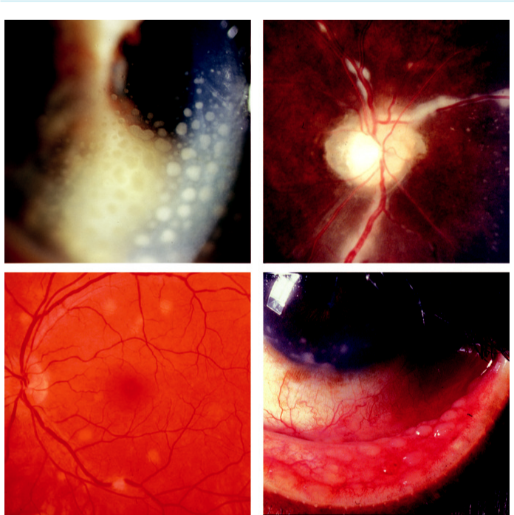

A B

C D

Fig. 12.6 Sarcoidosis: (A) granulomatous KP, (B) periphlebitis, (C) multiple granulomas, (D) lower lid granu-

lomas. (From Salmon JF, Kanski’s Clinical Ophthalmology: A Systematic Approach, 9th edition. Oxford, UK:

Elsevier; 2020.)

**Diagnosis**

***Recurrent oral ulceration:*** plus at least two of the following: (a) recurrent genital ulceration,

1. ocular inflammation, (c) skin lesions, (d) positive pathergy test (pustule at needle prick site). ***Other systemic features:*** (a) vascular (aneurysms, coronary artery disease, venous thrombo-sis), (b) arthritis, (c) skin hypersensitivity, (d) gastrointestinal ulceration, (e) occasionally neurological manifestations.

***Ocular features:*** common and often bilateral; (a) AAU (transient mobile hypopyon in a relatively white eye; Fig. 12.7A), (b) persistent vitritis, (c) transient superficial white reti-nal infiltrates, (d) diuse retinitis, (e) retinal vasculitis (veins and arteries, often occlusive; Fig. 12.7B), (f ) CMO, disc oedema and optic atrophy in end-stage disease.

**Treatment:**

anterior uveitis responds well to topical steroids. Posterior uveitis requires systemic steroids, aza-thioprine, ciclosporin and biological blockers (e.g. infliximab). Interferon-alpha is an alternative option in severe disease.

#*" ##%"#"+!#(&&%"'+$'""#* "%#! " +#!+ &)%#"$'!%

#%$%&#" (&#" +##'%(&&*'#('$%!&&#"#$+%', &)%" %'&%&%)

|  |  |
| --- | --- |
| Chapter 12—UVEITIS | **219** |
|  |  |

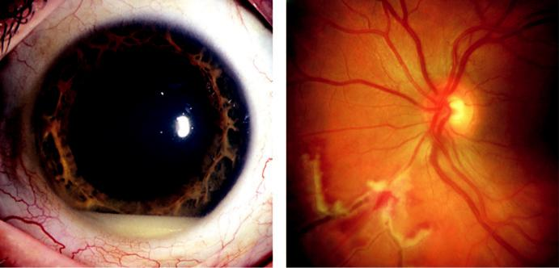

A B

Fig. 12.7 Behçet disease: (A) hypopyon in a white eye, (B) retinal vasculitis. (From Salmon JF, Kanski’s Clinical

Ophthalmology: A Systematic Approach, 9th edition. Oxford, UK: Elsevier; 2020.)

**Toxoplasmosis**

**PATHOGENESIS**

Toxoplasmosis is caused by the obligate intracellular protozoan *Toxoplasma gondii*.

***Hosts:*** the cat is the definitive host; intermediate hosts include mice, livestock and humans (Fig. 12.8).

***Sporozoites:*** excreted in the faeces of the cat and spread to intermediate hosts.

***Bradyzoites:*** contained within cysts in the brain, eye, skeletal muscles and other tissues and may lie dormant for many years.

***Tachyzoites:*** proliferating active form responsible for tissue destruction.

***Modes of human infection:*** (a) ingestion of undercooked meat from an intermediate host containing bradyzoites, (b) ingestion of sporocysts following inadvertent contamination of hands (e.g. cat litter tray), (c) transplacental tachyzoite transfer.

***Congenital toxoplasmosis:*** follows maternal infection during pregnancy. Manifestations range from stillbirth earlier in pregnancy through hydrocephalus, convulsions, paralysis, and visceral involvement to subclinical disease (may still cause intracranial calcification and chorioretinal scars).

***Acquired toxoplasmosis:*** commonly subclinical in the immunocompetent, although a lymphadenopathic syndrome and rarely meningoencephalitis or an exanthematous form, can occur. In immunocompromised patients, infection is much more commonly life-threat-ening (e.g. intracerebral space-occupying lesion in AIDS).

**TOXOPLASMA RETINITIS**

**Pathogenesis:**

reactivation at previously inactive cyst-containing scars. Inflammatory episodes (average age 25 years) occur when cysts rupture and release hundreds of tachyzoites into normal retina.

**Diagnosis**

***Presentation:*** subacute onset of floaters and blurring.

#*" ##%"#"+!#(&&%"'+$'""#* "%#! " +#!+ &)%#"$'!%

#%$%&#" (&#" +##'%(&&*'#('$%!&&#"#$+%', &)%" %'&%&%)

**220** SYNOPSIS OF CLINICAL OPHTHALMOLOGY

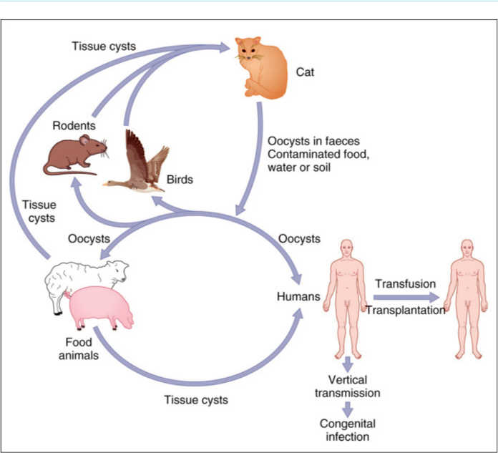

Fig. 12.8 Life cycle of Toxoplasma gondii. (From Salmon JF, Kanski’s Clinical Ophthalmology: A Systematic

Approach, 9th edition. Oxford, UK: Elsevier; 2020.)

***Signs:*** (a) ‘spillover’ anterior uveitis may be granulomatous or resemble Fuchs syndrome,

1. solitary focal retinitis near an old pigmented scar (‘satellite lesion’) is typical (Fig. 12.9A),
2. vitritis (Fig. 12.9B).

***Course:*** healing occurs within 6–8 weeks, with vitreous opacities taking longer to resolve; a sharply demarcated atrophic scar becomes progressively pigmented from the edges. ***Causes of permanent visual loss:*** (a) direct macula (Fig. 12.9C) or optic nerve head involve-ment, (b) macular oedema, (c) occlusion of a major blood vessel by the inflammatory focus, (d) choroidal neovascularization adjacent to an old scar (Fig. 12.9D).

**Treatment**

***Aims:*** (a) limitation of the duration and severity of acute inflammation, (b) limitation of the size of scarring, (c) reduction of recurrences.

***Indications:*** (a) sight-threatening lesion involving the macula, papillomacular bundle, optic nerve head, or a major blood vessel, (b) very severe vitritis (risk of tractional retinal detach-ment), (c) immunocompromised patients (all lesions).

***Regimen:*** (a) systemic prednisolone (1 mg/kg) daily, (b) pyrimethamine and folinic acid, combined with sulfadiazine, (c) azithromycin can be used with the above regimen. e risk of recurrence is reduced if the anti-toxoplasma treatment is used continuously for one year

#*" ##%"#"+!#(&&%"'+$'""#* "%#! " +#!+ &)%#"$'!%

#%$%&#" (&#" +##'%(&&*'#('$%!&&#"#$+%', &)%" %'&%&%)

|  |  |
| --- | --- |
| Chapter 12—UVEITIS | **221** |
|  |  |

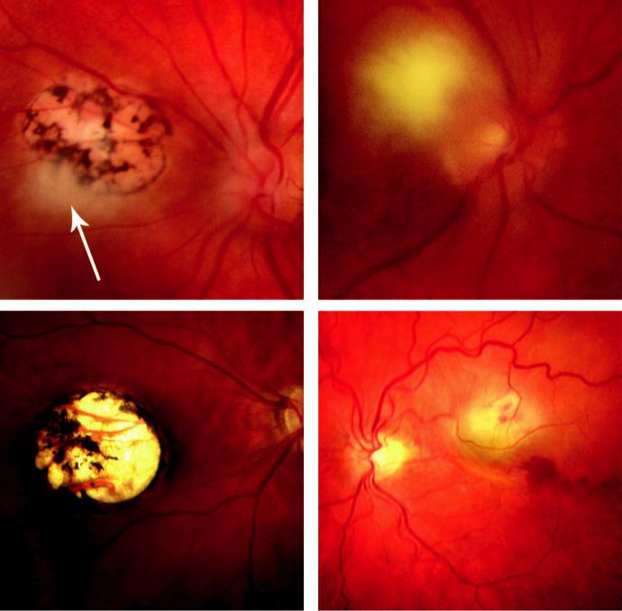

A B

C D

Fig. 12.9 Toxoplasmosis: (A) typical ‘satellite’ lesion adjacent to an old scar (arrow), (B) vitreous haze and ‘headlight in the fog’ appearance, (C) macular scar, (D) choroidal neovascularization adjacent to an old scar. (From Salmon JF, Kanski’s Clinical Ophthalmology: A Systematic Approach, 9th edition. Oxford, UK: Elsevier; 2020.)

after the initial inflammation has settled. Pyrimethamine should be avoided in individu-als with AIDS and steroids must be used with extreme caution in immunocompromised patients.

**Toxocariasis**

**Pathogenesis:**

*Toxocara canis* is a common intestinal roundworm of dogs. Human infestation is by accidental ingestion of soil or food contaminated with ova shed in dogs’ faeces, typically in young children. e ova develop into larvae that travel to various organs.

**Diagnosis**

***Visceral larva migrans:*** severe systemic infection (average age 2 years), which very occasion-ally causes death; there is leucocytosis and eosinophilia.

#*" ##%"#"+!#(&&%"'+$'""#* "%#! " +#!+ &)%#"$'!%

#%$%&#" (&#" +##'%(&&*'#('$%!&&#"#$+%', &)%" %'&%&%)

**222** SYNOPSIS OF CLINICAL OPHTHALMOLOGY

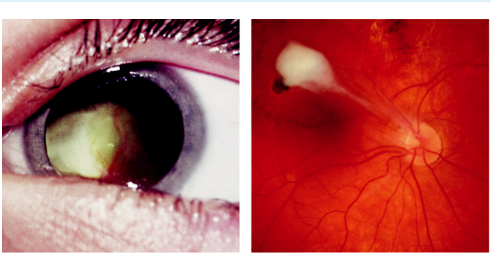

A B

Fig. 12.10 Toxocariasis: (A) leucocoria, (B) granuloma with vitreous band.

***Ocular toxocariasis:*** presents at an older average age in an otherwise healthy child; positive serology for *T. canis* but a normal white cell count without eosinophilia.

***Chronic endophthalmitis:*** presents at 2–9 years of age with leucocoria (Fig. 12.10A), stra-bismus, or unilateral visual loss. Retinoblastoma should be excluded. Prognosis is poor, with progression to tractional retinal detachment and phthisis bulbi.

***Posterior pole granuloma:*** presents at 6–14 years of age with unilateral visual impairment; a round, yellow-white, solid granuloma 1- to 2-disc diameters in size is seen in the posterior fundus (Fig. 12.10B); vitreoretinal traction may be present.

***Peripheral granuloma:*** may remain undetected or present with distortion of the macula or retinal detachment; a white hemispherical granuloma is evident, and may be associated with a vitreous band extending to the disc.

**Treatment:**

with steroids, either periocular or systemic, for inflamed eyes.

**Onchocerciasis**

**Pathogenesis:**

infestation with the parasitic helminth *Onchocerca volvulus* (Fig. 12.11). It is endemic in parts of Africa, where it is a common cause of blindness. e rickettsia *Wolbachia* lives symbiotically in adult worms and microfilaria.

**Diagnosis**

***Systemic features:*** (a) pruritus, (b) maculopapular rash, (c) subcutaneous onchocercomas consisting of encapsulated worms, (d) lymphadenopathy.

***Ocular features:*** (a) anterior uveitis and pear-shaped pupillary dilatation, (b) sclerosing ker-atitis (Fig. 12.12A), (c) chorioretinitis resembling choroidal ‘sclerosis’ (Fig. 12.12B), (d) live microfilariae can be seen in the anterior chamber after the patient has bent face down for a few minutes.

#*" ##%"#"+!#(&&%"'+$'""#* "%#! " +#!+ &)%#"$'!%

#%$%&#" (&#" +##'%(&&*'#('$%!&&#"#$+%', &)%" %'&%&%)

|  |  |
| --- | --- |
| Chapter 12—UVEITIS | **223** |
|  |  |

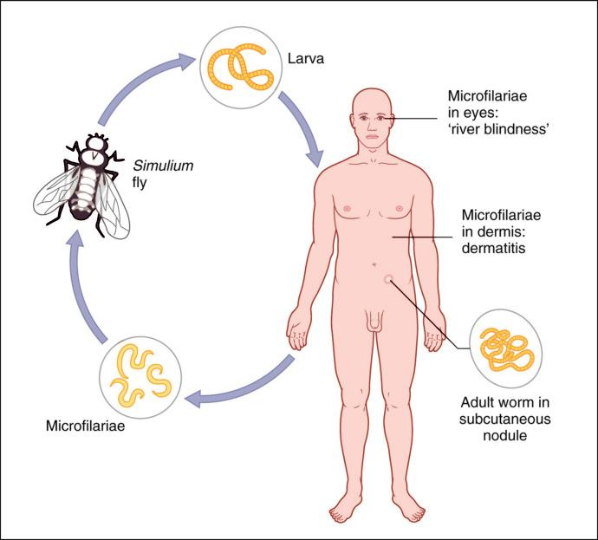

Fig. 12.11 Life cycle of Onchocerca volvulus. (From Salmon JF, Kanski’s Clinical Ophthalmology: A Systematic

Approach, 9th edition. Oxford, UK: Elsevier; 2020.)

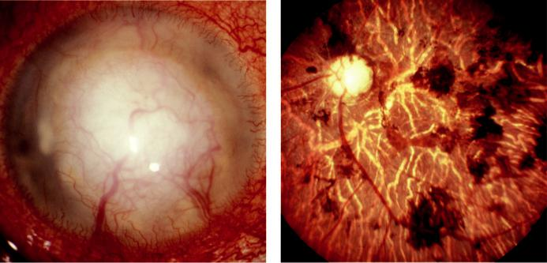

A B

Fig. 12.12 Ocular onchocerciasis: (A) advanced corneal scarring, (B) intraretinal pigment clumping and RPE

atrophy. (From Salmon JF, Kanski’s Clinical Ophthalmology: A Systematic Approach, 9th edition. Oxford, UK:

Elsevier; 2020.)

#*" ##%"#"+!#(&&%"'+$'""#* "%#! " +#!+ &)%#"$'!%

#%$%&#" (&#" +##'%(&&*'#('$%!&&#"#$+%', &)%" %'&%&%)

**224** SYNOPSIS OF CLINICAL OPHTHALMOLOGY



**Treatment:**

Ivermectin is given as a single dose annually. Doxycycline 100–200 mg daily for 6 weeks targets *Wolbachia* and is a useful adjunct.

**Uveitis in Individuals With AIDS**

**AIDS**

***Pathogenesis:*** human immunodeficiency virus (HIV) targets CD4+ T cells, which are vital to the initiation of the immune response to pathogens. Progressive immune deficiency is associated with a steady decline in CD4+ T cell numbers.

***Transmission:*** predominantly by heterosexual intercourse on a worldwide basis, but by male homosexual contact in the Western world. Transmission may also occur by contaminated blood or needles, transplacentally, or via breast milk.

***Course:*** (a) acute seroconversion illness is followed by an asymptomatic phase, (b) symp-tomatic infection (AIDS) then follows and is characterized by immunosuppression with opportunistic infections and neoplasms, as well as tissue damage directly due to HIV infection.

***Treatment:*** although there is no cure for AIDS, progression of disease can be radically slowed with ‘highly active antiretroviral therapy’ (HAART).

**OCULAR INVOLVEMENT IN AIDS**

***Eyelids:*** (a) blepharitis, (b) Kaposi sarcoma (see Fig. 20.7B), (c) severe molluscum contagio-sum (Fig. 12.13A), (d) herpes zoster ophthalmicus.

***Orbit:*** cellulitis and B cell lymphoma.

***Anterior segment:*** (a) conjunctiva (Kaposi sarcoma, squamous cell carcinoma, microangi-opathy), (b) keratitis (microsporidia, herpes simplex, herpes zoster), (c) keratoconjunctivitis sicca, (d) anterior uveitis (may be secondary to systemic drug toxicity with rifabutin or cidofovir).

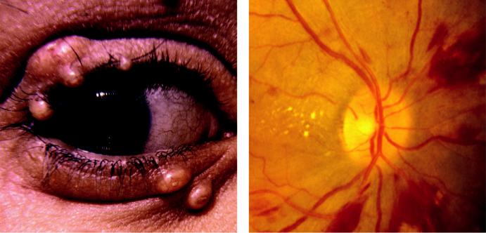

A B

Fig. 12.13 AIDS: (A) numerous molluscum lesions, (B) HIV microangiopathy. (From Salmon JF, Kanski’s

Clinical Ophthalmology: A Systematic Approach, 9th edition. Oxford, UK: Elsevier; 2020.)

#*" ##%"#"+!#(&&%"'+$'""#* "%#! " +#!+ &)%#"$'!%

#%$%&#" (&#" +##'%(&&*'#('$%!&&#"#$+%', &)%" %'&%&%)

|  |  |
| --- | --- |
| Chapter 12—UVEITIS | **225** |
|  |  |

***Posterior segment:*** (a) HIV microangiopathy, (b) HlV retinitis, (c) cytomegalovirus retinitis,

1. progressive retinal necrosis, (e) toxoplasmosis (frequently atypical), (f ) choroidal crypto-coccosis, (g) choroidal pneumocystosis, (h) B-cell intraocular lymphoma.

**HIV MICROANGIOPATHY**

HIV microangiopathy is the most frequent retinopathy in AIDS, developing in up to 70%. ***Pathogenesis:*** immune complex deposition and HIV infection of the retinal vascularendothelium.

***Signs:*** cotton wool spots which may be associated with retinal haemorrhages (Fig. 12.13B) and capillary abnormalities; resolves spontaneously after several weeks.

**CYTOMEGALOVIRUS RETINITIS**

Cytomegalovirus retinitis is the most common opportunistic ocular infection in AIDS, although since the advent of HAART its incidence and severity have declined.

**Diagnosis**

***Indolent retinitis:*** starts in the periphery and progresses slowly as granular opacification, which may be associated with a few punctate haemorrhages (Fig. 12.14A); vasculitis is absent. ***Fulminating retinitis:*** (a) mild vitritis, (b) vasculitis with perivascular sheathing and retinal opacification, (c) well-demarcated areas of dense white opacification often associated with retinal haemorrhages (Fig. 12.14B), (d) slow but relentless ‘brushfire-like’ extension along the course of the retinal vascular arcades, (e) retinal detachment associated with large pos-terior breaks in uncontrolled disease.

**Treatment**

***Systemic:*** (a) oral valganciclovir, (b) intravenous ganciclovir, foscarnet or cidofovir (with probenecid).

***Intravitreal cidofovir:*** may occasionally cause severe uveitis.

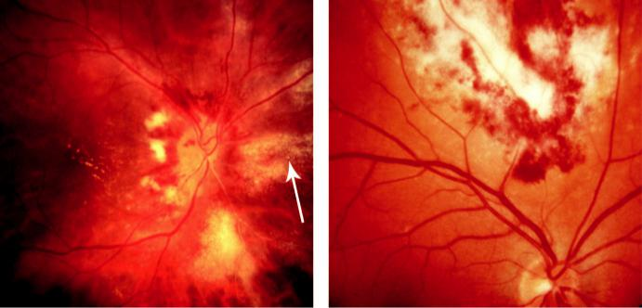

A B

Fig. 12.14 Cytomegalovirus retinitis: (A) indolent retinitis with typical granular appearance (arrow), (B) dense

retinal infiltration with flame-shaped haemorrhages. (From Salmon JF, Kanski’s Clinical Ophthalmology: A

Systematic Approach, 9th edition. Oxford, UK: Elsevier; 2020.)

#*" ##%"#"+!#(&&%"'+$'""#* "%#! " +#!+ &)%#"$'!%

#%$%&#" (&#" +##'%(&&*'#('$%!&&#"#$+%', &)%" %'&%&%)

**226** SYNOPSIS OF CLINICAL OPHTHALMOLOGY



**PROGRESSIVE RETINAL NECROSIS**

**Pathogenesis:**

necrotizing retinitis caused by VZV; occurs predominantly in AIDS, although also in patients with drug-induced immunosuppression.

**Diagnosis**

***Presentation:*** sudden onset of progressive visual loss; initially unilateral in 75%.

***Signs:*** (a) minimal anterior uveitis and vitritis, (b) yellow-white retinal infiltrates, (c) rapid confluence and full-thickness necrosis (Fig. 12.15A).

***Investigations:*** PCR of vitreous for VZV.

**Treatment:**

intravenous and intravitreal ganciclovir and foscarnet, but response is often disappointing.

**Acute Retinal Necrosis**

**Pathogenesis:**

necrotizing viral retinitis, typically aecting otherwise healthy individuals of all ages. Tends to be caused by HSV in younger and by VZV in older individuals.

**Diagnosis**

***Presentation:*** initially unilateral; some patients develop pain with severe visual impairment over a few days, others have an insidious onset with floaters.

***Signs:*** (a) granulomatous anterior uveitis, (b) vitritis, (c) peripheral periarteritis associated with multifocal yellow-white deep retinal infiltrates, (d) circumferential progression usually sparing the posterior pole until late (Fig. 12.15B), (e) optic nerve involvement.

***Course:*** acute features resolve in 6–12 weeks, leaving behind transparent necrotic retina with hyperpigmented borders. Without treatment, the second eye becomes involved in 30%, usu-ally within 2 months.

***Investigations:*** PCR of vitreous for HSV and VZV.

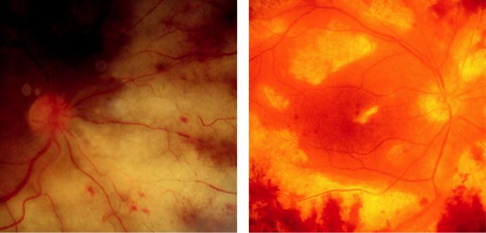

A B

Fig. 12.15 (A) Progressive retinal necrosis showing yellow-white infiltrates with well-defined borders, (B) acute retinal necrosis reaching the posterior pole. (Figure 12.15A courtesy of C. Herbort.)

#*" ##%"#"+!#(&&%"'+$'""#* "%#! " +#!+ &)%#"$'!%

#%$%&#" (&#" +##'%(&&*'#('$%!&&#"#$+%', &)%" %'&%&%)

|  |  |
| --- | --- |
| Chapter 12—UVEITIS | **227** |
|  |  |

**Treatment**

***Antivirals:*** (a) intravenous aciclovir (15 mg/kg every 8 hours) for 10–14 days, then orally 800 mg five times daily for 6–12 weeks (does not prevent retinal detachment), (b) oral valaciclovir and famciclovir give similar outcomes, (c) intravitreal ganciclovir or foscarnet are also used in severe cases.

***Systemic steroids:*** may be started 24 hours after initiation of antiviral therapy, particularly in severe cases (e.g. optic nerve involvement).

***Prognosis:*** 60% have final VA of less than 6/60.

**Fungal Uveitis**

**PRESUMED OCULAR HISTOPLASMOSIS SYNDROME (POHS)**

**Pathogenesis:**

histoplasmosis is a systemic granulomatous inflammatory condition caused by *Histoplasma capsu-latum*, acquired by inhalation. Although ocular histoplasmosis has never been reported in patientswith active systemic infection, POHS is believed to be an immune-mediated response in indi-viduals previously exposed to the fungus.

**Diagnosis**

***Presentation:*** asymptomatic in the absence of maculopathy.

***Signs:*** (a) absence of uveitis, (b) ‘histo’ spots (Fig. 12.16A) consist of roundish atrophic yellow-white lesions, often associated with pigment clumps, scattered in the mid-periphery and posterior fundus, (c) peripapillary atrophy (Fig. 12.16B), (d) occasionally mid-periph-eral linear streaks.

***Choroidal neovascularization (CNV):*** develops in approximately 5%, usually associated with an old macular histo spot in a relatively young adult.

**Treatment:**

intravitreal anti-VEGF agents.

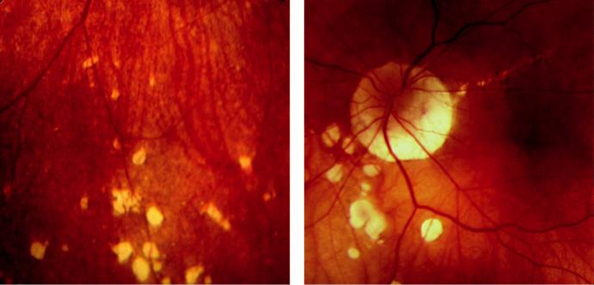

A B

Fig. 12.16 Presumed ocular histoplasmosis syndrome: (A) ‘histo’ spots, (B) circumferential peripapillary atro-

phy and ‘histo’ spots. (From Salmon JF, Kanski’s Clinical Ophthalmology: A Systematic Approach, 9th edition.

Oxford, UK: Elsevier; 2020.)

#*" ##%"#"+!#(&&%"'+$'""#* "%#! " +#!+ &)%#"$'!%

#%$%&#" (&#" +##'%(&&*'#('$%!&&#"#$+%', &)%" %'&%&%)

**228** SYNOPSIS OF CLINICAL OPHTHALMOLOGY



**CRYPTOCOCCOSIS**

**Pathogenesis:**

infection with *Cryptococcus neoformans*, which enters the body through inhalation; primarily aects patients with immune dysfunction, notably AIDS.

**Diagnosis:**

***Systemic features:*** (a) meningitis (most important), (b) pneumonia, (c) mucocutaneous lesions, (d) pyelonephritis, (e) endocarditis, (f ) hepatitis.

***Ocular features:*** (a) papilloedema, (b) optic neuropathy, (c) ophthalmoplegia, (d) multifocal choroiditis, (e) iris infiltration, (f ) keratitis, (g) conjunctival granuloma.

***Investigation:*** central nervous system imaging, lumbar puncture and serology.

**Treatment:**

intravenous antifungal agents.

**ENDOGENOUS FUNGAL ENDOPHTHALMITIS**

**Pathogenesis:**

the major source of fungal infection within the eye is metastatic spread from a septic focus associ-ated with a catheter, intravenous drug abuse, parenteral nutrition and chronic lung disease such as cystic fibrosis; immunosuppression and AIDS are also major risk factors; approximately 75% of isolates show *Candida* spp.

**Diagnosis**

***Presentation:*** insidious onset of blurring and floaters; bilateral involvement is common.

***Signs:*** (a) creamy-white chorioretinal lesions with overlying vitritis (Fig. 12.17A), (b) ‘cot-ton ball’ colonies, (c) chronic endophthalmitis with severe vitreous infiltration (Fig. 12.17B),

1. proliferative vitreoretinopathy and retinal detachment. ***Investigations:*** vitreous biopsy.

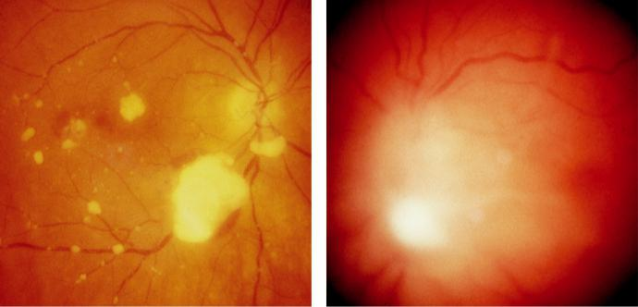

A B

Fig. 12.17 Candida endophthalmitis: (A) ‘cotton ball’ colonies, (B) severe vitritis. (From Salmon JF, Kanski’s

Clinical Ophthalmology: A Systematic Approach, 9th edition. Oxford, UK: Elsevier; 2020.)

#*" ##%"#"+!#(&&%"'+$'""#* "%#! " +#!+ &)%#"$'!%

#%$%&#" (&#" +##'%(&&*'#('$%!&&#"#$+%', &)%" %'&%&%)

|  |  |
| --- | --- |
| Chapter 12—UVEITIS | **229** |
|  |  |

**Treatment**

***Medical:*** (a) oral fluconazole, (b) oral, intravenous, or intravitreal voriconazole for cases resistant to fluconazole.

***Pars plana vitrectomy:*** with intravitreal amphotericin for severe vitreous involvement.

**Bacterial Uveitis**

**TUBERCULOSIS**

**Pathogenesis:**

chronic granulomatous infection usually caused by *Mycobacterium tuberculosis*, acquired by inhal-ing infected airborne droplets. It is primarily a pulmonary disease but may spread to other sites; it is more common in immunocompromised individuals.

**Diagnosis**

***Eyelids:*** reddish-brown nodules (lupus vulgaris).

***Cornea:*** phlyctenular keratoconjunctivitis and interstitial keratitis.

***Anterior uveitis:*** usually granulomatous.

***Choroiditis:*** (a) focal (Fig. 12.18A) or (b) less frequently, multifocal spreading in a serpiginous pattern (Fig. 12.18B), (c) extensive and diuse in AIDS, (d) large choroidal granulomas (rare). ***Periphlebitis:*** mild and innocuous or occlusive resulting in severe retinal ischaemia and neovascularization.

**Treatment:**

1. initially with at least three drugs (isoniazid, rifampicin, and pyrazinamide); quadruple therapy with the addition of ethambutol is necessary in some cases, (b) uveitis requires steroids.

**SYPHILIS**

**Pathogenesis:**

caused by the spirochaete bacterium *Treponema pallidum*. In adults, the disease is usually sex-ually acquired when the treponemes enter through an abrasion of skin or mucous membrane.

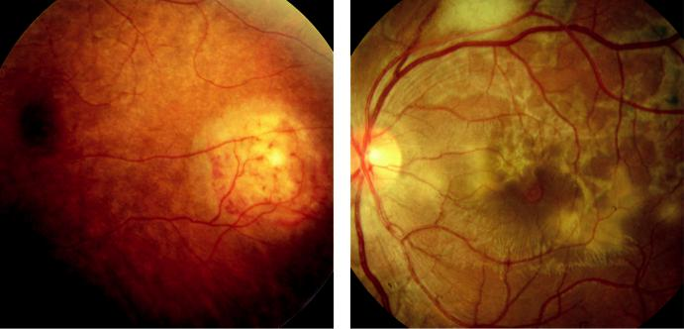

A B

Fig. 12.18 Tuberculosis choroiditis: (A) granuloma, (B) serpiginoid choroiditis showing a granuloma superiorly. (Figure 12.18B courtesy of C. Pavesio.)

#*" ##%"#"+!#(&&%"'+$'""#* "%#! " +#!+ &)%#"$'!%

#%$%&#" (&#" +##'%(&&*'#('$%!&&#"#$+%', &)%" %'&%&%)

**230** SYNOPSIS OF CLINICAL OPHTHALMOLOGY

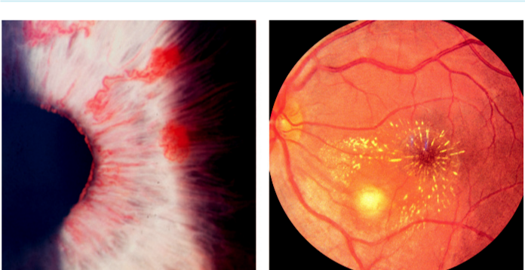

A B

Fig. 12.19 Ocular syphilis: (A) roseolae, (B) focal infiltration with macular star. (From Salmon JF, Kanski’s

Clinical Ophthalmology: A Systematic Approach, 9th edition. Oxford, UK: Elsevier; 2020.)

Transplacental infection can occur from a mother who has become infected during or shortly before pregnancy. e natural history of untreated syphilis is variable and the condition may remain latent.

**Diagnosis**

***Primary syphilis:*** painless ulcer (chancre) at the site of infection, resolving in 2–6 weeks.

***Secondary syphilis:*** 6–8 weeks later is characterized by: (a) generalized lymphadenopathy,

1. maculopapular rash, (c) condylomata lata, (d) snail-track ulcers (e.g. mouth), (e) menin-gitis, (f ) nephritis, (g) hepatitis.

***Latent syphilis:*** detected only by serology.

***Tertiary syphilis:*** (a) cardiovascular disease (e.g. aortitis), (b) neurosyphilis (e.g. tabes dorsa-lis), (c) Charcot joints, (d) general paresis of the insane, (e) gummatous infiltration of bone and viscera.

***AAU:*** occurs in 4% of patients with secondary syphilis; may feature dilated iris capillaries (roseolae; Fig. 12.19A).

***Posterior uveitis:*** (a) chorioretinitis, often bilateral, may be multifocal or placoid with pale yellowish subretinal lesions (Fig. 12.19B), (b) neuroretinitis, (c) vasculitis (may be occlusive).

***Investigations:*** serology with lumbar puncture for suspected neurosyphilis.

**Treatment:**

1. syphilis is treated with penicillin, alternatives including tetracycline or erythromycin in the penicillin-allergic; (b) uveitis requires steroids.

**LYME DISEASE (BORRELIOSIS)**

**Pathogenesis:**

caused by the spirochaete bacterium *Borrelia burgdorferi*, transmitted through a tick bite (Fig. 12.20). e disease is endemic in many temperate regions and has probably been significantly underdiagnosed in the past.

#*" ##%"#"+!#(&&%"'+$'""#* "%#! " +#!+ &)%#"$'!%

#%$%&#" (&#" +##'%(&&*'#('$%!&&#"#$+%', &)%" %'&%&%)

|  |  |
| --- | --- |
| Chapter 12—UVEITIS | **231** |
|  |  |

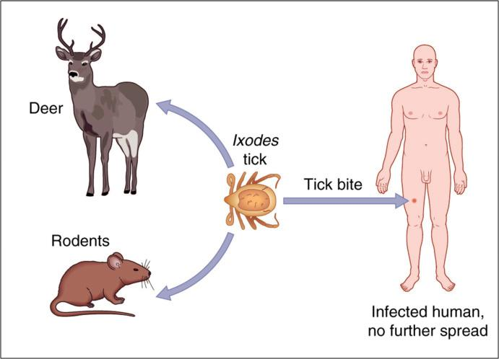

Fig. 12.20 Transmission of Lyme disease. (From Salmon JF, Kanski’s Clinical Ophthalmology: A Systematic

Approach, 9th edition. Oxford, UK: Elsevier; 2020.)

**Diagnosis**

***Presentation:*** (a) erythema chronicum migrans, a pathognomonic annular skin lesion at the site of the tick bite, (b) constitutional symptoms with lymphadenopathy which can last for several weeks and resolve even without treatment.

***Early complications:*** (a) neurological (cranial nerve palsies, meningitis), (b) cardiac (conduc-tion defects, myocarditis) may follow within 3–4 weeks.

***Late complications:*** (a) chronic arthritis, (b) polyneuropathy, (c) encephalopathy.

***Ocular features:*** (a) uveitis (anterior, IU, peripheral multifocal choroiditis, periphlebitis, neuroretinitis), (b) follicular conjunctivitis, (c) episcleritis and scleritis (see Fig. 9.6D), (d) keratitis, (e) orbital myositis, (f ) optic neuritis, (g) ocular motor nerve palsies, (h) reversible Horner syndrome.

***Investigations:*** serology.

**Treatment:**

1. oral doxycycline (not in children) or amoxicillin for acute stage, (b) prophylaxis with doxy-cycline may be eective if given within 72 hours of the tick bite, (c) intravenous ceftriaxone for ocular, cardiac, joint, or neurological disease.

**ENDOGENOUS (METASTATIC) BACTERIAL ENDOPHTHALMITIS**

**Pathogenesis:**

predisposing factors include diabetes and intravenous drug abuse. Sources of infection may be

(a) indwelling catheters, (b) systemic infection (e.g. pneumonia), (c) abdominal surgery; the most

#*" ##%"#"+!#(&&%"'+$'""#* "%#! " +#!+ &)%#"$'!%

#%$%&#" (&#" +##'%(&&*'#('$%!&&#"#$+%', &)%" %'&%&%)

**232** SYNOPSIS OF CLINICAL OPHTHALMOLOGY



common pathogen is *Klebsiella* spp. Both eyes are involved in approximately 1 in 10 cases and mortality from the underlying systemic disease is 5–10%.

**Diagnosis**

***Systemic features:*** headache, fever and rigors.

***Anterior segment:*** discrete iris nodules or plaques, and fibrinous anterior uveitis.

***Posterior segment:*** (a) retinal infiltrates, (b) vitreous haze or abscess, (c) retinal necrosis.

***Investigations:*** systemic infection screen and aqueous and vitreous sampling.

**Treatment**

***Systemic infection:*** intravenous antibiotics according to source and infectious agent; broad-spectrum treatment if no evident source of infection (e.g. ceftazidime, vancomycin). ***Endophthalmitis:*** add oral ciprofloxacin.

**CAT-SCRATCH DISEASE**

**Pathogenesis:**

rare subacute condition caused by infection with *Bartonella henselae*, transmitted by the scratch or bite of an apparently healthy cat; ocular involvement occurs in approximately 6%.

**Diagnosis**

***Presentation:*** red papule or pustule at the site of inoculation followed by fever, malaise, and regional lymphadenopathy.

***Disseminated disease:*** rare except in immunocompromised patients.

***Ocular features*** (a) most common; neuroretinitis (Fig. 12.21A and B), (b) uveitis, (c) Parinaud oculoglandular syndrome, (d) exudative maculopathy, (e) retinal vascular occlusion. ***Investigations:*** serology for *B. henselae*.

**Treatment:**

oral doxycycline or erythromycin, sometimes with rifampicin.

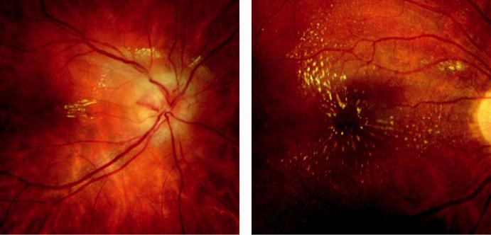

A B

Fig. 12.21 Cat-scratch disease, neuroretinitis: (A) disc oedema, (B) macular star. (From Salmon JF, Kanski’s

Clinical Ophthalmology: A Systematic Approach, 9th edition. Oxford, UK: Elsevier; 2020.)

#*" ##%"#"+!#(&&%"'+$'""#* "%#! " +#!+ &)%#"$'!%

#%$%&#" (&#" +##'%(&&*'#('$%!&&#"#$+%', &)%" %'&%&%)

|  |  |
| --- | --- |
| Chapter 12—UVEITIS | **233** |
|  |  |

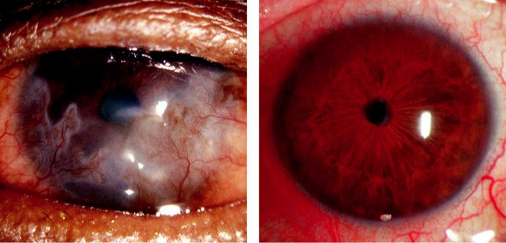

A B

Fig. 12.22 Leprosy: (A) corneal involvement showing pannus, (B) chronic anterior uveitis with miosis. (Figure 12.22A courtesy of ADN Murray.)

**LEPROSY**

**Pathogenesis:**

chronic granulomatous infection caused by *Mycobacterium leprae;* exhibits an anity for skin, peripheral nerves, and the anterior segment of the eye. e incubation period is typically approxi - mately 5 years.

**Diagnosis**

***Lepromatous leprosy:*** multisystem infection involving (a) skin, (b) peripheral nerves,

1. upper respiratory tract, (d) reticuloendothelial system, (e) eyes, (f ) bones, (g) character-istic ‘leonine’ facies.

***Tuberculoid leprosy:*** restricted to the skin and peripheral nerves, giving annular, anaesthetic and hypopigmented lesions with raised edges.

***Lepromin test:*** strongly positive in tuberculoid leprosy but negative in lepromatous disease.

***Ocular features:*** (a) keratitis (Fig. 12.22A), (b) chronic anterior uveitis, (c) iris pearls,

1. miosis due to damaged dilator pupillae innervation and (e) iris atrophy (Fig. 12.22B).

**Treatment:**

multidrug therapy (e.g. dapsone, rifampicin, clofazimine).

**White dot syndromes**



BOX 12.1 **The white dot syndromes**

Multiple evanescent white dot syndrome

Acute posterior multifocal placoid pigment epitheliopathy

Birdshot retinochoroiditis

Punctate inner choroidopathy

Serpiginous choroidopathy

Multiple choroiditis and panuveitis

Subretinal fibrosis and uveitis

#*" ##%"#"+!#(&&%"'+$'""#* "%#! " +#!+ &)%#"$'!%

#%$%&#" (&#" +##'%(&&*'#('$%!&&#"#$+%', &)%" %'&%&%)

**234** SYNOPSIS OF CLINICAL OPHTHALMOLOGY



**MULTIPLE EVANESCENT WHITE DOT SYNDROME (MEWDS)**

**Definition:**

usually unilateral, idiopathic self-limiting disease with a female preponderance.

**Diagnosis**

***Presentation:*** in 3rd and 4th decades with blurring and photopsia which may follow a viral-like illness.

***Signs:*** (a) mild vitritis, (b) numerous ill-defined small grey-white deep retinal dots at the posterior pole and mid-periphery (Box 12.1, Fig. 12.23A), (c) later granular orange macular appearance with abnormal/absent foveal reflex and an enlarged blind spot.

***Course:*** over several weeks the dots fade and central vision recovers. Foveal granularity may remain and the enlarged blind spot persists for much longer.

***FA:*** subtle early hyperfluorescence of the dots with late staining; sometimes minimal or absent findings.

***ICGA:*** more numerous hypofluorescent spots (Fig. 12.23B). Both FA and ICGA show peripapillary nonperfusion, consistent with an enlarged blind spot.

***Electroretinogram:*** decrease in a-wave amplitude that returns to a normal pattern within a few weeks.

**Treatment:**

not required.

**ACUTE IDIOPATHIC BLIND SPOT ENLARGEMENT SYNDROME**

**Definition:**

rare, self-limiting condition that seems to exclusively aect women.

**Diagnosis**

***Presentation:*** in 3rd to 6th decades with blurring and photopsia.

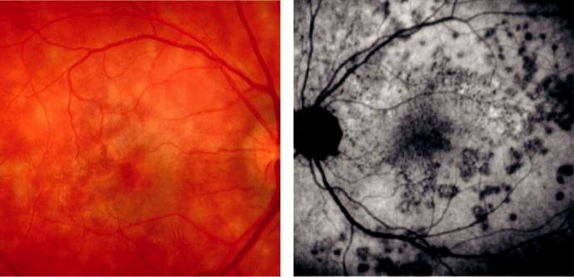

A B

Fig. 12.23 MEWDS: (A) numerous macular lesions, (B) ICGA appearance showing hypofluorescent spots that are more numerous than visible clinically. (Figure 12.23A courtesy of Moorfields Eye Hospital; Figure 12.23B courtesy of C. Herbort.)

#*" ##%"#"+!#(&&%"'+$'""#* "%#! " +#!+ &)%#"$'!%

#%$%&#" (&#" +##'%(&&*'#('$%!&&#"#$+%', &)%" %'&%&%)

|  |  |
| --- | --- |
| Chapter 12—UVEITIS | **235** |
|  |  |

***Signs:*** (a) relative aerent pupillary defect, (b) enlarged blind spot, (c) mild disc swelling or hyperaemia with peripapillary subretinal pigmentary changes.

**Treatment:**

not required.

**ACUTE POSTERIOR MULTIFOCAL PLACOID PIGMENT EPITHELIOPATHY (APMPPE)**

**Definition:**

uncommon, idiopathic, usually bilateral condition, which aects both sexes equally.

**Diagnosis**

***Presentation:*** in 3rd and 4th decades, following a flu-like illness in approximately one-third of patients, with subacute monocular central and paracentral scotomas; second eye is involved within days/weeks.

***Signs:*** (a) mild anterior uveitis and vitritis, (b) multiple large yellow-white placoid lesions, which typically begin at the posterior pole and extend to the post-equatorial fundus (Fig. 12.24A). ***Course:*** (a) lesions begin to fade after a few days leaving variable retinal pigment epithe-lium (RPE) disturbance, (b) VA usually recovers over months to normal or near-normal, (c) recurrence is rare.

***FA:*** active lesions show early dense hypofluorescence (Fig. 12.24B) and late staining.

***ICGA:*** nonperfusion of the choriocapillaris.

**Treatment:**

systemic steroids are sometimes given, but clear benefit has not been established.

**MULTIFOCAL CHOROIDITIS AND PANUVEITIS**

**Definition:**

uncommon chronic/recurrent disease that predominantly aects myopic females; usually bilateral but asymmetrical.

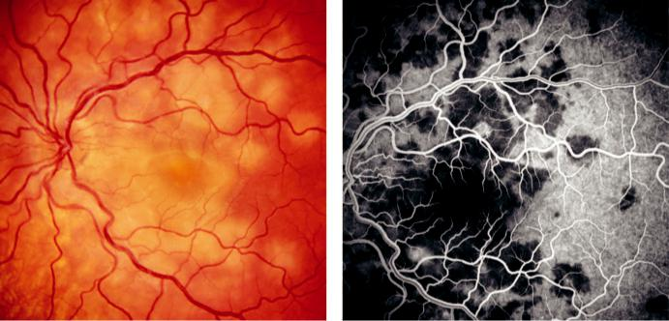

A B

Fig. 12.24 APMPPE: (A) fundal appearance, (B) FA early venous phase showing dense foci of hypofluores-cence. (Figure 12.24A, B courtesy of Chris Barry, Lions Eye Institute, Perth, Australia.)

#*" ##%"#"+!#(&&%"'+$'""#* "%#! " +#!+ &)%#"$'!%

#%$%&#" (&#" +##'%(&&*'#('$%!&&#"#$+%', &)%" %'&%&%)

**236** SYNOPSIS OF CLINICAL OPHTHALMOLOGY

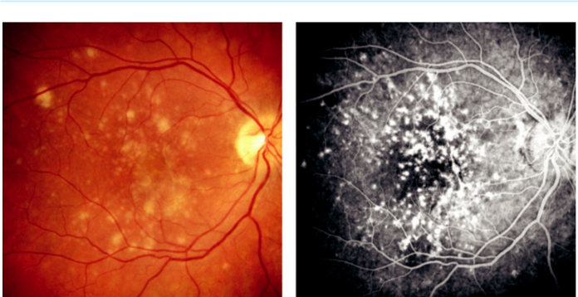

A B

Fig. 12.25 Multifocal choroiditis and panuveitis: (A) multiple, discrete, ovoid yellowish-grey lesions, (B) FA late

hyperfluorescence. (From Salmon JF, Kanski’s Clinical Ophthalmology: A Systematic Approach, 9th edition.

Oxford, UK: Elsevier; 2020.)

**Diagnosis**

***Presentation:*** in 3rd and 4th decades with blurring, floaters, and photopsia.

***Signs:*** (a) anterior uveitis and vitritis, (b) multiple ovoid yellowish-grey lesions involving the posterior pole (Fig. 12.25A) and/or periphery with (c) evolution into punched-out lesions with pigmented borders.

***Course:*** prolonged with recurrent inflammatory episodes; complications include CNV, CMO, and occasionally subretinal fibrosis.

***FA:*** active lesions show early blockage and late staining; old lesions show RPE window defects (Fig. 12.25B).

**Treatment:**

systemic and periocular steroids are eective when administered early; other immunosuppressives are sometimes required.

**PUNCTATE INNER CHOROIDOPATHY**

**Definition:**

uncommon idiopathic disease typically aecting young myopic women; both eyes are frequently involved but not simultaneously.

**Diagnosis**

***Presentation:*** photopsia and blurring.

***Signs:*** (a) absent or minimal uveitis, (b) multiple small yellow-white spots with fuzzy bor-ders at the posterior pole (Fig. 12.26A).

***Course:*** the lesions resolve after a few weeks, leaving sharply demarcated atrophic scars.

CNV develops in up to 40% of eyes, usually within 1 year.

***FA:*** active lesions show early hyperfluorescence and late staining (Fig. 12.26B).

**Treatment:**

reserved for CNV.

#*" ##%"#"+!#(&&%"'+$'""#* "%#! " +#!+ &)%#"$'!%

#%$%&#" (&#" +##'%(&&*'#('$%!&&#"#$+%', &)%" %'&%&%)

|  |  |
| --- | --- |
| Chapter 12—UVEITIS | **237** |
|  |  |

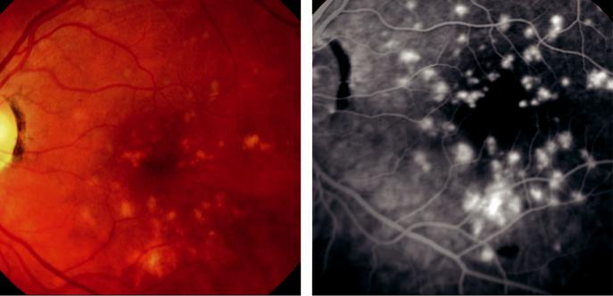

A B

Fig. 12.26 PIC: (A) active lesions, (B) FA late phase showing intense hyperfluorescent spots. (Figure 12.26A courtesy of S. Chen.)

**BIRDSHOT RETINOCHOROIDITIS**

**Definition:**

uncommon idiopathic chronic/recurrent bilateral inflammatory disease that predominantly aects females; 95% of patients are positive for HLA-A29.

**Diagnosis**

***Presentation:*** in 3rd to 6th decades with insidious impairment of central vision associated with photopsia and floaters.

***Signs:*** (a) vitritis, (b) multiple, ill-defined ovoid cream-coloured choroidal patches, in the posterior pole and mid-periphery (Fig. 12.27A), (c) radiate outward from the disc but usu-ally spare the macula, (d) inactive lesions consist of well-delineated atrophic spots, (e) CMO is common.

***Course:*** approximately 20% of patients have a self-limited course and maintain normal VA in at least one eye.

***FA:*** disc staining, hyperfluorescence due to leakage and CMO.

***ICGA:*** well-defined oval hypofluorescent spots (Fig. 12.27B).

**Treatment:**

systemic steroids, ciclosporin, mycophenolate mofetil, or azathioprine.

**SERPIGINOUS CHOROIDOPATHY**

**Definition:**

uncommon chronic/recurrent inflammatory disease of the RPE, choriocapillaris and choroid, with a male preponderance, which is usually bilateral although asymmetrical.

**Diagnosis**

***Presentation:*** in middle-age with blurring, central scotoma, or metamorphopsia.

#*" ##%"#"+!#(&&%"'+$'""#* "%#! " +#!+ &)%#"$'!%

#%$%&#" (&#" +##'%(&&*'#('$%!&&#"#$+%', &)%" %'&%&%)

**238** SYNOPSIS OF CLINICAL OPHTHALMOLOGY

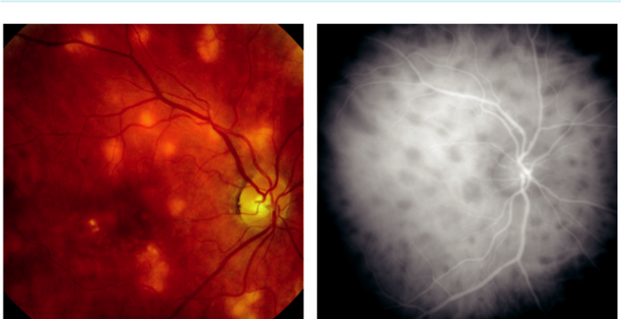

A B

Fig. 12.27 Birdshot retinochoroiditis: (A) active stage, (B) ICG early phase showing numerous hypofluorescent

lesions. (From Salmon JF, Kanski’s Clinical Ophthalmology: A Systematic Approach, 9th edition. Oxford, UK:

Elsevier; 2020.)

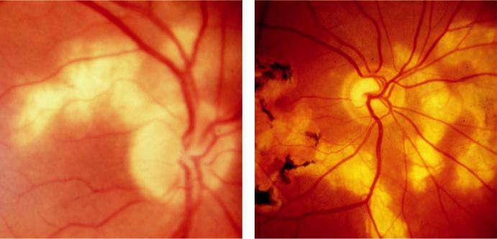

A B

Fig. 12.28 Serpiginous choroidopathy: (A) early active disease, (B) extension around the macula in typical snake-like fashion. (Figure 12.28B courtesy of R. Bates.)

***Signs:*** (a) mild anterior uveitis and vitritis, (b) grey-white lesions that typically start around the optic disc and gradually spread in a serpentine manner toward the macula and periphery (Fig. 12.28A).

***Course:*** lesions evolve over months and years to scalloped atrophic areas (Fig. 12.28B).

CNV and occasionally subretinal fibrosis can occur.

***FA:*** active lesions show early hypofluorescence, late hyperfluorescence, similar to APMPPE.

***ICGA:*** marked hypofluorescence.

**Treatment:**

periocular or systemic steroids for active lesions, and long-term immunosuppression for chronic disease; prognosis is poor.

#*" ##%"#"+!#(&&%"'+$'""#* "%#! " +#!+ &)%#"$'!%

#%$%&#" (&#" +##'%(&&*'#('$%!&&#"#$+%', &)%" %'&%&%)

|  |  |
| --- | --- |
| Chapter 12—UVEITIS | **239** |
|  |  |

**Acute Zonal Occult Outer Retinopathy (Azoor)**

**Pathogenesis:**

rare idiopathic condition usually aecting young or middle-aged females sometimes following a viral-like illness.

**Diagnosis**

***Presentation:*** acute onset with symptoms of photopsia and floaters.

***Signs:*** (a) loss of one or more zones of visual field, usually temporal, (b) minimal signs in the early stage, (c) RPE clumping and vascular attenuation in aected area.

***Course:*** stabilization within 6 months in 90%. Final VA of 6/12 in one eye in most cases.

***ERG:*** a-wave and b-wave amplitude reduction; delayed 30 Hz flicker

***FAF:*** hyperpigmentation in aected area ( Fig. 12.29A).

***OCT:*** serous retinal detachment (Fig. 12.29B).

**Treatment:**

no proven treatment; some reports of favourable outcome from systemic steroids.

**Primary Stromal Choroiditis**

**VOGT–KOYANAGI–HARADA SYNDROME (VKH)**

**Pathogenesis:**

autoimmune disease involving inflammation of melanocyte-containing tissues such as the uvea,

ear, and meninges, predominantly aecting Hispanics, Japanese and Middle-Eastern individuals.

Female to male ratio 2:1.

Subdivided into:

***Vogt–Koyanagi disease:*** skin changes and anterior uveitis.

***Harada disease:*** neurological features and exudative retinal detachment.

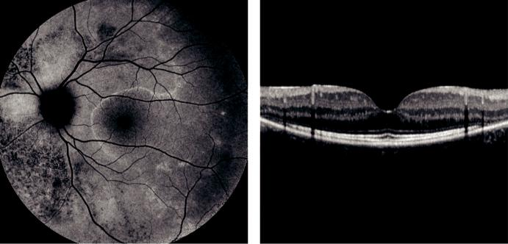

A B

Fig. 12.29 AZOOR (A): FAF showing hyperpigmentation nasal to the disc and an abrupt transition between normal and abnormal retina temporal to the disc, (B) OCT image showing serous retinal detachment. (Courtesy of P. Charbel Issa.)

#*" ##%"#"+!#(&&%"'+$'""#* "%#! " +#!+ &)%#"$'!%

#%$%&#" (&#" +##'%(&&*'#('$%!&&#"#$+%', &)%" %'&%&%)

**240** SYNOPSIS OF CLINICAL OPHTHALMOLOGY



**Diagnosis**

***Prodromal phase:*** neurological and auditory manifestations lasting a few days.

***Acute uveitic phase:*** bilateral non-granulomatous then granulomatous anterior or multifocal posterior uveitis with exudative retinal detachments (Fig. 12.30A) and papillitis. ***Convalescent phase:*** several weeks later with localized alopecia, poliosis, and vitiligo; focal depig-mented fundus lesions (‘sunset glow’ fundus) and depigmented limbal lesions (Sugiura sign). ***Chronic/recurrent phase:*** smouldering anterior uveitis with exacerbations.

***OCT:*** subretinal fluid with subretinal septae. e height of subretinal fluid correlates with disease activity (Fig. 12.30B)

***FA:*** (a) acute phase shows multifocal hyperfluorescent dots at the level of the RPE, then accumulation of dye in the subretinal space (Fig. 12.30C), (b) chronic phase shows areas of hyperfluorescent RPE window defects.

***FAF:*** multiple exudative detachments (Fig. 12.30D).

***ICGA:*** acute phase shows early regularly distributed hypofluorescent spots, with later diuse hyperfluorescence.

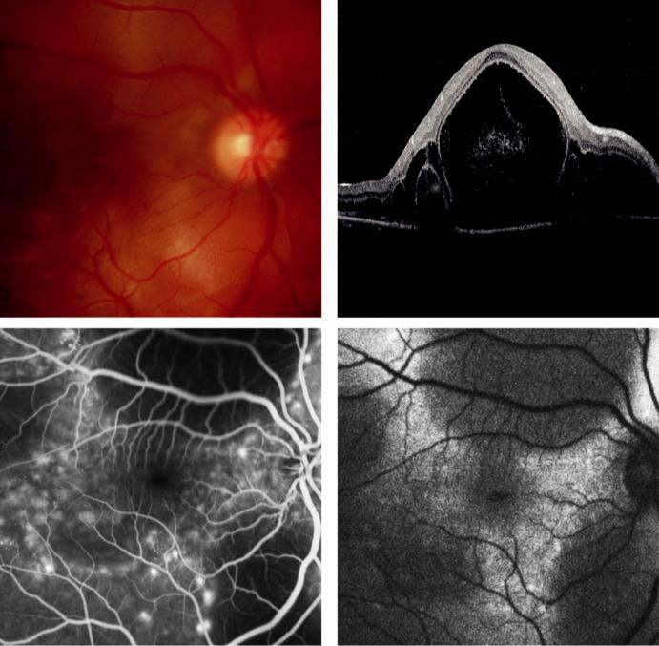

A B

C D

Fig. 12.30 VKH syndrome: (A) multifocal exudative retinal detachments in the acute phase, (B) OCT showing subretinal septae, (C) FA venous phase showing hyperfluorescent leaking spots, (D) FAF showing multiple exudative detachments. (Figure 12.30A, C, D courtesy of Chris Barry, Lions Eye Institute, Perth, Australia; Figure 12.30B courtesy of P. Charbel Issa.)

#*" ##%"#"+!#(&&%"'+$'""#* "%#! " +#!+ &)%#"$'!%

#%$%&#" (&#" +##'%(&&*'#('$%!&&#"#$+%', &)%" %'&%&%)

|  |  |
| --- | --- |
| Chapter 12—UVEITIS | **241** |
|  |  |

**Treatment:**

early high-dose systemic steroids. In refractory cases, aggressive immunomodulatory treatment should be used (cyclosporin, azathioprine, infliximab).

**SYMPATHETIC OPHTHALMITIS**

**Pathogenesis:**

bilateral granulomatous panuveitis occurring after penetrating trauma or intraocular surgery (usu-ally multiple vitreoretinal procedures). Presentation in 65% is between 2 weeks and 3 months of the initial insult; the exciting eye is the one originally injured, and the sympathizing eye is the fellow eye.

**Diagnosis**

***Presentation:*** (a) irritation, (b) blurred vision, (c) photophobia, and (d) loss of accommoda-tion in the sympathizing eye.

***Signs:*** (a) granulomatous anterior uveitis in both the exciting and sympathizing eye,

1. mid-peripheral multifocal choroidal infiltrates (Fig. 12.31A), (c) focal sub-RPE infil-trates (Dalen–Fuchs nodules), (d) exudative retinal detachment, (e) sunset-glow appearance similar to VKH, (e) residual chorioretinal scarring (Fig. 12.31B).

***Systemic features:*** same as in VKH but less common.

**Treatment**

***Enucleation:*** within first 10 days following trauma in an eye with a hopeless visual progno-sis. Evisceration is an acceptable option as long as all uveal tissue is removed.

***Systemic:*** steroids initially followed by immunomodulatory treatment. Ciclosporin, azathio-prine and infliximab should be used in resistant cases.

**Fuchs Uveitis Syndrome**

**Definition:**

idiopathic, usually unilateral, chronic uveitis of insidious onset, occurring equally in young adults of both sexes. e rubella virus has been implicated.

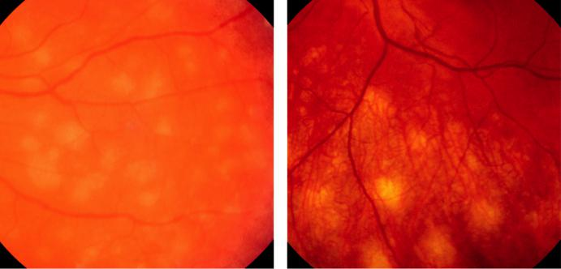

A B

Fig. 12.31 Sympathetic ophthalmitis: (A) multifocal choroidal infiltrates, (B) residual chorioretinal scarring after

treatment. (From Salmon JF, Kanski’s Clinical Ophthalmology: A Systematic Approach, 9th edition. Oxford,

UK: Elsevier; 2020.)

#*" ##%"#"+!#(&&%"'+$'""#* "%#! " +#!+ &)%#"$'!%

#%$%&#" (&#" +##'%(&&*'#('$%!&&#"#$+%', &)%" %'&%&%)

**242** SYNOPSIS OF CLINICAL OPHTHALMOLOGY



**Diagnosis**

***Presentation:*** chronic floaters, gradual blurring from cataract, or on incidental detection.

***Signs:*** (a) mild anterior uveitis, (b) vitritis (may be severe), (c) KP are round or stellate and grey-white in colour and are scattered throughout the corneal endothelium (Fig. 12. 32A),

(d) absence of posterior synechiae, (e) small nodules on the pupillary border (Fig. 12.32B) and iris stroma, (f ) diuse iris atrophy with associated heterochromia iridis ( Fig. 12.32C). ***Gonioscopy:*** normal or shows fine radial vessels and/or small irregular peripheral anteriorsynechiae.

***Complications:*** cataract (extremely common) and glaucoma (late manifestation).

**Treatment:**

troublesome vitreous opacities occasionally require treatment with periocular steroids and rarely vitrectomy. Topical steroids are relatively ineective for anterior uveitis.

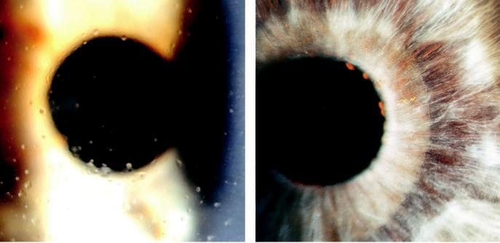

A B

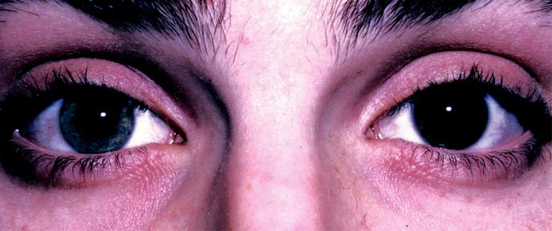

C

Fig. 12.32 Fuchs uveitis syndrome: (A) diffuse stellate keratic precipitates, (B) Koeppe nodules on pupil mar-gin with iris atrophy, (C) right eye involvement showing hypochromia. (From Salmon JF, Kanski’s Clinical Ophthalmology: A Systematic Approach, 9th edition. Oxford, UK: Elsevier; 2020.)

#*" ##%"#"+!#(&&%"'+$'""#* "%#! " +#!+ &)%#"$'!%

#%$%&#" (&#" +##'%(&&*'#('$%!&&#"#$+%', &)%" %'&%&%)



C H A P T E R 13

Retinal Vascular Disease



C H A P T E R O U T L I N E

Diabetic retinopathy 243

Introduction 243

Classification 244

Signs 245

Treatment of clinically significant macular oedema (CSMO) 247

Treatment of proliferative retinopathy 250 Advanced diabetic eye disease 251

Retinal venous occlusive disease 251

Introduction 251

Predisposing factors 251

Systemic assessment 252

Branch retinal vein occlusion 252

Non-ischaemic central retinal vein occlusion 254

Ischaemic central retinal vein occlusion 255 Hemiretinal vein occlusion 256

Retinal arterial occlusive disease 256

Introduction 256

Pathogenesis 256

Systemic assessment 257

Amaurosis fugax 257

Branch retinal artery occlusion 257

Central retinal artery occlusion 257

Treatment of acute retinal artery occlusion 258

Systemic prophylaxis following retinal arterial occlusion 259

Asymptomatic retinal embolus 260

Hypertensive disease 260

Retinopathy 260

Choroidopathy 261

Sickle cell retinopathy 261

Nonproliferative retinopathy 261

Proliferative retinopathy 262

Retinopathy of prematurity 262

Retinal artery macroaneurysm 264

Primary retinal telangiectasia 265

Idiopathic macular telangiectasia 265

Coats disease 266

Purtscher retinopathy 267

Valsalva retinopathy 267

Retinopathy in blood disorders 267

**Diabetic retinopathy**

**INTRODUCTION**

***Prevalence:*** (a) the overall prevalence of diabetic retinopathy (DR) in individuals with dia-betes is approximately 40%, (b) DR is more common in type 1 than in type 2 diabetes,

1. proliferative disease aects 5–10% of the diabetic population (60% after 30 years in type 1), (d) sight-threatening disease is present in up to 10%.

***Risk factors:*** (a) duration of diabetes (50% after 10 years if diagnosed before age 30 years; 5% of type 2 diabetics have DR at presentation), (b) poor control of diabetes, (c) pregnancy,

1. hypertension, (e) nephropathy, (f ) hyperlipidaemia, (g) smoking, (h) obesity, (i) anaemia.

**243**

#*" ##%"#"+!#(&&%"'+$'""#* "%#! " +#!+ &)%#"$'!%

#%$%&#" (&#" +##'%(&&*'#('$%!&&#"#$+%', &)%" %'&%&%)

**244** SYNOPSIS OF CLINICAL OPHTHALMOLOGY



**CLASSIFICATION**

e classification proposed in the Early Treatment Diabetic Retinopathy Study is widely used internationally. An abbreviated version is set out in Table 13.1; other commonly used clinical categories are as follows:

***Background diabetic retinopathy:*** (a) microaneurysms, (b) dot and blot haemorrhages,

(c) hard exudates.

***Diabetic maculopathy:*** vision-threatening macular oedema or ischaemia.

***Preproliferative diabetic retinopathy:*** (a) cotton wool spots, (b) venous changes, (c) intra-retinal microvascular anomalies (IRMA), (d) deep retinal haemorrhages.

***Proliferative diabetic retinopathy (PDR):*** (a) neovascularization on or within one disc diameter of the disc (NVD) and/or (b) new vessels elsewhere (NVE) in the fundus.



TABLE 13.1 Abbreviated early treatment diabetic retinopathy study classification of diabetic retinopathy



|  |  |  |
| --- | --- | --- |
| **Category/description** | **Management** |  |
|  |  |  |
| ***Nonproliferative diabetic retinopathy*** |  |  |
|  |  |  |
| **No DR** | Review in 12 months. |  |
|  |  |  |
| **Very mild** Microaneurysms only. | Review most patients in 12 months. |  |
|  |  |  |
| **Mild** Any or all of: microaneurysms, retinal haemorrhages, | Review range 6–12 months, depending on |  |
| exudates, cotton wool spots, up to the level of | severity of signs, stability, systemic factors, |  |
| moderate NPDR. No IRMA or significant beading. | and patient’s personal circumstances. |  |
|  |  |  |
| **Moderate** Severe retinal haemorrhages (more than | Review in approximately 6 months. PDR |  |
| ETDRS standard photograph 2A: approximately 20 | occurs in up to 26%, high-risk PDR in up |  |
| medium–large per quadrant) in 1–3 quadrants or | to 8% within 1 year. |  |
| mild IRMA. |  |  |
| • Significant venous beading can be present in no |  |  |
| more than 1 quadrant. |  |  |
| • Cotton wool spots commonly present. |  |  |
|  |  |  |
| **Severe** The 4-2-1 rule; one or more of: | Review in 4 months. PDR in up to 50%, high- |  |
| • Severe haemorrhages in all 4 quadrants. | risk PDR in up to 15% within 1 year. |  |
|  |  |
| • Significant venous beading in 2 or more quadrants. |  |  |
| • Moderate IRMA in 1 or more quadrants. |  |  |
|  |  |  |

**Very severe** Two or more of the criteria for severe NPDR.

Review in 2 or 3 months. High-risk PDR in up to 45% within 1 year.

***Proliferative diabetic retinopathy***

**Mild/moderate** NVD or NVE, but extent insufficient to meet the high-risk criteria.

Treatment considered according to severity of signs, stability, systemic factors, and patient’s personal circumstances such as reliability of attendance for review. If not treated, review in up to 2 months.

**High-risk**

* NVD greater than ETDRS standard photograph 10 A (approximately one-third disc area) or any NVD with vitreous or preretinal haemorrhage or NVE also present.
* Any NVD with vitreous or preretinal haemorrhage.
* NVE greater than one-half disc area with vitreous or preretinal haemorrhage (or haemorrhage with presumed obscured NVD/E).

Treatment advised – see text. Should be performed immediately when possible, and certainly same day if symptomatic presentation with good retinal view.

#*" ##%"#"+!#(&&%"'+$'""#* "%#! " +#!+ &)%#"$'!%

#%$%&#" (&#" +##'%(&&*'#('$%!&&#"#$+%', &)%" %'&%&%)

|  |  |
| --- | --- |
| Chapter 13—RETINAL VASCULAR DISEASE | **245** |
|  |  |

***Advanced diabetic eye disease:*** (a) tractional retinal detachment, (b) persistent vitreous haemorrhage, (c) neovascular glaucoma.

**SIGNS**

***Microaneurysms:*** tiny red dots (Fig. 13.1A) that tend to be the earliest signs. ey represent saccular outpouching of the capillary wall.

***Retinal nerve fibre layer haemorrhages:*** superficial and flame-shaped (Fig. 13.1B).

***Intraretinal haemorrhages:*** located in the compact middle layers of the retina, manifesting with a red ‘dot/blot’ configuration (Fig. 13.1C).

***Deeper dark round haemorrhages:*** haemorrhagic infarcts located within the middle retinal layers and are a risk marker for progression to retinal neovascularization.

***Hard exudates:*** waxy yellow lesions with distinct margins, often arranged in clumps and/or rings surrounding leaking microaneurysms (Fig. 13.1D).

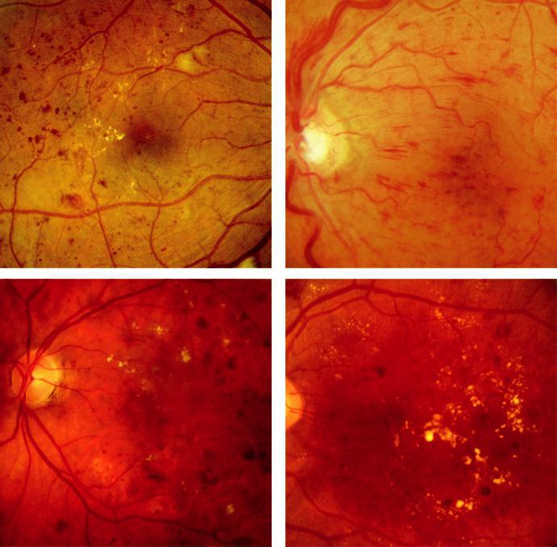

A B

C D

Fig. 13.1 Background diabetic retinopathy: (A) microaneurysms, (B) retinal nerve fibre layer haemorrhages,

1. dot/blot haemorrhages, (D) exudates forming a circinate pattern. (From Salmon JF, Kanski’s Clinical Ophthalmology: A Systematic Approach, 9th edition. Oxford, UK: Elsevier; 2020.)

#*" ##%"#"+!#(&&%"'+$'""#* "%#! " +#!+ &)%#"$'!%

#%$%&#" (&#" +##'%(&&*'#('$%!&&#"#$+%', &)%" %'&%&%)

**246** SYNOPSIS OF CLINICAL OPHTHALMOLOGY

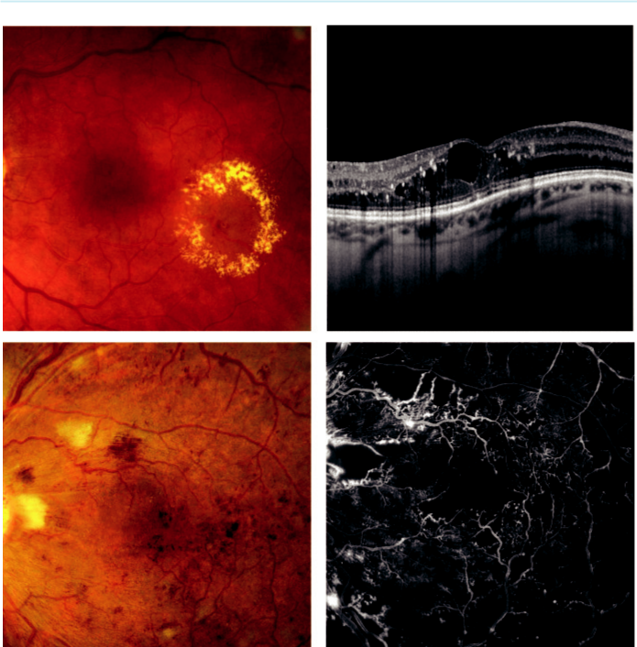

A B

C D

Fig. 13.2 Diabetic maculopathy: (A) ring of hard exudates, (B) OCT showing retinal thickening and cystoid spaces, (C) ischaemic changes showing cotton wool spots, (D) FA venous phase of (C) showing hypofluo-rescence due to capillary nonperfusion. (From Salmon JF, Kanski’s Clinical Ophthalmology: A Systematic Approach, 9th edition. Oxford, UK: Elsevier; 2020.)

***Diabetic maculopathy:*** this the most common cause of visual impairment in diabetes;

1. localized macular oedema is caused by focal leakage (Fig. 13.2A), (b) diuse oedema is caused by leakage, often with accumulation of fluid at the fovea in cystoid configura-tion (CMO). FA shows diuse late hyperfluorescence with a flower-petal pattern and OCT shows retinal thickening and cystoid spaces (Fig. 13.2B), (c) in ischaemic macu-lopathy, the macula may appear relatively normal despite reduced VA (Fig. 13.2C). FA shows capillary nonperfusion and an enlarged foveal avascular zone (FAZ) (Fig. 13.2D). ***Cotton wool spots:*** small whitish fluy lesions consisting of focal accumulations of neuro -nal debris within the nerve fibre layer (Fig. 13.3A); an important sign of retinal ischaemia. ***Venous anomalies:*** seen in ischaemia, consist of: (a) generalized dilatation and tortuos-ity, (b) looping (Fig. 13.3B), (c) ‘beading’ (focal narrowing and dilatation) (Fig. 13.3C),
2. segmentation. e extent of the involved retinal area correlates with the risk of developing PDR.

#*" ##%"#"+!#(&&%"'+$'""#* "%#! " +#!+ &)%#"$'!%

#%$%&#" (&#" +##'%(&&*'#('$%!&&#"#$+%', &)%" %'&%&%)

|  |  |
| --- | --- |
| Chapter 13—RETINAL VASCULAR DISEASE | **247** |
|  |  |

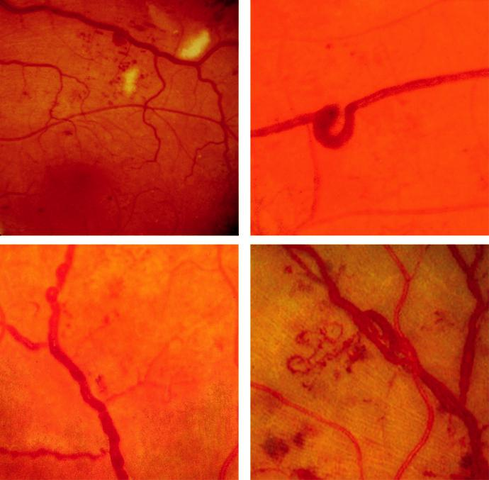

A B

C D

Fig. 13.3 Preproliferative changes: (A) cotton wool spots, (B) venous looping, (C) venous beading, (D) intrareti-

nal microvascular abnormalities. (From Salmon JF, Kanski’s Clinical Ophthalmology: A Systematic Approach,

9th edition. Oxford, UK: Elsevier; 2020.)

***Intraretinal microvascular abnormalities (IRMA):*** fine irregular intraretinal arteriove-nous shunts often seen adjacent to areas of capillary nonperfusion (Fig. 13.3D). FA shows absence of leakage.

***Neovascularization:*** (a) NVD describes neovascularization on or within one disc diameter of the optic nerve head (Fig. 13.4A), (b) NVE describes neovascularization further away from the disc (Fig. 13.4B), (c) new vessels on the iris (rubeosis iridis) carry a high risk of progression to neovascular glaucoma (see Chapter 11).

**TREATMENT OF CLINICALLY SIGNIFICANT MACULAR OEDEMA (CSMO)**

***Definition:*** (a) retinal thickening within 500 m of the centre of the macula (Fig. 13.5A), (b) exudates within 500 m of the centre of the macula, if associated with retinal thickening (Fig. 13.5B) or (c) retinal thickening one disc area (1500 m) or larger, any part of which is within one disc diameter of the centre of the macula (Fig. 13.5C).

#*" ##%"#"+!#(&&%"'+$'""#* "%#! " +#!+ &)%#"$'!%

#%$%&#" (&#" +##'%(&&*'#('$%!&&#"#$+%', &)%" %'&%&%)

**248** SYNOPSIS OF CLINICAL OPHTHALMOLOGY

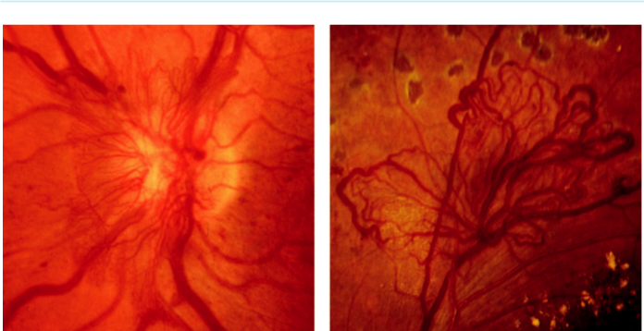

A B

Fig. 13.4 Proliferative retinopathy: (A) disc new vessels, (B) new vessels elsewhere. (From Salmon JF, Kanski’s

Clinical Ophthalmology: A Systematic Approach, 9th edition. Oxford, UK: Elsevier; 2020.)

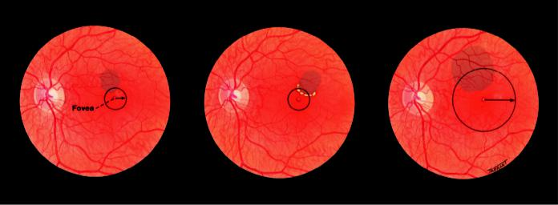

A B C

Fig. 13.5 Clinically significant macular oedema: (A–C): see text. (From Salmon JF, Kanski’s Clinical

Ophthalmology: A Systematic Approach, 9th edition. Oxford, UK: Elsevier; 2020.)

***Pretreatment FA:*** delineates the area and extent of leakage and detects ischaemic maculo-pathy (poor prognosis).

***Intravitreal anti-VEGF agents:*** are playing a prominent role (a) CSMO involving the cen-tre of the macula, but with a visual acuity of better than 6/15 can be treated with aflibercept, bevacizumab or ranibizumab (Fig. 13.6A and B), (b) when the acuity is 6/15 or worse aflibercept should be considered, with initial induction using monthly injections for 3–6 months, followed by an ‘as needed’ approach, (c) patients with CSMO and a visual acuity of 6/7.5 or better who otherwise meet criteria for treatment might prefer to be monitored once the risks of treatment are considered.

***Focal treatment:*** light/moderate intensity burns (50–100 m, 0.1 sec) applied to microaneurysms associated with CSMO (Fig. 13.7A and B). Treatment as close as 300 m from the centre of the macula may be considered in some cases, with a lighter intensity reaction closer to the centre.

***Grid treatment:*** burns (100 m, 0.1 sec) applied to areas of diuse retinal thickening more than 500 m from the centre of the macula to give a very light intensity reaction. Treatment should be particularly light if significant macular ischaemia is present.

#*" ##%"#"+!#(&&%"'+$'""#* "%#! " +#!+ &)%#"$'!%

#%$%&#" (&#" +##'%(&&*'#('$%!&&#"#$+%', &)%" %'&%&%)

|  |  |
| --- | --- |
| Chapter 13—RETINAL VASCULAR DISEASE | **249** |
|  |  |

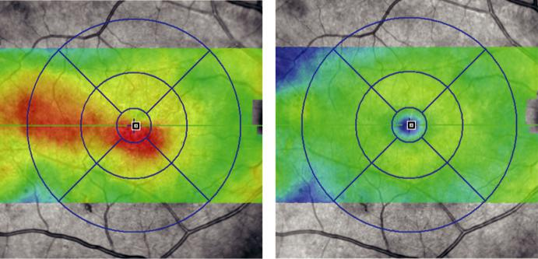

A B

Fig. 13.6 Anti-VEGF treatment for clinically significant macular oedema: (A) OCT appearance before treat-ment showing diffuse thickening of the macula (red), (B) 6 months after treatment showing resolution. (From Salmon JF, Kanski’s Clinical Ophthalmology: A Systematic Approach, 9th edition. Oxford, UK: Elsevier; 2020.)

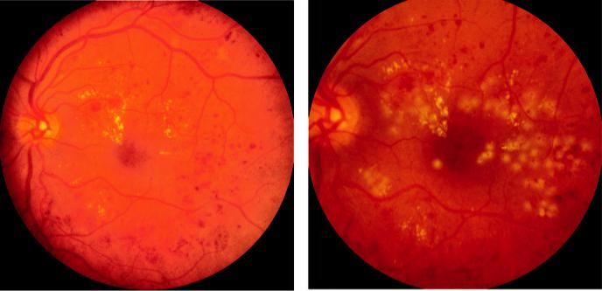

A B

Fig. 13.7 Laser treatment for macular oedema: (A) pre-treatment appearance, (B) immediate appearance after modified grid. (Courtesy of R. Bates.)

***Results:*** 70% of eyes achieve stable VA, 15% show improvement and 15% subsequently deteriorate; it may take up to 4 months for oedema to respond.

***Poor prognostic factors:*** (a) significant macular ischaemia, (b) foveal exudates, (c) diuse macular oedema, (d) CMO, (e) severe retinopathy at presentation, (f ) uncontrolled systemic hypertension, (g) renal disease, (h) poorly controlled blood glucose, (i) smoking. ***Micropulse diode laser:*** short duration (microseconds) burns to the RPE without signifi-cantly aecting the outer retina and choriocapillaris.

***Frequency-doubled micropulse Nd:YAG laser:*** (e.g. ‘pattern scan laser’ – PASCAL); oers the potential for a less destructive retinal eect than argon, with barely visible burns at the level of the RPE.

#*" ##%"#"+!#(&&%"'+$'""#* "%#! " +#!+ &)%#"$'!%

#%$%&#" (&#" +##'%(&&*'#('$%!&&#"#$+%', &)%" %'&%&%)

**250** SYNOPSIS OF CLINICAL OPHTHALMOLOGY



***Intravitreal triamcinolone:*** pseudophakic eyes with CSMO may benefit from intravitreal steroid injection followed by prompt laser. Can be considered in pregnancy or where there is a contraindication to anti-VEGF medication (e.g. recent myocardial infarct).

***Pars plana vitrectomy:*** when macular oedema is associated with tangential traction from a thickened and taut posterior hyaloid and possibly in other circumstances (e.g. vitreous haemorrhage)

***Lipid-lowering drugs:*** may reduce the requirement for laser treatment.

**TREATMENT OF PROLIFERATIVE RETINOPATHY**

***Risk characteristics and benefits:*** the landmark Diabetic Retinopathy Study established the characteristics of high-risk proliferative disease and the eect of PRP, showing that (a) mild NVD with haemorrhage carries a 26% risk of visual loss, reduced to 4% with PRP, (b) severe NVD without haemorrhage has a 26% risk of visual loss, reduced to 9%, (c) severe NVD with haemorrhage carries a 37% risk of visual loss, reduced to 20%, (d) severe NVE with haemorrhage carries a 30% risk of visual loss, reduced to 7% with treatment. ***Complications:*** visual field defects of sucient severity to legally preclude driving. Patients should also be made aware that there is some risk to central vision and that night and colour vision may be aected.

***Laser settings:*** (a) spot size depends on the contact lens used (e.g. Goldmann 200–500 m, panfundoscopic lens 100–300 m), (b) duration 0.05–0.1 sec, and (c) power sucient to produce only a light intensity burn.

***PRP technique:*** 1500–2000 burns in a scatter pattern extending from the posterior fundus to cover the peripheral retina in one or more sessions. In eyes with severe NVD, 3000 or more burns may be required (Fig. 13.8A and B). Many practitioners leave two disc diam-eters untreated at the nasal side of the disc to preserve paracentral field. Topical anaesthesia is adequate in most patients, although a local block is sometimes necessary. Follow-up after 4–6 weeks.

***Intravitreal anti-VEGF therapy:*** used as an adjunct to PRP, especially if there is central-involving DMO.

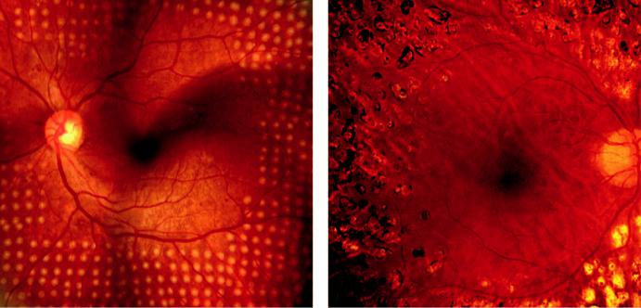

A B

Fig. 13.8 PRP: (A) composite image of ‘pattern scan’ multispot array treatment, (B) retinal appearance several weeks after laser. (Figure 13.8A courtesy of S. Chen; Figure 13.8D courtesy of Chris Barry, Lions Eye Institute, Perth, Australia.)

#*" ##%"#"+!#(&&%"'+$'""#* "%#! " +#!+ &)%#"$'!%

#%$%&#" (&#" +##'%(&&*'#('$%!&&#"#$+%', &)%" %'&%&%)

|  |  |
| --- | --- |
| Chapter 13—RETINAL VASCULAR DISEASE | **251** |
|  |  |

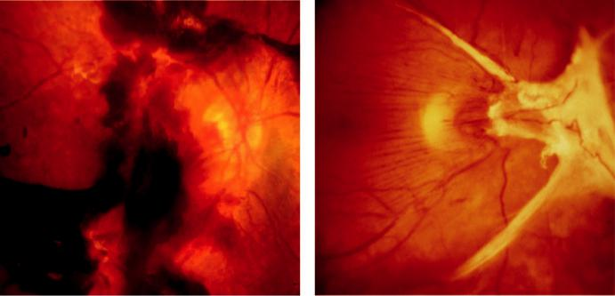

A B

Fig. 13.9 Advanced diabetic eye disease: (A) retrohyaloid and intragel haemorrhage, (B) preretinal traction. (Figure 13.9A courtesy of S. Chen.)

**ADVANCED DIABETIC EYE DISEASE**

**Definition:**

serious vision-threatening complication of DR that occurs in patients in whom treatment has been inadequate or unsuccessful.

**Diagnosis**

***Haemorrhage:*** may be preretinal (retrohyaloid; Fig. 13.9A), intragel, or both.

***Tractional retinal detachment*:** is caused by progressive contraction of fibrovascular mem-branes in areas of vitreoretinal attachment (Fig. 13.9B).

***Rubeosis iridis:*** which may lead to neovascular glaucoma (see Fig. 11.12A).

**Pars plana vitrectomy (PPV )**

***Indications:*** (a) severe persistent unilateral vitreous haemorrhage precluding adequate PRP,

1. severe bilateral vitreous haemorrhage, (c) progressive tractional retinal detachment (RD) threatening or involving the macula, (d) combined tractional and rhegmatogenous RD (urgent), (e) dense persistent premacular subhyaloid haemorrhage.

***Visual results:*** 70% achieve visual improvement, 10% worsen and the rest are unchanged.

**Retinal venous occlusive disease**

**INTRODUCTION**

is is the second most common retinal vascular disease after DR.

It is strongly associated with age-related local and systemic factors.

Examination should aim to do the following: (a) distinguish retinal vein occlusion as either branch retinal vein occlusion or central retinal vein occlusion, (b) determine the presence of macular oedema, (c) estimate the amount of retinal ischaemia, (d) check for retinal or iris neovascularization, (e) determine the cause.

**PREDISPOSING FACTORS**

Age: more than 50% of patients are older than 65 years.

#*" ##%"#"+!#(&&%"'+$'""#* "%#! " +#!+ &)%#"$'!%

#%$%&#" (&#" +##'%(&&*'#('$%!&&#"#$+%', &)%" %'&%&%)

**252** SYNOPSIS OF CLINICAL OPHTHALMOLOGY



Hypertension, particularly in branch retinal vein occlusion (BRVO).

Hyperlipidaemia.

Diabetes mellitus.

Oral contraceptive pill: the most common association in younger females.

Raised IOP in central retinal vein occlusion **(**CRVO).

Smoking is a likely risk factor.

Uncommon predispositions may be more important under the age of 50 years: (a) myelo-proliferative disorders, (b) acquired hypercoagulable states (e.g. hyperhomocysteinaemia, lupus anticoagulant, antiphospholipid antibodies), (c) inherited hypercoagulation diseases (e.g. activated protein C resistance; protein C and protein S deficiencies), (d) inflammatory disease associated with occlusive periphlebitis (e.g. Behçet syndrome, sarcoidosis), (e) mis-cellaneous causes (e.g. chronic renal failure, orbital disease, dehydration).

**SYSTEMIC ASSESSMENT**

***All patients:*** (a) blood pressure, (b) erythrocyte sedimentation rate (ESR), (c) full blood count (FBC), (d) blood glucose, (e) serum lipids, (f ) plasma protein electrophoresis, (g) urea, electrolytes, and creatinine, (h) thyroid function tests (dysfunction associated) and (i) ECG (left ventricular hypertrophy associated).

***Selected patients:*** (e.g. younger than 50 years, bilateral RVO, previous thromboses, family history of thrombosis); (a) chest X-ray, (b) C-reactive protein (CRP), (c) thrombophilia screen, (d) anticardiolipin antibody (IgG and IgM), lupus anticoagulant, (e) autoantibodies, (f ) serum angiotensin-converting enzyme, (g) fasting plasma homocysteine, (h) treponemal serology.

**BRANCH RETINAL VEIN OCCLUSION**

**Diagnosis**

***Presentation:*** macular involvement may cause sudden onset of blurred vision, metamor-phopsia and a relative field defect. Peripheral occlusions may be asymptomatic.

***Acute signs:*** (a) dilatation and tortuosity of the aected venous segment, (b) flame-shaped and dot/blot haemorrhages (Fig. 13.10A), (c) retinal oedema, (d) sometimes cotton wool spots aecting the drained retinal sector. e site of occlusion is often identifiable at an arteriovenous crossing point.

***FA:*** variable delayed venous filling, masking by blood (Fig. 13.10B), vessel wall staining, hypofluorescence due to capillary nonperfusion and ‘pruning’ of vessels in the ischaemic areas.

***OCT:*** demonstrates and quantifies macular oedema (present in 30%) (Fig. 13.10C).

***Chronic signs:*** (a) hard exudates, (b) venous sheathing and sclerosis, (c) residual haemor-rhage, (d) collaterals that appear as slender tortuous venules developing locally or across the horizontal raphe between the inferior and superior vascular arcades (Fig. 13.10D).

**Complications**

***Chronic macular oedema*:** patients with visual acuity of 6/12 or worse may benefit from anti-VEGF treatment or laser photocoagulation, provided the macula is not significantly ischaemic,

***Retinal neovascularization***: (usually NVE) develops in approximately 8% by 3 years (usually within 6–12 months) and can lead to recurrent vitreous and preretinal haemorrhage

***Prognosis:*** 50% of untreated eyes retain 6/12 or better; 25% will be <6/60.

#*" ##%"#"+!#(&&%"'+$'""#* "%#! " +#!+ &)%#"$'!%

#%$%&#" (&#" +##'%(&&*'#('$%!&&#"#$+%', &)%" %'&%&%)

|  |  |
| --- | --- |
| Chapter 13—RETINAL VASCULAR DISEASE | **253** |
|  |  |

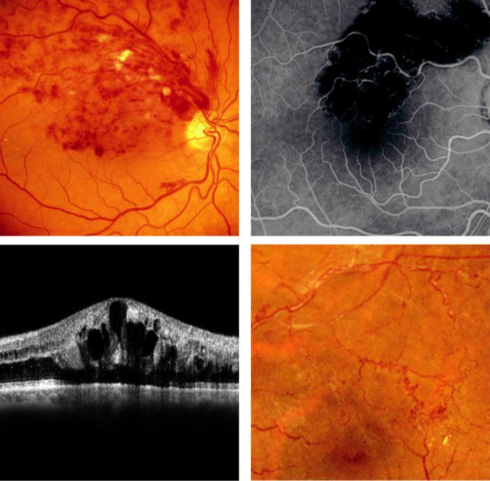

A B

C D

Fig. 13.10 Branch retinal vein occlusion: (A) upper temporal occlusion with macular extension, (B) FA of a pre-dominantly macular haemorrhage showing hypofluorescence, (C) OCT showing cystoid macular oedema, (D) old upper temporal BRVO showing shunt vessels. (Figure 13.10A courtesy of Chris Barry, Lions Eye Institute, Perth, Australia; Figure 13.10C courtesy of S. Chen.)

**Treatment**

***Treat systemic disease:*** especially arterial hypertension.

***Initial assessment and follow-up with OCT:*** for rapid quantitative analysis of the macula.

***Anti-VEGF treatment:*** this approach has been widely adopted and all available agents are eective.

***Treatment of macular oedema:*** (a) anti-VEGF treatment should be commenced as soon as the diagnosis is made; repeated injections are needed using OCT to guide the schedule of treat-ment, (b) alternatively, grid laser photocoagulation: spots of 50–100 m, 0.1 s duration one burn width apart, to produce a gentle reaction in the area of leakage as identified on FA, up to the edge of the FAZ, (c) other options include intravitreal triamcinolone and dexamethasone implants, but this treatment is associated with cataract formation and IOP elevation.

***Indications for laser:*** macular oedema associated with good macular perfusion and VA 6/12 or worse after 3–6 months. Combining laser and anti-VEGF injections may allow a reduc-tion in the frequency of injections.

#*" ##%"#"+!#(&&%"'+$'""#* "%#! " +#!+ &)%#"$'!%

#%$%&#" (&#" +##'%(&&*'#('$%!&&#"#$+%', &)%" %'&%&%)

**254** SYNOPSIS OF CLINICAL OPHTHALMOLOGY



***Relative contraindications to laser:*** (a) VA less than 6/60, (b) symptoms for more than 1 year,

(c) macular ischaemia.

***Subsequent follow-up:*** 3- to 6-monthly intervals for up to 2 years to detect neovascularization.

***Neovascularization:*** scatter laser photocoagulation (200–500 µm, 0.05–0.1 s, one burn width apart, medium reaction) applied to the area of nonperfusion decreases the risk of a vitreous haemorrhage.

**NON-ISCHAEMIC CENTRAL RETINAL VEIN OCCLUSION**

**Diagnosis**

***Presentation:*** sudden, unilateral blurred vision with moderate/severe reduction of VA.

***Relative aerent pupillary defect (RAPD):*** absent or mild.

***Acute signs:*** (a) tortuosity and dilatation of all branches of the CRV, (b) dot/blot and flame-shaped haemorrhages throughout the fundus (Fig. 13.11A), (c) cotton wool spots, (d) optic disc and macular oedema.

***FA:*** delayed arteriovenous transit time, masking by haemorrhages, good retinal capillary perfusion (Fig. 13.11B) and late leakage.

***OCT:*** useful in the assessment of CMO.

***Course:*** most acute signs resolve over 6–12 months to leave disc collaterals, macular epireti-nal gliosis and macular pigmentary changes. Conversion to ischaemic CRVO occurs in 34% within 3 years.

***Prognosis:*** return of VA to normal or near normal in approximately 50%; chronic macular oedema is the main cause of poor vision.

**Treatment**

***Control systemic risk factors:*** to reduce the risk to the fellow eye and to improve life expectancy.

***Follow-up:*** first review is after 3 months, with subsequent follow-up for up to 2 years.

***Treatment of macular oedema:*** (a) intravitreal anti-VEGF agents, (b) intravitreal steroid (triamcinolone or sustained-release implant).

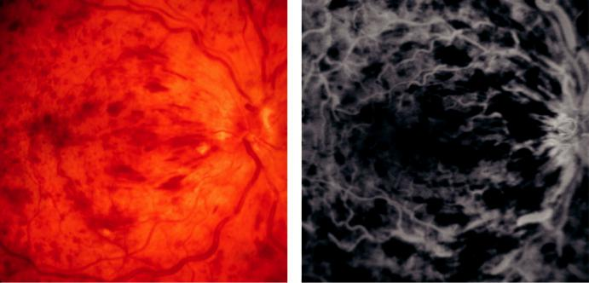

A B

Fig. 13.11 Non-ischaemic central retinal vein occlusion: (A) extensive flame-shaped haemorrhages, (B) FA late phase of (A) showing masking by blood and staining of vessel walls, but good capillary perfusion. (From Salmon JF, Kanski’s Clinical Ophthalmology: A Systematic Approach, 9th edition. Oxford, UK: Elsevier; 2020.)

#*" ##%"#"+!#(&&%"'+$'""#* "%#! " +#!+ &)%#"$'!%

#%$%&#" (&#" +##'%(&&*'#('$%!&&#"#$+%', &)%" %'&%&%)

|  |  |
| --- | --- |
| Chapter 13—RETINAL VASCULAR DISEASE | **255** |
|  |  |

**ISCHAEMIC CENTRAL RETINAL VEIN OCCLUSION**

**Diagnosis**

***Presentation:*** sudden and severe visual loss; VA is usually CF or worse.

***RAPD:*** marked.

***Acute signs:*** (a) severe tortuosity and engorgement of all branches of the CRV, (b) extensive deep blot and flame-shaped haemorrhages involving the peripheral retina and posterior pole (Fig. 13.12A), (c) severe disc oedema and hyperaemia, (d) often prominent cotton wool spots.

***FA:*** marked delay in arteriovenous transit time, central masking by retinal haemorrhages, extensive areas of capillary nonperfusion (Fig. 13.12B) and vessel wall staining.

***OCT:*** useful for CMO.

***Course:*** most acute signs resolve over 9–12 months to leave disc collaterals, macular epireti-nal gliosis, and macular pigmentary changes.

***Prognosis:*** extremely poor due to macular ischaemia.

***Rubeosis iridis:*** develops in approximately 50% of eyes, usually after 2–4 months, and is associated with a high risk of neovascular (100-day) glaucoma. is can be delayed by

18 months or longer if anti-VEGF agents have been used. e development of opticociliary shunts (retinochoroidal collateral veins) may protect against rubeosis.

**Treatment**

Control systemic risk factors.

Review: (a) monthly for 6 months to detect rubeosis iridis. Gonioscopy should be carried out at each visit to detect angle new vessels and the pupillary margin should also be exam-ined prior to mydriasis; (b) subsequent review is for up to 2 years.

Treatment of rubeosis: PRP as for PDR, with 1500–3000 burns initially. Intravitreal anti-VEGF agents should also be used.

Treatment of macular oedema: as for non-ischaemic CRVO, but with poorer prognosis.

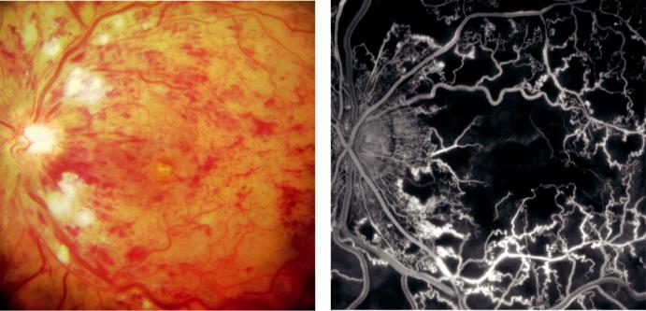

A B

Fig. 13.12 Ischaemic central retinal vein occlusion: (A) numerous cotton wool spots and haemorrhages in the acute stage, (B) FA showing hypofluorescence due to capillary nonperfusion. (From Salmon JF, Kanski’s Clinical Ophthalmology: A Systematic Approach, 9th edition. Oxford, UK: Elsevier; 2020.)

#*" ##%"#"+!#(&&%"'+$'""#* "%#! " +#!+ &)%#"$'!%

#%$%&#" (&#" +##'%(&&*'#('$%!&&#"#$+%', &)%" %'&%&%)

**256** SYNOPSIS OF CLINICAL OPHTHALMOLOGY

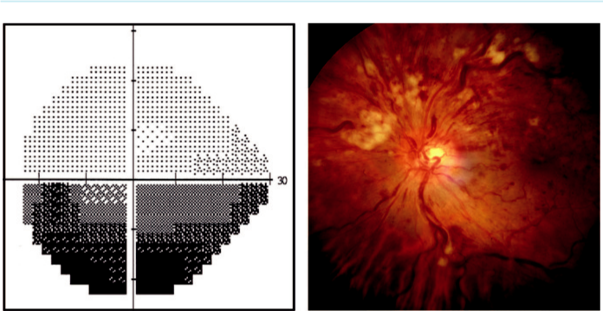

A B

Fig. 13.13 Hemiretinal vein occlusion: (A) inferior altitudinal visual field defect, (B) superior ischaemic occlu-

sion. (From Salmon JF, Kanski’s Clinical Ophthalmology: A Systematic Approach, 9th edition. Oxford, UK:

Elsevier; 2020.)

**HEMIRETINAL VEIN OCCLUSION**

**Definition:**

variant of CRVO and may be ischaemic or non-ischaemic; (a) hemispheric occlusion blocks a major branch of the CRV at or near the optic disc; (b) hemicentral occlusion, which is less com-mon, involves one trunk of a dual-trunked CRV.

**Diagnosis**

***Presentation:*** sudden-onset altitudinal visual field defect (Fig. 13.13A). VA is variable.

***Signs:*** features of BRVO, involving the superior (Fig. 13.13B) or inferior retina.

***FA:*** extensive hypofluorescence due to masking and capillary nonperfusion.

**Treatment:**

eyes with extensive retinal ischaemia are managed in the same way as ischaemic CRVO.

**Retinal arterial occlusive disease**

**INTRODUCTION**

is is an important cause of sudden, painless visual loss in one eye.

Urgent specialist cardiovascular evaluation is needed in order to reduce the risk of a stroke or a similar event occurring in the fellow eye.

**PATHOGENESIS**

***Atherosclerosis-related thrombosis:*** at the lamina cribrosa (80% of cases).

***Carotid embolism:*** most commonly from an atheromatous plaque at the carotid bifurcation.

***Uncommon:*** (a) giant cell arteritis (GCA), (b) cardiac embolism, (c) periarteritis (e.g. sys-temic lupus erythematosus, granulomatosis with polyangiitis, Behçet syndrome), (d) throm-bophilic disorders (e.g. hyperhomocysteinaemia), (e) antiphospholipid antibody syndrome, (f ) inherited defects of natural anticoagulants, (g) sickling haemoglobinopathies.

#*" ##%"#"+!#(&&%"'+$'""#* "%#! " +#!+ &)%#"$'!%

#%$%&#" (&#" +##'%(&&*'#('$%!&&#"#$+%', &)%" %'&%&%)

|  |  |
| --- | --- |
| Chapter 13—RETINAL VASCULAR DISEASE | **257** |
|  |  |

**SYSTEMIC ASSESSMENT**

***History:*** symptoms of GCA (e.g. headache, jaw claudication, scalp tenderness, limb girdle pain, weight loss, polymyalgia rheumatica).

***Examination:*** (a) pulse (e.g. atrial fibrillation), (b) blood pressure, (c) cardiac auscultation, (d) carotid examination (pulse, auscultation).

***All patients:*** (a) ECG, (b) ESR, (c) CRP, (d) FBC, (e) blood glucose, (f ) serum lipids, urea and electrolytes, (g) carotid duplex scanning.

***Selected patients:*** (particularly if younger and without cardiovascular risk factors)

1. further carotid imaging, (b) cranial MR or CT, (c) echocardiography, (d) chest X-ray,
2. 24-hr ECG (Holter monitor), (f ) fasting plasma homocysteine, (g) thrombophilia screen, (h) plasma protein electrophoresis, (i) thyroid function tests (associated with atrial fibrillation and dyslipidaemia), (j) autoantibodies, (k) blood cultures.

**AMAUROSIS FUGAX**

A transient ischaemic attack (TIA) is characterized by painless transient monocular loss of vision, usually lasting a few minutes.

Often described as a ‘curtain coming down over the eye’.

Sometimes accompanied by an ipsilateral cerebral TIA, with contralateral neurological features.

Investigation and management as for arterial occlusion.

**BRANCH RETINAL ARTERY OCCLUSION**

**Diagnosis**

***Presentation:*** sudden painless altitudinal or sectoral visual field loss; VA is variable.

***RAPD:*** often present.

***Signs:*** (a) emboli may be seen, especially at bifurcations (Fig. 13.14A and B), (b) narrowing

of arteries and veins, (c) segmentation of the blood column: ‘cattle trucking’/‘box-carting’,

(d) cloudy retina corresponding to the area of ischaemia (Fig. 13.14C).

***FA:*** delay in arterial filling, with hypofluorescence of the involved area due to masking by oedema (Fig. 13.14D).

**Treatment**

***Follow-up:*** single follow-up assessment in 3 months may be warranted to review the fundus and provide advice on prognosis; adequate systemic management is vital (see below). ***Prognosis:*** if central vision is severely compromised, prognosis is poor unless the obstruction is relieved within a few hours (see below).

**CENTRAL RETINAL ARTERY OCCLUSION**

**Diagnosis**

***Presentation:*** (a) sudden and profound loss of vision, (b) VA is severely reduced except when a portion of the papillomacular bundle is supplied by a cilioretinal artery.

***RAPD:*** profound.

***Signs:*** (a) similar to BRAO but more extensive, (b) an orange reflex from the intact choroid stands out at the foveola, giving a ‘cherry-red spot’ (Fig. 13.15A). In eyes with a cilioretinal artery, part of the macula will maintain a normal colour (Fig. 13.15B).

***Course:*** (a) retinal cloudiness and the cherry-red spot disappear over a few days to weeks but the arteries remain attenuated, (b) subsequent signs include optic atrophy, vessel sheathing,

#*" ##%"#"+!#(&&%"'+$'""#* "%#! " +#!+ &)%#"$'!%

#%$%&#" (&#" +##'%(&&*'#('$%!&&#"#$+%', &)%" %'&%&%)

**258** SYNOPSIS OF CLINICAL OPHTHALMOLOGY

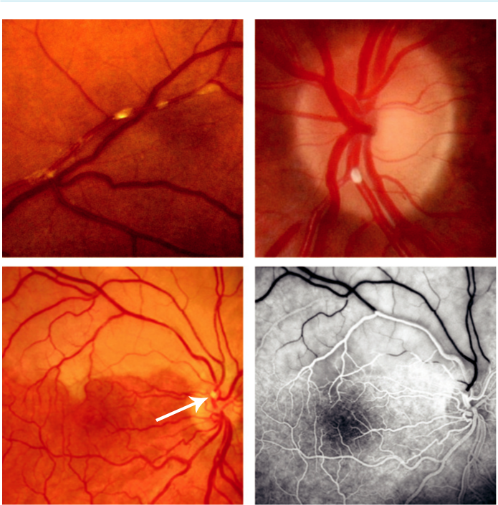

A B

C D

Fig. 13.14 Branch retinal artery occlusion: (A) fibrin-platelet emboli, (B) calcific embolus at the disc, (C) supe-rior occlusion secondary to an embolus (arrow), showing retinal pallor, (D) FA showing lack of arterial filling of the involved vessel. (Figure 13.14A courtesy of S. Chen; Figures 13.14B–D courtesy of Chris Barry, Lions Eye Institute, Perth, Australia.)

patchy inner retinal atrophy and RPE changes, (c) rubeosis iridis develops in a minority of cases and a few develop NVE or NVD.

***FA:*** delay in arterial filling and masking of background choroidal fluorescence by retinal swelling.

**Treatment:**

follow-up at 4 weeks and again a month later; adequate systemic management is vital (see below).

**TREATMENT OF ACUTE RETINAL ARTERY OCCLUSION**

***Aims:*** theoretically, timely dissolution of thrombus or dislodgement of emboli may ame-liorate visual loss. Various measures may be tried in patients with occlusions of less than 4–6 hours, but the prognosis is usually poor. Consider temporal arteritis in all elderly patients and treat accordingly. An immediate, urgent referral should be made to a specialist stroke centre.

#*" ##%"#"+!#(&&%"'+$'""#* "%#! " +#!+ &)%#"$'!%

#%$%&#" (&#" +##'%(&&*'#('$%!&&#"#$+%', &)%" %'&%&%)

|  |  |
| --- | --- |
| Chapter 13—RETINAL VASCULAR DISEASE | **259** |
|  |  |

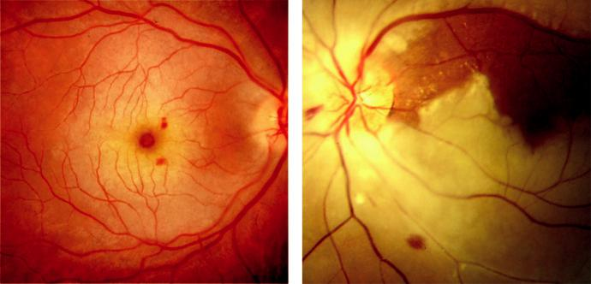

A B

Fig. 13.15 Central retinal artery occlusion: (A) recent central retinal artery occlusion with ‘cherry-red spot’, (B) with patent cilioretinal artery.

***Ocular massage:*** using a three-mirror contact lens (allows direct artery visualization) for cycles of 10 sec compression followed by 5 sec of release; self-massage through closed eyelids can be continued by the patient.

***Anterior chamber paracentesis:*** with prior povidone–iodine 5% and a short course of topical antibiotic afterwards. (is step should not delay urgent referral to a stroke centre.)

***Drug treatment:*** (a) topical apraclonidine 1% and timolol 0.5%, (b) intravenous acetazol-amide 500 mg, (c) sublingual isosorbide dinitrate to induce vasodilation.

***‘Rebreathing’ into a paper bag:*** to elevate blood carbon dioxide and promote vasodilatation. Breathing a high oxygen (95%) and carbon dioxide (5%) mixture, ‘carbogen,’ may exert the dual eects of retarding ischaemia and vasodilatation.

***Hyperosmotic agents:*** mannitol or glycerol for rapid IOP lowering and increasing intravas-cular volume.

***Transluminal Nd:YAG laser embolysis:*** if an occluding embolus is visible, shots of 0.5–1.0 mJ or higher are applied directly to the embolus. e main complication is subretinal and vitre - ous haemorrhage in 50%

***rombolysis:*** the use of local arterial (internal carotid and ophthalmic) or intravenous infu-sion is controversial and not usually eective.

**SYSTEMIC PROPHYLAXIS FOLLOWING RETINAL ARTERIAL OCCLUSION**

e risk of stroke is relatively high in the first few days following retinal artery occlusion or amaurosis fugax and urgent referral to a specialist stroke clinic is mandatory. General risk factors should be addressed and smoking discontinued.

Urgent referral for significant cardiac arrhythmia.

Antiplatelet therapy can be started immediately provided there are no contraindications and thrombolysis is not planned.

Oral anticoagulation in selected patients (e.g. atrial fibrillation).

Carotid endarterectomy may be indicated in patients with symptomatic stenosis greater than 70%.

#*" ##%"#"+!#(&&%"'+$'""#* "%#! " +#!+ &)%#"$'!%

#%$%&#" (&#" +##'%(&&*'#('$%!&&#"#$+%', &)%" %'&%&%)

**260** SYNOPSIS OF CLINICAL OPHTHALMOLOGY



**ASYMPTOMATIC RETINAL EMBOLUS**

A retinal embolus identified on routine examination of an asymptomatic older patient indicates a substantially increased risk of a future vascular event. Management is that of the risk factors discussed previously.

**Hypertensive disease**

**RETINOPATHY**

**Definition:**

spectrum of retinal vascular changes related to both transient and persistent microvascular damage from elevated blood pressure. e changes arise from a combination of acute vasoconstrictive and chronic involutional sclerotic responses.

**Diagnosis**

Arteriolar narrowing; may be focal or generalized (Fig. 13.16A).

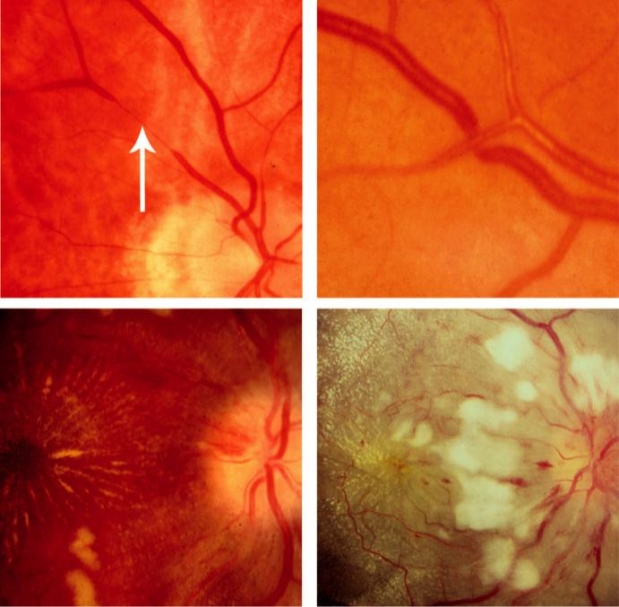

A B

C D

Fig. 13.16 Hypertensive retinopathy: (A) focal arteriolar attenuation (arrow), (B) arteriovenous nipping, (C) grade 3 retinopathy with macula star, (D) grade 4 retinopathy showing disc swelling and extensive cotton wool spots. (From Salmon JF, Kanski’s Clinical Ophthalmology: A Systematic Approach, 9th edition. Oxford, UK: Elsevier; 2020.)

#*" ##%"#"+!#(&&%"'+$'""#* "%#! " +#!+ &)%#"$'!% #%$%&#" (&#" +##'%(&&*'#('$%!&&#"#$+%', &)%" %'&%&%)

|  |  |
| --- | --- |
| Chapter 13—RETINAL VASCULAR DISEASE | **261** |
|  |  |

Nipping at arteriovenous crossings and broadening of the vessel light reflex is characteristic of arteriolosclerosis (Fig. 13.16B).

Chronic retinal oedema may lead to deposition of hard exudates around the fovea in a star configuration (Fig. 13.16C).

Cotton wool spots and flame-shaped haemorrhages in severe hypertension.

Swelling of the optic nerve head is the hallmark of malignant (accelerated) hypertension (Fig. 13.16D).

**CHOROIDOPATHY**

**Pathogenesis:**

acute hypertensive crisis (accelerated/malignant hypertension) in young adults.

**Diagnosis**

***Elschnig spots:*** focal choroidal infarcts seen as small black spots surrounded by yellow halos.

***Siegrist streaks:*** foci of fibrinoid necrosis manifest as flecks arranged linearly along choroi-dal vessels.

***Exudative retinal detachment:*** sometimes bilateral, may occur in severe acute hypertension (e.g. pre-eclampsia).

**Sickle cell retinopathy**

**Pathogenesis:**

hypoxia and acidosis induce red blood cells containing abnormal haemoglobin to adopt an anom-alous shape, resulting in microvascular occlusion.

**NONPROLIFERATIVE RETINOPATHY**

***Asymptomatic lesions:*** (a) venous tortuosity, (b) ‘silver wiring’ (previously occluded periph-eral arterioles), (c) ‘salmon patches’ (pink pre- or intraretinal haemorrhages) (Fig. 13.17A),

1. ‘black sunbursts’ (patches of RPE hyperplasia) (Fig. 13.17A), (e) macular depression sign (oval depression of the macular reflex due to retinal atrophy).

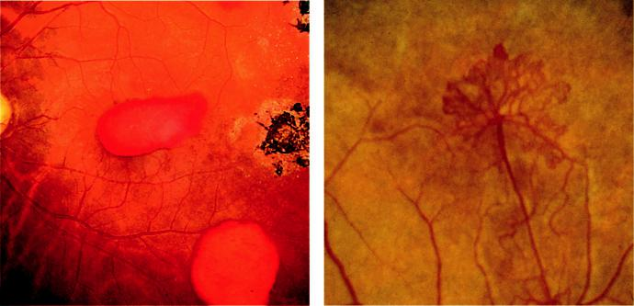

A B

Fig. 13.17 Sickle cell retinopathy: (A) ‘salmon patches’ and black ‘sun-burst,’ (B) ‘sea-fan’ neovascularization.

#*" ##%"#"+!#(&&%"'+$'""#* "%#! " +#!+ &)%#"$'!%

#%$%&#" (&#" +##'%(&&*'#('$%!&&#"#$+%', &)%" %'&%&%)

**262** SYNOPSIS OF CLINICAL OPHTHALMOLOGY



***Symptomatic lesions:*** (a) macular arteriolar occlusion, (b) RVO, (c) acute CRAO (rare), (d) choroidal vascular occlusion (usually in children), (e) angioid streaks (rare).

***Anterior segment features:*** conjunctival corkscrew vessels and circumscribed areas of isch-aemic iris atrophy, usually extending from the pupillary edge to the collarette; rubeosis is occasionally seen.

**PROLIFERATIVE RETINOPATHY**

**Diagnosis**

***Presentation:*** asymptomatic unless vitreous haemorrhage or retinal detachment occurs.

***Stage 1:*** peripheral arteriolar occlusion and ischaemia.

***Stage 2:*** peripheral arteriovenous anastomoses – dilated pre-existing capillary channels.

***Stage 3:*** sprouting of ‘sea fan’ new vessels from the anastomoses; 30–40% auto-infarct and appear as greyish fibrovascular lesions (Fig. 13.17B).

***Stage 4:*** neovascular tufts continue to proliferate, and bleed into the vitreous.

***Stage 5:*** extensive fibrovascular proliferation and retinal detachment.

***FA:*** sea fans show peripheral nonperfusion followed by leakage from new vessels.

**Treatment:**

not required in most cases; pars plana vitrectomy is occasionally required for tractional retinal detachment and/or persistent vitreous haemorrhage.

**Retinopathy of prematurity**

**Pathogenesis:**

proliferative retinopathy aecting premature infants of very low birth weight, who have often been exposed to high ambient oxygen concentrations. With premature birth, normal retinal vas-cularization is halted and excessive VEGF production leads to the neovascular complications of retinopathy of prematurity (ROP).

**Diagnosis**

***Location:*** (a) zone 1 is bounded by an imaginary circle the radius of which is twice the distance from the disc to the centre of the macula, (b) zone 2 extends concentrically from the edge of zone 1, its radius extends from the centre of the disc to the nasal ora serrata, and (c) zone 3 consists of a residual temporal crescent anterior to zone 2 (Fig. 13.18A).

***Extent of involvement:*** determined by the number of clock hours of retina involved (30° sectors).

***Staging:*** determined by the most severe manifestation: (a) stage 1 (demarcation line) is a thin, flat, tortuous, grey-white line running roughly parallel with the ora serrata, (b) stage 2 is a ridge arising in the region of the demarcation line (Fig. 13.18B), (c) stage 3 is extra-retinal fibrovascular proliferation from the ridge into the vitreous, (Fig. 13.18C), (d) stage 4 is partial retinal detachment – extrafoveal (4 A) and foveal (4B), (e) stage 5 is a total retinal detachment.

***‘Plus’ disease:*** (plus sign added to the stage number) signifies a tendency to progression:

1. failure of the pupil to dilate, (b) vascular iris engorgement, (c) vitreous haze, (d) dilated veins and tortuous arteries in at least two quadrants (Fig. 13.18D), (e) increasing preretinal and vitreous haemorrhage.

***‘reshold’ disease:*** five contiguous or eight cumulative clock hours of extraretinal neovascu-larization (stage 3) in zone 1 or 2 associated with plus disease – an indication for treatment. ***‘Rush’ disease:*** aggressive posterior disease.

#*" ##%"#"+!#(&&%"'+$'""#* "%#! " +#!+ &)%#"$'!%

#%$%&#" (&#" +##'%(&&*'#('$%!&&#"#$+%', &)%" %'&%&%)

|  |  |
| --- | --- |
| Chapter 13—RETINAL VASCULAR DISEASE | **263** |
|  |  |

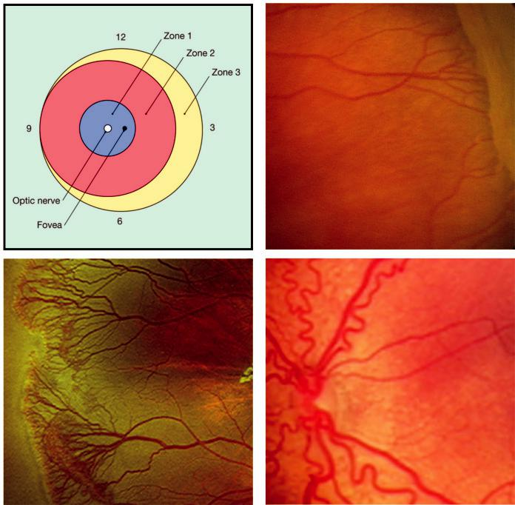

A B

C D

Fig. 13.18 ROP: (A) grading system according to location, (B) stage 2 showing a ridge, (C) stage 3 showing a ridge with extraretinal vascular proliferation, (D) ‘plus’ disease. (Figure 13.18C, D courtesy of C.K. Patel.)

***Course:*** spontaneous regression occurs in 80%, even in some eyes with partial retinal detachment.

***Screening:*** infants born at or before 31 weeks’ gestational age or weighing 1500 g or less should be screened for ROP, beginning 4–7 weeks postnatally with review 1–2 weekly until vascularization reaches zone 3; approximately 8% of infants screened require treatment.

**Treatment**

***PRP****:* of avascular immature retina in threshold disease.

***Intravitreal anti-VEGF agents:*** bevacizumab is increasingly being used; disease can recur following cessation of treatment.

***Lens-sparing pars plana vitrectomy:*** for tractional retinal detachment, especially if not involving the macula (stage 4 A). Visual outcome in stages 4B and 5 is often disappointing despite successful reattachment.

#*" ##%"#"+!#(&&%"'+$'""#* "%#! " +#!+ &)%#"$'!%

#%$%&#" (&#" +##'%(&&*'#('$%!&&#"#$+%', &)%" %'&%&%)

**264** SYNOPSIS OF CLINICAL OPHTHALMOLOGY



**Retinal artery macroaneurysm**

**Definition:**

localized dilatation of a retinal arteriole, usually involving one eye.

**Diagnosis**

***Presentation:*** usually seen in elderly hypertensive women with: (a) insidious impairment of central vision due to leakage involving the macula, (b) sudden visual loss due to haemor-rhage or (c) chance finding.

***Signs:*** (a) saccular or fusiform arteriolar dilatation, most frequently on a temporal vascular arcade, with (b) associated retinal haemorrhage in 50% (Fig. 13.19A).

***FA:*** immediate filling (Fig. 13.19B) with late leakage. Incomplete filling is due to thrombo-sis of the lumen.

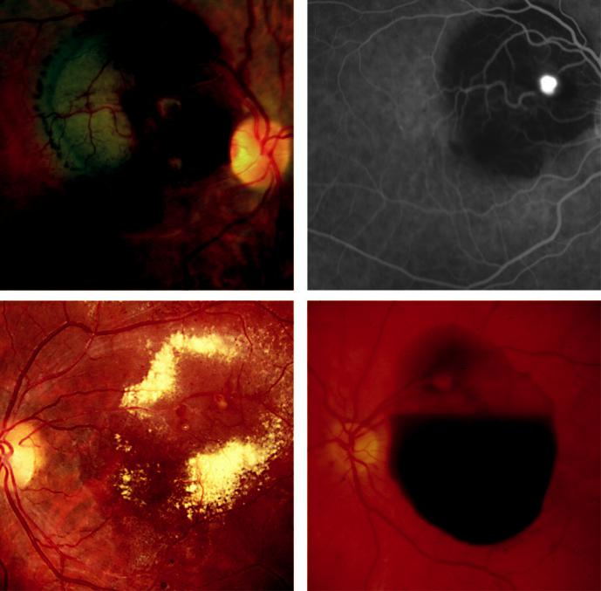

A B

C D

Fig. 13.19 Retinal artery macroaneurysm: (A) sub- and intra-retinal haemorrhage, (B) FA early venous phase showing hyperfluorescence of the aneurysm, which is surrounded by masking by blood, (C) hard exudates secondary to chronic leakage, (D) rupture with large preretinal haemorrhage in the macular region. (Figure 13.19A, B courtesy of S. Chen.)

#*" ##%"#"+!#(&&%"'+$'""#* "%#! " +#!+ &)%#"$'!%

#%$%&#" (&#" +##'%(&&*'#('$%!&&#"#$+%', &)%" %'&%&%)

|  |  |
| --- | --- |
| Chapter 13—RETINAL VASCULAR DISEASE | **265** |
|  |  |

***Course:*** (a) chronic leakage with oedema and exudate (Fig. 13.19C), (b) rupture with intra-, sub- (Fig. 13.19D) or preretinal haemorrhage, (c) spontaneous involution may occur follow-ing thrombosis, with fibrosis (very common).

***Prognosis:*** good with vitreous or premacular haemorrhage, but poor with sub-macular haemorrhage.

**Treatment**

***Observation:*** eyes with good VA.

***Photocoagulation:*** for oedema or exudates threatening or involving the fovea; burns may be applied to the lesion itself or to the surrounding area.

***Other:*** (a) YAG laser hyaloidotomy for persistent preretinal haemorrhage overlying the macula, (b) intravitreal injection of expandable gas with facedown positioning may shift sub-macular haemorrhage away from the fovea; adjunctive intravitreal tissue plasminogen activator (TPA) may be used.

**Primary retinal telangiectasia**

**Definition:**

group of rare idiopathic congenital or acquired retinal vascular anomalies characterized by dilata-tion and tortuosity of retinal blood vessels, multiple aneurysms, vascular leakage and deposition of hard exudates.

**IDIOPATHIC MACULAR TELANGIECTASIA**

**Diagnosis**

***Type 1 (aneurysmal telangiectasia):*** usually aects middle-aged males and may be related to Coats disease (see below); (a) telangiectasia, microaneurysms and later larger aneurysms, with leakage leading to CMO and lipid deposition (Fig. 13.20A), (b) peripheral retina may be involved in addition to the macula.

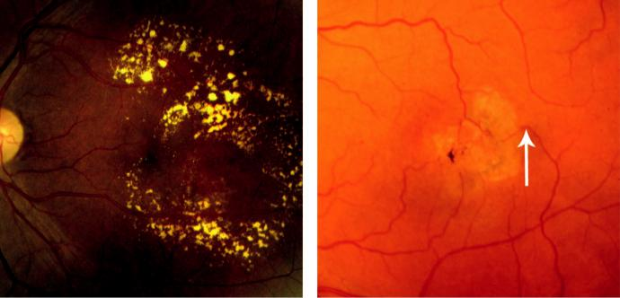

A B

Fig. 13.20 Idiopathic retinal telangiectasia: (A) circinate exudates in type 1, (B) perifoveal changes in type 2, showing a dilated venule that turns at right angles into the deep retina (arrow). (Figure 13.20B courtesy of P. Charbel Issa.)

#*" ##%"#"+!#(&&%"'+$'""#* "%#! " +#!+ &)%#"$'!%

#%$%&#" (&#" +##'%(&&*'#('$%!&&#"#$+%', &)%" %'&%&%)

**266** SYNOPSIS OF CLINICAL OPHTHALMOLOGY



***Type 2 (perifoveal telangiectasia):*** aects males and females equally, (a) subtle telangiectasia (Fig. 13.20B) progressing to cystic foveal atrophy without leakage, (b) subretinal and cho-roidal neovascularization; worse prognosis than in type 1.

***Occlusive telangiectasia:*** extremely rare, with manifestations relating to capillary occlusion rather than telangiectasia.

**Treatment**

***Type 1:*** (a) photocoagulation to areas of leakage may occasionally be beneficial; (b) intravit-real anti-VEGF agents may reduce oedema and improve vision.

***Type 2:*** intravitreal anti-VEGF agents decrease leakage on FA in the non-proliferative stage but are probably not helpful visually.

**COATS DISEASE**

**Diagnosis**

***Presentation:*** in early childhood (typically boys, average age 5 years) with: (a) unilateral visual loss, (b) strabismus or (c) leucocoria.

***Signs:*** (a) telangiectasia, typically inferior and temporal, and anterior to the equator (Fig. 13.21A), (b) intra- and subretinal exudation (Fig. 13.21B), often in areas remote from the vascular abnormalities, particularly the macula, with (c) progression to exudative retinal detachment.

***Complications:*** (a) rubeosis iridis, (b) glaucoma, (c) uveitis, (d) cataract, (e) phthisis bulbi.

***Prognosis***: depends on severity at presentation; the course is often milder in older children.

**Treatment**

***Observation:*** for mild non-vision-threatening disease.

***Photocoagulation:*** to areas of telangiectasia associated with progressive exudation.

***Anti-VEGF therapy:*** initial results are promising, although long-term safety in children remains unknown.

***Cryotherapy:*** for extensive exudative retinal detachment.

***Pars plana vitrectomy:*** for total retinal detachment.

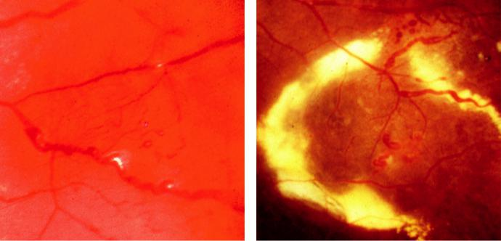

A B

Fig. 13.21 Coats disease: (A) retinal telangiectasia and aneurysmal arteriolar changes, (B) intraretinal exudates.

#*" ##%"#"+!#(&&%"'+$'""#* "%#! " +#!+ &)%#"$'!%

#%$%&#" (&#" +##'%(&&*'#('$%!&&#"#$+%', &)%" %'&%&%)

|  |  |
| --- | --- |
| Chapter 13—RETINAL VASCULAR DISEASE | **267** |
|  |  |

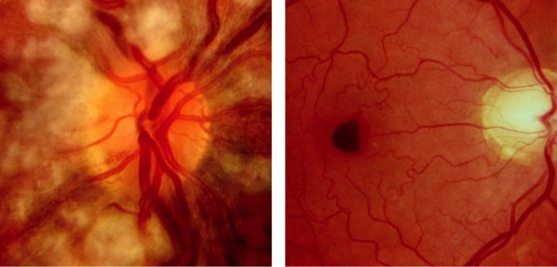

A B

Fig. 13.22 (A) Purtscher retinopathy, (B) Valsalva retinopathy. (From Salmon JF, Kanski’s Clinical Ophthalmology:

A Systematic Approach, 9th edition. Oxford, UK: Elsevier; 2020.)

**Purtscher retinopathy**

**Diagnosis**

***Presentation:*** following severe trauma; especially chest compressive, long-bone, or head trauma.

***Sign****s:* sudden visual loss (6/60 or less). Multiple unilateral or bilateral superficial white retinal patches (Fig. 13.22A), often associated with superficial peripapillary haemorrhages, cotton wool spots and disc swelling.

***Prognosis:*** the acute fundus changes clear within a few weeks, but only a small number regain normal vision.

**Valsalva retinopathy**

**Diagnosis**

***Presentation:*** sudden visual loss after a Valsalva manoeuvre.

***Signs:*** rupture of perifoveal capillaries leading to a premacular haemorrhage (Fig. 13.22B).

***Treatment:*** observation; Nd:YAG laser membranotomy in a few cases.

**Retinopathy in blood disorders**

***Leukaemia:*** (a) retinal haemorrhages and cotton wool spots are common, (b) Roth spots are red haemorrhages with a white centre (Fig. 13.23A), (c) peripheral retinal neovascular-ization, (c) retinal and choroidal infiltrates, causing a ‘leopard skin’ appearance in chronic leukaemia.

***Anaemia:*** (a) retinal venous tortuosity, related to severity of anaemia, (b) dot, blot and flame-shaped haemorrhages are more common with co-existing thrombocytopenia (Fig. 13.23B).

#*" ##%"#"+!#(&&%"'+$'""#* "%#! " +#!+ &)%#"$'!%

#%$%&#" (&#" +##'%(&&*'#('$%!&&#"#$+%', &)%" %'&%&%)

**268** SYNOPSIS OF CLINICAL OPHTHALMOLOGY

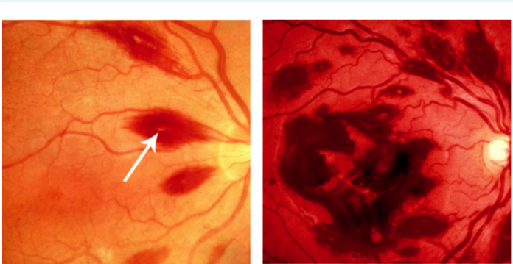

A B

Fig. 13.23 (A) Roth spot (arrow), (B) scattered haemorrhages. (From Salmon JF, Kanski’s Clinical Ophthalmology: A Systematic Approach, 9th edition. Oxford, UK: Elsevier; 2020.)

#*" ##%"#"+!#(&&%"'+$'""#* "%#! " +#!+ &)%#"$'!%

#%$%&#" (&#" +##'%(&&*'#('$%!&&#"#$+%', &)%" %'&%&%)



CHAPTER 14

Acquired Macular Disorders



C H A P T E R O U T L I N E

|  |  |  |
| --- | --- | --- |
| Anatomy 269 | Polypoidal choroidal vasculopathy 278 |  |
| Age-related macular degeneration | Age-related macular hole 278 |  |
| (AMD) 269 | Central serous chorioretinopathy 280 |  |
| Introduction 269 |  |
| Cystoid macular oedema 282 |  |
| Drusen 270 |  |
|  |  |
| Prophylactic antioxidant supplementation in | Macular epiretinal membrane 283 |  |
|  |  |
| AMD 270 | Degenerative myopia 284 |  |
|  |  |
| Non-exudative AMD 270 | Angioid streaks 285 |  |
| Retinal pigment epithelial detachment 271 |  |
| Choroidal folds 285 |  |
| Retinal pigment epithelial tear 273 |  |
|  |  |
| Exudative AMD 274 | Hypotony maculopathy 287 |  |
| Retinal angiomatous proliferation 277 | Vitreomacular traction syndrome 287 |  |
|  |  |  |

**Anatomy**

e macula is the part of the retina that lies inside the temporal vascular arcades and has a diam - eter of between 5 and 6 mm. Histologically, the macula has more than one layer of ganglion cells. It subserves the central 15–20° of the visual field and is responsible for detailed vision. e fovea is a depression in the retinal surface at the centre of the macula with a diameter of 1.5 mm. e foveal avascular zone is the central area containing no blood vessels (Fig. 14.1).

**Age-related macular degeneration (AMD)**

**INTRODUCTION**

***Definition***: degeneration aecting the macula; characterized by drusen and RPE changes, and sometimes choroidal neovascularization (CNV).

***Classification***: non-exudative form (‘dry’) and exudative form (‘wet’). Non-exudative AMD is more common than exudative AMD; the latter is more likely to progress rapidly to advanced sight loss.

***Importance***: most common cause of irreversible visual loss in industrialized countries. Advanced age-related macular degeneration (AMD) in one eye confers a 50% chance of advanced AMD in the fellow eye within 5 years.

***Risk factors***: (a) age, (b) race (higher in whites), (c) family history (three times greater in first degree relatives), (d) genetic factors, particularly variations in the complement factor H gene *CFH* on chromosome 1 and the *ARMS*2/*HTRA* genes on chromosome 10, (d) smoking (doubles risk), (e) dietary factors (e.g. high fat intake), (f ) other factors include hypertension and blue iris colour.

**269**

#*" ##%"#"+!#(&&%"'+$'""#* "%#! " +#!+ &)%#"$'!%

#%$%&#" (&#" +##'%(&&*'#('$%!&&#"#$+%', &)%" %'&%&%)

|  |  |  |  |
| --- | --- | --- | --- |
| **270** | SYNOPSIS OF CLINICAL OPHTHALMOLOGY | |  |
|  |  |  |  |
|  | Fovea | Inner limiting |  |
|  |  |  |
| Nerve fiber layer | Avascular zone | membrane |  |
|  |  |
|  |  | Ganglion cell layer |  |
| Inner plexiform layer | Foveola |  |  |
|  | Retinal capillaries |  |
|  |  |  |
| Inner nuclear layer |  |  |  |
| Outer plexiform |  |  |  |
| (Henle) layer |  |  |  |
|  |  | Rods and |  |
|  |  | cones |  |
| RPE |  |  |  |
| Bruch membrane |  | Choriocapillaris |  |

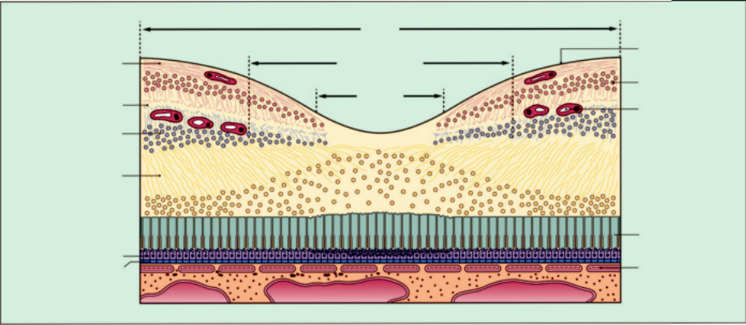

Fig. 14.1 Cross-section of the fovea (RPE = retinal pigment epithelium). (From Salmon JF, Kanski’s Clinical Ophthalmology: A Systematic Approach, 9th edition. Oxford, UK: Elsevier; 2020.)

**DRUSEN**

***Pathogenesis***: extracellular deposits at the interface between the RPE and Bruch membrane, derived from immune-mediated and metabolic processes in the RPE.

***‘Hard’ drusen***: well-defined and small (less than half a retinal vein width; Fig. 14.2A). eir presence in isolation carries little risk of visual loss.

***‘Soft’ drusen***: less distinct and larger than hard drusen. Numerous large soft drusen (Fig. 14.2B) are associated with a high risk of visual loss, including progression to CNV. ***‘Drusenoid RPE detachment’***: caused by coalesce of soft drusen resulting in a localized ele-vation of the RPE, a ‘drusenoid RPE detachment’ (Fig. 14.2C and D).

**PROPHYLACTIC ANTIOXIDANT SUPPLEMENTATION IN AMD**

e Age-Related Eye Disease Study (AREDS) established that taking high-dose antioxidant vitamins and minerals on a regular basis can decrease the risk of AMD progression.

***Indications***: those aged older than 55 years with one or more of the following high-risk

characteristics: (a) extensive intermediate-sized drusen, (b) at least one druse over 125 m,

1. geographic atrophy, (d) advanced AMD in one eye. Treatment confers a reduction in risk of up to 25% at 5 years.

***AREDS regimen***: vitamins C and E, beta-carotene, zinc and copper. Possible adverse eects include an increased risk of lung cancer in smokers.

***Other measures***: (a) macular xanthophylls (lutein and zeaxanthin) and omega-3 fatty acids,

1. adequate leafy green vegetable intake, (c) cessation of smoking.

**NON-EXUDATIVE AMD**

**Diagnosis**

***Presentation***: gradual impairment of central vision over months or years in one or both eyes.

***Signs***: (a) numerous intermediate–large soft drusen, (b) focal RPE changes, (c) areas of chorioretinal atrophy (Fig. 14.3A).

***Course***: enlargement of atrophic areas to give ‘geographical atrophy’ (Fig. 14.3B) with disap-pearance of pre-existing drusen.

***FA***: window defect if the choriocapillaris is still intact; exposed sclera may exhibit late staining.

#*" ##%"#"+!#(&&%"'+$'""#* "%#! " +#!+ &)%#"$'!%

#%$%&#" (&#" +##'%(&&*'#('$%!&&#"#$+%', &)%" %'&%&%)

|  |  |
| --- | --- |
| Chapter 14—ACQUIRED MACULAR DISORDERS | **271** |
|  |  |

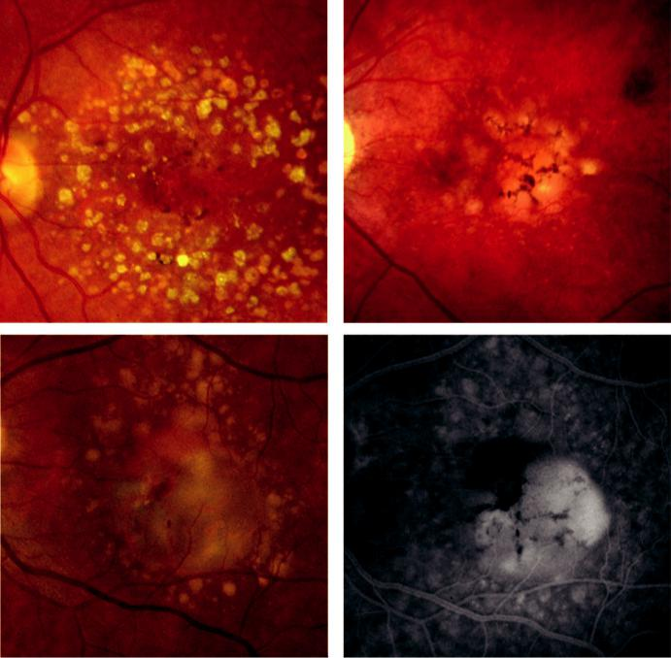

A B

C D

Fig. 14.2 Drusen: (A) hard, (B) soft, (C) drusenoid detachment of the RPE, (D) FA late phase of (C) showing hyperfluorescence due to staining. (Figure 14.2A,B courtesy of S. Chen.)

**Treatment**

prophylactic antioxidant supplementation.

**RETINAL PIGMENT EPITHELIAL DETACHMENT**

**Pathogenesis**

separation of the RPE from Bruch membrane caused by disruption of the physiological forces maintaining adhesion.

**Diagnosis**

***Serous retinal pigment epithelial detachment (PED)***: orange dome-shaped elevation with sharply delineated edges (Fig. 14.4A). Subretinal blood or lipid and irregularly distributed fluid are suggestive of underlying CNV.

***Imaging of serous PED***: (a) FA shows a well-demarcated oval area of hyperfluores-cence (Fig. 14.4B), increasing in intensity but not area – ‘pooling’ – in which a notch

#*" ##%"#"+!#(&&%"'+$'""#* "%#! " +#!+ &)%#"$'!%

#%$%&#" (&#" +##'%(&&*'#('$%!&&#"#$+%', &)%" %'&%&%)

**272** SYNOPSIS OF CLINICAL OPHTHALMOLOGY

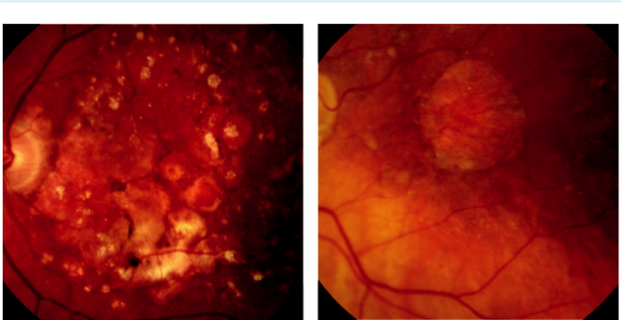

A B

Fig. 14.3 ‘Dry’ macular degeneration: (A) geographic atrophy and pigmentary abnormality, (B) geographic atrophy. (Figure 14.3A courtesy of S. Chen.)

may indicate CNV, (b) ICGA shows an oval area of hypofluorescence and a faint ring of surrounding hyperfluorescence, (c) diagrammatical representation (Fig. 14.4C) and OCT show separation of the RPE from Bruch membrane by an optically empty area (Fig. 14.4D).

***Course of serous PED***: (a) gradually increasing atrophy and an eventual VA of 6/60 or less,

1. spontaneous resolution can occur, sometimes with visual improvement but often leav-ing geographic atrophy, (c) rapid visual loss is typical of associated CNV (over 30%) or the development of an RPE tear (see below).

***Fibrovascular PED***: (a) a form of ‘occult’ CNV, much more irregular in outline and eleva-tion than serous PED, (b) FA shows markedly irregular granular or ‘stippled’ hyperfluores-cence, with uneven filling of the PED, leakage and late staining, (c) OCT shows an optically denser lesion than serous PED.

***‘Drusenoid’ PED***: (a) shallowly elevated pale area with irregular scalloped edges, (b) FA shows diuse hyperfluorescence, (c) OCT shows homogeneous hyperreflectivity. ***Haemorrhagic PED***: virtually all eyes have underlying CNV or polypoidal choroidal vasculopathy and the prognosis is poor. (a) Presentation is with sudden impairment of central vision, (b) a dark red dome-shaped lesion is seen on examination, (c) FA shows dense masking but with overlying vessels visible.

**Treatment**

***Serous PED***: observation may be appropriate in eyes without CNV, especially in younger patients. Options for CNV are (a) intravitreal anti-VEGF agents, (b) PDT, (c) intravitreal triamcinolone, often in combination. ere is a 5–20% risk of RPE tear with treatment (see below).

***Fibrovascular PED***: as for serous PED with CNV.

***Drusenoid PED***: observation in most cases. Long-term stability is common, but 75% prog-ress to develop geographic atrophy and 25% to CNV by 10 years.

***Haemorrhagic PED***: see below for management of polypoidal choroidal vasculopathy (PCV) and small CNV.

#*" ##%"#"+!#(&&%"'+$'""#* "%#! " +#!+ &)%#"$'!%

#%$%&#" (&#" +##'%(&&*'#('$%!&&#"#$+%', &)%" %'&%&%)

|  |  |
| --- | --- |
| Chapter 14—ACQUIRED MACULAR DISORDERS | **273** |
|  |  |

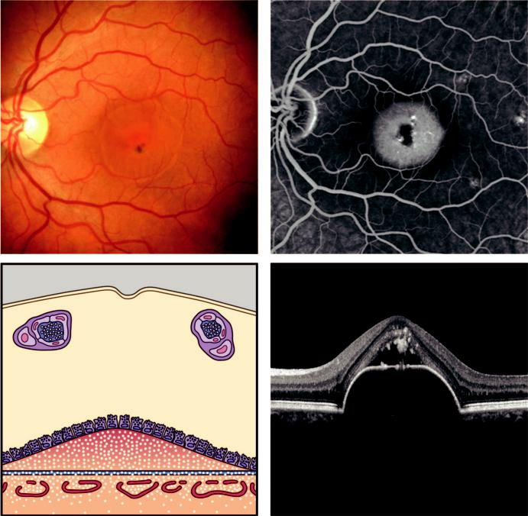

A B

C D

Fig. 14.4 Detachment of the RPE: (A) clinical appearance, (B) FA at 10 minutes showing hyperfluorescence,

1. diagrammatic representation, (D) OCT showing separation of the RPE from Bruch membrane and mate-rial under the sensory retina. (From Salmon JF, Kanski’s Clinical Ophthalmology: A Systematic Approach, 9th edition. Oxford, UK: Elsevier; 2020.)

**RETINAL PIGMENT EPITHELIAL TEAR**

**Pathogenesis**

tearing at the junction of attached and detached RPE, either spontaneously or after interventions such as laser or intravitreal injection.

**Diagnosis**

***Presentation***: sudden central visual loss.

***Signs***: crescent-shaped pale area of RPE dehiscence, next to a darker area corresponding to the retracted and folded flap (Fig. 14.5A).

***FA***: late phase shows hypofluorescence over the flap due to the thickened folded RPE, with a linear border and adjacent hyperfluorescence where the RPE is absent (Fig. 14.5B). ***OCT***: hyperreflectivity adjacent to the folded RPE (Fig. 14.5C and D). ***Prognosis***: poor in subfoveal tears.

#*" ##%"#"+!#(&&%"'+$'""#* "%#! " +#!+ &)%#"$'!%

#%$%&#" (&#" +##'%(&&*'#('$%!&&#"#$+%', &)%" %'&%&%)

**274** SYNOPSIS OF CLINICAL OPHTHALMOLOGY

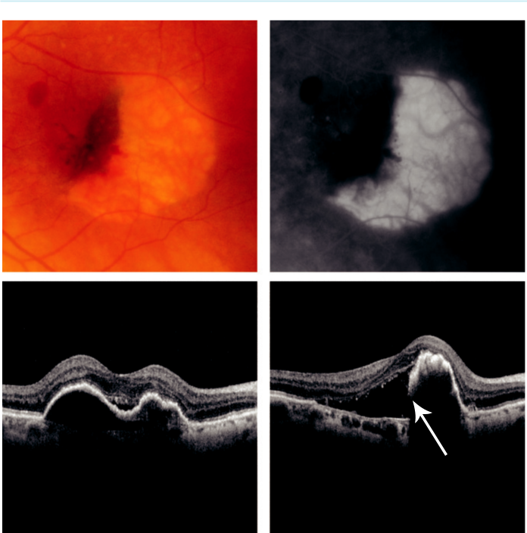

A B

C D

Fig. 14.5 RPE tear: (A) clinical appearance, (B) FA late phase showing relative hypofluorescence of the folded flap with adjacent hyperfluorescence where the RPE is missing, (C) OCT showing multilobed PED with sub-retinal fluid prior to tear, (D) OCT after tear (arrow) showing corrugation of the elevated RPE. (Figures 14.5C and D courtesy of A. Ambresin.)

**Treatment**

no recognized treatment.

**EXUDATIVE AMD**

**Pathogenesis**

abnormal vessel complexes originating from the choriocapillaris (CNV) grow through Bruch mem-brane. Aetiological factors at cellular level include: (a) age-related compromise of Bruch membrane,

1. promotion of blood vessel growth by vascular endothelial growth factor (VEGF), (c) influence of inhibitory mediators (complement factor H and pigment epithelium-derived factor).

**Diagnosis**

***Presentation***: in 6th to 8th decades with blurring and/or metamorphopsia.

***Signs***: (a) CNV itself is sometimes identifiable as a grey-green or pinkish-yellow subreti-nal lesion; localized subretinal fluid (Fig. 14.6A), (b) hard exudate (Fig. 14.6B), (c) blood

#*" ##%"#"+!#(&&%"'+$'""#* "%#! " +#!+ &)%#"$'!%

#%$%&#" (&#" +##'%(&&*'#('$%!&&#"#$+%', &)%" %'&%&%)

|  |  |
| --- | --- |
| Chapter 14—ACQUIRED MACULAR DISORDERS | **275** |
|  |  |

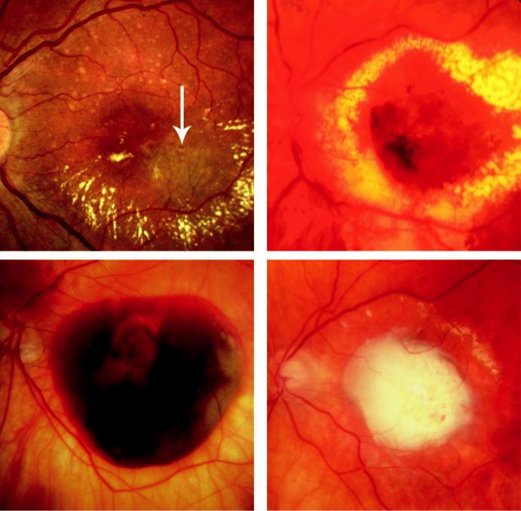

A B

C D

Fig. 14.6 Choroidal neovascularization (CNV): (A) CNV visible as a grey-green sub-macular area (arrow) with surrounding exudation, (B) extensive lipid deposition, (C) intra- and subretinal haemorrhage, (D) ‘disciform’ scar. (From Salmon JF, Kanski’s Clinical Ophthalmology: A Systematic Approach, 9th edition. Oxford, UK: Elsevier; 2020.)

(Fig. 14.6C) (subretinal, preretinal), (d) later, retinal and subretinal fibrosis (Fig. 14.6D) ensues in an evolved or treated lesion.

***Prognosis of untreated CNV***: often very poor, leading to ‘hand movements’ vision.

***OCT*** used to confirm diagnosis and monitor response to treatment.

***FA***: (a) ‘occult’ CNV (type 1) is poorly defined (Fig. 14.7A) and often denotes a fibro-vascular PED; 80% of total, (b) ‘classic’ CNV (type 2) is a well-defined membrane that fills with dye in a ‘lacy’ pattern early, with later leakage and staining; 20% of total (Fig. 14.7B).

***OCT angiography***: allows blood flow in the outer retina to be visualized and demonstrates abnormal vasculature (Fig. 14.7C and D).

***ICGA***: a focal hyperfluorescent ‘hot spot’ or ‘plaque’ can be a more sensitive adjunct to FA for the detection of CNV, for distinguishing other entities such as PCV and for identifica-tion of vascular feeder complexes in some situations.

#*" ##%"#"+!#(&&%"'+$'""#* "%#! " +#!+ &)%#"$'!%

#%$%&#" (&#" +##'%(&&*'#('$%!&&#"#$+%', &)%" %'&%&%)

**276** SYNOPSIS OF CLINICAL OPHTHALMOLOGY

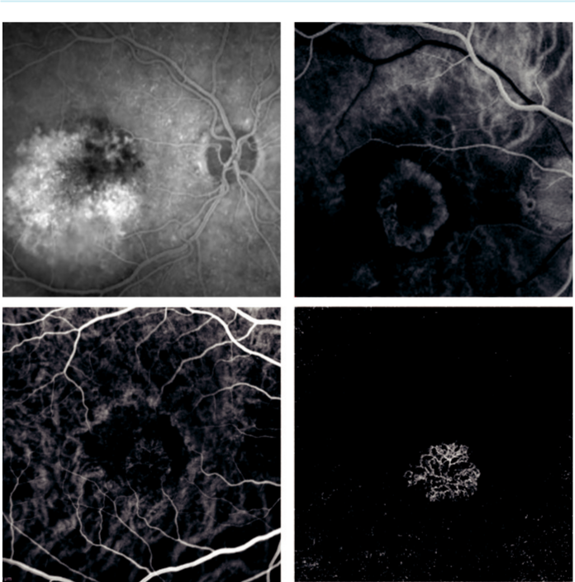

A B

C D

Fig. 14.7 Angiography: (A) FA of occult membrane showing hyperfluorescence with poorly defined mem-brane limits, (B) FA of classic membrane showing ‘lacy’ hyperfluorescence and an area of hypofluorescence secondary to a haemorrhage, (C) typical CNV membrane with (D) corresponding OCT angiographic appear-ance. (Figures 14.7C and D courtesy of A. Ambresin.)

**Treatment**

intravitreal anti-VEGF agents have dramatically improved the visual prognosis in ‘wet’ degen-eration. An eye with almost any level of vision may benefit, although better VA at the outset is associated with a superior outcome.

***Aflibercept (Eylea)***: recombinant fusion protein that binds to VEGF and PlGF. Longer acting than ranibizumab.

***Ranibizumab (Lucentis)***: monoclonal antibody fragment developed specifically for the eye.

***Bevacizumab (Avastin)***: complete antibody developed for systemic use. Much cheaper, although similar in ecacy and side-eect profile to ranibizumab; used ‘o label’ in the eye. ***Brolucizumab (Beovu)***: smaller molecule than other anti-VEGF agents, with high binding anity and lasts longer in the eye

***Complications of anti-VEGF treatment***: (a) endophthalmitis and sterile uveitis, (b) lens damage, (c) RPE tears, (d) retinal detachment, (e) elevated IOP, (f ) ocular haemorrhage, especially subconjunctival haemorrhage.

#*" ##%"#"+!#(&&%"'+$'""#* "%#! " +#!+ &)%#"$'!%

#%$%&#" (&#" +##'%(&&*'#('$%!&&#"#$+%', &)%" %'&%&%)

|  |  |
| --- | --- |
| Chapter 14—ACQUIRED MACULAR DISORDERS | **277** |
|  |  |

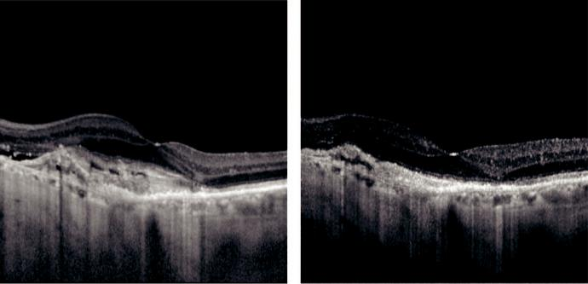

A B

Fig. 14.8 OCT of classic CNV: (A) on presentation, (B) after three anti-VEGF injections showing significant improvement. (Courtesy of A. Ambresin.)

***Treatment strategy***: long-term regular monthly injection is highly ecacious, but it is resource-intensive, inconvenient for patients and carries a higher risk of adverse eects. Overall, approximately 95% of eyes maintain vision regardless of lesion type and 35–40% significantly improve vision, most markedly during the first 3 months (Fig. 14.8A and B). ***Alternative treatment strategies***: (a) three initial monthly injections followed by monthly review with re-injection upon deterioration of VA or on OCT and (b) ‘treat and extend,’ entailing the administration of three initial injections at monthly intervals followed by a gradual increase in the period between injections until deterioration is evident.

***PDT***: intravenous administration of a light-activated compound (e.g. verteporfin = Visudyne) preferentially taken up by dividing cells including neovascular tissue, and then activated focally by a low-energy laser, leading to thrombosis but sparing healthy tissue. Its use has declined fol-lowing the introduction of VEGF inhibition, but it remains useful in certain circumstances.

***Combination therapies***: (e.g. PDT plus anti-VEGFs) are under investigation and may allow a reduction in the frequency of injections.

***Laser photocoagulation***: now rarely performed, although may still be suitable for some patients (e.g. PCV and retinal angiomatous proliferation) (see below).

***Investigational modalities***: (a) sustained-release anti-VEGF systems, (b) inhibitors of other cytokines, (c) RNA strand modification of gene expression, (d) gene therapy.

**RETINAL ANGIOMATOUS PROLIFERATION**

**Definition**

variant of exudative AMD (type 3) in which the major component of the neovascular complex is initially located within the retina; often bilateral and symmetrical.

**Diagnosis**

***Presentation***: similar to CNV.

***Signs***: (a) dilated retinal vessels, typically accompanied by (b) intra-, sub-, and preretinal haemorrhage (Fig. 14.9A), (c) oedema, (d) hard exudate, (e) often PED, (f ) intra-retinal cysts, (g) reticular pseudodrusen.

***OCT***: hyperreflectivity of intraretinal neovascularization.

#*" ##%"#"+!#(&&%"'+$'""#* "%#! " +#!+ &)%#"$'!%

#%$%&#" (&#" +##'%(&&*'#('$%!&&#"#$+%', &)%" %'&%&%)

**278** SYNOPSIS OF CLINICAL OPHTHALMOLOGY

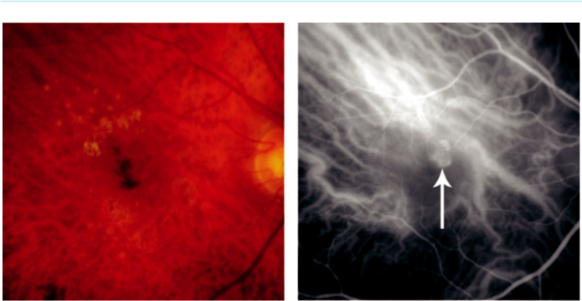

A B

Fig. 14.9 Retinal angiomatous proliferation: (A) drusen and small intraretinal haemorrhage at the macula,

1. ICGA early phase showing hyperfluorescence in the angioma (arrow). (From Salmon JF, Kanski’s Clinical Ophthalmology: ASystematic Approach , 9th edition. Oxford, UK: Elsevier; 2020.)

***FA***: similar to occult CNV, but may show focal intraretinal hyperfluorescence. Shunting of blood blow to the lesion in half the patients.

***ICGA***: ‘hot spot’ in mid or late frames (Fig. 14.9B).

**Treatment**

anti-VEGF therapy.

**Polypoidal choroidal vasculopathy**

**Definition**

idiopathic disease characterized by a dilated network of inner choroidal vessels with multiple terminal aneurysmal protuberances. It is: (a) more common in Africans and East Asians, (b) more common in women than men (5:1), (c) often bilateral but asymmetrical.

**Diagnosis**

***Presentation***: in 7th decade with sudden visual impairment.

***Signs***: (a) recurrent serosanguineous retinal and RPE detachments (Fig. 14.10A), (b) termi-nal swellings may be seen as reddish-orange nodules beneath the RPE.

***Course***: may be slow; up to 50% may eventually involute spontaneously.

***ICGA***: network of large choroidal vessels with surrounding hypofluorescence, with leaking polyp-like swellings on the larger vessels (Fig. 14.10B).

**Treatment**

***Anti-VEGF therapy***: less eective than in conventional CNV.

***PDT***: moderately eective. e combination of ranibizumab and PDT is superior to ranibi - zumab alone.

**Age-related macular hole**

**Diagnosis**

***Presentation***: in 7th decade with a missing central patch in one eye or metamorphopsia.

#*" ##%"#"+!#(&&%"'+$'""#* "%#! " +#!+ &)%#"$'!%

#%$%&#" (&#" +##'%(&&*'#('$%!&&#"#$+%', &)%" %'&%&%)

|  |  |
| --- | --- |
| Chapter 14—ACQUIRED MACULAR DISORDERS | **279** |
|  |  |

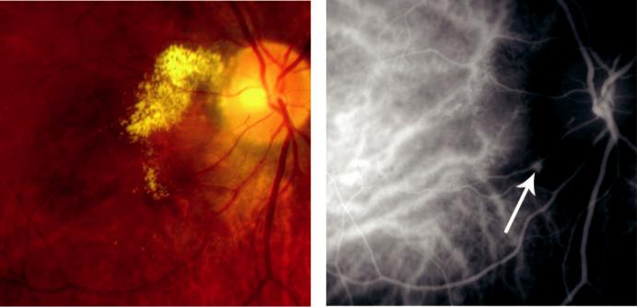

A B

Fig. 14.10 Polypoidal choroidal vasculopathy: (A) reddish-orange nodular terminal swellings with surrounding

exudation, (B) ICGA showing polyp (arrow). (From Salmon JF, Kanski’s Clinical Ophthalmology: A Systematic

Approach, 9th edition. Oxford, UK: Elsevier; 2020.)

***Stage 1a (‘impending’ macular hole)***: (a) flattening of the foveal depression with an underly-ing yellow spot, (b) inner retinal layers detach from the underlying photoreceptor layer. ***Stage 1b (occult macular hole)***: (a) yellow ring, (b) centrifugal displacement of the photore-ceptor layer to form a tiny schisis (Fig. 14.11A). OCT shows subtle pathology that may not be obvious clinically (Fig. 14.11B).

***Stage 2 (small full-thickness hole)***: (a) <400 m central or eccentric defect, (b) dehiscence in the roof of the schitic cavity, often with persistent vitreofoveolar adhesion.

***Stage 3 (full-size macular hole)***: (a) >400 m with a red base in which yellow-white dots may be seen, (b) surrounding grey cu of subretinal fluid ( Fig. 14.11C), (c) overlying operculum, (d) persistent parafoveal attachment of the vitreous cortex; VA is typically 6/60.

***Stage 4 (full-size macular hole with complete posterior vitreous detachment*)** (Fig. 14.11D). ***Watzke–Allen test***: a narrow beam is projected over the centre of the hole. With a macular hole the beam appears thinned or broken; with other diagnoses it is distorted but of uniform thickness.

***Course***: 50% of stage 1 holes resolve spontaneously and so are managed conservatively. Approximately 10% of full-thickness holes also close spontaneously, with variable visual improvement.

***OCT***: useful in diagnosis and staging (see Fig. 14.11B and D)

***FA***: full-thickness hole shows an early well-defined window defect.

***Other causes of full-thickness macular hole***: high myopia and blunt trauma.

***Lesions with a similar appearance***: (a) pseudohole in a macular epiretinal membrane (see Fig. 14.14C), (b) lamellar hole in CMO, (c) foveal pseudocyst, (d) vitreomacular traction syndrome, (e) solar and laser-induced maculopathy, (f ) alkyl nitrite ‘poppers’.

**Treatment**

***Pars plana vitrectomy***: with peeling of the internal limiting membrane, gas tamponade and postoperative face-down posturing, for stage 2 or worse holes with VA less than 6/9. Results are better in holes present for less than 6 months.

***Results***: the hole is closed in up to 100% of cases, with visual improvement in 80–90% of eyes; VA is 6/12 in approximately 65%, but worse in 10%.

#*" ##%"#"+!#(&&%"'+$'""#* "%#! " +#!+ &)%#"$'!%

#%$%&#" (&#" +##'%(&&*'#('$%!&&#"#$+%', &)%" %'&%&%)

**280** SYNOPSIS OF CLINICAL OPHTHALMOLOGY

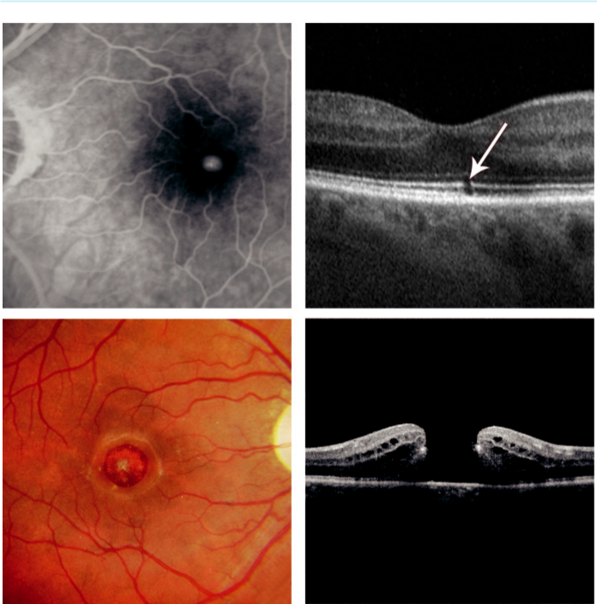

A B

C D

Fig. 14.11 Macular hole: (A) FA showing early hyperfluorescence secondary to a window defect, (B) OCT of resolved macular microhole showing tiny inner/outer-segment junction defect (arrow), (C) full thickness hole,

1. OCT of stage 4. (From Salmon JF, Kanski’s Clinical Ophthalmology: A Systematic Approach, 9th edition. Oxford, UK: Elsevier; 2020.)

**Central serous chorioretinopathy**

**Pathogenesis**

localized serous detachment of the sensory retina at the macula, secondary to leakage from the choriocapillaris through hyperpermeable areas in the RPE. e condition is much more common in men than in women. Risk factors include stress and steroid administration.

**Diagnosis**

***Presentation***: in 4th and 5th decades with unilateral metamorphopsia and mild/moderate blurring. VA is usually 6/9–6/18, partly due to hypermetropia from retinal elevation. ***Signs***: (a) round or oval sensory retinal elevation (Fig. 14.12A and B), (b) fluid may be clear or turbid, (c) one or more depigmented RPE foci may be visible, (d) small patches of RPE atrophy and hyperplasia elsewhere in the posterior pole may mark the site of older lesions.

#*" ##%"#"+!#(&&%"'+$'""#* "%#! " +#!+ &)%#"$'!%

#%$%&#" (&#" +##'%(&&*'#('$%!&&#"#$+%', &)%" %'&%&%)

|  |  |
| --- | --- |
| Chapter 14—ACQUIRED MACULAR DISORDERS | **281** |
|  |  |

***Course***: (a) spontaneous resolution within 3–6 months in most cases, with normal or near-normal VA in >80%, but with recurrence in up to 50%, (b) chronic course in a minority, with gradual retinal degeneration.

***OCT***: optically empty sensory retinal elevation. RPE detachment or deficit may also be seen.

***FA***: (a) ‘smokestack’ appearance with an early hyperfluorescent spot progressing to a ver-tical column (Fig. 14.12C), then diusion throughout the detached area, (b) ‘inkblot’ (most common) appearance shows an early hyperfluorescent spot that gradually enlarges (Fig. 14.12D). An underlying PED may be demonstrated; multiple leakage points are sometimes seen.

**Treatment**

***Observation***: in most cases.

***Stop corticosteroid treatment***: if possible.

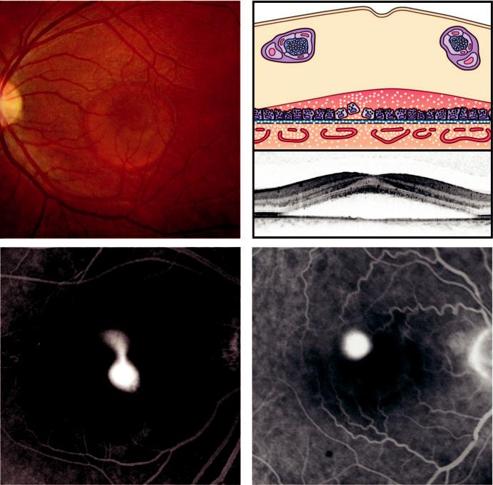

A B

C D

Fig. 14.12 Central serous chorioretinopathy: (A) clinical appearance, (B) diagrammatic representation, (C)

‘smokestack’ appearance, (D) ‘ink blot’ appearance. (From Salmon JF, Kanski’s Clinical Ophthalmology: A

Systematic Approach, 9th edition. Oxford, UK: Elsevier; 2020.)

#*" ##%"#"+!#(&&%"'+$'""#* "%#! " +#!+ &)%#"$'!%

#%$%&#" (&#" +##'%(&&*'#('$%!&&#"#$+%', &)%" %'&%&%)

**282** SYNOPSIS OF CLINICAL OPHTHALMOLOGY



***Oral spironolactone***: 40 mg twice daily results in faster resorption of fluid in acute cases.

***Low-dose PDT***: now considered first-line treatment if spontaneous resorption does not occur.

***Laser photocoagulation***: to the RPE leak speeds resolution but does not influence the visual outcome or recurrence rate; inadvisable if a leak is within the foveal avascular zone. ***Intravitreal anti-VEGF agents***: may have a role.

**Cystoid macular oedema**

**Pathogenesis**

intraretinal leakage with the formation of cyst-like cavities in the fovea and surrounding central macula. Long-standing cases may progress to lamellar hole formation with irreversible impair-ment of central vision. e causes are varied and include: (a) ocular surgery and laser, (b) retinal vascular disease (e.g. diabetic retinopathy, retinal vein occlusion), (c) chronic uveitis (particularly intermediate), (d) drug-induced (e.g. topical prostaglandins), (e) retinal dystrophies (e.g. retinitis pigmentosa), (f ) vitreomacular disease (e.g. macular epiretinal membrane).

**Diagnosis**

***Presentation***: predisposing disease is generally evident, but CMO may be the presenting feature; blurring and metamorphopsia are typical. Amsler chart testing demonstrates cen-tral distortion.

***Signs***: loss of the foveal depression and thickening of the sensory retina with multiple cystoid areas.

***FA***: early hyperfluorescent spots progressing to a characteristic petaloid pattern (Fig. 14.13A).

***OCT***: retinal thickening with hyporeflective spaces (Fig. 14.13B). Vitreoretinal traction and a lamellar hole will be shown if present.

**Treatment**

dependent on cause.

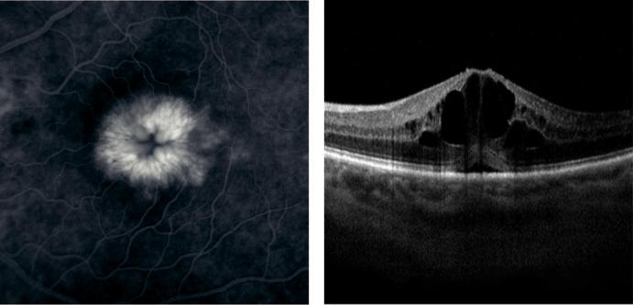

A B

Fig. 14.13 Cystoid macular oedema: (A) FA late phase showing a ‘flower petal’ pattern of hyperfluores-cence, (B) OCT showing hyporeflective spaces within the retina, macular thickening and loss of the foveal depression. (From Salmon JF, Kanski’s Clinical Ophthalmology: A Systematic Approach, 9th edition. Oxford, UK: Elsevier; 2020.)

#*" ##%"#"+!#(&&%"'+$'""#* "%#! " +#!+ &)%#"$'!%

#%$%&#" (&#" +##'%(&&*'#('$%!&&#"#$+%', &)%" %'&%&%)

|  |  |
| --- | --- |
| Chapter 14—ACQUIRED MACULAR DISORDERS | **283** |
|  |  |

**Macular epiretinal membrane**

**Pathogenesis**

sheet-like fibrocellular structure that develops on or above the surface of the retina. Classification:

1. idiopathic (bilateral in 10%; tends to be mild), (b) secondary (e.g. intraocular surgery or laser, retinal detachment, trauma, inflammation).

**Diagnosis**

***Presentation***: blurring and metamorphopsia but may be asymptomatic if mild. Amsler grid typically shows distortion in moderate–advanced cases.

***Signs***: (a) initially irregular translucent preretinal sheen (‘cellophane maculopathy’), (b) later the membrane thickens and contracts, typically causing mild distortion of blood vessels (Fig. 14.14A), (c) advanced lesions may give severe distortion of blood vessels, marked retinal wrinkling, and can obscure underlying structures (macular pucker; Fig. 14.14B). Associated findings include macular pseudohole (Fig. 14.14C), CMO and small haemorrhages.

***OCT***: highly reflective (red) surface layer associated with retinal thickening (Fig. 14.14D).

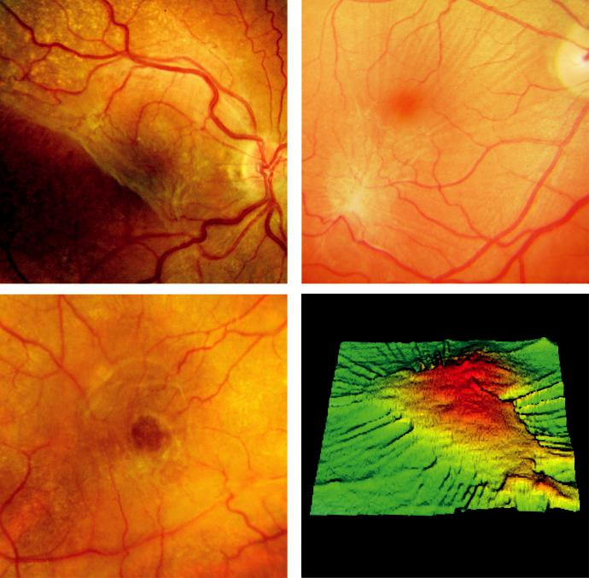

A B

C D

Fig. 14.14 Macular epiretinal membrane: (A) translucent membrane, (B) retinal puckering, (C) pseudohole,

(D) OCT thickness map showing foveal thickening and macular traction. (Figure 14.14D courtesy of P. Scanlon.)

#*" ##%"#"+!#(&&%"'+$'""#* "%#! " +#!+ &)%#"$'!%

#%$%&#" (&#" +##'%(&&*'#('$%!&&#"#$+%', &)%" %'&%&%)

**284** SYNOPSIS OF CLINICAL OPHTHALMOLOGY



**Treatment**

***Observation***: if mild and nonprogressive; spontaneous separation sometimes occurs.

***Pars plana vitrectomy***: surgical peeling of the membrane usually reduces distortion, with an improvement in VA of at least two lines in 75%; approximately 2% get worse.

**Degenerative myopia**

**Definition**

high myopia is defined as a refractive error of more than 6 dioptres and an axial length greater than 26 mm. Degenerative (pathological) myopia is characterized by progressive enlargement of the scleral envelope with a range of secondary ocular changes.

**Diagnosis**

***Signs***: (a) fundus pallor due to diuse attenuation of the RPE, with visible choroidal ves - sels, (b) focal chorioretinal atrophy and a ‘tilted’ disc associated with peripapillary atrophy (Fig. 14.15A), (c) posterior staphyloma due to focal expansion and thinning, (d) ‘lacquer

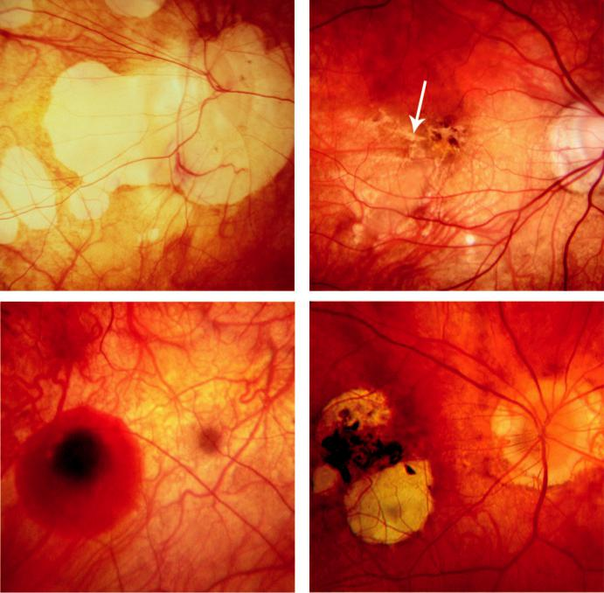

A B

C D

Fig. 14.15 Degenerative myopia: (A) chorioretinal atrophy and ‘tilted’ disc, (B) lacquer cracks, (C) ‘coin’ haem-

orrhage, (D) Fuchs spot. (From Salmon JF, Kanski’s Clinical Ophthalmology: A Systematic Approach, 9th

edition. Oxford, UK: Elsevier; 2020.)

#*" ##%"#"+!#(&&%"'+$'""#* "%#! " +#!+ &)%#"$'!%

#%$%&#" (&#" +##'%(&&*'#('$%!&&#"#$+%', &)%" %'&%&%)

|  |  |
| --- | --- |
| Chapter 14—ACQUIRED MACULAR DISORDERS | **285** |
|  |  |

cracks’; fine irregular yellow ruptures in the RPE–Bruch membrane–choriocapillaris complex at the posterior pole (Fig. 14.15B)

that can be associated with CNV or retinal haemorrhages without CNV (‘coin’ haemor-rhages) (Fig. 14.15C), (e) Fuchs spot, a circular pigmented macular lesion seen following absorption of a subretinal haemorrhage (Fig. 14.15D).

***Complications and associations***: (a) rhegmatogenous retinal detachment, (b) CNV, (c) macu-lar hole, (d) cataract, (e) increased prevalence of primary open-angle glaucoma and pigment dispersion syndrome.

***Slowing the rate***: (a) low-dose atropine 0.01% instilled in at bed-time in children aged 5–15 years whose myopia is progressing at more than 1 dioptre per year, (b) children should be encouraged to spend more time outdoors in sunshine.

**Angioid streaks**

**Pathogenesis**

band-like dehiscence in brittle, thickened and calcified Bruch membrane, associated with atro-phy of the overlying RPE. Visual impairment occurs in more than 70%. Systemic associations:

1. pseudoxanthoma elasticum (most common), (b) Paget disease, (c) certain haemoglobinopa-thies, including sickle cell disease and thalassaemia.

**Diagnosis**

***Signs***: (a) linear grey or dark-red lesions with serrated edges, communicating around the optic disc and radiating outwards (Fig. 14.16A), which tend to increase in width and extent slowly over time, (b) ‘peau d’orange’ (orange skin) mottled retinal pigmentation (Fig. 14.16B), (c) optic disc drusen are a common association.

***FA***: corresponding hyperfluorescent window defects due to RPE atrophy; may show CNV (Fig. 14.16C)

***Causes of visual loss***: (a) CNV (most common), (b) streak through the fovea, (c) choroidal rupture, which may occur from relatively trivial trauma (Fig. 14.16D).

**Treatment**

CNV is treated with intravitreal anti-VEGF agents alone or combined with PDT. Protective spectacles should be worn when appropriate and contact sports avoided.

**Choroidal folds**

**Pathogenesis**

parallel striae involving the inner choroid, Bruch membrane and the RPE. Idiopathic (‘congeni-tal’) folds may be present in healthy, often hypermetropic individuals in whom VA is unaected. Causes of secondary folds: (a) chronic papilloedema, (b) orbital disease, (c) ocular disease (e.g. choroidal tumours, posterior scleritis, hypotony). e eect on vision is variable and dependent on the cause.

**Diagnosis**

***Presentation***: depends on the underlying cause.

***Signs***: horizontally orientated parallel grooves or striae at the posterior pole (Fig. 14.17A). Crests are less pigmented from stretching and thinning of the RPE and troughs are darker due to RPE compression.

***OCT***: allows dierentiation between choroidal and retinal folds.

***FA***: hyperfluorescent crests and hypofluorescent troughs.

#*" ##%"#"+!#(&&%"'+$'""#* "%#! " +#!+ &)%#"$'!%

#%$%&#" (&#" +##'%(&&*'#('$%!&&#"#$+%', &)%" %'&%&%)

**286** SYNOPSIS OF CLINICAL OPHTHALMOLOGY

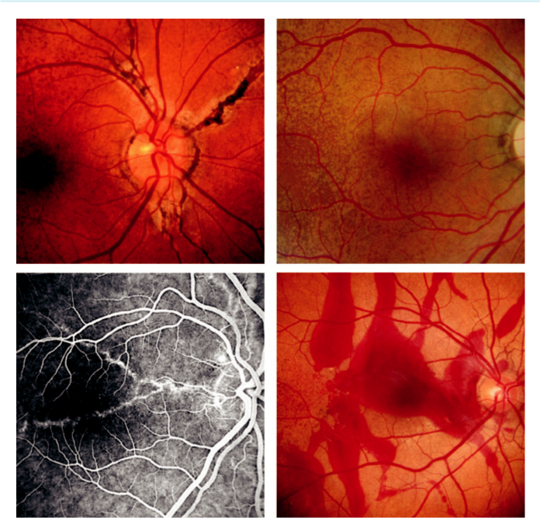

A B

C D

Fig. 14.16 Angioid streaks: (A) clinical appearance, (B) ‘peau d’ orange’ temporal to the macula, (C) FA showing hyperfluorescent streaks, (D) subretinal haemorrhage secondary to traumatic choroidal rupture. (Figure 14.16B courtesy of P. Scanlon; Figure 14.16D courtesy of S. Chen.)

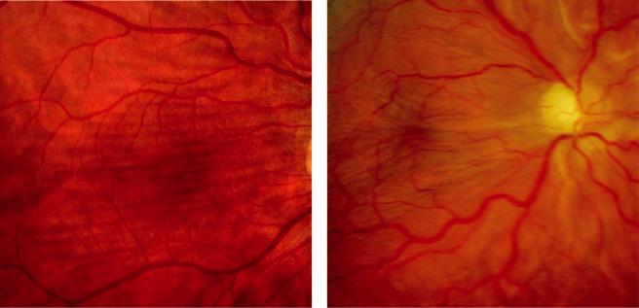

A B

Fig 14.17 (A) Choroidal folds, (B) hypotony maculopathy. (From Salmon JF, Kanski’s Clinical Ophthalmology:

A Systematic Approach, 9th edition. Oxford, UK: Elsevier; 2020.)

#*" ##%"#"+!#(&&%"'+$'""#* "%#! " +#!+ &)%#"$'!%

#%$%&#" (&#" +##'%(&&*'#('$%!&&#"#$+%', &)%" %'&%&%)

|  |  |
| --- | --- |
| Chapter 14—ACQUIRED MACULAR DISORDERS | **287** |
|  |  |

**Hypotony maculopathy**

**Pathogenesis**

very low IOP (<6 mm Hg), usually caused by excessive drainage following glaucoma filtration surgery. Other causes include trauma (cyclodialysis cleft), chronic uveitis and retinal detachment. Severe hypotony may deteriorate to phthisis bulbi.

**Diagnosis**

***Signs***: (a) fine retinal folds radiating outwards from the fovea (Fig. 14.17B), (b) choroidal folds.

***Other features***: depend on aetiology: (a) shallow anterior chamber, (b) uveitis, (c) cystic trabeculectomy bleb, (d) bleb leak, (e) choroidal detachment, (f ) CMO.

***US***: to rule out a cyclitic membrane or cyclodialysis cleft if no cause is identified.

**Treatment**

aimed at restoring normal IOP.

**Vitreomacular traction syndrome**

**Pathogenesis**

vitreous cortex remains attached to the fovea but is detached from the perifoveal region, with resultant exertion of persistent anteroposterior traction on the fovea.

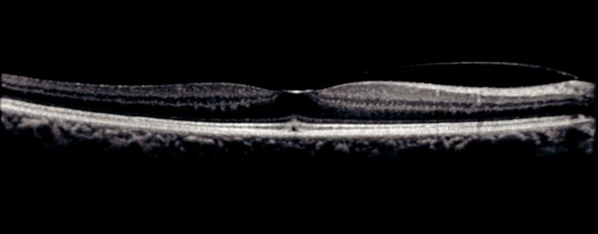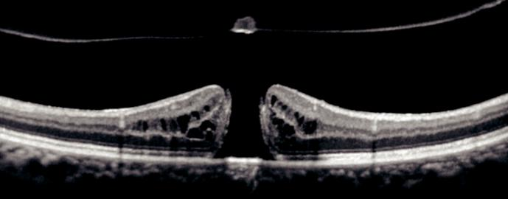

A

B

Fig 14.18 Vitreomacular traction (VMT): (A) OCT showing mild VMT, (B) OCT showing interruption of all retinal

layers and a small operculum. (From Salmon JF, Kanski’s Clinical Ophthalmology: A Systematic Approach,

9th edition. Oxford, UK: Elsevier; 2020.)

#*" ##%"#"+!#(&&%"'+$'""#* "%#! " +#!+ &)%#"$'!%

#%$%&#" (&#" +##'%(&&*'#('$%!&&#"#$+%', &)%" %'&%&%)

**288** SYNOPSIS OF CLINICAL OPHTHALMOLOGY



**Diagnosis**

***Presentation***: blurring and metamorphopsia, photopsia, and micropsia.

***Signs***: macular retinal wrinkling, epiretinal membrane or CMO.

***OCT***: incomplete posterior vitreous separation with persistent attachment of vitreous to the fovea (Fig. 14.18A). Interruption of all retinal layers can be seen, associated with an operculum (Fig. 14.18B).

**Treatment**

options include observation, intravitreal steroid and pars plana vitrectomy to relieve macular trac-tion; spontaneous resolution may occur.

#*" ##%"#"+!#(&&%"'+$'""#* "%#! " +#!+ &)%#"$'!%

#%$%&#" (&#" +##'%(&&*'#('$%!&&#"#$+%', &)%" %'&%&%)



CHAPTER 15

Hereditary Fundus Dystrophies



C H A P T E R O U T L I N E

Introduction 289

Generalized photoreceptor dystrophies 289 Retinitis pigmentosa 289

Important systemic associations 290

Progressive cone dystrophy 291

Leber congenital amaurosis 292

Stargardt disease and fundus flavimaculatus 294

Bietti crystalline corneoretinal dystrophy 294

Congenital stationary night blindness 294

Congenital monochromatism 295

Macular dystrophies 295

Best macular dystrophy 295

Pattern dystrophy 296

Familial dominant drusen (malattia leventinese) 297

Sorsby pseudoinflammatory dystrophy 297

Generalized choroidal dystrophies 298

Choroideremia 298

Gyrate atrophy 298

Vitreoretinal dystrophies 299

Juvenile X-linked retinoschisis 299

Stickler syndrome 300

Familial exudative vitreoretinopathy 300 Albinism 301

Tyrosinase-negative (complete) oculocutaneous albinism 301

Tyrosinase-positive (incomplete) oculocutaneous albinism 301

Ocular albinism 302 Cherry-red spot at the macula 303

**Introduction**

e hereditary retinal dystrophies are a group of disorders that exert their major eect on the retinal pigment epithelium–photoreceptor complex and choriocapillaris to cause a range of visual symptoms. In individuals with a retinal dystrophy, mutation in dierent genes (genetic hetero - geneity) can cause the same clinical phenotype. In addition, mutations in the same gene can cause dierent phenotypes (phenotypical heterogeneity). A monogenetic retinal dystrophy can develop at any age and the genetic abnormality can usually be determined using modern tech-niques. Identifying the precise mutation aids genetic counselling and can facilitate enrolment in a clinical trial.

**Generalized photoreceptor dystrophies**

**RETINITIS PIGMENTOSA**

**Genetics:**

typical retinitis pigmentosa (RP) is a group of retinal dystrophies initially mainly aecting the rod photoreceptor cells and subsequently cones (rod–cone dystrophy). It can be sporadic or inherited as AD, AR, or X-L; many cases are due to mutation in the rhodopsin gene. X-L has the worst prognosis with severe visual loss by the 4th decade; AR and sporadic cases have a

**289**

#*" ##%"#"+!#(&&%"'+$'""#* "%#! " +#!+ &)%#"$'!%

#%$%&#" (&#" +##'%(&&*'#('$%!&&#"#$+%', &)%" %'&%&%)

**290** SYNOPSIS OF CLINICAL OPHTHALMOLOGY

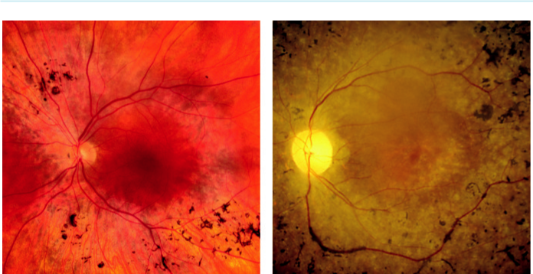

A B

Fig. 15.1 Retinitis pigmentosa: (A) intraretinal mid-peripheral ‘bone-spicule’ pigmentary changes, (B) ‘waxy’ disc pallor. (Figure 15.1A courtesy of P. Saine.)

more favourable course with retention of central vision until the 5th or 6th decade or later and AD disease has the best outlook.

**Diagnosis**

***Presentation***: decreased peripheral and night vision; age of onset is variable.

***Signs***: (a) mid-peripheral RPE atrophy and intraretinal perivascular ‘bone-spicule’ pigmen-tary changes together with mild arteriolar narrowing (Fig. 15.1A), (b) gradual increase in density and extent of the pigmentary change, (c) gliotic ‘waxy’ pallor of the optic discs (Fig. 15.1B), (d) the macula may show atrophy, epiretinal membrane formation or CMO.

***Electroretinogram (ERG)***: reduced scotopic rod and combined responses in early disease; later, photopic responses reduce and eventually the ERG is extinguished. ***Electro-oculogram (EOG)***: subnormal with an absence of the light rise.

***Perimetry***: small mid-peripheral scotomas gradually coalesce, leaving a tiny central island (‘tunnel vision’), that may eventually be extinguished.

***Ocular associations***: (a) posterior subcapsular cataract, (b) open angle glaucoma, (c) myopia, (d) keratoconus, (e) Coats disease, (f ) disc drusen.

***Atypical RP***: either closely related to typical RP or representing incomplete forms of the disease (e.g. cone–rod dystrophy, sector RP, RP sine pigmento).

**Treatment:**

associations such as cataract and glaucoma are amenable to treatment; CMO may respond to systemic acetazolamide.

**IMPORTANT SYSTEMIC ASSOCIATIONS**

RP, often atypical, may be associated with the following:

***Bassen–Kornzweig syndrome (abetalipoproteinaemia)***: AR lipoprotein abnormality with malabsorption of fat-soluble vitamins causing failure to thrive followed by severe spino-cerebellar ataxia. Blood microscopy shows ‘thorny’ red cells (acanthocytosis) (Fig. 15.2A). Treatment with large doses of vitamins A, D, E and K may prevent visual loss.

#*" ##%"#"+!#(&&%"'+$'""#* "%#! " +#!+ &)%#"$'!%

#%$%&#" (&#" +##'%(&&*'#('$%!&&#"#$+%', &)%" %'&%&%)

|  |  |
| --- | --- |
| Chapter 15—HEREDITARY FUNDUS DYSTROPHIES | **291** |
|  |  |

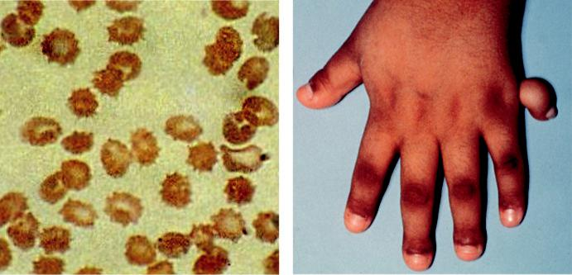

A B

Fig. 15.2 Systemic associations: (A) acanthocytosis in Bassen–Kornzweig syndrome, (B) polydactyly in

Bardet–Biedl syndrome. (From Salmon JF, Kanski’s Clinical Ophthalmology: A Systematic Approach, 9th

edition. Oxford, UK: Elsevier; 2020.)

***Refsum disease***: AR enzyme deficiency resulting in phytanic acid accumulation; there are distinct infantile and adult types. Early detection and a diet low in phytanic acid can arrest progression of the potentially severe neurological and other features.

***Kearns–Sayre syndrome***: mitochondrial inheritance; chronic progressive external ophthal-moplegia associated with systemic problems (see Chapter 19).

***Bardet–Biedl syndrome***: genetically heterogeneous condition with systemic features includ-ing mental handicap, polydactyly (Fig. 15.2B); fundus often shows a bull’s-eye maculopathy due to cone–rod dystrophy.

***Usher syndrome***: AR, but genetically heterogeneous; accounts for approximately 5% of all cases of profound deafness in children and approximately half of all cases of combined deaf-ness and blindness.

**PROGRESSIVE CONE DYSTROPHY**

**Definition:**

an usually sporadic dystrophy predominantly aecting the cone system. In some cases, there is no evidence of rod dysfunction, whereas in others rod dysfunction subsequently develops but cone deficiency still predominates (cone–rod dystrophy).

**Diagnosis**

***Presentation***: in 2nd to 4th decades with impaired central and colour vision.

***Signs***: the macula may show (a) virtually normal appearance, (b) nonspecific pigmentary changes or (c) bull’s-eye configuration (Box 15.1, Fig. 15.3A); geographic atrophy subse-quently ensues with VA of 6/60 or worse.

***ERG***: photopic responses are subnormal or unrecordable and flicker fusion frequency is reduced, but rod responses are preserved until late.

***EOG***: normal to subnormal.

***FAF***: is often the key diagnostic test showing various annular patterns concentric with the fovea (Fig. 15.3B).

#*" ##%"#"+!#(&&%"'+$'""#* "%#! " +#!+ &)%#"$'!%

#%$%&#" (&#" +##'%(&&*'#('$%!&&#"#$+%', &)%" %'&%&%)

**292** SYNOPSIS OF CLINICAL OPHTHALMOLOGY

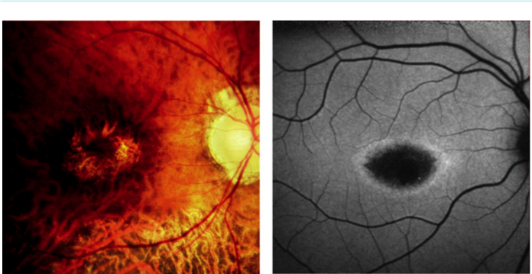

A B

Fig. 15.3 Cone dystrophy: (A) bull’s eye appearance, (B) FAF showing annular pattern concentric with the fovea. (Figure 15.3B courtesy of Chris Barry, Lions Eye Institute, Perth, Australia.)

**LEBER CONGENITAL AMAUROSIS**

**Definition:**

severe AR condition aecting the retina, presenting in childhood. It is the most common genetic cause of visual impairment in children and at least 20 dierent forms have been identified, each with slightly dierent symptoms and speed of progression.

**Diagnosis**

***Presentation***: perinatal night blindness and poor peripheral vision leading to blindness, associated with nystagmus or roving eye movements.

***Signs***: (a) absent or sluggish pupillary light reflexes, (b) mild pigmentary retinopathy may be seen initially, followed by (c) coloboma-like fundus lesions (Fig. 15.4A), optic atrophy, severe arteriolar narrowing and macular pigmentation.

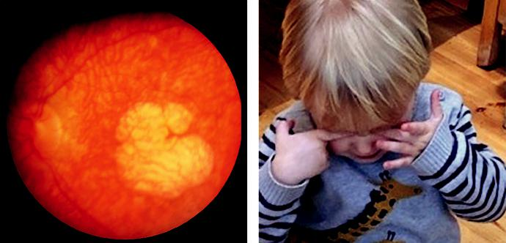

A B

Fig. 15.4 Leber congenital amaurosis: (A) coloboma-like macular atrophy in late disease, (B) ‘oculodigital’ syndrome.

#*" ##%"#"+!#(&&%"'+$'""#* "%#! " +#!+ &)%#"$'!%

#%$%&#" (&#" +##'%(&&*'#('$%!&&#"#$+%', &)%" %'&%&%)

|  |  |
| --- | --- |
| Chapter 15—HEREDITARY FUNDUS DYSTROPHIES | **293** |
|  |  |



BOX 15.1 **Other causes of bull’s-eye macular appearance**

Chloroquine maculopathy

Advanced Stargardt disease

Fenestrated sheen macular dystrophy

Benign concentric annular macular dystrophy

Bardet–Biedl syndrome

Lipofuscinosis

‘***Oculodigital syndrome’***: constant rubbing of the eyes causing enophthalmos is characteristic (Fig. 15.4B)

***ERG***: usually nonrecordable even in early cases.

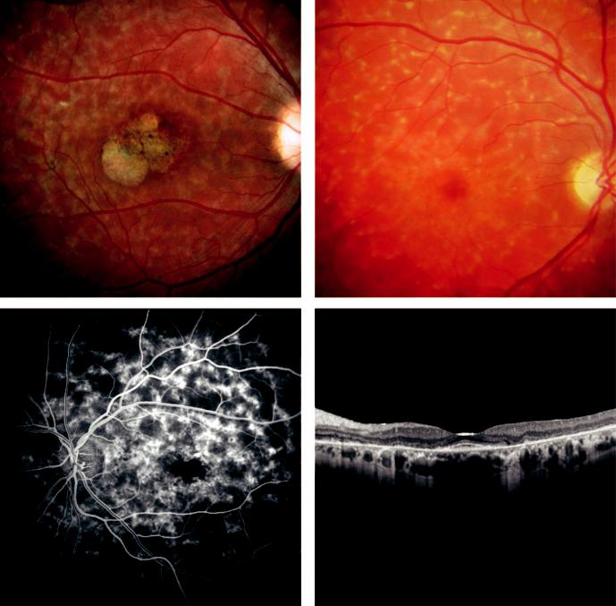

A B

C D

Fig. 15.5 Stargardt disease: (A) ‘beaten-bronze’ maculopathy, (B) pisciform flecks, (C) FA showing general-ized ‘dark choroid”, (D) OCT showing RPE and retinal atrophy, sparing the macula. (Figure 15.5D courtesy of P. Charbel Issa.)

#*" ##%"#"+!#(&&%"'+$'""#* "%#! " +#!+ &)%#"$'!%

#%$%&#" (&#" +##'%(&&*'#('$%!&&#"#$+%', &)%" %'&%&%)

**294** SYNOPSIS OF CLINICAL OPHTHALMOLOGY



**STARGARDT DISEASE AND FUNDUS FLAVIMACULATUS**

**Definition:**

Stargardt disease and fundus flavimaculatus (FFM) are variants of the same disease, characterized by diuse accumulation of lipofuscin within the RPE. Commonest form of macular dystrophy. Inheritance is usually AR with a mutation in the *ABCA*4 gene; mutations in at least two other genes. Symptoms may be disproportionate to visible fundus changes.

**Diagnosis**

***Presentation***: in the 1st and 2nd decades, occasionally later, with gradual impairment of central vision. Some patients may remain asymptomatic until late, especially with predomi-nantly peripheral changes (FFM pattern).

***Maculopathy***: (a) the macula may be normal initially and then show nonspecific mottling or an oval ‘snail-slime’ or ‘beaten-bronze’ appearance (Fig. 15.5A), with (b) progression to geographic atrophy or bull’s-eye maculopathy.

***Flecks***: yellow-white lesions at the level of the RPE, of various size and shape such as round, oval, or pisciform (fish-shaped), at the posterior pole exclusively or extending to the mid-periphery (Fig. 15.5B).

***Course***: VA tends to stabilize at approximately 6/60; patients with only flecks have a better prognosis.

***ERG***: photopic is normal to subnormal and scotopic normal.

***EOG***: subnormal in advanced cases.

***FA***: (a) maculopathy shows central hyperfluorescence, (b) generalized ‘dark choroid’ with prominence of the retinal vasculature is classic (Fig. 15.5C), (c) fresh flecks show early hypofluorescence and old flecks show RPE window defects.

***OCT***: RPE and retinal atrophy sparing the macula (Fig. 15.5D).

**BIETTI CRYSTALLINE CORNEORETINAL DYSTROPHY**

**Definition:**

Deposition of crystals in retina and peripheral cornea in young adults often of East Asian ances-try; AR **(***CYP4VZ* gene).

**Diagnosis**

***Presentation***: progressive visual loss.

***Signs***: (a) numerous fine yellow-white crystals scattered throughout the posterior fundus (Fig. 15.6A), (b) later atrophy of RPE and choriocapillaris at the macula and then diuse atrophy, (c) superficial peripheral corneal crystals.

***Course***: rate of change varies. ere is no treatment.

***OCT***: demonstrates the crystalline deposits and macular changes.

**CONGENITAL STATIONARY NIGHT BLINDNESS**

**Definition:**

group of disorders characterized by infantile-onset nyctalopia and nonprogressive retinal dysfunc-tion; the fundus appearance may be normal or abnormal.

**Diagnosis**

***With normal fundus***: types range from complete absence of rod function with normal cone function, to mixed impairment.

#*" ##%"#"+!#(&&%"'+$'""#* "%#! " +#!+ &)%#"$'!%

#%$%&#" (&#" +##'%(&&*'#('$%!&&#"#$+%', &)%" %'&%&%)

|  |  |
| --- | --- |
| Chapter 15—HEREDITARY FUNDUS DYSTROPHIES | **295** |
|  |  |

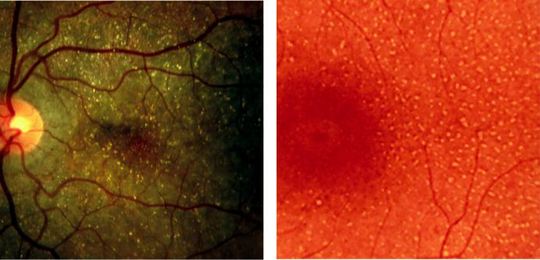

A B

Fig. 15.6 (A) Bietti crystalline corneoretinal dystrophy, (B) fundus albipunctatus. (Figure 15.6B courtesy of Chris Barry, Lions Eye Institute, Perth, Australia.)

***With abnormal fundus***: (a) Oguchi disease, in which the fundus has an unusual golden-yellow colour when light-adapted, becoming normal after prolonged dark adaptation (Mizuo phenom-enon) and (b) fundus albipunctatus, an innocuous AR or AD condition in which there are numerous tiny yellow-white spots sparing the fovea and extending to the periphery (Fig. 15.6B).

**CONGENITAL MONOCHROMATISM**

**Definition:**

group of inherited conditions with abnormal colour vision as the predominant feature.

**Diagnosis**

Monochromatism ranges from partial impairment of colour vision and slightly reduced VA such as blue cone monochromatism (incomplete achromatopsia) to complete absence of colour perception and poor VA as in rod monochromatism (complete achromatopsia).

Fundus signs are often subtle; nystagmus and photophobia are present in all but the milder forms.

**Macular dystrophies**

**BEST MACULAR DYSTROPHY**

**Genetics:**

inheritance is AD (*BEST1* gene on chromosome 11q13). Second commonest macular dystrophy. Occasionally, multifocal vitelliform lesions identical to those in Best disease may become manifest in adult life. However, in these patients the EOG is normal and the family history negative.

**Diagnosis**

***Presentation***: in 5th decade with gradual onset of central blurring.

***Signs***: (a) vitelliform appearance develops in early childhood with a round, sharply delin-eated (‘sunny side up’) macular lesion (Fig. 15.7A), (b) slow progression to ‘vitelliruptive’ stage (Fig. 15.7B) with a gradual fall in VA and later (c) macular atrophy.

***FA***: vitelliform lesions show corresponding hypofluorescence due to blockage.

#*" ##%"#"+!#(&&%"'+$'""#* "%#! " +#!+ &)%#"$'!%

#%$%&#" (&#" +##'%(&&*'#('$%!&&#"#$+%', &)%" %'&%&%)

**296** SYNOPSIS OF CLINICAL OPHTHALMOLOGY

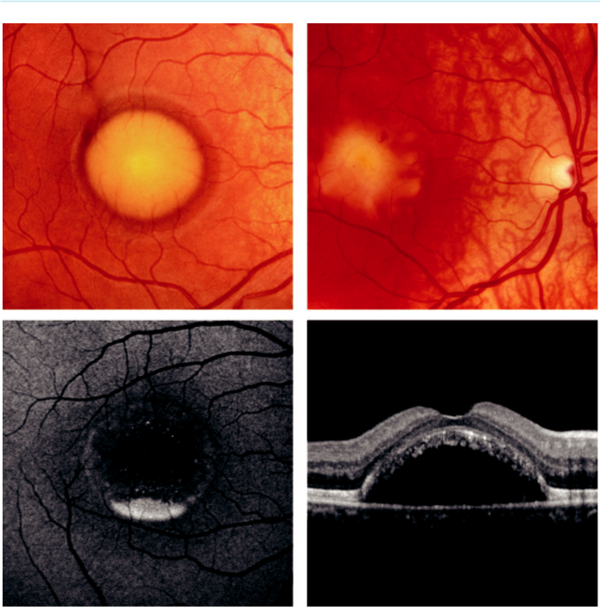

A B

C D

Fig. 15.7 Best macular dystrophy: (A) ‘sunny side up’ appearance, (B) vitelliform stage, (C) FAF showing pseudohypopyon, (D) OCT in vitelliform stage showing subretinal hyporeflective component. (Figure 15.7C, D courtesy of P. Charbel Issa.)

***FAF***: the yellowish material is intensely hyperautofluorescent (Fig. 15.7C). In the later atro-phic stages hypoautofluorescent areas supervene.

***OCT***: material beneath, above and within the RPE (Fig. 15.7D).

***EOG***: severely subnormal during all stages; also abnormal in carriers with normal fundi.

**PATTERN DYSTROPHY**

***Definition***: generic term that encompasses several retinal dystrophies exhibiting yellow, orange or grey deposits at the macula in a variety of morphologies. Most are AD and have a relatively benign course. e following are two examples:

***Adult-onset macular vitelliform dystrophy***: small foveal vitelliform lesions similar in appearance to those of Best disease (Fig. 15.8A).

***Butterfly-shaped macular dystrophy***: yellow pigment at the fovea in a triradiate confor-mation. FA shows central, spoke-like radiating hypofluorescence, surrounded by hyper-fluorescence (Fig. 15.8B).

#*" ##%"#"+!#(&&%"'+$'""#* "%#! " +#!+ &)%#"$'!%

#%$%&#" (&#" +##'%(&&*'#('$%!&&#"#$+%', &)%" %'&%&%)

|  |  |
| --- | --- |
| Chapter 15—HEREDITARY FUNDUS DYSTROPHIES | **297** |
|  |  |

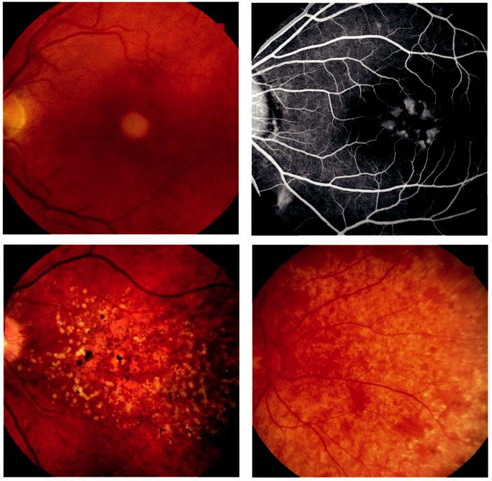

A B

C D

Fig. 15.8 (A) Adult-onset macular vitelliform dystrophy, (B) FA showing butterfly-shaped dystrophy, (C) familial dominant drusen, (D) Sorsby pseudoinflammatory dystrophy (early). (Figure 15.8C courtesy of S. Chen.)

**FAMILIAL DOMINANT DRUSEN (MALATTIA LEVENTINESE)**

***Definition***: early onset variant of AMD.

***Asymptomatic stage***: (a) yellow-white radially orientated drusen develop at the macula (Fig. 15.8C) in the 2nd decade, (b) with time they become more numerous and acquire a honeycomb configuration.

***Symptomatic stage***: geographic atrophy and occasionally CNV during the 4th and 5th decades.

**SORSBY PSEUDOINFLAMMATORY DYSTROPHY**

**Definition:**

AD with full penetrance but variable expressivity (*TIMP*3 gene). Rare macular disorder of late middle age.

#*" ##%"#"+!#(&&%"'+$'""#* "%#! " +#!+ &)%#"$'!%

#%$%&#" (&#" +##'%(&&*'#('$%!&&#"#$+%', &)%" %'&%&%)

**298** SYNOPSIS OF CLINICAL OPHTHALMOLOGY



**Diagnosis**

***Presentation***: in 3rd decade with nyctalopia.

***Signs***: (a) confluent yellow white drusen-like deposits along the arcades nasal to the disc and mid-periphery (Fig. 15.8D), (b) in the 5th decade, exudative maculopathy secondary to CNV, (c) in the 7th decade, peripheral chorioretinal atrophy.

**Generalized choroidal dystrophies**

**CHOROIDEREMIA**

**Definition:**

severe and progressive diuse degeneration of the choroid, RPE and retinal photoreceptors.

Inheritance is X-L recessive with the locus on Xq21.2 (*CHM* gene).

**Diagnosis**

***Presentation***: in 2nd and 3rd decades with nyctalopia.

***Signs***: (a) atrophy of the RPE and choroid, which spreads peripherally and centrally with sparing of the fovea until late (Fig. 15.9A), (b) choroidal vessels course over bare sclera, with retinal vascular attenuation; optic atrophy, (c) severe central and peripheral visual loss occurs by the 6th decade.

***ERG***: markedly abnormal.

***Gene therapy***: the placement of functional copies of the faulty gene behind the retina appear to stabilize the condition.

***Signs in female carriers***: patchy mild peripheral RPE changes; VA, fields, and ERG are usu-ally normal but nyctalopia can occur; 50% of carriers’ sons will develop the condition, and 50% of daughters will be carriers.

**GYRATE ATROPHY**

**Pathogenesis:**

AR metabolic disorder caused by a deficiency of the enzyme ornithine aminotransferase, leading to elevated ornithine levels. e mutation is in the *OAT* gene on chromosome 10.

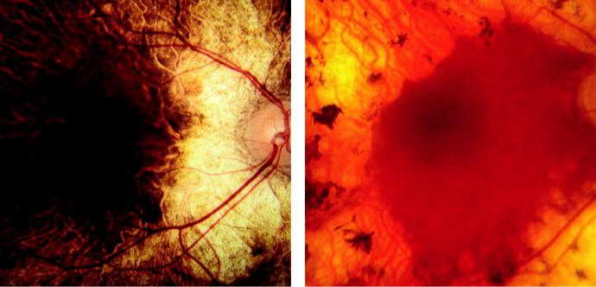

A B

Fig. 15.9 (A) Choroideremia, (B) gyrate atrophy (late). (From Salmon JF, Kanski’s Clinical Ophthalmology: A

Systematic Approach, 9th edition. Oxford, UK: Elsevier; 2020.)

#*" ##%"#"+!#(&&%"'+$'""#* "%#! " +#!+ &)%#"$'!%

#%$%&#" (&#" +##'%(&&*'#('$%!&&#"#$+%', &)%" %'&%&%)

|  |  |
| --- | --- |
| Chapter 15—HEREDITARY FUNDUS DYSTROPHIES | **299** |
|  |  |

**Diagnosis**

***Presentation***: in 1st and 2nd decades with myopia and nyctalopia; legal blindness tends to occur by the 4th to 6th decades.

***Signs***: (a) sharply demarcated oval areas of chorioretinal atrophy, often with crystalline deposits at the posterior pole, (b) coalescence and extension of atrophic areas with sparing of the fovea until late (Fig. 15.9B), (c) extreme attenuation of retinal vasculature.

***ERG***: subnormal in early disease and later extinguished.

**Treatment:**

restriction of dietary arginine; pyridoxine (vitamin B6) may normalize ornithine levels in some patients.

**Vitreoretinal dystrophies**

**JUVENILE X-LINKED RETINOSCHISIS**

**Pathogenesis:**

defect in Müller cell function with splitting of the retinal nerve fibre layer from the rest of the sensory retina – this diers from acquired retinoschisis, in which splitting occurs at the outer plexiform layer. *RS*1 gene mutation on X chromosome.

**Diagnosis**

***Presentation***: (a) diculty reading at age 5–10 years, (b) squint, nystagmus, or vitreous haemorrhage.

***Maculopathy (universal)***: ‘bicycle wheel’ striae radiating from the foveola, and cystoid changes (Fig. 15.10A).

***Peripheral retinoschisis (in 50%)***: predominantly inferotemporal. Does not extend but oval defects (Fig. 15.10B) may develop and coalesce to leave retinal blood vessels floating in the vitreous (‘vitreous veils’).

***Complications***: vitreous haemorrhage and rarely retinal detachment.

***Prognosis***: poor due to progressive maculopathy.

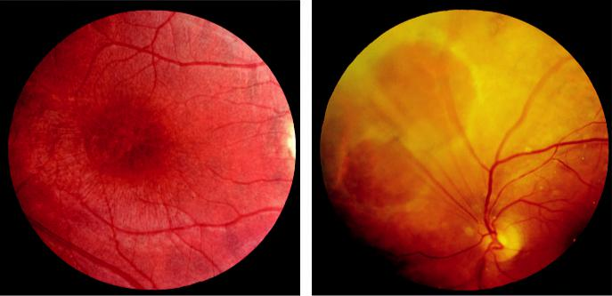

A B

Fig. 15.10 Juvenile X-linked retinoschisis: (A) ‘bicycle wheel’ striae radiating from the fovea, (B) peripheral

retinoschisis. (From Salmon JF, Kanski’s Clinical Ophthalmology: A Systematic Approach, 9th edition. Oxford,

UK: Elsevier; 2020.)

#*" ##%"#"+!#(&&%"'+$'""#* "%#! " +#!+ &)%#"$'!%

#%$%&#" (&#" +##'%(&&*'#('$%!&&#"#$+%', &)%" %'&%&%)

**300** SYNOPSIS OF CLINICAL OPHTHALMOLOGY



***OCT***: to assess maculopathy.

***ERG and EOG***: abnormal in peripheral schisis.

**STICKLER SYNDROME**

**Genetics:**

AD disorder of connective tissue; is the most common inherited cause of paediatric retinal detach-ment. It is classified into clinically and genetically distinct subtypes STL1, STL2, and STL3; the latter lacking ocular features. Wagner syndrome shows similar vitreous changes but is not associ-ated with systemic abnormalities.

**Diagnosis**

***Presentation***: early childhood with high but nonprogressive myopia.

***Signs***: (a) optically empty vitreous (Fig. 15.11A), (b) radial lattice-like degeneration, (c) reti-nal detachment in approximately 50% in the 1st decade, often bilateral and with multiple or giant tears (Fig. 15.11B), (d) other features (cataract, ectopia lentis, glaucoma).

***Systemic anomalies***: (a) mid-facial hypoplasia, (b) cleft and high-arched palate, (c) joint hypermobility, (d) deafness.

**Treatment:**

regular screening is mandatory so that retinal breaks can be treated prophylactically.

**FAMILIAL EXUDATIVE VITREORETINOPATHY**

**Definition:**

AD (rarely AR or XRL depending on the gene defect). Failure of vascularization of temporal peripheral retina similar to ROP.

**Diagnosis**

***Presentation***: childhood; slowly progressing.

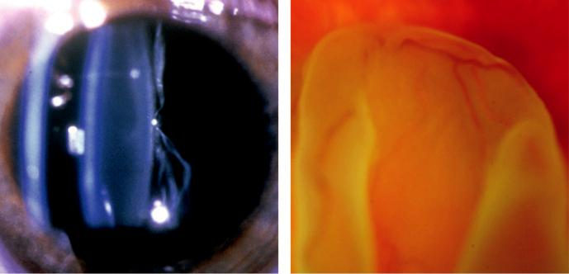

A B

Fig. 15.11 Stickler syndrome: (A) optically empty vitreous, (B) retinal detachment secondary to giant tear. (Courtesy of M. Snead.)

#*" ##%"#"+!#(&&%"'+$'""#* "%#! " +#!+ &)%#"$'!%

#%$%&#" (&#" +##'%(&&*'#('$%!&&#"#$+%', &)%" %'&%&%)

|  |  |
| --- | --- |
| Chapter 15—HEREDITARY FUNDUS DYSTROPHIES | **301** |
|  |  |

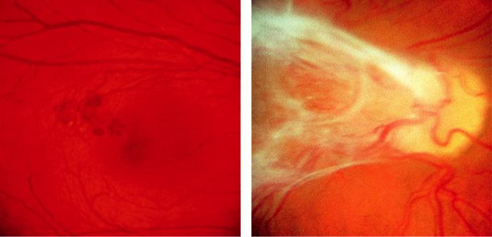

A B

Fig. 15.12 Familial exudative vitreoretinopathy: (A) peripheral telangiectasia, (B) ‘dragging’ of the disc and

macula with underlying retinal detachment. (From Salmon JF, Kanski’s Clinical Ophthalmology: A Systematic

Approach, 9th edition. Oxford, UK: Elsevier; 2020.)

***Signs***: (a) high myopia, (b) stage 1: peripheral avascularity, (c) stage 2: peripheral vascular tortuosity and telangiectasia (Fig. 15.12A) progressing to preretinal fibrovascular prolif-eration, (d) stage 3: tractional/rhegmatogenous retinal detachment with macular sparing (Fig. 15.12B), (e) stage 4/5 macula involving and total retinal detachment.

***Treatment***: (a) anti-VEGF as a temporizing measure, (b) laser to avascular retina, (c) vitrec-tomy for retinal detachment

**Albinism**

**TYROSINASE-NEGATIVE (COMPLETE) OCULOCUTANEOUS ALBINISM**

**Pathogenesis:**

inability to synthesize melanin results in lack of the pigment in all ocular structures; inheritance is usually AR.

**Diagnosis**

***VA***: usually <6/60 due to foveal hypoplasia.

***Signs***: (a) iris is diaphanous and translucent (Fig. 15.13A), giving rise to a ‘pink-eyed’ appearance, (b) pale fundus with large conspicuous choroidal vessels (Fig. 15.13B), (c) foveal hypoplasia with absence of the foveal pit, (d) nystagmus, high refractive errors, and squint.

***Systemic features***: (a) white hair and very pale skin, (b) anomalous optic chiasm (majority of nerve fibres from each eye cross to the contralateral hemisphere, demonstrated by visual evoked potentials).

**TYROSINASE-POSITIVE (INCOMPLETE) OCULOCUTANEOUS ALBINISM**

**Pathogenesis:**

ability to synthesize variable amounts of melanin; inheritance is usually AR.

#*" ##%"#"+!#(&&%"'+$'""#* "%#! " +#!+ &)%#"$'!%

#%$%&#" (&#" +##'%(&&*'#('$%!&&#"#$+%', &)%" %'&%&%)

**302** SYNOPSIS OF CLINICAL OPHTHALMOLOGY

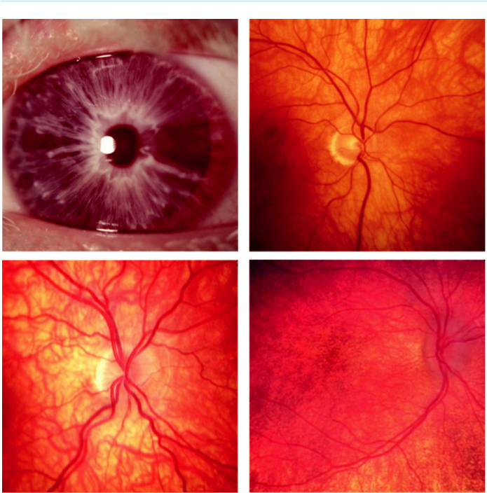

A B

C D

Fig. 15.13 Oculocutaneous albinism: (A) tyrosinase-negative showing translucent iris, (B) pale fundus with conspicuous choroidal vessels, (C) tyrosinase-positive showing variable fundus hypopigmentation, (D) female carrier of ocular albinism showing macular stippling and mid-peripheral depigmentation. (Figure 15.13D cour-tesy of M. Pennesi.)

**Diagnosis**

***VA***: usually impaired due to foveal hypoplasia.

***Signs***: (a) iris is blue to dark brown, with variable translucency, (b) variable fundus hypopig-mentation (Fig. 15.13C).

***Systemic features***: (a) hair may be white, yellow, or red – darkens with age, (b) skin is very pale at birth but usually darkens by 2 years; (c) systemic conditions featuring incomplete oculocutaneous albinism include Chédiak–Higashi, Hermansky–Pudlak, and Waardenburg syndromes.

**OCULAR ALBINISM**

***Definition***: X-L condition in which aected males have hypopigmented irides and fundi, and often reduced vision and nystagmus.

#*" ##%"#"+!#(&&%"'+$'""#* "%#! " +#!+ &)%#"$'!%

#%$%&#" (&#" +##'%(&&*'#('$%!&&#"#$+%', &)%" %'&%&%)

|  |  |
| --- | --- |
| Chapter 15—HEREDITARY FUNDUS DYSTROPHIES | **303** |
|  |  |

***Female carriers***: are asymptomatic, although often have mild signs (e.g. partial iris translu-cency), macular stippling, and mid-peripheral areas of retinal depigmentation and granular-ity (Fig. 15.13D).

**Cherry-red spot at the macula**

***Pathogenesis***: a cherry-red spot is seen when the relatively thin fovea retains transmission of the choroidal vascular hue, despite loss of transparency of the wider posterior pole retina as a result of accumulation of lipids in the ganglion cell layer. It is also a feature of central retinal artery occlusion.

***Systemic associations***: sphingolipidoses are a group of rare inherited metabolic diseases fea-turing intracellular accumulation of lipid metabolites in various tissues. ese include GM1 and GM2 (Tay–Sachs, Sandho) gangliosidoses, Niemann–Pick disease, and sialidosis; many have other ocular features such as corneal clouding.

#*" ##%"#"+!#(&&%"'+$'""#* "%#! " +#!+ &)%#"$'!%

#%$%&#" (&#" +##'%(&&*'#('$%!&&#"#$+%', &)%" %'&%&%)



CHAPTER 16

Retinal Detachment



|  |  |  |
| --- | --- | --- |
| CHAPTER | OUTLINE |  |
|  |  |  |
| Definitions 305 |  | Tractional retinal detachment 312 |
| Degenerative (acquired) retinoschisis 305 | | Exudative retinal detachment 313 |
| Rhegmatogenous retinal detachment 306 | | Pars plana vitrectomy 313 |
|  |  |  |

**Definitions**

***Retinal detachment (RD):*** separation of the neurosensory retina (NSR) from the RPE, with the accumulation of subretinal fluid (SRF).

***Rhegmatogenous RD:*** occurs when a full-thickness defect in the NSR permits synchytic (liquefied) vitreous to gain access to the subretinal space.

***Tractional RD:*** involves the contraction of vitreoretinal membranes in the absence of a retinal break.

***Exudative RD:*** SRF is derived from retinal or choroidal vessels (e.g. inflammation, tumour).

***Retinal break:*** full-thickness defect in the NSR, either (a) a tear, caused by dynamic vitreo-retinal traction or (b) a hole, caused by chronic retinal atrophy.

***U-tear:*** consists of a flap with the apex pulled anteriorly by adherent vitreous, the base attached to the retina (Fig. 16.1A).

***Operculated tear:*** flap has been completely torn away from the retina (Fig. 16.1B).

***Dialysis:*** circumferential tear along the ora serrata with vitreous gel attached to its posterior margins (Fig. 16.1C).

***Giant tear:*** involves 90° or more of the NSR (Fig. 16.1D).

**Degenerative (acquired) retinoschisis**

***Pathogenesis:*** (a) coalescence of individual lesions within areas of peripheral microcystoid degeneration, (b) the NSR splits into inner and outer layers with severing of neurons and complete loss of visual function in the aected area (absolute scotoma), (c) the split in ‘typi - cal’ retinoschisis is through the outer plexiform layer and in the less common ‘reticular’ form at the nerve fibre layer.

***Signs:*** (a) early retinoschisis appears as a shallowly elevated area of microcystoid degenera-tion usually starting inferotemporally, (b) progresses to smooth immobile elevation of the retina (Fig. 16.2A), (c) may extend circumferentially, the typical form usually remaining anterior to the equator although the reticular type may spread beyond.

***Associated*** ***features:*** (a) the inner layer surface may have a snowflake-like appearance,

1. vascular sheathing and sclerosis, (c) breaks in the inner layer are small and round, whereas the less common outer layer breaks are usually larger, with rolled edges (Fig. 16.2B).

**305**

#*" ##%"#"+!#(&&%"'+$'""#* "%#! " +#!+ &)%#"$'!%

#%$%&#" (&#" +##'%(&&*'#('$%!&&#"#$+%', &)%" %'&%&%)

**306** SYNOPSIS OF CLINICAL OPHTHALMOLOGY

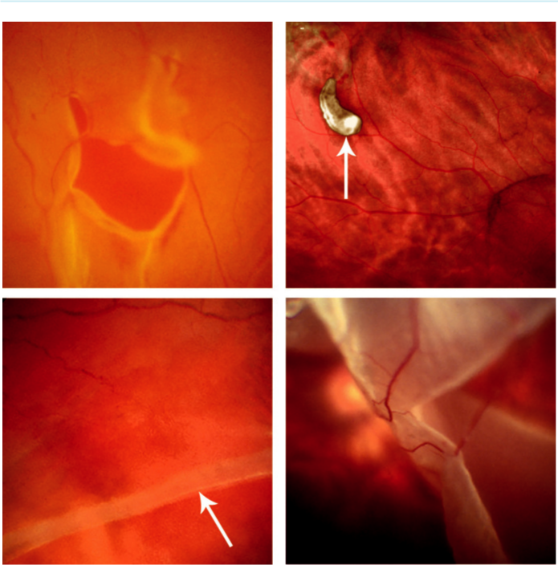

A B

C D

Fig. 16.1 Retinal breaks: (A) U-tear, (B) operculated tear (arrow), (C) dialysis (arrow showing the retinal edge), (D)giant tear. ( Figure 16.1C courtesy of Chris Barry, Lions Eye Institute, Perth, Australia.)

***Prognosis:*** in most cases retinoschisis is asymptomatic, innocuous and almost never pro-gresses. RRD may rarely develop in eyes with breaks in both layers; only the inner break needs to be closed surgically.

**Rhegmatogenous retinal detachment**

**Pathogenesis:**

rhegmatogenous retinal detachment (RRD) aects approximately 1 in 10,000 of the popula - tion each year; both eyes are eventually involved in approximately 10%. Presentation is typically between 45 and 65 years of age but may be earlier, especially if there is a predisposition (e.g. myo-pia). Other major causes include cataract surgery and trauma.

***Posterior vitreous detachment (PVD):*** (a) separation of the cortical vitreous from the inter-nal limiting membrane (ILM) of the neurosensory retina posterior to the vitreous base with the remaining solid vitreous gel collapsing inferiorly (Fig. 16.3A), (b) some eyes with acute PVD develop retinal tears and subsequent RRD, (c) occasionally avulsion of a peripheral blood vessel may cause vitreous haemorrhage without a retinal tear (Fig. 16.3B).

#*" ##%"#"+!#(&&%"'+$'""#* "%#! " +#!+ &)%#"$'!%

#%$%&#" (&#" +##'%(&&*'#('$%!&&#"#$+%', &)%" %'&%&%)

|  |  |
| --- | --- |
| Chapter 16—RETINAL DETACHMENT | **307** |
|  |  |

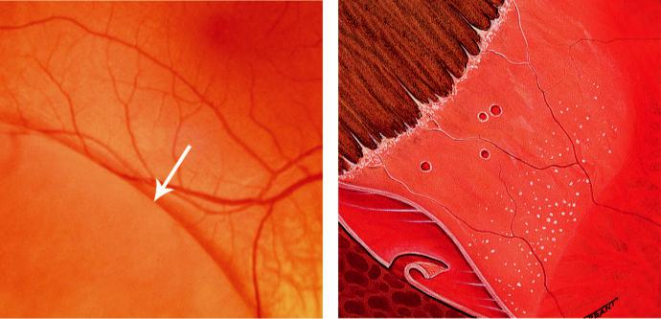

A B

Fig. 16.2 Retinoschisis: (A) shallow dome-shaped elevation of peripheral retina (arrow), (B) breaks in inner and

outer layers. (From Salmon JF, Kanski’s Clinical Ophthalmology: A Systematic Approach, 9th edition. Oxford,

UK: Elsevier; 2020.)

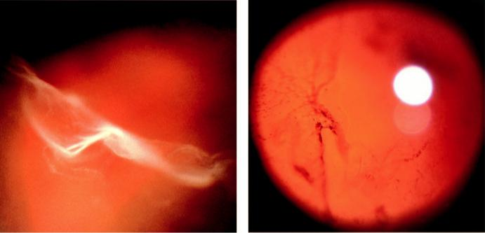

A B

Fig. 16.3 (A) Posterior vitreous detachment, (B) resorbing vitreous haemorrhage. (From Salmon JF, Kanski’s Clinical Ophthalmology: A Systematic Approach, 9th edition. Oxford, UK: Elsevier; 2020.)

***RRD without PVD:*** usually associated with a retinal dialysis or round holes.

***Lattice degeneration:*** present in approximately 8% of the population and in approximately 40% of eyes with RRD: (a) spindle-shaped islands of retinal thinning with a characteristic network of white lines (Fig. 16.4A), (b) associated RPE hyperplasia (Fig. 16.4B), (c) small holes within islands are common, (d) overlying gel is liquefied, but its adhesions around the margins of lattice are exaggerated, (e) tears typically occur at the posterior edge of an island. ***Snailtrack degeneration:*** (a) sharply demarcated peripheral bands of tightly packed ‘snow-flakes’ (Fig. 16.4C), (b) small holes, (c) overlying vitreous is liquefied but marked adhesions are seldom present so that tears are less common than in lattice.

‘***White with pressure’:*** translucent grey appearance of a region of retina induced by indenting the sclera that may be associated with abnormally strong vitreous attachments.

#*" ##%"#"+!#(&&%"'+$'""#* "%#! " +#!+ &)%#"$'!%

#%$%&#" (&#" +##'%(&&*'#('$%!&&#"#$+%', &)%" %'&%&%)

**308** SYNOPSIS OF CLINICAL OPHTHALMOLOGY

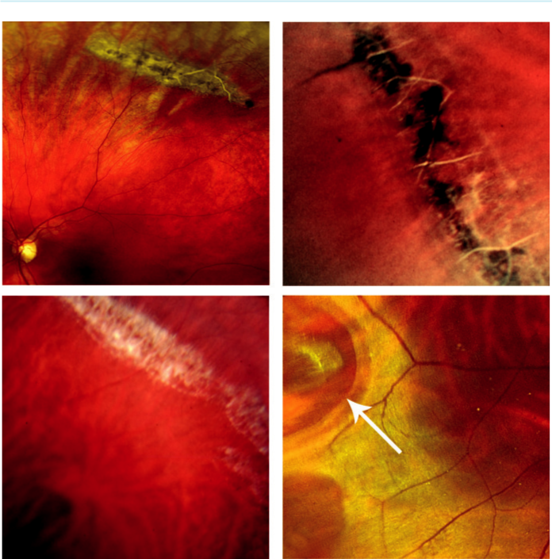

A B

C D

Fig. 16.4 Peripheral retinal degeneration: (A) lattice degeneration, (B) lattice with pigmentary change, (C) snailtrack, (D) ‘white without pressure’ showing a retinal tear (arrow). (From Salmon JF, Kanski’s Clinical Ophthalmology: A Systematic Approach, 9th edition. Oxford, UK: Elsevier; 2020.)

***‘White without pressure’:*** same appearance without scleral indentation (Fig. 16.4D).

***Significance of myopia:*** more than 40% of all RRDs occur in myopic eyes. In particular: (a) macular holes may give rise to RRD in highly myopic eyes, (b) vitreous loss and laser poste-rior capsulotomy are more likely to lead to RRD than in non-myopic eyes, (c) predisposing factors are more common in myopic eyes (vitreous degeneration, PVD, lattice and snailtrack degenerations).

***Other predisposing lesions:*** (a) pigment clumps, (b) diuse chorioretinal atrophy, (c) abnor - mal paravascular vitreoretinal adhesions.

**Symptoms:**

the classic premonitory symptoms in RRD are flashing lights (photopsia), floaters and a shadow encroaching on the field of vision.

***Photopsia:*** caused in acute PVD by traction at sites of vitreoretinal adhesion.

***‘Floaters’:*** types; (a) ring-shaped (Weiss ring; Fig. 16.5A) composed of the detached annular attachment of vitreous to the margin of the optic disc, (b) ‘cobwebs’ caused by condensation

#*" ##%"#"+!#(&&%"'+$'""#* "%#! " +#!+ &)%#"$'!%

#%$%&#" (&#" +##'%(&&*'#('$%!&&#"#$+%', &)%" %'&%&%)

|  |  |
| --- | --- |
| Chapter 16—RETINAL DETACHMENT | **309** |
|  |  |

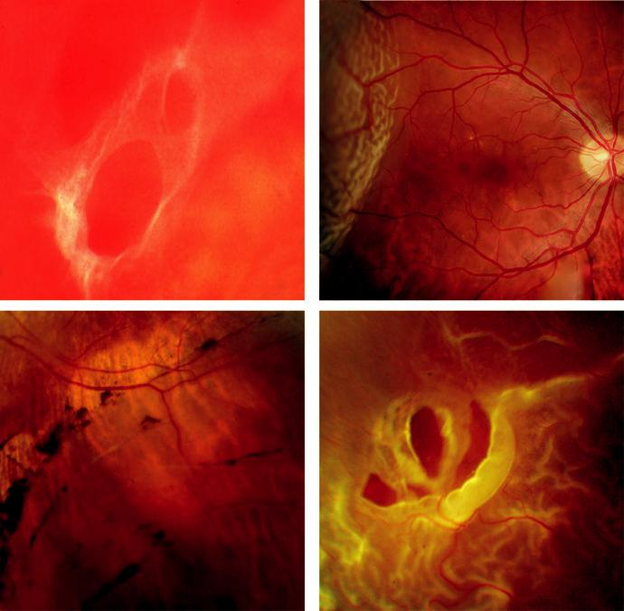

A B

C D

Fig. 16.5 Rhegmatogenous retinal detachment: (A) Weiss ring, (B) fresh detachment, (C) subretinal ‘high water’ marks, (D) PVR showing fixed folds. (Figure 16.5B courtesy of S. Chen.)

of vitreous collagen fibres, (c) a shower of minute dark or red spots that may indicate vitre-ous haemorrhage.

***Visual field defect:*** detached retina causes a progressive relative peripheral visual field defect or ‘curtain,’ in many cases eventually involving central vision.

**Signs**

***General:*** (a) relative aerent pupillary defect, (b) intraocular pressure is lower than in the normal eye, (c) mild anterior uveitis, (d) ‘tobacco dust,’ consisting of pigment cells in the anterior vitreous.

***Retinal breaks:*** appear dark orange-red; a pseudohole at the macula is frequently seen if the posterior pole is detached but rarely there may be a true macular hole.

***Fresh RD:*** detached retina is convex, slightly opaque and has a corrugated appearance (Fig. 16.5B).

***Long-standing RD:*** (a) retinal thinning (not to be mistaken for retinoschisis), (b) secondary intraretinal cysts, (c) subretinal demarcation lines (‘high water marks’) at the junction of flat and detached retina (Fig. 16.5C).

#*" ##%"#"+!#(&&%"'+$'""#* "%#! " +#!+ &)%#"$'!%

#%$%&#" (&#" +##'%(&&*'#('$%!&&#"#$+%', &)%" %'&%&%)

**310** SYNOPSIS OF CLINICAL OPHTHALMOLOGY



***Proliferative vitreoretinopathy (PVR):*** refers to a process of epiretinal and subretinal mem-brane formation leading to retinal folds and rigidity. ree grades are recognized: (a) diuse vitreous haze and tobacco dust, (b) wrinkling of the inner retinal surface, tortuosity of blood vessels, retinal stiness, decreased mobility of vitreous gel and rolled edges of retinal breaks, (c) rigid full-thickness retinal folds with heavy vitreous condensation (Fig. 16.5D).

***B-scan US:*** good mobility of the retina and vitreous in a fresh RRD. In long-standing cases there is reduction of mobility with retinal shortening and a characteristic triangular cross-sectional appearance.

**Prophylaxis:**

symptomatic retinal breaks require prophylactic treatment to reduce the risk of progression to RRD. ***Risk factors:*** (a) a tear is more prone to detach the retina than a hole, (b) a large break (Fig. 16.6A)is more likely than a small one to progress to RRD, (c) a symptomatic tear associated with acute PVD is more dangerous than a tear detected by chance, (d) superior breaks are higher risk than inferior, (e) the presence of localized SRF (‘subclinical’ RD) is a high-risk feature in a symptom-atic tear, (f) pigmentation around a break usually indicates chronicity and lower risk.

***Other considerations:*** (a) cataract surgery (particularly if associated with vitreous loss),

1. myopia, (c) family history of RRD, (d) systemic disease associated with increased RRD risk (e.g. Marfan and Stickler syndromes).

***Modalities:*** (a) surrounding the break with laser (Fig. 16.6B) using a slit-lamp delivery system (not for very peripheral breaks), (b) laser using an indirect ophthalmoscopic delivery system combined with scleral indentation, (c) cryotherapy (especially in hazy media).

**Surgery for rhegmatogenous retinal detachment**

***Urgency:*** most important consideration in an acute RRD is whether the central macula is involved (‘macula on’ or ‘macula o’); in ‘macula o’ there is less urgency than in ‘macula on’ cases. ***Pneumatic retinopexy:*** outpatient procedure for uncomplicated RRD with a small superior break or cluster of breaks. An intravitreal gas bubble is used to reattach the retina without scleral buckling (see below), with subsequent laser or cryopexy (Fig. 16.7A and B).

***Scleral buckling:*** silicone ‘explant’ sutured onto the sclera (Fig. 16.8A) creates an inward indentation (buckle), closing a retinal break by apposing the RPE to the NSR and also

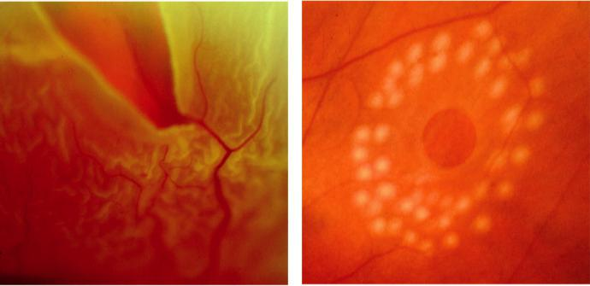

A B

Fig. 16.6 (A) Large tear, (B) laser surrounding retinal hole. (From Salmon JF, Kanski’s Clinical Ophthalmology:

A Systematic Approach, 9th edition. Oxford, UK: Elsevier; 2020.)

#*" ##%"#"+!#(&&%"'+$'""#* "%#! " +#!+ &)%#"$'!%

#%$%&#" (&#" +##'%(&&*'#('$%!&&#"#$+%', &)%" %'&%&%)

|  |  |
| --- | --- |
| Chapter 16—RETINAL DETACHMENT | **311** |
|  |  |

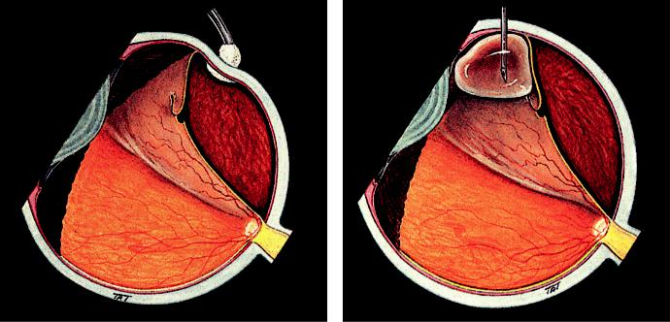

A B

Fig. 16.7 Pneumatic retinopexy: (A) cryopexy to break, (B) insertion of gas bubble. (From Salmon JF, Kanski’s

Clinical Ophthalmology: A Systematic Approach, 9th edition. Oxford, UK: Elsevier; 2020.)

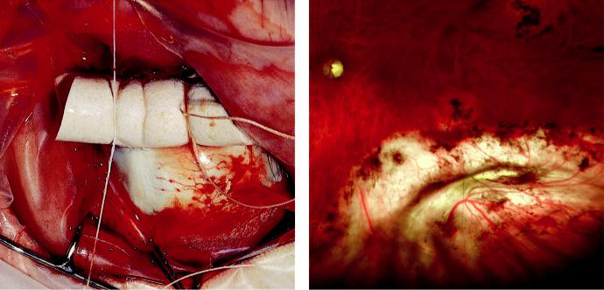

A B

Fig. 16.8 Scleral buckle: (A) short circumferential explant, (B) radial indentation with cryopexy scars. (Figure 16.8B courtesy of S. Chen.)

reducing local vitreoretinal traction. Buckles can be: (a) radial (Fig. 16.8B), (b) segmental circumferential or (c) encircling circumferential. A circumferential buckle should be used when a detachment occurs secondary to a retinal dialysis.

***Indications for drainage of SRF:*** (a) deep SRF preventing adequate cryotherapy, (b) long-standing cases in which SRF is viscous and may take a long time (many months) to absorb spontaneously without drainage.

***Clinical appearance:*** preoperative (Fig. 16.9A) and after successful reattachment (Fig. 16.9B).

***Causes of failure:*** caused by: (a) inadequate explant size (Fig. 16.9C), (b) incorrect position-ing (Fig. 16.9D), (c) missed breaks, (d) inadequate cryotherapy, (e) PVR (most common cause of late failure).

***Pars plana vitrectomy:*** (see below) is generally indicated for more complex RRD.

#*" ##%"#"+!#(&&%"'+$'""#* "%#! " +#!+ &)%#"$'!%

#%$%&#" (&#" +##'%(&&*'#('$%!&&#"#$+%', &)%" %'&%&%)

**312** SYNOPSIS OF CLINICAL OPHTHALMOLOGY

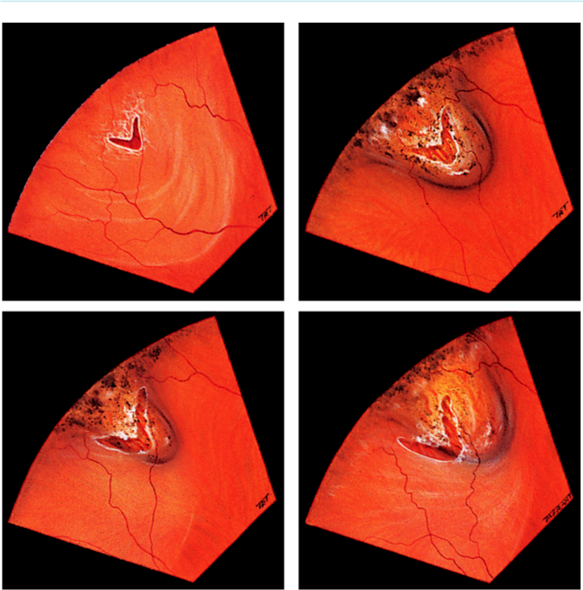

A B

C D

Fig. 16.9 Causes of failure: (A) preoperative appearance, (B) successful reattachment, (C) inadequate explant

size, (D) incorrect positioning. (From Salmon JF, Kanski’s Clinical Ophthalmology: A Systematic Approach, 9th

edition. Oxford, UK: Elsevier; 2020.)

**Tractional retinal detachment**

**Pathogenesis:**

progressive contraction of fibrovascular membranes over large areas of vitreoretinal adhesion. Main causes are proliferative retinopathy (e.g. diabetes, retinopathy of prematurity) and penetrat-ing posterior segment trauma (see Chapter 22).

**Diagnosis**

***Presentation:*** (a) photopsia and floaters are usually absent because vitreoretinal traction develops insidiously and is not associated with acute PVD, (b) any visual field defect usually progresses slowly.

***Signs:*** (a) RD has a concave configuration and breaks are absent (Fig. 16.10A), (b) SRF is shallow and immobile and seldom extends to the ora serrata.

***B-scan US:*** posterior vitreous detachment and a relatively immobile retina (Fig. 16.10B).

#*" ##%"#"+!#(&&%"'+$'""#* "%#! " +#!+ &)%#"$'!%

#%$%&#" (&#" +##'%(&&*'#('$%!&&#"#$+%', &)%" %'&%&%)

|  |  |
| --- | --- |
| Chapter 16—RETINAL DETACHMENT | **313** |
|  |  |

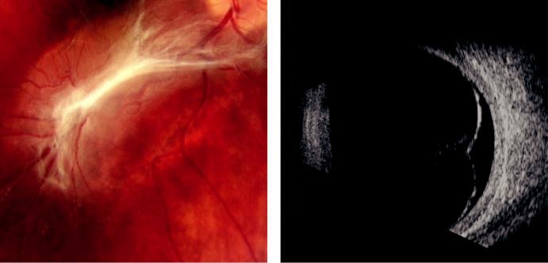

A B

Fig. 16.10 (A) Tractional retinal detachment, (B) B-scan ultrasound appearance. (Figure 16.10B courtesy of P. Terry.)

**Treatment:**

vision-threatening cases require pars plana vitrectomy (see below).

**Exudative retinal detachment**

**Pathogenesis:**

there is accumulation of SRF in the absence of retinal breaks or vitreoretinal traction. e SRF is derived from leaking vessels (e.g. choroidal tumours, severe uveitis, extensive CNV).

**Diagnosis**

***Presentation:*** (a) photopsia is absent because traction is lacking, but (b) floaters may be pres-ent if there is associated vitritis, (c) a visual field defect may develop suddenly and progress rapidly; both eyes may be involved simultaneously, depending on the cause.

***Signs:*** (a) RD has a convex configuration but in contrast to RRD its surface is smooth (Fig. 16.11A), (b) SRF is usually deep and highly mobile, exhibiting the phenomenon of ‘shifting fluid,’ (c) the cause of the RD may be apparent (e.g. choroidal tumour), (d) ‘leop-ard spots’ consisting of scattered subretinal pigment clumps may be seen after resolution (Fig. 16.11B).

**Treatment:**

depends on the cause.

**Pars plana vitrectomy**

**Introduction**

***Instrumentation:*** (a) vitreous cutter has an inner guillotine blade that operates extremely rapidly (up to 2500 times/minute or more), (b) intraocular fibre optic probe for illumina-tion, (c) infusion cannula maintains intraocular pressure, (d) accessory instruments (e.g. scissors, forceps, flute needle, endodiathermy, endolaser delivery systems) (Fig. 16.12A).

***Tamponading agents:*** achieve intraoperative retinal flattening combined with internal

drainage of SRF, and produce internal tamponade of retinal breaks postoperatively: (a) air

#*" ##%"#"+!#(&&%"'+$'""#* "%#! " +#!+ &)%#"$'!%

#%$%&#" (&#" +##'%(&&*'#('$%!&&#"#$+%', &)%" %'&%&%)

**314** SYNOPSIS OF CLINICAL OPHTHALMOLOGY

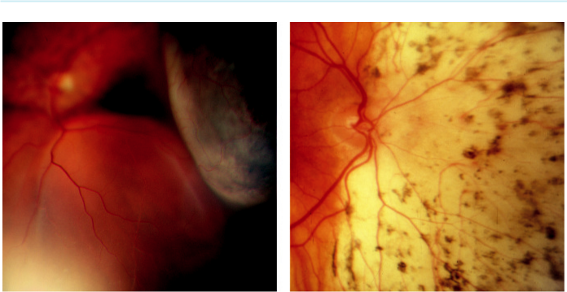

A B

Fig. 16.11 (A) Exudative retinal detachment secondary to choroidal melanoma, (B) ‘leopard spots’ seen after resorption of fluid. (Figure 16.11A courtesy of B. Damato.)

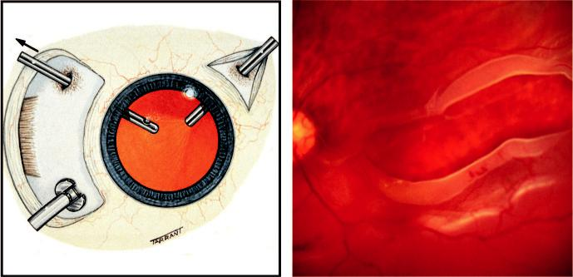

A B

Fig. 16.12 (A) Technique of pars plana vitrectomy, (B) large posterior retinal break. (Figure 16.12B courtesy of Chris Barry, Lions Eye Institute, Perth, Australia.)

(rarely used due to short duration), (b) expanding gases such as sulphur hexafluoride (SF6) and perfluoropropane (C3F8), (c) heavy liquids (perfluorocarbons – heavier than water and so remain in a dependent position in the vitreous cavity), (d) silicone oils (buoyant).

**Indications:**

pars plana vitrectomy has greatly improved the prognosis for complex RD and the threshold for using the technique has fallen during recent years. Specific indications include the following:

***RRD:*** (a) when the retina cannot be adequately visualized (e.g. haemorrhage, posterior cap-sular opacification), (b) when retinal breaks cannot be closed by scleral buckling (e.g. giant tears, large posterior breaks, PVR) (Fig. 16.12B).

***Tractional RD:*** diabetic retinopathy (e.g. when the macula is involved or threatened) and secondary to penetrating trauma.

#*" ##%"#"+!#(&&%"'+$'""#* "%#! " +#!+ &)%#"$'!%

#%$%&#" (&#" +##'%(&&*'#('$%!&&#"#$+%', &)%" %'&%&%)

|  |  |
| --- | --- |
| Chapter 16—RETINAL DETACHMENT | **315** |
|  |  |

**Postoperative complications**

***Wound leak***: after sutureless vitrectomy

***Raised intraocular pressure:*** may be caused by (a) overexpansion of intraocular gas, (b) pupil-lary block by silicone oil (prevented by performing an inferior iridotomy), (c) late silicone glaucoma caused by trabecular blockage with emulsified droplets, (d) ghost cell glaucoma. ***Cataract:*** may be (a) gas-induced (usually transient), (b) silicone oil-induced (Fig. 16.13A) also shows a superior collection of oil in the anterior chamber (hyperoleon), (c) vitrectomy-related (nuclear sclerosis).

***Band keratopathy:*** caused by prolonged contact between silicone oil and the endothelium (Fig. 16.13B).

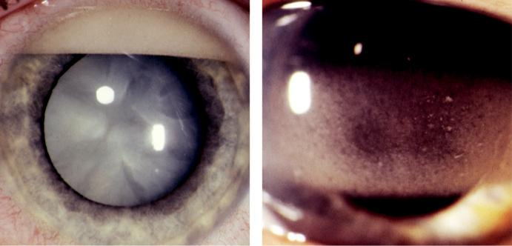

A B

Fig. 16.13 Complications of silicone oil: (A) cataract with hyperoleon, (B) band keratopathy. (From Salmon JF,

Kanski’s Clinical Ophthalmology: A Systematic Approach, 9th edition. Oxford, UK: Elsevier; 2020.)

#*" ##%"#"+!#(&&%"'+$'""#* "%#! " +#!+ &)%#"$'!%

#%$%&#" (&#" +##'%(&&*'#('$%!&&#"#$+%', &)%" %'&%&%)



C H A P T E R 17

Vitreous Opacities



C H A P T E R O U T L I N E

|  |  |
| --- | --- |
| Muscae volitantes 317 | Asteroid hyalosis 317 |
| Vitreous haemorrhage 317 | Synchysis scintillans 318 |
|  |  |

**Muscae volitantes**

Muscae volitantes are extremely common tiny fly- or worm-like physiological opacities best seen by the patient against a pale background. ey are thought to be predominantly composed of embryological remnants in the vitreous gel.

**Vitreous haemorrhage**

Vitreous haemorrhage is a relatively common condition with a number of causes (Table 17.1). In an eye with a dense vitreous haemorrhage ultrasound investigation should be undertaken to exclude a retinal detachment or choroidal melanoma.

***Presentation***: varies according to the severity of the bleed and the underlying cause. Mild haemorrhage causes sudden-onset blurring and floaters which may not aect visual acuity, whereas a dense bleed may result in severe visual loss (Fig. 17.1A).

***Terson syndrome***: this syndrome describes the combination of intraocular and subarachnoid haemorrhage secondary to rupture of a berry aneurism (Fig. 17.1B) (see Chapter 19). ***B-scan US***: initially shows a uniform appearance; once cellular aggregates develop, small focal echoes become visible.

**Asteroid hyalosis**

**Pathogenesis:**

common idiopathic degenerative process, often unilateral, in which tiny calcium pyrophosphate globules collect within the vitreous gel. e prevalence increases with age; the condition is usually asymptomatic. Because this condition rarely causes visual symptoms, dual pathology should be suspected if the visual acuity is reduced.

**Diagnosis**

***Signs***: (a) numerous small round yellow-white particles of various sizes (Fig. 17.2A),

1. mobile within the vitreous during eye movements, but not settling inferiorly when the eye is still.

***B-scan US***: high-amplitude echoes (Fig. 17.2B).

**317**

#*" ##%"#"+!#(&&%"'+$'""#* "%#! " +#!+ &)%#"$'!%

#%$%&#" (&#" +##'%(&&*'#('$%!&&#"#$+%', &)%" %'&%&%)

**318** SYNOPSIS OF CLINICAL OPHTHALMOLOGY



TABLE 17.1 Causes of vitreous haemorrhage



1. Acute posterior vitreous detachment associated either with a retinal tear or avulsion of a peripheral vessel

2. Proliferative retinopathy

* Diabetes
* Following retinal vein occlusion
* Sickle cell disease
* Eales disease
* Vasculitis

3. Miscellaneous retinal disorders

* Macroaneurysm
* Telangiectasia
* Capillary haemangioma

4. Trauma

* Blunt
* Penetrating
* Iatrogenic

5. Systemic

* Bleeding disorders
* Terson syndrome

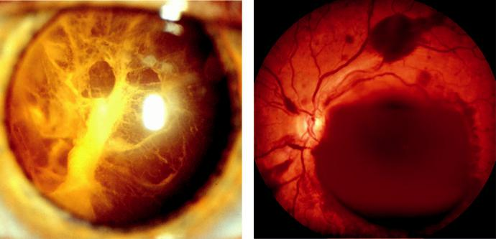

A B

Fig. 17.1 (A) Resorbing vitreous haemorrhage, (B) acute intra- and pre-retinal haemorrhage in Terson syn-drome. (Figure 17.1A courtesy of Chris Barry, Lions Eye Institute, Perth, Australia.)

**Synchysis scintillans**

**Pathogenesis:**

uncommon condition that follows a chronic vitreous haemorrhage, often in a blind eye. Usually discovered when frank haemorrhage is no longer present. e vitreous particles are derived from degraded blood cells and are composed of cholesterol.

**Diagnosis:**

numerous flat golden-brown refractile particles. In contrast to asteroid hyalosis, they tend to sedi-ment inferiorly when the eye is immobile.

#*" ##%"#"+!#(&&%"'+$'""#* "%#! " +#!+ &)%#"$'!%

#%$%&#" (&#" +##'%(&&*'#('$%!&&#"#$+%', &)%" %'&%&%)

|  |  |
| --- | --- |
| Chapter 17—VITREOUS OPACITIES | **319** |
|  |  |

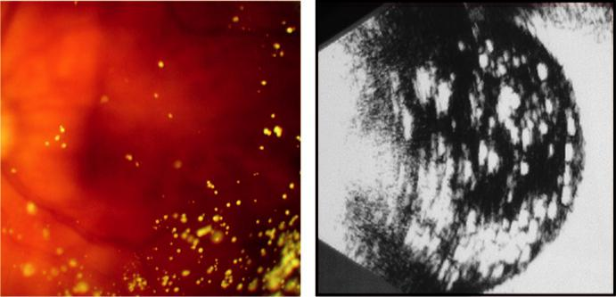

A B

Fig. 17.2 (A) Mild asteroid hyalosis, (B) appearance on B-scan ultrasound. (From Salmon JF, Kanski’s Clinical Ophthalmology: A Systematic Approach, 9th edition. Oxford, UK: Elsevier; 2020.)

#*" ##%"#"+!#(&&%"'+$'""#* "%#! " +#!+ &)%#"$'!%

#%$%&#" (&#" +##'%(&&*'#('$%!&&#"#$+%', &)%" %'&%&%)



CHAPTER 18

Strabismus



C H A P T E R O U T L I N E

Amblyopia 321

Heterophoria 322

Vergence abnormalities 323

Convergence insufficiency 323

Divergence insufficiency 323

Near reflex insufficiency 324

Spasm of the near reflex 324

Esotropia 325

Definition 325

Early onset (essential) esotropia 325 Accommodative esotropia 328

Microtropia 329

Other forms of esotropia 330

Exotropia 330

Constant (early onset) exotropia 330

Intermittent exotropia 330

Other forms of exotropia 331

Special syndromes 331

Duane retraction syndrome 331

Brown syndrome 332

Alphabet patterns 333

Strabismus surgery 334

**Amblyopia**

**Definition:**

unilateral, or rarely bilateral, subnormal best corrected visual acuity caused by form vision depriva-tion and/or abnormal binocular interaction, for which there is no identifiable pathology of the eye or visual pathway.

**Classification**

***Strabismic:*** resulting from abnormal binocular interaction in which there is continued mon-ocular suppression of the deviating eye.

***Anisometropic:*** caused by a dierence in refractive error between the eyes.

***Stimulus deprivation:*** caused by marked vision deprivation – may be unilateral or bilateral and is caused by opacities in the media (e.g. cataract) or ptosis.

***Ametropic:*** resulting from high bilateral but symmetrical refractive error (usually hypermetropia).

**Diagnosis**

In the absence of an organic lesion, a dierence in best corrected VA of two Snellen lines or more (or >1 log unit) is indicative of amblyopia.

VA in an amblyopic eye is usually better when reading single letters than when reading let-ters in a row (‘crowding’ phenomenon).

**321**

#*" ##%"#"+!#(&&%"'+$'""#* "%#! " +#!+ &)%#"$'!%

#%$%&#" (&#" +##'%(&&*'#('$%!&&#"#$+%', &)%" %'&%&%)

**322** SYNOPSIS OF CLINICAL OPHTHALMOLOGY



**Treatment**

It is essential to examine the fundi to diagnose any organic disease prior to commencing treatment.

If VA does not respond to treatment, investigations should be considered (e.g. electrodiag-nostics, imaging).

e sensitive period during which VA can be improved is usually up to about 8 years in strabismic amblyopia but may be longer for anisometropic amblyopia where good binocular vision is present.

Occlusion of the normal eye is the most eective treatment, with the regimen depending on age and amblyopia density.

e younger the patient, the more rapid the likely improvement, but the greater the risk of inducing amblyopia in the normal eye; it is essential to monitor VA in both eyes.

In general, the better the VA at the start of treatment, the shorter the duration of occlusion required.

If there has been no improvement after 6 months of eective occlusion, further treatment is unlikely to be fruitful.

Penalization of the normal eye with atropine is an alternative method. It works best in the treatment of mild–moderate amblyopia (6/24 or better). Conventionally used when compliance with occlusion is poor. It creates less of a psychosocial problem than patching, especially in a school-going child.

**Heterophoria**

**Definition:**

heterophoria (latent squint) implies a tendency of the eyes to deviate when fusion is blocked. e ‘phoria’ can be either a small inward imbalance (esophoria) or an outward imbalance (exophoria). Slight phoria is present in most normal individuals and is overcome by the fusion reflex. When fusional amplitudes are insucient to maintain alignment, sometimes at times of stress or poor health, the phoria is described as ‘decompensating’.

**Classification:**

both esophoria and exophoria can be classified by the distance at which the angle is greater:

(a) convergence excess or weakness, (b) divergence excess or weakness and (c) mixed.

**Diagnosis**

***Presentation:*** symptoms of binocular discomfort (asthenopia) or double vision (diplopia).

***Tests:*** (a) cover–uncover test detects heterophoria and should be performed both for near using an accommodative target (Fig. 18.1A) and for distance, (b) Maddox wing which dis-sociates the eyes for near fixation and measures heterophoria (Fig. 18.1B).

**Treatment**

***Refraction:*** correct significant refractive error.

***Orthoptic treatment:*** of most value in convergence weakness.

***Symptom relief:*** with temporary stick-on Fresnel prisms that may subsequently be incorpo-rated into spectacles (maximum usually 10–12 , split between the eyes).

***Surgery:*** occasionally required for large deviations.

#*" ##%"#"+!#(&&%"'+$'""#* "%#! " +#!+ &)%#"$'!%

#%$%&#" (&#" +##'%(&&*'#('$%!&&#"#$+%', &)%" %'&%&%)

|  |  |
| --- | --- |
| Chapter 18—STRABISMUS | **323** |
|  |  |

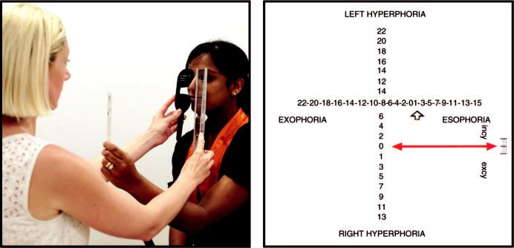

A B

Fig. 18.1 (A) Cover test using an accommodative target, (B) Maddox wing. (From Salmon JF, Kanski’s Clinical Ophthalmology: A Systematic Approach, 9th edition. Oxford, UK: Elsevier; 2020.)

**Vergence abnormalities**

**CONVERGENCE INSUFFICIENCY**

**Pathogenesis:**

convergence insuciency (CI) typically aects individuals with excessive near visual demand. Accommodative insuciency (AI) is often also present. CI is usually idiopathic and sometimes post-viral and typically aects school-age children.

**Diagnosis**

***Presentation:*** with asthenopia or diplopia.

***Signs:*** (a) reduced near point of convergence independent of any heterophoria, (b) reduced near point of accommodation in AI.

**Treatment**

Orthoptic exercises aimed at normalizing the near point and maximizing fusional amplitudes.

With good compliance symptoms should be eliminated within a few weeks, but if persistent can be treated with base-in prisms and very occasionally surgery.

With AI, the minimum reading correction to give clear vision is prescribed but is often dif-ficult to discard.

**DIVERGENCE INSUFFICIENCY**

***Pathogenesis:*** divergence paresis or paralysis is a rare condition typically associated with underlying neurological disease such as intracranial space-occupying lesions, cerebrovascu-lar accidents and head trauma.

***Presentation:*** at any age and may be dicult to dierentiate from 6th nerve palsy, but is pri - marily a concomitant esodeviation with reduced or absent divergence fusional amplitudes. ***Treatment:*** dicult; prisms are the best option.

#*" ##%"#"+!#(&&%"'+$'""#* "%#! " +#!+ &)%#"$'!%

#%$%&#" (&#" +##'%(&&*'#('$%!&&#"#$+%', &)%" %'&%&%)

**324** SYNOPSIS OF CLINICAL OPHTHALMOLOGY



**NEAR REFLEX INSUFFICIENCY**

***Pathogenesis:*** complete paralysis, in which no convergence or accommodation can be initi-ated, may be of functional origin, due to midbrain disease or may follow head trauma. ***Signs:*** (a) dual convergence and accommodation insuciency, (b) mydriasis may be seen on attempted near fixation.

***Treatment:*** reading glasses, base-in prisms, and possibly botulinum toxin (orthoptic exer-cises have no eect); it is dicult to eradicate.

**SPASM OF THE NEAR REFLEX**

**Pathogenesis:**

functional condition aecting individuals of all ages who are mainly female.

**Diagnosis**

***Presentation:*** diplopia, blurred vision, and headaches.

***Signs:*** (a) esotropia, (b) pseudomyopia, (c) miosis. Spasm may be triggered when testing ocular movements (Fig. 18.2A and B). Observation of miosis is the key to the diagnosis. Refraction with and without cycloplegia confirms pseudomyopia, which must not be cor-rected optically.

**Treatment**

***Reassurance:*** with advice to discontinue any activity that triggers the response.

***If persistent:*** atropine and a full reading correction are prescribed, but it is dicult later to abandon treatment without recurrence.

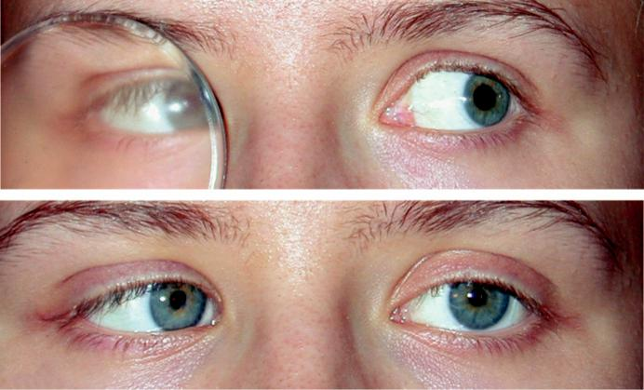

A

B

Fig. 18.2 (A) Spasm of the near reflex on testing eye movements, (B) right esotropia and miosis. (From Salmon JF, Kanski’s Clinical Ophthalmology: A Systematic Approach, 9th edition. Oxford, UK: Elsevier; 2020.)

#*" ##%"#"+!#(&&%"'+$'""#* "%#! " +#!+ &)%#"$'!%

#%$%&#" (&#" +##'%(&&*'#('$%!&&#"#$+%', &)%" %'&%&%)

|  |  |
| --- | --- |
| Chapter 18—STRABISMUS | **325** |
|  |  |



BOX 18.1 **Classification of esotropia**

**1.** Accommodative

1. Refractive

Fully accommodative

Partially accommodative

1. Non-refractive

With convergence excess

With accommodation weakness

**c.** Mixed

**2.** Non-accommodative

Essential (congenital, early onset)

Microtropia

Convergence excess

Convergence spasm

Divergence insuciency

Divergence paralysis

Sensory

Consecutive

Acute onset

Cyclic

**Esotropia**

**DEFINITION**

Esotropia (manifest convergent squint) may be concomitant or incomitant. In concomitant eso-tropia the variability of the angle of deviation is within 5 in dierent horizontal gaze positions and in an incomitant deviation the angle diers in various positions of gaze as a result of abnormal innervation or restriction. is section deals only with concomitant esotropia (classification is shown in Box 18.1).

**EARLY ONSET (ESSENTIAL) ESOTROPIA**

**Definition:**

idiopathic esotropia developing within the first 6 months of life in an otherwise normal infant with no significant refractive error and no limitation of ocular movements.

**Diagnosis**

***Angle:*** fairly large (>30 ) and stable.

***Refraction:*** normal for age (+1 to +2 D).

***Fixation:*** (a) alternates between right and left in the primary position (Fig. 18.3A and B),

1. cross-fixating in side gaze, so that the child uses the left eye in right gaze (Fig. 18.4A) and the right eye on left gaze (Fig. 18.4B). is may give a false impression of bilateral 6th nerve palsy.

***Nystagmus:*** usually horizontal; latent nystagmus (LN) is seen only when one eye is covered, when the fast phase beats toward the side of the fixating eye. e direction of the fast phase reverses according to which eye is covered.

***Manifest latent nystagmus:*** same as LN except that it is present with both eyes open, although with increased amplitude when one is covered.

***Asymmetry of optokinetic nystagmus***

#*" ##%"#"+!#(&&%"'+$'""#* "%#! " +#!+ &)%#"$'!%

#%$%&#" (&#" +##'%(&&*'#('$%!&&#"#$+%', &)%" %'&%&%)

**326** SYNOPSIS OF CLINICAL OPHTHALMOLOGY

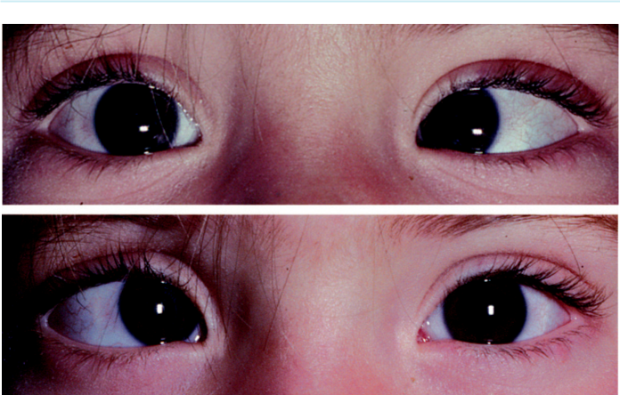

A

B

Fig. 18.3 Alternating fixation in early-onset esotropia: (A) fixating with the right eye, (B) fixating with the left eye. (Courtesy of ADN Murray.)

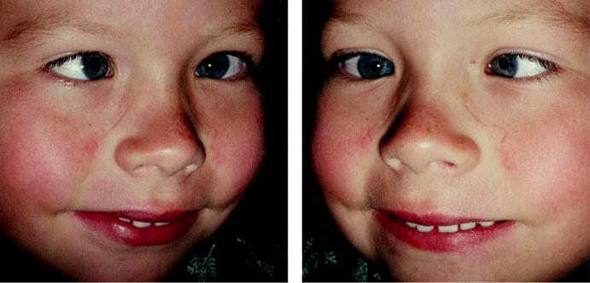

A B

Fig. 18.4 Cross-fixation in early-onset esotropia: (A) left fixation on right gaze, (B) right fixation in left gaze. (Courtesy of ADN Murray.)

***Inferior oblique overaction*** (Fig. 18.5A): may be present initially or develop later.

***Dissociated vertical deviation (DVD):*** develops in 80% by the age of 3 years and is character-ized by up-drift with excyclorotation, when the eye is covered (Fig. 18.5B), or spontaneously during periods of visual inattention.

***Diﬀerential diagnosis:*** (a) pseudostrabismus (Fig. 18.6A and B), (b) congenital bilateral 6th nerve palsy, (c) secondary (sensory) esotropia, (d) nystagmus blockage syndrome (con-vergence dampens horizontal nystagmus), (e) mechanical limitation of eye movements (e.g. Duane syndrome, Möbius syndrome, strabismus fixus).

#*" ##%"#"+!#(&&%"'+$'""#* "%#! " +#!+ &)%#"$'!%

#%$%&#" (&#" +##'%(&&*'#('$%!&&#"#$+%', &)%" %'&%&%)

|  |  |
| --- | --- |
| Chapter 18—STRABISMUS | **327** |
|  |  |

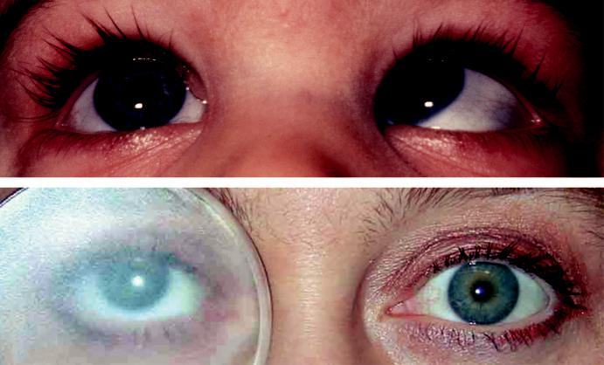

A

B

Fig. 18.5 (A) Left inferior oblique overaction, (B) dissociated vertical deviation. (From Salmon JF, Kanski’s Clinical Ophthalmology: A Systematic Approach, 9th edition. Oxford, UK: Elsevier; 2020.)

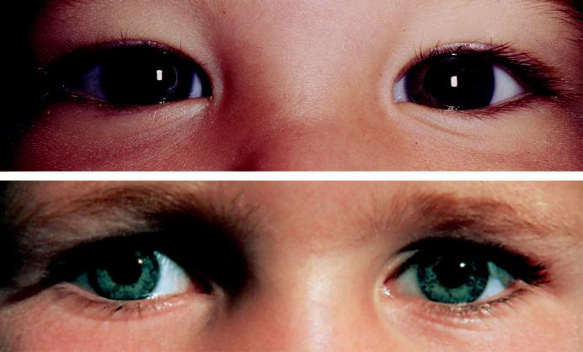

A

B

Fig. 18.6 Pseudostrabismus: (A) prominent epicanthic folds simulating esotropia, (B) wide interpupillary dis-

tance simulating exotropia. (From Salmon JF, Kanski’s Clinical Ophthalmology: A Systematic Approach, 9th

edition. Oxford, UK: Elsevier; 2020.)

**Treatment**

***Preliminar y:*** correction of amblyopia and significant refractive error.

***Initial surgery:*** early surgery oers the best chance of the development of some degree of binocular function. Ideally, the eyes should be aligned surgically to within 10 by the age

#*" ##%"#"+!#(&&%"'+$'""#* "%#! " +#!+ &)%#"$'!%

#%$%&#" (&#" +##'%(&&*'#('$%!&&#"#$+%', &)%" %'&%&%)

**328** SYNOPSIS OF CLINICAL OPHTHALMOLOGY



of 12 months and at the latest by 2 years. May involve: (a) recession of both medial recti or

1. unilateral medial rectus recession with lateral rectus resection, (c) inferior oblique over-action can be corrected at the initial operation (e.g. disinsertion, recession, myectomy) or later if it subsequently develops (commonly at age 2 years).

***Further surgery:*** required for under-correction, but an accommodative element should be suspected if the eyes are initially straight or almost straight after surgery and then start to reconverge. DVD may require specific surgery (e.g. superior rectus recession with or without posterior fixation sutures).

***Amblyopia:*** subsequently develops in approximately 50%, associated with unilateral fixation preference.

**ACCOMMODATIVE ESOTROPIA**

**Introduction:**

near vision involves both accommodation and convergence. Accommodation is the process by which the eye focuses on a near target by altering the curvature of the crystalline lens. Simultaneously, the eyes converge in order to fixate bifoveally on the target. Both accommodation and convergence are quantitatively related to the proximity of the target and have a fairly constant relationship to each other. e AC/A or ‘accommodative convergence to accommodation’ ratio is the amount of convergence in prism dioptres per dioptre change in accommodation.

**Diagnosis**

***Refractive:*** AC/A ratio is normal; (a) presents at 18 months to 3 years, (b) angle varies little (<10 ) between distance and near, (c) optical correction of the hypermetropia eliminates the deviation entirely in the fully accommodative form (Fig. 18.7A and B) but not entirely in partially accommodative (Fig. 18.8A and B).

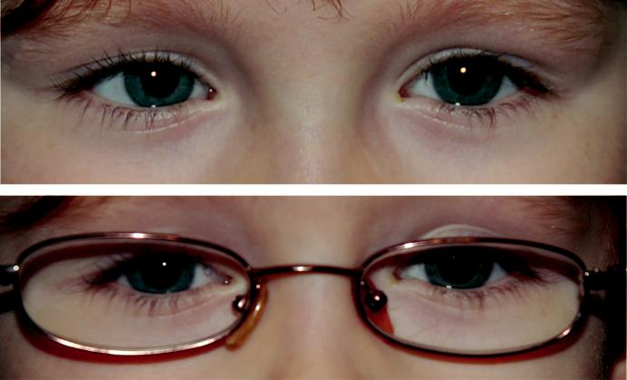

A

B

Fig. 18.7 Fully accommodative esotropia: (A) right esotropia without glasses, (B) straight eyes for near and

distance with glasses. (From Salmon JF, Kanski’s Clinical Ophthalmology: A Systematic Approach, 9th edition.

Oxford, UK: Elsevier; 2020.)

#*" ##%"#"+!#(&&%"'+$'""#* "%#! " +#!+ &)%#"$'!%

#%$%&#" (&#" +##'%(&&*'#('$%!&&#"#$+%', &)%" %'&%&%)

|  |  |
| --- | --- |
| Chapter 18—STRABISMUS | **329** |
|  |  |

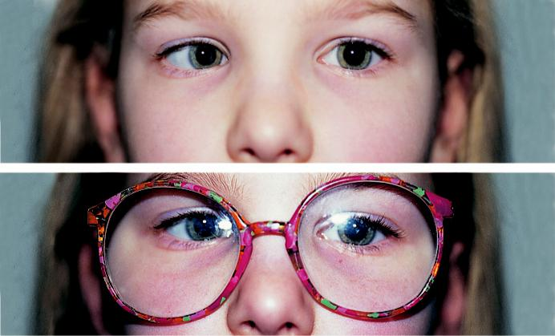

A

B

Fig. 18.8 Partially accommodative esotropia: (A) right esotropia without glasses, (B) angle is reduced but not

eliminated with glasses. (From Salmon JF, Kanski’s Clinical Ophthalmology: A Systematic Approach, 9th edition.

Oxford, UK: Elsevier; 2020.)

***Non-refractive:*** AC/A ratio is high; (a) convergence excess type (high AC/A ratio due to increased accommodative convergence; normal accommodation but increased convergence), with straight eyes for distance but esotropia for near, (b) hypoaccommodative convergence excess (high AC/A ratio due to weak accommodation necessitating increased eort, pro - ducing overconvergence), with straight eyes for distance but esotropia for near.

**Treatment**

***Fully accommodative:*** correction of full cycloplegic refractive error for children younger than 6 years and the maximally tolerated subjective correction over the age of 8 years will control the deviation for both near and distance.

***Convergence excess:*** bifocals to relieve accommodation (and thereby accommodative con-vergence), allowing ocular alignment at near. e minimum ‘add’ required is prescribed, gradually reduced and eliminated by the early teens.

***Hypoaccommodative:*** bifocals are more likely to be eective when the AC/A ratio is not overly excessive; at higher levels, surgery is the better long-term solution.

***Surgery:*** aimed at restoring or improving binocular single vision (BSV) as well as address-ing any cosmetic implications. It should only be considered if spectacles do not fully correct the deviation. Bilateral medial rectus recessions are performed in patients in whom the deviation for near is greater than that for distance.

**MICROTROPIA**

**Definition:**

small-angle (<10 ) squint, often seen in association with other forms of strabismus. For example, a patient with fully accommodative esotropia may control with glasses to a microtropia rather than true bifoveal binocular single vision.

#*" ##%"#"+!#(&&%"'+$'""#* "%#! " +#!+ &)%#"$'!%

#%$%&#" (&#" +##'%(&&*'#('$%!&&#"#$+%', &)%" %'&%&%)

**330** SYNOPSIS OF CLINICAL OPHTHALMOLOGY



**Diagnosis**

***Symptoms:*** rare unless associated with decompensating heterophoria.

***Angle:*** very small manifest deviation that may or may not be detectable on cover testing.

***Other signs:*** (a) anisometropia, (b) amblyopia of the more ametropic eye, (c) stereopsis is present but reduced.

***Central suppression scotoma (CSS):*** in the deviating eye; 4 prism test dierentiates bifo - veal fixation (normal BSV) and CSS in microtropia.

***Abnormal retinal correspondence:*** noncorresponding retinal elements acquire a common sub-jective visual direction so that fusion occurs in the presence of a small-angle manifest squint.

**Treatment:**

correction of refractive error and occlusion for amblyopia; most patients remain stable and symptom-free.

**OTHER FORMS OF ESOTROPIA**

***Near esotropia (non-accommodative convergence excess):*** (a) presentation in older children and young adults, (b) no significant refractive error, (c) esotropia for near but orthophoria or small esophoria with BSV for distance, (d) AC/A ratio normal or low, (e) normal near point of accommodation. Treatment involves bilateral medial rectus recession.

***Distance esot ropia:*** (a) presentation in young early adult life, (b) often myopic refrac-tion, (c) intermittent or constant esotropia for distance but minimal or no deviation for near. Treatment is with prisms until spontaneous resolution, or surgery in persistent cases.

***Acute (late-onset) esotropia:*** (a) presentation at approximately 5 or 6 years of age with sud-den onset of diplopia and esotropia, (b) eye movements are normal but an underlying 6th nerve palsy must be excluded. Treatment is aimed at re-establishing BSV to prevent sup-pression, using prisms, botulinum toxin, or surgery.

***Secondary (sensory) esotropia:*** caused by a unilateral reduction in VA in childhood that interferes with or abolishes fusion (e.g. cataract, optic atrophy, retinoblastoma); fundus examination is therefore essential.

***Consecutive esotropia:*** follows surgical overcorrection of an exodeviation.

**Exotropia**

**CONSTANT (EARLY ONSET) EXOTROPIA**

***Presentation:*** often at birth with a large and constant divergence. Neurological anomalies are frequently present, in contrast to early onset esotropia.

***Treatment:*** lateral rectus recession and medial rectus resection.

***Diﬀerential diagnosis:*** secondary exotropia, which may conceal serious ocular pathology.

**INTERMITTENT EXOTROPIA**

**Classification**

***Distance:*** deviation is greater for distance than near; further subdivided into ‘simulated’ and ‘true’ types.

***Nonspecific:*** deviation is the same for distance and near fixation.

***Near:*** deviation is greater for near fixation.

#*" ##%"#"+!#(&&%"'+$'""#* "%#! " +#!+ &)%#"$'!%

#%$%&#" (&#" +##'%(&&*'#('$%!&&#"#$+%', &)%" %'&%&%)

|  |  |
| --- | --- |
| Chapter 18—STRABISMUS | **331** |
|  |  |

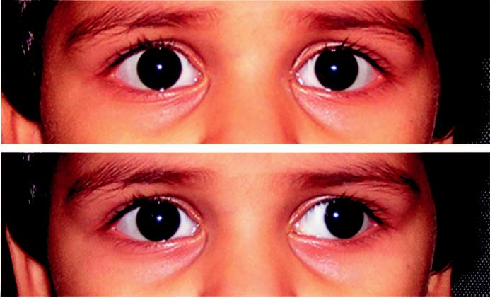

A

B

Fig. 18.9 Intermittent exotropia: (A) eyes straight most of the time, (B) left exotropia under conditions of visual inattention or fatigue. (Courtesy of M. Parulekar.)

**Diagnosis**

***P resentation:*** approximately 2 years with exophoria that breaks down to exotropia (Fig. 18.9A and B) under conditions of visual inattention, bright light (resulting in reflex closure of the aected eye) and fatigue or ill health.

***Signs:*** (a) straight with BSV at times, (b) manifest exotropia with suppression at other times.

**Treatment**

***Refraction:*** correction of myopia may control the deviation. In some cases, an over-minus prescription may be eective.

***Part-time occlusion:*** of the deviating eye may improve control.

***Orthoptic exercises:*** for near exotropia.

***Surgery***: if control is poor or is progressively deteriorating.

**OTHER FORMS OF EXOTROPIA**

***Secondary (sensory):*** caused by acquired monocular or binocular visual impairment in adult-hood. Treatment involves correction of the visual deficit where possible, followed by muscle surgery if still necessary.

***Consecutive:*** follows surgical correction of an esodeviation, or less commonly, spontaneously in an amblyopic eye.

**Special syndromes**

**DUANE RETRACTION SYNDROME**

**Pathogenesis:**

failure of innervation of the lateral rectus by the 6th nerve, with anomalous innervation of the lateral rectus by the 3rd nerve; involvement is often bilateral but asymmetrical.

#*" ##%"#"+!#(&&%"'+$'""#* "%#! " +#!+ &)%#"$'!%

#%$%&#" (&#" +##'%(&&*'#('$%!&&#"#$+%', &)%" %'&%&%)

**332** SYNOPSIS OF CLINICAL OPHTHALMOLOGY

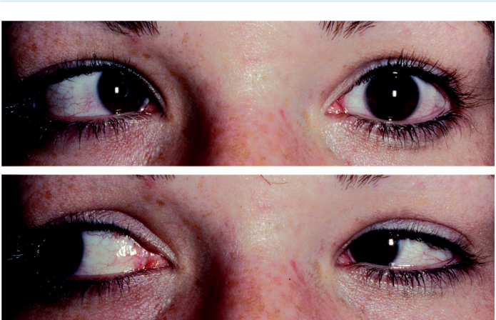

A

B

Fig. 18.10 Duane syndrome, Huber type I: (A) limited left abduction, (B) narrowing of the left palpebral fissure on adduction. (Courtesy of ADN Murray.)

**Diagnosis**

***Primary position:*** BSV often with a face turn.

***Signs:*** (a) restricted abduction (Fig. 18.10A), (b) restricted adduction, although usually only partial, (c) retraction of the globe on adduction as the result of co-contraction of the medial and lateral recti, with resultant narrowing of the palpebral fissure (Fig. 18.10B), (d) an upshoot or downshoot in adduction may be present.

***Huber classification:*** (a) type I limitation of abduction, (b) type Il limited adduction, and

(c) type III both adduction and abduction are restricted.

**Treatment**

***Conservative:*** most do not need surgery. When amblyopia is present, it is usually the result of anisometropia rather than as a consequence of strabismus.

***Surgery:*** may be indicated in young children if there is evidence of loss of BSV. In older individuals, the indication is often an uncomfortable or cosmetically unacceptable abnormal head posture (AHP).

**BROWN SYNDROME**

**Pathogenesis:**

mechanical restriction of the superior oblique muscle tendon. It is generally congenital and idio-pathic but occasionally acquired following trauma or inflammation (e.g. rheumatoid arthritis) of the trochlea or tendon; involvement is usually unilateral.

**Diagnosis**

Primary position: BSV.

Major signs of left Brown syndrome: (a) limited elevation of the left eye in adduction (Fig. 18.11A), (b) normal right elevation in abduction, (c) absence of right superior oblique overaction.

#*" ##%"#"+!#(&&%"'+$'""#* "%#! " +#!+ &)%#"$'!%

#%$%&#" (&#" +##'%(&&*'#('$%!&&#"#$+%', &)%" %'&%&%)

|  |  |
| --- | --- |
| Chapter 18—STRABISMUS | **333** |
|  |  |

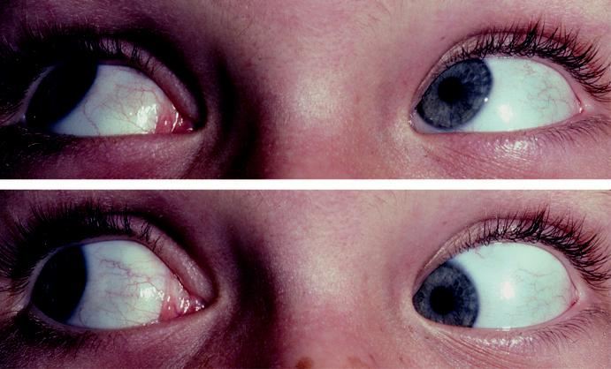

A

B

Fig. 18.11 Left Brown syndrome: (A) limited left elevation in adduction, (B) down-shoot in adduction. (Courtesy of ADN Murray.)

Variable signs: (a) downshoot in adduction (Fig. 18.11B), (b) hypotropia in the primary position, (c) AHP with chin elevation and ipsilateral head tilt.

**Treatment**

***Congenital cases:*** not usually required if BSV is maintained with an acceptable head posi-tion; lengthening of the superior oblique tendon is occasionally performed.

***Acquired cases:*** steroids (oral or peri-trochlear injection) are sometimes used.

**Alphabet patterns**

***Definition:*** ‘V ‘or ‘A’ pattern is present when there is a significant dierence in the angle of deviation between upgaze and downgaze. It is usually due to an abnormal balance of the horizontal vectors of extraocular muscles and can occur in both concomitant and incomitant strabismus.

***‘V ’ pattern:*** is significant when the dierence between upgaze and downgaze is 15 or

more (Fig. 18.12A–C). Causes include inferior oblique overaction associated with 4th nerve

palsy or childhood esotropia and Brown syndrome.

***‘A’ pattern:*** is significant when the dierence between upgaze and downgaze is 10 or more (Fig. 18.13A–C). Causes include primary superior oblique overaction and inferior oblique underaction/palsy with subsequent superior oblique overaction.

***Treatment:*** either surgery to the oblique muscles or by performing downward or upward transposition of the horizontal rectus muscles in conjunction with recessions.

#*" ##%"#"+!#(&&%"'+$'""#* "%#! " +#!+ &)%#"$'!%

#%$%&#" (&#" +##'%(&&*'#('$%!&&#"#$+%', &)%" %'&%&%)

**334** SYNOPSIS OF CLINICAL OPHTHALMOLOGY

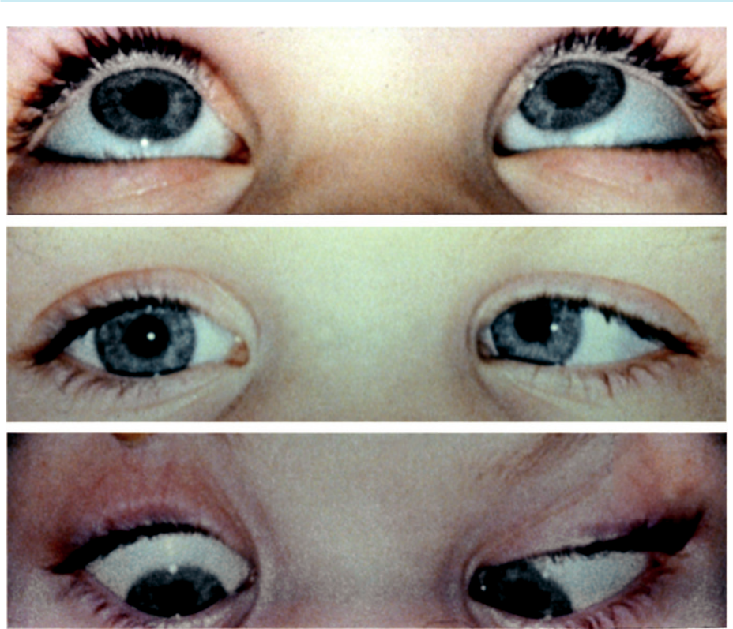

A

B

C

Fig. 18.12 ‘V’ pattern esotropia.

**Strabismus surgery**

***Aims of surgery:*** to correct misalignment of the extraocular muscles including improvement of binocular function and appearance of the patient and reduction of an AHP.

***Types of procedure:*** (a) weakening may involve recession of the muscle insertion (Fig. 18.14A and B), disinsertion/myectomy and posterior fixation suture (e.g. Faden procedure to suture the muscle belly to the sclera posteriorly so as to decrease the pull of the muscle as the eye moves into its field of action), (b) strengthening – resection (shortening; Fig. 18.15A and B), tucking (usually superior oblique) and advancement nearer to the limbus of a previously recessed muscle, (c) procedures that change the direction of muscle action (e.g. transposition for alphabet patterns).

***Adjustable sutures:*** indicated when a precise outcome is essential and when the results are likely to be unpredictable (e.g. thyroid myopathy). Following surgery, slackening or tighten-ing is carried out under topical anaesthesia (Fig. 18.16A and B).

#*" ##%"#"+!#(&&%"'+$'""#* "%#! " +#!+ &)%#"$'!%

#%$%&#" (&#" +##'%(&&*'#('$%!&&#"#$+%', &)%" %'&%&%)

|  |  |
| --- | --- |
| Chapter 18—STRABISMUS | **335** |
|  |  |

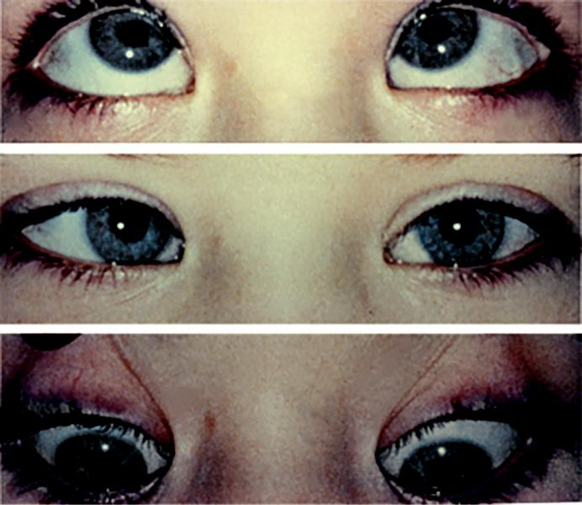

A

B

C

Fig. 18.13 ‘A’ pattern esotropia.

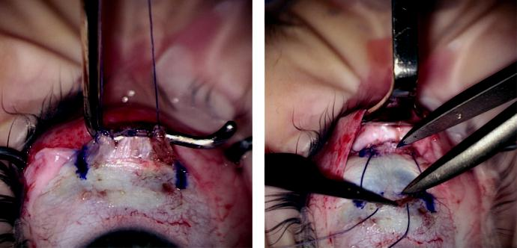

A B

Fig. 18.14 (A,B) Recession of medial rectus muscle. (Courtesy of D. Hildebrand.)

#*" ##%"#"+!#(&&%"'+$'""#* "%#! " +#!+ &)%#"$'!%

#%$%&#" (&#" +##'%(&&*'#('$%!&&#"#$+%', &)%" %'&%&%)

**336** SYNOPSIS OF CLINICAL OPHTHALMOLOGY

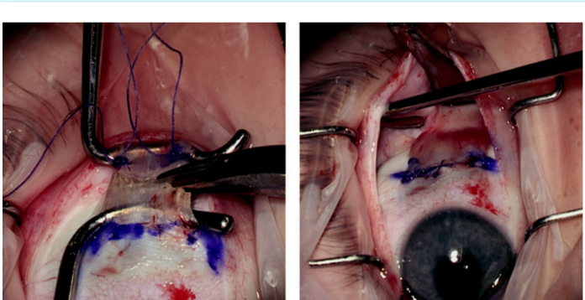

A B

Fig. 18.15 (A,B) Resection of lateral rectus muscle. (Courtesy of D. Hildebrand.)

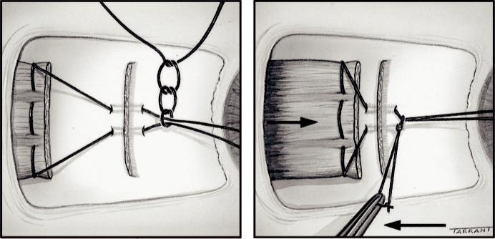

A B

Fig. 18.16 Adjustable sutures: (A) the two ends of the suture are passed through the tendon stump and a noose knot is tied, (B) the noose knot can be moved forward or backward postoperatively to adjust the muscle position. (From Salmon JF, Kanski’s Clinical Ophthalmology: A Systematic Approach, 9th edition. Oxford, UK: Elsevier; 2020.)

***Botulinum toxin chemodenervation*** (Fig. 18.17A and B): induces temporary (3 months) paralysis of an extraocular muscle by injection of botulinum toxin under topical anaesthesia using electromyographic guidance. Indications: (a) to determine the risk of postoperative diplopia, (b) assessment of the potential for BSV in a patient with a constant manifest squint, (c) symptom relief during recovery of a lateral rectus palsy.

#*" ##%"#"+!#(&&%"'+$'""#* "%#! " +#!+ &)%#"$'!%

#%$%&#" (&#" +##'%(&&*'#('$%!&&#"#$+%', &)%" %'&%&%)

|  |  |
| --- | --- |
| Chapter 18—STRABISMUS | **337** |
|  |  |

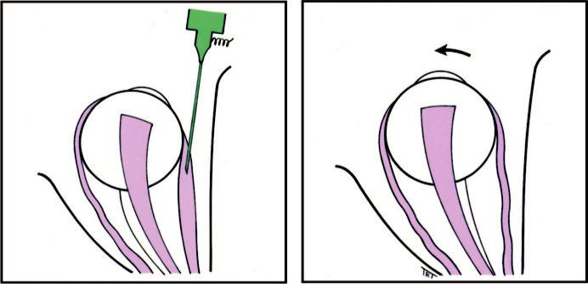

A B

Fig. 18.17 Botulinum toxin chemodenervation in left sixth nerve palsy: (A) needle in position under EMG control, (B) muscle lengthens while paralyzed and its antagonist contracts. (From Salmon JF, Kanski’s Clinical Ophthalmology: A Systematic Approach, 9th edition. Oxford, UK: Elsevier; 2020.)

#*" ##%"#"+!#(&&%"'+$'""#* "%#! " +#!+ &)%#"$'!%

#%$%&#" (&#" +##'%(&&*'#('$%!&&#"#$+%', &)%" %'&%&%)



CHAPTER 19

Neuro-Ophthalmology



C H A P T E R O U T L I N E

Optic nerve 340

Optic atrophy 340

Classification of optic neuritis 341

Demyelinating optic neuritis 341

Miscellaneous optic neuritis

(see Chapter 12) 342

Neuroretinitis 343

Non-arteritic anterior ischaemic optic neuropathy 344

Arteritic anterior ischaemic optic neuropathy 344

Posterior ischaemic optic neuropathy 346 Diabetic papillopathy 346

Leber hereditary optic neuropathy 346

Nutritional optic neuropathy (tobacco–alcohol amblyopia) 347

Papilloedema 347

Terson syndrome 349

Congenital optic disc anomalies 349

Pupils 351

Relative afferent pupillary defect (RAPD) 351

Horner syndrome (oculosympathetic palsy) 352

Adie pupil 353

Other abnormal pupillary reactions 354

Pituitary adenoma 354

Retrochiasmal pathways 356

Introduction 356

Optic tracts 356

Optic radiations 356

Ocular motor nerves 357

Third (oculomotor) nerve disease 357

Fourth (trochlear) nerve disease 360

Sixth (abducens) nerve disease 362

Supranuclear disorders of ocular motility 364

Horizontal gaze palsy 364

Vertical gaze palsy 365

Nystagmus 366

Introduction 366

Physiological nystagmus 368

Motor imbalance nystagmus 368

Sensory deprivation nystagmus 368

Surgery for nystagmus 369

Nystagmoid movements 369

Ocular myopathies 369

Myasthenia gravis 369

Myotonic dystrophy 370

Chronic progressive external

ophthalmoplegia 371

Neurofibromatosis 372

Genetics 372

NF1 372

NF2 373

Migraine 373

Neuralgias 375

Facial spasm 375

Essential blepharospasm 375 Hemifacial spasm 375

**339**

#*" ##%"#"+!#(&&%"'+$'""#* "%#! " +#!+ &)%#"$'!%

#%$%&#" (&#" +##'%(&&*'#('$%!&&#"#$+%', &)%" %'&%&%)

**340** SYNOPSIS OF CLINICAL OPHTHALMOLOGY



**Optic nerve**

**OPTIC ATROPHY**

**Classification**

***Primary:*** occurs without antecedent swelling of the optic nerve head. It may be caused by lesions from the retrolaminar optic nerve to the lateral geniculate body (Fig. 19.1A). Disease anterior to the chiasm gives rise to unilateral atrophy, while that of the chiasm and optic tract causes bilateral changes.

***Secondary:*** preceded by disc swelling (e.g. chronic papilloedema, anterior ischaemic optic neuropathy, papillitis).

***Consecutive:*** caused by disease of the inner retina or its blood supply (e.g. retinitis pigmen-tosa, central retinal artery occlusion).

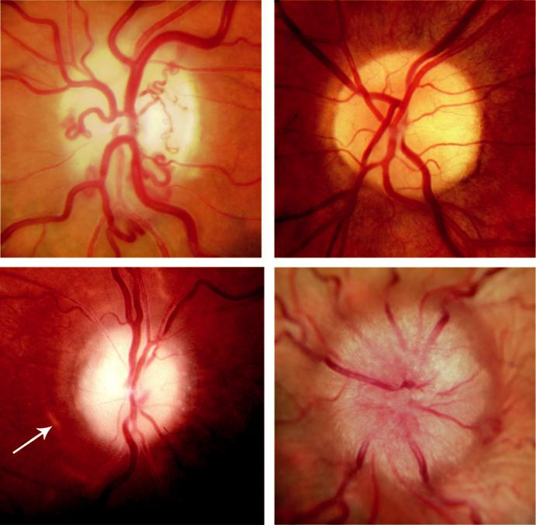

A B

C D

Fig. 19.1 Optic atrophy: (A) primary due to compression, showing shunt vessels, (B) primary due to nutritional neuropathy, (C) secondary due to chronic papilloedema, showing Paton lines, (D) papillitis.

#*" ##%"#"+!#(&&%"'+$'""#* "%#! " +#!+ &)%#"$'!%

#%$%&#" (&#" +##'%(&&*'#('$%!&&#"#$+%', &)%" %'&%&%)

|  |  |
| --- | --- |
| Chapter 19—NEURO-OPHTHALMOLOGY | **341** |
|  |  |

**Diagnosis**

***Symptoms:*** varied and dependent on cause.

***Signs:*** (a) white, flat disc with clearly delineated margins in primary (Fig. 19.1B) and con-secutive atrophy, (b) white or dirty grey, slightly raised disc with poorly delineated margins and occasionally surrounding ‘water marks’ in secondary atrophy (Fig. 19.1C). ere is also reduction in the number of surface disc vessels in all types. In primary atrophy, changes may be sectoral depending on the lesion (e.g. temporal pallor from papillomacular bundle dam-age, band atrophy with sparing of the superior and inferior portions in lesions of the chiasm or optic tract).

**CLASSIFICATION OF OPTIC NEURITIS**

***Ophthalmoscopic:*** (a) retrobulbar neuritis, in which the optic nerve head is not primarily involved and so it appears normal, (b) papillitis, characterized by disc oedema (Fig. 19.1D) and hyperaemia, that may be associated with flame-shaped peripapillary haemorrhages, (c) neuroretinitis (see below).

***Aetiological:*** (a) demyelination (most common), (b) parainfectious, following viral infec-tion or immunization, (c) infectious, which may be sinus-related or associated with sys-temic infections (e.g. syphilis, Lyme disease), (d) other (e.g. sarcoidosis, systemic lupus erythematosus).

**DEMYELINATING OPTIC NEURITIS**

**Definition:**

demyelination is a pathological process by which nerve fibres lose their insulating myelin layer, disrupting nervous conduction within the white matter tracts of the brain, brainstem and spinal cord.

**Classification:**

demyelinating diseases that may cause ocular problems include the following:

***Isolated optic neuritis:*** in a high proportion of cases, generalized disease subsequently devel-ops. e overall 15-year risk of developing multiple sclerosis (MS) following an acute epi - sode of optic neuritis is approximately 50%, but with no lesions on MRI the risk is 25% ***Multiple sclerosis:*** most common by far.

***Devic disease (neuromyelitis optica):*** bilateral optic neuritis and subsequent transverse myelitis (spinal cord demyelination).

**Diagnosis**

***Presentation:*** in 3rd to 6th decades with (a) monocular blurring, (b) occasionally phos-phenes (tiny light flashes), (c) discomfort or pain in or around the eye frequently exacer-bated by ocular movements, (d) tender globe, (e) worsening of vision on exercise or increase in body temperature (Uhtho phenomenon).

***VA:*** 6/18–6/60, occasionally worse.

***Other signs of optic nerve dysfunction:*** (see Box 19.1).

***Disc appearance***: normal in the majority of cases (retrobulbar neuritis), remainder show papillitis.

***Perimetry:*** diuse visual field depression with superimposed focal defects, typically central, altitudinal, or arcuate.

#*" ##%"#"+!#(&&%"'+$'""#* "%#! " +#!+ &)%#"$'!%

#%$%&#" (&#" +##'%(&&*'#('$%!&&#"#$+%', &)%" %'&%&%)

**342** SYNOPSIS OF CLINICAL OPHTHALMOLOGY



BOX 19.1 **Signs of optic nerve dysfunction**

Reduced VA

Relative aerent pupillary defect

Dyschromatopsia: impairment of colour vision, mainly red and green

Diminished light brightness sensitivity

Diminished contrast sensitivity

Visual field defects, varying with the underlying pathology

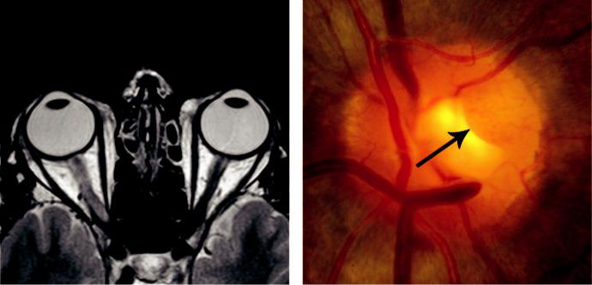

A B

Fig. 19.2 (A) Axial T2-weighted image of optic neuritis secondary to MS, (B) sarcoid granuloma of the optic nerve head (arrow).

***MRI:*** shows changes in the optic nerve on STIR imaging (Fig. 19.2A) and characteristic lesions in the white matter of the brain.

***Course:*** vision worsens over several days to 2 weeks and then begins to improve; initial recovery is fairly rapid and then there is slow improvement over months.

***Prognosis:*** 90% recover to 6/9 or better. Residual signs include: (a) abnormal colour vision and light brightness appreciation, (b) optic atrophy, (c) a mild RAPD.

**Treatment**

***Indications:*** treatment may speed recovery but does not influence eventual visual outcome. It may be considered in some circumstances such as poor vision in the fellow eye or for occupational requirements.

***Intravenous methylprednisolone:*** 1 g daily for 3 days, followed by a reducing course of oral prednisolone (1 mg/kg daily for 11 days).

***Immunomodulation therapy:*** (a) interferon-beta at the first episode of optic neuritis to reduce the risk of clinical MS, (b) glatiramer acetate to reduce the frequency of relapses,

1. natalizumab may be used for highly active relapsing-remitting MS if there has been a poor response to interferon beta or glatiramer acetate, (d) ocrelizumab may be used for highly active disease and primary progressive MS, (e) alemtuzumab may be the most cost-eective of the monoclonal antibodies because of the favourable dosing strategy.

**MISCELLANEOUS OPTIC NEURITIS (SEE CHAPTER 12)**

***Parainfectious:*** may follow various viral infections (e.g. measles, mumps, chickenpox, glan-dular fever), as well as immunization. e prognosis is usually good and treatment is not required in the majority.

#*" ##%"#"+!#(&&%"'+$'""#* "%#! " +#!+ &)%#"$'!%

#%$%&#" (&#" +##'%(&&*'#('$%!&&#"#$+%', &)%" %'&%&%)

|  |  |
| --- | --- |
| Chapter 19—NEURO-OPHTHALMOLOGY | **343** |
|  |  |

***Sinus-related:*** may be due to direct spread of infection, occlusive vasculitis and mucocoele; treatment is with antibiotics and surgical drainage.

***Cat-scratch fever (benign lymphoreticulosis):*** typically causes neuroretinitis (see below).

***Syphilis***: acute papillitis or neuroretinitis may occur during primary or secondary stages.

***Lyme disease (borreliosis):*** may cause neuroretinitis and occasionally acute retrobulbar neu-ritis, which may be associated with neurological manifestations that can mimic MS. ***Cryptococcal meningitis:*** may be associated with acute optic neuritis, which may be bilateral. ***Varicella zoster virus:*** may cause papillitis by spread from contiguous retinitis (e.g. acute retinal necrosis, progressive retinal necrosis), in herpes zoster ophthalmicus or chickenpox. ***Sarcoidosis:*** optic neuritis aects a minority of patients with neuro-sarcoid. e optic nerve head may exhibit a lumpy appearance suggestive of granulomatous infiltration (Fig. 19.2B) and there is often associated vitritis.

***Autoimmune optic nerve involvement:*** retrobulbar neuritis or anterior ischaemic optic neu-ropathy are the usual manifestations.

**NEURORETINITIS**

**Causes:**

cat-scratch fever (which is quite rare) is responsible for 60% and approximately 25% are idiopathic (Leber idiopathic stellate neuroretinitis); other causes include syphilis, Lyme disease, mumps and leptospirosis.

**Diagnosis**

***Presentation:*** gradual onset of painless unilateral visual impairment.

***VA***: variable reduction.

***Signs of optic nerve dysfunction:*** usually mild.

***Progression of fundus signs:*** (a) papillitis associated with peripapillary and macular oedema,

1. macular star develops as the disc swelling is resolving (Fig. 19.3A), (c) macular star resolves with return to normal or near-normal VA in 6–12 months.

***FA:*** shows subtle optic disc hyperfluorescence secondary to swelling (Fig. 19.3B).

**Treatment:**

varies according to cause. Recurrent idiopathic cases may require steroids and/or other immunosuppressants.

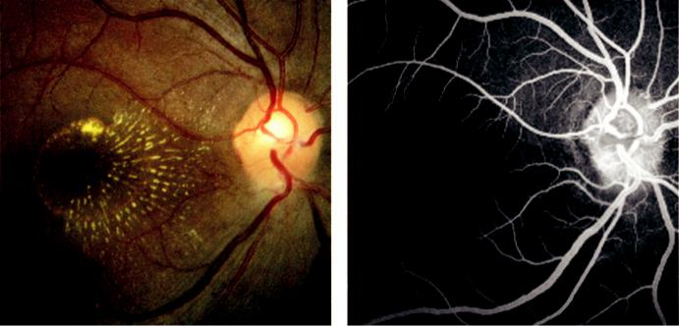

A B

Fig. 19.3 Neuroretinitis: (A) macular star, (B) papillitis.

#*" ##%"#"+!#(&&%"'+$'""#* "%#! " +#!+ &)%#"$'!%

#%$%&#" (&#" +##'%(&&*'#('$%!&&#"#$+%', &)%" %'&%&%)

**344** SYNOPSIS OF CLINICAL OPHTHALMOLOGY



**NON-ARTERITIC ANTERIOR ISCHAEMIC OPTIC NEUROPATHY**

**Pathogenesis:**

occlusion of the short posterior ciliary arteries resulting in partial or total infarction of the optic nerve head. Predispositions include: (a) structural crowding of the optic nerve head so that the physiological cup is either very small or absent, (b) cardiovascular risk factors, particularly hypertension.

**Diagnosis**

***Presentation:*** in 6th and 7th decades with sudden, painless, monocular visual loss, that is usually altitudinal in appearance.

***VA:*** normal or only slightly reduced in approximately 30%; remainder have moderate to severe impairment.

***Perimetry:*** usually inferior altitudinal defect.

***Signs:*** (a) diffuse or sectoral hyperaemic disc swelling, often associated with a few peripapillary splinter haemorrhages (Fig. 19.4A), (b) swelling gradually resolves and pallor ensues.

***Involvement of the fellow eye*** occurs in approximately 10% of patients after 2 years and 15% at 5 years. Risk factors include bilateral optic disc drusen and non-compliance with CPAP in patients with moderate/severe obstructive sleep apnoea.

***Investigations:*** (a) blood pressure, (b) fasting lipid profile and blood glucose, (c) it is critical to exclude occult giant cell arteritis (GCA see below).

**Treatment:**

there is no definitive treatment, but predisposing systemic factors should be addressed. Aspirin reduces the short-term risk of involvement of the fellow eye, but does not appear to reduce the long-term risk.

**ARTERITIC ANTERIOR ISCHAEMIC OPTIC NEUROPATHY**

**Pathogenesis:**

giant cell arteritis (GCA), a granulomatous necrotizing arteritis with a predilection for large and medium-sized arteries, including the superficial temporal. 30–50% of patients develop arteritic anterior ischaemic optic neuropathy (AAION). e disease is strongly associated with polymyal-gia rheumatica, characterized by pain and stiness in proximal muscle groups. Rare complications of GCA include dissecting aneurysm, myocardial infarction and stroke.

**Diagnosis**

Presentation of GCA: in old age.

Symptoms of GCA: (a) scalp tenderness, (b) headache, (c) jaw claudication (pain on speak-ing and chewing), (d) nonspecific symptoms such as neck pain, weight loss, fever, night sweats, malaise and depression.

Superficial temporal arteritis: thickened, tender, inflamed and nodular temporal arteries (Fig. 19.4B). Absent pulsation is strongly suggestive of GCA.

Presentation of AAION: (a) sudden profound unilateral visual loss (commonly light per-ception) that may be preceded by transient visual disturbance, (b) without treatment the fellow eye becomes involved in 30% of cases, usually within 1 week.

Signs of AAION: (a) strikingly pale oedematous disc (Fig. 19.4C), (b) swelling resolves over 1 or 2 months and atrophy ensues, (c) altitudinal visual field defect (Fig. 19.4D and Box 19.2).

#*" ##%"#"+!#(&&%"'+$'""#* "%#! " +#!+ &)%#"$'!%

#%$%&#" (&#" +##'%(&&*'#('$%!&&#"#$+%', &)%" %'&%&%)

|  |  |
| --- | --- |
| Chapter 19—NEURO-OPHTHALMOLOGY | **345** |
|  |  |

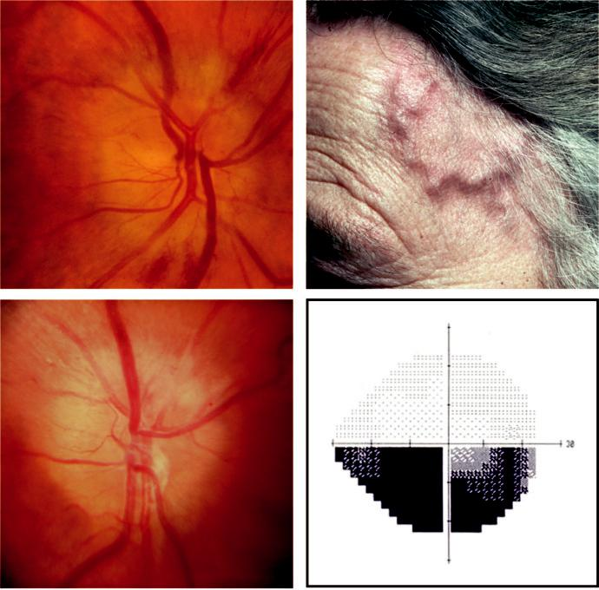

A B

C D

Fig. 19.4 Anterior ischaemic optic neuropathy: (A) disc swelling and flame-shaped haemorrhages, (B) thick-ened temporal artery, (C) pale swelling of the upper half of the optic disc in temporal arteritis, (D) lower altitu-dinal visual field defect. (Figure 19.4B courtesy of S Farley, T. Cole, and L. Rimmer.)



BOX 19.2 **Visual field defects in optic neuropathies**

**1.** Central scotoma

Demyelination

Toxic and nutritional

Leber hereditary optic neuropathy

Compression

**2.** Enlarged blind spot

Papilloedema

Congenital anomalies

**3.** Respecting horizontal meridian

Anterior ischaemic optic neuropathy

Glaucoma

Disc drusen

**4.** Upper temporal defects not respecting vertical meridian Tilted discs

#*" ##%"#"+!#(&&%"'+$'""#* "%#! " +#!+ &)%#"$'!%

#%$%&#" (&#" +##'%(&&*'#('$%!&&#"#$+%', &)%" %'&%&%)

**346** SYNOPSIS OF CLINICAL OPHTHALMOLOGY



Investigations: (a) ESR is often very high (60 mm/hour or more), although normal in approximately 20%, (b) C-reactive protein is invariably raised and may be helpful when ESR is equivocal, (c) platelet levels may be elevated, (d) ultrasound of the temporal artery shows a hypoechoic halo around the temporal artery lumen in 75%.

Temporal artery biopsy: should be performed urgently if GCA is suspected. Steroids (see below) should not be withheld pending biopsy.

**Treatment**

***Aims:*** mainly to prevent blindness of the fellow eye. Very rarely, prompt treatment may result in improvement in the primary eye.

***Regimen:*** (a) intravenous methylprednisolone 500 mg–1 g/day for 3 days followed by long-term oral prednisolone, (b) oral prednisolone alone in some circumstances, (c) antiplatelet therapy (e.g. aspirin) to reduce the risk of stroke and visual loss, (d) immunosuppressants in steroid-resistant cases or as steroid-sparing agents.

**POSTERIOR ISCHAEMIC OPTIC NEUROPATHY**

Ischaemia of the retrolaminar portion of the optic nerve is much less common than the anterior variety. It is a diagnosis of exclusion and may be of the following types:

***Operative posterior ischaemic optic neuropathy (PION):*** develops following a variety of sur-gical procedures (e.g. cardiac, spinal). Bilateral involvement is common and the visual prog-nosis is often poor.

***Arteritic PION:*** associated with GCA and carries a poor visual prognosis.

***Non-arteritic PION:*** associated with the same systemic risk factors as the anterior variety apart from crowded optic discs.

**DIABETIC PAPILLOPATHY**

**Pathogenesis:**

occurs in both type 1 and type 2 diabetics, probably due to small-vessel disease but is milder than AION.

**Diagnosis**

***VA:*** 6/12 or better.

***Signs:*** (a) unilateral or bilateral mild disc swelling and hyperaemia, (b) disc surface telangi-ectasia is common.

***Course:*** usually several months.

**Treatment:**

systemic steroids are of questionable benefit.

**LEBER HEREDITARY OPTIC NEUROPATHY**

**Genetics:**

maternally inherited mitochondrial DNA mutation. Typically aects males, but asymptomatic female relatives may show telangiectatic microangiopathy.

**Diagnosis**

***Presentation:*** between the 2nd and 4th decades with acute or subacute severe, painless, unilateral loss of central vision. e fellow eye is aected within weeks or months.

#*" ##%"#"+!#(&&%"'+$'""#* "%#! " +#!+ &)%#"$'!%

#%$%&#" (&#" +##'%(&&*'#('$%!&&#"#$+%', &)%" %'&%&%)

|  |  |
| --- | --- |
| Chapter 19—NEURO-OPHTHALMOLOGY | **347** |
|  |  |

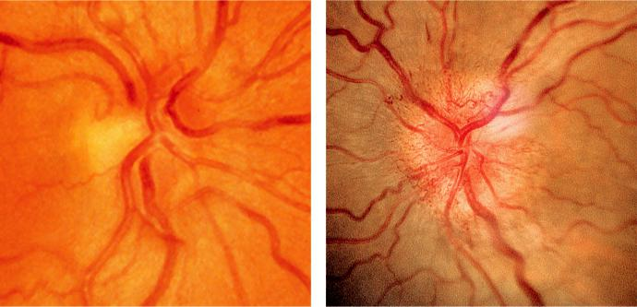

A B

Fig. 19.5 Leber hereditary optic neuropathy: (A) acute stage showing hyperaemic disc swelling, (B) telangi-ectatic microangiopathy.

***Acute signs:*** (a) often subtle disc hyperaemia with obscuration of margins (Fig. 19.5A),

1. surface telangiectasia (Fig. 19.5B), (c) swelling of the peripapillary nerve fibre layer,
2. dilatation and tortuosity of posterior pole vasculature, (e) FA shows absence of leakage; pupillary light reactions may remain brisk.

***Course:*** vessels regress, swelling resolves and severe optic atrophy supervenes with a final VA of 6/60 or less.

***Perimetry:*** central or centrocaecal scotomas.

**Treatment:**

generally ineective; smoking and excessive consumption of alcohol should be discouraged.

**NUTRITIONAL OPTIC NEUROPATHY (TOBACCO–ALCOHOL AMBLYOPIA)**

**Pathogenesis:**

deficiency in protein and B vitamins after dietary neglect, particularly aecting heavy drinkers and cigar smokers. Some also have defective vitamin B12 absorption and may develop pernicious anaemia.

**Diagnosis**

***Presentation:*** insidious onset of progressive, usually symmetrical, bilateral visual impair-ment associated with dyschromatopsia.

***Discs:*** normal at presentation in most cases, although some show subtle pallor (see Fig. 19.1B)

***Perimetry:*** bilateral centrocaecal scotomas, easier to plot and larger with a red target.

**Treatment:**

abstention from drinking and smoking; intramuscular hydroxocobalamin and oral multivitamins, including thiamine and folate.

**PAPILLOEDEMA**

**Pathogenesis:**

swelling of the optic nerve head secondary to raised intracranial pressure. It is nearly always bilateral, although it may be asymmetrical. Causes of raised intracranial pressure: (a) idiopathic

#*" ##%"#"+!#(&&%"'+$'""#* "%#! " +#!+ &)%#"$'!%

#%$%&#" (&#" +##'%(&&*'#('$%!&&#"#$+%', &)%" %'&%&%)

**348** SYNOPSIS OF CLINICAL OPHTHALMOLOGY



intracranial hypertension (pseudotumour cerebri), (b) space-occupying intracranial lesions, (c) cerebral venous sinus thrombosis, (d) severe systemic hypertension.

**Diagnosis**

***General symptoms:*** (a) headache occurs early in the morning and may wake the patient from sleep; may intensify with head movement, bending, or coughing, (b) sudden nausea and vomiting, often projectile, and sometimes (c) deterioration of consciousness.

***Visual symptoms:*** (a) normal visual acuity, but transient obscurations lasting a few seconds,

1. horizontal diplopia (due to stretching of one or both 6th nerves over the petrous tip) is a false localizing sign, (c) persistent visual loss in long-standing papilloedema with secondary optic atrophy (see below).

***Early papilloedema:*** (a) mild disc hyperaemia with preservation of the optic cup, (b) indis-tinct peripapillary retinal nerve striations and disc margins (Fig. 19.6A), (c) loss of previous spontaneous venous pulsation (also absent in 20% of normal individuals).

***Established papilloedema:*** (a) severe disc hyperaemia (Fig. 19.6B), (b) moderate disc eleva-tion with absence of the cup, (c) venous engorgement, (d) peripapillary flame haemorrhages

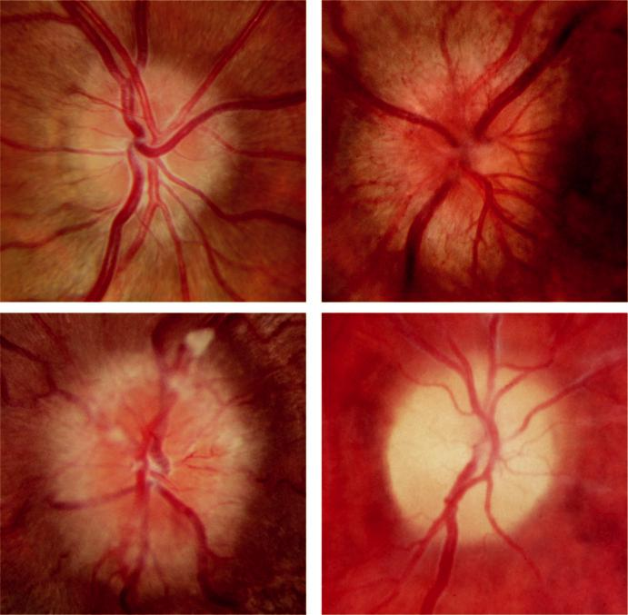

A B

C D

Fig. 19.6 Papilloedema: (A) early, (B) acute established, (C) chronic, (D) atrophic.

#*" ##%"#"+!#(&&%"'+$'""#* "%#! " +#!+ &)%#"$'!%

#%$%&#" (&#" +##'%(&&*'#('$%!&&#"#$+%', &)%" %'&%&%)

|  |  |
| --- | --- |
| Chapter 19—NEURO-OPHTHALMOLOGY | **349** |
|  |  |

and cotton wool spots, (e) circumferential retinal folds (Paton lines), (f ) hard exudates that typically radiate from the centre of the fovea.

***Chronic papilloedema:*** (a) severe disc elevation (Fig. 19.6C), (b) absence of cotton wool spots and haemorrhage, (c) optociliary shunts, (d) drusen-like crystalline surface deposits (uncommon).

***Atrophic papilloedema:*** (a) discs are dirty grey and slightly elevated, with (b) few crossing blood vessels, (c) indistinct margins (secondary optic atrophy; Fig. 19.6D).

***Perimetry:*** blind spot is enlarged in the early established stages; atrophy may be associated with constriction.

***Investigations:*** to determine the cause. MR, CT and B-scan US show an enlarged optic nerve diameter in most cases.

**TERSON SYNDROME**

***Definition:*** combination of intraocular and subarachnoid haemorrhage secondary to rup-ture of an intracranial aneurysm. Intraocular haemorrhage may also occur with subdural haematoma and acute elevation of intracranial pressure from other causes.

***Intraocular haemorrhage:*** frequently bilateral and typically intraretinal and/or preretinal (subhyaloid; see Fig. 17.1B), although occasionally subhyaloid blood may break into the vitre-ous; probably caused by retinal venous stasis secondary to increased cavernous sinus pressure. ***Prognosis:*** usually good as the blood commonly resolves spontaneously within a few months. Early vitrectomy may be considered for dense bilateral haemorrhage.

**CONGENITAL OPTIC DISC ANOMALIES**

***Tilted optic disc:*** (a) oblique entry of the optic nerve into the globe, with (b) angulation of the cup axis and elevation of the neuroretinal rim, (c) associated findings include inferonasal chorioretinal thinning (Fig. 19.7A), (d) myopic astigmatic refractive error, (e) perimetry may show superotemporal defects that do not respect the vertical midline.

***Optic disc pit:*** (a) large disc, (b) round or oval pit of variable size, usually located temporally (Fig. 19.7B), (c) perimetry may show glaucoma-like defects, (d) serous macular detachment (in 50%).

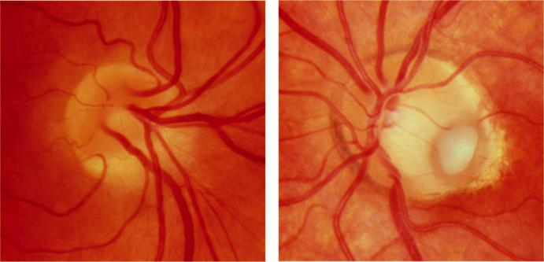

A B

Fig. 19.7 (A) Tilted optic disc, (B) optic disc pit.

#*" ##%"#"+!#(&&%"'+$'""#* "%#! " +#!+ &)%#"$'!%

#%$%&#" (&#" +##'%(&&*'#('$%!&&#"#$+%', &)%" %'&%&%)

**350** SYNOPSIS OF CLINICAL OPHTHALMOLOGY

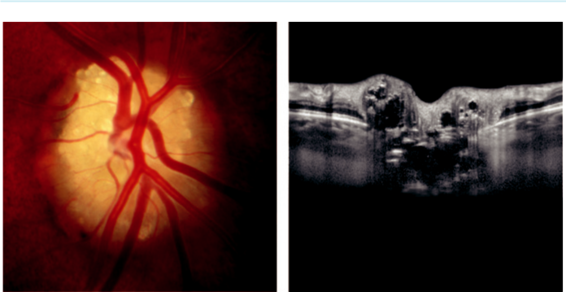

A B

Fig. 19.8 Optic disc drusen: (A) clinical appearance, (B) OCT appearance.

***Optic disc drusen:*** (a) waxy pearl-like deposits of calcific material (Fig. 19.8A) present in approximately 0.3% of the population, (b) dicult to detect in early childhood because they lie deep to the disc surface and may mimic papilloedema, (c) anomalous vascular patterns, (d) associations include retinitis pigmentosa and angioid streaks, (e) complica-tions (rare) include juxtapapillary CNV and progressive, but limited visual field defects, (f ) drusen can be demonstrated on OCT (Fig. 19.8B), autofluorescent imaging, and B-scan US.

***Optic disc coloboma:*** unilateral or bilateral; (a) glistening white bowl-shaped excavation so that the inferior neuroretinal rim is thin or absent, (b) may be associated with an adjacent choroidal and iris coloboma (Fig. 19.9A), (c) perimetry shows a superior defect, (d) sys-temic associations (uncommon) include chromosomal and CNS anomalies and CHARGE syndrome.

***Morning glory anomaly:*** unilateral; (a) large disc with a funnel-shaped excavation sur-rounded by an annulus of chorioretinal disturbance (Fig. 19.9B), (b) white tuft of glial tissue overlies the central portion, (c) blood vessels emerge radially from the rim of the excavation,

1. serous retinal detachment (in 30%), (e) systemic associations (uncommon) include fron-tonasal dysplasia (mid-facial anomalies, basal encephalocele, midline brain malformations) and NF2.

***Optic nerve hypoplasia:*** may occur as an (a) isolated anomaly in a normal eye, (b) in a grossly malformed eye, or (c) in association with systemic disorders, typically involving midline brain structures (e.g. de Morsier syndrome – septo-optic dysplasia – in approximately 10%). Maternal ingestion of predisposing agents (e.g. steroids, alcohol, anticonvulsants) during pregnancy has been implicated. (a) VA ranges from normal to no light perception, (b) small grey disc, (c) surrounding yellow halo of hypopigmentation (double-ring sign; Fig. 19.9C),

1. retinal vascular tortuosity (common).

***Myelinated nerve f ibres:*** (a) white feathery streaks running within the retinal nerve fibre layer from the disc (Fig. 19.9D), (b) ocular associations of extensive myelination include high myopia, anisometropia and amblyopia, (c) systemic associations include NF1.

***Aicardi syndrome:*** X-L dominant condition that is lethal *in utero* in males; (a) bilateral multiple depigmented chorioretinal lacunae clustered around the disc, (b) disc may be

#*" ##%"#"+!#(&&%"'+$'""#* "%#! " +#!+ &)%#"$'!%

#%$%&#" (&#" +##'%(&&*'#('$%!&&#"#$+%', &)%" %'&%&%)

|  |  |
| --- | --- |
| Chapter 19—NEURO-OPHTHALMOLOGY | **351** |
|  |  |

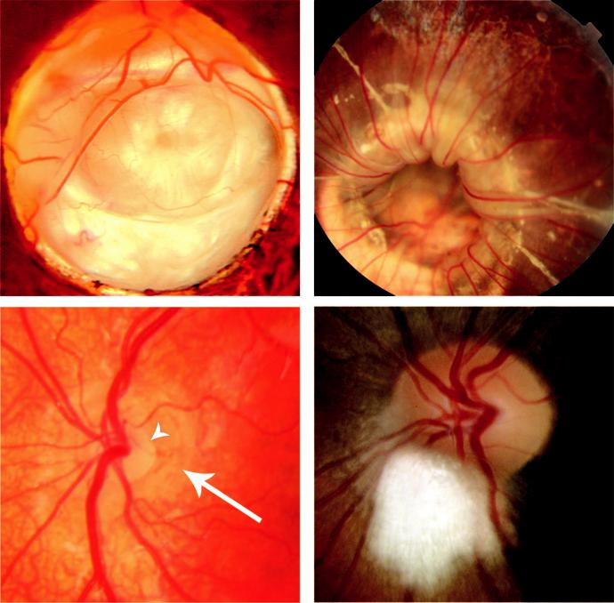

A B

C D

Fig. 19.9 (A) Large disc coloboma, (B) ‘morning glory’ optic disc anomaly, (C) hypoplastic disc showing the double ring sign (arrowhead shows the edge of the disc and the arrow shows the edge of the visible sclera), (D) myelinated nerve fibres. (Figure 19.9A courtesy of P. Gili, Figure 19.9C courtesy of D. Hildebrand.)

hypoplastic, colobomatous, or pigmented, (c) ocular associations include microphthalmos and iris colobomas, (d) systemic associations a range of severe CNS and skeletal anomalies. ***Optic disc dysplasia:*** markedly deformed disc that does not conform to any recognizablecategory described above.

**Pupils**

Anatomy: e light reflex is mediated by the photoreceptors and is subserved by four neurons (Fig. 19.10A*)*.

**RELATIVE AFFERENT PUPILLARY DEFECT (RAPD)**

***Marcus Gunn pupil:*** a relative aerent pupillary defect is caused by an incomplete optic nerve lesion or by severe retinal disease, but never by a dense cataract. e pupils respond weakly to stimulation of the diseased eye and briskly to that of the normal eye. e dier - ence between the pupillary reactions of the two eyes is highlighted by the ‘swinging flash-light’ test (Fig. 19.10 B and C).

#*" ##%"#"+!#(&&%"'+$'""#* "%#! " +#!+ &)%#"$'!%

#%$%&#" (&#" +##'%(&&*'#('$%!&&#"#$+%', &)%" %'&%&%)

**352** SYNOPSIS OF CLINICAL OPHTHALMOLOGY

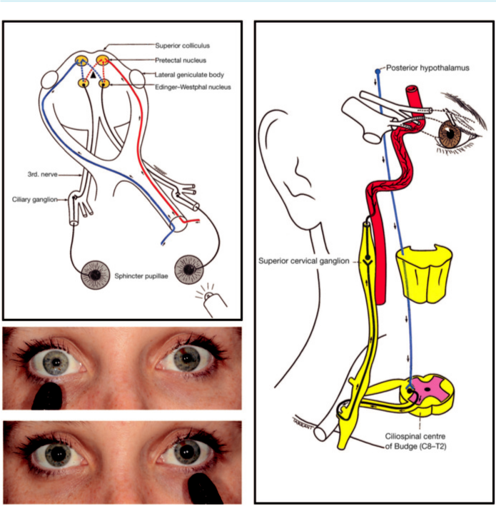

A

B

C D

Fig. 19.10 (A) Anatomical pathway of the pupillary light reflex, (B and C) ‘swinging flashlight test’ in a left affer-ent pupillary defect, (D) anatomical pathway of the sympathetic nerve supply.

**HORNER SYNDROME (OCULOSYMPATHETIC PALSY)**

**Pathogenesis:**

damage to the sympathetic nervous supply of the eye, which involves three neurons (Fig. 19.10D).

**Anatomy and causes**

***First (central) neuron:*** originates in the posterior hypothalamus and descends down the brainstem to terminate in the ciliospinal centre of Budge, between C8 and T2 in the spinal cord. Causes of damage include brain stem disease (e.g. stroke, tumours).

***Second (preganglionic) neuron:*** passes from the ciliospinal centre to the superior cervical ganglion in the neck, where it can be damaged by apical lung disease and neck lesions including surgery.

***ird (postganglionic) neuron:*** ascends along the internal carotid artery to enter the cavern-ous sinus where it joins the ophthalmic division of the trigeminal nerve; sympathetic fibres reach the ciliary body and the dilator pupillae muscle via the nasociliary nerve and the long ciliary nerves. Causes of damage include internal carotid artery dissection, cavernous sinus lesions, and otonasopharyngeal disease.

#*" ##%"#"+!#(&&%"'+$'""#* "%#! " +#!+ &)%#"$'!%

#%$%&#" (&#" +##'%(&&*'#('$%!&&#"#$+%', &)%" %'&%&%)

|  |  |
| --- | --- |
| Chapter 19—NEURO-OPHTHALMOLOGY | **353** |
|  |  |

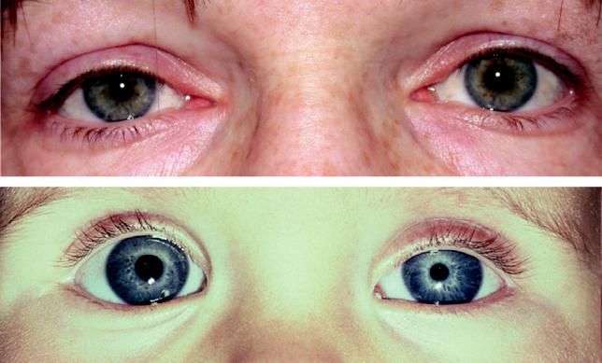

A

B

Fig. 19.11 Horner syndrome: (A) mild ptosis, (B) miosis (in a child). (Figure 19.11B courtesy of ADN Murray.)

**Diagnosis**

Most cases are unilateral.

***Mild ptosis:*** (1 or 2 mm) due to weakness of Müller muscle (Fig. 19.11A).

***Miosis*** due to the unopposed action of the sphincter pupillae (Fig. 19.11B). Miosis is accen-tuated in dim light since a Horner pupil will not dilate, unlike its fellow.

***Hypochromic heterochromia:*** in congenital or long-standing lesions.

***Slight elevation of the inferior eyelid:*** due to weakness of the inferior tarsal muscle.

***Reduced ipsilateral sweating (anhidrosis):*** occurs if the lesion is below the superior cervical ganglion, because the sudomotor fibres supplying the skin of the face take a separate path along the external carotid artery.

***Pharmacological tests:*** (a) apraclonidine 0.5% or 1.0% is instilled into both eyes – Horner pupil will dilate but a normal pupil is unaected (there is a latent period of 2–7 days before the test becomes positive), (b) cocaine 4% is instilled into both eyes to ascertain the diag-nosis – a normal pupil will dilate but a Horner pupil will not, (c) hydroxyamphetamine 1%

– both pupils will dilate in a preganglionic lesion but in a postganglionic lesion a Horner pupil will not dilate, (d) adrenaline 0.1% – in a preganglionic lesion neither pupil will dilate, whereas in a postganglionic lesion the Horner pupil will dilate.

**ADIE PUPIL**

**Pathogenesis:**

denervation of the postganglionic supply to the sphincter pupillae and the ciliary muscle that may follow a viral illness. One eye is involved in 80% of cases, although the fellow eye will often be aected later. Associated diminished deep tendon reflexes (Holmes–Adie syndrome) and wider autonomic dysfunction are common.

**Diagnosis**

***Presentation:*** early adult life, usually by noticing a dilated pupil.

***Pupil size:*** large regular pupil (Fig. 19.12A – right eye); in long-standing cases the pupil may become small.

#*" ##%"#"+!#(&&%"'+$'""#* "%#! " +#!+ &)%#"$'!%

#%$%&#" (&#" +##'%(&&*'#('$%!&&#"#$+%', &)%" %'&%&%)

**354** SYNOPSIS OF CLINICAL OPHTHALMOLOGY

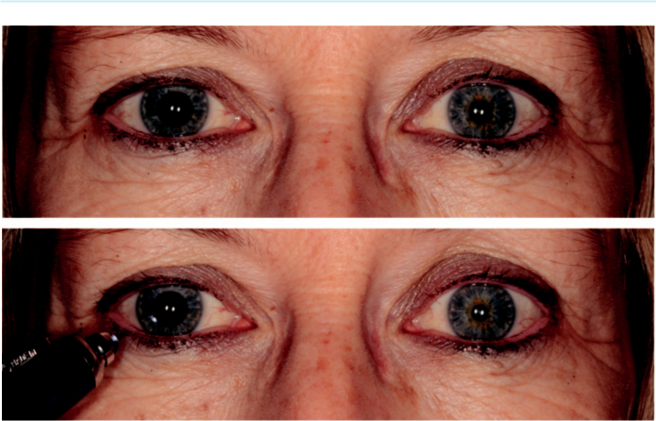

A

B

Fig. 19.12 Right Adie pupil: (A) large right pupil, (B) absent direct light reflex.

***Pupillary light reflex:*** (a) direct is absent or sluggish (Fig. 19.12B) and is associated with ver-miform movements of the pupillary border, (b) consensual reflex is also absent or sluggish. ***Pupillary near reflex:*** slow constriction followed by slow dilatation (tonicity). ***Accommodation:*** may manifest similar tonicity.

***Pharmacological test:*** 2.5% methacholine or 0.125% pilocarpine is instilled into both eyes – Adie pupil will constrict (denervation hypersensitivity), but not the normal pupil.

**OTHER ABNORMAL PUPILLARY REACTIONS**

***Argyll Robertson pupils:*** classically caused by neurosyphilis; (a) in dim light both pupils are small and may be irregular, (b) lack of constriction to light but normal to accommodation (light-near dissociation), (c) do not dilate well in the dark.

***Tectal (dorsal midbrain) pupils:*** (a) bilateral mydriasis in dim light, which may be asym-metrical, (b) light-near dissociation, (c) other signs of Parinaud (dorsal midbrain) syndrome.

**Pituitary adenoma**

**Anatomy**

***Sella turcica:*** a depression in the superior surface of the body of the sphenoid bone in which the pituitary gland lies (Fig. 19.13A).

***Diaphragma sellae:*** the dural roof of the sella. Tumours less than 10 mm in diameter tend to remain confined to the sellae.

***Optic nerve and chiasm:*** lie above the diaphragma sellae. Compression by a pituitary ade-noma causes a bitemporal hemianopia, starting with the upper visual field (Fig. 19.13B).

**Classification**

***Basophil adenoma:*** secretes adrenocorticotrophic hormone and causes Cushing disease. Bitemporal hemianopia is uncommon with secreting pituitary adenomas, which tend to

#*" ##%"#"+!#(&&%"'+$'""#* "%#! " +#!+ &)%#"$'!%

#%$%&#" (&#" +##'%(&&*'#('$%!&&#"#$+%', &)%" %'&%&%)

|  |  |
| --- | --- |
| Chapter 19—NEURO-OPHTHALMOLOGY | **355** |
|  |  |

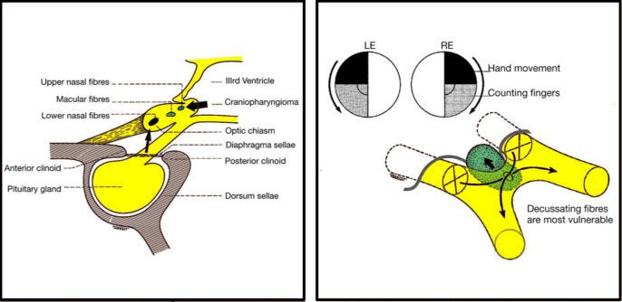

A B

Fig. 19.13 (A) Anatomy of the chiasm in relation to the pituitary gland, (B) typical progression of bitemporal hemianopia caused by compression of the chiasm from below by a pituitary adenoma.

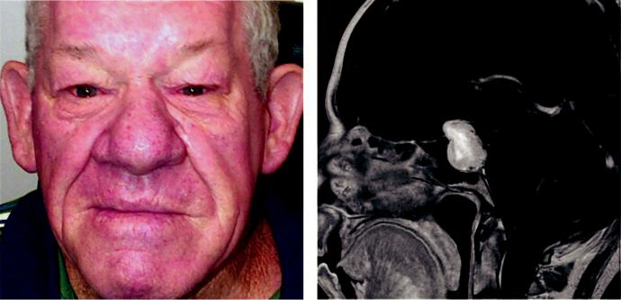

A B

Fig. 19.14 (A) Acromegaly, (B) sagittal TI-weighted gadolinium-enhanced MR of a pituitary adenoma com-pressing the optic chiasm.

present with systemic features of hypersecretion. Treatment is with surgery and medical suppression of cortisol secretion.

***Acidophil adenoma:*** causes gigantism in children and acromegaly in adults, due to excessive growth hormone (Fig. 19.14A). Bitemporal hemianopia and optic atrophy are relatively common. Treatment options include bromocriptine, radiotherapy and trans-sphenoidal hypophysectomy.

***Chromophobe adenoma:*** may secrete prolactin (prolactinoma) or be non-secreting. It is the most common primary intracranial tumour to produce neuro-ophthalmological features. Presentation is typically during early adult life or middle age with nonspecific headache or symptoms of endocrine disturbance. Treatment may involve bromocriptine, radiotherapy or surgery.

#*" ##%"#"+!#(&&%"'+$'""#* "%#! " +#!+ &)%#"$'!%

#%$%&#" (&#" +##'%(&&*'#('$%!&&#"#$+%', &)%" %'&%&%)

**356** SYNOPSIS OF CLINICAL OPHTHALMOLOGY



**Diagnosis**

***Presentation:*** may not present until central vision is aected from pressure on macular fibres in the chiasm.

***Colour desaturation:*** across the vertical midline of the uniocular visual field is an early sign of chiasmal compression; can be detected simply using a red target.

***Optic atrophy:*** present in approximately 50% of cases with field defects.

***Field loss:*** extensive loss of the temporal visual field in both eyes which can cause: (a) post-fixational blindness, (b) disrupt sensory fusion, (c) decompensated phoria, (d) problems with near vision.

***Dierential diagnosis of bitemporal field defects:*** (a) dermatochalasis of the upper eyelids,

1. tilted discs, (c) optic nerve colobomas, (d) nasal retinoschisis, (e) nasal retinitis pigmen-tosa, (f ) functional visual loss.

***Investigations:*** MR is the key investigation (Fig. 19.14B), with endocrinological assessment by an appropriate specialist.

**Retrochiasmal pathways**

**INTRODUCTION**

***Principles:*** retrochiasmal pathology results in binocular visual field defects involving con-tralateral visual space. Both eyes therefore manifest partial or total visual hemifield loss opposite the side of a retrochiasmal lesion.

***Hemianopia:*** involving the same side of visual space in both eyes is homonymous, in con-tradistinction to that seen in chiasmal compression, which produces heteronymous (bitem-poral) hemianopia, in which opposite sides of the field are aected in each eye.

***Incongruity:*** congruity refers to how closely the extent and pattern of incomplete hemi-anopia in one eye matches that of the other. Almost identical field defects in either eye are therefore congruous (and generally indicate a lesion posterior to the lateral geniculate body), whereas mismatching right and left visual field defects are incongruous.

**OPTIC TRACTS**

***Anatomy:*** the optic tracts arise at the posterior aspect of the chiasm, diverging and extending posteriorly around the cerebral peduncles, to terminate in the lateral genicu-late bodies.

***Hemianopia:*** caused by pathology in the anterior retrochiasmal visual pathways (e.g. the optic tracts) is characteristically incongruous, whereas that involving the posterior optic radiations shows a higher degree of congruity.

***Optic atrophy:*** may occur when the optic tracts are damaged because the fibres in the optic tract are axons of the retinal ganglion cells.

**OPTIC RADIATIONS**

***Anatomy:*** (Fig. 19.15) the optic radiations extend from the lateral geniculate body to the striate cortex on the medial aspect of the occipital lobe, above and below the calcarine fissure.

***Temporal radiations:*** visual field defect consists of a contralateral, homonymous, superior quadrantanopia (‘pie in the sky’) because the inferior fibres of the optic radiations, which subserve the upper visual fields, first sweep antero-inferiorly into the temporal lobe as the Meyer loop (Fig. 19.15a).

#*" ##%"#"+!#(&&%"'+$'""#* "%#! " +#!+ &)%#"$'!%

#%$%&#" (&#" +##'%(&&*'#('$%!&&#"#$+%', &)%" %'&%&%)

|  |  |
| --- | --- |
| Chapter 19—NEURO-OPHTHALMOLOGY | **357** |
|  |  |

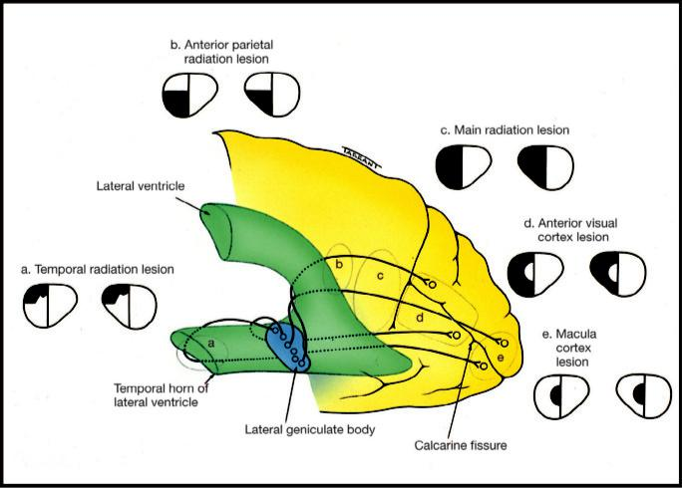

Fig. 19.15 Visual field defects caused by lesions of the optic radiations and visual cortex.

***Anterior parietal radiations:*** visual field defect consists of a contralateral, homonymous, inferior quadrantanopia (‘pie on the floor’) because the superior fibres of the radiations, which subserve the inferior visual fields, proceed directly posteriorly through the parietal lobe to the occipital cortex. In general, hemianopia resulting from parietal lobe lesions tends to be relatively congruous (Fig. 19.15b).

***Main radiations:*** lesions deep in the parietal lobe usually cause a complete homonymous hemianopia (Fig. 19.15c).

***Striate cortex:*** in the striate cortex, the peripheral visual fields are represented anteriorly – this part of the occipital lobe is supplied by the posterior cerebral artery. Central macular vision is represented posteriorly, supplied by terminal branches of both middle and posterior cerebral arteries. Occlusion of the posterior cerebral artery will therefore tend to produce a macular-sparing congruous homonymous hemianopia (Fig. 19.15d).

***Damage to the tip of the occipital cortex:*** as might occur from a head injury, tends to give rise to congruous homonymous central defects (Fig. 19.15e).

**Ocular motor nerves**

**THIRD (OCULOMOTOR) NERVE DISEASE**

**Anatomy and causes**

***Nuclear complex:*** situated in the midbrain, causes of nuclear complex lesions are (a) vascular disease, (b) primary tumours, (c) metastases. ese often also involve the adjacent 4th nerve nucleus (Fig. 19.16).

***Fasciculus:*** fibres passing from the nucleus; causes of nuclear and fascicular lesions are similar, with the addition of demyelination. (a) **Weber** syndrome manifests with ipsilateral

#*" ##%"#"+!#(&&%"'+$'""#* "%#! " +#!+ &)%#"$'!%

#%$%&#" (&#" +##'%(&&*'#('$%!&&#"#$+%', &)%" %'&%&%)

**358** SYNOPSIS OF CLINICAL OPHTHALMOLOGY

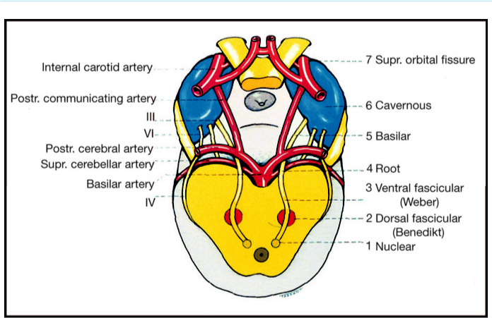

Fig. 19.16 Dorsal view of the course of the 3rd nerve

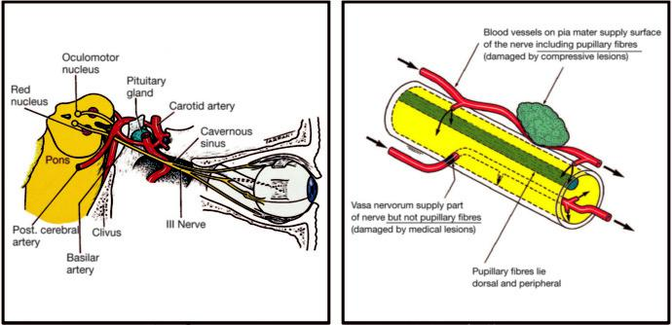

A B

Fig. 19.17 (A) Lateral view of the course of the 3rd nerve, (B) location of the pupillomotor fibres within the trunk of the 3rd nerve.

3rdnerve palsy and contralateral hemiparesis. (b) **Benedikt** syndrome is characterized by ipsilateral 3rd nerve palsy and contralateral extrapyramidal signs.

***Basilar part:*** ‘rootlets’ leave the midbrain on the medial aspect of the cerebral peduncle, coalescing to form the main trunk, subsequently running lateral to and parallel with the posterior communicating artery (Fig. 19.17A). (a) An aneurysm of the posterior commu-nicating artery typically presents as an acute, painful 3rd nerve palsy with involvement of the pupil, (b) extradural or subdural haematoma may cause downward herniation of the temporal lobe, compressing the 3rd nerve at the tentorial edge.

***Intracavernous part:*** the 3rd nerve runs in the lateral wall above the 4th nerve, dividing into superior and inferior branches which then enter the orbit. (a) Diabetes may cause a vascular

#*" ##%"#"+!#(&&%"'+$'""#* "%#! " +#!+ &)%#"$'!%

#%$%&#" (&#" +##'%(&&*'#('$%!&&#"#$+%', &)%" %'&%&%)

|  |  |
| --- | --- |
| Chapter 19—NEURO-OPHTHALMOLOGY | **359** |
|  |  |

paresis, which usually spares the pupil, (b) intracavernous pathology such as aneurysm, meningioma and carotid–cavernous fistula may all cause 3rd nerve palsy, usually associated with 4th and 6th nerve involvement because of their proximity.

***Intraorbital part:*** the superior division innervates the levator and superior rectus, the infe-rior division the medial rectus, inferior rectus and inferior oblique. e branch to the infe - rior oblique also contains parasympathetic fibres to the sphincter pupillae and the ciliary muscle. Lesions of the superior and inferior divisions are commonly traumatic or vascular. ***Pupillomotor fibres:*** between the brainstem and the cavernous sinus, the pupillomotor fibres are superficial and are supplied by the pial vessels, whereas the main trunk of the nerve is sup-plied by the vasa nervorum (Fig. 19.17B). Pupillary involvement therefore frequently dier - entiates a ‘surgical’ compressive lesion from a ‘medical’ lesion resulting from deeper ischaemia. ***Causes of isolated 3rd nerve palsy:*** (a) idiopathic (25%), (b) vascular (hypertension, diabetes),

(c) posterior communicating artery aneurysm, (d) trauma, (e) other (e.g. tumours, GCA).

**Diagnosis**

***Presentation:*** depends on the cause.

***Signs:*** (a) profound ptosis (levator weakness; Fig. 19.18A), (b) divergence in the primary position (intact lateral rectus), (c) intorsion at rest (intact superior oblique), (d) normal

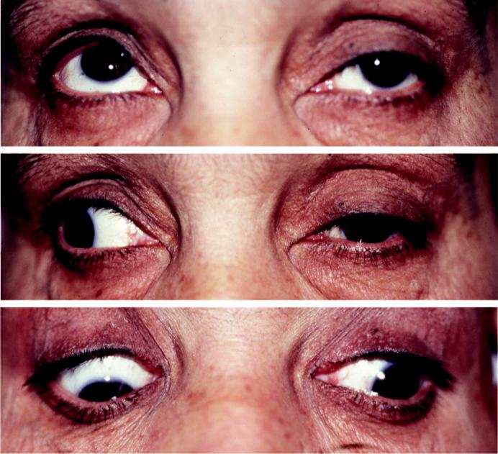

A

B

C

Fig. 19.18 Third nerve palsy: (A) ptosis, (B) limited adduction, (C) limited depression.

#*" ##%"#"+!#(&&%"'+$'""#* "%#! " +#!+ &)%#"$'!%

#%$%&#" (&#" +##'%(&&*'#('$%!&&#"#$+%', &)%" %'&%&%)

**360** SYNOPSIS OF CLINICAL OPHTHALMOLOGY

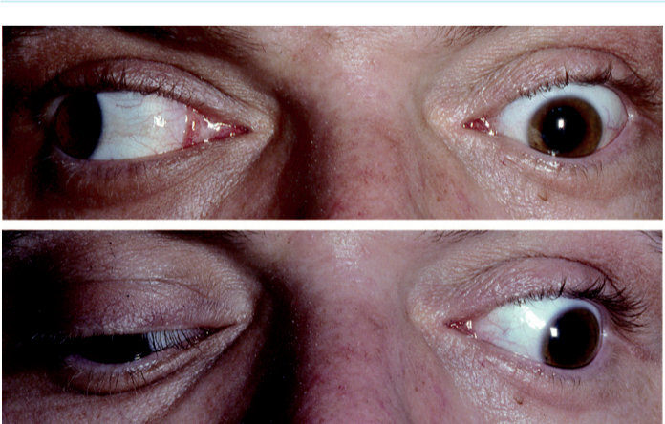

A

B

Fig. 19.19 Aberrant regeneration of the 3rd nerve: (A) lid elevation with reduced adduction on attempted right gaze, (B) lid elevation on depression of the eye. (Courtesy of ADN Murray.)

abduction, (e) limited adduction (Fig. 19.18B), (f ) limited elevation (see Fig. 19.18A) and depression (Fig. 19.18C), (g) mydriasis and defective accommodation.

***Aberrant regeneration:*** may follow acute traumatic and compressive, but not vascular, 3rd nerve palsy. Bizarre defects in ocular motility are seen (Fig. 19.19A and B), and can be asso-ciated with pupillary light-near dissociation.

**FOURTH (TROCHLEAR) NERVE DISEASE**

**Anatomy and causes**

***Important anatomical features:*** (a) the only cranial nerve to emerge from the dorsal aspect of the brain (Fig. 19.20), (b) it is a ‘crossed’ nerve such that it innervates the contralateral superior oblique muscle, (c) very long and slender (hence vulnerable to trauma), (d) the intracavernous part runs in the lateral wall of the sinus, inferiorly to the 3rd nerve and above the first division of the 5th nerve. e features of nuclear, fascicular and peripheral 4th nerve palsies are clinically identical, except that nuclear palsies produce contralateral superior oblique weakness.

***Causes of isolated 4th nerve palsy:*** (a) congenital (common) – symptoms may not develop until decompensation in adult life (abnormal head posture (AHP) on old photographs) (Fig. 19.21A), (b) trauma (frequently bilateral lesions), (c) vascular.

**Diagnosis**

***Presentation:*** vertical diplopia in the absence of ptosis, combined with a characteristic AHP, strongly suggests 4th nerve disease.

***Signs of left 4th nerve palsy:*** (a) left hypertropia (‘left-over-right’) in the primary position (Fig. 19.22A), (b) increase in left hypertropia on right gaze due to left inferior oblique overaction (Fig. 19.22B), (c) limitation of left depression on adduction (Fig. 19.22C), (d)normalleft abduction, normal left depression, and normal left elevation, (e) AHP with contralateral head tilt, contralateral face turn, and chin depression (Fig. 19.21A).

#*" ##%"#"+!#(&&%"'+$'""#* "%#! " +#!+ &)%#"$'!%

#%$%&#" (&#" +##'%(&&*'#('$%!&&#"#$+%', &)%" %'&%&%)

|  |  |
| --- | --- |
| Chapter 19—NEURO-OPHTHALMOLOGY | **361** |
|  |  |

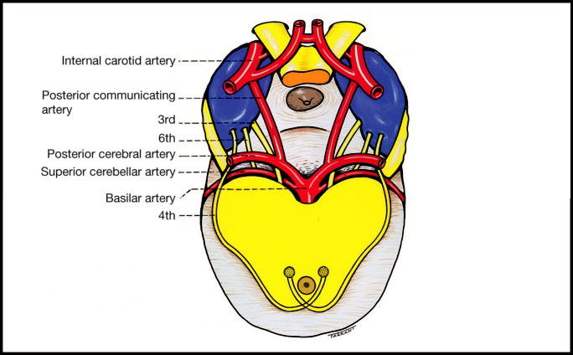

Fig. 19.20 Dorsal view of the 4th nerve.

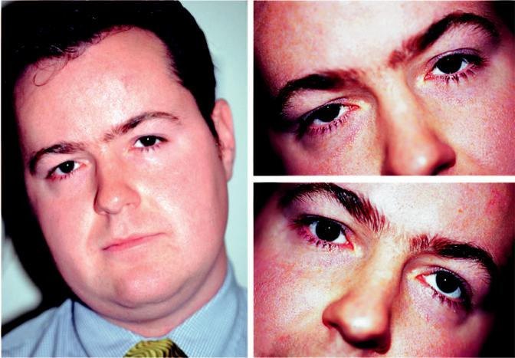

B

A C

Fig. 19.21 Left 4th nerve palsy: (A) compensatory head posture, (B) no hypertropia on right head tilt, (C) posi-tive Bielschowsky test, showing marked hypertropia on left head tilt.

#*" ##%"#"+!#(&&%"'+$'""#* "%#! " +#!+ &)%#"$'!%

#%$%&#" (&#" +##'%(&&*'#('$%!&&#"#$+%', &)%" %'&%&%)

**362** SYNOPSIS OF CLINICAL OPHTHALMOLOGY

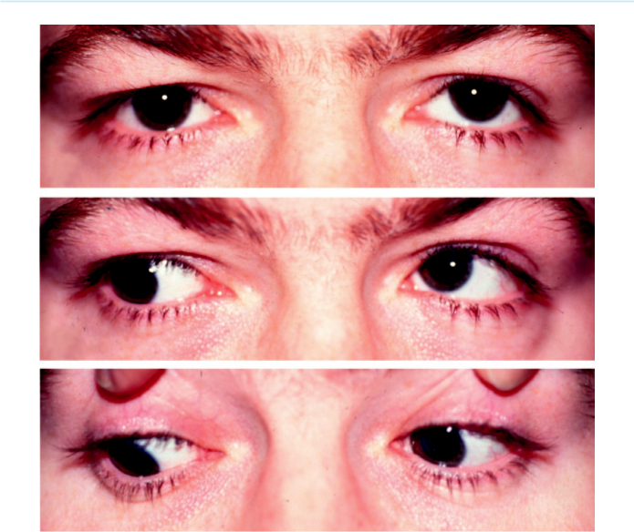

A

B

C

Fig. 19.22 Left 4th nerve palsy: (A) left hypertropia in the primary position, (B) increase in left hypertropia on right gaze due to left inferior oblique overaction, (C) limitation of left depression on adduction.

***Bilateral involvement:*** right hypertropia in left gaze, left hypertropia in right gaze, and a ‘V’ pattern esotropia. Compensatory head posture with chin down.

***Parks three-step test:*** (a) Which eye is hypertropic in the primary position? Left hypertro-pia may be caused by weakness of one of the following: a depressor of the left eye (supe-rior oblique or inferior rectus) or an elevator of the right eye (superior rectus or inferior oblique); in 4th nerve palsy, the involved eye is higher. (b) Is left hypertropia greater in right gaze or left gaze? Increase on right gaze implicates either the right superior rec-tus or left superior oblique, and increase on left gaze implicates either the right inferior oblique or left inferior rectus; in 4th nerve palsy, the deviation is ***w***orse ***o***n ***o***pposite ***g***aze (WOOG). (c) Bielschowsky head tilt test (3 m target); head is tilted to the right shoulder (Fig. 19.21B) and then to the left. Increased left hypertropia on left head tilt implicates the left superior oblique (Fig. 19.21C) and increase of right hypertropia on left head tilt implicates the right inferior rectus; in 4th nerve palsy, the deviation is ***b***etter ***o***n ***o***pposite ***t***ilt (BOOT).

***Double Maddox rod test:*** to detect and quantify torsional abnormality.

**SIXTH (ABDUCENS) NERVE DISEASE**

***Nucleus:*** lies at the midlevel of the pons, closely related to the horizontal gaze centre and the fasciculus of the 7th nerve. Isolated 6th nerve palsy is therefore never nuclear in origin.

#*" ##%"#"+!#(&&%"'+$'""#* "%#! " +#!+ &)%#"$'!%

#%$%&#" (&#" +##'%(&&*'#('$%!&&#"#$+%', &)%" %'&%&%)

|  |  |
| --- | --- |
| Chapter 19—NEURO-OPHTHALMOLOGY | **363** |
|  |  |

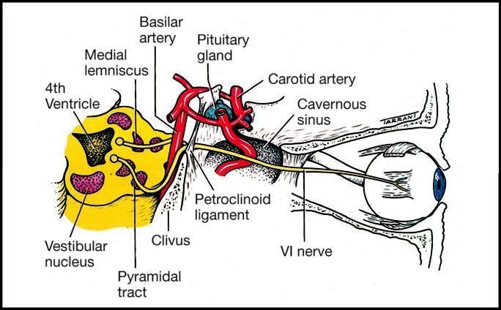

Fig. 19.23 Lateral view of the course of the 6th nerve.

Nuclear lesions cause (a) ipsilateral weakness of abduction (6th nerve), (b) failure of hori-zontal gaze toward the side of the lesion, (c) ipsilateral lower motor neuron facial nerve palsy.

***Fasciculus:*** leaves the brainstem at the pontomedullary junction; involvement here (vascular disease, tumours, demyelination) causes: (a) **Millard–Gubler** syndrome (6th nerve, pyra-midal tract causing contralateral hemiplegia and often ipsilateral LMN facial nerve palsy),

1. **Foville** syndrome (ipsilateral lesions of 5th–8th cranial nerves, horizontal gaze centre and central sympathetic fibres).

***Basilar part*** (Fig. 19.23): is vulnerable to damage by acoustic neuroma (may be accompanied by hearing loss and decreased corneal sensation), nasopharyngeal tumour, basal skull frac-ture or infection (**Gradenigo** syndrome). Raised intracranial pressure may stretch the nerve over the petrous tip to give 6th nerve palsy as a false localizing sign.

***Intracavernous part:*** runs below the 3rd and 4th nerves and the first division of the 5th nerve.

***Intraorbital part:*** enters the orbit through the superior orbital fissure within the annulus of Zinn to innervate the lateral rectus muscle.

**Diagnosis**

***Signs of acute left 6th nerve palsy:*** (a) left esotropia in the primary position (Fig. 19.24A),

1. marked limitation of left abduction (Fig. 19.24B), (c) compensatory face turn to the left. ***Dierential diagnosis:*** (a) myasthenia gravis, (b) restrictive thyroid myopathy, (c) medialorbital wall blowout fracture with entrapment of the medial rectus, (d) orbital myositis involving the lateral rectus, (e) Duane syndrome, (f ) convergence spasm, (g) divergence paralysis, (h) acute-onset esotropia.

#*" ##%"#"+!#(&&%"'+$'""#* "%#! " +#!+ &)%#"$'!%

#%$%&#" (&#" +##'%(&&*'#('$%!&&#"#$+%', &)%" %'&%&%)

**364** SYNOPSIS OF CLINICAL OPHTHALMOLOGY

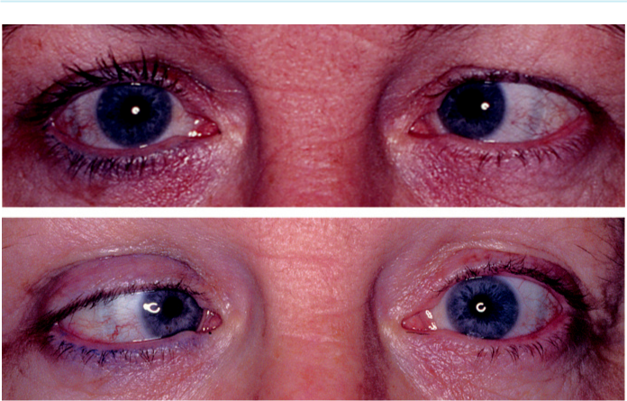

A

B

Fig. 19.24 Left 6th nerve palsy: (A) left esotropia in the primary position, (B) limitation of left abduction.

(From Salmon JF, Kanski’s Clinical Ophthalmology: A Systematic Approach, 9th edition. Oxford, UK:

Elsevier; 2020.)

**Supranuclear disorders of ocular motility**

**HORIZONTAL GAZE PALSY**

**Anatomy**

Horizontal eye movements are generated in a common pathway from the horizontal gaze centre in the paramedian pontine reticular formation (PPRF; Fig. 19.25).

From there, neurons connect to the ipsilateral 6th nerve nucleus, which innervates the lat-eral rectus.

Internuclear neurons cross the midline from the 6th nerve nucleus at the level of the pons and pass up the contralateral medial longitudinal fasciculus (MLF) to synapse with motor neurons in the medial rectus subnucleus in the 3rd nerve complex that innervates the medial rectus.

Stimulation of the PPRF on one side therefore causes a conjugate movement of the eyes to the same side, with loss of normal movement when the pathways are disrupted by disease such as demyelination, stroke and tumours.

**Diagnosis**

***PPRF lesion:*** ipsilateral horizontal gaze palsy with inability to look in the direction of the lesion.

***Left MLF lesion (internuclear ophthalmoplegia – INO):*** (a) normal left gaze (Fig. 19.26A),

1. straight eyes in primary position (Fig. 19.26B), (c) ataxic nystagmus of the right eye on right gaze, (d) defective left adduction (Fig. 19.26C).

***Bilateral INO:*** (a) limitation of left adduction, (b) ataxic nystagmus of right eye on right gaze, (c) limitation of right adduction, (d) ataxic nystagmus of the left eye on left gaze,

1. intact convergence if the lesion is discrete but may be absent if extensive.

#*" ##%"#"+!#(&&%"'+$'""#* "%#! " +#!+ &)%#"$'!%

#%$%&#" (&#" +##'%(&&*'#('$%!&&#"#$+%', &)%" %'&%&%)

|  |  |
| --- | --- |
| Chapter 19—NEURO-OPHTHALMOLOGY | **365** |
|  |  |

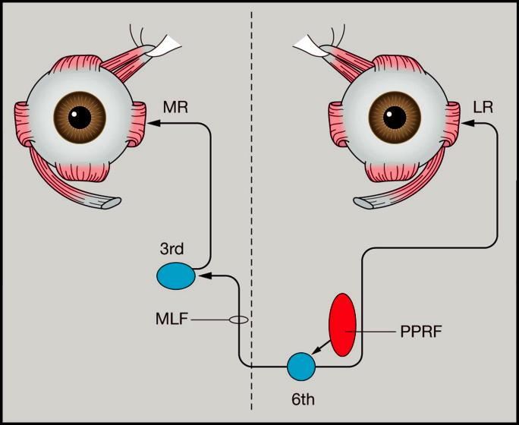

Fig. 19.25 Anatomical pathways for horizontal eye movements. (LR = lateral rectus, MLF = medial longi-tudinal fasciculus, MR = medial rectus, PPRF = paramedian pontine reticular formation.) (From Salmon JF, Kanski’s Clinical Ophthalmology: A Systematic Approach, 9th edition. Oxford, UK: Elsevier; 2020.)

***Combined ipsilateral PPRF and MLF:*** ‘one-and-a-half syndrome’ a combination of ipsilat-eral gaze palsy and INO.

**VERTICAL GAZE PALSY**

**Anatomy:**

vertical eye movements are generated from the vertical gaze centre (rostral interstitial nucleus of the MLF) in the midbrain, from where impulses pass to the subnuclei of the eye muscles control-ling vertical gaze in both eyes.

**Diagnosis**

***Parinaud (dorsal midbrain) syndrome:*** (a) straight eyes in the primary position, (b) upgaze palsy (Fig. 19.27A), (c) defective downgaze on saccadic movement (Fig. 19.27B), (d) defective convergence, (e) large pupils with light-near dissociation, (f) lid retraction (Collier sign), (g) convergence–retraction nystagmus (see below). Causes include: (a) meningitis, pinealoma in children, (b) demyelination in younger adults, (c) stroke and tumours in the elderly.

***Progressive supranuclear palsy (Steele–Richardson–Olszewski syndrome):*** severe idiopathic degenerative disease presenting in old age. Characterized by vertical gaze palsy (downgaze first), followed by horizontal then global gaze palsy, pseudobulbar palsy, extrapyramidal rigidity, gait ataxia and dementia.

#*" ##%"#"+!#(&&%"'+$'""#* "%#! " +#!+ &)%#"$'!%

#%$%&#" (&#" +##'%(&&*'#('$%!&&#"#$+%', &)%" %'&%&%)

**366** SYNOPSIS OF CLINICAL OPHTHALMOLOGY

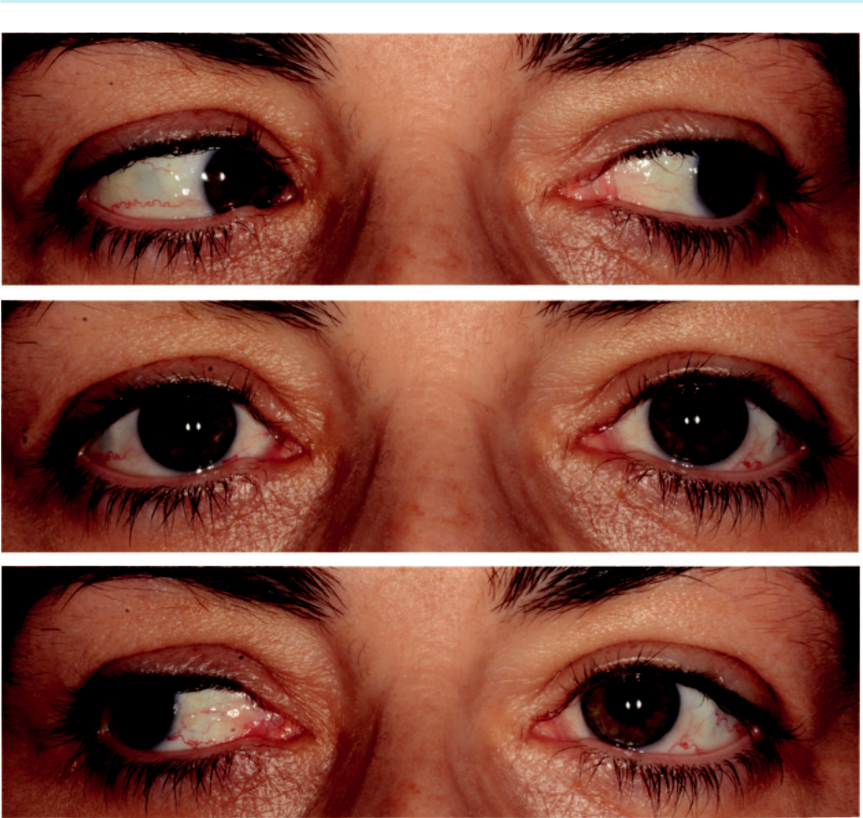

A

B

C

Fig. 19.26 Left internuclear ophthalmoplegia: (A) normal left abduction on left gaze, (B) straight in primary position, (C) limitation of left adduction on right gaze.

**Nystagmus**

**INTRODUCTION**

**Definition:**

repetitive involuntary to-and-fro oscillation of the eyes, which may be physiological or patho-logical. In pathological nystagmus, each cycle of movement is usually initiated by an involuntary defoveating drift of the eye away from the object of interest, followed by a returning refixation saccadic movement.

**Characteristics:**

can be documented using the scheme shown in Fig. 19.28 ***Plane:*** horizontal, vertical, torsional or nonspecific. ***Amplitude:*** fine or coarse.

***Frequency:*** high, moderate or low.

***Direction:*** described in terms of the direction of the fast component.

#*" ##%"#"+!#(&&%"'+$'""#* "%#! " +#!+ &)%#"$'!%

#%$%&#" (&#" +##'%(&&*'#('$%!&&#"#$+%', &)%" %'&%&%)

|  |  |
| --- | --- |
| Chapter 19—NEURO-OPHTHALMOLOGY | **367** |
|  |  |

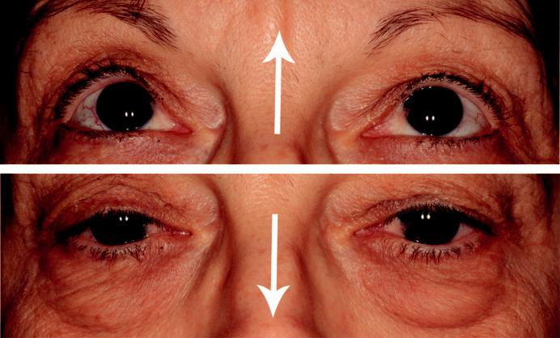

A

B

Fig. 19.27 Parinaud syndrome: (A) defective upgaze, (B) defective downgaze on saccadic movement. (From

Salmon JF, Kanski’s Clinical Ophthalmology: A Systematic Approach, 9th edition. Oxford, UK: Elsevier; 2020.)

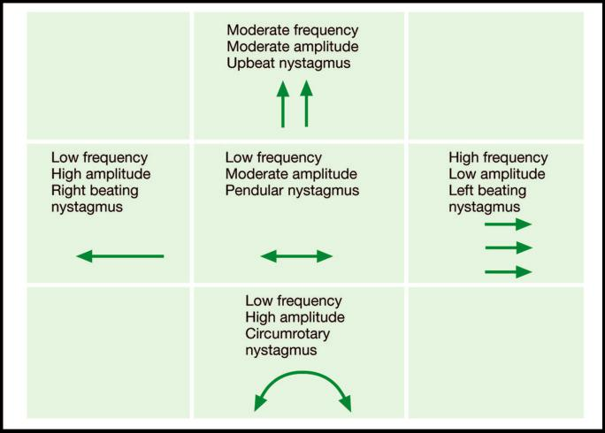

Fig. 19.28 Schematic for recording nystagmus. (From Salmon JF, Kanski’s Clinical Ophthalmology: A

Systematic Approach, 9th edition. Oxford, UK: Elsevier; 2020.)

#*" ##%"#"+!#(&&%"'+$'""#* "%#! " +#!+ &)%#"$'!%

#%$%&#" (&#" +##'%(&&*'#('$%!&&#"#$+%', &)%" %'&%&%)

**368** SYNOPSIS OF CLINICAL OPHTHALMOLOGY



***Jerk nystagmus:*** is saccadic with a slow defoveating ‘drift’ movement and a fast corrective refoveating saccadic movement. Jerk nystagmus can be divided into gaze-evoked and gaze-paretic; the latter is slow and usually indicates brain stem damage.

***Pendular nystagmus:*** equal velocity in both directions (nonsaccadic).

**PHYSIOLOGICAL NYSTAGMUS**

***End point:*** fine jerk nystagmus when the eyes are in extreme positions of gaze.

***Optokinetic (OKN):*** jerk nystagmus induced by moving repetitive targets (e.g. OKN tape or drum) across the visual field. e slow phase is a pursuit movement in which the eyes follow the target, whereas the fast phase is a saccadic movement in the opposite direction as the eyes fixate on the next target.

***Vestibular:*** jerk nystagmus caused by altered input from the vestibular nuclei to the horizon-tal gaze centres. It may be demonstrated by caloric stimulation: (a) cold water into the right ear elicits left jerk nystagmus (i.e., fast phase to the left) and (b) warm water into the right ear elicits right jerk nystagmus (mnemonic is ‘COWS’ – cold-opposite, warm-same).

**MOTOR IMBALANCE NYSTAGMUS**

Motor imbalance nystagmus is the result of primary defects in eerent mechanisms.

***Primary congenital nystagmus:*** presentation approximately 2 or 3 months of age, with vari-able inheritance modes; (a) low-amplitude pendular nystagmus in the primary position, converting to jerk nystagmus on side gaze, (b) horizontal plane, (c) may be dampened by convergence and is not present during sleep, (d) there is usually a null point – a position of gaze in which nystagmus is minimal, and an AHP may be adopted to take advantage of this; in contrast to acquired nystagmus, oscillopsia is absent.

***Spasmus nutans:*** rare condition presenting between 3 and 18 months. ere is unilateral or bilateral small-amplitude high-frequency horizontal nystagmus associated with head nod-ding. Can be idiopathic (spontaneously resolves) or due to anterior visual pathway pathol-ogy including glioma.

***Periodic alternating nystagmus:*** conjugate horizontal jerk nystagmus interspersed with a 4- to 20-sec interlude after which the direction reverses; 1- to 3-min cycle in total. Causes include isolated congenital, cerebellar disease, ataxia telangiectasia and drugs (e.g. phenytoin).

***Convergence–retraction nystagmus:*** (a) induced by rotating OKN tape or drum downwards, when on the upward refixation saccade, the eyes move toward each other in a rhythmic convergence movement due to co-contraction of the medial recti, (b) associated retraction of the globe. Causes include lesions of the pretectal area (Parinaud syndrome) such as pine-aloma and vascular accidents.

***Downbeat nystagmus:*** vertical nystagmus with the fast phase downwards. Causes include lesions of the cranio-cervical junction at the foramen magnum (e.g. Arnold–Chiari malfor-mation), drugs, Wernicke encephalopathy, demyelination, hydrocephalus.

***Upbeat nystagmus:*** vertical nystagmus with the fast phase upwards; causes include posterior fossa lesions, drugs and Wernicke encephalopathy.

***See-saw nystagmus of Maddox:*** pendular in which one eye elevates and intorts while the other depresses and extorts; the eyes then reverse direction. Causes include parasellar tumours (often associated with bitemporal hemianopia), syringobulbia, brainstem stroke.

**SENSORY DEPRIVATION NYSTAGMUS**

Sensory deprivation (ocular) nystagmus is caused by severe bilateral impairment of central vision before the age of approximately 2 years (e.g. congenital cataract). e nystagmus is horizontal and

#*" ##%"#"+!#(&&%"'+$'""#* "%#! " +#!+ &)%#"$'!%

#%$%&#" (&#" +##'%(&&*'#('$%!&&#"#$+%', &)%" %'&%&%)

|  |  |
| --- | --- |
| Chapter 19—NEURO-OPHTHALMOLOGY | **369** |
|  |  |

pendular and can often be dampened by convergence. Compensatory AHP may be adopted to move the eyes into a null point and decrease the amplitude.

**SURGERY FOR NYSTAGMUS**

Surgery for nystagmus may be considered if there is an AHP with a null position or for congenital motor/sensory nystagmus without a null point.

***To mimic a null point:*** muscles are moved in order to duplicate the tension in each judged to be present when the face is turned into the null point. For example, with a null point in left gaze (i.e., with a right head turn), the right medial rectus is recessed (weakened) and the right lateral rectus resected (strengthened) and left lateral rectus is weakened and the left medial rectus strengthened.

***Surgery for congenital motor/sensory nystagmus:*** involves large recessions on the four hori-zontal recti to reduce the amplitude, but should be contemplated only when the wave form and characteristics of the nystagmus have been determined by eye movement studies.

**NYSTAGMOID MOVEMENTS**

***Definition:*** movements resemble nystagmus, but the initial defoveating movement is a pathological saccadic intrusion.

***Ocular flutter and opsoclonus:*** saccadic oscillations with no intersaccadic interval; in ocular flutter, oscillations are purely horizontal, and in opsoclonus they are multiplanar. Causes include viral encephalitis, myoclonic encephalopathy in infants (‘dancing eyes and dancing feet’), transient (idiopathic) in healthy neonates and drug-induced.

***Ocular bobbing:*** rapid, conjugate, downward eye movements with a slow drift up to the primary position. Causes include pontine lesions (usually haemorrhage), cerebellar lesions compressing the pons and metabolic encephalopathy.

**Ocular myopathies**

**MYASTHENIA GRAVIS**

**Pathogenesis:**

autoimmune disease in which antibodies mediate damage to acetylcholine receptors in striated muscle. e resultant impairment of neuromuscular conduction causes weakness and fatigue of skeletal musculature but not of cardiac and involuntary muscles. e disease aects females twice as often as males. Involvement can be predominantly ocular or systemic (including the eyes).

**Diagnosis**

***Presentation:*** in 3rd decade, most frequently with ptosis or diplopia. Generalized involve-ment may cause fatigue, often worse toward the end of the day or brought on by exercise. ***Systemic features:*** (a) fatigue of the limbs, (b) lack of expression and ptosis – myopathic facial appearance (Fig. 19.29A), (c) bulbar (medulla oblongata) problems (dysphagia, dysar-thria), (d) respiratory diculty (rare).

***Ocular features:*** involvement occurs in 90% and is the presenting feature in 60%; (a) ptosis (may be precipitated by prolonged upgaze; Fig. 19.29B), (b) diplopia, frequently vertical, although any of the extraocular muscles may be aected, (c) nystagmoid move - ments, (d) bizarre defects of ocular motility (e.g. mimicking INO), (e) Cogan twitch sign is a brief upshoot of the eyelid as the eyes saccade from depression to the primary position.

#*" ##%"#"+!#(&&%"'+$'""#* "%#! " +#!+ &)%#"$'!% #%$%&#" (&#" +##'%(&&*'#('$%!&&#"#$+%', &)%" %'&%&%)

**370** SYNOPSIS OF CLINICAL OPHTHALMOLOGY

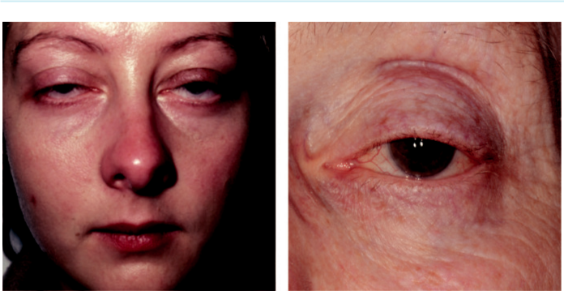

A B

Fig. 19.29 Myasthenia gravis: (A) facial appearance, (B) ptosis. (From Salmon JF, Kanski’s Clinical Ophthalmology:

A Systematic Approach, 9th edition. Oxford, UK: Elsevier; 2020.)

***Ice pack test:*** ptosis usually improves after an ice pack is placed on the lid for 2 min because cold improves neuromuscular transmission. e test is negative in non-myasthenic ptosis. ***Edrophonium test:*** edrophonium is a short-acting anticholinesterase agent that increases the amount of acetylcholine available at the neuromuscular junction, resulting in transient improvement in myasthenic features. Objectivity can be improved by using a Hess test. Sensitivity is approximately 85% in ocular and 95% in systemic myasthenia. Uncommon complications include bradycardia, loss of consciousness and even death.

***Serum acetylcholine receptor antibody levels:*** elevated in up to 90% of patients with systemic disease and in 50% of ocular cases.

***Anti-muscle-specific kinase (MuSK) antibodies:*** may be elevated.

***Single-fibre electromyography:*** highly sensitive and specific.

***oracic MR or CT:*** to detect thymoma, present in 15% of cases.

**Treatment**

***Options:*** (a) anticholinesterase drugs (e.g. pyridostigmine, neostigmine), (b) steroids, (c) other immunosuppressants (azathioprine, ciclosporin), (d) plasma exchange, (e) intravenous immunoglobulins, (f ) thymectomy (usually not helpful in pure ocular myasthenia).

***Botulinum toxin injection and/or muscle surgery:*** sometimes used for patients with stable ocular deviations.

**MYOTONIC DYSTROPHY**

**Genetics:**

AD inheritance. Two types: (a) classic – DM1, caused by a mutation in gene *DMPK* on chromo-some 19 – this form is considered below and (b) DM2, characterized by proximal muscle myopa-thy, fewer systemic features, and a better long-term prognosis.

**Diagnosis**

***Presentation:*** in 3rd to 6th decades with weakness of the hands and diculty walking.

***Systemic features:*** (a) diculty in releasing grip, (b) muscle wasting and weakness,

1. mournful facial expression with bilateral facial wasting (Fig. 19.30A), (d) slurred speech,
2. frontal baldness (males), (f ) intellectual decline.

#*" ##%"#"+!#(&&%"'+$'""#* "%#! " +#!+ &)%#"$'!%

#%$%&#" (&#" +##'%(&&*'#('$%!&&#"#$+%', &)%" %'&%&%)

|  |  |
| --- | --- |
| Chapter 19—NEURO-OPHTHALMOLOGY | **371** |
|  |  |

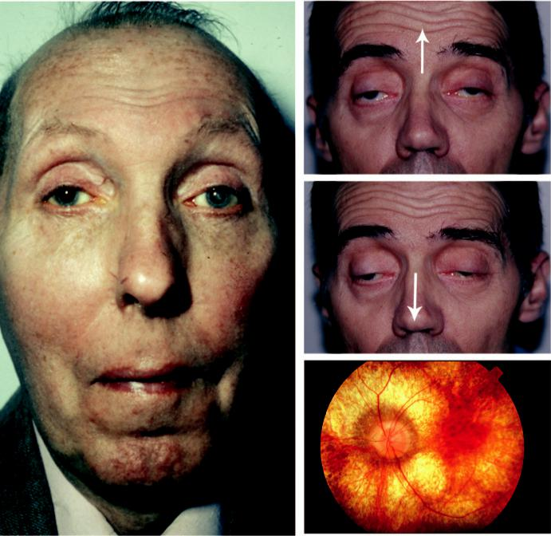

B

C

A D

Fig. 19.30 Ocular myopathy: (A) facial appearance of myotonic dystrophy showing a cataract in the left eye, (B and C) CPEO showing limitation of ocular movement, (D) Kearns–Sayre syndrome, showing choroidal atrophy. (Figure 19.30B,C courtesy of J. Yangüela.)

***Ophthalmic features:*** (a) early onset cataract, (b) ptosis, (c) external ophthalmoplegia (uncommon), (d) light-near dissociation, (e) mild pigmentary retinopathy, (f ) bilateral optic atrophy (uncommon), (g) low IOP.

***Investigations:*** electromyography shows myotonic and myopathic potentials; serum cre-atine kinase is elevated.

**Treatment:**

exercise and prevention of contractures.

**CHRONIC PROGRESSIVE EXTERNAL OPHTHALMOPLEGIA**

**Definition:**

chronic progressive external ophthalmoplegia (CPEO) comprises a group of mitochondrial cytopathies characterized by ptosis and slowly progressive bilateral ocular immobility, with a range

#*" ##%"#"+!#(&&%"'+$'""#* "%#! " +#!+ &)%#"$'!%

#%$%&#" (&#" +##'%(&&*'#('$%!&&#"#$+%', &)%" %'&%&%)

|  |  |  |  |
| --- | --- | --- | --- |
| **372** | SYNOPSIS OF CLINICAL OPHTHALMOLOGY | | |
|  | |  |  |
| of causative mitochondrial DNA abnormalities. e clinical features of CPEO may occur in isola | | - |  |
| tion or associated with a systemic condition such as Kearns–Sayre syndrome. | |  |  |
| **Diagnosis** | |  |  |
|  | ***Presentation:*** in young adulthood with bilateral ptosis, which may be asymmetrical followed | | |
|  | by limitation of upgaze and then downgaze (Fig. 19.30B and C). |  |  |
|  | ***External ophthalmoplegia:*** unremitting progressive course of bilateral symmetrical involve- | | |
|  | ment – diplopia is rare; inadequate convergence may aect reading. |  |  |
|  | ***Kearns–Sayre syndrome:*** (a) cerebellar ataxia, (b) cardiac conduction abnormalities, (c) | | |
|  | fatigue and proximal muscle weakness, (d) occasionally deafness, diabetes, short stature, | | |
|  | renal disease and dementia, (e) fundus typically shows a ‘salt-and-pepper’ pigmentary reti- | | |
|  | nopathy most striking at the macula, followed by choroidal atrophy (Fig. 19.30D). |  |  |
|  | ***Lumbar puncture:*** elevation of cerebrospinal fluid protein. |  |  |
|  | ***ECG:*** cardiac conduction defects. |  |  |
|  | ***Histology:*** aected muscles in CPEO show ‘ragged red fibres’ due to intramuscular accumu | - |  |
|  | lation of abnormal mitochondria. |  |  |

**Neurofibromatosis**

**GENETICS**

e two main types are NF1 and NF2. NF1 (von Recklinghausen disease) is a disorder that primarily aects cell growth of neural tissues. Inheritance is AD (gene mutation on 17q11) with irregular penetrance and variable expressivity, although approximately 50% have new mutations. NF2 is AD (gene mutation on 22q12).

**NF1**

***Systemic features:*** (a) intracranial tumours (e.g. meningioma, glioma), (b) neurofibromas of peripheral and autonomic nerves, (c) skeletal abnormalities (e.g. short stature, mild mac-rocephaly, facial hemiatrophy, absence of the greater wing of the sphenoid bone, scoliosis), (d) dermal abnormalities (café-au-lait macules (Fig. 19.31A), neurofibromas (Fig. 19.31B),

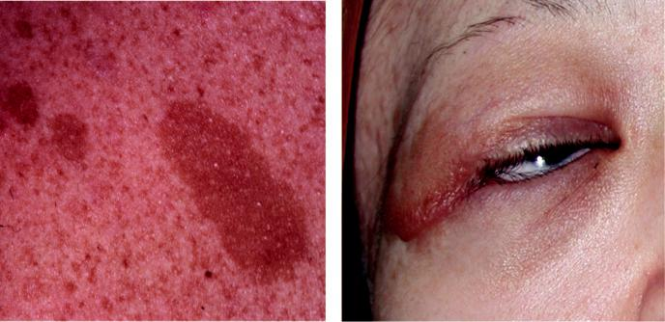

A B

Fig. 19.31 NF1: (A) café-au-lait macule, (B) nodular plexiform neurofibroma of the eyelid. (From Salmon JF,

Kanski’s Clinical Ophthalmology: A Systematic Approach, 9th edition. Oxford, UK: Elsevier; 2020.)

#*" ##%"#"+!#(&&%"'+$'""#* "%#! " +#!+ &)%#"$'!%

#%$%&#" (&#" +##'%(&&*'#('$%!&&#"#$+%', &)%" %'&%&%)

|  |  |
| --- | --- |
| Chapter 19—NEURO-OPHTHALMOLOGY | **373** |
|  |  |

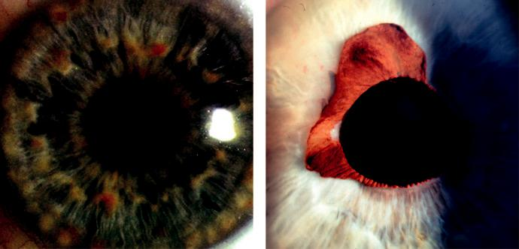

A B

Fig. 19.32 NF1 iris: (A) Lisch nodules, (B) congenital ectropion uveae. (From Salmon JF, Kanski’s Clinical

Ophthalmology: A Systematic Approach, 9th edition. Oxford, UK: Elsevier; 2020.)

axillary and inguinal freckles), (e) other features (malignancies, hypertension, mental handicap).

***Orbital lesions:*** (a) optic nerve glioma in 15%, (b) other tumours (e.g. neurilemmoma, plexi-form neurofibroma, meningioma), (c) spheno-orbital encephalocele due to absence of the greater wing of the sphenoid.

***Eyelid:*** neurofibromas (nodular or plexiform); may cause a mechanical ptosis.

***Iris:*** (a) Lisch nodules in 95% (Fig. 19.32A), (b) congenital ectropion uveae (uncommon; Fig. 19.32B), (c) rarely mammillations.

***Prominent corneal nerves:*** uncommon.

***Glaucoma:*** (rare) is usually unilateral and congenital; 50% have associated facial hemiatrophy.

***Fundus:*** choroidal naevi (common) with increased risk of choroidal melanoma and retinal astrocytomas (rare).

**NF2**

***Neurological features:*** bilateral vestibular schwannoma (acoustic neuroma) (Fig. 19.33A), usually presenting in the late teens or early 20 s with hearing loss, tinnitus or imbalance. ***Cataract:*** aects approximately two-thirds of patients and usually develops before the age of 30 years.

***Fundus:*** combined hamartomas of the retina and RPE and perifoveal epiretinal membranes.

***Other uncommon ocular features:*** motility abnormalities, optic nerve sheath meningioma, optic nerve glioma (Fig. 19.33B), unilateral Lisch nodules and an abnormal electroretinogram.

**Migraine**

**Definition:**

recurrent attacks of headache and/or other symptoms, widely variable in intensity, duration, and frequency.

**Diagnosis**

***Common migraine (migraine without aura):*** headache with autonomic dysfunction (e.g. pallor and nausea), but without neurological or ophthalmic features. Premonitory features (e.g. mood change) may occur; headache is pounding or throbbing, spreads to involve half

#*" ##%"#"+!#(&&%"'+$'""#* "%#! " +#!+ &)%#"$'!%

#%$%&#" (&#" +##'%(&&*'#('$%!&&#"#$+%', &)%" %'&%&%)

**374** SYNOPSIS OF CLINICAL OPHTHALMOLOGY

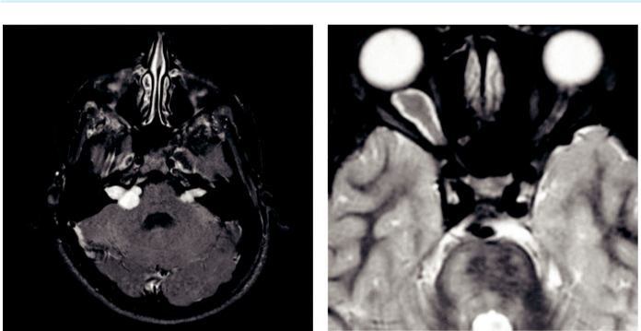

A B

Fig. 19.33 NF2: (A) axial MR showing bilateral vestibular schwannomas, (B) optic nerve glioma. (From Salmon

JF, Kanski’s Clinical Ophthalmology: A Systematic Approach, 9th edition. Oxford, UK: Elsevier; 2020.)

or more of the head and lasts from hours to a day or more. e patient is frequently photo - phobic and phonophobic.

***Classic migraine (migraine with aura):*** an attack is heralded by a visual aura (e.g. scoto-mata, bright or dark spots, zigzag ‘fortification spectra’), typically lasting 10–30 min and followed by a headache that is usually hemicranial, opposite the hemianopia, and which may be severe and accompanied by nausea and photophobia. e headache may, however, be absent or trivial and there is considerable variation between attacks even in the same individual.

***Visual aura without headache (migraine sine migraine):*** fairly common.

***Cluster headache (migrainous neuralgia):*** typically aects men during the 4th and 5th decades and is characterized by an excruciating unilateral oculotemporal headache 10 min to 2 hours in duration occurring almost every day, not infrequently at approximately 2 a.m., accompanied by various autonomic phenomena (e.g. lacrimation, conjunctival injection, rhinorrhea); may cause a transient or permanent postganglionic Horner syndrome.

***Focal migraine:*** transient dysphasia, hemisensory symptoms or focal weakness in addition to other symptoms of migraine.

***Retinal migraine:*** acute unilateral transient visual loss, that should be investigated as retinal embolization until proved otherwise.

***Ophthalmoplegic migraine:*** rare and typically starts before the age of 10 years. Characterized by a recurrent transient 3rd nerve palsy that begins after the headache.

***Familial hemiplegic migraine:*** may have failure of full recovery of focal neurological features after an attack of migraine subsides.

***Basilar migraine:*** occurs in children and is characterized by a typical migrainous aura asso-ciated with numbness and tingling of the lips and extremities, together with other neuro-logical phenomena.

**Treatment**

***General measures:*** elimination of precipitants (e.g. chocolate, cheese, long intervals without food).

***Prophylaxis:*** involves beta-adrenergic blockers, calcium channel blockers, amitriptyline, clonidine, pizotifen and low-dose aspirin.

#*" ##%"#"+!#(&&%"'+$'""#* "%#! " +#!+ &)%#"$'!%

#%$%&#" (&#" +##'%(&&*'#('$%!&&#"#$+%', &)%" %'&%&%)

|  |  |
| --- | --- |
| Chapter 19—NEURO-OPHTHALMOLOGY | **375** |
|  |  |

***Monoclonal antibody prophylactic treatment:*** if the above measures are ineective, erenumab and fremanezumab (versus calcitonin gene-related peptide) reduce the frequency of epi-sodic migraine, chronic migraine or cluster headaches.

***Treatment of an acute attack:*** simple analgesics and an anti-emetic; drugs for refractory patients include sumatriptan and ergotamine.

**Neuralgias**

e following conditions should be considered in the dierential diagnosis of ocular or periocular pain in the absence of apparent physical disease:

***Herpes zoster ophthalmicus:*** presents with pain 2–3 days before the onset of the character-istic vesicular rash. Very occasionally no rash will form (zoster sine herpete).

***Trigeminal neuralgia:*** brief attacks of severe pain that start in the distribution of one of the divisions of the trigeminal nerve; facial sensation is normal.

***Raeder paratrigeminal syndrome:*** aects middle-aged men and is characterized by severe unilateral headache with periocular pain in the distribution of the first division of the trigeminal nerve, associated with ipsilateral Horner syndrome; may last from hours to weeks.

***Carotid dissection:*** headache with peri- or retrobulbar pain; there may be other features such as Horner syndrome.

***Occipital neuralgia:*** attacks of pain that begin in the occipital region and then spread to the eye, temple, and face.

**Facial spasm**

**ESSENTIAL BLEPHAROSPASM**

**Definition:**

distressing idiopathic condition typically presenting in women (3:1) in the 6th decade. In severe cases, blepharospasm is disabling because it may temporarily render the patient functionally blind.

**Diagnosis**

Bilateral involuntary spasm of the orbicularis oculi and upper facial muscles (Fig. 19.34A) with no other neurological signs.

Spasms may be precipitated by a variety of factors, notably stress and anxiety.

**Treatment**

***Exclude:*** reflex blepharospasm (e.g. ocular surface disease) and extrapyramidal disease (e.g.

Parkinsonism).

***Botulinum toxin injection:*** along the upper and lower eyelid and eyebrow aords temporary relief in most patients and is typically repeated every 3 or 4 months. Side eects include ptosis and other abnormalities of lid position and occasionally diplopia due to extraocular muscle paralysis; these are virtually always temporary.

**HEMIFACIAL SPASM**

**Diagnosis**

Brief episodes of unilateral spasm of the orbicularis oculi that spreads along the distribution of the facial nerve (Fig. 19.34B). Presents in the 5th and 6th decades.

#*" ##%"#"+!#(&&%"'+$'""#* "%#! " +#!+ &)%#"$'!%

#%$%&#" (&#" +##'%(&&*'#('$%!&&#"#$+%', &)%" %'&%&%)

**376** SYNOPSIS OF CLINICAL OPHTHALMOLOGY

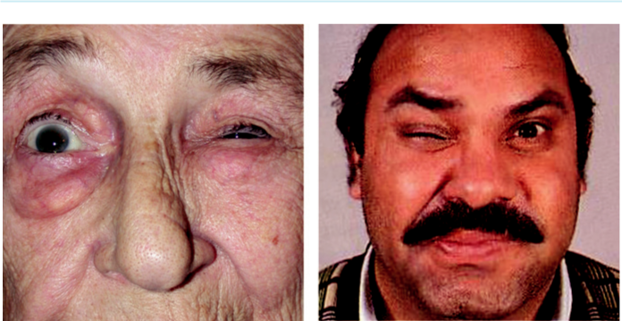

A B

Fig. 19.34 (A) Essential blepharospasm, (B) hemifacial spasm. (From Salmon JF, Kanski’s Clinical Ophthalmology:

A Systematic Approach, 9th edition. Oxford, UK: Elsevier; 2020.)

May be idiopathic or the result of irritation at any region from the facial nucleus to the peripheral nerve; occasionally seen months or years after a Bell palsy. Neuroimaging should be performed to exclude a compressive aetiology.

**Treatment:**

similar to that of essential blepharospasm.

#*" ##%"#"+!#(&&%"'+$'""#* "%#! " +#!+ &)%#"$'!%

#%$%&#" (&#" +##'%(&&*'#('$%!&&#"#$+%', &)%" %'&%&%)



CHAPTER 20

Ocular Tumours



C H A P T E R O U T L I N E

Benign epibulbar tumours 377

Conjunctival naevus 377

Conjunctival papilloma 378

Dermoid 378

Dermolipoma 379

Pyogenic granuloma 380

Conjunctival (racial) epithelial melanosis 380

Malignant and premalignant epibulbar tumours 380

Primary acquired melanosis (PAM) 380 Conjunctival melanoma 381

Ocular surface squamous neoplasia 382

Lymphoproliferative lesions 383

Kaposi sarcoma 383

Iris tumours 384

Iris naevus 384

Iris melanoma 384

Iris cysts 385

Primary 385

Secondary 385

Ciliary body melanoma 386

Tumours of the choroid 386



Choroidal naevus 386

Choroidal melanoma 387

Circumscribed choroidal haemangioma 389

Diffuse choroidal haemangioma 390

Optic disc melanocytoma 390

Choroidal osteoma 391

Metastatic tumours 391

Neural retinal tumours 393

Retinoblastoma 393

Astrocytoma 394

Vascular retinal tumours 395

Capillary haemangioma 395

Cavernous haemangioma 396

Racemose haemangioma 397

Primary intraocular lymphoma 397

Congenital hypertrophy of the retinal pigment epithelium (CHRPE) 398

Combined hamartoma of the retina and RPE 399

**Benign epibulbar tumours**

**CONJUNCTIVAL NAEVUS**

**Diagnosis**

***Presentation:*** in 1st and 2nd decades.

***Signs:*** (a) slightly elevated pigmented bulbar lesion of variable size and pigmentation,

(b) often juxtalimbal (Fig. 20.1A), (c) cystic spaces are common (Fig. 20.1B).

***Signs of potential malignancy:*** (a) prominent feeder vessels, (b) sudden growth or increase in pigmentation, (c) development after the 2nd decade, particularly in an unusual site such as palpebral or forniceal conjunctiva.

**Treatment**

excision, usually for cosmetic reasons; less commonly for irritation or suspicion of malignancy.

**377**

#*" ##%"#"+!#(&&%"'+$'""#* "%#! " +#!+ &)%#"$'!%

#%$%&#" (&#" +##'%(&&*'#('$%!&&#"#$+%', &)%" %'&%&%)

**378** SYNOPSIS OF CLINICAL OPHTHALMOLOGY

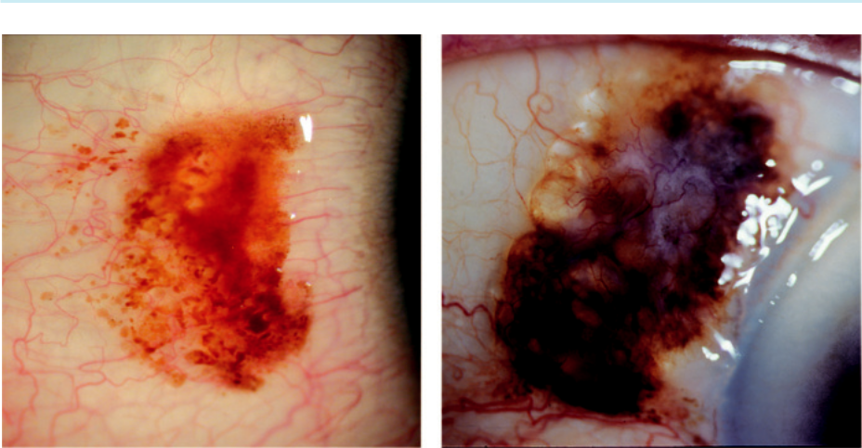

A B

Fig. 20.1 Conjunctival naevus: (A) juxtalimbal, (B) showing cystic changes. (From Salmon JF, Kanski’s Clinical

Ophthalmology: A Systematic Approach, 9th edition. Oxford, UK: Elsevier; 2020.)

**CONJUNCTIVAL PAPILLOMA**

**Pathogenesis:**

often infection with human papillomavirus (especially types 6 and 11), particularly in childhood.

**Diagnosis:**

1. solitary pedunculated or sessile lesion, (b) most frequently juxtalimbal in the fornix (Fig. 20.2A) or caruncle, (c) may occasionally be multiple and confluent.

**Treatment:**

small lesions often resolve spontaneously. Large papillomas may require excision, sometimes with cryotherapy to the base and surrounding area.

**DERMOID**

**Histology:**

solid mass of collagenous tissue containing dermal elements covered by stratified squamous epithelium.

**Diagnosis**

***Presentation:*** in early childhood.

***Signs:*** (a) smooth yellowish subconjunctival mass of soft consistency, (b) most frequently at the inferotemporal limbus, (c) protruding hair may be seen (Fig. 20.2B).

***Systemic associations:*** Goldenhar syndrome (oculoauriculovertebral spectrum) and less commonly, Treacher Collins syndrome.

**Treatment:**

small lesions are excised; large dermoids may require lamellar keratosclerectomy.

#*" ##%"#"+!#(&&%"'+$'""#* "%#! " +#!+ &)%#"$'!%

#%$%&#" (&#" +##'%(&&*'#('$%!&&#"#$+%', &)%" %'&%&%)

|  |  |
| --- | --- |
| Chapter 20—OCULAR TUMOURS | **379** |
|  |  |

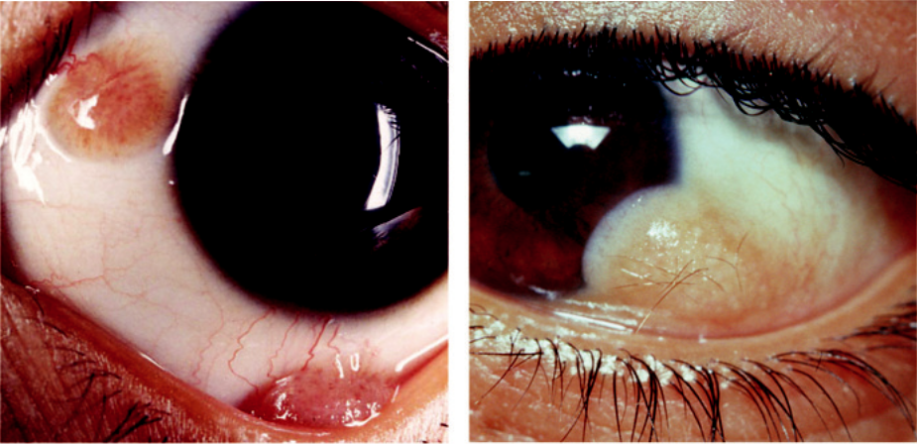

A B

Fig. 20.2 (A) Conjunctival papilloma, (B) dermoid. (From Salmon JF, Kanski’s Clinical Ophthalmology: A

Systematic Approach, 9th edition. Oxford, UK: Elsevier; 2020.)

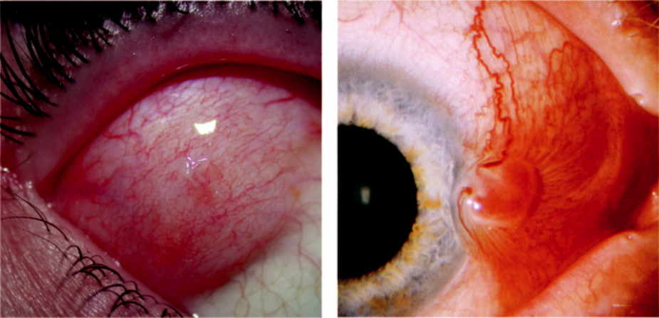

A B

Fig. 20.3 (A) Dermolipoma, (B) pyogenic granuloma after pterygium surgery. (From Salmon JF, Kanski’s Clinical Ophthalmology: A Systematic Approach, 9th edition. Oxford, UK: Elsevier; 2020.)

**DERMOLIPOMA**

**Histology:**

similar to solid dermoid, but also contains fatty tissue.

**Diagnosis**

Presentation: adulthood

Signs: (a) soft yellowish subconjunctival mass near the outer canthus (Fig. 20.3A),

(b) keratinized surface; may exhibit hairs

Treatment: usually avoided, but in selected cases anterior debulking procedure (beware:

lacrimal gland lobe)

#*" ##%"#"+!#(&&%"'+$'""#* "%#! " +#!+ &)%#"$'!%

#%$%&#" (&#" +##'%(&&*'#('$%!&&#"#$+%', &)%" %'&%&%)

**380** SYNOPSIS OF CLINICAL OPHTHALMOLOGY



**PYOGENIC GRANULOMA**

**Pathogenesis:**

fibrovascular proliferation in response to a conjunctival insult such as surgery, trauma, or ruptured chalazion; spontaneous lesions are rare.

**Diagnosis**

***Presentation:*** usually a few weeks after surgery, with a fast-growing, pink, fleshy, vascular-ized conjunctival mass, near a wound (Fig. 20.3B).

***Diﬀerential diagnosis:*** (a) suture granuloma, (b) vascular tumour, (c) Tenon granuloma or cyst.

**Treatment:**

topical steroids; excision of persistent granuloma.

**CONJUNCTIVAL (RACIAL) EPITHELIAL MELANOSIS**

**Definition:**

very common in dark-skinned individuals. Both eyes are aected, often asymmetrically.

**Diagnosis:**

1. areas of flat, patchy, brownish pigmentation scattered throughout the conjunctiva, (b) more intensely at the limbus and around perforating vessels or nerves as they enter the sclera (Axenfeld loop; Fig. 20.4A), (c) the pigment lies within the epithelium and therefore moves freely over the surface of the globe.

**Malignant and premalignant epibulbar tumours**

**PRIMARY ACQUIRED MELANOSIS (PAM)**

**Definition:**

unilateral condition typically aecting white individuals older than 45 years of age. ere are two histological variants which cannot be distinguished clinically:

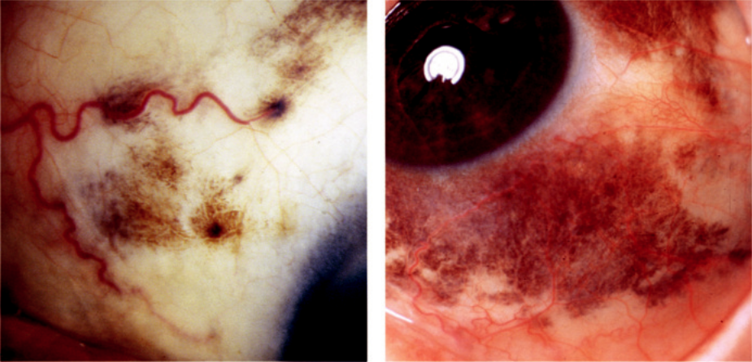

A B

Fig. 20.4 (A) Conjunctival epithelial melanosis, (B) primary acquired melanosis.

#*" ##%"#"+!#(&&%"'+$'""#* "%#! " +#!+ &)%#"$'!%

#%$%&#" (&#" +##'%(&&*'#('$%!&&#"#$+%', &)%" %'&%&%)

|  |  |
| --- | --- |
| Chapter 20—OCULAR TUMOURS | **381** |
|  |  |

***PAM without atypia:*** no risk of malignant transformation.

***PAM with atypia:*** regarded as melanoma *in situ*; has a 50% chance of infiltrative malignancy within 5 years.

**Diagnosis**

***Signs:*** (a) irregular solitary or multifocal areas of flat, golden brown to dark chocolate epithelial pigmentation, (b) seen most commonly in the interpalpebral region, although any part of the conjunctiva may be aected ( Fig. 20.4B).

***Course:*** (a) PAM may expand, shrink, or remain stable for long periods, (b) may focally lighten or darken, (c) malignant transformation should be suspected if a flat lesion becomes nodular.

**Treatment:**

1. small lesions may be excised, (b) large lesions should undergo incisional biopsy from various sites, with subsequent cryotherapy or topical mitomycin C for PAM with atypia.

**CONJUNCTIVAL MELANOMA**

**Origin:**

(a) from PAM with atypia (75%), (b) pre-existing naevus (20%) or (c) *de novo*.

**Diagnosis**

***Presentation:*** in 6th decade.

***Signs:*** (a) black, grey, or pinkish (amelanotic) vascularized nodule; may be fixed to the epi-sclera, (b) commonly at the limbus (Fig. 20.5A), but may develop anywhere, (c) multifocal lesions can arise from PAM with atypia as areas of thickening and nodularity (Fig. 20.5B). ***Poor prognostic indicators:*** (a) multifocal tumour, (b) forniceal location, (c) thickness of 2 mm or more. Mortality at 10 years is 25%.

***Diﬀerential diagnosis:*** (a) large naevus, (b) ciliary body melanoma with extraocular exten-sion, (c) pigmented conjunctival carcinoma.

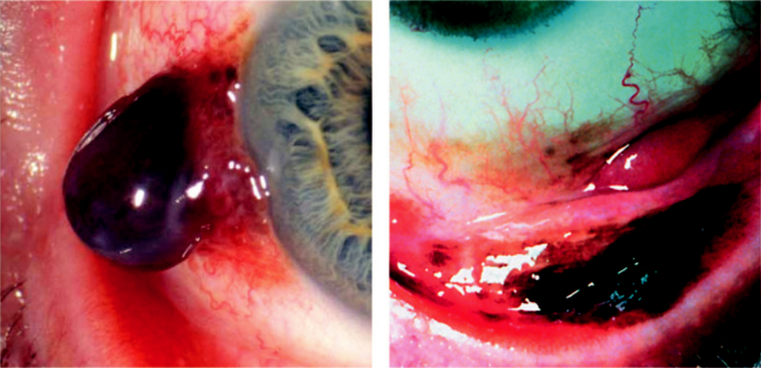

A B

Fig. 20.5 Conjunctival melanoma: (A) at the limbus, (B) multifocal. (From Salmon JF, Kanski’s Clinical

Ophthalmology: A Systematic Approach, 9th edition. Oxford, UK: Elsevier; 2020.)

#*" ##%"#"+!#(&&%"'+$'""#* "%#! " +#!+ &)%#"$'!%

#%$%&#" (&#" +##'%(&&*'#('$%!&&#"#$+%', &)%" %'&%&%)

**382** SYNOPSIS OF CLINICAL OPHTHALMOLOGY

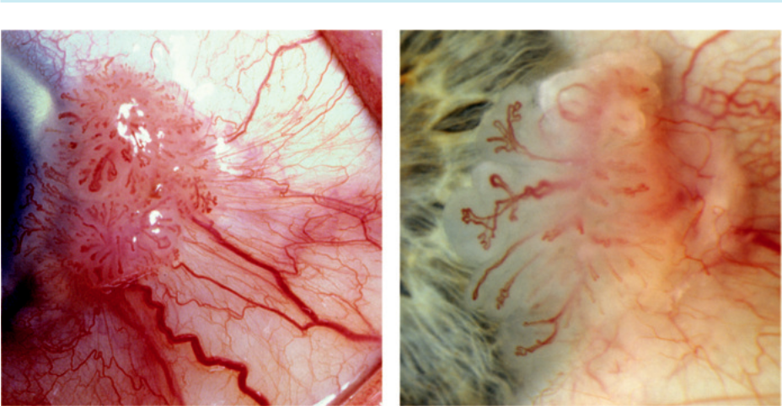

A B

Fig. 20.6 Squamous carcinoma: (A) limbal, with dysplastic epithelium, (B) gelatinous lesion extending onto

cornea. (From Salmon JF, Kanski’s Clinical Ophthalmology: A Systematic Approach, 9th edition. Oxford, UK:

Elsevier; 2020.)

**Treatment:**

excision with a wide-margin lamellar scleroconjunctivectomy and cryotherapy; radiotherapy to the base if deep extension is present histologically.

**OCULAR SURFACE SQUAMOUS NEOPLASIA**

**Definition:**

spectrum of benign, premalignant and malignant unilateral, slowly progressive epithelial lesions of the conjunctiva and cornea.

**Risk factors:**

1. excessive ultraviolet exposure, (b) human papilloma virus infection, (c) AIDS, (d) xeroderma pigmentosum, (e) smoking.

**Diagnosis**

***Presentation:*** in old age with irritation or a visible mass within the interpalpebral fissure; commonly juxtalimbal, but may involve any part of the conjunctiva or cornea. Male prepon-derance in Europe and the USA; female in sub-Saharan Africa.

***Signs:*** variable and limited correlation with histological type: (a) gelatinous mass with superficial vessels (Fig. 20.6A), (b) elevated white leucoplakic plaque, (c) fleshy pink papil-lomatous lesion with prominent feeder and surface blood vessels, (d) can masquerade as chronic conjunctivitis, (e) corneal involvement may occur (Fig. 20.6B).

***Spread:*** intraocular extension is uncommon and metastatic disease is rare.

***Investigations:*** ultrasonic biomicroscopy (UBM) to estimate the depth of invasion, and impression cytology.

**Treatment:**

1. Excision with 2- or 3-mm margins and assessment of clearance with frozen sections. Take care not to excise below Bowman membrane, as recurrent disease can then penetrate the corneal stroma. (b) Adjunctive measures aimed at reducing recurrence include cryotherapy, brachytherapy

#*" ##%"#"+!#(&&%"'+$'""#* "%#! " +#!+ &)%#"$'!%

#%$%&#" (&#" +##'%(&&*'#('$%!&&#"#$+%', &)%" %'&%&%)

|  |  |
| --- | --- |
| Chapter 20—OCULAR TUMOURS | **383** |
|  |  |

and topical chemotherapy. (c) Topical interferon alpha-2b is particularly eective, leading to com - plete resolution in 80% of patients. In the immune-compromised, a once daily instillation should be used lifelong to prevent recurrence.

**LYMPHOPROLIFERATIVE LESIONS**

**Pathology:**

most conjunctival lymphoproliferative lesions consist of reactive lymphoid hyperplasia, but lym-phoma may arise *de novo*, by extension from orbital disease or occasionally associated with systemic involvement. Rarely, reactive hyperplasia undergoes malignant transformation. Most conjunctival lymphomas are of B cell origin.

**Diagnosis**

***Presentation:*** in the 7th and 8th decades with irritation or painless swelling; may be bilateral.

***Signs:*** slow-growing salmon-pink or flesh-coloured mobile infiltrate (Fig. 20.7A).

**Treatment:**

radiotherapy, chemotherapy and excision.

**KAPOSI SARCOMA**

**Definition:**

slowly growing vascular tumour (Fig. 20.7B) occurring almost exclusively in individuals with AIDS.

**Diagnosis:**

in the early stages presents as a flat bright-red lesion that may mimic a subconjunctival haemorrhage.

**Treatment:**

radiotherapy or excision, with or without adjunctive cryotherapy.

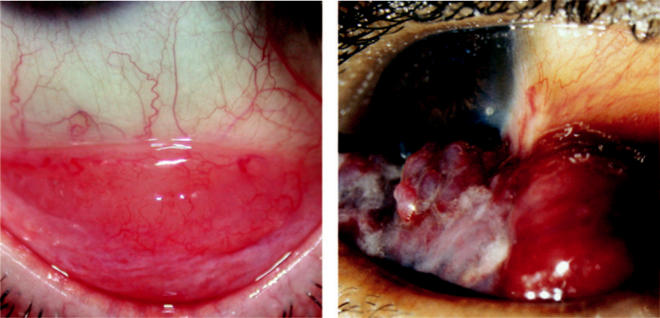

A B

Fig. 20.7 (A) Conjunctival lymphoma, (B) Kaposi sarcoma. (Figure 20.7B courtesy of T. Carmichael.)

#*" ##%"#"+!#(&&%"'+$'""#* "%#! " +#!+ &)%#"$'!%

#%$%&#" (&#" +##'%(&&*'#('$%!&&#"#$+%', &)%" %'&%&%)

**384** SYNOPSIS OF CLINICAL OPHTHALMOLOGY

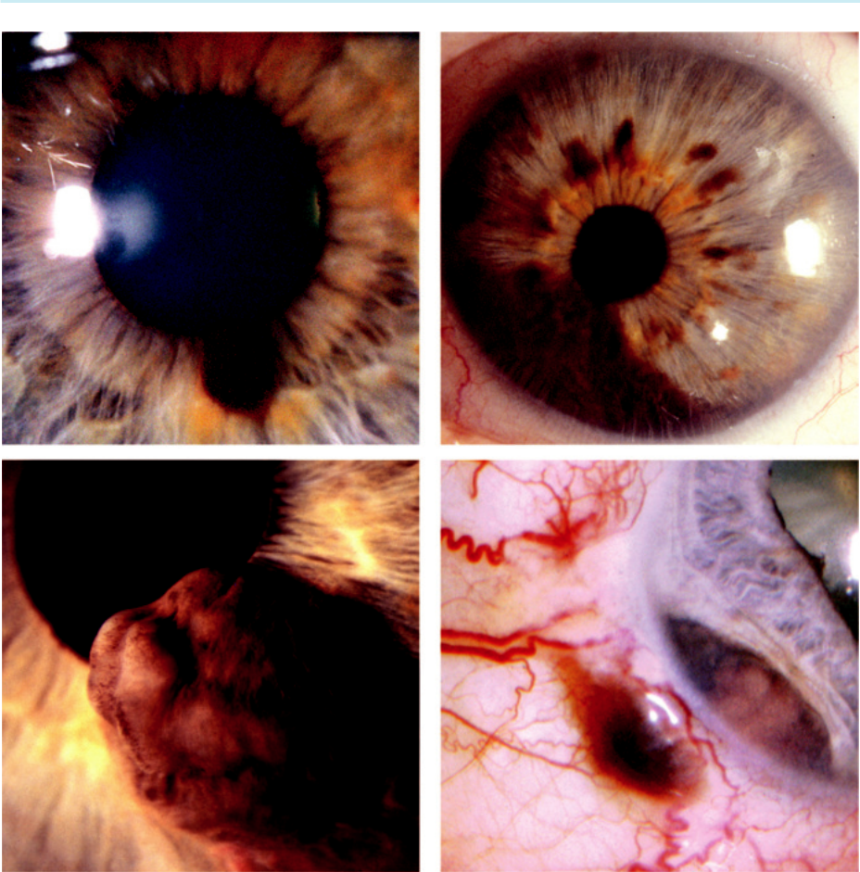

A B

C D

Fig. 20.8 Iris tumours: (A) naevus, (B) melanoma, (C) melanoma with pupillary distortion, (D) melanoma with angle invasion. (Figure. 20.8D courtesy of B. Damato.)

**Iris tumours**

**IRIS NAEVUS**

**Diagnosis**

***Signs:*** (a) solitary pigmented, flat or slightly elevated, circumscribed lesion usually less than 3 mm in diameter, (b) typically located inferiorly (Fig. 20.8A).

***Signs of potential malignancy:*** (a) prominent vascularity, (b) rapid growth, (c) diuse spread, (d) seeding.

**Treatment:**

not required, although observation is sometimes indicated.

**IRIS MELANOMA**

**Pathology:**

approximately 8% of uveal melanomas arise in the iris. e majority are composed of spindle cells of low-grade malignancy. Predisposing factors include: (a) fair skin, (b) light iris colour,

#*" ##%"#"+!#(&&%"'+$'""#* "%#! " +#!+ &)%#"$'!%

#%$%&#" (&#" +##'%(&&*'#('$%!&&#"#$+%', &)%" %'&%&%)

|  |  |
| --- | --- |
| Chapter 20—OCULAR TUMOURS | **385** |
|  |  |

1. numerous cutaneous naevi, (d) congenital ocular and oculodermal melanocytosis (naevus of Ota), (e) NF1.

**Diagnosis**

***Presentation:*** in 5th and 6th decades with enlargement of a pre-existing iris lesion.

***Typical signs:*** (a) very slowly growing pigmented or nonpigmented nodule at least 3 mm in diameter, (b) usually in the inferior half of the iris (Fig. 20.8B), (c) often associated with surface blood vessels.

***Associated signs:*** (a) pupillary distortion (Fig. 20.8C), (b) ectropion uveae, (c) angle invasion (Fig. 20.8D) with glaucoma, (d) localized cataract.

**Treatment:**

1. observation of suspicious lesions, (b) iridectomy for small tumours and iridocyclectomy for angle invasion, (c) brachytherapy or external proton beam irradiation, (d) enucleation for diusely growing tumours if radiotherapy is not possible.

**Iris cysts**

**PRIMARY**

**Diagnosis**

***Signs:*** unilateral or bilateral, solitary or multiple globular brown (Fig. 20.9A) or transparent structures located at the pupillary border, midzone or iris root.

***Complications:*** rarely glaucoma and corneal decompensation.

**Treatment:**

options include: (a) observation, (b) argon laser photocoagulation, (c) needle aspiration, (d) excision.

**SECONDARY**

**Pathogenesis:**

1. implantation cysts originate by deposition of surface epithelial cells from the conjunctiva or cornea onto the iris following penetrating trauma or surgery, (b) extended use of long-acting miotics may be associated with formation of multiple small cysts along the pupillary border.

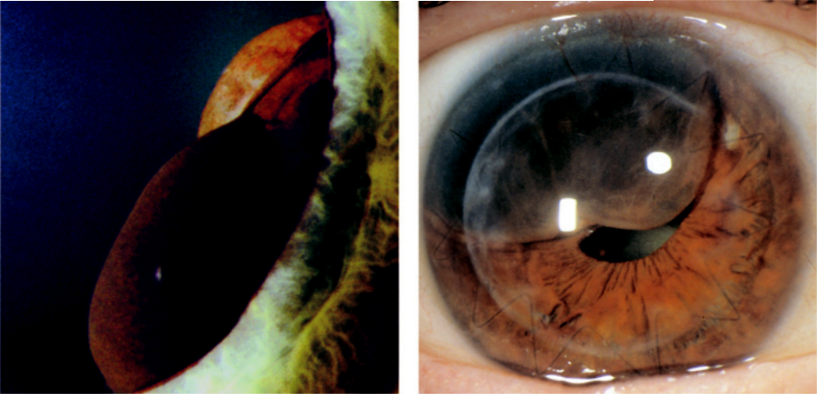

A B

Fig. 20.9 Iris cyst: (A) primary, (B) implantation. (Figure 20.9A courtesy of R. Bates.)

#*" ##%"#"+!#(&&%"'+$'""#* "%#! " +#!+ &)%#"$'!%

#%$%&#" (&#" +##'%(&&*'#('$%!&&#"#$+%', &)%" %'&%&%)

**386** SYNOPSIS OF CLINICAL OPHTHALMOLOGY



**Diagnosis**

***Signs:*** pearly and solid-appearing or serous and translucent lesions (Fig. 20.9B).

***Complications:*** (a) corneal decompensation, (b) anterior uveitis, (c) glaucoma.

**Treatment:**

similar to primary cysts.

**Ciliary body melanoma**

**Diagnosis**

***Presentation:*** in 6th decade with visual symptoms caused by pressure on the lens giving rise to astigmatism, subluxation, or cataract formation; occasionally discovered incidentally. ***Signs:*** (a) may be visible following pupillary dilatation, (b) ‘sentinel’ vessels in the same quadrant as the tumour (Fig. 20.10A), (c) erosion through the iris root may mimic an iris melanoma, (d) extraocular extension may mimic a conjunctival melanoma (Fig. 20.10B),

1. circumferential (annular) growth. ***Investigations:*** UBM and biopsy.

***Diﬀerential diagnosis:*** medulloepithelioma; rare childhood neoplasm.

**Treatment:**

1. iridocyclectomy for small or medium-sized tumours, (b) brachytherapy or proton beam irra-diation, (c) enucleation for large and extensively invasive tumours.

**Tumours of the choroid**

**CHOROIDAL NAEVUS**

**Introduction:**

choroidal naevi are present in 5–10% of white individuals, but are unusual in dark-skinned races. ey are probably present at birth, although growth occurs mainly during prepubertal years and is extremely rare in adulthood. e risk of malignant transformation of typical small naevi is low.

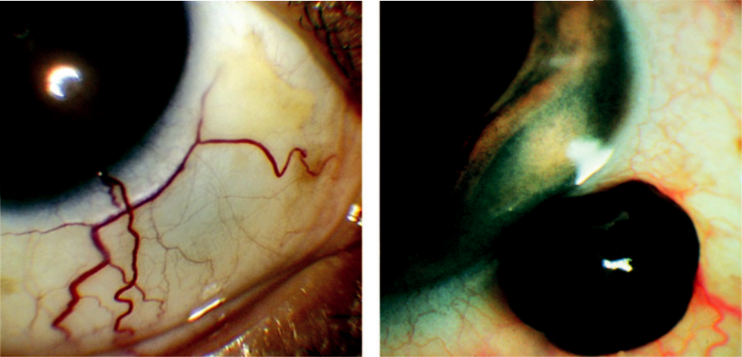

A B

Fig. 20.10 Ciliary body melanoma: (A) ‘sentinel’ vessel, (B) extraocular extension. (From Salmon JF, Kanski’s

Clinical Ophthalmology: A Systematic Approach, 9th edition. Oxford, UK: Elsevier; 2020.)

#*" ##%"#"+!#(&&%"'+$'""#* "%#! " +#!+ &)%#"$'!%

#%$%&#" (&#" +##'%(&&*'#('$%!&&#"#$+%', &)%" %'&%&%)

|  |  |
| --- | --- |
| Chapter 20—OCULAR TUMOURS | **387** |
|  |  |

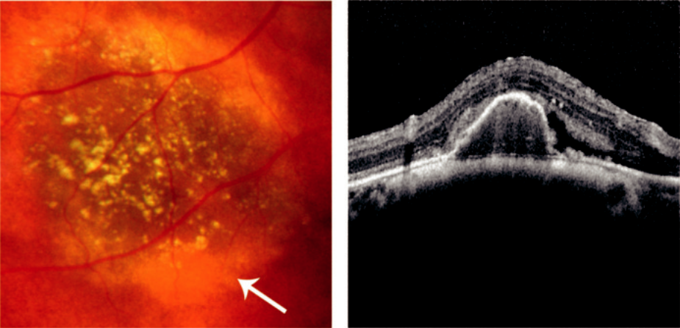

A B

Fig. 20.11 Choroidal naevus: (A) showing surface drusen and halo (arrow), (B) US showing high internal

acoustic reflectivity. (From Salmon JF, Kanski’s Clinical Ophthalmology: A Systematic Approach, 9th edition.

Oxford, UK: Elsevier; 2020.)

**Diagnosis**

***Presentation:*** most are asymptomatic and detected by chance.

***Signs:*** (a) usually post-equatorial, oval or circular, brown to slate-grey lesion with indistinct margins, (b) surface drusen may be present (Fig. 20.11A), (c) a depigmented halo is common. ***Features of potential malignancy:*** (a) visual loss, (b) documented growth, (c) dimensions >5 mm diameter or >2 mm in thickness, (d) orange surface pigment, (e) absence of surface drusen on a thick lesion, (f ) associated serous retinal detachment.

***Investigations:*** (a) baseline photography, (b) FA shows blockage of background choroidal fluorescence, (c) US shows a localized flat or slightly elevated lesion with high internal acoustic reflectivity, (d) OCT is useful to determine lesion thickness as well as the detection of subtle associated fluid (Fig. 20.11B).

***Diﬀerential diagnosis:*** (a) congenital hypertrophy of the RPE, (b) choroidal melanocytoma, (c) small melanoma.

**Treatment:**

baseline fundus photography and US, with indefinite follow-up of suspicious cases.

**CHOROIDAL MELANOMA**

**Pathology:**

choroidal melanoma is the most common primary intraocular malignancy in adults and accounts for 80% of all uveal melanomas. Histologically, it may consist of (a) spindle cells, (b) epithelioid cells or (c) mixed spindle and epithelioid cells.

**Diagnosis**

***Presentation:*** in 7th decade with blurring, metamorphopsia, visual field loss, floaters and photopsia; occasionally discovered by chance.

***Signs:*** (a) a solitary elevated dome-shaped subretinal, mass which may be pigmented (grey or brown; Fig. 20.12A) or less commonly amelanotic (Fig. 20.12B) often within 3 mm of

#*" ##%"#"+!#(&&%"'+$'""#* "%#! " +#!+ &)%#"$'!%

#%$%&#" (&#" +##'%(&&*'#('$%!&&#"#$+%', &)%" %'&%&%)

**388** SYNOPSIS OF CLINICAL OPHTHALMOLOGY

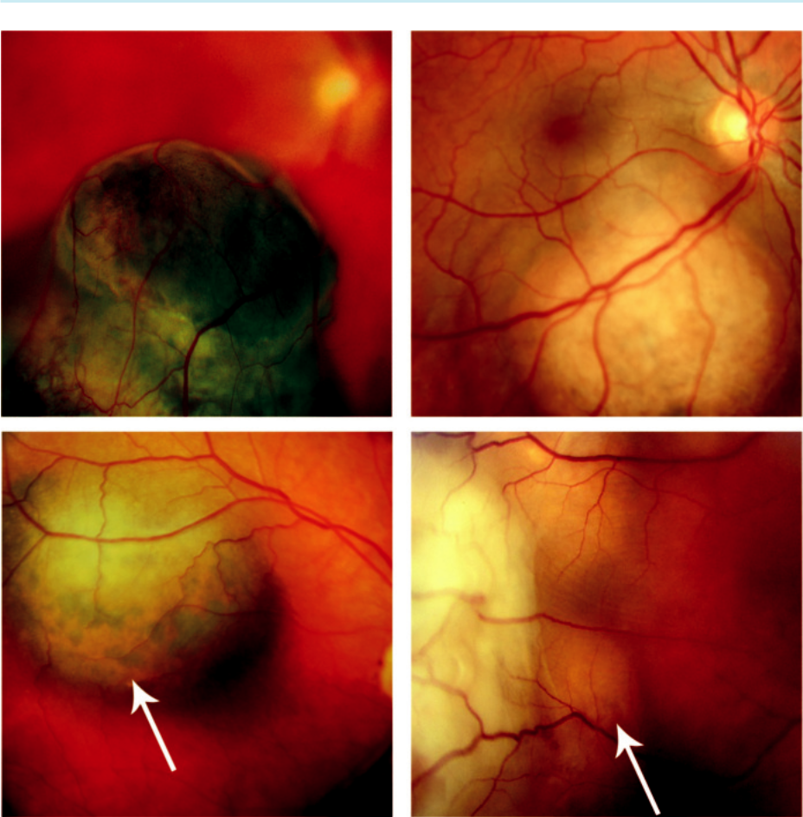

A B

C D

Fig. 20.12 Choroidal melanoma: (A) typical appearance, (B) amelanotic lesion, (C) showing clumps of orange pigment (arrow), (D) associated exudative retinal detachment (arrow). (Figure 20.12A courtesy of Chris Barry, Lions Eye Institute, Perth, Australia.)

the optic disc or fovea, (b) clumps of surface orange pigment (Fig. 20.12C), (c) a ‘collar-stud’ appearance if the tumour breaks through Bruch membrane.

***Associated signs:*** (a) exudative retinal detachment is common (Fig. 20.12D), (b) choroidal folds, (c) uveitis, (d) haemorrhage, (e) rubeosis iridis, (f ) secondary glaucoma, (g) cataract. ***Tumour spread:*** (a) via scleral channels to the orbit, (b) haematogenous metastatic spread to liver, bone and lung. Mortality is 50% at 10 years.

***Adverse prognostic factors:*** (a) large size, (b) extrascleral extension, (c) anterior location,

1. tumour genetic characteristics; somatic mutations in the tumour suppressor gene *BAP*1 imply a greater chance of metastasis.

***FA:*** no pathognomonic pattern, but may be useful in distinguishing simulating lesions (e.g. choroidal haemangioma) (Fig. 20.13A).

***US:*** shows (a) internal homogeneity, (b) choroidal excavation, (c) orbital shadowing (Fig. 20.13B).

***MRI:*** to assess extraocular extension.

***Systemic investigation:*** (a) liver function tests and ultrasound, (b) chest X-ray to exclude met-astatic spread to or from the choroid; only 1–2% have detectable metastasis at presentation.

#*" ##%"#"+!#(&&%"'+$'""#* "%#! " +#!+ &)%#"$'!%

#%$%&#" (&#" +##'%(&&*'#('$%!&&#"#$+%', &)%" %'&%&%)

|  |  |
| --- | --- |
| Chapter 20—OCULAR TUMOURS | **389** |
|  |  |

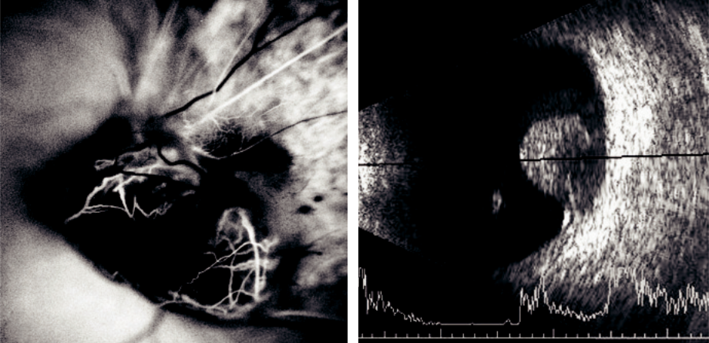

A B

Fig. 20.13 Imaging of choroidal melanoma: (A) FA early phase showing a ‘dual circulation’, (B) B-scan of a ‘collar stud’ tumour. (Figure 20.13A courtesy of B. Damato.)

***Diﬀerential diagnosis:*** (a) large choroidal naevus, (b) melanocytoma, (c) sub-RPE haemor-rhage, (d) choroidal metastasis, (e) choroidal haemangioma, (f ) solitary choroidal granu-loma (e.g. sarcoidosis, TB), (g) posterior scleritis, (h) eccentric CNV, (i) prominent vortex vein ampulla.

**Treatment:**

the following factors are taken into consideration: (a) size and location of the tumour and its eects on vision, (b) state of the fellow eye, (c) general health and age of the patient and the patient’s preferences.

***Observation:*** when it is not possible to determine clinically whether a tumour is a small melanoma or a large naevus.

***Treatment:*** (a) brachytherapy for tumours less than 20 mm in diameter and up to 10 mm thick, (b) external proton beam radiotherapy, (c) stereotactic radiotherapy, (d) trans-pupillary thermotherapy (TTT), (e) trans-scleral choroidectomy, (f ) enucleation for large tumours and in eyes with irreversible loss of useful vision.

**CIRCUMSCRIBED CHOROIDAL HAEMANGIOMA**

**Diagnosis**

***Presentation:*** in 2nd to 4th decades with blurring, visual field defect or metamorphopsia.

In some cases, the tumour lies dormant throughout life and is discovered by chance.

***Signs:*** (a) oval orange mass with indistinct margins at the posterior pole (Fig. 20.14A),

(b) subretinal fluid in symptomatic cases.

***Complications:*** (a) fibrous surface metaplasia, (b) cystoid retinal degeneration, (c) RPE degeneration, (d) subretinal fibrosis.

***FA:*** spotty hyperfluorescence in the pre-arterial or early arterial phase and diuse intense late hyperfluorescence (Fig. 20.14B).

***US:*** (a) acoustically solid lesion with a sharp anterior surface, (b) absence of choroidal excavation and orbital shadowing

***Diﬀerential diagnosis:*** (a) amelanotic choroidal melanoma, (b) choroidal metastasis, (c) RPE detachment, (d) posterior scleritis.

#*" ##%"#"+!#(&&%"'+$'""#* "%#! " +#!+ &)%#"$'!%

#%$%&#" (&#" +##'%(&&*'#('$%!&&#"#$+%', &)%" %'&%&%)

**390** SYNOPSIS OF CLINICAL OPHTHALMOLOGY

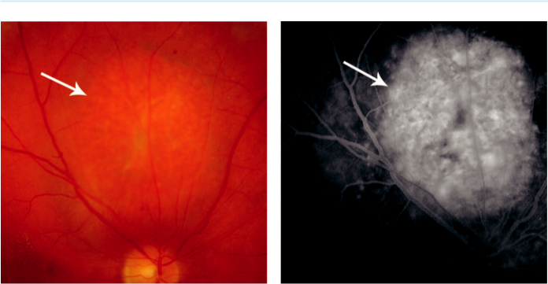

A B

Fig. 20.14 Circumscribed choroidal haemangioma: (A) indistinct margins (arrow), (B) FA late phase of (A), showing hyperfluorescence (arrow).

**Treatment:**

of vision-threatening lesions may include: (a) intravitreal anti-VEGF injection, (b) photodynamic therapy (PDT), (c) TTT, (d) radiotherapy.

**DIFFUSE CHOROIDAL HAEMANGIOMA**

**Systemic implication:**

the tumour occurs almost exclusively in patients with Sturge–Weber syndrome.

**Diagnosis**

***Presentation:*** in 2nd decade.

***Signs:*** (a) diuse deep red ‘tomato ketchup’ colour, is most marked at the posterior pole (Fig. 20.15A), (b) localized areas of thickening may be present.

***Complications:*** (a) cystoid retinal degeneration, (b) exudative retinal detachment, (c) neo-vascular glaucoma.

***US:*** diuse choroidal thickening.

**Treatment:**

similar to circumscribed haemangioma.

**OPTIC DISC MELANOCYTOMA**

**Definition:**

rare unilateral heavily pigmented congenital hamartoma, seen most frequently at the optic nerve head but rarely anywhere in the uvea. More common in dark-skinned individuals and is usually asymptomatic and stable.

**Diagnosis**

***Signs:*** (a) dark brown or black, flat or slightly elevated lesion with feathery edges (Fig. 20.15B), (b) a relative aerent pupillary defect may be present, even if VA is good.

#*" ##%"#"+!#(&&%"'+$'""#* "%#! " +#!+ &)%#"$'!%

#%$%&#" (&#" +##'%(&&*'#('$%!&&#"#$+%', &)%" %'&%&%)

|  |  |
| --- | --- |
| Chapter 20—OCULAR TUMOURS | **391** |
|  |  |

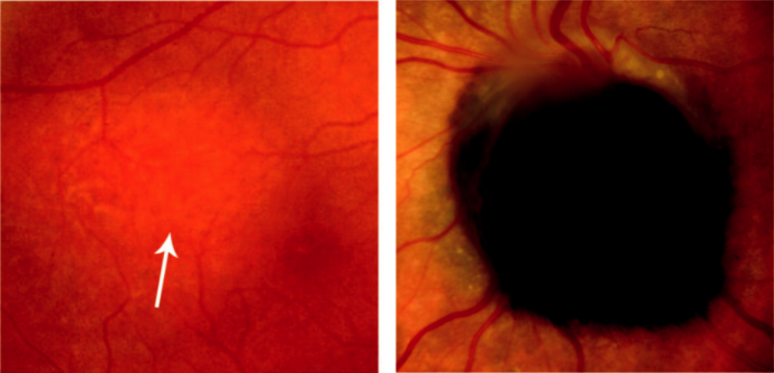

A B

Fig. 20.15 (A) Diffuse choroidal haemangioma (arrow), (B) optic disc melanocytoma. (From Salmon JF, Kanski’s Clinical Ophthalmology: A Systematic Approach, 9th edition. Oxford, UK: Elsevier; 2020.)

***Rare complications:*** (a) malignant transformation, (b) spontaneous necrosis, (c) optic nerve compression, (d) retinal vein obstruction.

**Treatment:**

not required except for malignant transformation.

**CHOROIDAL OSTEOMA**

**Definition:**

rare benign ossifying tumour, which grows slowly and has a strong female preponderance; bilateral in 25% of cases.

**Diagnosis**

***Presentation:*** in 2nd and 3rd decades with gradual visual impairment if the macula is involved. Choroidal neovascularization can cause rapid visual loss.

***Signs:*** yellow-white flat or minimally elevated lesion with well-defined margins, near the disc or at the posterior pole (Fig. 20.16 A and B).

***Course:*** slow growth over several years; long-standing cases may develop RPE changes.

***FA:*** early diuse mottled hyperfluorescence and late staining.

***US:*** highly reflective anterior surface and orbital shadowing.

***Diﬀerential diagnosis:*** (a) choroidal metastasis, (b) amelanotic choroidal naevus or mela-noma, (c) osseous metaplasia (e.g. associated with choroidal haemangioma), (d) sclerocho-roidal calcification.

**METASTATIC TUMOURS**

**Primary sites:**

90% of uveal metastases are to the choroid, the most frequent primary sites being the breast and bronchus; unusual sites include the gastrointestinal tract, kidney and skin melanoma. Patient survival is generally poor, with a median survival of 8–12 months.

#*" ##%"#"+!#(&&%"'+$'""#* "%#! " +#!+ &)%#"$'!%

#%$%&#" (&#" +##'%(&&*'#('$%!&&#"#$+%', &)%" %'&%&%)

**392** SYNOPSIS OF CLINICAL OPHTHALMOLOGY

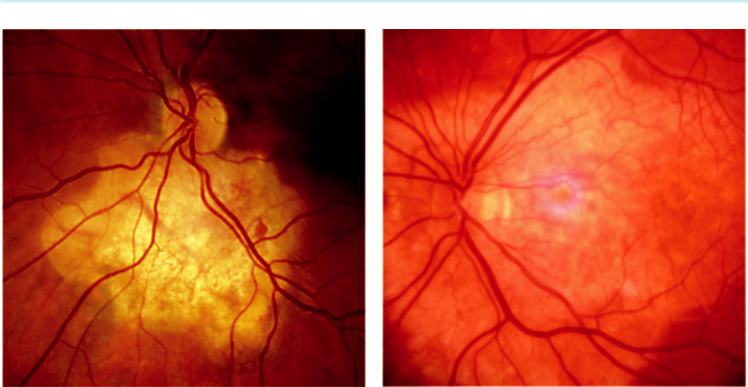

A B

Fig. 20.16 Choroidal osteoma: (A) near disc, (B) at posterior pole. (From Salmon JF, Kanski’s Clinical

Ophthalmology: A Systematic Approach, 9th edition. Oxford, UK: Elsevier; 2020.)

**Diagnosis**

***Presentation:*** visual impairment, though may be asymptomatic depending on location.

***Signs:*** (a) fast-growing white to orange placoid lesion with indistinct margins, most fre-quently located at the posterior pole (Fig. 20.17A), (b) multifocal deposits (Fig. 20.17B) occur in approximately 30% of patients, (c) bilateral involvement in 10–30% of cases,

1. secondary exudative retinal detachment is common, even with small deposits. ***US:*** moderately high internal acoustic reflectivity.

***Systemic investigations:*** aimed at locating the primary tumour, if unknown, together with other metastatic sites.

**Treatment**

***Observation:*** if the patient is asymptomatic or receiving systemic chemotherapy.

***Treatment options:*** (a) radiotherapy, (b) TTT, (c) systemic therapy for the primary tumour may also be beneficial for choroidal lesions.

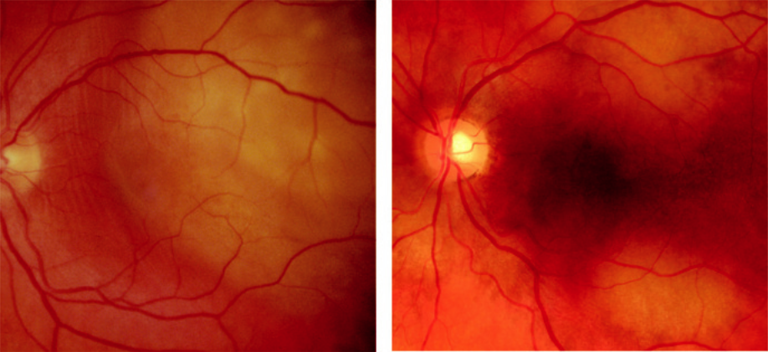

A B

Fig. 20.17 Metastatic carcinoma: (A) solitary, (B) multifocal deposits from breast. (Figure. 20.17B courtesy of B. Damato.)

#*" ##%"#"+!#(&&%"'+$'""#* "%#! " +#!+ &)%#"$'!%

#%$%&#" (&#" +##'%(&&*'#('$%!&&#"#$+%', &)%" %'&%&%)

|  |  |
| --- | --- |
| Chapter 20—OCULAR TUMOURS | **393** |
|  |  |

**Neural retinal tumours**

**RETINOBLASTOMA**

**Pathology:**

retinoblastoma is the most common primary intraocular malignancy of childhood, but is still very rare at 1:17,000 live births. It results from malignant transformation of primitive retinal cells before final dierentiation. Metastatic spread is to regional nodes, lung, brain and bone. Risk fac - tors for metastasis include advanced tumour growth, retrolaminar optic nerve invasion, massive choroidal invasion, anterior chamber involvement and orbital spread.

**Genetics:**

the gene predisposing to retinoblastoma, RB1, is at 13q14.

***Heritable retinoblastoma:*** accounts for 40% of cases. e mutation is transmitted in 50% but because of incomplete penetrance only 40% of ospring will be aected. If a child has heritable retinoblastoma, the risk to siblings is only 2% if the parents are healthy, but 40% if a parent is aected.

***Nonheritable (somatic) retinoblastoma:*** accounts for 60% of cases. If a patient has a solitary retinoblastoma and no positive family history, this is probably (but not definitely) nonher-itable so that the risk in each sibling and ospring is about 1%.

**Diagnosis**

***Presentation:*** within the first year of life in bilateral cases. Approximately 2 years of age if unilateral with: (a) leucocoria (60%; Fig. 20.18A), (b) strabismus (20%; fundus examination is mandatory in all childhood strabismus), (c) secondary glaucoma, (d) tumour-induced uveitis, (e) orbital involvement. e tumour may be revealed by routine examination of an at-risk patient.

***Diﬀerential diagnosis of leucocoria:*** (a) persistent anterior fetal vasculature (persistent hyperplastic primary vitreous), (b) Coats disease, (c) retinopathy of prematurity, (d) toxocariasis.

***Intraretinal tumour:*** homogeneous dome-shaped whitish lesion, often with white flecks of calcification (Fig. 20.18B).

***Endophytic tumour:*** projects into the vitreous as a white mass (Fig. 20.18C).

***Exophytic tumour:*** multilobular white subretinal mass with overlying retinal detachment (Fig. 20.18D).

***US:*** often shows calcification; can be used to measure size.

***MR:*** superior to CT for optic nerve evaluation, detection of extraocular extension, and pinealoblastoma.

***Other tests:*** bone scans, bone marrow aspiration and lumbar puncture to detect metastatic disease; genetic studies on patient and relatives and on tumour tissue.

**Treatment**

***Screening of siblings at risk:*** prenatal US, with ophthalmoscopy soon after birth, then regularly until 5 years old.

***Small tumours:*** (up to 3 mm diameter and 2 mm thick) photocoagulation, cryotherapy or chemotherapy. Intravenous treatment involves cycles of carboplatin, etoposide and vincris-tine (CEV).

***Medium-sized tumours:*** (up to 12 mm wide and 6 mm thick) brachytherapy and chemo-therapy. Selective ophthalmic artery perfusion using melphalan or topotecan is providing promising results.

#*" ##%"#"+!#(&&%"'+$'""#* "%#! " +#!+ &)%#"$'!%

#%$%&#" (&#" +##'%(&&*'#('$%!&&#"#$+%', &)%" %'&%&%)

**394** SYNOPSIS OF CLINICAL OPHTHALMOLOGY

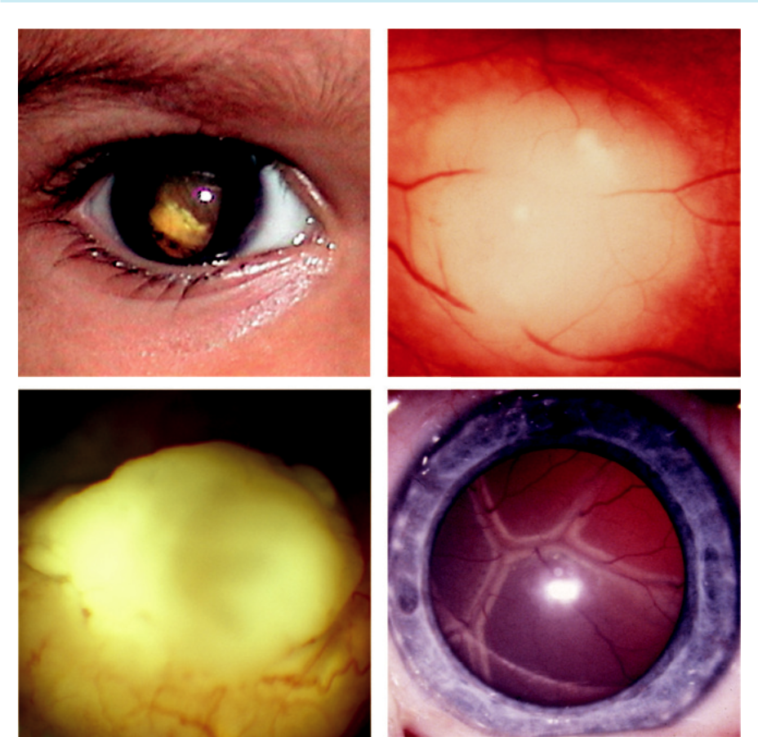

A B

C D

Fig. 20.18 Retinoblastoma: (A) leucocoria, (B) intraretinal tumour, (C) endophytic, projecting into vitre-ous, (D) exophytic, showing subretinal mass with retinal detachment. (From Salmon JF, Kanski’s Clinical Ophthalmology: A Systematic Approach, 9th edition. Oxford, UK: Elsevier; 2020.)

***Large tumours:*** (a) chemotherapy (chemo-reduction) to shrink the tumour and facilitate local treatment, (b) intravitreal melphalan for vitreous seeding, (c) enucleation (including a long piece of optic nerve) in some circumstances such as eyes with poor visual potential. ***Extraocular extension:*** adjuvant chemotherapy and external beam radiotherapy. ***Follow-up:*** regular examination and imaging, according to risk.

**ASTROCYTOMA**

**Systemic implications:**

astrocytoma is occasionally seen as a solitary lesion in normal individuals but most frequently occurs in tuberous sclerosis and occasionally in NF1. **Tuberous sclerosis** (Bourneville disease) is a pha-comatosis characterized by hamartomas in multiple organ systems. e mutation is in the *TSC1* gene on chromosome 9q34 coding for hamartin, or *TSC2* gene on chromosome 16p13 coding for tuberin. ese proteins act as suppressors of tumour growth. A classic triad of: (a) epilepsy, (b) men - tal retardation, (c) adenoma sebaceum (Fig. 20.19A) is diagnostic. Ash leaf spots are characteristic (Fig. 20.19B) and demonstrate fluorescence under ultraviolet light. Approximately 60% of cases are

#*" ##%"#"+!#(&&%"'+$'""#* "%#! " +#!+ &)%#"$'!%

#%$%&#" (&#" +##'%(&&*'#('$%!&&#"#$+%', &)%" %'&%&%)

|  |  |
| --- | --- |
| Chapter 20—OCULAR TUMOURS | **395** |
|  |  |

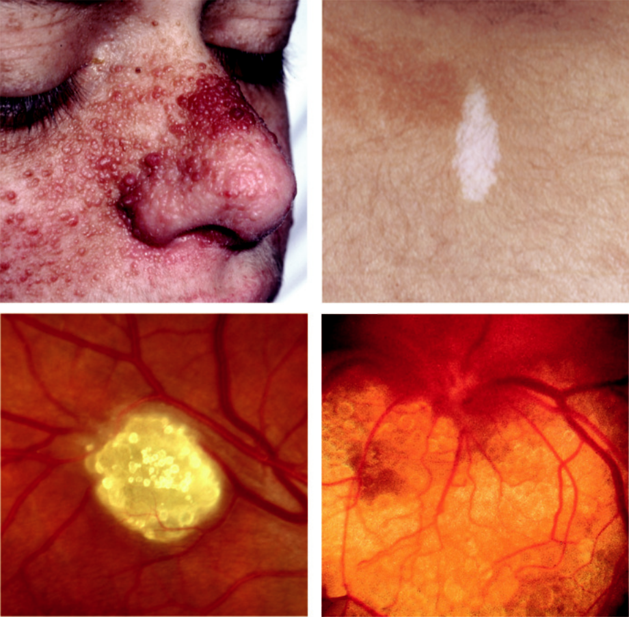

A B

C D

Fig. 20.19 Tuberous sclerosis: (A) adenoma sebaceum, (B) ash leaf spot, (C) solitary astrocytoma, (D) large diffuse astrocytoma.

sporadic and 40% are AD. About 50% of patients with tuberous sclerosis have fundus astrocytomas that may be multiple and bilateral.

**Diagnosis**

***Presentation:*** asymptomatic and detected on screening for tuberous sclerosis.

***Signs:*** (a) yellowish, round plaque or nodule (Fig. 20.19C), (b) large elevated mulberry-like lesion (Fig. 20.19D), (c) calcification in long-standing tumours.

***FA:*** prominent superficial vascular network with late leakage and staining.

**Vascular retinal tumours**

**CAPILLARY HAEMANGIOMA**

**Systemic implication:**

50% of patients with solitary tumours and virtually all with multiple lesions have von Hippel–Lindau syndrome (VHL), an AD condition caused by mutations of the *VHL* gene on chromosome 3p25,

#*" ##%"#"+!#(&&%"'+$'""#* "%#! " +#!+ &)%#"$'!%

#%$%&#" (&#" +##'%(&&*'#('$%!&&#"#$+%', &)%" %'&%&%)

**396** SYNOPSIS OF CLINICAL OPHTHALMOLOGY

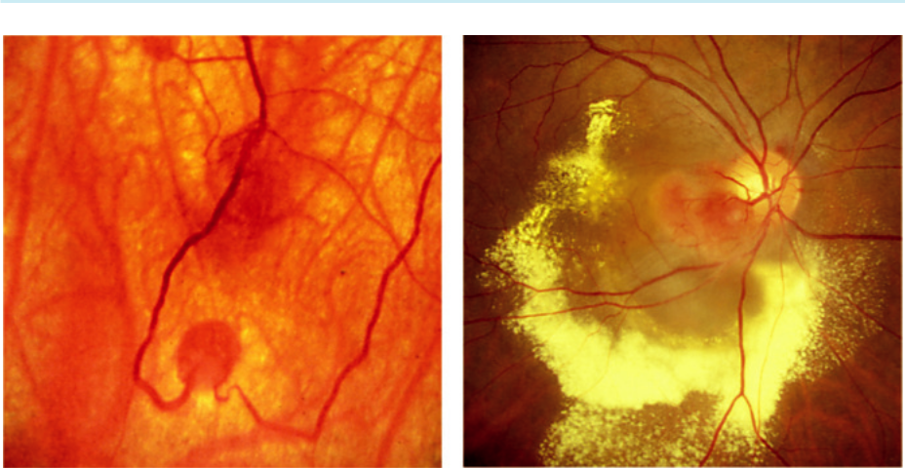

A B

Fig. 20.20 Retinal capillary haemangioma: (A) early tumour, (B) optic disc lesion with associated macular exudation in von Hippel–Lindau syndrome. (Figure 20.20B courtesy of Chris Barry, Lions Eye Institute, Perth, Australia.)

characterized by: (a) CNS haemangioma, (b) pheochromocytoma, (c) renal carcinoma, (d) cysts in various viscera, (e) polycythaemia. e prevalence of retinal tumours in VHL is approximately 60%. e median age at diagnosis in patients with VHL is earlier (18 years) than in those without (31 years).

**Diagnosis**

***Presentation:*** decreased vision, or detected by screening of those at risk.

***Early tumour:*** small, well-defined oval red lesion located between an arteriole and venule (Fig. 20.20A).

***Well-established tumour:*** round orange-red mass, usually located in the supero- or infero-temporal periphery, with dilatation and tortuosity of the supplying artery and draining vein; disc involvement may occur.

***Complications:*** (a) hard exudate formation surrounding the tumour and/or at the macula (Fig. 20.20B), (b) exudative retinal detachment, (c) epiretinal fibrosis, (d) vitreous haemor-rhage, (e) secondary glaucoma.

***FA:*** early hyperfluorescence and late leakage.

**Treatment:**

1. observation of asymptomatic juxtapapillary lesions without exudation, (b) laser photocoagula-tion for small lesions, (c) cryotherapy for larger peripheral lesions, (d) brachytherapy for lesions too large for cryotherapy, (e) PDT, (f ) anti-VEGF therapy.

**CAVERNOUS HAEMANGIOMA**

**Definition:**

rare, unilateral, congenital hamartoma. Usually sporadic but occasionally AD; may occur in com-bination with lesions of the skin and CNS.

**Diagnosis**

***Presentation:*** usually a chance finding, rarely with vitreous haemorrhage.

***Signs:*** (a) clusters of saccular aneurysms resembling a bunch of grapes, located in the periph-eral retina (Fig. 20.21A), (b) red cells may separate from plasma, giving rise to ‘fluid levels.’

#*" ##%"#"+!#(&&%"'+$'""#* "%#! " +#!+ &)%#"$'!%

#%$%&#" (&#" +##'%(&&*'#('$%!&&#"#$+%', &)%" %'&%&%)

|  |  |
| --- | --- |
| Chapter 20—OCULAR TUMOURS | **397** |
|  |  |

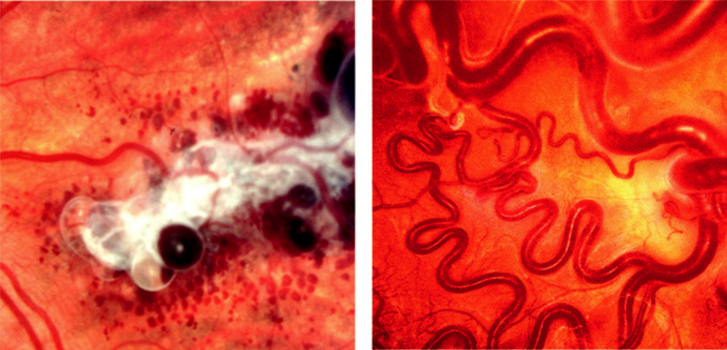

A B

Fig. 20.21 (A) Cavernous haemangioma, (B) racemose haemangioma. (From Salmon JF, Kanski’s Clinical Ophthalmology: A Systematic Approach, 9th edition. Oxford, UK: Elsevier; 2020.)

***FA:*** highlights the sedimentation of erythrocytes and shows a lack of leakage.

***Uncommon complications:*** haemorrhage and epiretinal membrane formation.

**Treatment:**

anti-VEGF therapy may have a role.

**RACEMOSE HAEMANGIOMA**

**Definition:**

racemose haemangioma (arteriovenous malformation) of the retina and optic nerve head is a rare sporadic congenital condition, usually unilateral, involving direct communication between the arteries and veins without an intervening capillary bed. Some patients have similar ipsilat-eral lesions involving the midbrain, basofrontal region and posterior fossa (Wyburn–Mason syndrome).

**Diagnosis**

***Presentation:*** usually a chance finding.

***Signs:*** (a) tortuous enlarged blood vessels; the vein and artery appearing similar (Fig. 20.21B), (b) with time become more dilated and tortuous; may become sclerotic.

**Treatment:**

not required.

**Primary intraocular lymphoma**

**Systemic implication:**

primary intraocular lymphoma represents a subset of primary CNS lymphoma, a variant of extra-nodal non-Hodgkin B cell lymphoma. Tends to present in the 6th and 7th decades and most patients develop CNS involvement after a mean delay of 29 months.

#*" ##%"#"+!#(&&%"'+$'""#* "%#! " +#!+ &)%#"$'!%

#%$%&#" (&#" +##'%(&&*'#('$%!&&#"#$+%', &)%" %'&%&%)

**398** SYNOPSIS OF CLINICAL OPHTHALMOLOGY

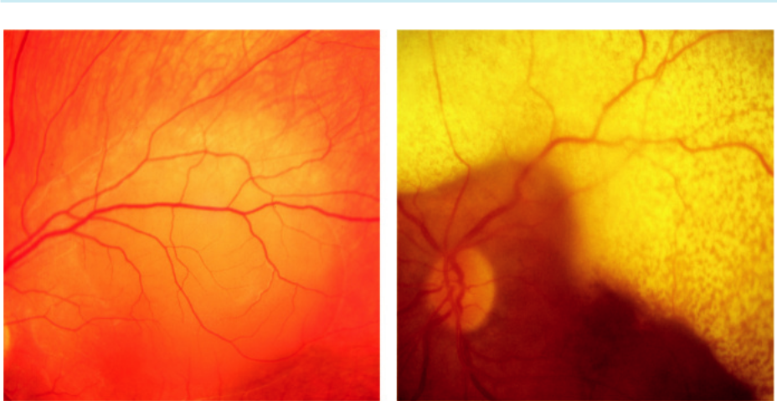

A B

Fig. 20.22 Primary lymphoma: (A) subretinal infiltrate, (B) extensive subretinal infiltration with overlying mot-tling. (Figure 20.22A courtesy of Chris Barry, Lions Eye Institute, Perth, Australia.)

**Diagnosis**

***Presentation:*** floaters, blurred vision, red eye, or photophobia.

***Signs:*** (a) vitritis, (b) large multifocal subretinal infiltrates (Fig. 20.22A), (c) coalescence that may occasionally form a ring encircling the equator (Fig. 20.22B), (d) retinal vasculitis and occlusion, (e) exudative retinal detachment, (f ) optic atrophy.

***US:*** vitreous debris, elevated subretinal lesions, retinal detachment, thickening of the optic nerves.

***Biopsy:*** of vitreous samples or subretinal nodules.

**Treatment:**

1. radiotherapy, (b) intravitreal methotrexate, (c) systemic chemotherapy, (d) biological agents involving specific anti-B cell monoclonal antibodies (e.g. rituximab).

**Congenital hypertrophy of the retinal pigment epithelium (CHRPE)**

**Classification:**

1. *typical*, either solitary or grouped, (b) *atypical*. It is important to dierentiate between the two types because the latter may have important systemic implications.

**Diagnosis**

***Solitary:*** flat, dark grey or black, round or oval lesion with well-defined margins; depig-mented lacunae are common (Fig. 20.23A).

***Grouped:*** multiple lesions organized in a pattern simulating animal footprints (‘bear-track’ pigmentation), often confined to one sector of the fundus. Smaller spots are usually located centrally (Fig. 20.23B).

***Atypical:*** bilateral multiple oval or spindle-shaped lesions of variable size, associated with hypopigmentation at one margin.

#*" ##%"#"+!#(&&%"'+$'""#* "%#! " +#!+ &)%#"$'!%

#%$%&#" (&#" +##'%(&&*'#('$%!&&#"#$+%', &)%" %'&%&%)

|  |  |
| --- | --- |
| Chapter 20—OCULAR TUMOURS | **399** |
|  |  |

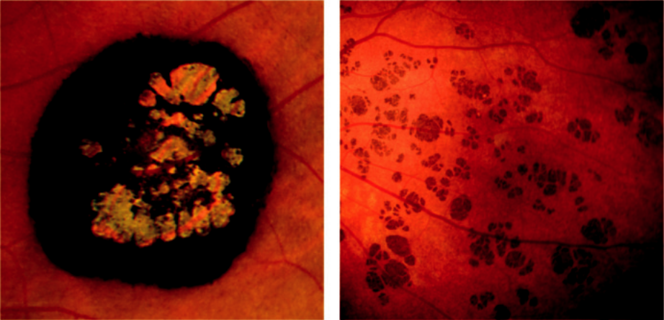

A B

Fig. 20.23 CHRPE: (A) solitary lesion with depigmented lacunae, (B) ‘bear-track’ lesions. (From Salmon JF,

Kanski’s Clinical Ophthalmology: A Systematic Approach, 9th edition. Oxford, UK: Elsevier; 2020.)

**Systemic associations of atypical CHRPE**

***Familial adenomatous polyposis (FAP):*** AD condition characterized by adenomatous polyps throughout the rectum and colon that develop in adolescence. If untreated, virtually all patients develop colorectal carcinoma by 50 years of age. More than 80% of patients with FAP have atypical CHRPE lesions.

***Gardner syndrome:*** FAP associated with osteomas of the skull, mandible, long bones and cutaneous soft tissue tumours.

***Turcot syndrome:*** AD or AR condition characterized by FAP and tumours of the CNS.

**Combined hamartoma of the retina and RPE**

**Definition:**

rare lesion of the posterior pole, probably congenital, more common in males. Occurs sporadically, but when seen in children may be associated with NF type 2.

**Diagnosis**

***Symptoms:*** decreased vision or strabismus in early childhood

***Presentation:*** (a) VA is 6/60 or less in 40–50%, usually secondary to macular involvement,

1. slightly elevated deep grey or brown pigmented lesion that blends into adjacent RPE at its margins (Fig. 20.24A), (c) superficial whitish membrane formation (ERM) with retinal wrinkling, (d) tortuosity and prominence of overlying vessels, (e) dragging of the disc or macula.

***FA:*** (a) hyperfluorescence of vascular abnormality (Fig. 20.24B), (b) blockage by pigment.

***Uncommon complications:*** (a) macular oedema, (b) exudation, (c) choroidal pre-retinal neovascularization.

**Treatment:** (a) monitoring for complications, (b) treatment for CNV and leakage,

1. vitrectomy for ERM in some cases.

#*" ##%"#"+!#(&&%"'+$'""#* "%#! " +#!+ &)%#"$'!%

#%$%&#" (&#" +##'%(&&*'#('$%!&&#"#$+%', &)%" %'&%&%)

**400** SYNOPSIS OF CLINICAL OPHTHALMOLOGY

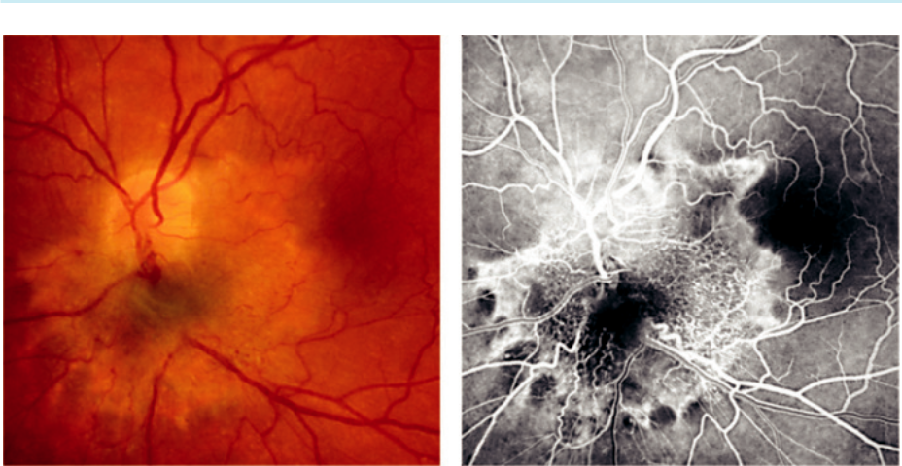

A B

Fig. 20.24 Combined hamartoma of the retina and RPE: (A) peripapillary lesion, (B) FA of lesion in (A). (From

Salmon JF, Kanski’s Clinical Ophthalmology: A Systematic Approach, 9th edition. Oxford, UK: Elsevier; 2020.)

#*" ##%"#"+!#(&&%"'+$'""#* "%#! " +#!+ &)%#"$'!%

#%$%&#" (&#" +##'%(&&*'#('$%!&&#"#$+%', &)%" %'&%&%)



CHAPTER 21

Ocular Side Effects of Systemic Medication



C H A P T E R O U T L I N E

Eyelids 401

Cornea 401

Vortex keratopathy (cornea verticillata) 401

Chlorpromazine 402

Argyrosis 402

Chrysiasis 402

Amantadine 402

Ciliary body 402

Lens 403

Steroids 403

Other drugs 403

Uveitis 403

Rifabutin 403



Cidofovir 404

Retina 404

Chloroquine and hydroxychloroquine 404 Phenothiazines 405

Drug-induced crystalline maculopathies 405 Other drugs 405

Optic nerve 406

Ethambutol 406

Amiodarone 406

Vigabatrin 406

Sildenafil 406

**Eyelids**

***Epidermal growth factor receptor inhibitors:*** used in the treatment of solid tumours and can

cause: (a) trichomegaly, (b) blepharitis, (c) dry eye syndrome.

***Imatinib:*** used in the treatment of chronic myeloid leukaemia and gastrointestinal tumours. Mild periorbital oedema occurs in two thirds approximately 6 weeks after commencing treatment.

***Ipilimumab:*** used for metastatic melanoma. Symptoms and signs similar to thyroid eye disease may rarely occur.

***Bortezomib:*** used for multiple myeloma and predisposes to recurrent chalazia.

**Cornea**

**VORTEX KERATOPATHY (CORNEA VERTICILLATA)**

***Signs:*** (a) fine greyish or golden-brown opacities in the inferior corneal epithelium, (b) progressing to a whorl-like pattern that originates from a point below the pupil and swirls outwards, sparing the limbus (Fig. 21.1A). Vision is usually not impaired, but some patients may experience halos around lights.

**401**

#*" ##%"#"+!#(&&%"'+$'""#* "%#! " +#!+ &)%#"$'!%

#%$%&#" (&#" +##'%(&&*'#('$%!&&#"#$+%', &)%" %'&%&%)

**402** SYNOPSIS OF CLINICAL OPHTHALMOLOGY

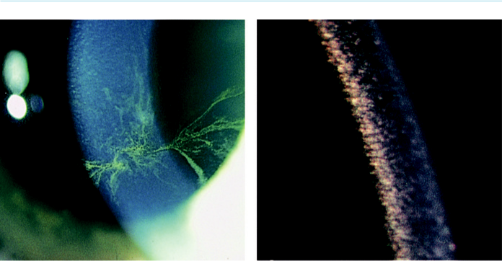

A B

Fig. 21.1 Drug-induced keratopathy: (A) amiodarone-induced vortex keratopathy stained with fluorescein,

1. chlorpromazine. (From Salmon JF, Kanski’s Clinical Ophthalmology: A Systematic Approach, 9th edition. Oxford, UK: Elsevier; 2020.)

***Causes:*** amiodarone (the higher the dose and the longer the duration of use, the more sub-stantial the changes), quinolone antimalarials (chloroquine, hydroxychloroquine). Usually reversible on cessation of medication. Also, a sign of Fabry disease.

**CHLORPROMAZINE**

Long-term therapy may cause subtle and visually innocuous yellowish-brown granular deposits in the endothelium, Descemet membrane and deep stroma (Fig. 21.1B).

**ARGYROSIS**

Keratopathy in argyrosis (silver deposition) is characterized by greyish-brown granular deposits in Descemet membrane; conjunctival involvement may also occur.

**CHRYSIASIS**

Chrysiasis describes the deposition of gold in tissues after prolonged administration (chryso-therapy), usually in the treatment of rheumatoid arthritis. Keratopathy is characterized by asymptomatic dust-like or glittering purple granules scattered throughout the epithelium and stroma.

**AMANTADINE**

Soon after commencement of therapy some patients develop reversible diuse, white, punctate corneal opacities sometimes associated with epithelial oedema.

**Ciliary body**

Acute angle closure with myopia, may occur secondary to ciliochoroidal eusion. Causes include:

(a) topiramate, (b) acetazolamide and other sulfonamides, (c) bupropion. e prognosis is good

#*" ##%"#"+!#(&&%"'+$'""#* "%#! " +#!+ &)%#"$'!%

#%$%&#" (&#" +##'%(&&*'#('$%!&&#"#$+%', &)%" %'&%&%)

|  |  |
| --- | --- |
| Chapter 21—OCULAR SIDE EFFECTS OF SYSTEMIC MEDICATION | **403** |
|  |  |

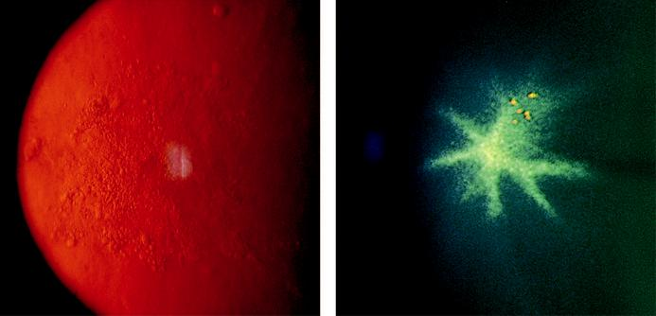

A B

Fig. 21.2 (A) Steroid-induced posterior subcapsular cataract, on retroillumination, (B) anterior capsular deposits secondary to chlorpromazine. (From Salmon JF, Kanski’s Clinical Ophthalmology: A Systematic Approach, 9th edition. Oxford, UK: Elsevier; 2020.)

provided the complication is recognized and the medication is stopped. Laser iridotomy is not needed as the mechanism of angle closure is not pupillary block.

**Lens**

**STEROIDS**

Both systemic and topical steroids are cataractogenic. e relationship between dose and duration of systemic administration and cataract (posterior subcapsular) is unclear (Fig. 21.2A).

**OTHER DRUGS**

***Chlorpromazine:*** fine stellate yellowish-brown granules on the anterior lens capsule within the pupillary area (Fig. 21.2B) develop in 50% of patients who have received a cumulative dose of 1000 g. e deposits persist despite discontinuation of therapy, but do not cause visual symptoms.

***Busulphan:*** occasionally causes lens opacities.

***Gold***: innocuous anterior capsular deposits in approximately 50% of patients treated for more than 3 years.

***Allopurinol:*** increases the risk of cataract formation in elderly patients with large cumulative doses.

**Uveitis**

**RIFABUTIN**

Used in the treatment of pulmonary tuberculosis

Acute anterior uveitis, typically unilateral and frequently associated with hypopyon; associ-ated vitritis may be mistaken for endophthalmitis. Treatment involves withdrawal of the drug or reduction of dose.

#*" ##%"#"+!#(&&%"'+$'""#* "%#! " +#!+ &)%#"$'!%

#%$%&#" (&#" +##'%(&&*'#('$%!&&#"#$+%', &)%" %'&%&%)

**404** SYNOPSIS OF CLINICAL OPHTHALMOLOGY



Drugs that inhibit metabolism of rifabutin (e.g. clarithromycin, fluconazole) increase the risk of uveitis.

**CIDOFOVIR**

Acute anterior uveitis with few cells, but a marked fibrinous exudate may develop following several intravenous infusions. Vitritis is common and hypopyon may occur with long-term administration.

Treatment with topical steroids and mydriatics is usually successful, avoiding the need to discontinue therapy.

**Retina**

**CHLOROQUINE AND HYDROXYCHLOROQUINE**

***Pathogenesis of toxicity:*** these are melanotropic drugs that become concentrated in melanin-containing structures of the eye, such as the RPE and choroid. Chloroquine can result in retinal toxicity (the risk increases significantly when the cumulative dose exceeds 300 g.). Individual susceptibility is variable. Hydroxychloroquine is much safer than chloroquine, particularly if the dose is kept to less than 5 mg/kg real weight/day. e risk of retinal toxic - ity is 7.5% if used for more than 5 years. Significant damage can occur without signs on fundus examination and OCT scanning of the macula has therefore emerged as a key part of the screening strategy.

***Premaculopathy:*** (a) VA is normal, (b) scotoma to a red target located between 4° and 9° from fixation, (c) a subtle colour vision defect may be present on specialized testing.

***Early maculopathy:*** (a) VA 6/9–6/12, (b) a subtle ‘bull’s-eye’ macular lesion that may prog-ress even if the drug is stopped.

***Moderate maculopathy:*** (a) VA 6/18–6/24, (b) obvious ‘bull’s-eye’ maculopathy (Fig. 21.3A),

1. with progressive loss of perifoveal outer retina, the preserved central foveal tissue results in the ‘flying saucer’ sign on OCT scanning (Fig. 21.3B)

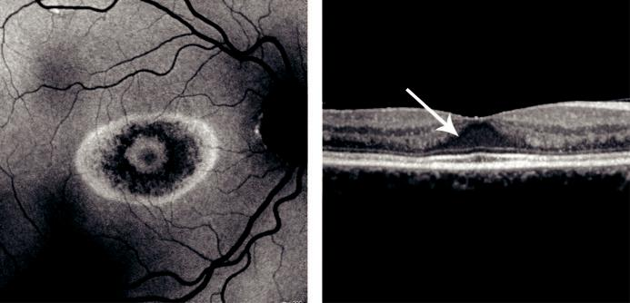

A B

Fig. 21.3 Imaging in hydroxychloroquine retinopathy: (A) fundus autofluorescence showing loss of RPE in the parafoveal region, (B) OCT showing disruption of photoreceptors and loss of inner-outer segment junction (arrow showing ‘flying saucer’ sign). (Courtesy of I. Yusuf.)

#*" ##%"#"+!#(&&%"'+$'""#* "%#! " +#!+ &)%#"$'!%

#%$%&#" (&#" +##'%(&&*'#('$%!&&#"#$+%', &)%" %'&%&%)

|  |  |
| --- | --- |
| Chapter 21—OCULAR SIDE EFFECTS OF SYSTEMIC MEDICATION | **405** |
|  |  |

***Severe maculopathy:*** (a) VA 6/36–6/60 and (b) widespread RPE atrophy surrounding the fovea.

***End-stage maculopathy:*** (a) VA CF–PL, (b) marked RPE atrophy, retinal arteriolar attenu-ation and peripheral pigment clumping.

**PHENOTHIAZINES**

***ioridazine:*** doses exceeding 800 mg/day for just a few weeks may be sucient to cause reduced VA and impairment of dark adaptation. Progression of retinotoxicity is as fol-lows: (a) ‘salt-and-pepper’ pigmentary disturbance at the mid-periphery and posterior pole,

1. plaque-like pigmentation, (c) loss of the RPE and choriocapillaris (Fig. 21.4A). ***Chlorpromazine:*** retinotoxicity may occur with large doses over a prolonged period; it ischaracterized by nonspecific pigmentary granularity and clumping.

**DRUG-INDUCED CRYSTALLINE MACULOPATHIES**

***Tamoxifen:*** retinotoxicity may rarely develop, usually in patients on high doses. (a) Fine yellow crystalline deposits are present in the inner retina and (b) punctate grey lesions in the outer retina and RPE (Fig. 21.4B). Visual impairment is thought to be caused by macu-lopathy associated with foveolar cyst formation.

***Canthaxanthin:*** long-term use may cause the deposition of innocuous glistening yellow inner retinal deposits in a doughnut shape at the posterior pole.

***Methoxyflurane:*** can be associated with calcium oxalate crystals scattered throughout the retina, which may later be associated with RPE hyperplasia at the posterior pole. ***Nitrofurantoin:*** long-term use may result in slight visual impairment associated with glistening retinal deposits.

**OTHER DRUGS**

***Interferon-alpha:*** retinopathy (cotton wool spots and intraretinal haemorrhages) develops in some patients, but usually resolves spontaneously with cessation of therapy.

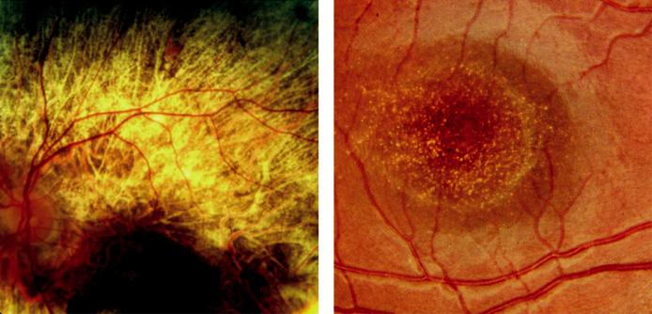

A B

Fig. 21.4 (A) Thioridazine retinopathy, (B) tamoxifen crystalline retinopathy.

#*" ##%"#"+!#(&&%"'+$'""#* "%#! " +#!+ &)%#"$'!%

#%$%&#" (&#" +##'%(&&*'#('$%!&&#"#$+%', &)%" %'&%&%)

**406** SYNOPSIS OF CLINICAL OPHTHALMOLOGY



***Desferrioxamine:*** retinotoxicity typically presents with rapid visual loss. e fundi may be normal, but within several weeks mottled pigmentary changes develop.

***Nicotinic acid:*** rarely patients on high doses develop cystoid maculopathy suggestive of cystoid macular oedema, but without leakage on FA.

***Alkyl nitrates (‘poppers’):*** rarely can result in toxic maculopathy with loss of visual acuity and photopsia.

**Optic nerve**

**ETHAMBUTOL**

***Incidence of toxicity:*** optic neuropathy is dose- and duration-dependent. Rare at a dose of 15 mg/kg/day, but occurs in up to 6% of patients at a daily dose of 25 mg/kg/day; typically, within 3–6 months of starting treatment.

***Presentation:*** visual impairment, with normal or slightly swollen optic discs.

***Signs:*** (a) loss of contrast sensitivity, (b) decreased VA, (c) blue-yellow dyschromatopsia (early), (d) central scotoma, (e) constriction of peripheral fields with red-green dyschroma-topsia (late).

***Prognosis:*** usually good following drug discontinuation.

***Screening:*** every 4 weeks for doses higher than 15 mg/kg and every 3–6 months for lower doses.

**AMIODARONE**

***Incidence of toxicity:*** optic neuropathy, probably demyelinating, is rare and not dose-related, aecting approximately 1% of patients during the initial years of therapy.

***Presentation:*** insidious unilateral or bilateral visual impairment associated with disc swelling.

***Prognosis:*** variable; drug cessation may not result in improvement.

***Screening:*** not appropriate but patients must be warned to report visual symptoms.

**VIGABATRIN**

***Use:*** treatment of epilepsy and infantile spasms

***Pathogenesis of optic neuropathy:*** probably idiosyncratic rather than dose-related.

***Presentation:*** concentric or binasal field defects months or years after starting treatment.

***Fundus:*** usually normal. Occasional changes include peripheral atrophy, nasal disc atrophy, arteriolar narrowing, altered macular reflex and surface wrinkling.

***Perimetry:*** recommended prior to starting treatment, then every 6 months for 3 years and subsequently annually.

**SILDENAFIL**

***Rare:*** nonarteritic ischaemic optic neuropathy.

#*" ##%"#"+!#(&&%"'+$'""#* "%#! " +#!+ &)%#"$'!%

#%$%&#" (&#" +##'%(&&*'#('$%!&&#"#$+%', &)%" %'&%&%)



CHAPTER 22

Trauma



C H A P T E R O U T L I N E

Eyelid trauma 407

Periocular haematoma 407

Laceration 407

Blow-out orbital floor fracture 409

Trauma to the globe 409

Definitions 409

Imaging 411

Blunt trauma to the anterior segment 411 Blunt injuries to the posterior segment 411

Shaken baby syndrome (non-accidental head injury) 414

Penetrating trauma 414 Superficial foreign bodies 415 Intraocular foreign bodies 415 Enucleation/evisceration 417 Bacterial endophthalmitis 418

Chemical injuries 418



**Eyelid trauma**

**PERIOCULAR HAEMATOMA**

A ‘black eye’ consists of a haematoma (focal collection of blood) and/or periocular ecchy-mosis (diuse bruising) and oedema. It is a common result of blunt injury and is generally innocuous (Fig. 22.1A).

It is important to exclude serious associated damage to the eyeball or orbital structures, particularly occult orbital fracture (subconjunctival haemorrhage without a visible posterior limit may be an indicator) and basal skull fracture which may result in bilateral ring haema-toma – ‘panda eyes’ (Fig. 22.1B).

**LACERATION**

Whenever possible, repair should be undertaken using direct closure, as this oers the best func - tional and cosmetic result.

***Marginal lacerations:*** sutured with perfect alignment to prevent notching.

***Extensive tissue loss:*** may require a major reconstructive procedure as following tumour resection.

***Canalicular lacerations*** (Fig. 22.2A)***:*** should be repaired within 24 hours with a bicanalicular (e.g. Crawford) or monocanalicular (e.g. Mini Monoka) silicone stent.

***Infection*** is always a risk, even with a small laceration (Fig. 22.2B).

***Foreign body:*** if there is any suspicion of a foreign body in the soft tissues, a CT scan should be undertaken (Fig. 22.2C and D).

**407**

#*" ##%"#"+!#(&&%"'+$'""#* "%#! " +#!+ &)%#"$'!%

#%$%&#" (&#" +##'%(&&*'#('$%!&&#"#$+%', &)%" %'&%&%)

**408** SYNOPSIS OF CLINICAL OPHTHALMOLOGY

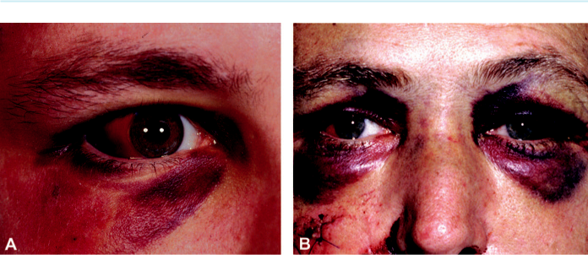

Fig. 22.1 Periocular haematoma: (A) lower lid haematoma with subconjunctival haemorrhage, (B) ‘panda

eyes’. (From Salmon JF, Kanski’s Clinical Ophthalmology: A Systematic Approach, 9th edition. Oxford, UK:

Elsevier; 2020.)

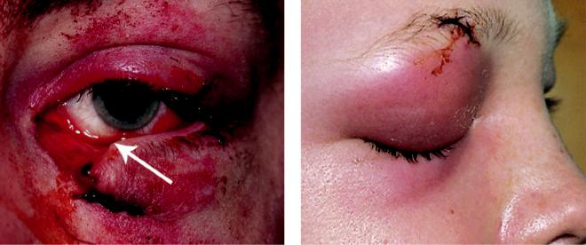

A B

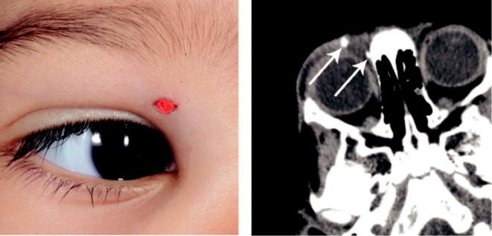

C D

Fig. 22.2 Lid laceration: (A) lower lid laceration involving the canaliculus (arrow), (B) orbital cellulitis secondary to a small laceration, (C) right upper lid showing tip of coloured pencil in a child, (D) CT scan of (C) showing the broken pencil tips (arrows). (From Salmon JF, Kanski’s Clinical Ophthalmology: A Systematic Approach, 9th edition. Oxford, UK: Elsevier; 2020.)

#*" ##%"#"+!#(&&%"'+$'""#* "%#! " +#!+ &)%#"$'!%

#%$%&#" (&#" +##'%(&&*'#('$%!&&#"#$+%', &)%" %'&%&%)

|  |  |
| --- | --- |
| Chapter 22—TRAUMA | **409** |
|  |  |

**Blow-out orbital floor fracture**

**Pathogenesis:**

sudden increase in orbital pressure due to an impacting object. e fracture most frequently involves the relatively weak floor of the orbit along the thin bone covering the infraorbital canal. Occasionally, the orbital wall, the rim and/or adjacent facial bones may be fractured.

**Diagnosis**

***Periorbital:*** (a) ecchymosis, (b) oedema, (c) occasionally subcutaneous emphysema.

***Infraorbital nerve anaesthesia:*** (lower lid, cheek, side of nose, upper lip, upper teeth, gums) is common.

***Mechanisms of diplopia:*** (a) restriction due to haemorrhage and oedema, (b) mechanical entrapment of extraocular muscle or adjacent connective tissue within the fracture, with diplopia typically occurring in both upgaze (Fig. 22.3A) and downgaze, (c) direct injury to an extraocular muscle (negative forced duction test).

***Enophthalmos:*** in severe fracture.

***Globe damage:*** uncommon but should be excluded.

***CT:*** with coronal views for fracture evaluation (Fig. 22.3B).

***Hess test:*** for monitoring diplopia.

**Initial treatment**

***Oral antibiotics:*** no nose blowing because infected sinus contents may be forced into the orbit.

***Ice packs and nasal decongestants:*** for swelling.

***Systemic steroids:*** occasionally required for severe oedema, especially if there is optic nerve compromise.

**Subsequent treatment**

***Aims:*** prevention of permanent diplopia and/or cosmetically unacceptable enophthalmos.

***Surgery not required:*** (a) fractures involving up to one-third of the orbital floor, (b) little or no herniation, (c) no significant enophthalmos, (d) improving diplopia.

***Surgery within 2 weeks:*** (a) fractures with entrapment of orbital contents, (b) enophthalmos greater than 2 mm, (c) significant diplopia.

***Urgent surgery:*** (a) early marked enophthalmos, (b) ‘white-eyed’ fracture subgroup with acute trap-door incarceration of herniated tissue. is requires urgent repair to avoid perma - nent neuromuscular damage. Patients are typically younger than 18 years of age with little visible external soft tissue injury and CT signs may be subtle.

***Surgical technique:*** (a) transconjunctival or subciliary approach, (b) removal of entrapped orbital contents, (c) defect is covered with a synthetic patch (e.g. silicone).

**Trauma to the globe**

**DEFINITIONS**

***Closed injury:*** commonly due to blunt trauma; the cornea and sclera are intact.

***Open injury:*** full-thickness wound of the corneoscleral envelope.

***Rupture:*** full-thickness wound caused by blunt trauma. e globe gives way at its weakest point, which may not be at the site of impact.

#*" ##%"#"+!#(&&%"'+$'""#* "%#! " +#!+ &)%#"$'!%

#%$%&#" (&#" +##'%(&&*'#('$%!&&#"#$+%', &)%" %'&%&%)

**410** SYNOPSIS OF CLINICAL OPHTHALMOLOGY

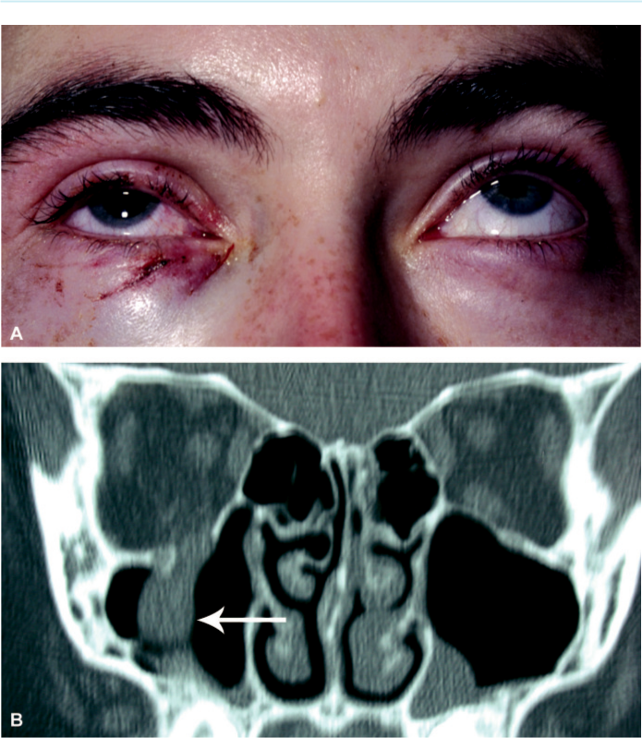

Fig. 22.3 Blow-out orbital floor fracture: (A) restricted upgaze, (B) coronal CT of right blow-out fracture show-ing the tear-drop sign due to soft tissue prolapse into the maxillary antrum (arrow). (From Salmon JF, Kanski’s Clinical Ophthalmology: A Systematic Approach, 9th edition. Oxford, UK: Elsevier; 2020.)

***Laceration:*** full-thickness defect in the eye wall produced by a tearing injury, usually due to a direct impact.

***Incised injury:*** caused by a sharp object such as glass or a knife.

***Penetrating injury:*** single full-thickness wound, usually caused by a sharp object, without an exit wound; may be associated with an intraocular foreign body.

***Perforating injury:*** full-thickness entry and exit wounds, usually caused by a missile.

#*" ##%"#"+!#(&&%"'+$'""#* "%#! " +#!+ &)%#"$'!%

#%$%&#" (&#" +##'%(&&*'#('$%!&&#"#$+%', &)%" %'&%&%)

|  |  |
| --- | --- |
| Chapter 22—TRAUMA | **411** |
|  |  |

**IMAGING**

***Plain radiographs:*** may be taken when a foreign body is suspected.

***CT:*** superior to plain radiographs in detection and localization of foreign bodies.

***MR:*** more accurate than CT in assessment of the globe such as detection of an occult pos-terior rupture, although not for bony structures. MR should never be performed if a ferrous foreign body is suspected.

***US:*** may identify an intraocular foreign body, globe rupture, suprachoroidal haemorrhage and retinal detachment.

**Blunt trauma to the anterior segment**

***Corneal abrasion:*** breach of the epithelium, demonstrated by fluorescein staining (Fig.

22.4A).

***Corneal oedema:*** folds in Descemet membrane and stromal thickening.

***Hyphaema:*** blood in the anterior chamber with a horizontal ‘fluid level’ pattern (Fig. 22.4B). is usually causes a slight rise in IOP. Uncontrolled high IOP secondary to a large hypha - ema can result in ischaemic optic neuropathy and corneal blood staining. An occult poste-rior scleral rupture should be suspected if the IOP is low in the presence of a full hyphaema. (See Chapter 11 for management.)

***Pupillary damage:*** (a) compression of the pupillary margin against the lens results in imprinting of pigment (Vossius ring; Fig. 22.4C), (b) damage to the iris sphincter may cause mydriasis, (c) radial tears in the pupillary margin (Fig. 22.4D).

***Iridodialysis:*** dehiscence of the iris from the ciliary body at its root. e pupil is typically D-shaped and the dialysis is seen as a dark biconvex area near the limbus (Fig. 22.4E). ***Angle recession:*** tear involving the face of the ciliary body that carries a risk of late glaucoma (see Fig. 11.15B). is is the commonest sign of previous blunt trauma to the eye.

***IOP***: (a) elevation (hyphaema, inflammation), (b) hypotony (temporary cessation of aque-ous secretion – ‘ciliary shock’ or occult scleral rupture).

***Lens damage:*** (a) flower-shaped ‘rosette’ lens opacity (Fig. 22.4F), (b) tearing of the zonular fibres may lead to subluxation; complete dislocation is rare and the lens may be into the vitreous or anterior chamber.

***Globe rupture:*** usually anterior, with prolapse of iris and vitreous but may be masked by sub-conjunctival haemorrhage. An occult posterior rupture should be suspected if the anterior chamber is unusually deep and the IOP is low.

**Blunt injuries to the posterior segment**

***Vitreous haemorrhage:*** often in association with posterior vitreous detachment.

***Commotio retinae:*** concussion of the sensory retina resulting in cloudy swelling that gives the involved area a grey appearance (Fig. 22.5A). If the macula is involved, a ‘cherry-red spot’ may be seen at the fovea. Prognosis is dependent on severity and may result in progres-sive pigmentary degeneration and macular hole formation.

***Choroidal rupture:*** (a) a fresh rupture may be partially obscured by subretinal haemorrhage (Fig. 22.5B), (b) following absorption of blood, a white crescentic vertical streak of exposed sclera concentric with the optic disc becomes visible. e visual prognosis is poor if the fovea is involved. An uncommon late complication is choroidal neovascularization.

***Retinal breaks and RD:*** an injury is responsible for approximately 10% of RD and is the most common cause in children. A dialysis (break at the ora serrata) is commonly caused

#*" ##%"#"+!#(&&%"'+$'""#* "%#! " +#!+ &)%#"$'!%

#%$%&#" (&#" +##'%(&&*'#('$%!&&#"#$+%', &)%" %'&%&%)

**412** SYNOPSIS OF CLINICAL OPHTHALMOLOGY

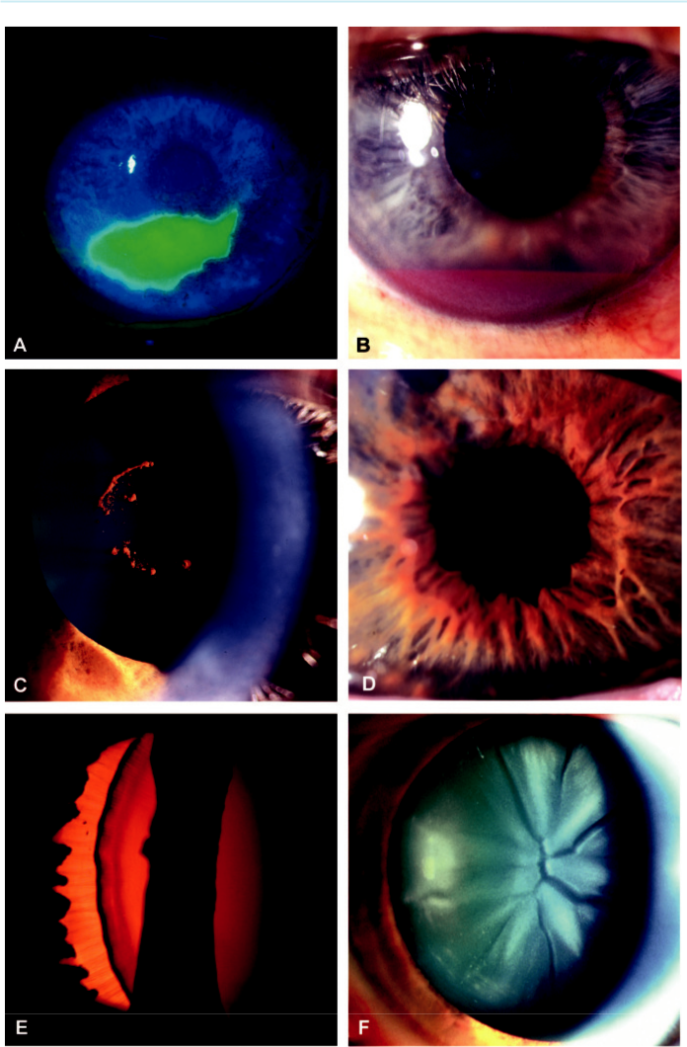

Fig. 22.4 Blunt trauma to the anterior segment: (A) corneal abrasion, (B) hyphaema, (C) Vossius ring,

1. pupillary sphincter tears, (E) iridodialysis, (F) flower-shaped lens opacity. (Figure 22.4A courtesy of Chris Barry, Lions Eye Institute, Perth, Australia.)

#*" ##%"#"+!#(&&%"'+$'""#* "%#! " +#!+ &)%#"$'!%

#%$%&#" (&#" +##'%(&&*'#('$%!&&#"#$+%', &)%" %'&%&%)

|  |  |
| --- | --- |
| Chapter 22—TRAUMA | **413** |
|  |  |

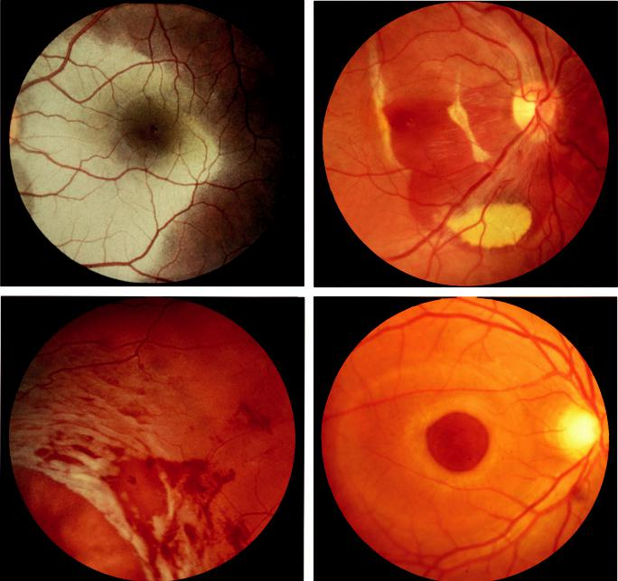

A B

C D

Fig. 22.5 Blunt trauma to the posterior segment: (A) commotio retinae, (B) choroidal rupture with sub-retinal and sub-RPE haemorrhage, (C) retinal dialysis, (D) macular hole.

by impact-related traction of the gel along the posterior aspect of the vitreous base. It may be associated with avulsion of the vitreous base giving rise to a ‘bucket-handle’ appear-ance (Fig. 22.5C). Equatorial breaks and macular holes (Fig.22.5D ) are less common. (See Chapter 16 for management.)

***Traumatic optic neuropathy:*** presents with sudden visual loss that cannot be explained by other pathology. Vision is often very poor from the outset, with 50% having perception of light on presentation. Typically, the only objective finding is an APD, with disc pallor devel-oping subsequently. Some spontaneous improvement occurs in up to half of indirect injury cases, but if there is initially no light perception the prognosis is very poor. No clear benefit has been demonstrated for any form of treatment, but steroids, optic nerve decompression, or fenestration may be useful in some cases.

***Optic nerve avulsion:*** rare and typically occurs when an object intrudes between the globe and the orbital wall, displacing the eye. Fundus examination shows peripapillary haemor-rhage and a cavity where the optic nerve head has retracted from its dural sheath.

#*" ##%"#"+!#(&&%"'+$'""#* "%#! " +#!+ &)%#"$'!%

#%$%&#" (&#" +##'%(&&*'#('$%!&&#"#$+%', &)%" %'&%&%)

**414** SYNOPSIS OF CLINICAL OPHTHALMOLOGY



**Shaken baby syndrome (non-accidental head injury)**

**Pathogenesis:**

physical abuse occurring in children typically younger than age 2 years caused principally by vio-lent shaking. Brainstem traction injury causes apnoea, consequent hypoxia leading to raised intra-cranial pressure and ischaemia. Mortality is more than 25%, and it is responsible for up to 50% of deaths from child abuse.

**Diagnosis**

***Presentation:*** irritability, lethargy and vomiting; often misdiagnosed because the history of injury is withheld.

***Systemic features:*** impact head injuries (bruising, skull fractures, subdural and subarachnoid haemorrhage), rib and long bone fractures. Visual loss occurs in 20%, mainly due to cerebral damage.

***Ocular features:*** (a) periocular bruising, (b) subconjunctival haemorrhage (Fig. 22.6A), (c) APD, (d) poor visual responses, (e) retinal haemorrhages, typically involving multiple layers (Fig. 22.6B).

**Penetrating trauma**

**Causes:**

penetrating injuries are more common in males than in females (3:1); 50% occur in individu-als aged 15–34 years. e most frequent causes are assault, domestic/occupational accidents and sporting injury.

**Treatment**

***Corneal wounds:*** (a) small self-sealing shelving wounds with a formed anterior chamber may not require suturing because they will usually heal spontaneously or with a bandage contact lens. Prophylactic topical antibiotics are essential. Topical steroids and a mydriatic may be needed for traumatic iritis, (b) large wounds should be sutured urgently. If possible, healthy iris should be reposited. Devitalized incarcerated iris should be excised, particularly if there is a risk of contamination by foreign material (Fig. 22.7A).

***Lens damage:*** corneal/scleral lacerations are sutured, following which the lens is removed. Implantation of an IOL is generally associated with a favourable visual outcome and a low rate of complications.

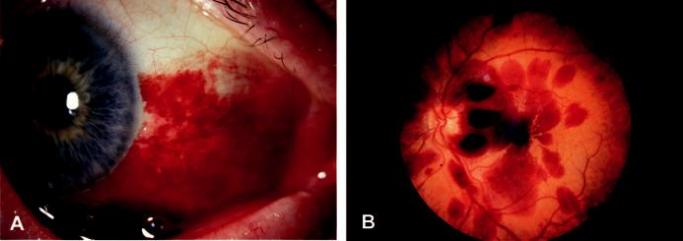

Fig. 22.6 Shaken baby syndrome: (A) subconjunctival haemorrhage, (B) haemorrhages involving different levels of the retina. (Figure. 22.6B courtesy of R. Bates.)

#*" ##%"#"+!#(&&%"'+$'""#* "%#! " +#!+ &)%#"$'!%

#%$%&#" (&#" +##'%(&&*'#('$%!&&#"#$+%', &)%" %'&%&%)

|  |  |
| --- | --- |
| Chapter 22—TRAUMA | **415** |
|  |  |

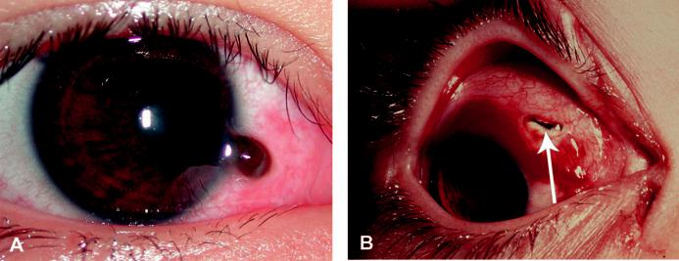

Fig. 22.7 Penetrating trauma: (A) corneoscleral laceration with iris prolapse, (B) anterior scleral laceration

with vitreous prolapse (arrow). (From Salmon JF, Kanski’s Clinical Ophthalmology: A Systematic Approach,

9th edition. Oxford, UK: Elsevier; 2020.)

***Anterior scleral laceration:*** every attempt should be made to reposit viable uveal tissue and cut prolapsed vitreous flush with the wound in order to reduce the risk of tractional retinal detachment (Fig. 22.7B).

***Posterior scleral laceration:*** frequently associated with retinal damage. Primary repair of the sclera should be the initial priority, with subsequent vitreoretinal assessment.

***Tractional RD:*** requires pars plana vitrectomy.

**SUPERFICIAL FOREIGN BODIES**

***Subtarsal:*** small foreign bodies such as particles of steel, coal, or sand often impact on the corneal or conjunctival surface and sometimes adhere to the superior tarsal conjunctiva (Fig. 22.8A) from where the cornea is abraded with every blink – a pathognomonic pattern of linear corneal abrasions is usual (Fig. 22.8B). After the insertion of a topical anaesthetic, the foreign body can be removed with a cotton bud.

***Inner canthus:*** occasionally a barbed foreign body, such as an insect (Fig. 22.8C) or plant material, will become deeply embedded.

***Corneal ferrous foreign bodies:*** of even a few hours’ duration often result in rust staining (‘rust ring’) (Fig. 22.8D). ere is a risk of secondary bacterial keratitis, particularly with organic particles and stone fragments. e foreign body is removed under slit-lamp visualization using a sterile needle (e.g. 26 gauge), following which antibiotic ointment is inserted together with a short-acting cycloplegic. A residual ‘rust ring’ is best removed with a sterile burr.

**INTRAOCULAR FOREIGN BODIES**

**Introduction:**

an intraocular foreign body (IOFB) may traumatize the eye: (a) mechanically (e.g. cataract, retinal haemorrhages, retinal tears), (b) by introducing infection (especially stone and organic foreign bodies), (c) by exerting other toxic eects on the intraocular structures. A ferrous IOFB undergoes dissociation resulting in the deposition of iron in the intraocular epithelial structures (siderosis). An IOFB with a high copper content induces a violent endophthalmitis-like picture. An alloy with low copper content (such as brass) results in chalcosis in which dissociated copper becomes deposited intraocularly, giving similar ocular features to Wilson disease.

#*" ##%"#"+!#(&&%"'+$'""#* "%#! " +#!+ &)%#"$'!%

#%$%&#" (&#" +##'%(&&*'#('$%!&&#"#$+%', &)%" %'&%&%)

**416** SYNOPSIS OF CLINICAL OPHTHALMOLOGY

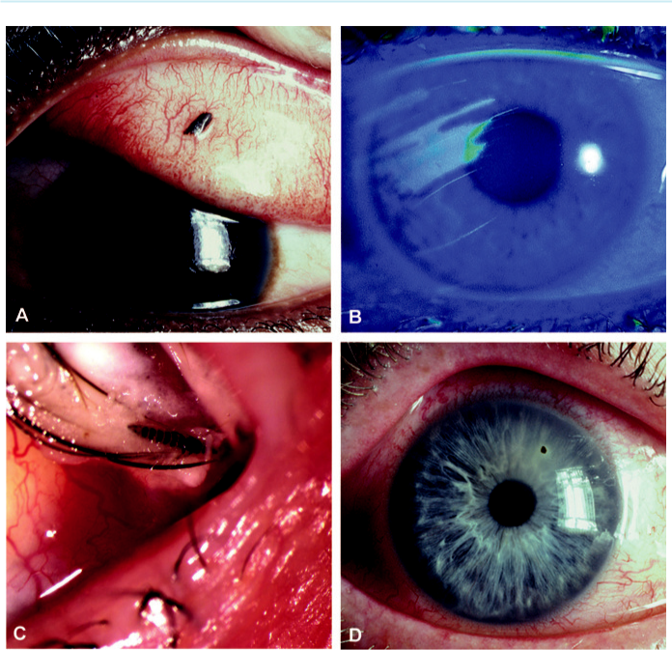

Fig. 22.8 Superficial foreign body: (A) subtarsal, (B) linear corneal abrasion, (C) insect retained in the inner

canthus, (D) embedded corneal foreign body. (From Salmon JF, Kanski’s Clinical Ophthalmology: A Systematic

Approach, 9th edition. Oxford, UK: Elsevier; 2020.)

**Diagnosis**

***Accurate history:*** to determine the likelihood and origin of an IOFB.

***Examination:*** to confirm presence and location (Fig. 22.9A and B).

***Gonioscopy:*** may reveal an IOFB lodged in the anterior chamber angle.

***Siderosis:*** (a) radial iron deposits on the anterior lens capsule (Fig. 22.9C), (b) reddish-brown staining of the iris sometimes with heterochromia iridis, (c) complications include secondary glaucoma and pigmentary retinopathy, followed by atrophy of the retina and RPE with severe visual loss.

***Chalcosis:*** (a) Kayser–Fleischer ring, (b) anterior ‘sunflower’ cataract, (c) golden retinal plaques. Because copper is less retinotoxic than iron, degenerative retinopathy does not develop and visual function may be preserved.

***CT:*** axial and coronal cuts used to detect and localize a metallic IOFB (Fig. 22.9D).

***B-scan US:*** often very helpful, although care should be taken not to exert pressure on an open eye.

***MR:*** contraindicated in the context of a ferrous IOFB.

#*" ##%"#"+!#(&&%"'+$'""#* "%#! " +#!+ &)%#"$'!%

#%$%&#" (&#" +##'%(&&*'#('$%!&&#"#$+%', &)%" %'&%&%)

|  |  |
| --- | --- |
| Chapter 22—TRAUMA | **417** |
|  |  |

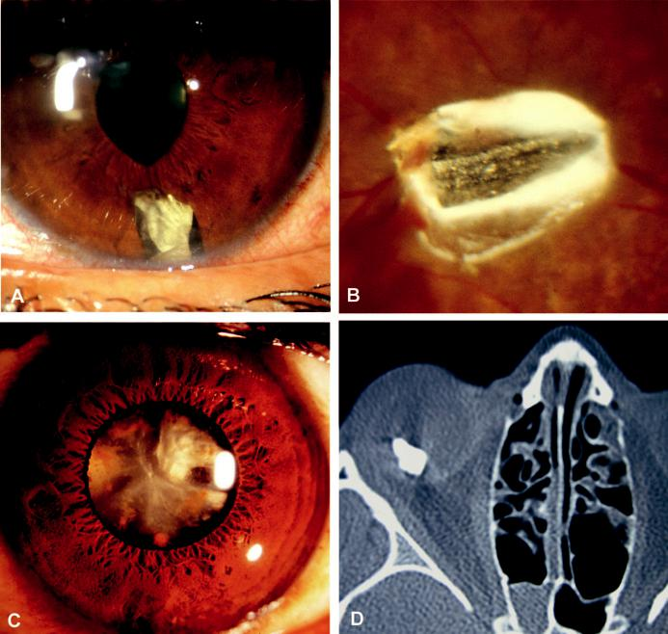

Fig. 22.9 Intraocular foreign body: (A) in the anterior chamber, (B) retinal impaction, (C) siderosis oculi showing lenticular ferrous deposits, (D) axial CT showing a localized intraocular foreign body within the eye. (Figure 22.9D courtesy of S. Chen.)

**Treatment**

***Magnetic removal:*** of ferrous IOFB involves the creation of an adjacent sclerotomy, with application of a magnet.

***Forceps removal:*** for nonmagnetic IOFB or ferrous IOFB that cannot be safely removed with a magnet. A pars plana vitrectomy is undertaken and the foreign body is removed with forceps either through the pars plana or limbus.

***Prophylaxis against infection:*** *Staphylococcus* spp. and *Bacillus* spp. are isolated in 90%.

Prophylactic antibiotics are critical to reduce the risk of infection (see below).

**ENUCLEATION/EVISCERATION**

***Primary enucleation/evisceration:*** only for very severe injuries where there is no prospect of retention of vision (no light perception preoperatively) and when it is impossible to repair the sclera.

#*" ##%"#"+!#(&&%"'+$'""#* "%#! " +#!+ &)%#"$'!%

#%$%&#" (&#" +##'%(&&*'#('$%!&&#"#$+%', &)%" %'&%&%)

**418** SYNOPSIS OF CLINICAL OPHTHALMOLOGY



***Secondary enucleation/evisceration:*** following primary repair if the eye is severely and irre-versibly damaged, particularly if it is also blind, unsightly and uncomfortable. It has been recommended that the surgery should be performed within 10 days of the original injury in order to reduce the risk of sympathetic ophthalmitis (see Chapter 12).

**BACTERIAL ENDOPHTHALMITIS**

**Risk factors:**

endophthalmitis develops in approximately 8% of cases of penetrating trauma with retained for-eign body. Risk factors include: (a) delay in primary repair, (b) retained IOFB, (c) position and extent of the laceration. Clinical signs are the same as for acute postoperative endophthalmitis (see Chapter 10).

**Treatment**

***Prophylaxis:*** (a) oral fluoroquinolone antibiotics (ciprofloxacin, moxifloxacin) for open globe injuries, together with topical antibiotic, steroid and cycloplegic, (b) prompt removal and culture of a retained IOFB, (c) intravitreal antibiotics for high-risk cases such as agri-cultural injuries.

***Treatment of established cases:*** same as that of acute postoperative bacterial endophthalmitis (see Chapter 10).

**Chemical injuries**

**Introduction:**

alkalis tend to penetrate more deeply than acids because the latter coagulate surface proteins, forming a protective barrier. Pathological eects include necrosis of the conjunctival and corneal epithelium with disruption, occlusion of the limbal vasculature and loss of limbal stem cells and damage to internal tissues following anterior chamber penetration; hypotony and phthisis may ensue in severe cases.

**Diagnosis**

***History:*** delayed until after initial treatment as below.

***Grading (Roper-Hall system):*** aids the planning of later treatment and gives an indication of

prognosis; (a) grade 1: clear cornea (epithelial damage only) and no limbal ischaemia (excel-

lent prognosis), (b) grade 2: hazy cornea but with visible iris details and less than one-third limbal ischaemia (good prognosis; Fig. 22.10A), (c) grade 3: total loss of corneal epithe-lium, stromal haze obscuring iris details and between one-third and half limbal ischaemia (guarded prognosis; Fig. 22.10B), (d) grade 4: opaque cornea and more than half limbal ischaemia (very poor prognosis).

**Treatment**

***Immediate emergency treatment:*** (a) topical anaesthesia (if available), (b) copious irrigation with normal saline or Ringer solution (tap water to avoid delay) for 15–30 min or until pH is neutral, (c) double-eversion of the upper eyelid, (d) debridement of contaminating debris and necrotic areas of epithelium.

***Treatment of mild (grade 1 and 2) injuries:*** topical antibiotic ointment for approximately 1 week, with topical steroid and cycloplegic if necessary.

***Treatment of moderate–severe injuries:*** (a) topical steroid, initially 4–8 times daily then tailed o after 7–10 days and replaced by topical NSAID, cycloplegic, antibiotic, ascorbic

#*" ##%"#"+!#(&&%"'+$'""#* "%#! " +#!+ &)%#"$'!%

#%$%&#" (&#" +##'%(&&*'#('$%!&&#"#$+%', &)%" %'&%&%)

|  |  |
| --- | --- |
| Chapter 22—TRAUMA | **419** |
|  |  |

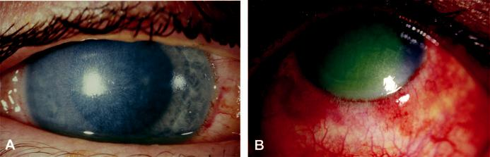

Fig. 22.10 Chemical injuries: (A) corneal haze but visible iris detail, (B) limbal ischaemia with corneal haze

obscuring iris details. (From Salmon JF, Kanski’s Clinical Ophthalmology: A Systematic Approach, 9th edition.

Oxford, UK: Elsevier; 2020.)

and citric acid and acetylcysteine, (b) systemic ascorbic acid and tetracycline (for corneal melting), (c) lysis of developing symblepharon with a sterile glass rod or damp cotton bud, (d) monitoring of IOP.

***Early surgery:*** in severe cases to maintain corneal integrity (e.g. advancement of Tenon cap-sule to re-establish limbal vascularity, limbal stem cell transplantation, amniotic membrane grafting, gluing or keratoplasty for actual or impending perforation).

***Late surgery:*** (e.g. division of conjunctival bands, conjunctival or other mucous membrane grafts, correction of eyelid deformities, keratoplasty, keratoprosthesis).

#*" ##%"#"+!#(&&%"'+$'""#* "%#! " +#!+ &)%#"$'!%

#%$%&#" (&#" +##'%(&&*'#('$%!&&#"#$+%', &)%" %'&%&%)